Date : 05/01/2014
Anoop Hallur <ahallur>

NEURAL SIGNAL PROCESSING
Problem Set 8

Q.1.a

>> Plot the square-rooted eigenvalue spectrum

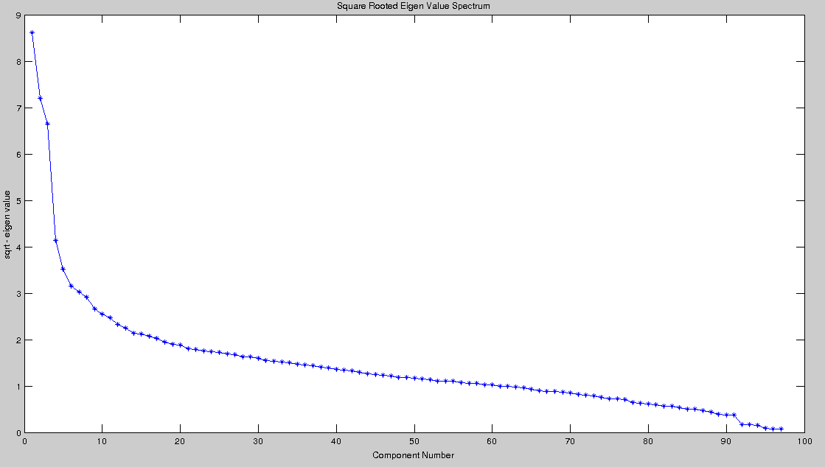

>> How many dominant eigenvalues would there be
From the above figure, we have to make a guess by eyeballing the figure for an elbow.
It seems that there are three dominant eigenvalues.

>> What percentage of the overall variance is captured by the top 3 principal
components

percentage_in_top_PrinComp =

0.4479

If we consider top 3, then about 44.79% of total variance is captured in it.

However if we cons top 4 components, then 49.31% of total variance is captured in it. → 0.4931
Similarly top 5 → 52.56%, so we need not compute it henceforth.

Also, if we consider only top 2, → It captures only 33.16% of total variance.

Hence it looks like the optimal number of principal components is 3, capturing 44.79% of the total variance.

Q.1.b

>> Project the data into the three-dimensional PC space.

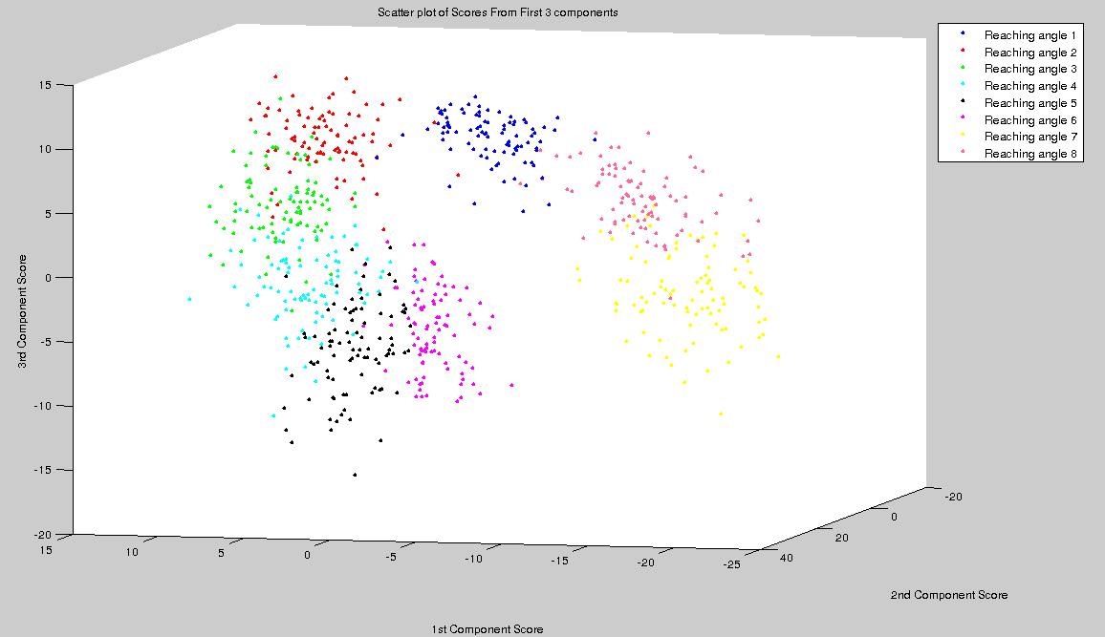

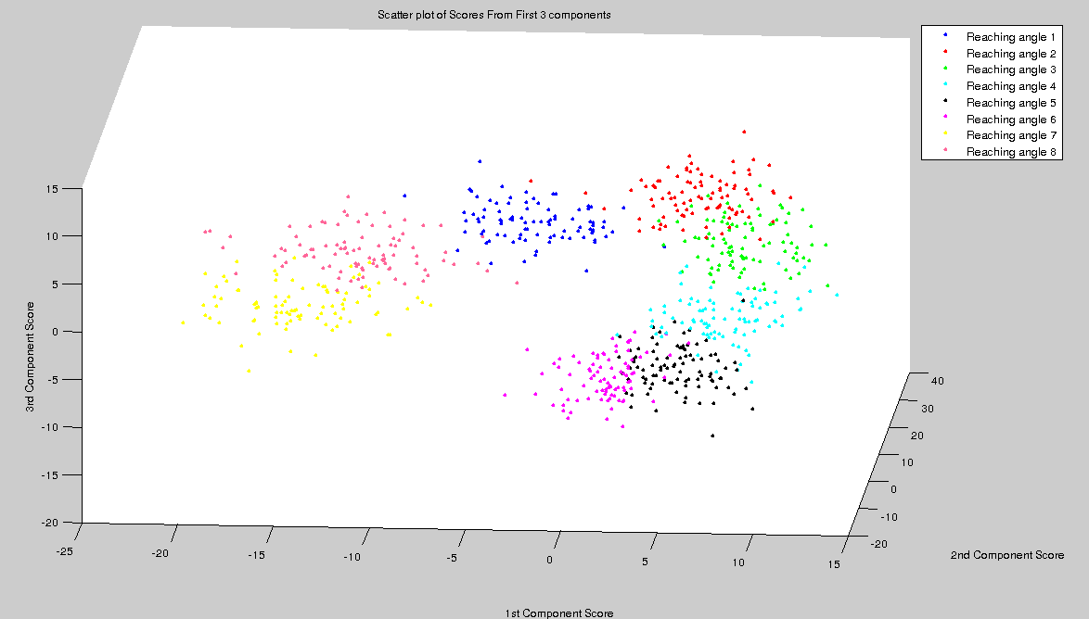
Q.1.c

>> Show the values in UM by calling ‘imagesc(UM )’

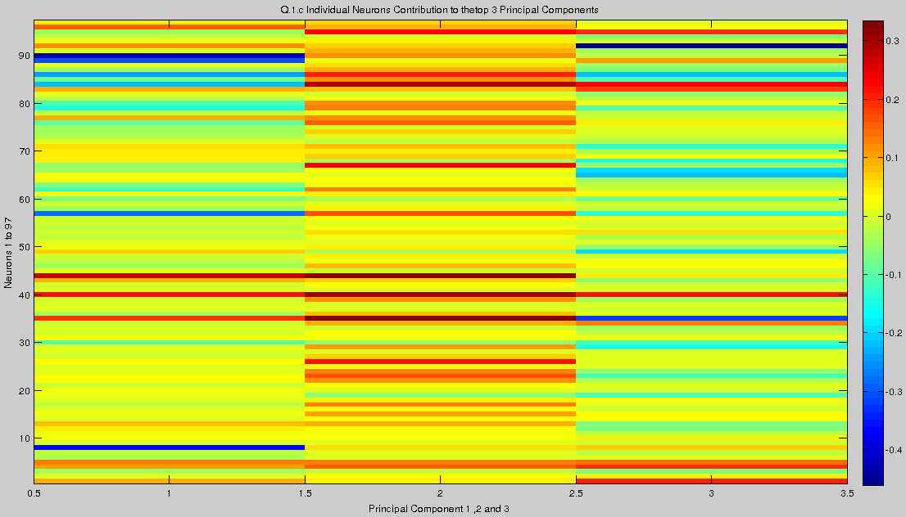
This figure gives us the idea of how much each neuron contributes to the 1st, 2nd and 3rd Principal Components.

From the above figure we can infer that

~> Contribution of neighboring neurons to a particular component is gradual, we can see peaks of blue and slowly decreasing intensity on either sides.

~> For 1st and 3rd Principal components, the contribution is highest by particular neurons(peaks at one place) and is very minimal throughout the other neurons

~> For 2nd Principal component, the contribution is gradual,i.e the all neurons contribute in an approximately equal manner as can be seen by the absence of distinguishable peaks.
MATLAB Code For Problem 1

% Load all data
load ps8_data.mat

% Number of principal components to be considerd(by eyeballing)
NUM_PRINCOMP = 3;

% Extracting out the constants used frequently
NUM_TRIALS = size(Xplan, 1);
DIMENSION = size(Xplan, 2);

% Computing mean and covariance
mean_spike_counts = mean(Xplan, 1);
cov_spike_counts = cov(Xplan);

% Eigen Decomposition
[U, Lambda] = eig(cov_spike_counts);

% Plotting the graph for problem 1.a
eigen_values = diag(Lambda);
eigen_values_increasing = fliplr(eigen_values')';
plot(fliplr(sqrt(eigen_values_increasing)));
hold on
plot(fliplr(sqrt(eigen_values_increasing)), '*');
xlabel('Component Number');
ylabel('sqrt - eigen value');
title('Square Rooted Eigen Value Spectrum');

percentage_in_top_PrinComp = sum(eigen_values_increasing ...
(1:NUM_PRINCOMP))./ sum(eigen_values_increasing);
% This is 44.79% for top 3 components

% Question 1b
figure
PC1 = U(:,end);
PC2 = U(:,end-1);
PC3 = U(:,end-2);
mean_repeated = repmat(mean_spike_counts, NUM_TRIALS, 1);
% Top 3 Principal Components
Z1 = PC1' * (Xplan - mean_repeated)';
Z2 = PC2' * (Xplan - mean_repeated)';
Z3 = PC3' * (Xplan - mean_repeated)';
plot3(Z1(91*0+1:91*1), Z2(91*0+1:91*1), Z3(91*0+1:91*1), '.b');hold on;
plot3(Z1(91*1+1:91*2), Z2(91*1+1:91*2), Z3(91*1+1:91*2), '.r');hold on;
plot3(Z1(91*2+1:91*3), Z2(91*2+1:91*3), Z3(91*2+1:91*3), '.g');hold on;
plot3(Z1(91*3+1:91*4), Z2(91*3+1:91*4), Z3(91*3+1:91*4), '.c');hold on;
plot3(Z1(91*4+1:91*5), Z2(91*4+1:91*5), Z3(91*4+1:91*5), '.k');hold on;
plot3(Z1(91*5+1:91*6), Z2(91*5+1:91*6), Z3(91*5+1:91*6), '.m');hold on;
plot3(Z1(91*6+1:91*7), Z2(91*6+1:91*7), Z3(91*6+1:91*7), '.y');hold on;
plot3(Z1(91*7+1:91*8), Z2(91*7+1:91*8), Z3(91*7+1:91*8), '.',...
'Color',[1,0.4,0.6]);hold on;
legend('Reaching angle 1','Reaching angle 2','Reaching angle 3', ...
'Reaching angle 4','Reaching angle 5','Reaching angle 6',...
'Reaching angle 7','Reaching angle 8');
xlabel('1st Component Score');
ylabel('2nd Component Score');
zlabel('3rd Component Score');
title('Scatter plot of Scores From First 3 components');

% Question 1c
figure
U_m = [PC1 PC2 PC3];
imagesc(U_m);
colorbar
xlabel('Principal Component 1 ,2 and 3');
ylabel('Neurons 1 to 97');
axis xy;
title(['Q.1.c Individual Neurons Contribution to the' ...
'top 3 Principal Components']);

Q.2.a

>> Create one plot containing all of the following for PCA

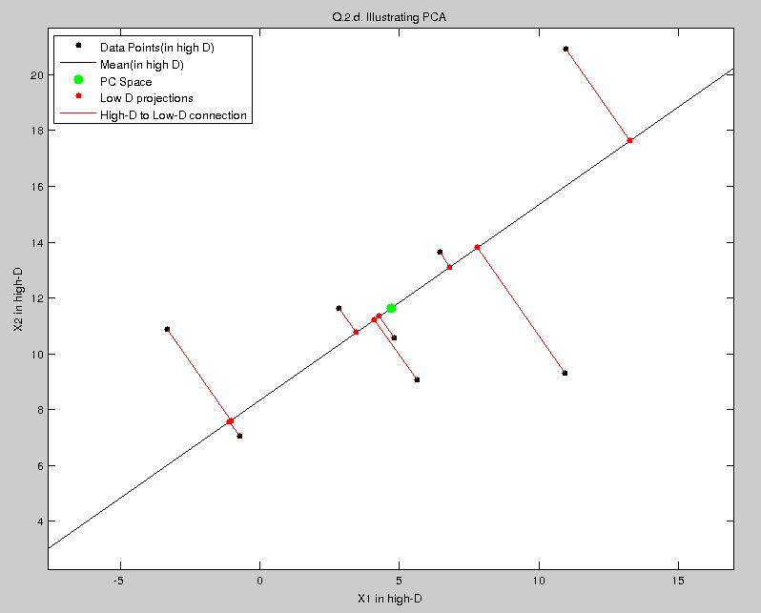

MATLAB Code for Problem 2.a

clear;
load ps8_data.mat

LINE_LENGTH = 15;
X = Xsim';
NUMBER_OF_POINTS = size(X, 2);
HIGH_DIMENSION = size(X, 1);
LOW_DIMENSION = 1;

% Q.1.a.1
plot (X(1,:), X(2,:), 'k.', 'markersize',15);
hold on;

mu = mean(X,2);
S = cov(X');

[U, Lambda] = eig(S);
% The dominant component
U1 = U(:,end);

% Q.1.a.3
point_1_for_plot = mu - LINE_LENGTH * U1;
point_2_for_plot = mu + LINE_LENGTH * U1;
line([point_1_for_plot(1), point_2_for_plot(1)],...
[point_1_for_plot(2), point_2_for_plot(2)], 'Color', 'k');
hold on;

% Q.1.a.2
plot (mu(1), mu(2), 'g.', 'markersize',25);
hold on;

mu_rep = repmat(mu, [1, NUMBER_OF_POINTS]);
Z = U1'*(X-mu_rep);
X_cap = (U1 * Z) + mu_rep;

% Q.1.a.4 and 5
plot (X_cap(1,:), X_cap(2,:), 'r.', 'markersize',15);
hold on;
for i=1:NUMBER_OF_POINTS
line([X_cap(1, i), X(1, i) ], [X_cap(2, i), X(2, i) ], 'Color', 'r');
hold on
end
axis equal;
xlabel('X1 in high-D');
ylabel('X2 in high-D');
title('Q.2.d. Illustrating PCA')
legend('Data Points(in high D)', 'Mean(in high D)', 'PC Space', ...
'Low D projections', 'High-D to Low-D connection'...
,'Location','NorthWest');

save q2.mat

Q.2.b

>> Implement the EM algorithm for PPCA in Matlab, and run the
algorithm on the data in Xsim

MATLAB Code For Problem 2.b

load q2.mat

LINE_LENGTH = 15;
sigma_sqr = 0.5;
mu_bkp = mu;
W = [1;1];
n_iter = 20;
L = zeros(1,n_iter);

for k =1:n_iter
C = W*W' + sigma_sqr*eye(HIGH_DIMENSION);

% E step
mu_rep = repmat(mu, [1, NUMBER_OF_POINTS]);
z_x_mu = W'*inv(C)*(X-mu_rep);
z_x_sigma = eye(LOW_DIMENSION) - W'*inv(C)*W;

% M Step
E_zzt = z_x_sigma + z_x_mu * z_x_mu';

term1 = (X-mu_rep) * z_x_mu';
term2 = inv(sum(repmat(E_zzt, [1, NUMBER_OF_POINTS])));
W = term1 * term2;

term3 = (X-mu_rep)*(X-mu_rep)';
term4 = W*(z_x_mu*(X-mu_rep)');
sigma_sqr = trace(term3 - term4)/ ...
(NUMBER_OF_POINTS * HIGH_DIMENSION);

% Calculating log likelihood
for i = 1:NUMBER_OF_POINTS
L(k) = L(k) + logmvnpdf(X(:,i), mu, C);
end
end
plot(L);
xlabel('Iteration Number');
ylabel('Log Likelihood');
title('Q.2.b. Log likelihood v/s iteration number');
figure;

% Question 2d
plot (X(1,:), X(2,:), 'k.', 'markersize',30);
hold on;
plot (mu(1), mu(2), 'g.', 'markersize',45);
hold on;
point_1_for_plot = mu - LINE_LENGTH * W;
point_2_for_plot = mu + LINE_LENGTH * W;
line([point_1_for_plot(1), point_2_for_plot(1)],...
[point_1_for_plot(2), point_2_for_plot(2)], 'Color', 'k');
hold on;

X_cap = W*z_x_mu + mu_rep;
plot (X_cap(1,:), X_cap(2,:), 'r.', 'markersize',15);
hold on;
for i=1:NUMBER_OF_POINTS
line([X_cap(1, i), X(1, i) ], [X_cap(2, i), X(2, i) ], 'Color', 'r');
hold on
end
xlabel('X1 in high-D');
ylabel('X2 in high-D');
title('Q.2.d. Illustrating PPCA')
legend('Data Points(in high D)', 'Mean(in high D)', 'PC Space', ...
'Low D projections', 'High-D to Low-D connection'...
,'Location','NorthWest');
axis equal

>> Plot the log data likelihood

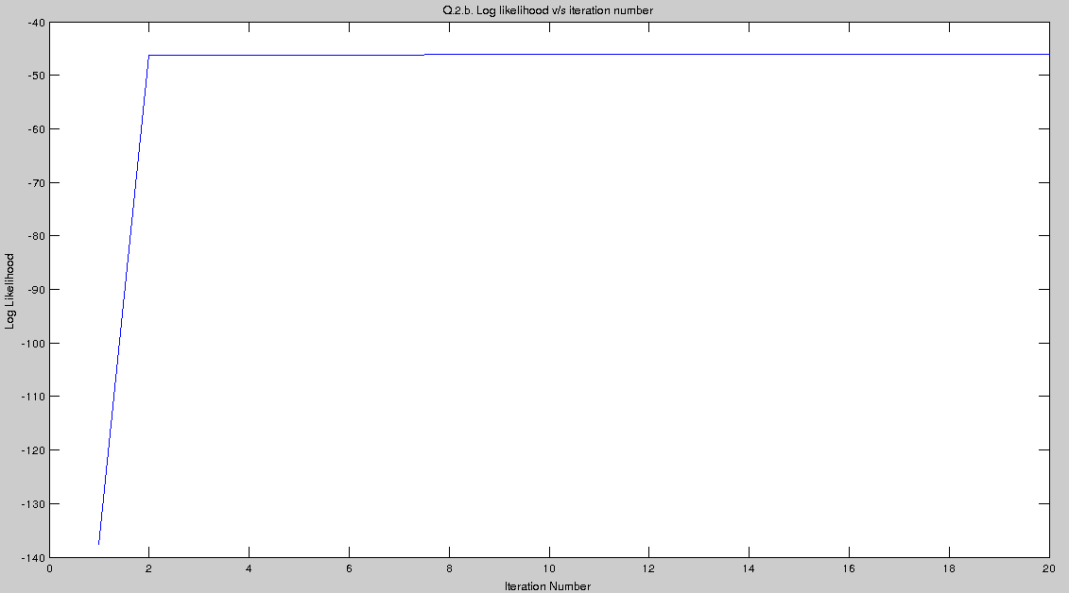

Q.2.c

>> What is the PPCA covariance (W*W' + (σ *2)I)

The observed co-variance after convergence was observed to be

C =

18.9364 0.4165
0.4165 18.6346
The sample co-variance, of the given data was found to be

S =

25.6359 10.7883
10.7883 17.8197

Though not exactly similar, they are related to each other.

Q.2.d

>> Create one plot containing all of the following for PPCA

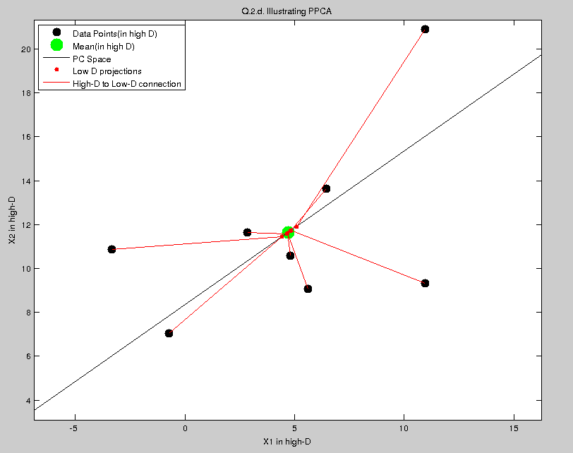

Q.2.e

>> Implement EM algorithm for FA

MATLAB Code for problem 2.e

load q2.mat

LINE_LENGTH = 15;
psi = rand(HIGH_DIMENSION);
mu_bkp = mu;
W = [1;1];
n_iter = 20;
L = zeros(1,n_iter);

for k =1:n_iter
C = W*W' + sigma_sqr*eye(HIGH_DIMENSION);

% E step
mu_rep = repmat(mu, [1, NUMBER_OF_POINTS]);
z_x_mu = W'*inv(C)*(X-mu_rep);
z_x_sigma = eye(LOW_DIMENSION) - W'*inv(C)*W;

% M Step
E_zzt = z_x_sigma + z_x_mu * z_x_mu';

term1 = (X-mu_rep) * z_x_mu';
term2 = inv(sum(repmat(E_zzt, [1, NUMBER_OF_POINTS])));
W = term1 * term2;

term3 = (X-mu_rep)*(X-mu_rep)';
term4 = W*(z_x_mu*(X-mu_rep)');
psi = diag(diag(term3 - term4))/NUMBER_OF_POINTS;

% Calculating log likelihood
for i = 1:NUMBER_OF_POINTS
L(k) = L(k) - logmvnpdf(X(:,i), mu, C);
end
end
plot(L);
xlabel('Iteration Number');
ylabel('Log Likelihood');
title('Q.2.e. Log likelihood v/s iteration number');
figure;

% Question 2d
plot (X(1,:), X(2,:), 'k.', 'markersize',30);
hold on;
plot (mu(1), mu(2), 'g.', 'markersize',30);
hold on;
point_1_for_plot = mu - LINE_LENGTH * W;
point_2_for_plot = mu + LINE_LENGTH * W;
line([point_1_for_plot(1), point_2_for_plot(1)],...
[point_1_for_plot(2), point_2_for_plot(2)], 'Color', 'k');
hold on;

X_cap = W*z_x_mu + mu_rep;
plot (X_cap(1,:), X_cap(2,:), 'r.', 'markersize',15);
hold on;
for i=1:NUMBER_OF_POINTS
line([X_cap(1, i), X(1, i) ], [X_cap(2, i), X(2, i) ], 'Color', 'r');
hold on
end
xlabel('X1 in high-D');
ylabel('X2 in high-D');
title('Q.2.g. Illustrating Factor Analysis')
legend('Data Points(in high D)', 'Mean(in high D)', 'PC Space', ...
'Low D projections', 'High-D to Low-D connection'...
,'Location','NorthWest');
axis equal

>> Plot the log data likelihood
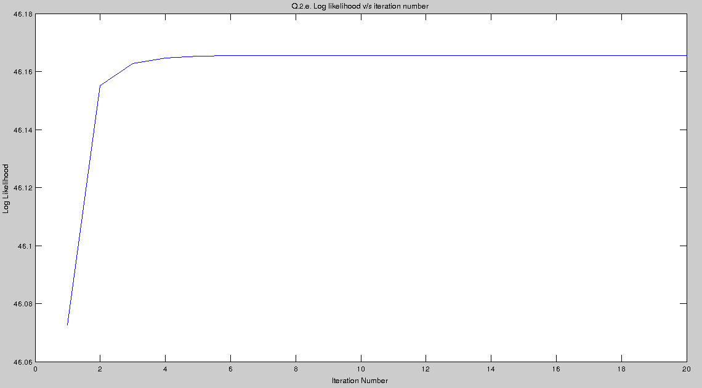

Q.2.f

>> What is the FA covariance (WWT + Ψ)?

FA Covariance

C =

18.9364 0.4165
0.4165 18.6346

The sample co-variance, of the given data was found to be

S =

25.6359 10.7883
10.7883 17.8197

Q.2.g

>> Create one plot containing all of the following for FA

