SNOWFLAKE ASSIGNMENT
-- PART 1 : WAREHOUSE SETUP

-- Marketing Warehouse
CREATE WAREHOUSE MARKETING_WH
WITH WAREHOUSE_SIZE = 'SMALL'
AUTO_SUSPEND = 300
AUTO_RESUME = TRUE;

-- Finance Warehouse
CREATE WAREHOUSE FINANCE_WH
WITH WAREHOUSE_SIZE = 'XSMALL'
AUTO_SUSPEND = 300
AUTO_RESUME = TRUE;

-- ETL Warehouse
CREATE WAREHOUSE ETL_WH
WITH WAREHOUSE_SIZE = 'MEDIUM'
AUTO_SUSPEND = 300
AUTO_RESUME = TRUE;
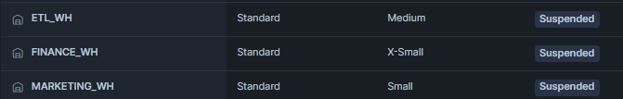

-- PART 2 : ROLE SETUP & Warehouse Access
CREATE ROLE MARKETING_ANALYST;
GRANT USAGE ON WAREHOUSE MARKETING_WH TO ROLE MARKETING_ANALYST;

CREATE ROLE FINANCE_USER;
GRANT USAGE ON WAREHOUSE FINANCE_WH TO ROLE FINANCE_USER;

CREATE ROLE ETL_DEVELOPER;
GRANT USAGE ON WAREHOUSE ETL_WH TO ROLE ETL_DEVELOPER;

-- PART 3 : USER SETUP

CREATE USER MA1 PASSWORD = 'MA1' LOGIN_NAME = 'MA1' DEFAULT_ROLE = 'MARKETING_ANALYST' DEFAULT_WAREHOUSE = 'MARKETING_WH' MUST_CHANGE_PASSWORD = FALSE;

CREATE USER FIN1 PASSWORD = 'FIN1' LOGIN_NAME = 'FIN1' DEFAULT_ROLE = 'FINANCE_USER' DEFAULT_WAREHOUSE = 'FINANCE_WH' MUST_CHANGE_PASSWORD = FALSE;

CREATE USER ETL1 PASSWORD = 'ETL1' LOGIN_NAME = 'ETL1' DEFAULT_ROLE = 'ETL_DEVELOPER' DEFAULT_WAREHOUSE = 'ETL_WH' MUST_CHANGE_PASSWORD = FALSE;

GRANT ROLE FINANCE_USER TO USER FIN1;
GRANT ROLE MARKETING_ANALYST TO USER MA1;
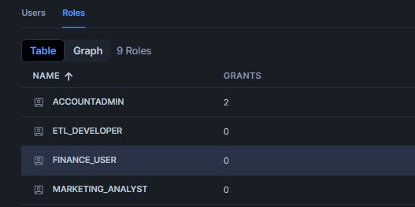
GRANT ROLE ETL_DEVELOPER TO USER ETL1;
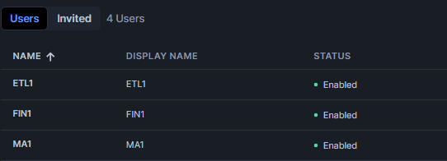

-- PART 4 : CREATE DATABASE & TABLE

CREATE OR REPLACE DATABASE RETAIL_MARKETING_DB;
USE DATABASE RETAIL_MARKETING_DB;
CREATE OR REPLACE SCHEMA CAMPAIGN_SCHEMA;
USE SCHEMA CAMPAIGN_SCHEMA;

-- Create Campaign Sales Table
CREATE OR REPLACE TABLE CAMPAIGN_SALES AS
SELECT SS.SS_SOLD_DATE_SK, D.D_DATE AS SALE_DATE,
SS.SS_CUSTOMER_SK, C.C_FIRST_NAME, C.C_LAST_NAME,
SS.SS_ITEM_SK, I.I_ITEM_DESC,
SS.SS_QUANTITY,
SS.SS_SALES_PRICE,
SS.SS_NET_PROFIT
FROM SNOWFLAKE_SAMPLE_DATA.TPCDS_SF10TCL.STORE_SALES SS
JOIN SNOWFLAKE_SAMPLE_DATA.TPCDS_SF10TCL.CUSTOMER C
ON SS.SS_CUSTOMER_SK = C.C_CUSTOMER_SK
JOIN SNOWFLAKE_SAMPLE_DATA.TPCDS_SF10TCL.DATE_DIM D
ON SS.SS_SOLD_DATE_SK = D.D_DATE_SK
JOIN SNOWFLAKE_SAMPLE_DATA.TPCDS_SF10TCL.ITEM I
ON SS.SS_ITEM_SK = I.I_ITEM_SK
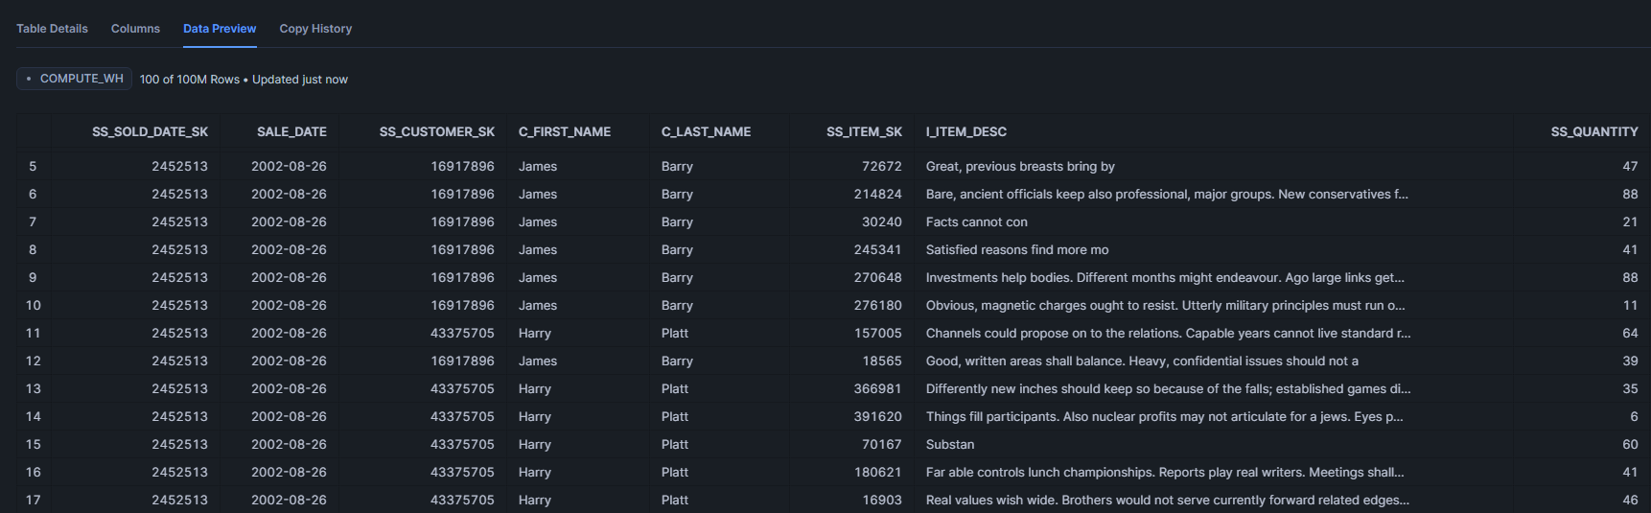
LIMIT 100000000;

-- PART 5 : GRANT PERMISSIONS
-- Database Access
GRANT USAGE ON DATABASE RETAIL_MARKETING_DB TO ROLE MARKETING_ANALYST;
GRANT USAGE ON DATABASE RETAIL_MARKETING_DB TO ROLE FINANCE_USER;
GRANT USAGE ON DATABASE RETAIL_MARKETING_DB TO ROLE ETL_DEVELOPER;
-- Schema Access
GRANT USAGE ON SCHEMA RETAIL_MARKETING_DB.CAMPAIGN_SCHEMA TO ROLE MARKETING_ANALYST;
GRANT USAGE ON SCHEMA RETAIL_MARKETING_DB.CAMPAIGN_SCHEMA TO ROLE FINANCE_USER;
GRANT USAGE ON SCHEMA RETAIL_MARKETING_DB.CAMPAIGN_SCHEMA TO ROLE ETL_DEVELOPER;
-- Read Access
GRANT SELECT ON TABLE RETAIL_MARKETING_DB.CAMPAIGN_SCHEMA.CAMPAIGN_SALES TO ROLE MARKETING_ANALYST;
GRANT SELECT ON TABLE RETAIL_MARKETING_DB.CAMPAIGN_SCHEMA.CAMPAIGN_SALES TO ROLE FINANCE_USER;
-- ETL Full Access
GRANT SELECT, INSERT, UPDATE, DELETE, TRUNCATE ON TABLE RETAIL_MARKETING_DB.CAMPAIGN_SCHEMA.CAMPAIGN_SALES TO ROLE ETL_DEVELOPER;
GRANT CREATE TABLE, CREATE VIEW, CREATE STAGE ON SCHEMA RETAIL_MARKETING_DB.CAMPAIGN_SCHEMA TO ROLE ETL_DEVELOPER;

-- PART 6 : PERFORMANCE TESTING
-- Scale down Warehouse
ALTER WAREHOUSE MARKETING_WH
SET WAREHOUSE_SIZE = 'XSMALL';

-- Sales Analysis Query
SELECT
SALE_DATE,
SUM(SS_SALES_PRICE) AS TOTAL_SALES,
SUM(SS_NET_PROFIT) AS TOTAL_PROFIT
FROM CAMPAIGN_SALES
GROUP BY SALE_DATE
ORDER BY TOTAL_SALES DESC;
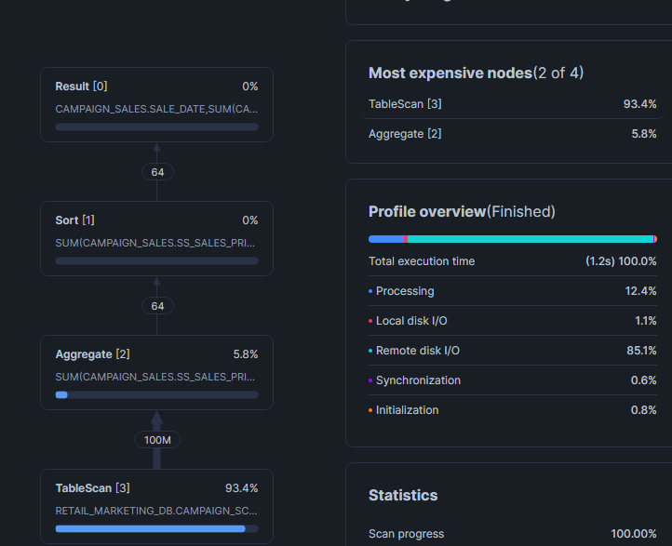

-- Scale Up Warehouse
ALTER WAREHOUSE MARKETING_WH
SET WAREHOUSE_SIZE = 'SMALL';
-- Run Same Query Again
SELECT
SALE_DATE,
SUM(SS_SALES_PRICE) AS TOTAL_SALES,
SUM(SS_NET_PROFIT) AS TOTAL_PROFIT
FROM CAMPAIGN_SALES
GROUP BY SALE_DATE
ORDER BY TOTAL_SALES DESC;

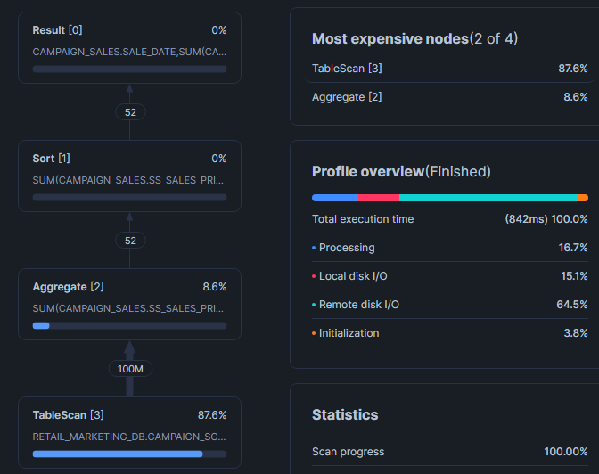

-- PART 7 : CACHE TESTING

-- First Run
SELECT
AVG(SS_SALES_PRICE)
FROM CAMPAIGN_SALES;
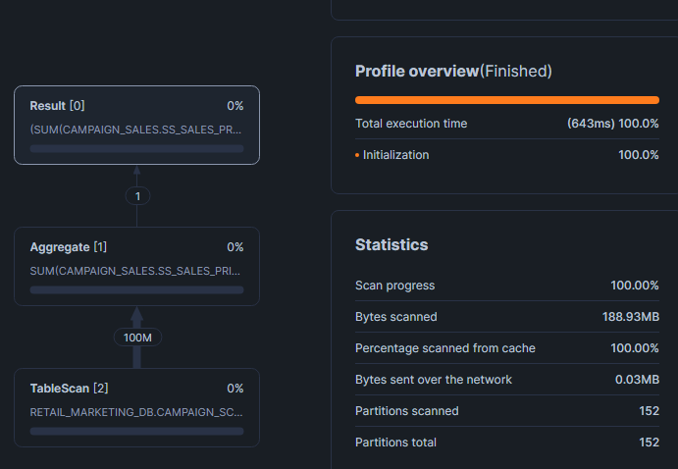
-- Second Run (Faster due to Result Cache)
SELECT
AVG(SS_SALES_PRICE)
FROM CAMPAIGN_SALES;
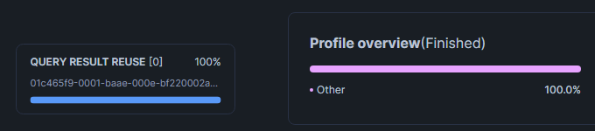
Runs Faster Because it reuses query result from cache

-- PART 8 : CLUSTER KEY TESTING

-- Before Clustering
SELECT
SALE_DATE,
SUM(SS_SALES_PRICE) AS TOTAL_SALES
FROM CAMPAIGN_SALES
WHERE SALE_DATE = '2002-09-18'
GROUP BY SALE_DATE;

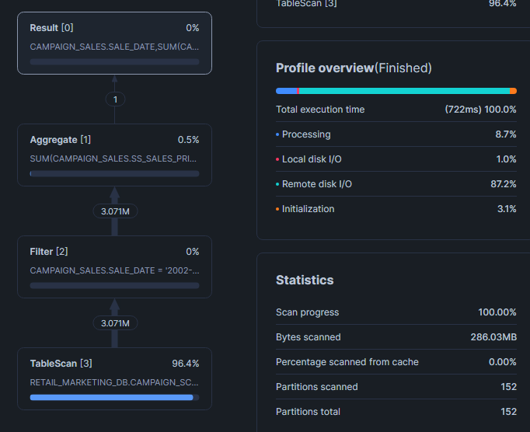

-- Add Cluster Key
ALTER TABLE CAMPAIGN_SALES
CLUSTER BY (SALE_DATE);
-- After Clustering
SELECT
SALE_DATE,
SUM(SS_SALES_PRICE) AS TOTAL_SALES
FROM CAMPAIGN_SALES
WHERE SALE_DATE = '2002-09-18'
GROUP BY SALE_DATE;
