Documentation for Data Processing Flow

Overview
End-to-end data processing flow for providing the feedfiles to engineering and (Talisman) material processing team. The process is designed to handle various file types, validate their contents, parse data, and generate consolidated outputs for technical purposes.
The key files processed include:
- PMSISOH (Piping Component Files)
- PMSSPL (Piping Material Supply Files)
- PMSMAT (Material Mapping Files)
- PMSJNTH (Joint Mapping Files)
- PMSISOD (Isometric Data Detail Files)

Process Steps

1. Input Data Handling
- Input Type: Compressed ZIP files containing multiple files (e.g., .txt, .pcf).
- Validation:
  - The ZIP files are extracted, and the presence of required files is validated.
  - Missing files trigger an email notification to eng team, and the process stops for that ZIP.

2. Centralized Runner Script
  - Orchestrates the entire process.
  - Ensures modular execution of individual workflows for each file type.
- Steps:
  - Calls zipExtraction.py to extract and validate files.
  - Executes specific scripts like pcf.py, pmsspl.py, pmsmat.py, pmsjnth.py, and pmsisod.py sequentially.

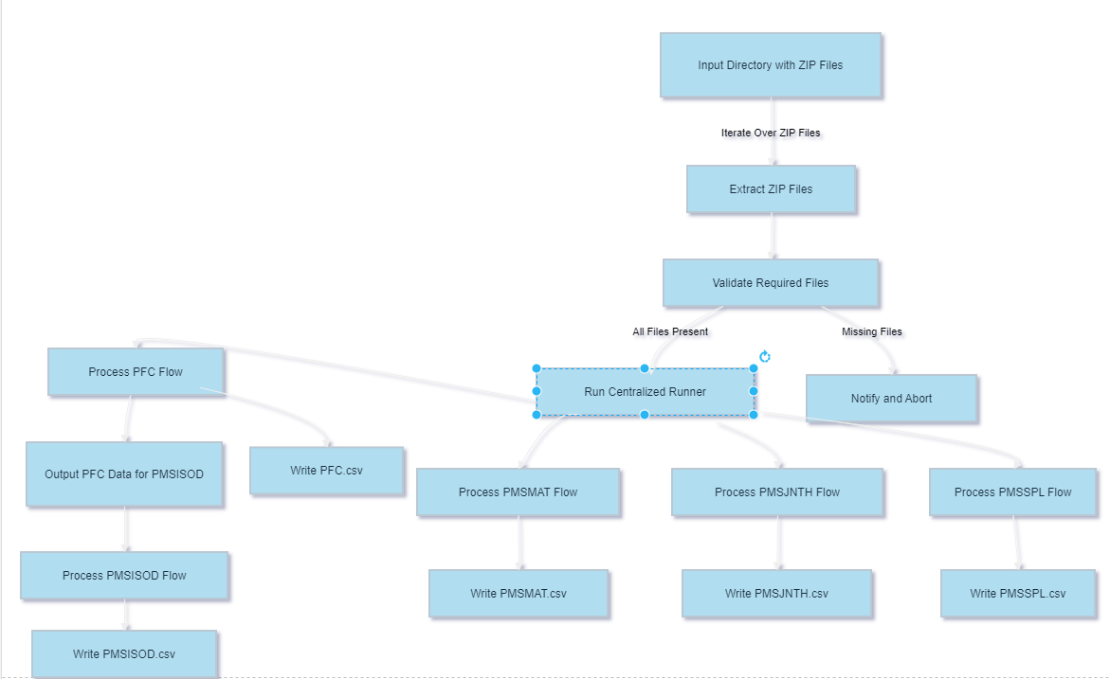

3. File Processing
Each file type has a dedicated script that performs the following:
PCF Processing (pmsisoh.py):
- Parses .pcf files for piping component attributes.
- Maps attributes like isono, action, area, and fabrevno.
- Outputs a CSV file for business use.
PMSSPL Processing (pmsspl.py):
- Combines data from MAT.txt, MTC.txt, and Weld.txt files.
- Performs calculations (e.g., spool volume, inch diameter, joint count).
- Outputs a consolidated CSV for material supply tracking.
PMSMAT Processing (pmsmat.py):
- Reads MAT.txt as a fixed-length file.
- Maps attributes like matcode, matsubcode, lsize, and ssize.
- Removes duplicate records based on unique keys (e.g., matcode + matsubcode).
PMSJNTH Processing (pmsjnth.py):
- Extracts joint-specific data from Weld.txt.
- Maps attributes like isono, weld_no, branchdia, and weldtype.
- Ensures proper formatting of fields (e.g., weld_no padded to 3 digits).

PMSISOD Processing (pmsisod.py):
- Reads MAT.txt and enriches data using mappings from PMSISOH and PMSJNTH.
- Generates the final output CSV with attributes like area, isono, paint, and trace.

4. Output Data Generation
- Outputs are generated in CSV format for each workflow.
- Data is consolidated, ensuring unique records and proper mapping.
- Final files are stored in a location for further processing.

Flow Summary
Technical Flow:
- Extract and Validate:
  - ZIP files are unzipped, and required files are checked.
- Process Each File Type:
  - PMSISOH: Piping component data.
  - PMSSPL: Material supply and weld data.
  - PMSMAT: Material mapping.
  - PMSJNTH: Joint mapping.
  - PMSISOD: Data enrichment.
- Generate Outputs:
  - CSV files are created for each file type, ensuring consistency and completeness.

