Docker

Why Docker:

* Help to resolve the issue /scenarios where application have problem to run on different developer machine/prod machine.

VMware

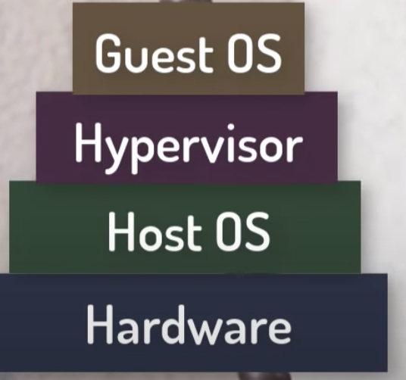

Problem with Hypervisor:

When we have multiple applications/software’s on same host ,which would require multiple guests OS with different Kernal on same Hypervisor. In this case we will have to maintain multiple guest OS and it will consumes more resources(CPU ,Memory ,etc)

To avoid the Hypervisor problem Container came:::

Think container as Hypervisor but In Container we don’t install new OS.All the container will share same OS kernel .Container can be created with the help of images.

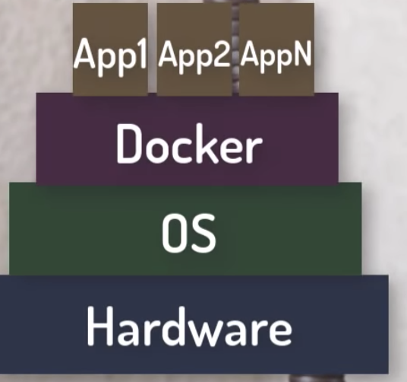

Docker is a software for managing the container that’s allow you to create a container :like MY SQL,Cassendra etc…

* Docker is client side application program.
* Docker can also be work as service and can be deploy on any server.
* You can also share your docker image. You can pull the docker image for application development like radiis ,cassendra ,db2 etc….
* In Docker install application image as conatiner

Image is blueprint of container .You can think of image as class and container as image.

Container: is running instance of docker image

Container Benefits:

* Simplicity
* Collaboration
* Flexibility
* Totality
* Container can boot up instantly

Hypervisor have guest OS whereas Container virtualize the guest OS.In Docker , Hypervisor is equivalent to Docker Demon.

Docker image is blueprint for how you build out the application and run the image to build container.

For docker application you create a image just like Java application you create a jar

In Spring Boot application

Add Dcokerfile with following details:

From openjdk:8 //docker container name

ADD target/docker-spring-boot.jar docker-spring-boot.jar //copy the jar in docker image

EXPOSE 8085//expose to port

ENTRYPOINT [ "java","-jar","docker-spring-boot.jar" ]//execute the jar

Create the Image of the Application. By command :

1. Build t**he image ::** docker build -f Dockerfile -t docker-spring-boot .
2. **To check the docker images on Docker, run the command “docker images “**

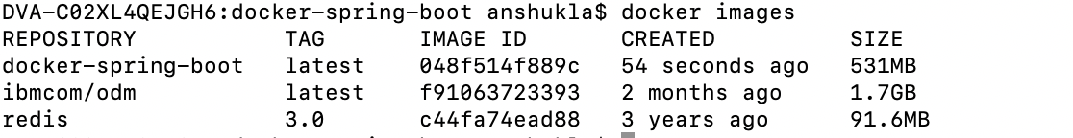

1. **Run the docker images :”docker run -p 8085 :8085 dcoker-spring-boot “ and it will create the container**

[**http://localhost:8085/rest/docker/hello**](http://localhost:8085/rest/docker/hello)