STANDARD OPERATING PROCEDURE
Essbase–Mainframe Batch Operations & L1/L2 Production Support
B2B / Corporate Finance & Reinsurance Batch Support | Liberty Mutual Insurance

Table of Contents

1. Purpose of This Document
This document explains, in plain language, how the daily Essbase-to-Mainframe batch operations are run, monitored, and supported. It is written so that anyone new to the process — including someone with no prior technical or Essbase background — can understand what the system does, what the support team checks every day, and what to do when something goes wrong.
It brings together the daily checklists, the job/server architecture, the incident-management workflow, and the most common problems and fixes into one single reference.

1.1 Who This Document Is For
- New joiners being onboarded onto the batch support / production support team.
- L1 and L2 support engineers who monitor and action the nightly batch schedule.
- Anyone who needs a quick, simple explanation of “what is Essbase batch processing and why does it matter.”

1.2 What “Essbase Operations” Means, in Plain Words
Liberty Mutual uses a software system called Essbase to store and calculate financial numbers (for example, monthly close numbers, reinsurance data, and reports). Essbase runs on Linux servers. Every night, a series of automated jobs run one after another — some on the Essbase (Linux) side and some on the company’s Mainframe (a separate, older, very reliable computer system that also holds financial data).
These jobs must run in the correct order and hand off data to each other correctly. The support team’s job is to make sure this nightly “relay race” completes successfully, and to step in quickly if any job fails, runs late, or gets stuck.

2. Glossary — Key Terms Explained Simply
If a word or abbreviation in this document is unfamiliar, look it up here first.
Term | What It Means
Essbase | The financial database (OLAP) system that stores and calculates numbers used for reporting, planning, and close. Runs on Linux servers.
Cube | A single financial database inside Essbase (for example, a Reinsurance cube or a GAAP cube).
Mainframe | A separate, older, high-reliability computer system used by the company. It runs its own batch jobs (called JCL jobs) and exchanges data files with the Essbase Linux servers.
JCL Job | “Job Control Language” — the type of batch job that runs on the Mainframe (for example FNEBNIPY, FNEBLMIP).
Flag File | A small marker file (a .txt file) that one system creates to signal to another system, “I am finished — you can start now.” This is how Essbase and the Mainframe hand off work to each other without a human in the middle.
Linux Script ($BIN/…) | A script that runs on the Essbase Linux server. It usually waits for a flag file to appear, then kicks off the next step (for example, a calculation job).
Calc Job | A calculation script (for example NiglCalc.sh) that processes/loads data into an Essbase cube once its flag file has arrived.
Nightly String / Nightly Schedule | The full ordered sequence of jobs that is expected to run overnight, across both Essbase servers and the Mainframe.
ESP | The Mainframe’s job scheduling system, referenced in job paths such as PRODMA.ESP.END.JCLPROD.JOBCARD.
LXPIP-EESSBS01 / 02 | The host names of the two production Essbase Linux servers that this SOP covers.
Essbase Notification Mailbox | A shared mailbox that automatically receives an email every time a job starts, finishes, or fails. This is the team’s main source of truth for what happened overnight.
On-Call | The engineer (from the support team or from Liberty Mutual IT Boston) who is designated to be contacted for urgent issues outside business hours.
SLA | Service Level Agreement — the maximum time allowed to acknowledge or resolve an issue (for example, 3 hours to acknowledge a new incident).
ServiceNow | The ticketing tool used to log, track, and close incidents and service requests.
Remedy | A request tool used to submit certain actions, such as a request to restart Essbase.
SmartView | An Excel add-in that lets users (and support staff) connect directly to Essbase to check that it is up and responding.
L1 / L2 / L3 | Support tiers. L1/L2 is the front-line production support team (this SOP). L3 is deeper, specialist engineering support that gets involved when an issue is outside L1/L2’s scope or has no existing SOP.
Goaldiggers | The Liberty Mutual business/application team that L1L2 coordinates with for reinsurance-related runs and sign-offs.

3. How the Nightly Process Works (Big Picture)
Think of the nightly batch as a relay race between two systems — Essbase (Linux) and the Mainframe — that hand a “baton” back and forth using small marker files called flag files.

3.1 The Basic Hand-off Pattern
- An Essbase-side script (for example NiglFlagPy.sh) starts and prepares data.
- It triggers or waits on a Mainframe JCL job (for example FNEBNIPY) to run.
- When the Mainframe job finishes, it produces a flag file (for example Niglflgp.txt) in a shared /flags/ folder.
- A Linux script on the Essbase server is watching that folder. As soon as it sees the flag file appear, it knows the Mainframe step is done and safe to move on from.
- The Linux script then runs the next step — usually a calculation job (for example NiglCalc.sh) — which loads or processes the data inside the Essbase cube.
NOTE
If a flag file never appears, the downstream Essbase job will simply keep waiting — this is one of the most common reasons a nightly job looks “stuck.” See Section 6, Scenario 4.

3.2 The Two Essbase Servers Covered by This SOP
Server | Role
LXPIP-EESSBS01 (PIP01) | Hosts the Nightly (Nigl), Cmsub, Safdac, Cidac/Ciadc, Niay, Grmusgl (Usgl), Cicat, and Pmay job flows, plus related file-transfer utility scripts.
LXPIP-EESSBS02 (PIP02) | Hosts the Lmi, Corpsr, Corpcan, Globalsp, LMIRe (Reinsurance), and Gaap job flows, plus related file-transfer and reporting utility scripts.
The full list of jobs, their Mainframe counterparts, and the flag files they depend on is in Section 4 (Job Dependency Reference).

3.3 Mainframe Scheduler View — What This Looks Like in Practice
The diagrams below are sample snapshots from the Mainframe job scheduler. Each box is one Mainframe job; the arrows show which jobs must finish before the next one is allowed to start. You don’t need to memorize these — they are here so a new team member can see what the on-call team is looking at when they say “the job dependency chain.”
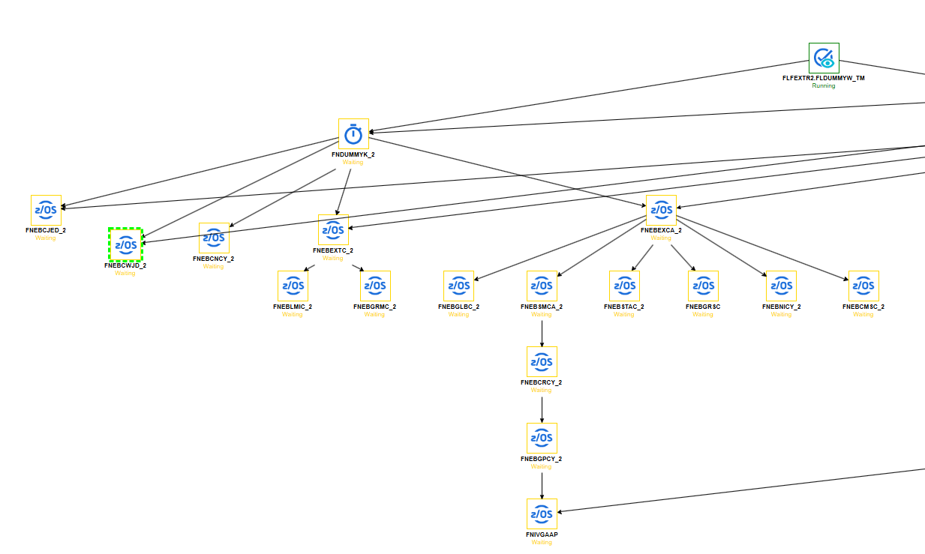
Sample Mainframe job dependency view — Server PIP01 (each box = one Mainframe job; arrows = required run order)
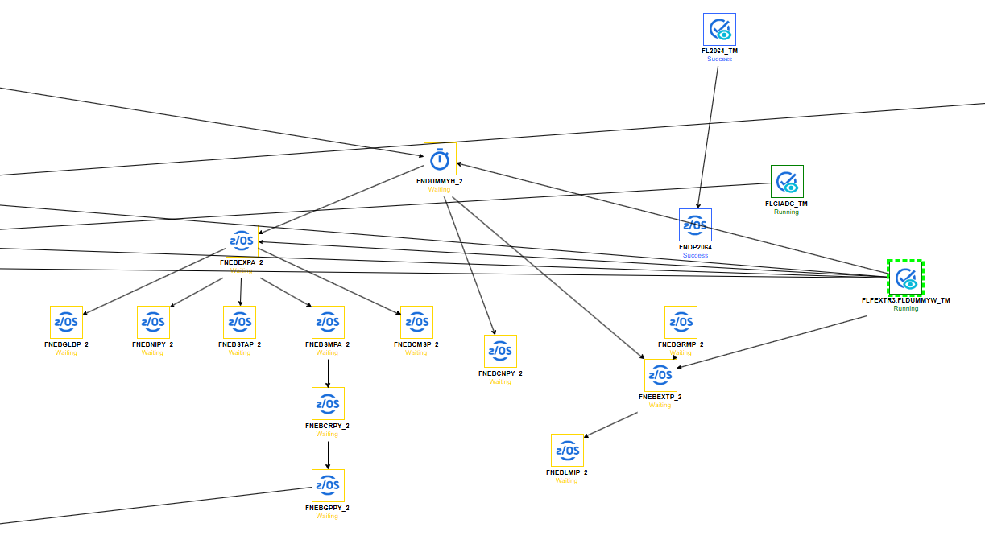
Sample Mainframe job dependency view — Server PIP02
On the Essbase (Linux) side, the equivalent nightly jobs are grouped into “strings” that are released at set times, as shown below.
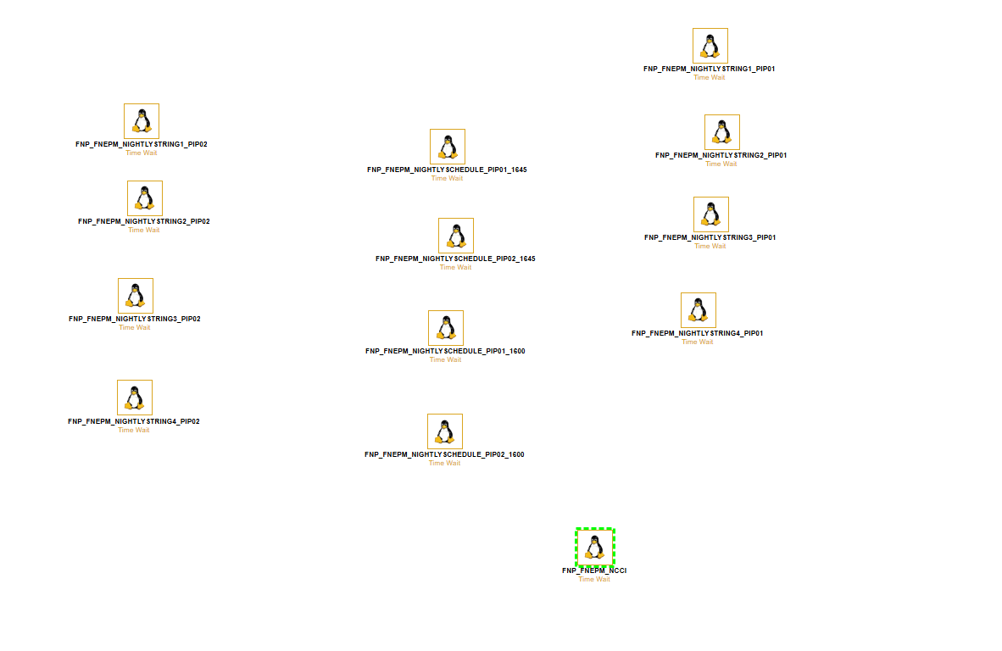
Sample Linux-side nightly string schedule for PIP01 and PIP02 (each icon is one nightly string / scheduled job)

3.4 Utility / File-Transfer Scripts
Some scripts don’t calculate data — they simply move files between systems: from the Linux server to the Mainframe, from the Mainframe back to Linux, or from the Linux server to the NAS (network storage). A few extract data from one cube so it can be reused by another cube. These are listed at the end of each server’s table in Section 4.

4. Job Dependency Reference
Use this section to look up which Mainframe job and flag file a given Essbase script is waiting on, and which script runs next. Column meanings: “Essbase Trigger Script” starts the flow; “Mainframe Job(s)” is what runs on the Mainframe; “Flag File(s)” is the marker file produced when the Mainframe job completes; “Next Linux Script” is what fires once the flag file appears.

4.1 Server: LXPIP-EESSBS01 (PIP01)
Essbase Trigger Script | Mainframe Job(s) | Flag File(s) | Next Linux Script
NiglFlagPy.sh | FNEBNIPY, FNEBNICY | Niglflgp.txt, Niglflgc.txt | NiglFlag.sh
CmsubFlagPy.sh | FNEBCMSP, FNEBCMSC | Cmsflgpy.txt, Cmsflgcy.txt | CmsubFlag.sh
SafdacFlag.sh (Day 1 only) | FLDACFH1 | Safdflgcy.txt | SafdacCalc.sh
CidacFlag.sh / CiadcFlag.sh | FNEBCWJD | Ciadcflg.txt | CiadcCalc.sh
NiayFlag.sh | FLNIAYFT | Niayflg.txt | NiayCalc.sh
GrmusglFlagPy.sh | FNEBGRMC | Grmflgcy.txt | GrmusglCalc.sh
CicatFlag.sh | FNEBCJED | Cicatflg.txt | CicatCalc.sh
PmayFlag.sh | FLPMAYFT | Pmayflg.txt | PmayCalc.sh
Utility / file-transfer scripts on this server:
- NiglSAP.sh
- GrsNi_put.sh
- GRMPOWERBI5AM.sh

4.2 Server: LXPIP-EESSBS02 (PIP02)
Essbase Trigger Script | Mainframe Job(s) | Flag File(s) | Next Linux Script
LmiFlagPy.sh | FNEBLMIP, FNEBLMIC | Lmiflgpy.txt, Lmiflgcy.txt | LmicFlag.sh
CorpsrFlagPy.sh | FNEBSTAP, FNEBSTAC | Crflgpy.txt, Crflgcy.txt | CorpsrCalc.sh
CorpcanFlagPy.sh | FNEBCNPY, FNEBCNCY | Crflgpy.txt, Crflgcy.txt | CorpsrFlag.sh
GlobalspFlagPy.sh | FNEBGLBP, FNEBGLBC | Glblflgp.txt, Glblflgc.txt | GlobalspCalc.sh
LMIReJEDFlag.sh | FLCRIJFT | Crijflg.txt | LMIReCalc.sh
GaapFlagPy.sh | FNEBNIPY, FNEBNICY | Niglflgp.txt, Niglflgc.txt | GaapFlag.sh
Utility / file-transfer scripts on this server:
- GlobalspSAP.sh
- GrsLMIReJED_put.sh
- LMIRetoCpare.sh
- EALHISTSOX
- EALtoSOX
- GaapExportCalc.sh
- /scripts/Soxreport
- GaapToInvestment.sh
NOTE
The same Mainframe job can feed more than one Essbase flow (for example FNEBNIPY/FNEBNICY feed both the Nigl flow on PIP01 and the Gaap flow on PIP02). If that Mainframe job runs late, expect delays on both sides.

5. Daily Operations — What the Team Checks Every Day
Monday to Friday are treated as business days. Three checks are performed on a fixed schedule every night. All times are US Eastern Time (EST).

5.1 Check 1 — Essbase Schedule Checkup (around 8:30 PM EST)
- Open the Essbase Notification mailbox (Essbase_Notification@LibertyMutual.com).
- Filter the emails by subject and collapse all groups for a clean view.
- Search for “Nightly Schedule lxpip-qessbs01” and “Nightly Schedule lxpip-qessbs02” (keyword: “Nig”).
- Compare the jobs that actually ran against the expected list in the EssbaseSchedule sheet.
- The jobs that ran on servers 01 and 02 should match the schedule exactly.
- If anything doesn’t match, notify the on-call person — by phone and email — before 9:30 PM EST.

5.2 Check 2 — Essbase Server Checkup (every 2 hours overnight)
Performed at 10:00 PM, 12:00 AM, 2:00 AM, and 4:00 AM EST, Monday to Friday.
- Open the Essbase Notification mailbox and filter by subject; collapse all groups.
- Search for keyword “ESS” and find the “Essbase production server” subject line; expand it.
- Open the latest server-status email and confirm both servers are shown as running.
- If either server is not running, immediately inform the IT Boston on-call team by phone and email.

5.3 Check 3 — Essbase Schedule Completion Checkup (before 6:00 AM EST)
Daily jobs are expected to finish before 6:00 AM EST (typically around 3:00 AM on a normal day; the start of a month usually takes longer).
- Go to the Essbase Notification mailbox, filter by subject, and collapse all groups.
- Search for “Nightly Schedule lxpip-qessbs01” and “Nightly Schedule lxpip-qessbs02” (keyword “Nig”).
- Compare every expected job against the completion emails received.
- Mark each job green if its completion email was received, or red if it was not.
- Send the completion status to the I/S Corporate Boston distribution list and to the on-call person, before the 6:00 AM deadline.
NOTE
On Day 1 and Day 2 of the schedule cycle, the Mainframe post is held until 2:00 AM, so some Essbase jobs may not finish until 5:30 AM. This is expected — it is not automatically a failure.

5.4 If Jobs Are Not Complete by 5:30 AM
Before escalating to the IT Boston (GFT) on-call support, perform both of these checks:
- Submit a Remedy request to run fnp_fnepm_EssValCalcPIP11 (or PIP12, matching the affected server). Wait 10 minutes and check the Notification mailbox for a success email. If no “completed” email arrives, call GFT on-call support.
- Log in to Essbase via SmartView, open the EssVal application, and confirm you can connect and retrieve its dimensions. If you cannot connect, call GFT on-call support.

5.5 Understanding the Schedule Day Codes (DAY1 … DAY-1)
The schedule sheet labels each business day of the month with a code instead of a date, so the same SOP works every month regardless of how the calendar falls:
- The first business day of the month is DAY1, the second is DAY2, and so on.
- Counting backwards from month end, the last business day is DAY-1, the second-to-last is DAY-2, and so on.
- Weekends and US holidays are skipped — they don’t get a day code.
A full worked example calendar is provided in Appendix A for reference.

6. Incident Management Workflow

6.1 Scope of the L1/L2 Team
Area | What It Covers
SOP Tasks | Book-close tasks and monthly, quarterly, and year-end activities, performed per SOP for the AM URS, LM URS, and CM URS processes.
Incident Management | Handling incidents raised for batch failures, alerts, and user access issues.
Service Requests | On-demand runs and special schedule runs requested by the business (Goaldiggers), plus year-end Pre/Post URS updates.
Automation / Permanent Fixes | Reducing redundant batch failures, updating schedules, automating SOP steps, and optimizing batch jobs — proposed fixes are reviewed together with Goaldiggers.

6.2 Communication Escalation Ladder
For every category above (SOP tasks, incidents, service requests, automation), the team follows the same escalation pattern when a response is needed:
- Send an email to Goaldiggers (the business/application contact).
- If there is no response, follow up via Microsoft Teams chat.
- If there is still no response, escalate with a phone call — Offshore first, then Onshore during non-business hours.
For Automation / Permanent Fixes specifically, the team also holds a Teams meeting to review test cases and raises a Service Delivery (SD) ticket to Goaldiggers for formal review and follow-up.

6.3 How an Incident Moves Through the System
This is the step-by-step path a ticket follows from the moment it lands in the queue to the moment it is resolved:
- An incident ticket arrives in the ServiceNow queue.
- L1/L2 must acknowledge the ticket within the SLA of 3 hours.
- L1/L2 analyzes the issue: is it within L1/L2’s scope?
  - If No → the ticket is routed / re-assigned to the appropriate support group.
  - If Yes → continue to the next check.
- Does a documented SOP already exist for this issue?
  - If Yes → L1/L2 resolves the issue by following the SOP, and the incident is closed.
  - If No → the ticket is escalated to L3.
- When escalated, the L3 support person acknowledges the issue, takes corrective action, and resolves it (looping in other support groups if needed).
IMPORTANT
Non-Production incidents and SB (sandbox) migration incidents are escalated straight to L3 — they skip the L1/L2 SOP check. Production job-failure incidents always stay owned by the L1/L2 queue until closure, even if L3 is helping. When L3 is involved, an SR ticket should also be created to track L3’s effort and analysis separately.

7. ServiceNow Ticket Management

7.1 When to Create a Ticket
A ServiceNow incident ticket must be created whenever an issue needs to be escalated to the on-call support person. Typical examples include:
- A mismatch between the planned schedule and what actually ran.
- An Essbase server failure, or a server status reported as stopped.
- A job failure or abnormal job termination.
- A long-running job that needs investigation.
- A missing schedule-completion notification.
- Any other issue that needs the on-call support team’s involvement.

7.2 Assignment and Notification
- Add “ESSBASE CRIBS APP SUPPORT” as the notification/distribution list on the ticket.
- Assign the ticket to the support team member actively handling the issue.
- Include full details: what happened, which server(s) and job(s) were impacted, any error message, and what actions were already taken.
- Reference the ServiceNow incident number in every email sent to the on-call person or the IT Boston team about this issue.

7.3 Working and Closing a Ticket
- Keep the ticket updated with each troubleshooting step, communication, and status change.
- Once the issue is resolved and verified, add the resolution details to the ticket.
- Only resolve/close the ticket after confirming that the affected service, schedule, or job is functioning normally again.
- Make sure all stakeholders are informed of the resolution, via the ticket and/or email.

8. Common On-Call Issues & How to Fix Them

Scenario 1 — Reported discrepancy between the Nightly Strings and the Essbase Schedule
Trigger: Cognizant is contacted about a mismatch between what the schedule expects and what the Nightly Strings show.
- Compare the Essbase Schedule against the contents of the Nightly Strings.
- Confirm the discrepancy and correct it.

Scenario 2 — A job has failed
- Check the job-status email in the Essbase Notification mailbox for an error message.
- If no error message is visible there, access the server logs via Putty or Bladelogic and review the most recent log for the affected cube.
- Error “Cannot clear data for database [APP NAME] while other users are connected” → usually caused by a large user retrieval that has frozen in the system. Follow the Stop/Start Application steps (Section 9.2), then re-run the failed flag job’s calc version (e.g. LmiFlag.sh + LmiCalc.sh), or submit the job(s) again via the OnDemand script.
- Error “essmsh: Not logged in to Essbase” → the job could not log in to Essbase — this can point to a deeper server issue. Contact the on-call Deployer for further investigation.
- No error message visible anywhere, and the status email gives no clue → a Deployer needs to log in to the server directly. Check the /a/logs directory for additional logs, and /a/errors/<cube name> for error details.
Example: checking whether a calc script is genuinely still running before re-submitting it —
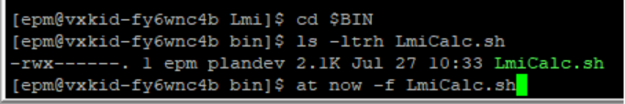
Example terminal check — confirming the calc script file and re-submitting it with 'at now -f'
Example: opening the most recent log file for a job to see whether it completed or is still in progress —
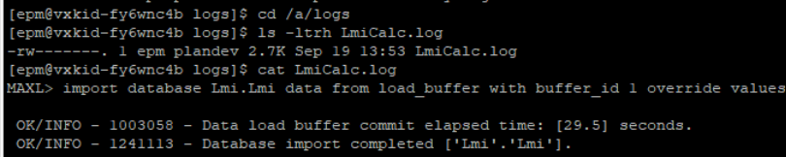
Example terminal check — viewing a job's log file under /a/logs to confirm successful completion
Example: opening the error file for a specific cube to see the exact failure reason —
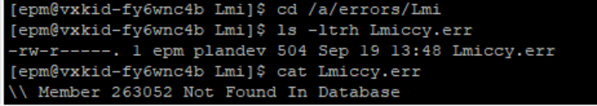
Example terminal check — viewing a job's error file under /a/errors/<cube name>

Scenario 3 — A job is taking much longer than normal and still hasn’t finished
- Ask a Deployer to log you in to the affected server.
- Go to /a/logs, list files by most recent (ls -ltrh), and view the latest job log. If the last timestamp is more than 30 minutes old, Essbase is most likely hung and needs a restart.
- Restart Essbase (see Section 9.1).
- Review the logs to see which jobs completed successfully and which still need to be submitted.

Scenario 4 — Jobs in a Nightly String have not started
- The job may simply be waiting for its flag file. Go to /flags and check the folder for the first job in the affected string to see if the flag file is present.
- Confirm whether the related Mainframe jobs have already run, by checking the Essbase Notifications for “MF → FNEB…(CY)” or “(PY)” entries. If they haven’t run, the issue is likely on the Mainframe side — contact the on-call Deployer.
- If the Essbase server itself appears frozen, find the last completed job’s status email and the last completed timestamp in /a/logs.
- Restart Essbase (see Section 9.1), then review the logs to see what completed and what still needs to be submitted.

9. Resolution Procedures

9.1 Restart Essbase
- Submit a Remedy request to restart Essbase for the affected server.
- Wait for the completion email in the Essbase Notifications mailbox.
- Server PIP01 restart job: fnp_fnepm_EssbaseRestart_pip01
- Server PIP02 restart job: fnp_fnepm_EssbaseRestart_pip02

9.2 Stop / Start an Application
Used when a stuck user session is blocking a job (for example, the “cannot clear data … other users are connected” error).
- Ask a Deployer to log in to Essbase Web for the affected server.
- Stop the application associated with the failed job, then Start it again. This forces any stuck users to be logged out and clears the lock.
- LXPIP-EESSBS01: https://global-epm-ess01.lmig.com/essbase/jet/login.html
- LXPIP-EESSBS02: https://global-epm-ess02.lmig.com/essbase/jet/login.html
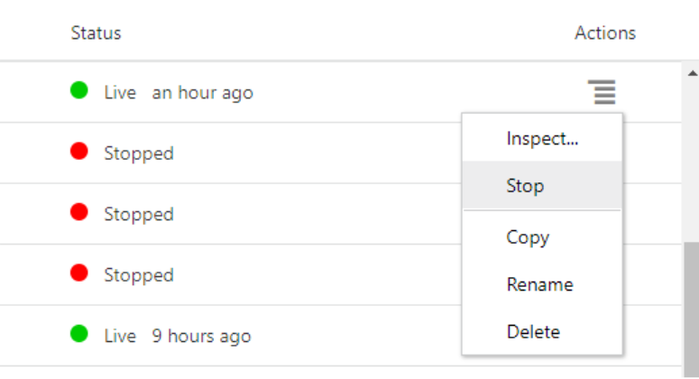
Essbase Web — Stop the affected application from the Actions menu
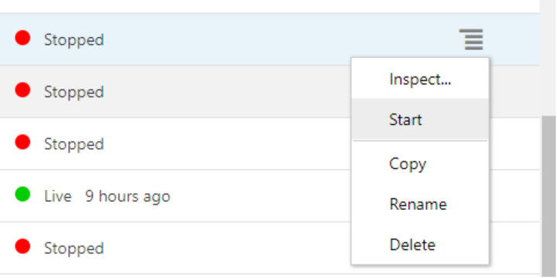
Essbase Web — Start the application again once it has stopped

10. Case Study: RNP Monthly Load Delay (Reference Example)
This real example shows how a small, one-time workaround can turn into a bigger issue if it isn’t tracked carefully — and why the checklists in Section 5 and the SOP-first approach in Section 6 matter.

10.1 What Happened
On October 3, 2025, the RNP Informatica monthly batch (which runs on the first Sunday of every month) started before the Mainframe FTP job had finished. As a result, all data through the end of the previous month loaded correctly, but the data for October 3rd itself was missed.

10.2 Timeline
When | What Happened
9/25 3:45 AM | Informatica annual-loss load job failed due to a duplicate entry in the control file; a temporary fix (updating the control file) was applied to resume the batch.
9/25 3:35 PM | After validating the file, the failed Informatica job was restarted; the Mainframe job was placed on hold for the next cycle.
9/26 7:30 AM | The control file issue for 09/25 was fixed, with instructions to hold, one-time-fix, and release the job for future runs.
9/27 – 10/02 | The one-time fix was applied daily, per instructions.
10/03 8:30 PM | Job RN0105 failed and halted the batch; the daily control-file fix activity was missed.
10/03 11:00 PM | L2 offshore support engaged to analyze the issue.
10/04 12:10–12:20 AM | Support escalated by phone; the job was force-completed after confirming no cycle impact.
10/05 3:00 PM | The RNP Monthly cycle was released on schedule (first Sunday of the month).
10/05 11:37 PM | RNP Informatica Monthly cycle completed.
10/06 5:03 AM | Support flagged that the held Mainframe job had not been released before the monthly cycle triggered.
10/06 8:00 AM – 6:06 PM | Next steps were discussed; the Informatica daily cycle was re-triggered to load the missed 10/03 data and completed successfully.

10.3 Business Impact
Reports to the business were delayed; the missing data was fully caught up on October 6th, and no lasting impact was observed.

10.4 Root Cause
A temporary workaround (a daily manual control-file update) had been put in place after an earlier job failure on September 25th. This workaround was applied correctly every day from 9/26 to 10/2, but was missed on 10/3 due to other job failures happening at the same time — which shows the risk of relying on a manual, temporary fix for an extended period instead of a permanent one.

10.5 Resolution
The held Mainframe job was released, and the Informatica daily cycle was triggered on demand to load the missing 10/3 data.

10.6 Remediation Actions Agreed
Gap | Reason | Action Item | Owner | Status
Delay in engaging support person | The on-call L2 person was engaged over a weekend, causing a delay. | Revise weekend support to have uninterrupted coverage. | L2 | In Progress
Late alerts not set up | No late-alert existed to track completion of this event/workflow. | Raise a request to set up late alerts for Reinsurance events. | L1L2 | In Progress
Informatica cycle ran before Mainframe FTP job | The monthly cycle is released manually by L1 on the first Sunday. | Validate the job dependency to remove manual intervention when releasing the monthly trail. | L2 | In Progress
SOP gap | No SOP existed to validate Mainframe job completion before releasing the monthly trail. | Revise the SOP to include this validation step. | L1 | Completed
Missed action on hold instructions | L2 missed the instruction to release the held job. | Implement an automatic email trigger for jobs left in hold. | L1L2 | Completed

11. Roles, Escalation Contacts & Reference Links

11.1 Who to Contact
Situation | Who to Contact
Schedule mismatch found during the 8:30 PM checkup | On-call person, by phone and email, before 9:30 PM EST.
Essbase server not running | IT Boston on-call team, immediately, by phone and email.
Job stuck / login failures / server-level issues | On-call Deployer (and Marty / Will for deeper investigation, per the original SOP).
Mainframe-side job not yet run | On-call Deployer and Georgy / Stan.
Issue is outside L1/L2 scope, or no SOP exists | Escalate to L3 via ServiceNow, per Section 6.3.
Non-production or sandbox (SB) migration incident | Escalate directly to L3.
Reinsurance run questions / sign-off | Goaldiggers business team, following the escalation ladder in Section 6.2.

11.2 Useful Reference Links
- On-Call Schedule (SharePoint)
- EssbaseSchedule.xlsx (SharePoint)
- Flag_Calc jobs.xlsx (SharePoint) — calc-version reference for re-running failed flag jobs
- On-Call CAESP Jobs.xlsx (SharePoint) — OnDemand script reference
- Essbase Notification mailbox: Essbase_Notification@LibertyMutual.com
TIP
Exact SharePoint URLs are maintained in the team’s reference sheet rather than duplicated here, so this SOP does not go out of date if a link changes.

Appendix A — Sample Schedule Day Calculation
This worked example shows how calendar dates map to schedule day codes for a sample month. Weekends and the two US holidays in this example receive no schedule code.
Date | Day | Schedule Name
1 | Tuesday | DAY1
2 | Wednesday | DAY2
3 | Thursday | DAY3
4 | Friday | DAY4
5 | Saturday | —
6 | Sunday | —
7 | Monday | DAY5
8 | Tuesday (US Holiday) | —
9 | Wednesday | DAY6
10 | Thursday | DAY7
11 | Friday | DAY8
12 | Saturday | —
13 | Sunday | —
14 | Monday | DAY9
15 | Tuesday | DAY10
16 | Wednesday | DAY11
17 | Thursday | DAY12
18 | Friday (US Holiday) | —
19 | Saturday | —
20 | Sunday | —
21 | Monday | DAY13
22 | Tuesday | DAY14
23 | Wednesday | DAY15
24 | Thursday | DAY16
25 | Friday | DAY-5
26 | Saturday | —
27 | Sunday | —
28 | Monday | DAY-4
29 | Tuesday | DAY-3
30 | Wednesday | DAY-2
31 | Thursday | DAY-1

