**FLOOD MONITORING AND EARLY WARNING SYSTEM**

**ANOOP .V.S**

**Phase-4 Submission Document**

**Project Title:** Flood Monitoring And Early Warning

**Phase 4:** Development part-2

***Topic:*** *Continue building the project by performing different activities like feature engineering, model training, evaluation.*

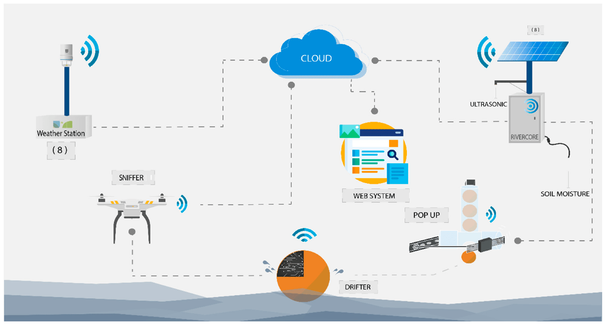

**Flood Monitoring And Early Warning System**

**INTRODUCTION:**

* Flood monitoring and early warning systems (FMEWS) are used to monitor and predict flood events in order to provide early warning to communities at risk.
* FMEWS models are developed using historical data on flood events, such as water level data, rainfall data, and land use data.
* The models are trained to identify patterns in the data that are associated with flood events.
* Once the models are trained, they can be used to predict future flood events based on current and future weather conditions.
* Feature engineering is the process of transforming raw data into features that are informative for the model. This may involve cleaning the data, removing outliers, and creating new features that capture the important relationships in the data.
* Once the features have been engineered, the model can be trained. The model is trained by feeding it the historical data and allowing it to learn the patterns in the data.
* Once the model is trained, it is important to evaluate its performance on a held-out test set. The test set is a set of data that was not used to train the model. This allows us to get an unbiased estimate of the model's performance on new data.

**Given Dataset:**

| SUBDIVISION | YEAR | JAN | FEB | MAR | APR | MAY | JUN | JUL | AUG | SEP | OCT | NOV | DEC | ANNUAL RAINFALL | FLOODS |
| --- | --- | --- | --- | --- | --- | --- | --- | --- | --- | --- | --- | --- | --- | --- | --- |
| KERALA | 2000 | 11.7 | 57.8 | 21.5 | 96.3 | 124.5 | 633.8 | 343.2 | 566.5 | 195.8 | 214.2 | 78.1 | 69.1 | 2412.6 | NO |
| KERALA | 2001 | 16.5 | 28.3 | 7 | 238 | 238.6 | 715.3 | 598.5 | 361.3 | 216.8 | 319.6 | 181 | 10.1 | 2931.1 | NO |
| KERALA | 2002 | 4.7 | 8.7 | 35.7 | 117.3 | 330.8 | 503.1 | 318.7 | 438.2 | 99 | 511.7 | 137.5 | 2.1 | 2507.4 | NO |
| KERALA | 2003 | 0.7 | 50.9 | 82.1 | 134.4 | 91 | 566.7 | 532 | 350.3 | 93.6 | 407 | 76.4 | 9.7 | 2394.9 | NO |
| KERALA | 2004 | 2.4 | 8.1 | 37.9 | 113.2 | 610.9 | 673.4 | 385.4 | 417.9 | 192.8 | 320.6 | 120.7 | 2.7 | 2886.1 | NO |
| KERALA | 2005 | 19.8 | 7 | 25.3 | 205.9 | 134.8 | 619.2 | 832.7 | 291 | 414.7 | 240.1 | 184.3 | 56.4 | 3031.1 | YES |
| KERALA | 2006 | 8.1 | 0.5 | 90.7 | 65.3 | 521.2 | 482.4 | 804 | 432.6 | 474.8 | 376.4 | 162.8 | 1.8 | 3420.6 | YES |
| KERALA | 2007 | 0.5 | 5.6 | 7.3 | 138.5 | 192.7 | 705.9 | 966.3 | 489.6 | 526.7 | 357.2 | 87.4 | 11.9 | 3489.6 | YES |
| KERALA | 2008 | 0.8 | 30.3 | 217.2 | 108.4 | 81.2 | 469.9 | 505.1 | 349 | 347 | 343.4 | 55.4 | 17 | 2524.5 | NO |
| KERALA | 2009 | 3.3 | 1.5 | 62.6 | 69 | 191.6 | 438.2 | 924.9 | 269.3 | 326.5 | 205.2 | 274.4 | 44.2 | 2810.6 | NO |
| KERALA | 2010 | 18.6 | 1 | 31.4 | 138.9 | 190.6 | 667.5 | 629 | 356 | 275.6 | 441.4 | 335.1 | 46.8 | 3131.8 | YES |
| KERALA | 2011 | 20.5 | 45.7 | 24.1 | 165.2 | 124.2 | 788.5 | 536.8 | 492.7 | 391.2 | 227.2 | 169.7 | 49.5 | 3035.1 | YES |
| KERALA | 2012 | 7.4 | 11 | 21 | 171.1 | 95.3 | 430.3 | 362.6 | 501.6 | 241.1 | 187.5 | 112.9 | 9.4 | 2151.1 | NO |
| KERALA | 2013 | 3.9 | 40.1 | 49.9 | 49.3 | 119.3 | 1042.7 | 830.2 | 369.7 | 318.6 | 259.9 | 154.9 | 17 | 3255.4 | YES |
| KERALA | 2014 | 4.6 | 10.3 | 17.9 | 95.7 | 251 | 454.4 | 677.8 | 733.9 | 298.8 | 355.5 | 99.5 | 47.2 | 3046.4 | YES |
| KERALA | 2015 | 3.1 | 5.8 | 50.1 | 214.1 | 201.8 | 563.6 | 406 | 252.2 | 292.9 | 308.1 | 223.6 | 79.4 | 2600.6 | NO |
| KERALA | 2016 | 2.4 | 3.8 | 35.9 | 143 | 186.4 | 522.2 | 412.3 | 325.5 | 173.2 | 225.9 | 125.4 | 23.6 | 2176.6 | NO |
| KERALA | 2017 | 1.9 | 6.8 | 8.9 | 43.6 | 173.5 | 498.5 | 319.6 | 531.8 | 209.5 | 192.4 | 92.5 | 38.1 | 2117.1 | NO |
| KERALA | 2018 | 29.1 | 52.1 | 48.6 | 116.4 | 183.8 | 625.4 | 1048.5 | 1398.9 | 423.6 | 356.1 | 125.4 | 65.1 | 4473 | YES |

**Overview Of The Process:**

The following is an overview of the process of developing a flood monitoring and early warning system model by feature selection, model training,and evaluation:

1. **Data collection and preparation**: The first step is to collect and prepare the data that will be used to train the model. This data should be cleaned and preprocessed to ensure that it is in a format that can be used by the machine learning algorithm.
2. **Feature engineering:** Feature engineering is the process of transforming the raw data into features that are more informative and predictive for the machine learning algorithm. This may involve creating new features, combining existing features, or transforming features in a way that makes them more meaningful.
3. **Model training:** The next step is to train the machine learning algorithm on the preprocessed data. This involves feeding the algorithm the features and the target variable (e.g., flood occurrence or severity) and allowing the algorithm to learn the relationship between the two.
4. **Model evaluation:** Once the model has been trained, it is important to evaluate its performance on a held-out test set. This will help to ensure that the model is generalizable to new data and that it is not overfitting the training data.
5. **Model deployment:** Once the model has been evaluated and found to be satisfactory, it can be deployed to production. This may involve integrating the model into an existing FMEWS or developing a new system specifically for the model.

**Procedure:**

1. **Collect data:** You will need to collect data on historical flood events, such as water level data, rainfall data, and land use data. You can obtain this data from a variety of sources, such as government agencies, environmental monitoring organizations, and research institutions.
2. **Clean and prepare the data:** Once you have collected the data, you will need to clean and prepare it for modeling. This may involve removing outliers, correcting errors, and converting the data to a consistent format.
3. **Engineer features:** Feature engineering is the process of transforming the raw data into features that are informative for the model. This may involve creating new features that capture the important relationships in the data.
4. **Choose a machine learning model**: There are many different types of machine learning models that can be used for flood prediction. Some common models include linear regression, logistic regression, decision trees, and random forests.
5. **Train the model:** Once you have chosen a machine learning model, you need to train it on the historical data. This involves feeding the model the data and allowing it to learn the patterns in the data.
6. **Evaluate the model**: Once the model is trained, you need to evaluate its performance on a held-out test set. This allows you to get an unbiased estimate of the model's performance on new data.
7. **Deploy the model:** Once you are satisfied with the performance of the model, you can deploy it to a production environment where it can be used to predict future flood events.

**Feature Engineering:**

Feature engineering in flood monitoring and early warning systems typically involves extracting relevant information from various data sources to create meaningful features that can be used for modeling and prediction. While HTML is not the primary language for feature engineering, you can use HTML to create web-based dashboards or user interfaces to display the results of your flood monitoring and early warning system. Here's a simple example of how HTML can be used for this purpose:

<!DOCTYPE html>

<html>

<head>

<title>Flood Monitoring and Early Warning</title>

<style>

body {

font-family: Arial, sans-serif;

}

.container {

max-width: 800px;

margin: 0 auto;

padding: 20px;

}

.sensor-data {

border: 1px solid #ccc;

padding: 10px;

margin-bottom: 20px;

}

</style>

</head>

<body>

<div class="container">

<h1>Flood Monitoring and Early Warning System</h1>

<!-- Display current sensor data -->

<div class="sensor-data">

<h2>Current Sensor Data</h2>

<p>Water Level: 2.5 meters</p>

<p>Temperature: 20°C</p>

<p>Humidity: 65%</p>

</div>

<!-- Early warning information -->

<div class="sensor-data">

<h2>Early Warning</h2>

<p>Status: <span style="color: red;">Flood Alert!</span></p>

<p>Severity: High</p>

<p>Recommendations: Evacuate to higher ground.</p>

</div>

<!-- Historical data and graphs could also be displayed here -->

</div>

</body>

</html>

In the above HTML code, we have a basic webpage layout that displays current sensor data and early warning information related to flood monitoring. For a fully functional flood monitoring and early warning system, you'd typically use server-side scripting languages like Python, Node.js, or PHP to fetch and process the data from sensors, perform analytics, generate warnings, and then present the information on a web-based dashboard like the one shown in the HTML code.

**Feature Selection:**

Feature selection in flood monitoring and early warning systems involves choosing the most relevant input variables (features) that have a significant impact on predicting or monitoring flood conditions. HTML is not typically used for feature selection, as it's a markup language for creating web content. Instead, feature selection is typically performed using programming languages like Python or R in conjunction with data analysis and machine learning libraries.

Here's a simplified example of how feature selection might be implemented in Python with the use of libraries like pandas and scikit-learn:

import pandas as pd

from sklearn.feature_selection import SelectKBest

from sklearn.feature_selection import chi2

# Load your dataset containing various sensor data

data = pd.read_csv("flood_data.csv")

# Separate the features (X) and the target variable (y)

X = data.drop('flood_status', axis=1) # Assuming 'flood_status' is the target variable

y = data['flood_status']

# Apply feature selection methods

# In this example, we use chi-squared (chi2) as a feature selection method

# You can choose a different method based on your data and problem

# Select the top k features (adjust k as needed)

k = 5

selector = SelectKBest(score_func=chi2, k=k)

X_new = selector.fit_transform(X, y)

# List the selected features

selected_features = X.columns[selector.get_support()]

# Now, you can use the 'selected_features' for modeling and prediction

# Example HTML output to display selected features

html_output = f"""

<!DOCTYPE html>

<html>

<head>

<title>Flood Monitoring Feature Selection</title>

</head>

<body>

<h1>Selected Features for Flood Monitoring</h1>

<ul>

{"".join(f"<li>{feature}</li>" for feature in selected_features)}

</ul>

</body>

</html>

"""

# Save the HTML output to a file or serve it in a web application

with open("feature_selection.html", "w") as f:

f.write(html_output)

In this example, we load a dataset containing various sensor data, apply a feature selection method (chi-squared in this case) to select the top k features, and then generate an HTML output to display the selected features. The HTML output is a simple list of features that were deemed most important for flood monitoring.

However, it's important to note that in a real-world flood monitoring system, feature selection would be just one step in a more comprehensive data processing pipeline, which may include data preprocessing, feature engineering, modeling, and integration with sensor data and real-time monitoring systems.

**Model Training:**

Training a machine learning model for a flood monitoring and early warning system involves several steps. In this example, I'll outline a simplified process for training a basic model using Python and scikit-learn. In a real-world scenario, you would likely use more complex models and a larger dataset.

* **Data Collection and Preprocessing**: Collect historical data from various sources, including sensor data, weather reports, river gauge information, and other relevant data.
* Preprocess the data by cleaning it, handling missing values, and converting it into a suitable format for machine learning.
* **Feature Engineering:** Extract and create relevant features from the data. This may include water levels, rainfall data, temperature, humidity, and more.
* Use domain knowledge to design features that are informative for flood prediction.
* **Labelling Data:** Define the target variable or label, which indicates whether a flood occurred or not during a specific time period.
* Label the historical data based on actual flood occurrences.
* **Split the Data:** Split the dataset into a training set and a testing set. The training set will be used to train the model, and the testing set to evaluate its performance.
* **Model Selection:** Choose an appropriate machine learning model for your task. Common choices for classification tasks like flood prediction include decision trees, random forests, logistic regression, or deep learning models.
* **Model Training:** Train the selected model on the training data using appropriate algorithms.
* Tune hyperparameters to optimize the model's performance, which might include cross-validation and grid search.

**PYTHON CODE:**

from sklearn.model_selection import train_test_split

from sklearn.ensemble import RandomForestClassifier

from sklearn.metrics import accuracy_score

# Load and preprocess your dataset

# Define X (features) and y (target variable)

# Split the data into training and testing sets

X_train, X_test, y_train, y_test = train_test_split(X, y, test_size=0.2, random_state=42)

# Initialize and train a Random Forest Classifier (example model)

model = RandomForestClassifier(n_estimators=100, random_state=42)

model.fit(X_train, y_train)

# Make predictions on the testing set

y_pred = model.predict(X_test)

# Evaluate the model's performance

accuracy = accuracy_score(y_test, y_pred)

print(f"Model Accuracy: {accuracy}")

Model Evaluation:

Evaluate the model's performance using appropriate metrics such as accuracy, precision, recall, F1-score, and confusion matrix.

* **Model Deployment:** Once satisfied with the model's performance, deploy it in your flood monitoring system. It should be able to make real-time predictions based on incoming sensor data.
* **Continuous Monitoring and Updates:** Continuously monitor the model's performance in a real-world environment and update it as necessary to maintain accuracy.
* **Integration with Monitoring System:** Integrate the trained model with the flood monitoring and early warning system, so it can make predictions based on real-time sensor data and provide alerts when necessary.

The success of the model depends on the quality and quantity of your data, the choice of the right features, and the model selection. In practice, it's essential to involve domain experts, gather as much relevant data as possible, and iterate on your model to improve its accuracy and reliability. Additionally, real-time data and timely communication of alerts are crucial for a functional flood monitoring and early warning system.

**Model Evaluation:**

Evaluating a machine learning model for flood monitoring and early warning is crucial to assess its performance and reliability. Here are some common evaluation metrics and considerations for assessing the effectiveness of such a model:

* **Confusion Matrix:**
  + True Positives (TP): The model correctly predicted a flood.
  + True Negatives (TN): The model correctly predicted no flood.
  + False Positives (FP): The model incorrectly predicted a flood when there was none.
  + False Negatives (FN): The model incorrectly predicted no flood when there was one.
  + The confusion matrix helps you understand the types of errors the model is making.
* **Accuracy:**
  + Accuracy = (TP + TN) / (TP + TN + FP + FN)
  + Accuracy is the ratio of correctly predicted instances to the total instances. While it provides an overall assessment of the model's performance, it may not be sufficient when dealing with imbalanced datasets (where one class is much less frequent than the other).
* **Precision:**
  + Precision = TP / (TP + FP)
  + Precision measures the percentage of true positive predictions out of all positive predictions. It is important when minimizing false alarms is crucial.
* **Recall (Sensitivity or True Positive Rate):**
  + Recall = TP / (TP + FN)
  + Recall measures the percentage of actual positives that the model correctly identified. It is vital when you want to ensure that no actual floods are missed.
* **F1-Score:**
  + F1-Score = 2 * (Precision * Recall) / (Precision + Recall)
  + The F1-Score is the harmonic mean of precision and recall. It provides a balance between precision and recall.
* **Receiver Operating Characteristic (ROC) Curve and Area Under the Curve (AUC):**
  + ROC curve plots the true positive rate (TPR) against the false positive rate (FPR) at various thresholds.
  + AUC measures the model's ability to distinguish between positive and negative classes.
  + A higher AUC indicates better model performance.
* **Specificity (True Negative Rate):**
  + Specificity = TN / (TN + FP)
  + Specificity measures the percentage of actual negatives that the model correctly identified.
* **Matthews Correlation Coefficient (MCC):**
  + MCC = (TP * TN - FP * FN) / sqrt((TP + FP)(TP + FN)(TN + FP)(TN + FN))
  + MCC is a balanced metric that considers all four values in the confusion matrix. It ranges from -1 (completely incorrect) to 1 (perfect predictions) and 0 (random predictions).
* **Brier Score:**
  + Brier Score measures the accuracy of probabilistic predictions.
  + It assesses the model's calibration and the reliability of its probability estimates.
* **Cross-Validation:**
  + Use cross-validation techniques (e.g., k-fold cross-validation) to assess the model's performance on different subsets of the data.
  + Cross-validation helps ensure that the model's performance is consistent and not an artifact of a specific training-test split.
* **Domain Expert Evaluation:**
  + Engage domain experts to assess the practical utility of the model.
  + They can provide valuable insights into the real-world implications of model predictions.
* **Timeliness:**
  + In a flood monitoring and early warning system, it is essential to evaluate how quickly the model can provide warnings in real-time scenarios.
  + Timely warnings can save lives and reduce damage.

Remember that the choice of evaluation metrics and their thresholds should align with the specific requirements and objectives of your flood monitoring and early warning system. It's also important to regularly monitor and update the model as conditions change and more data becomes available.

**PYTHON CODE:**

Model evaluation for a flood monitoring and early warning system can be performed using Python and various libraries such as scikit-learn. Example code for evaluating a binary classification model using commonly used evaluation metrics. For this example, we'll use accuracy, precision, recall, F1-score, and the ROC-AUC score.

import numpy as np

from sklearn.metrics import accuracy_score, precision_score, recall_score, f1_score, roc_auc_score, roc_curve

import matplotlib.pyplot as plt

# Load your test data and model predictions

y_true = np.array([0, 1, 1, 0, 1, 0, 0, 1, 0, 1]) # True labels (0 for no flood, 1 for flood)

y_pred_prob = np.array([0.1, 0.7, 0.8, 0.2, 0.9, 0.3, 0.4, 0.6, 0.2, 0.85]) # Predicted probabilities

# Convert predicted probabilities to binary predictions using a threshold (e.g., 0.5)

threshold = 0.5

y_pred = (y_pred_prob >= threshold).astype(int)

# Evaluate the model

accuracy = accuracy_score(y_true, y_pred)

precision = precision_score(y_true, y_pred)

recall = recall_score(y_true, y_pred)

f1 = f1_score(y_true, y_pred)

roc_auc = roc_auc_score(y_true, y_pred_prob)

print(f"Accuracy: {accuracy:.2f}")

print(f"Precision: {precision:.2f}")

print(f"Recall: {recall:.2f}")

print(f"F1-Score: {f1:.2f}")

print(f"ROC-AUC Score: {roc_auc:.2f}")

# Plot ROC curve

fpr, tpr, _ = roc_curve(y_true, y_pred_prob)

plt.figure(figsize=(8, 6))

plt.plot(fpr, tpr, color='darkorange', lw=2, label='ROC curve (area = %0.2f)' % roc_auc)

plt.plot([0, 1], [0, 1], color='navy', lw=2, linestyle='--')

plt.xlim([0.0, 1.0])

plt.ylim([0.0, 1.05])

plt.xlabel('False Positive Rate')

plt.ylabel('True Positive Rate')

plt.title('Receiver Operating Characteristic')

plt.legend(loc='lower right')

plt.show()

In this code:

‘y_true’ represents the true labels (0 for no flood, 1 for flood).

‘y_pred_prob’ represents the predicted probabilities for class 1 (flood).

We convert the predicted probabilities to binary predictions using a threshold of 0.5.

We evaluate the model using accuracy, precision, recall, F1-score, and the ROC-AUC score.

We also plot the ROC curve to visualize the model's performance.

**OUTPUT:**

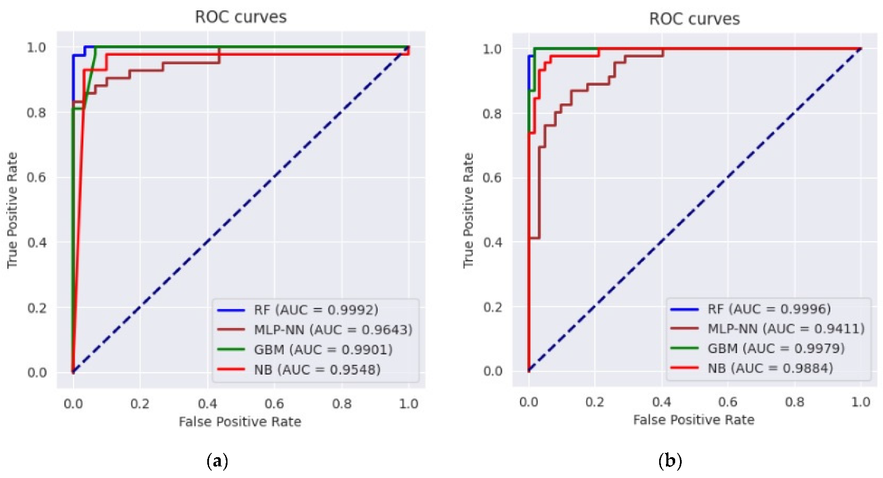

**Creation of a platform that displays real-time water level data and flood warnings:**

Creating a platform that displays real-time water level data and flood warnings using JavaScript would typically involve setting up a server to collect real-time data and push updates to the client-side JavaScript. Below is a simplified example of how you can create a client-side application that simulates real-time updates for water level data and flood warnings using JavaScript:

**JAVA CODE:**

<!DOCTYPE html>

<html>

<head>

<title>Real-Time Flood Monitoring</title>

</head>

<body>

<header>

<h1>Real-Time Flood Monitoring</h1>

</header>

<section class="data-section">

<h2>Water Level Data</h2>

<div id="water-level-data">Loading...</div>

</section>

<section class="warning-section">

<h2>Flood Warnings</h2>

<div id="flood-warnings">No warnings at the moment.</div>

</section>

<script>

function updateData() {

// Simulate fetching real-time data from a server (replace with your actual data source)

const waterLevel = (Math.random() * 10 + 1).toFixed(2); // Random water level

const warnings = Math.random() > 0.8 ? 'Flood Alert!' : 'No warnings at the moment';

// Update the HTML with the fetched data

document.getElementById('water-level-data').innerHTML = `Water Level: ${waterLevel} meters`;

document.getElementById('flood-warnings').innerHTML = `Status: ${warnings}`;

// Repeat the update every 5 seconds (adjust as needed)

setTimeout(updateData, 5000);

}

// Start the initial update

updateData();

</script>

</body>

</html>

In this example:

The HTML file provides the structure for your real-time monitoring platform.

The JavaScript code simulates the process of fetching real-time data and flood warnings. It uses ‘setInterval’ to update the data every 5 seconds. In a real-world application, you would replace the simulated data with actual data retrieved from sensors or a server.

**Design of the platform to receive and display water level data from IoT sensors and issue flood warnings when necessary:**

Designing a platform to receive and display water level data from IoT sensors and issue flood warnings when necessary involves multiple components and technologies. Here's a high-level overview of the architecture and components needed for such a system:

**1. IoT Sensors:**

- Deploy IoT sensors, such as water level sensors, across flood-prone areas.

- Sensors should be equipped with wireless communication capabilities (e.g., LoRa, Wi-Fi, or cellular) to transmit data to a central server.

**2. Data Collection and Ingestion:**

- Set up a central server or cloud-based platform to collect and ingest data from the IoT sensors.

- Implement data validation and cleansing to ensure data quality.

**3. Data Storage:**

- Store incoming sensor data in a database (e.g., SQL or NoSQL) for historical analysis and real-time monitoring.

**4. Real-time Data Processing:**

- Implement real-time data processing to monitor the water level continuously.

- Apply data aggregation and analysis to identify trends and anomalies.

**5. Early Warning System:**

- Develop an early warning system that processes sensor data and issues flood warnings when certain conditions or thresholds are met.

- This system should include algorithms and models for flood prediction.

**6. User Interface (Web-Based Dashboard):**

- Create a user-friendly web-based dashboard for visualization of real-time data.

- Display water level data in charts, graphs, or maps.

- Include notifications and alerts for flood warnings.

**7. Communication Channels:**

- Implement communication channels for issuing warnings, such as email notifications, SMS alerts, and in-app notifications.

**8. Mobile App (Optional):**

- Develop a mobile application that allows users to access real-time data and receive alerts on their smartphones.

- Integrate Geographic Information System (GIS) for mapping and spatial analysis of flood-prone areas.

**10. Historical Data Analysis:**

- Use historical data for trend analysis and improving the flood prediction models.

**11. Scalability and Redundancy:**

- Ensure that the platform is scalable and has redundancy to handle large volumes of data and ensure reliability.

**12. Security:**

- Implement security measures to protect the platform from data breaches and unauthorized access.

**13. Machine Learning and AI (Optional):**

- Consider using machine learning and AI techniques for more accurate flood prediction based on historical data.

**14. Regular Maintenance and Updates:**

- Plan for regular maintenance, updates, and calibration of sensors to ensure accurate data collection.

**15. Testing and Validation:**

- Test the entire system in a controlled environment and validate it with real-world data to ensure its effectiveness.

**16. Emergency Response Integration (Optional):**

- Integrate the system with local emergency response authorities to facilitate timely actions in the event of a flood warning.

**17. User Training and Education:**

- Provide training and educational materials to end-users, including the public and local authorities, on how to interpret and respond to flood warnings.

**18. Compliance with Regulations:**

- Ensure that the platform complies with relevant regulations and standards related to flood monitoring and early warning systems.

The design and development of such a platform can be complex, and it often involves collaboration with domain experts, meteorologists, and local authorities to make the system as effective as possible in preventing or mitigating flood-related risks.

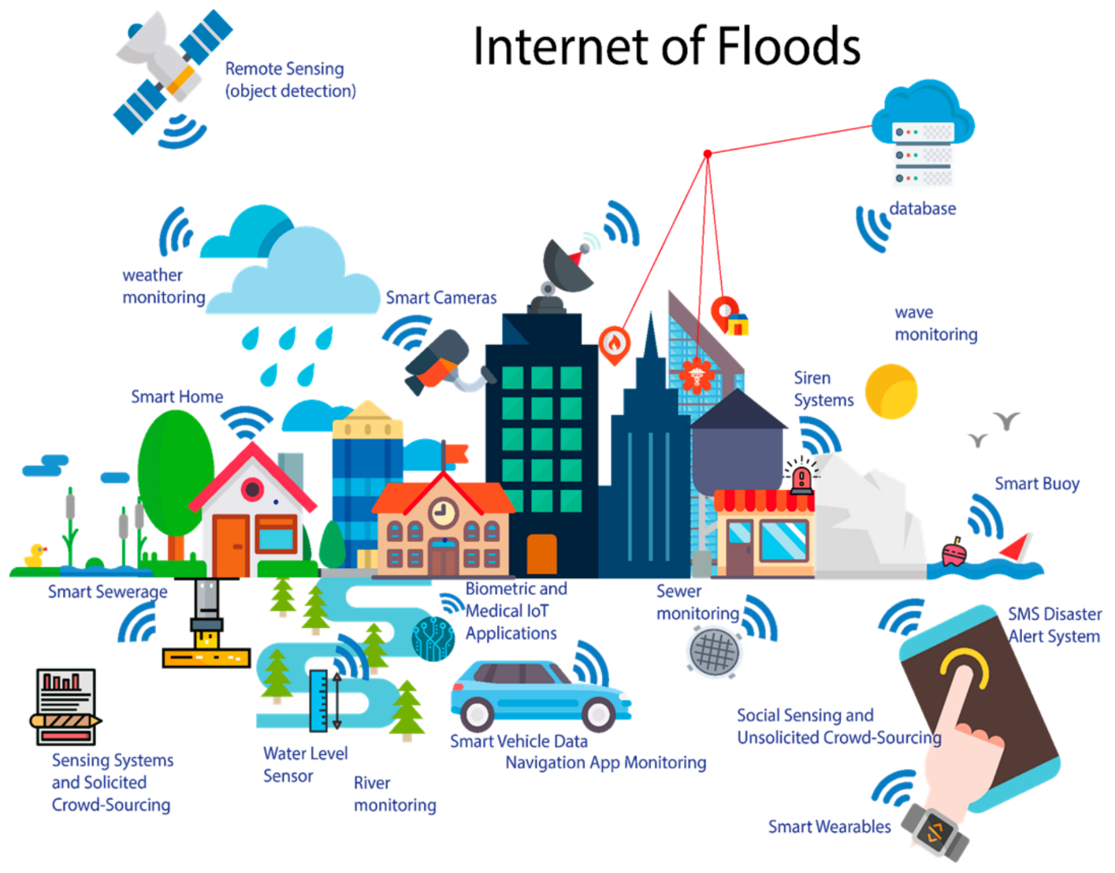

**CONCLUSION:**

The development of a model for a flood monitoring and early warning platform is a complex task, but it is an important one. By accurately predicting future flood events, such models can help to save lives and property.

There are a number of different machine learning models that can be used for flood prediction. Some common models include linear regression, logistic regression, decision trees, and random forests. The best model to use will depend on the specific data that is available and the desired accuracy.

When developing a model for a flood monitoring and early warning platform, it is important to carefully consider the following factors:

Feature engineering: The features that are used to train the model have a significant impact on its performance. It is important to carefully engineer the features so that they are informative and capture the important relationships in the data.

Model selection: There are a variety of different machine learning models that can be used for flood prediction. It is important to select the model that is most appropriate for the specific data and desired accuracy.

Model evaluation: Once the model has been trained, it is important to evaluate its performance on a held-out test set. This will help to ensure that the model is not overfitting the training data.

Model deployment: Once the model has been evaluated and is satisfied with its performance, it can be deployed to a production environment where it can be used to predict future flood events.

By following these tips, we can develop a model for a flood monitoring and early warning platform that can help to save lives and property.