Function App Creation

1. Select the **Create a resource** button found on the upper left-hand corner of the Azure portal, then select **Compute** > **Function App**.

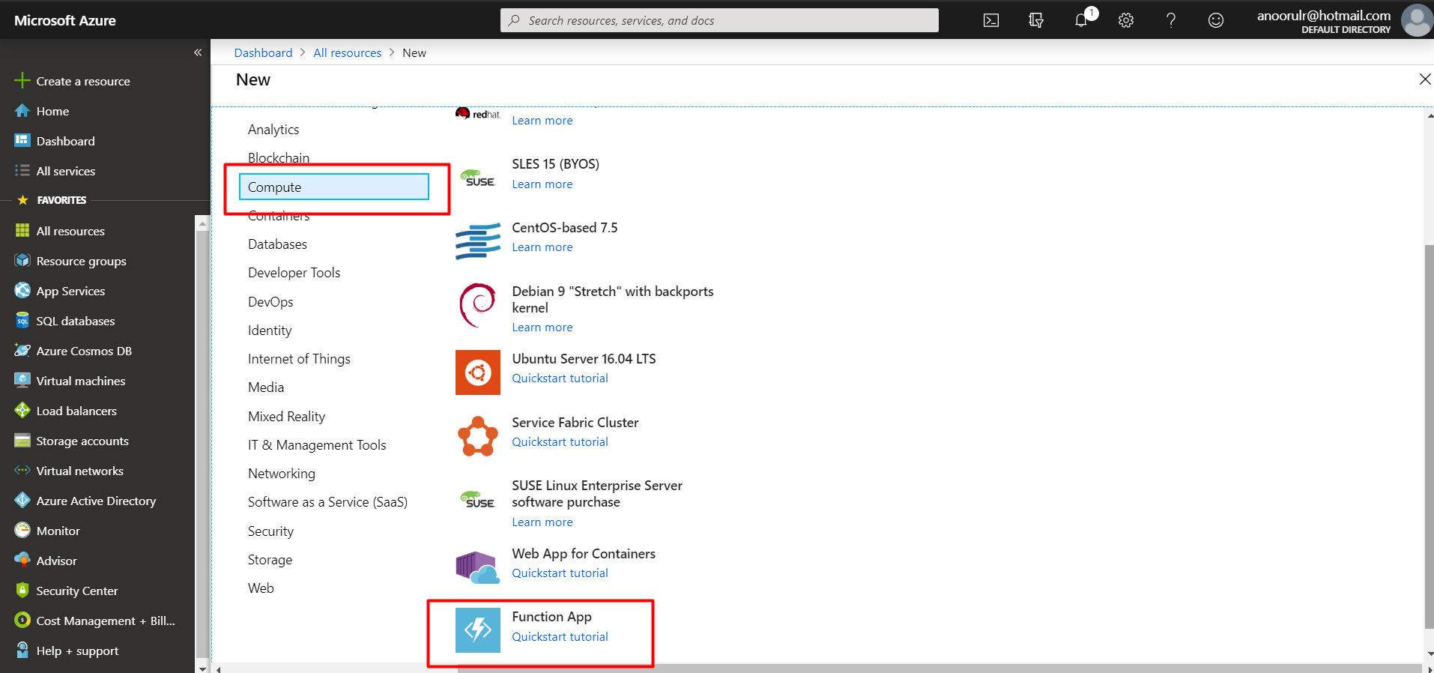

1. Use the function app settings as specified in the table below the image.

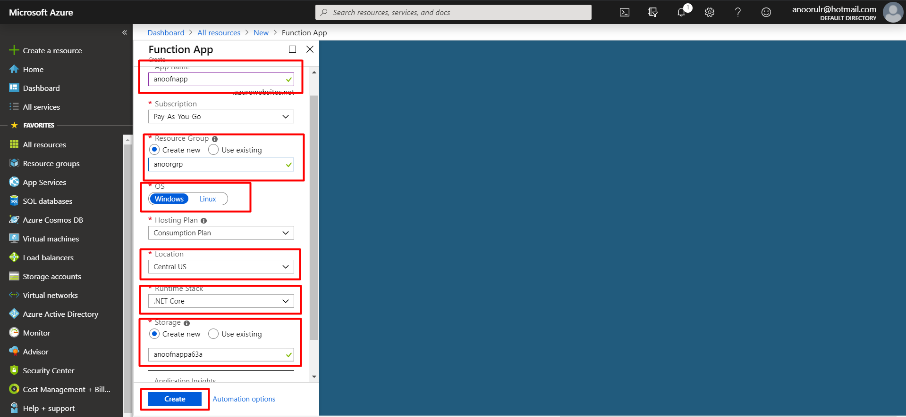

**App Name:** Globally unique name

**Subscription**: What you have

**Resource Group:** You can create a new resource group, or you can user a existing one.

**OS**: It will be the operating system that will be used, here we are using Windows operating system. Also, you can choose Linux OS.

**Hosting Plan:** It defines how the resources are allocated to your function app. Here I am using the default plan.

**Location**: It is the region near to you or near other services that will use you function.

**Storage**: It will be used by your function app.

1. **After configuring all inputs press the create button**

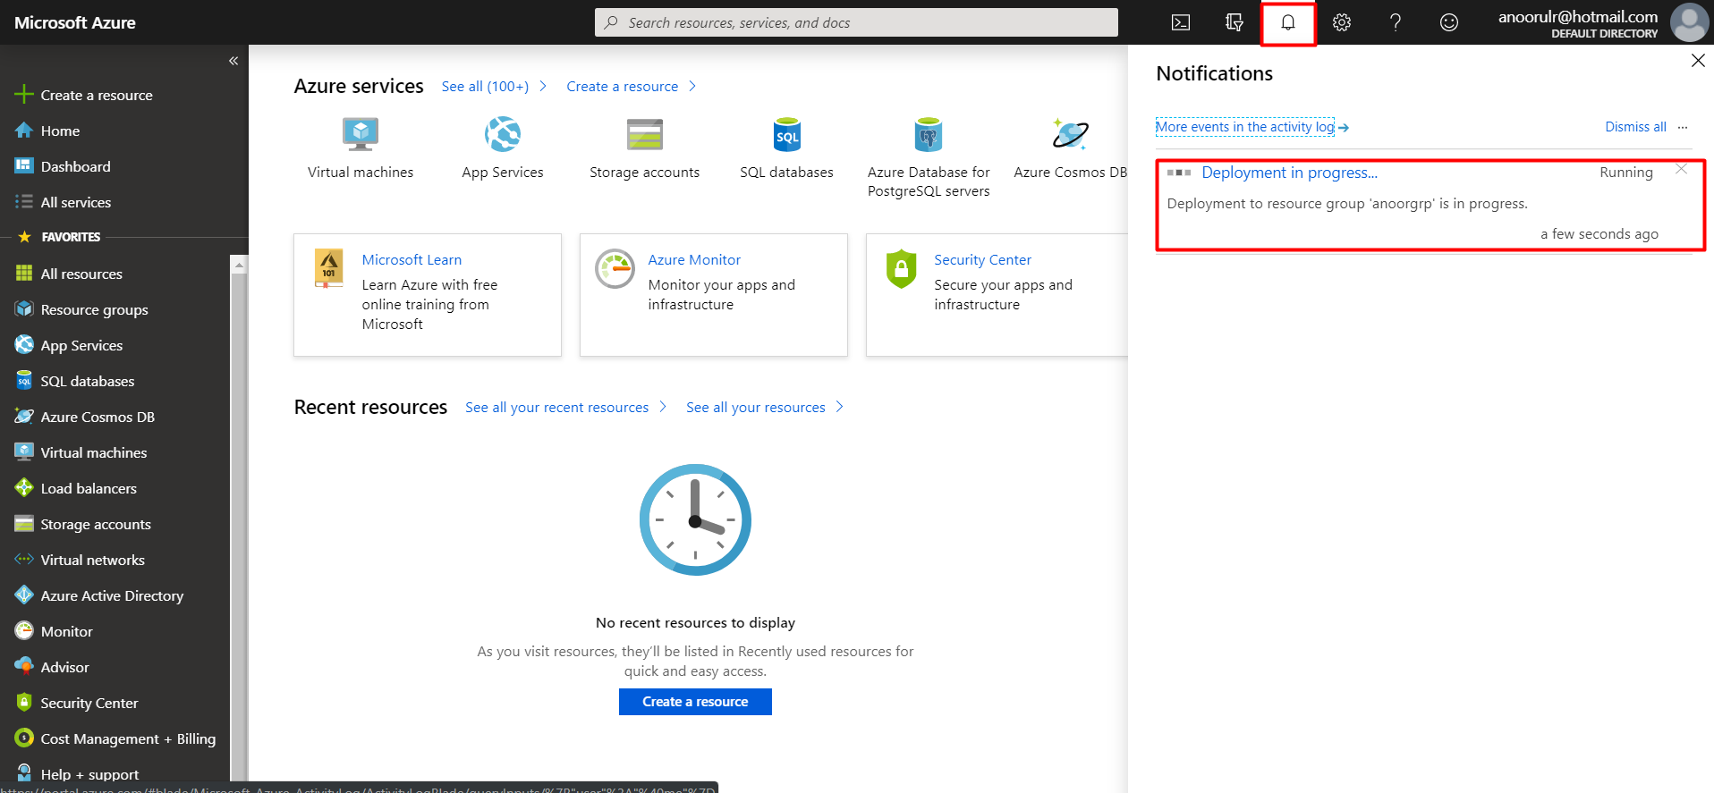

1. After creating the app, the following screen will be shown as

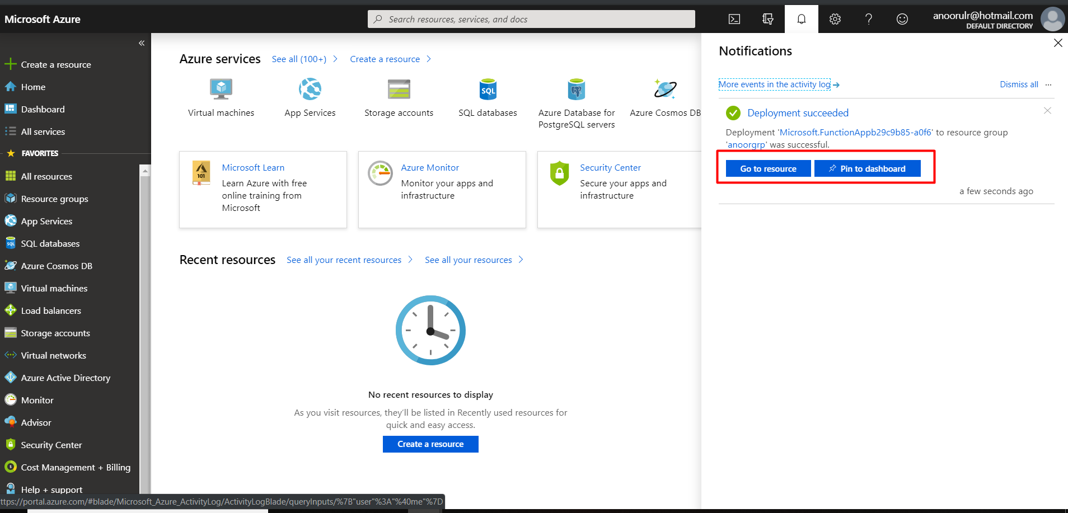

1. Then press “goto resource” button. **Creating the trigger**

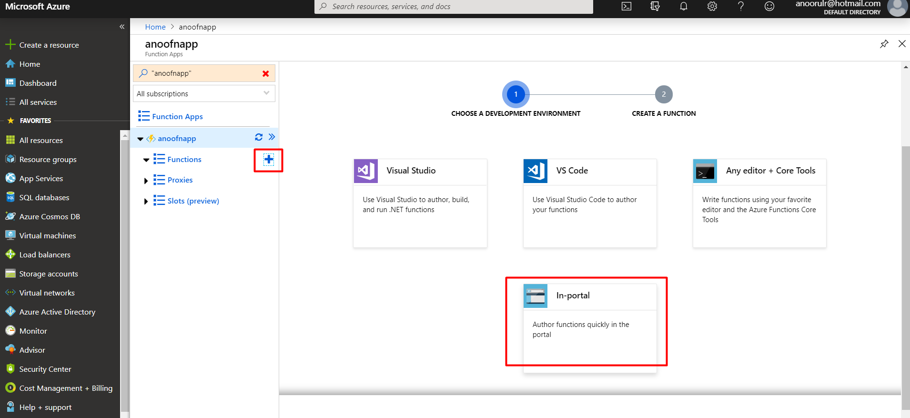

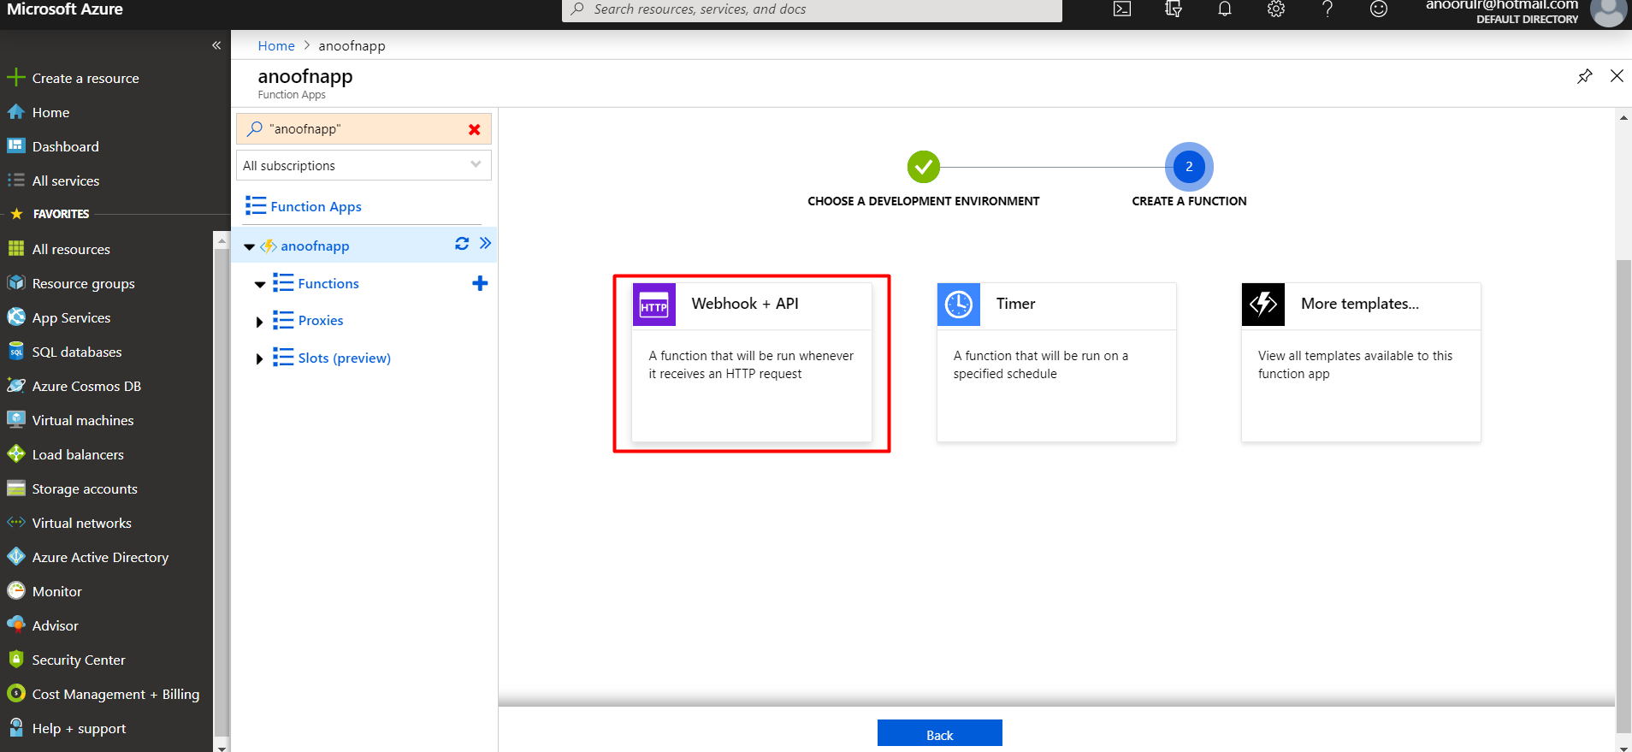

**Get the URL**

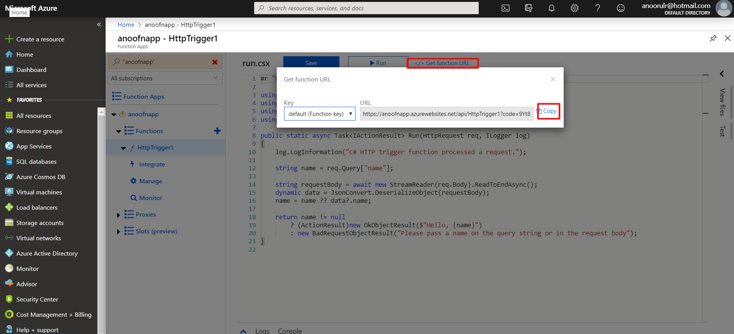

Past the url into your browser to see the putput, you can add query-sting as your name.

**Output**

