practise

## Read the data

setwd("C:/Users/Anusha/Downloads/bigdata/")  
mydata<-read.csv("Ozone_data.csv")  
summary(lm(Ozone ~ Temp+Month, data = mydata))

##   
## Call:  
## lm(formula = Ozone ~ Temp + Month, data = mydata)  
##   
## Residuals:  
## Min 1Q Median 3Q Max   
## -41.814 -14.587 0.031 11.468 120.272   
##   
## Coefficients:  
## Estimate Std. Error t value Pr(>|t|)   
## (Intercept) -138.7831 18.8220 -7.373 3.57e-11 ***  
## Temp 2.6739 0.2568 10.412 < 2e-16 ***  
## Month -3.7596 1.6610 -2.264 0.0256 *   
## ---  
## Signif. codes: 0 '***' 0.001 '**' 0.01 '*' 0.05 '.' 0.1 ' ' 1  
##   
## Residual standard error: 23.48 on 108 degrees of freedom  
## Multiple R-squared: 0.5112, Adjusted R-squared: 0.5021   
## F-statistic: 56.46 on 2 and 108 DF, p-value: < 2.2e-16

##Inference1 : The value r2 is a fraction between 0.0 and 1.0, and has no units. An r2 value of 0.0 means that knowing X does not help you predict Y. There is no linear relationship between X and Y, and the best-fit line is a horizontal line going through the mean of all Y values. When r2 equals 1.0, all points lie exactly on a straight line with no scatter. Knowing X lets you predict Y perfectly.  
  
##inference 2: Example r2 value =0.58  
  
## inference 3: Ozone is Directly proportional to Temp & Ozone is Indirectly proportional to Wind & Wind impacts more than Temp  
  
  
## Call:  
lm(formula = Ozone ~ Temp + Wind, data = mydata)

##   
## Call:  
## lm(formula = Ozone ~ Temp + Wind, data = mydata)  
##   
## Coefficients:  
## (Intercept) Temp Wind   
## -67.322 1.828 -3.295

# draws a correlation plot  
pairs(mydata)

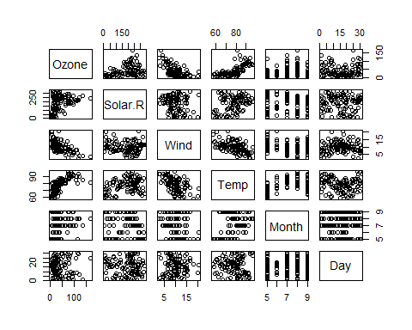

# calculates the Pearson's correlation coefficient   
cor(mydata)

## Ozone Solar.R Wind Temp Month  
## Ozone 1.000000000 0.34834169 -0.61249658 0.6985414 0.142885168  
## Solar.R 0.348341693 1.00000000 -0.12718345 0.2940876 -0.074066683  
## Wind -0.612496576 -0.12718345 1.00000000 -0.4971897 -0.194495804  
## Temp 0.698541410 0.29408764 -0.49718972 1.0000000 0.403971709  
## Month 0.142885168 -0.07406668 -0.19449580 0.4039717 1.000000000  
## Day -0.005189769 -0.05775380 0.04987102 -0.0965458 -0.009001079  
## Day  
## Ozone -0.005189769  
## Solar.R -0.057753801  
## Wind 0.049871017  
## Temp -0.096545800  
## Month -0.009001079  
## Day 1.000000000