Date: 18/5/2026
Author: Anusha Shetty
Classical-to-Quantum Encoding Methods
In Quantum Machine Learning (QML), encoding is the process of taking your regular classical data (numbers like 0.23, 0.45, etc.) and transforming them into quantum states that a quantum computer can process. Think of it as translation: your data speaks "classical" (ordinary numbers), and the quantum computer speaks "quantum" (qubits, superpositions, and probabilities). Encoding is the dictionary that bridges the two worlds.
The encoding method determines three critical things:
How many qubits you need: quantum hardware has limited qubits
How much information is preserved: some methods compress data, losing details
How expressive the quantum state is: some methods create richer quantum states
Different encodings can lead to dramatically different model accuracies, even when everything else in the pipeline stays the same.
Below are some of the encoding methods:
1. Angle encoding
2. Dense Angle encoding (*)
3. Amplitude encoding
4. ZZ Feature Map encoding
5. Phase encoding

What does our classical data look like before encoding?
Our dataset has 8 features per sample. Each feature is a real number (after scaling, typically in the range [0, 1]). For example, one sample might look like: [0.23, 0.45, 0.12, 0.67, 0.33, 0.89, 0.05, 0.71]. These are just ordinary numbers stored in a classical array. All five encoding methods start from exactly this same data.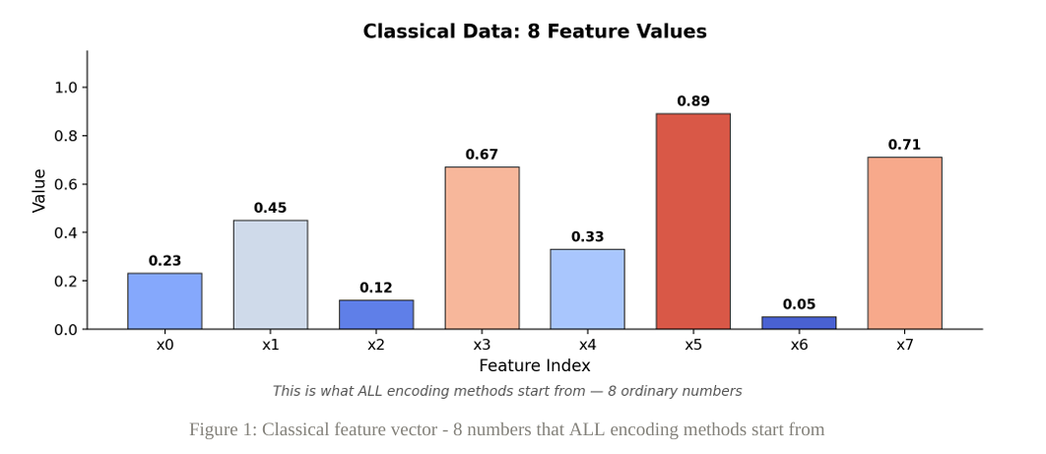

Angle Encoding:
Angle Encoding is the most intuitive way to put classical data into qubits. Each feature value becomes a rotation angle on a single qubit. Specifically, if your feature value is x, the qubit is rotated by an angle of (pi times x) using an RY gate. A qubit can be thought of as a tiny compass needle (on a sphere called the Bloch sphere). It starts pointing "up" (which represents the state |0>), and the rotation tilts it. A feature value of 0 means no tilt (stays |0>), while a feature value of 1 means the needle points fully "down" (|1>). Values in between tilt the needle partially. One feature goes into one qubit, so 8 features require 8 qubits. The "Repeated" variant applies the same rotation twice: once before entanglement and once after, which helps the circuit learn feature correlations.
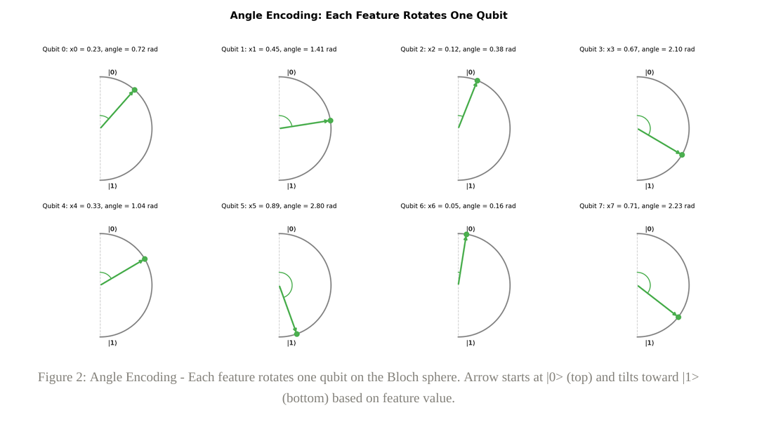
After encoding, each qubit is in a state that is a superposition of |0> and |1>, with the balance determined by the feature value. A feature of 0.23 means the qubit is mostly |0> with a small |1> component. A feature of 0.89 means the qubit is mostly |1>. The key visual: imagine 8 compass needles, each tilted to a different angle based on its feature.

Dense Angle Encoding
Dense Angle Encoding is a more qubit-efficient variant. Instead of one feature per qubit, it packs TWO features onto each qubit using sequential RY rotations. For qubit i, the first feature x[2i] is applied as RY(pi * x[2i]), then the second feature x[2i+1] as RY(pi * x[2i+1]). The two rotations add up on the same qubit, so the final tilt angle encodes both features combined. After all qubits are rotated, a CNOT ring (circular chain of entangling gates) connects the qubits, and then the SAME features are applied AGAIN. This "re-uploading" allows the circuit to learn higher-order feature combinations because the features interact with each other through the entanglement layer.
Each qubit's final tilt angle is the sum of two feature rotations. For example, if feature x0 = 0.23 and x1 = 0.45, the qubit first tilts by 0.23*pi, then by 0.45*pi more, ending at a combined angle of 0.68*pi. The visual: imagine 4 compass needles, each tilted by the combined effect of two features. The CNOT ring creates correlations between qubits, and the re-uploading makes the pattern even richer.
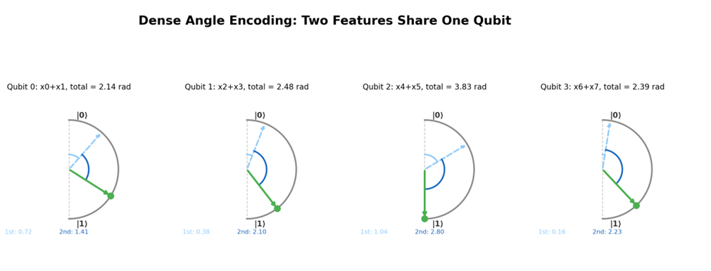
Amplitude Encoding
Amplitude Encoding is the most qubit-efficient method. Instead of rotating qubits, it uses the feature values directly as the probability amplitudes of the quantum state. With 3 qubits, there are 23 = 8 possible basis states (|000>, |001>, |010>, ..., |111>). Each of the 8 features becomes the amplitude of one basis state. Before encoding, the features are made positive (absolute value) and normalized so that the sum of squared amplitudes equals 1 (required by quantum mechanics). This normalization preserves the relative magnitudes of features but loses the absolute scale.
After encoding, the quantum state is a superposition of all 8 basis states, where each state's amplitude is proportional to the original feature value. If you measured the qubits, you would observe each basis state with probability equal to the squared amplitude. The visual: imagine 8 buckets (basis states) with water levels proportional to the feature values. The tallest bucket corresponds to the largest feature, and the shortest to the smallest. This is the most direct mapping from features to quantum states.

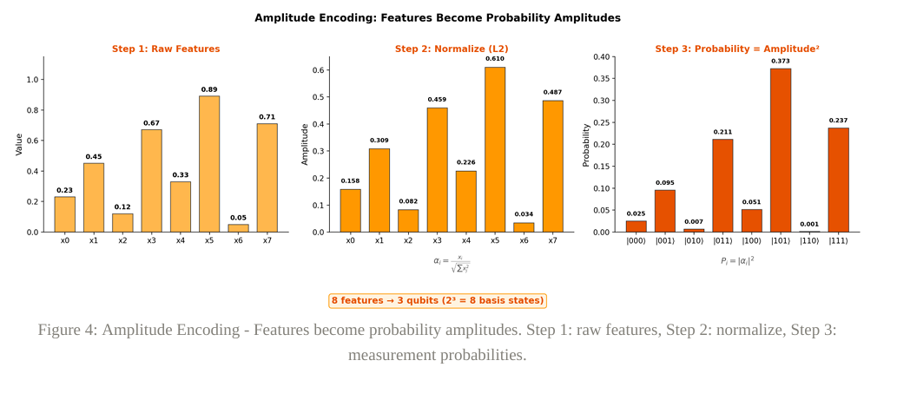
ZZ Feature Map
The ZZ Feature Map is a more sophisticated encoding inspired by quantum kernel methods. It starts by putting all qubits into superposition using Hadamard gates (creating an equal mixture of all possible states). Then each feature is encoded as a phase rotation using RZ gates. The key innovation is the pairwise RZZ gates: for each pair of adjacent features, a gate is applied that encodes the product x[i] * x[j] as an additional phase. This captures second-order feature interactions, not just individual features. The result is a quantum state that contains information about how features relate to each other, which simple angle encoding cannot represent.
The resulting quantum state is a complex superposition where each basis state's amplitude depends on both individual features and their pairwise products. Unlike angle encoding (where each qubit is independent), the ZZ Feature Map creates correlations between qubits. The visual: imagine a calm lake (superposition) where each feature adds a ripple (RZ phase), and then pairs of features create combined ripples that interfere with each other (RZZ interactions). The final pattern of ripples encodes not just individual features but how they interact.
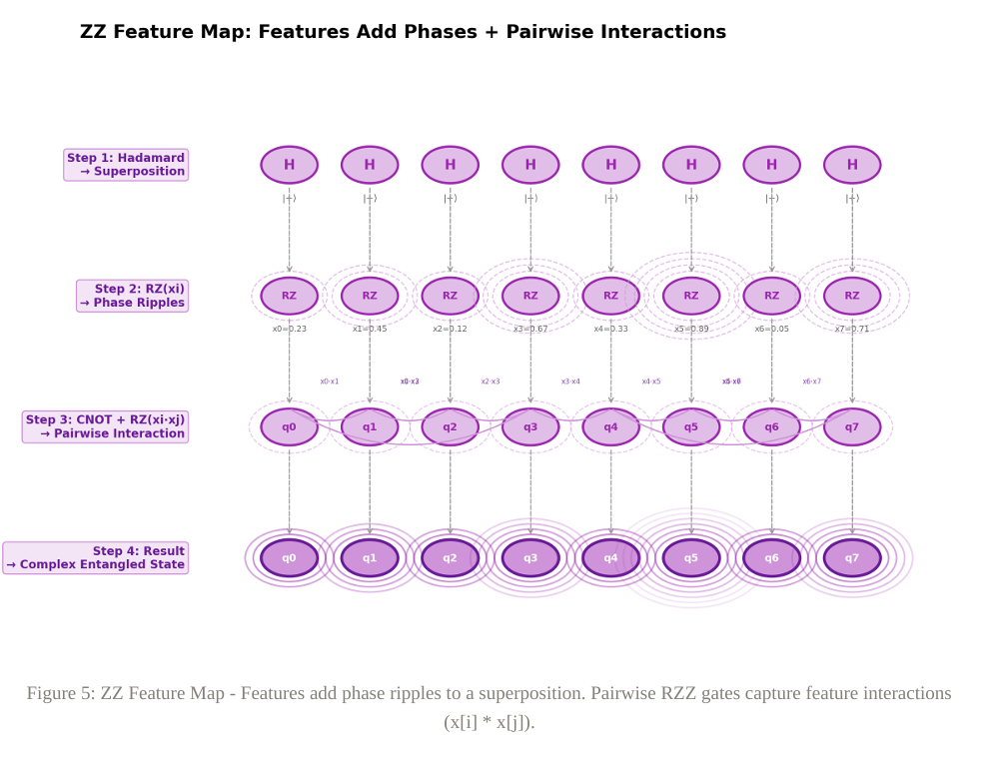
Phase Encoding
Phase Encoding uses RZ gates (phase rotations) instead of RY gates (axis rotations) to encode features. The key difference: RY gates tilt a qubit's arrow in a visible direction on the Bloch sphere, while RZ gates add an invisible "phase" between the |0> and |1> components of a superposition. To make these phases measurable, the circuit starts and ends with Hadamard gates. The first Hadamard creates superposition (so the phase has something to affect), and the final Hadamard converts the phase information back into amplitude information that can be measured. Between the two Hadamards, features are encoded as RZ phases, a CNOT chain entangles the qubits, and the features are re-applied (similar to re-uploading in Dense Angle Encoding).
The final measurement probabilities (after the closing Hadamard gates) show a distribution that reflects both the individual feature values and their interactions through entanglement. The visual: imagine the process in four steps: (1) All qubits split into superposition (half |0>, half |1>), (2) Each feature adds an invisible phase shift between the |0> and |1> parts, (3) CNOT gates entangle the qubits, creating correlations, (4) The final Hadamard converts the phase patterns into measurable probability differences. Features near zero still create distinct patterns because the phase shift affects the interference at the final Hadamard, even though the qubit state appears unchanged before that gate.

