
Assignment number: 1
Complete actual name: Anoosha Irfan
Registration number: FA24B1-SE-048
Course code: SE-665
Section: A

Task 1: Install Gitea and Push a Repository from the Ubuntu Server
Step 1.1: Install and Run Gitea on the Ubuntu Server
Update the Ubuntu package index and install Docker Engine and curl.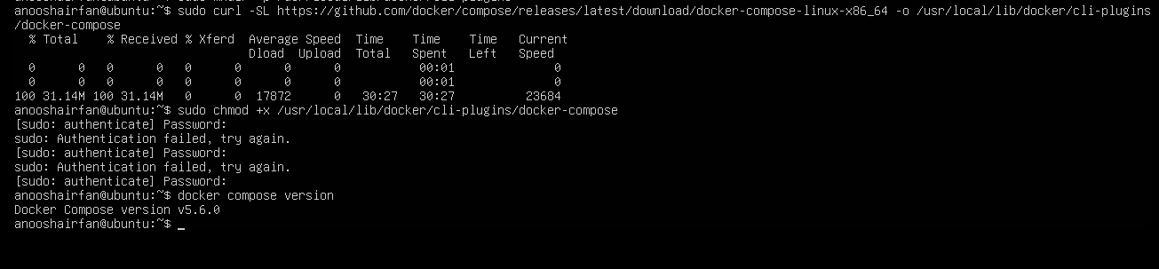 Create the system-wide Docker CLI plug-in directory and download the Docker Compose plug-in for an x86_64 Ubuntu server. Start the Docker service and add your current Ubuntu account to the docker group: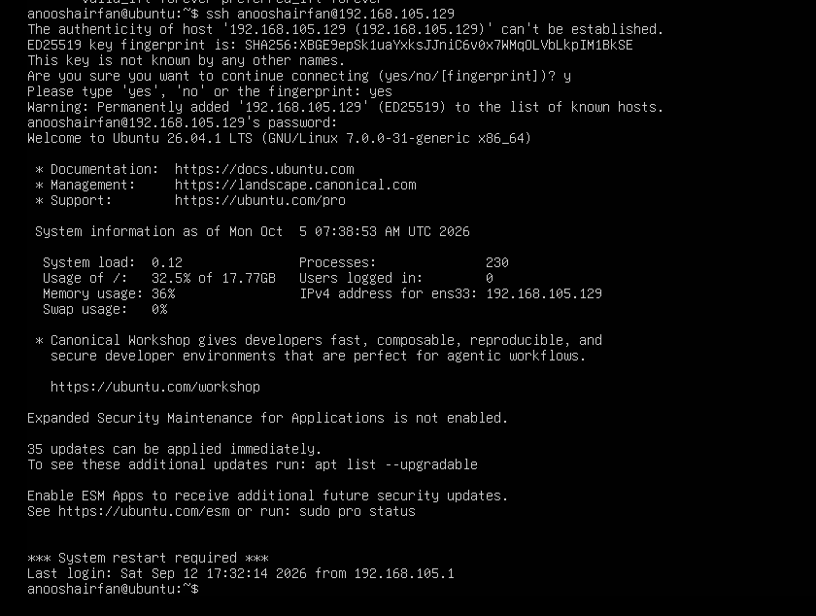
Verify the Git, Docker, and Docker Compose installations: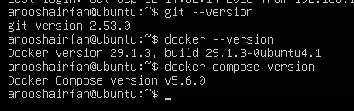
Clone the instructor-provided Gitea setup repository on the Ubuntu server:
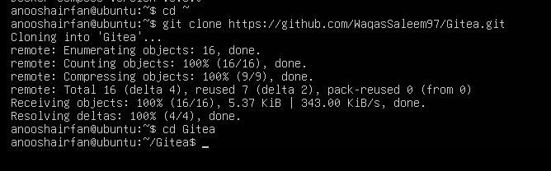
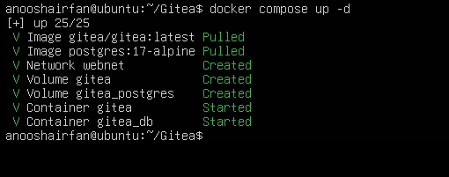
Start Gitea and PostgreSQL:

Confirm that both containers are running and Confirm that Gitea responds locally on port 3000:
On the initial Gitea installation page,
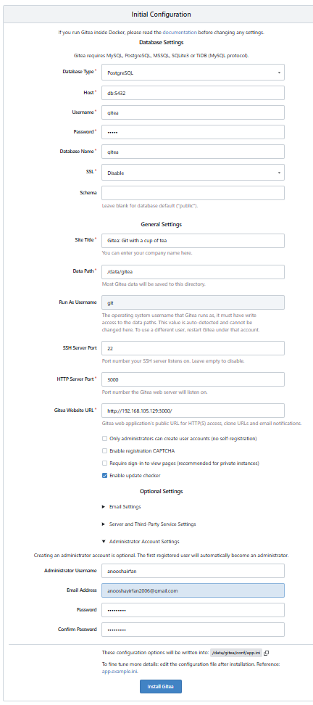
The screenshot must show your <github-username>@ubuntu prompt, the docker compose ps
command,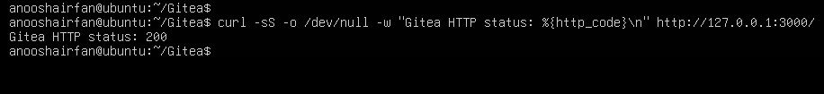 Step 1.2: Create and Push the Initial Repository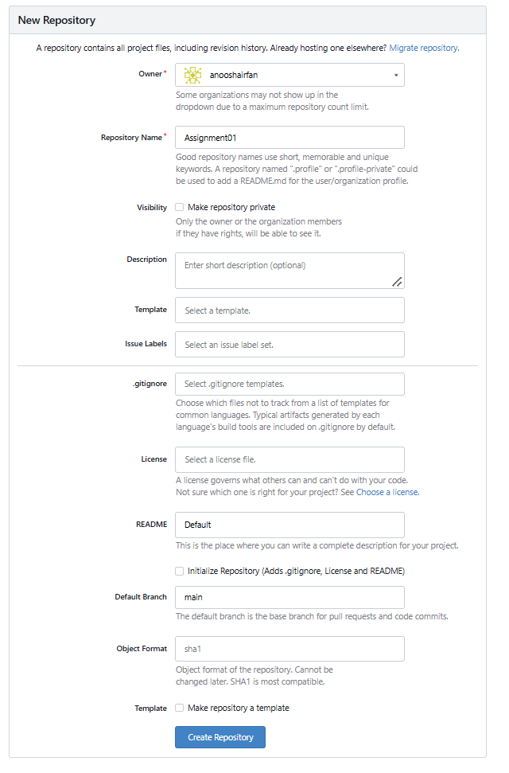
create a separate local repository outside both the Gitea directory and the existing CC repository. Create a README.md containing:
• your full name; and
• your registration number. Commit the README:

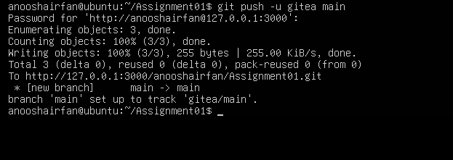
generate a personal access token: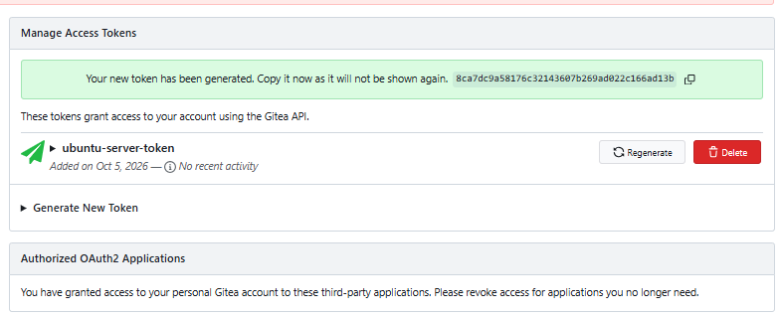
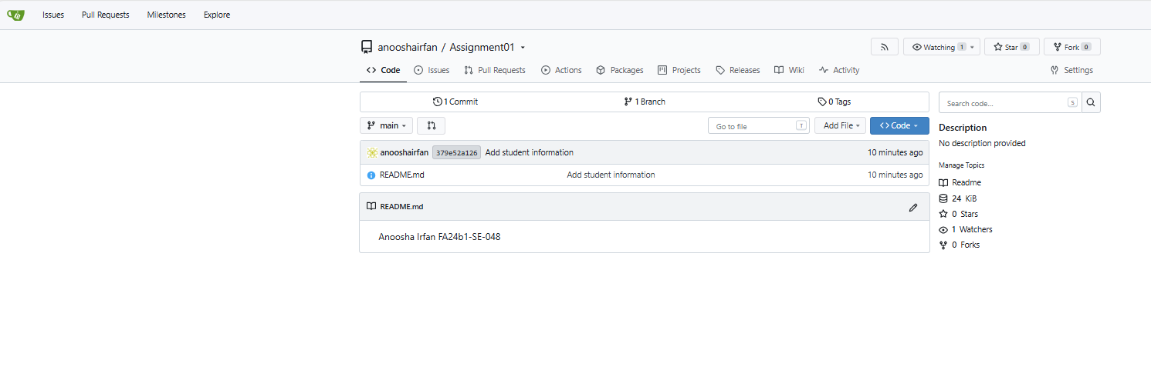 add the local Gitea address as the gitea remote and Verify that the remote URL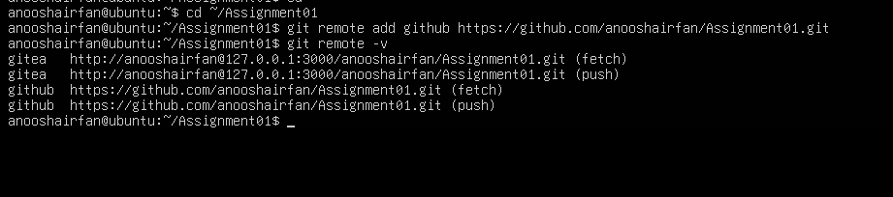Push the initial commit: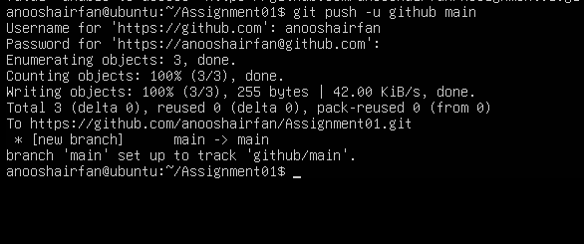
Step 1.3: Verify the Gitea RepositoryTask 2: Push the Same Repository to GitHub
Step 2.1: Create the GitHub Repository and Verify Both Remotes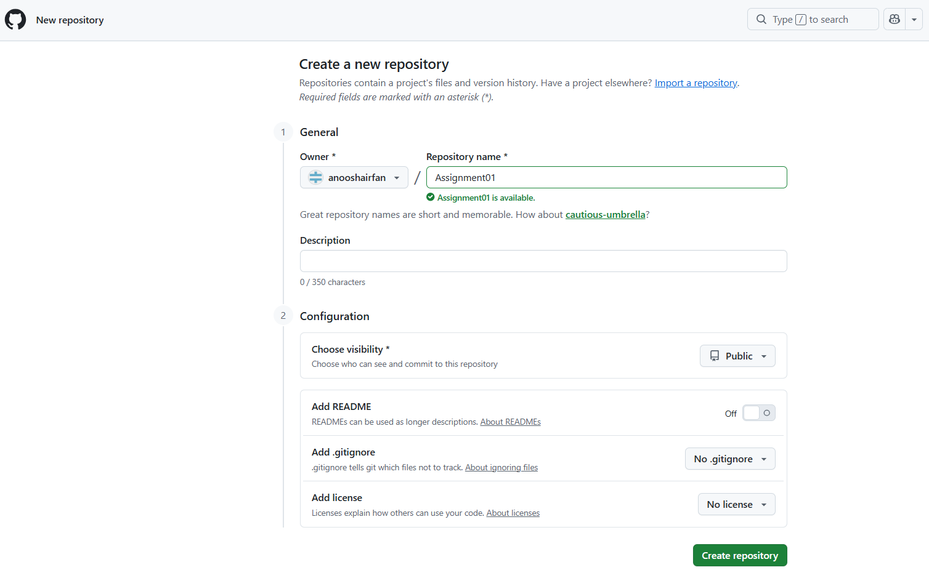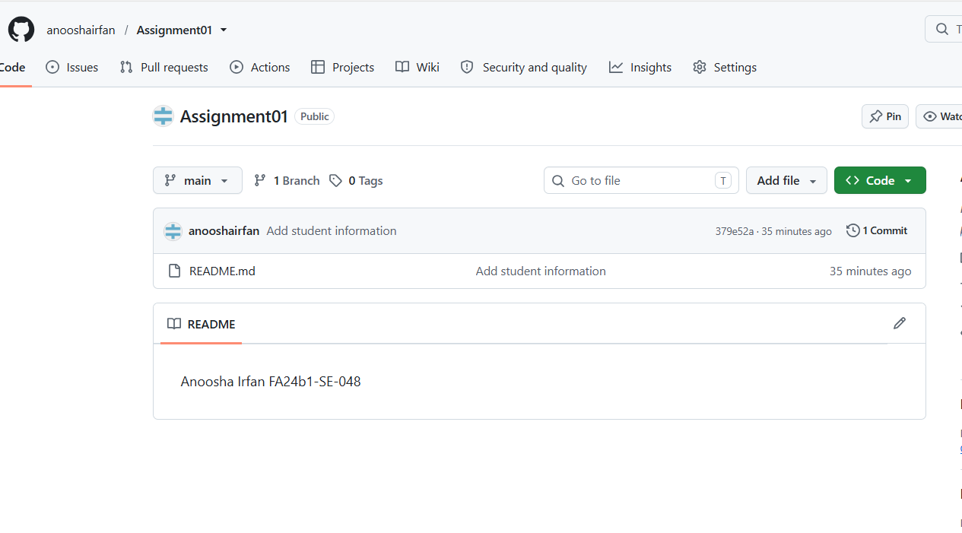Add GitHub as the second remote and Verify both remotes: Step 2.2: Push to GitHub
Step 2.3: Verify the GitHub Repository
Task 3: Track Three Large Files with Git LFS
Step 3.1: Configure Git LFS 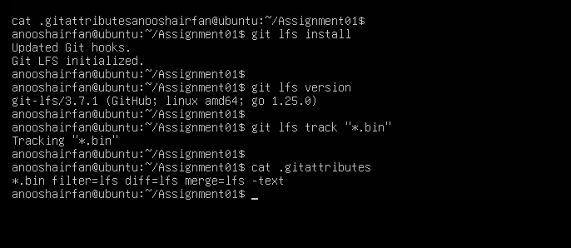Step 3.2: Create and Verify Three LFS Files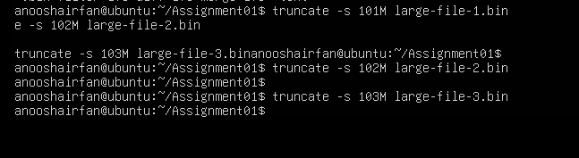Stage .gitattributes and the three files and Verify that all three files are tracked by Git LFS and display their sizes: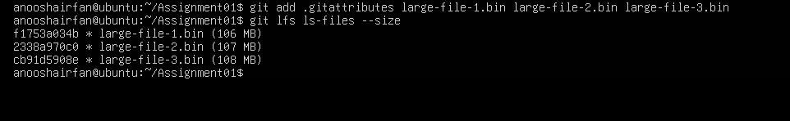 Step 3.3: Commit and Push the LFS Files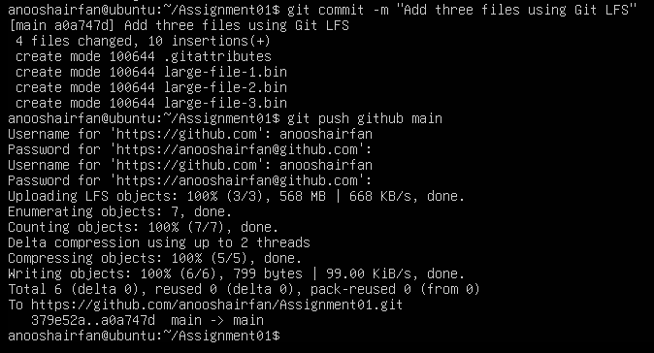
Task 4: Create a Portfolio or CV with GitHub Pages
4.1: Create and Push the Portfolio Repository
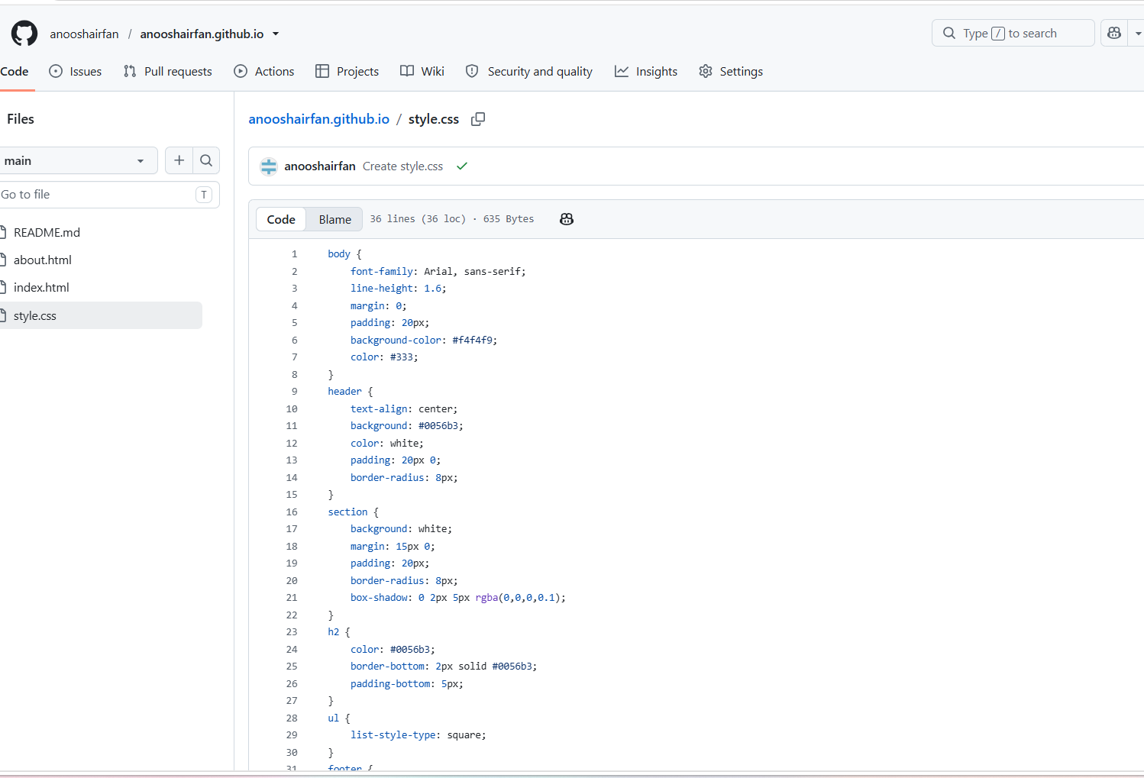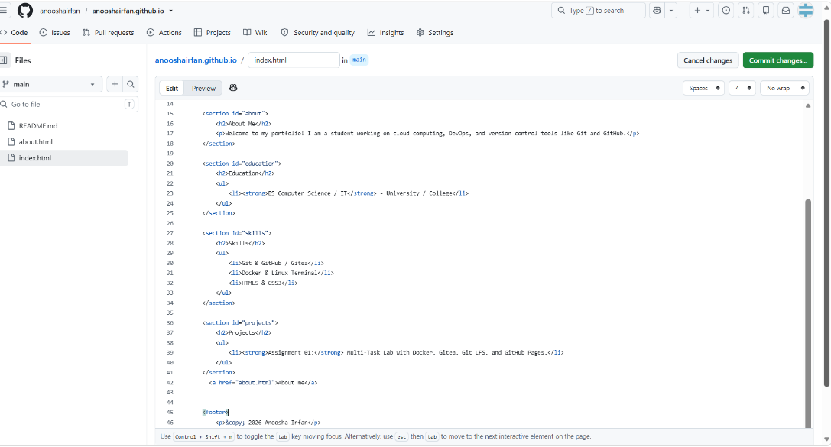
Step 4.2: Publish with GitHub Pages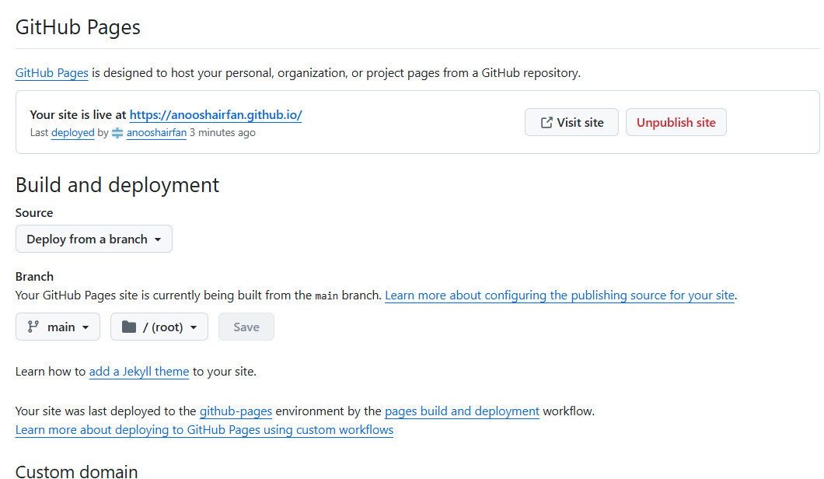Step 4.3: Verify the Live Portfolio