>>> import pyspark

>>> from pyspark.sql import sparksession

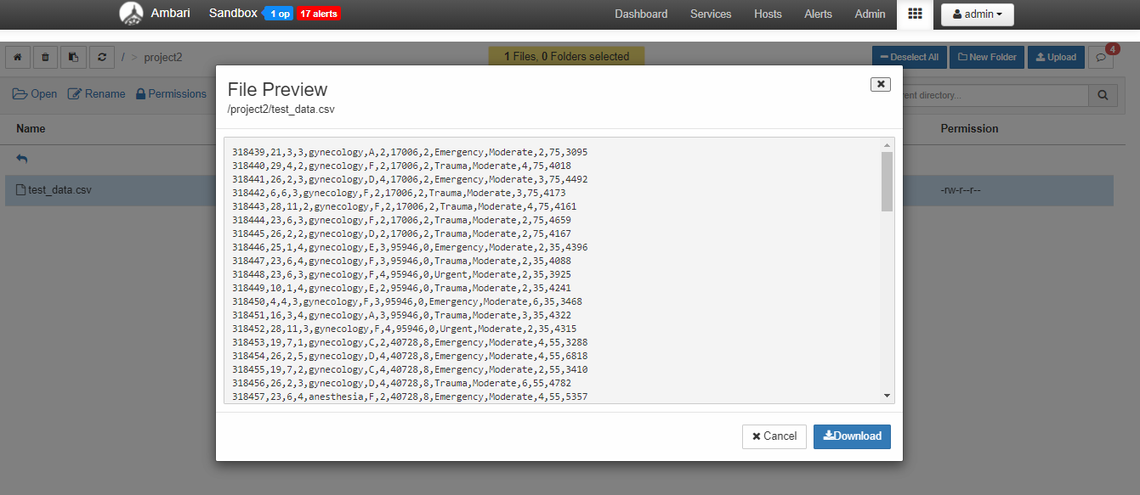

df2 = spark.read.csv('/project2/test_data.csv',inferSchema=True,header=False).toDF("id","Hcode","HCcode","A_Room","Dep","Wcode","Bed_Grade","pid"

,"PCcode","Admission","Illness","Visit_P","P_age","Deposit")

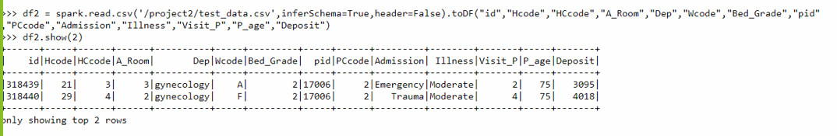

>>> df2.show(2)

df2.filter(df2.Dep == "gynecology").show()

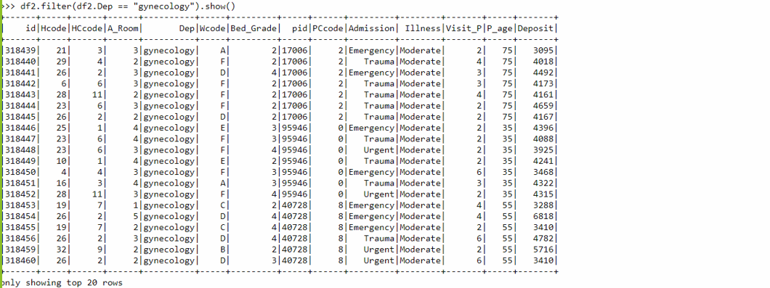

df2.filter(df2.Dep == "gynecology").count()

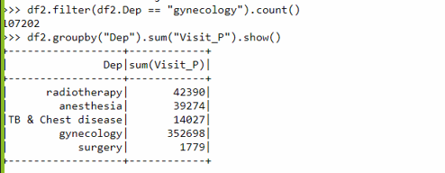

df2.groupby("Dep").sum("Visit_P").show()



df2.groupby("Dep").max("Visit_P").show()



df2.groupby("Admission").count().show()



df3=df2.createOrReplaceTempView("Health_Care")

df4=spark.sql('select * from Health_Care where Dep="gynecology"')

df2.write.mode("overwrite").csv("/output/output.csv")

>>> b.write.mode("overwrite").csv("/output/output.csv")

>>> b=spark.sql('select Dep from Health_Care')



Partition :

df2.write.partitionBy("Dep").mode("overwrite").csv("/output/partition.csv")

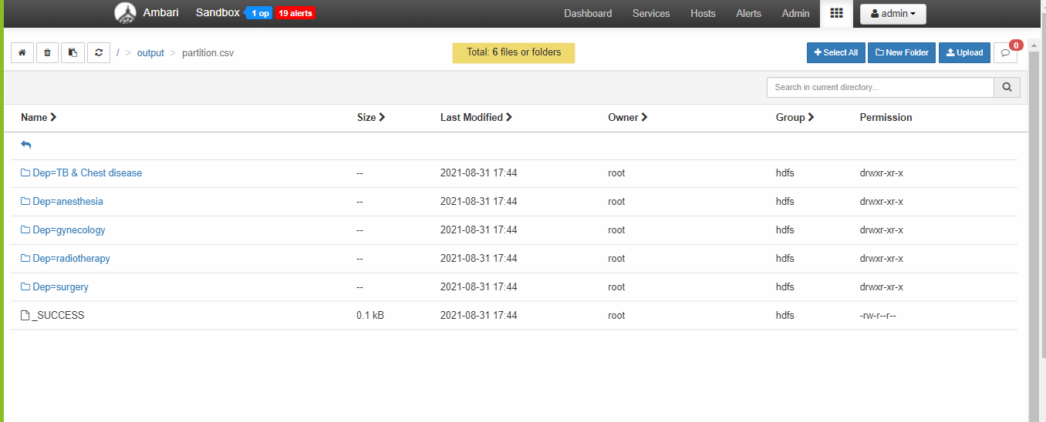

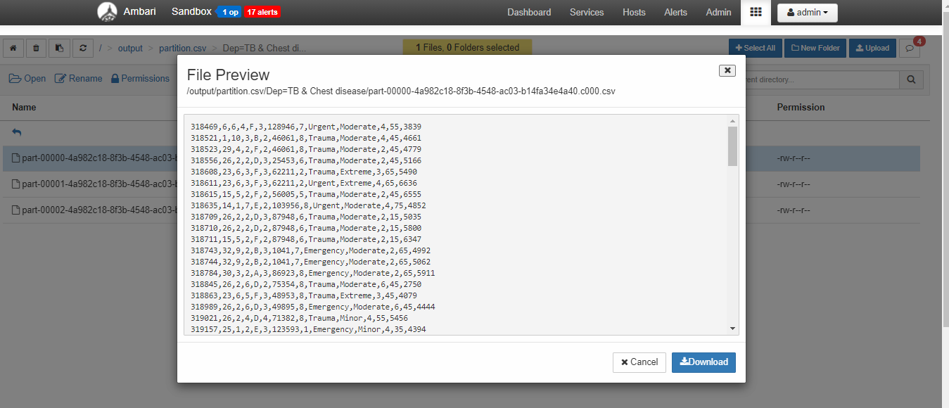

df2.write.format("csv").bucketBy(10,"Dep").saveAsTable("Buck3")

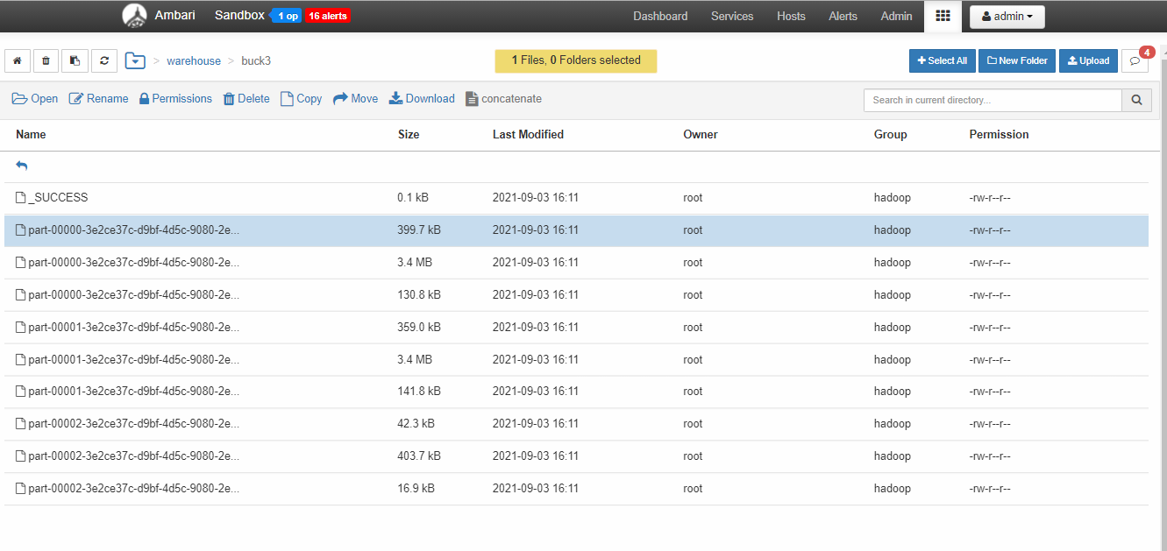

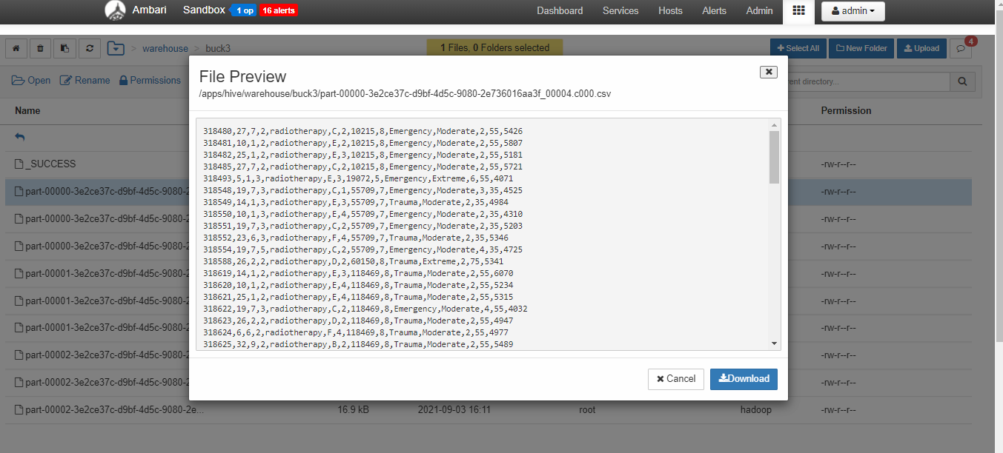

df5=spark.sql("select dep,count(id) AS Count_Patient from Health_care where Illness='Moderate' group by dep ").show() 

df5=spark.sql("select pid,P_age,(select max(Deposit) max_deposit from Health_Care) from Health_Care group by pid,p_age order by pid desc").show(

)

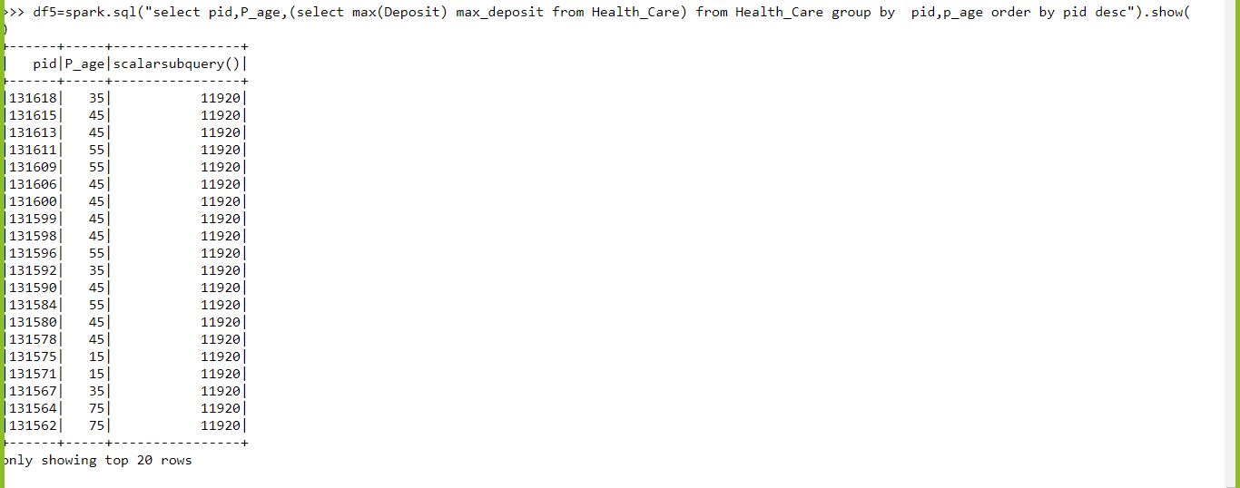

df5=spark.sql("select Wcode,round(avg(Bed_Grade),2) as bed_grade from Health_Care where group by Wcode order by Bed_Grade desc limit 1 ").show()

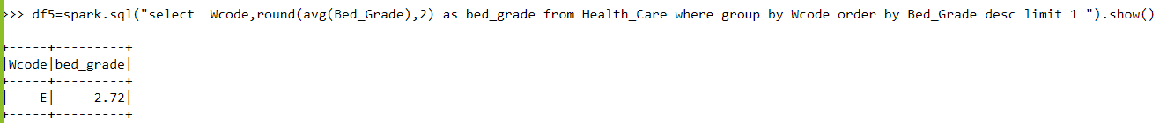

df5=spark.sql("select pid,P_age,sum(Deposit) as Total_Deposit from Health_Care where group by P_age,pid order by Total_Deposit desc ").show()

df5=spark.sql("select pid,P_age,sum(Deposit) as Total_Deposit from Health_Care where group by P_age,pid order by Total_Deposit desc limit 1 ").sh

ow()

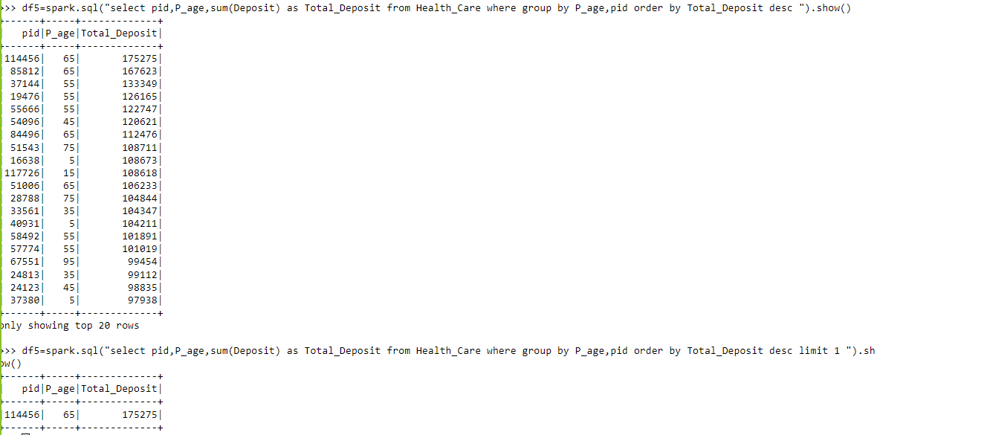

df5=spark.sql("select Dep,sum(A_Room) as Available_Room from Health_Care where group by Dep order by Available_Room desc ").show()



df5=spark.sql("select count(pid),P_age,Illness,Dep from Health_Care where Illness='Extreme' group by Illness,Dep,P_age order by Dep ").show(250)

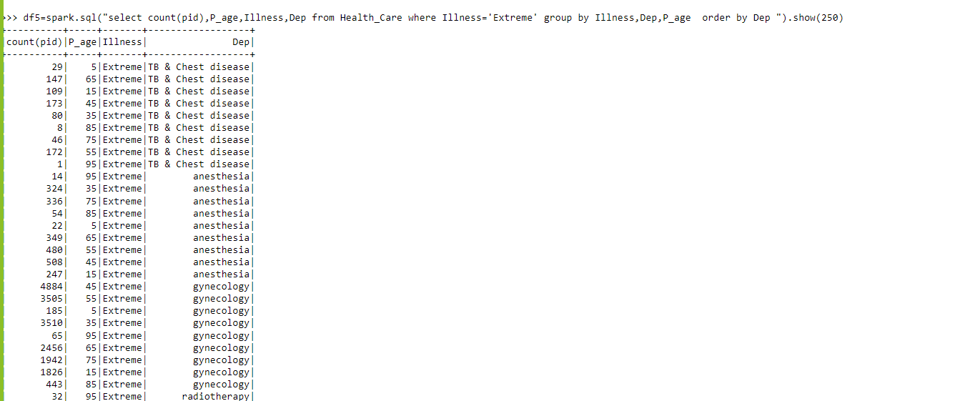

df5=spark.sql("select count(pid),P_age,Illness,Dep from Health_Care where Illness='Extreme'and Dep='surgery' group by Illness,Dep,P_age order by Dep ").show(250

)



 