MINISTRY OF INNOVATION AND TECHNOLOGY
Federal Democratic Republic of Ethiopia

Internship Management System
Software Design Document
IEEE Std 1016-2009 Compliant · Version 2.0 · May 2026

Document ID | MInT-IMS-SDD-2026-001
Version | 2.0 — Final Release
Date | May 2026
Status | APPROVED FOR IMPLEMENTATION
IEEE Standard | IEEE Std 1016-2009: Software Design Descriptions
SRS Reference | MInT-IMS-SRS-2026-001 v2.0
DDD Reference | IMS-DDD-001 v1.0
Prepared For | Ministry of Innovation and Technology (MInT), Ethiopia
Classification | INTERNAL — RESTRICTED DISTRIBUTION

Document Revision History
Version | Date | Description | Author
1.0 | April 2026 | Initial SDD baseline derived from SRS v2.0 | IMS Design Team
2.0 | May 2026 | Major revision: full schema alignment with DDD v1.0; Mermaid diagrams; enhanced security, attendance, monthly reports, state machines; API inventory expanded | IMS Design Team

1. Introduction

1.1 Purpose
This Software Design Document (SDD) provides the complete architectural, structural, behavioural, and data-level design specification for the Internship Management System (IMS) commissioned by the Ministry of Innovation and Technology (MInT) of the Federal Democratic Republic of Ethiopia. This document conforms to IEEE Std 1016-2009: IEEE Standard for Information Technology — Systems Design — Software Design Descriptions.
The SDD translates all functional requirements (FR-*) and non-functional requirements (NFR-*) defined in MInT-IMS-SRS-2026-001 v2.0 into concrete, unambiguous architectural decisions, component designs, interface contracts, data schemas, and deployment configurations. It additionally incorporates the full database schema defined in IMS-DDD-001 v1.0. Every design decision is traceable to at least one SRS or DDD requirement.
This document serves as the authoritative technical blueprint for all development, integration, testing, security assessment, and maintenance activities. It is intended for software engineers, database administrators, security reviewers, testers, project managers, and government IT stakeholders.

1.2 Scope
This SDD covers the full design of the IMS platform — a centralized, web-based application managing the end-to-end internship lifecycle between MInT and accredited Ethiopian universities. The design scope includes:
- Three-tier web application architecture: React/Next.js 14 frontend, Node.js/NestJS RESTful API backend, PostgreSQL 15 relational database
- Role-Based Access Control (RBAC) enforcing four roles: ROLE_ADMIN, ROLE_UNIVERSITY, ROLE_SUPERVISOR, ROLE_STUDENT
- Twenty-two functional database entities across eleven design layers, supporting the complete internship lifecycle
- Bulk application workflow supporting up to 50 students per university submission
- Milestone → submission → review workflow with state machine enforcement
- Attendance tracking, monthly progress reporting, and final evaluation subsystems
- On-premise deployment on MInT-managed infrastructure within Ethiopia (NFR-DAT-001)
- Security architecture aligned with INSA government IT security guidelines
Out of scope: internship management for private companies, payroll processing, mobile application interfaces, and university-internal academic grading systems.

1.3 Definitions, Acronyms, and Abbreviations
Term / Acronym | Definition
SDD | Software Design Document — this document
SRS | Software Requirements Specification — MInT-IMS-SRS-2026-001 v2.0
DDD | Database Design Document — IMS-DDD-001 v1.0
IMS | Internship Management System
MInT | Ministry of Innovation and Technology, Federal Democratic Republic of Ethiopia
IEEE 1016 | IEEE Standard for Information Technology — Systems Design — Software Design Descriptions (2009)
RBAC | Role-Based Access Control — enforced via NestJS Guards
JWT | JSON Web Token (RFC 7519) — RS256 signed, stateless authentication token
REST | Representational State Transfer — API architectural style
DTO | Data Transfer Object — typed object for inter-layer data exchange
ORM | Object-Relational Mapping — Prisma ORM used for database access
SMTP | Simple Mail Transfer Protocol — transactional email delivery
EAT | East Africa Time (UTC+3) — system canonical timezone
DI | Dependency Injection — NestJS inversion-of-control pattern
ACID | Atomicity, Consistency, Isolation, Durability — database transaction properties
INSA | Ethiopian Information Network Security Agency
WCAG | Web Content Accessibility Guidelines 2.1 Level AA
SERIAL | PostgreSQL auto-incrementing integer primary key type
FK | Foreign Key
PK | Primary Key
3NF | Third Normal Form — normalization standard applied to all IMS tables
RTO | Recovery Time Objective — 4 hours (NFR-REL-003)
RPO | Recovery Point Objective — 24 hours (NFR-REL-003)
WAL | Write-Ahead Log — PostgreSQL durability and backup mechanism
CI/CD | Continuous Integration / Continuous Deployment
N+1 | N+1 query anti-pattern — prevented by Prisma include/select API

1.4 References
- MInT-IMS-SRS-2026-001 v2.0 — Software Requirements Specification, Internship Management System
- IMS-DDD-001 v1.0 — Database Design Document, Internship Management System
- IEEE Std 1016-2009 — IEEE Standard for Information Technology — Software Design Descriptions
- IEEE Std 830-1998 — Recommended Practice for Software Requirements Specifications
- MInT-IMS-PLAN-2026 — Project Plan — Technology Stack Authorization
- RFC 7519 — JSON Web Token (JWT)
- RFC 7231 — Hypertext Transfer Protocol (HTTP/1.1): Semantics and Content
- OWASP Top 10 Web Application Security Risks (2021 Edition)
- INSA Government IT Security Guidelines — Federal Democratic Republic of Ethiopia
- WCAG 2.1 Level AA — W3C Web Content Accessibility Guidelines
- PostgreSQL 15 Official Documentation — https://www.postgresql.org/docs/15/
- NestJS Framework Documentation — https://docs.nestjs.com
- Next.js 14 Documentation — https://nextjs.org/docs
- Prisma ORM Documentation — https://www.prisma.io/docs

1.5 Document Overview
Section 2 provides system overview and context. Section 3 documents design considerations including constraints, assumptions, and trade-offs. Section 4 defines the complete architectural design with all UML diagrams in Mermaid syntax. Section 5 covers data design including the full 22-entity schema. Section 6 specifies component-level design for all functional modules. Section 7 describes interface design including the complete API inventory. Section 8 defines the deployment architecture, backup strategy, and security hardening.

2. System Overview

2.1 System Context
The IMS is a purpose-built, standalone web application deployed exclusively on MInT-managed server infrastructure within Ethiopia. It replaces manual, paper-based, and email-driven internship coordination with a structured, role-scoped, fully auditable digital workflow. The system operates as the single authoritative platform for all internship lifecycle operations between MInT and participating Ethiopian universities.
The system manages a bulk application model: a single university submission may include up to 50 students. Each student is evaluated individually by MInT admin and, upon approval, automatically becomes an active system user. The complete lifecycle — application, approval, assignment, internship execution, evaluation — is orchestrated through well-defined workflow state machines.

2.1.1 System Context Diagram (Mermaid)
The following Mermaid C4 Context diagram defines all actors, the IMS boundary, and external dependencies. Render using any Mermaid-compatible viewer (e.g., Mermaid Live Editor at mermaid.live).
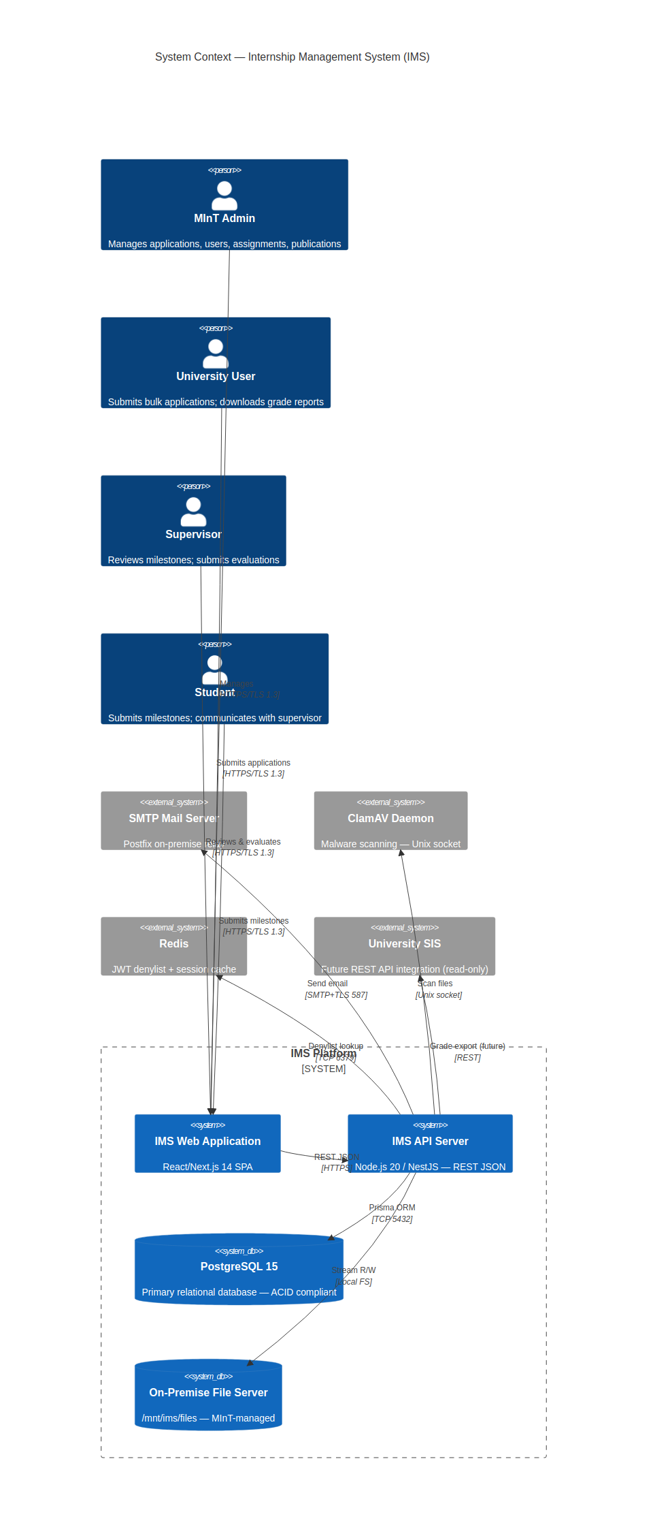
⚑ All IMS infrastructure — database, file storage, SMTP relay — MUST reside within Ethiopia (NFR-DAT-001). No PII transits foreign servers.

2.2 System Functions Summary
# | System Function | Primary Actor | Module | Priority
F-01 | Bulk internship application submission (up to 50 students) with document upload | University User | MOD-APP | High
F-02 | Individual student application review, approval, rejection, and hold management | MInT Admin | MOD-REV | High
F-03 | Automatic student account provisioning upon per-student approval | System (Auto) | MOD-AUTH | High
F-04 | Supervisor assignment with workload enforcement (max 10 students) | MInT Admin | MOD-SUP | High
F-05 | Student internship dashboard — tasks, milestones, supervisor contact | Student | MOD-STU | High
F-06 | Milestone creation and student submission workflow | Student | MOD-MIL | High
F-07 | Supervisor milestone review — accept, request revision, reject | Supervisor | MOD-MIL | High
F-08 | Attendance percentage tracking (supervisor-entered per student) | Supervisor | MOD-ATT | Medium
F-09 | Monthly progress report submission and supervisor review | Student/Supervisor | MOD-RPT | Medium
F-10 | Formal final evaluation (score, grade, remarks) — supervisor submits | Supervisor | MOD-EVAL | High
F-11 | Evaluation review and official grade publication | MInT Admin | MOD-EVAL | High
F-12 | Official PDF/CSV grade report download | University User | MOD-RPT | High
F-13 | Internal messaging between student and assigned supervisor | Student/Supervisor | MOD-MSG | High
F-14 | Automated in-system and email notifications for all key events | System (Auto) | MOD-NOT | High
F-15 | User account, university, and system configuration management | MInT Admin | MOD-ADM | High
F-16 | Immutable audit logging and administrative reporting | System/Admin | MOD-AUD | High

2.3 Internship Lifecycle Workflow
The system orchestrates the following sequential workflow, governed by state machines defined in Section 4.7:
- Step 1 — University submits a bulk application (1–50 students) with a single cover letter and per-student academic documents.
- Step 2 — MInT Admin reviews each student individually. Per-student decisions: Approve / Reject / Hold.
- Step 3 — On approval, the system auto-creates an internship record and provisions a student user account; credentials are emailed.
- Step 4 — Admin assigns an available MInT Supervisor to the student's internship (enforcing max 10 active students per supervisor).
- Step 5 — Supervisor creates milestones (tasks/deliverables). Student submits milestone responses.
- Step 6 — Supervisor reviews submissions: Accept / Request Revision / Reject. Student may revise and resubmit.
- Step 7 — Student submits monthly progress reports. Supervisor reviews and approves.
- Step 8 — Supervisor records attendance percentage.
- Step 9 — On internship completion, supervisor submits formal evaluation (score 0–100, letter grade A–F, narrative remarks).
- Step 10 — Admin reviews and publishes evaluation. University User and Student are notified. Grade report available for download.

2.4 User Classes and Design Implications
Role | Constant | Est. Volume | Key Design Consideration
System Administrator | ROLE_ADMIN | 5–10 | Full CRUD all entities; audit visibility; system config; grade publication authority
University User | ROLE_UNIVERSITY | 50–100 | Scoped to own institution; bulk application submission (up to 50/batch); grade report download
Internship Supervisor | ROLE_SUPERVISOR | 100–200 | Scoped to assigned students only; max 10 active; milestone + attendance + evaluation write access
Student | ROLE_STUDENT | 500–1,000 | Auto-provisioned on approval; scoped to own record; milestone submissions; read-only evaluation

3. Design Considerations

3.1 Design Constraints
ID | Constraint | Design Impact
CON-001 | Deployment exclusively on MInT-managed Ethiopia-based infrastructure | On-premise only; no cloud provider APIs in critical path; stateless API supports future HA
CON-002 | All data and documents must reside on MInT-controlled storage within Ethiopia | FileStorageService abstraction; no S3/GCS integration without ministerial authorization
CON-003 | Technology stack: React/Next.js, Node.js, PostgreSQL (MInT-IMS-PLAN-2026) | NestJS selected for Node.js framework; Prisma ORM for PostgreSQL; fixed per project plan
CON-004 | File uploads: PDF/DOCX only, maximum 10 MB per file | MIME magic-byte validation + Multer size guard; ClamAV scan before storage
CON-005 | Browser support: Chrome, Firefox, Edge (latest 2 major versions), 1280x720+ | Web-only delivery; responsive design; no mobile-first required for v1.0
CON-006 | INSA government IT security guidelines compliance mandatory | Formal security assessment required before production deployment
CON-007 | Passwords: bcrypt, minimum cost factor 12; no plaintext ever stored or transmitted | Auth module enforces at all code paths; config externalized in .env
CON-008 | JWT server-side invalidation on logout mandatory (NFR-SEC-007) | Redis-backed token denylist; JTI checked in JwtAuthGuard before role validation
CON-009 | Database: PostgreSQL 15 (upgraded from v14 in DDD v1.0 specification) | Full ACID compliance; partial unique index for single active internship rule

3.2 Assumptions
ID | Assumption | Design Response
ASM-001 | Universities have designated trained personnel as University Users | Onboarding UX designed for basic proficiency; Amharic secondary language support
ASM-002 | Bulk applications contain 1–50 students per submission | application_students junction table; batch processing in ApplicationService
ASM-003 | Students have active institutional email addresses | Email used as unique login identifier; uniqueness enforced at DB level
ASM-004 | MInT IT provisions and maintains server infrastructure for full operational life | All configuration externalized in .env; infrastructure-as-documented approach
ASM-005 | Universities are solely responsible for verifying student document authenticity | System stores metadata and path references; document integrity is submitter's responsibility
ASM-006 | ClamAV daemon is installed and operational on the application server | ClamAVService fails securely — scan ERROR treated as INFECTED
ASM-007 | Redis is available on the same server for JWT denylist operations | TokenDenylistService has PostgreSQL fallback if Redis is unavailable at startup
ASM-008 | Supervisor assignment is a manual admin decision; hints are advisory only | Department-matching hint UI; no auto-assignment engine implemented

3.3 Design Trade-offs and Rationale

3.3.1 NestJS over Express.js
NestJS (built on Express.js) is selected as the Node.js framework. NestJS provides a modular, opinionated architecture with built-in dependency injection, guard-based RBAC, ValidationPipe, and Interceptors. This directly satisfies NFR-MNT-001 (modular architecture) and reduces security defect surface area through enforced patterns. Express compatibility ensures full alignment with CON-003.

3.3.2 Prisma ORM over Raw SQL / TypeORM
Prisma ORM is used for all database interactions. Prisma provides full type-safety, automatic migration management via prisma migrate, and native prevention of N+1 queries through its include/select API. This satisfies NFR-SCA-002 (schema optimization for 50,000+ records). The Prisma schema serves as the single source of truth for all database entity definitions, directly referencing IMS-DDD-001.

3.3.3 Integer SERIAL PKs (Aligned with DDD v1.0)
Following the DDD v1.0 specification, all primary keys use PostgreSQL SERIAL (auto-incrementing integer) rather than UUID v4. This provides smaller index sizes, faster joins, and simpler foreign key references while still satisfying all uniqueness requirements within the system. External API responses that should not expose internal IDs will use opaque reference tokens where needed.

3.3.4 Bulk Application Model
The system supports a bulk application model (up to 50 students per university submission), implemented via the applications → application_students junction table pattern. This reflects the actual MInT procurement workflow where universities submit batch requests. The applications table represents the cover-level submission; application_students represents per-student review decisions within that batch.

3.3.5 Separate internships Table
The internships table is a distinct entity separate from applications and assignments. This design (from DDD v1.0) cleanly separates the approval lifecycle (applications) from the execution lifecycle (internships) and the supervision assignment (assignments). It enables historical internship records to persist independently of the original application and its supervisor assignment history.

3.3.6 Redis JWT Denylist
JWT logout invalidation uses a Redis-backed denylist (O(1) lookup). The denylist entry TTL matches the token's remaining validity period for automatic cleanup. NFR-SEC-007 mandates server-side invalidation; a pure short-lived token approach cannot satisfy immediate revocation. A PostgreSQL-backed fallback table (token_denylist) is maintained as a fallback when Redis is unavailable.

4. Architectural Design

4.1 Architectural Style
The IMS employs a Three-Tier Layered Architecture: Presentation Tier (React/Next.js 14 SPA), Application Tier (Node.js 20/NestJS Modular Monolith), and Data Tier (PostgreSQL 15 + On-Premise File Storage). Within the Application Tier, a Modular Monolith pattern organizes eleven independent NestJS feature modules communicating through well-defined internal service interfaces. This pattern enables future microservice decomposition if scale demands it while keeping operational complexity low for the initial on-premise deployment.

4.2 System Architecture Diagram (Mermaid)
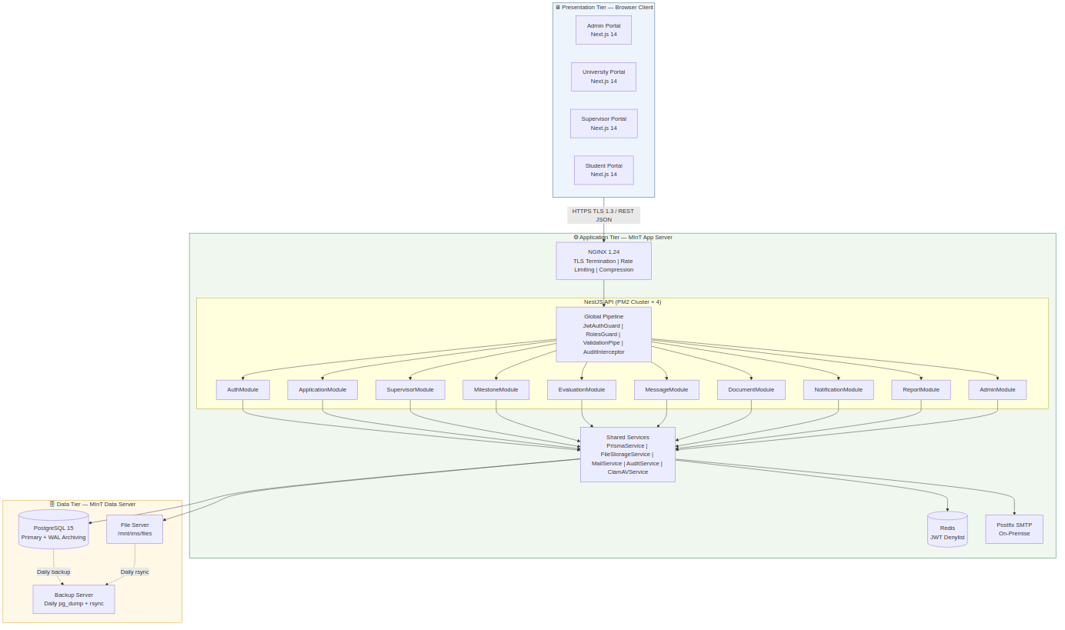

4.3 Use Case Diagram (Mermaid)
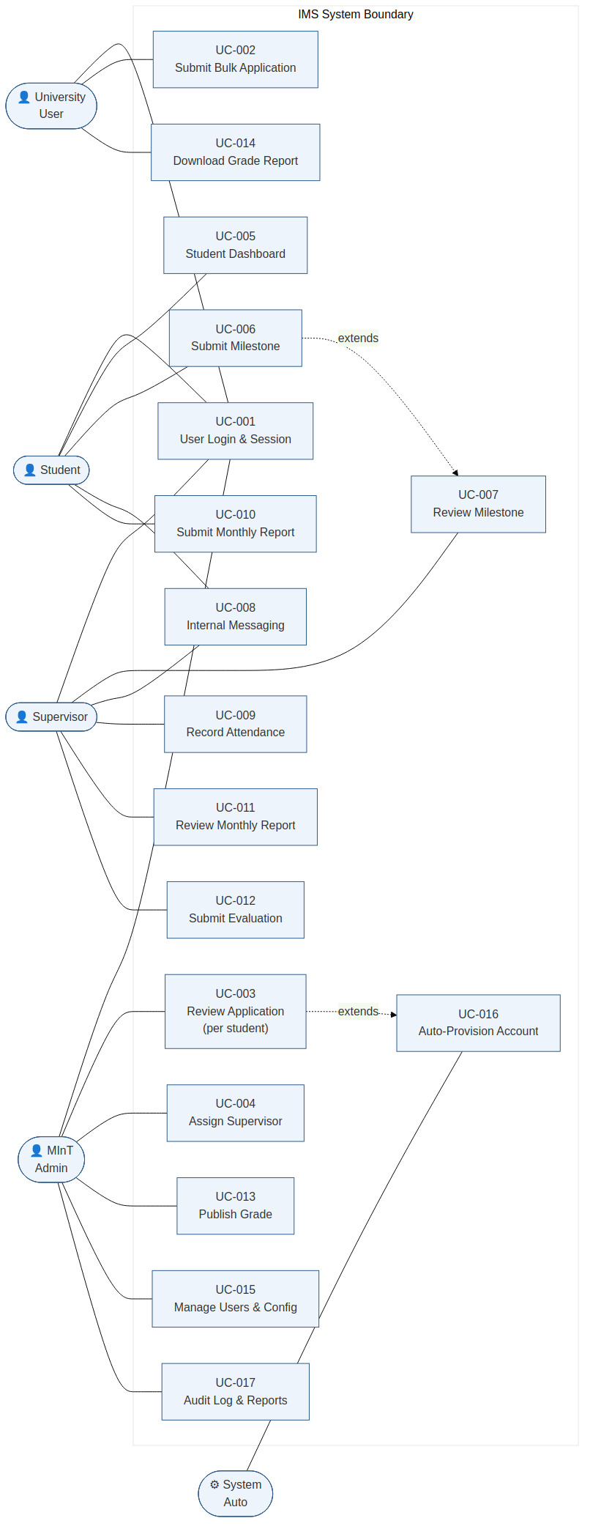

4.4 Sequence Diagrams

4.4.1 UC-002: Bulk Application Submission
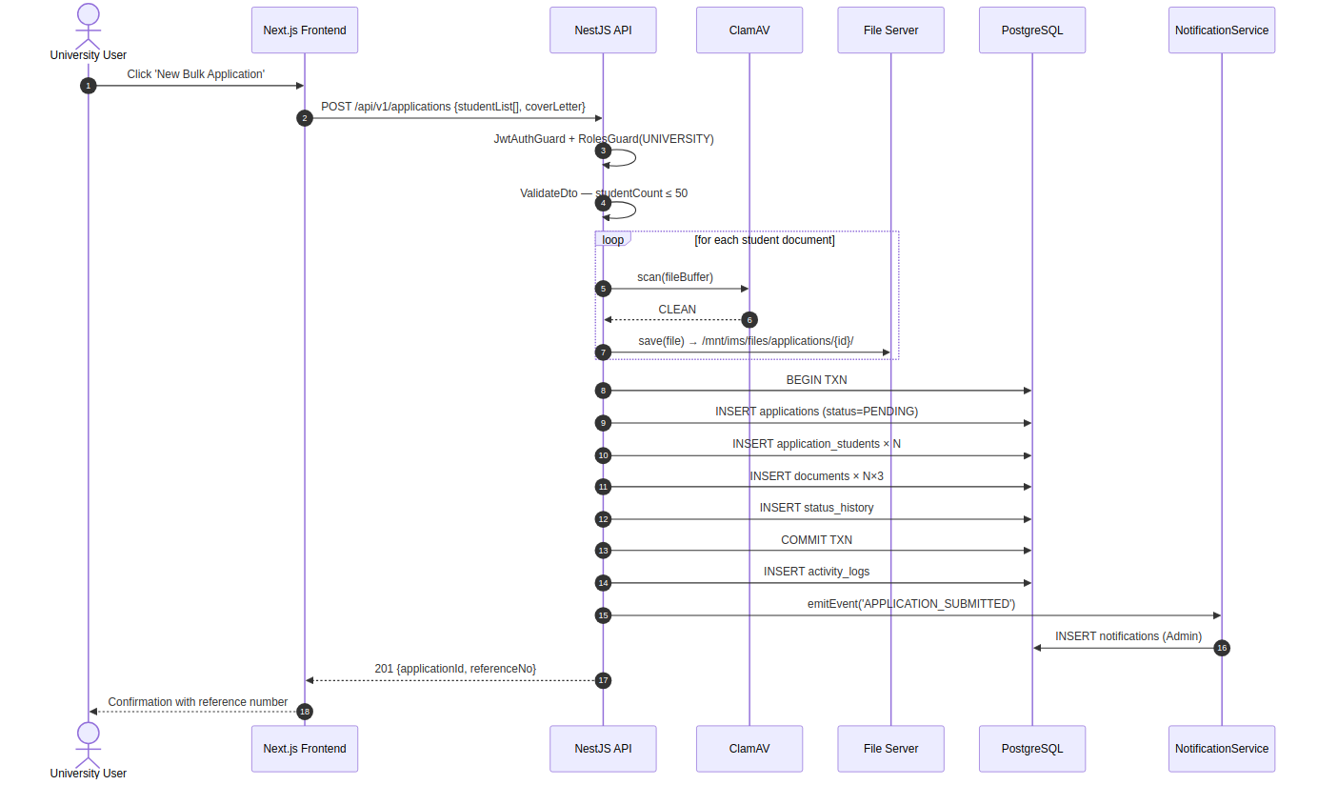

4.4.2 UC-003: Admin Approves Per-Student Application
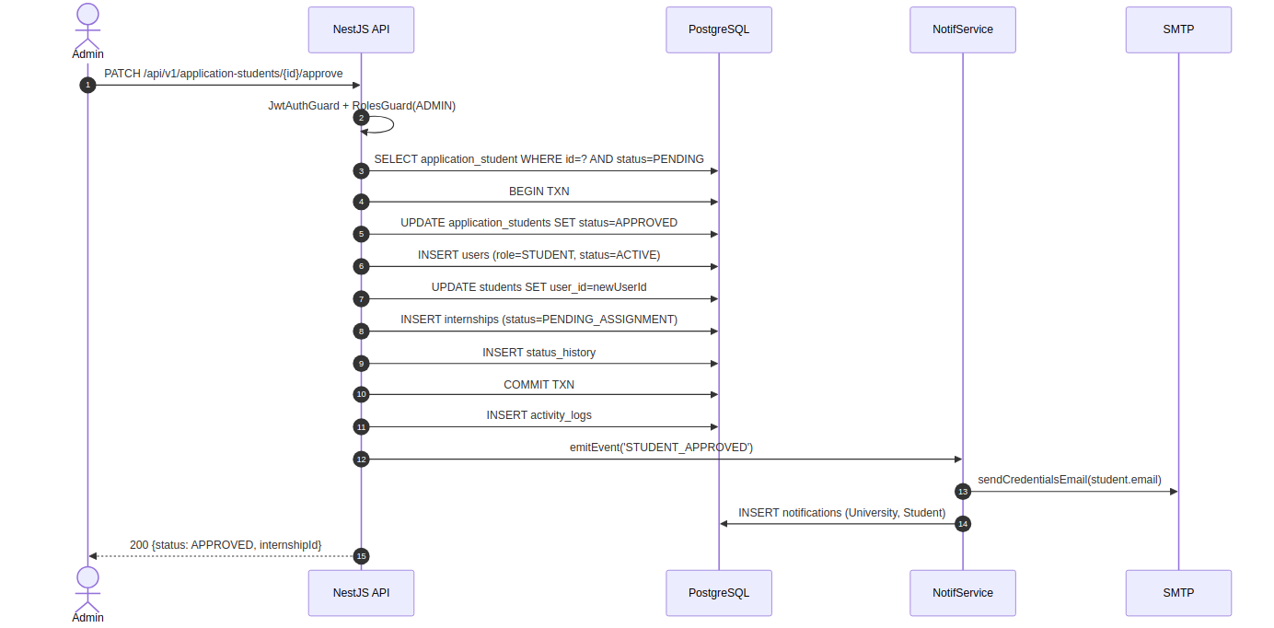

4.4.3 UC-006/007: Milestone Submission and Review
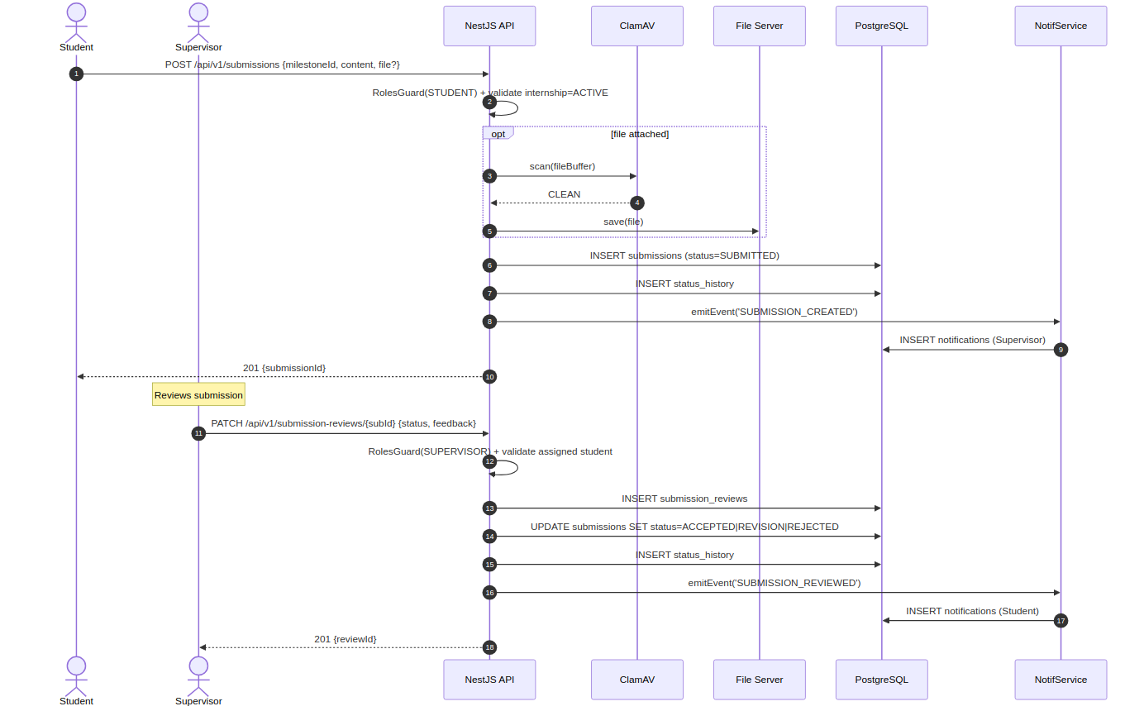

4.4.4 UC-012/013: Evaluation Submission and Grade Publication
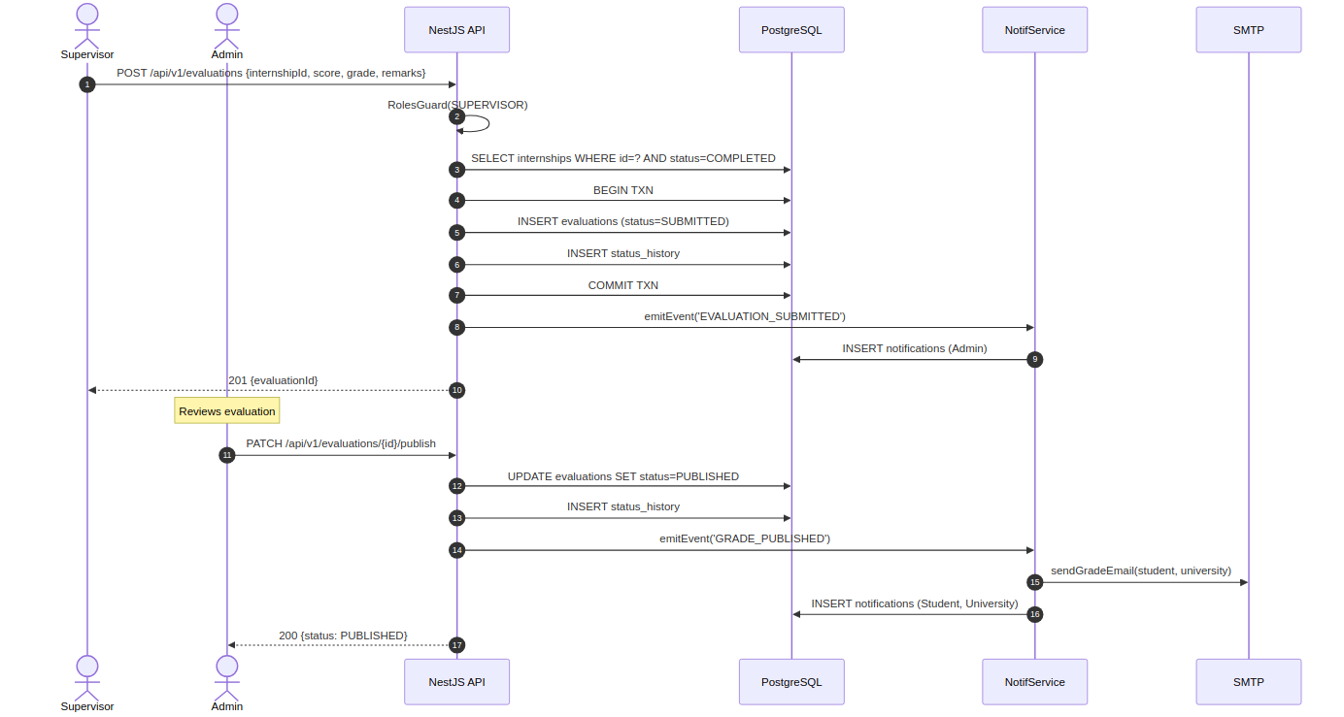

4.5 Class Diagram — Core Domain Model (Mermaid)
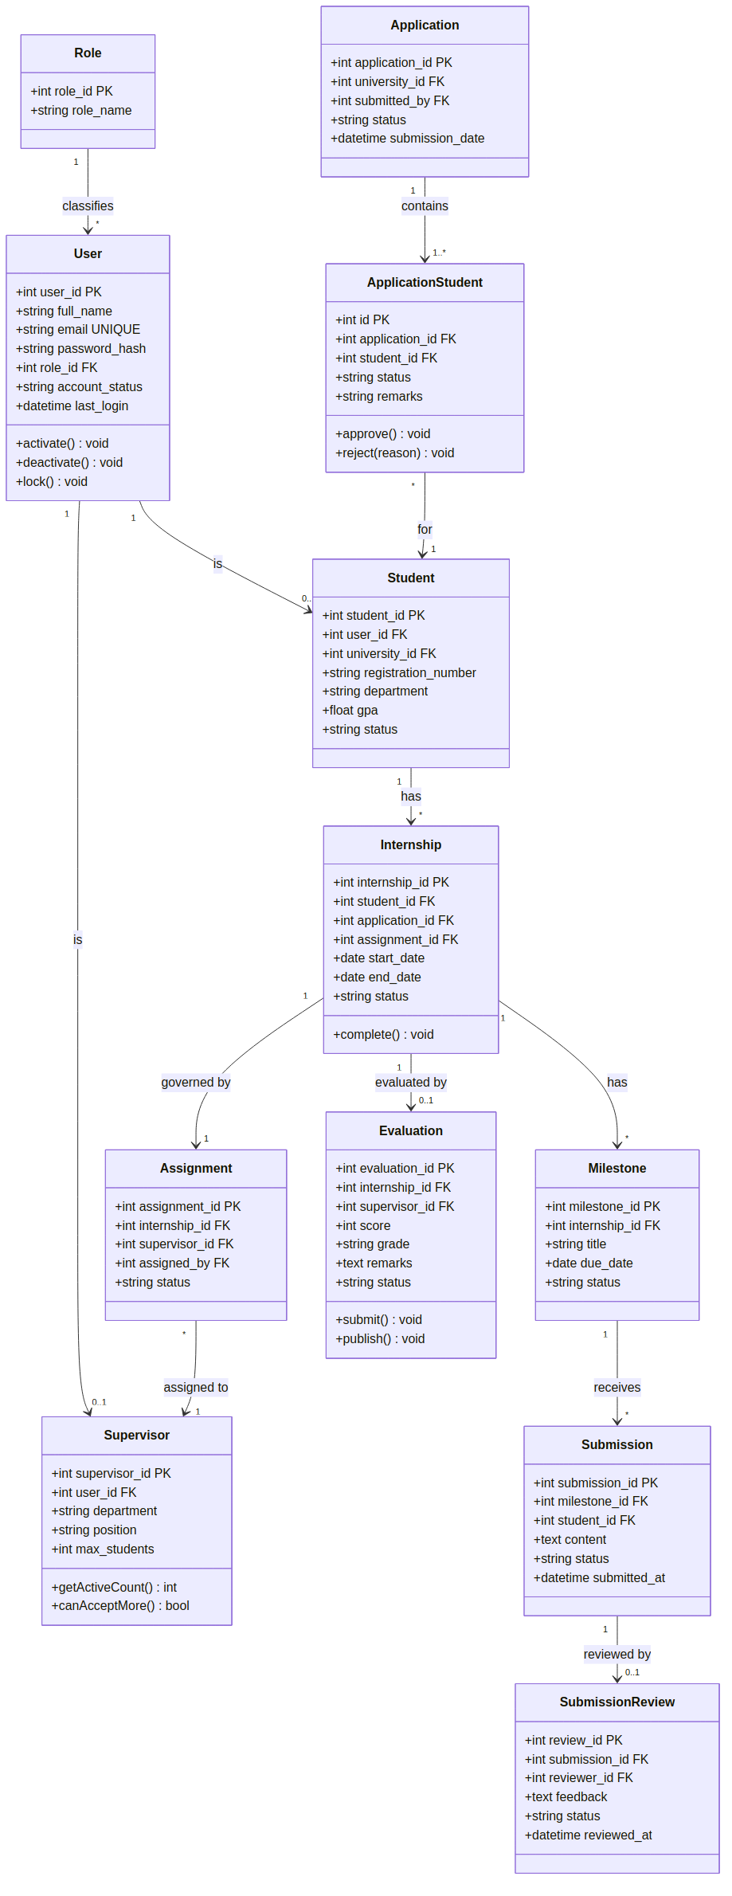

4.6 Component Diagram (Mermaid)
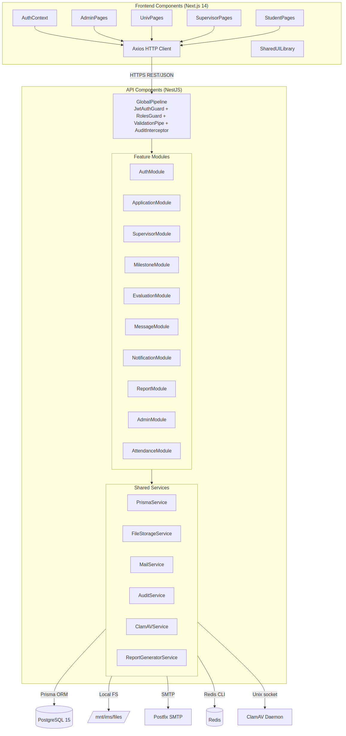

4.7 State Machine Diagrams

4.7.1 Application Student State Machine
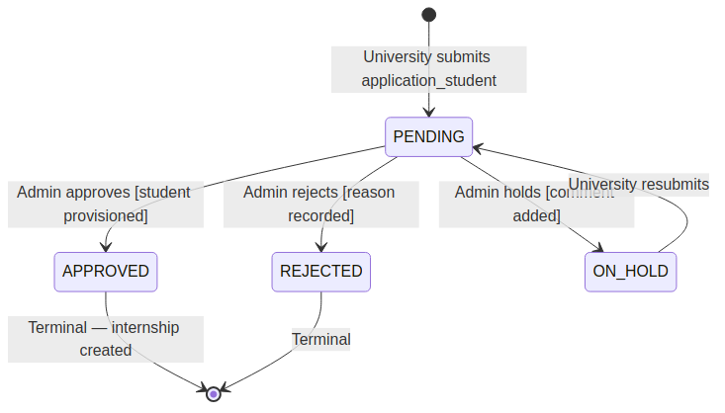

4.7.2 Internship State Machine
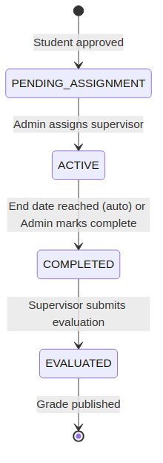

4.7.3 Submission (Milestone Response) State Machine
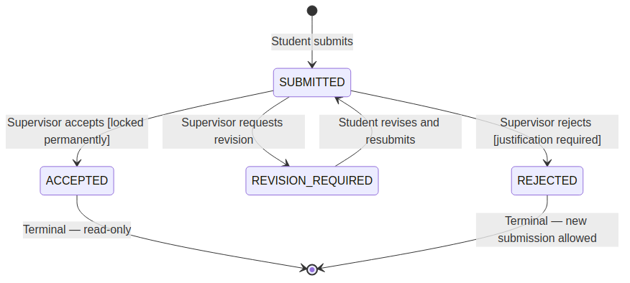

4.7.4 Evaluation State Machine
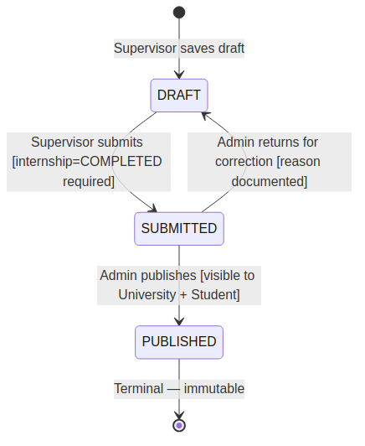

5. Data Design

5.1 Data Architecture Overview
The IMS data tier consists of a PostgreSQL 15 relational database containing 22 primary tables organized across eleven functional layers, plus an on-premise Linux file server for binary document storage. The database is designed in Third Normal Form (3NF) per IMS-DDD-001 §2.2.1, eliminating all data redundancy while preserving full relational integrity.
All database access from the API tier is performed through Prisma ORM. The Prisma schema file (schema.prisma) is the authoritative source of truth for all table definitions and is kept in strict alignment with IMS-DDD-001 v1.0. Native SQL is used only for complex analytical report queries via prisma.$queryRaw with full parameterization.

5.2 Entity-Relationship Diagram (Mermaid)
The following Mermaid ER diagram covers all 22 entities from IMS-DDD-001. Render in any Mermaid-compatible tool.
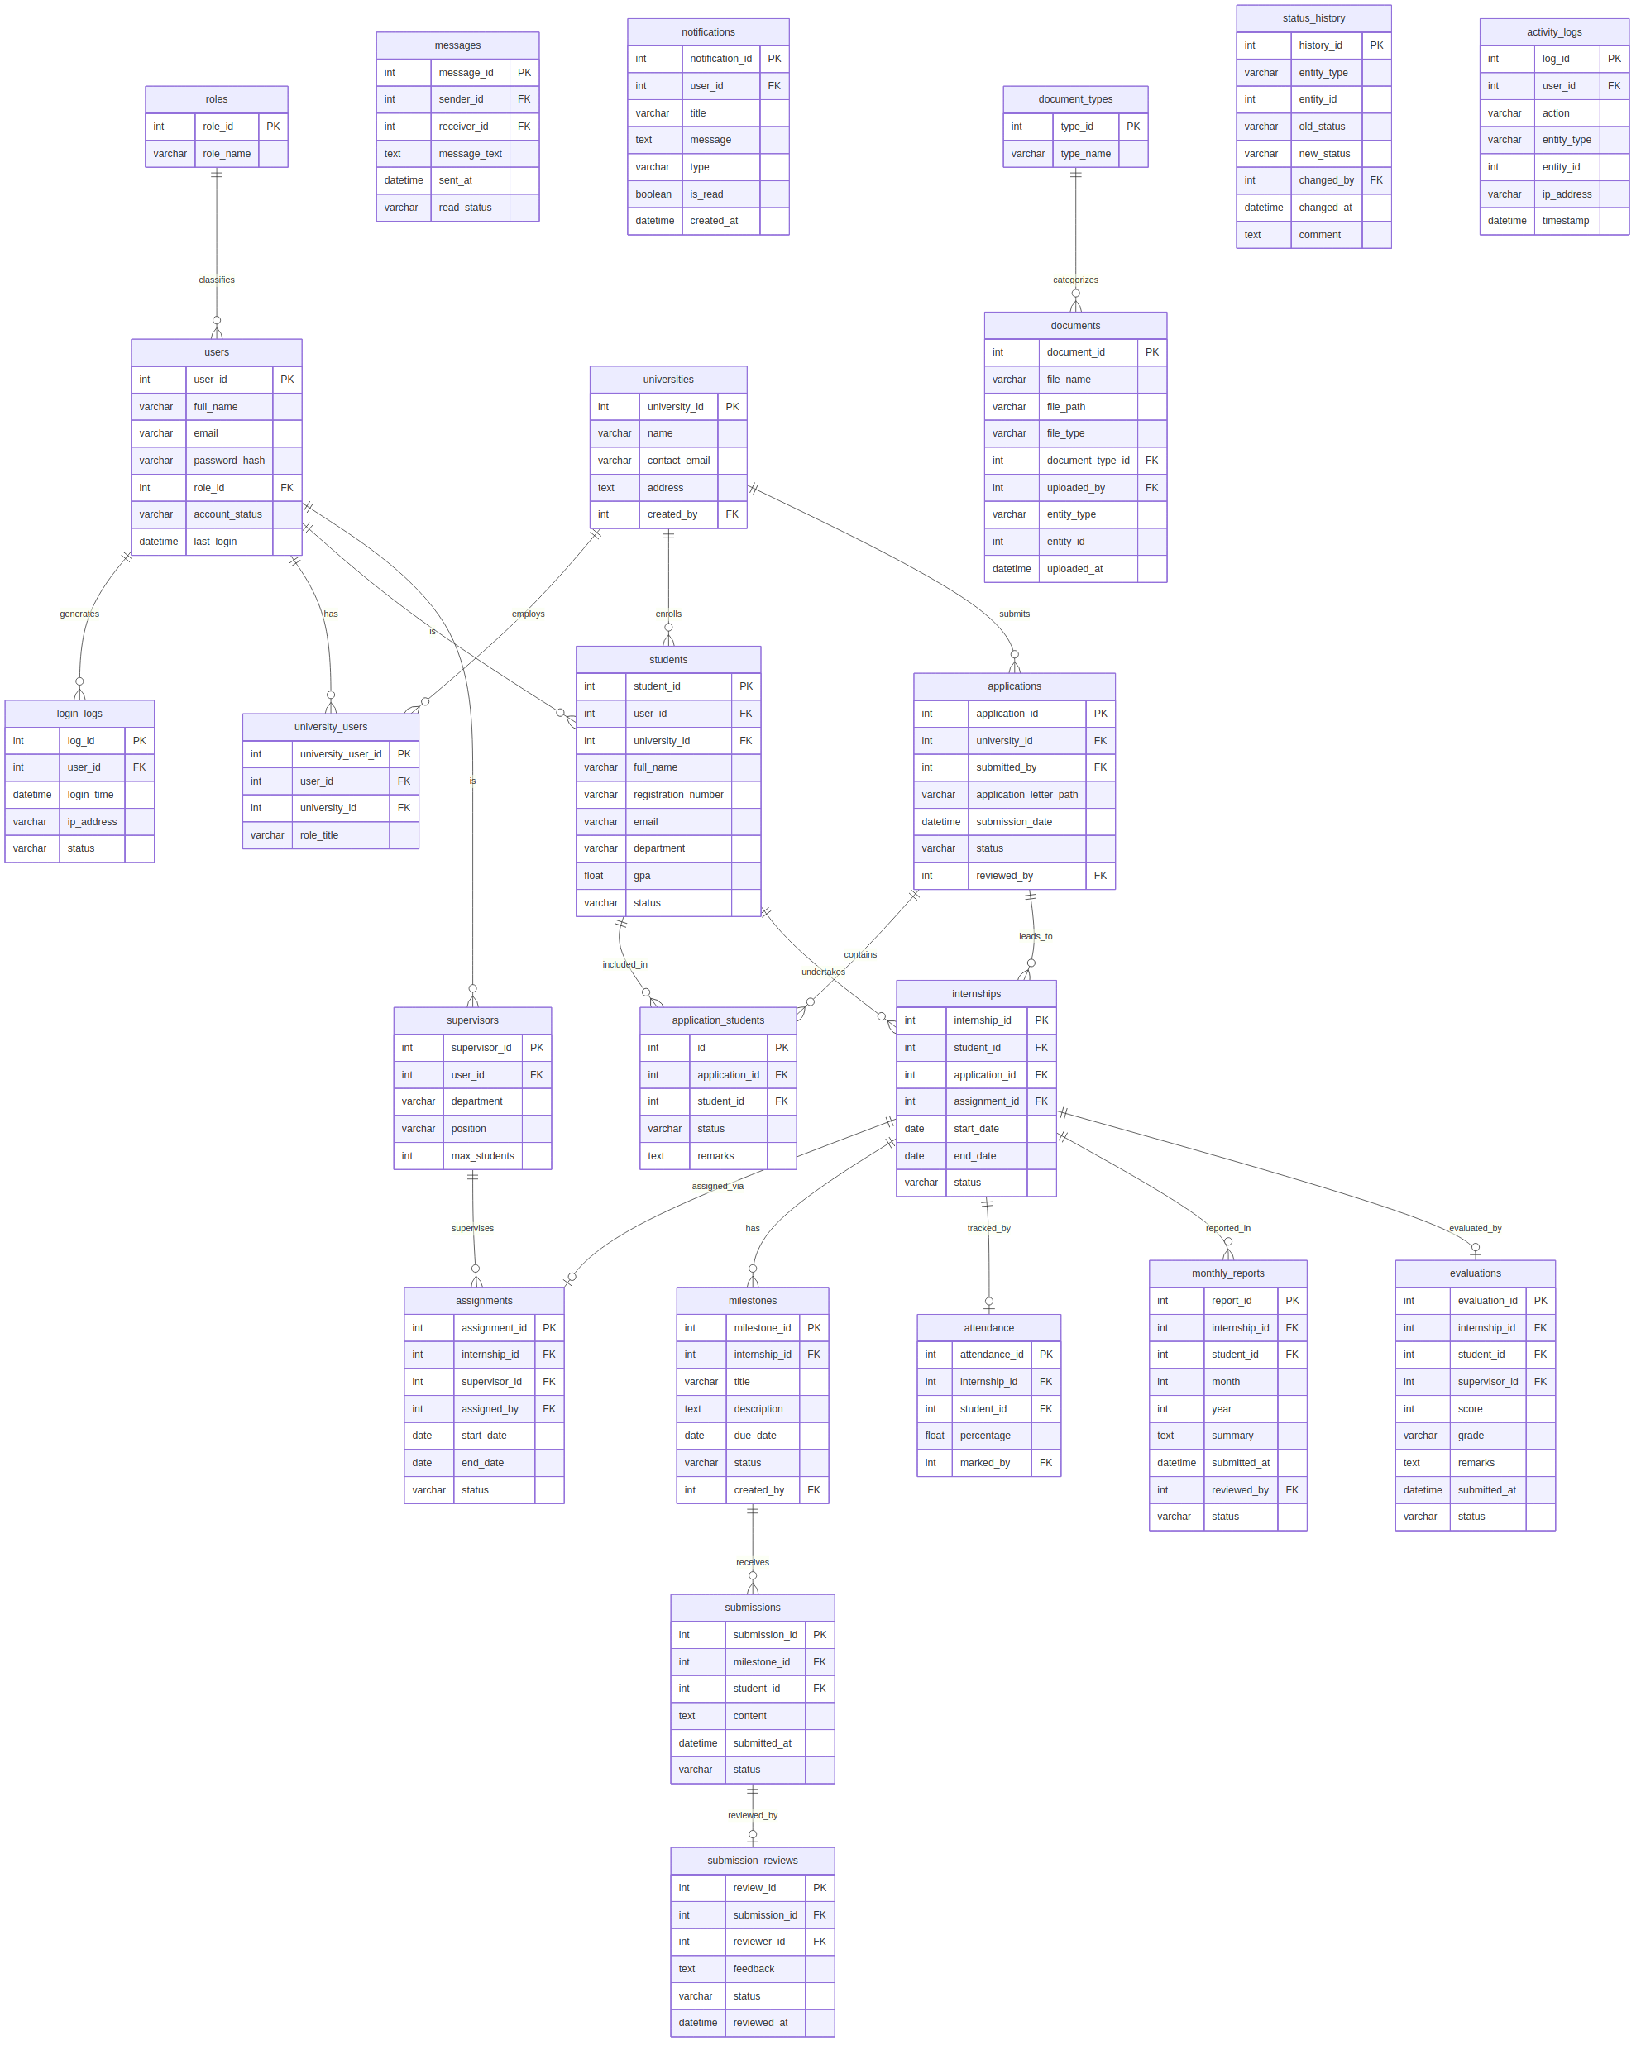

5.3 Database Layer Specifications

5.3.1 Identity and Access Layer
Table | PK | Key FK(s) | Purpose
roles | role_id SERIAL | — | Defines 4 system roles: Admin, University, Supervisor, Student
users | user_id SERIAL | role_id → roles | Central auth table for all actors; single source of identity regardless of role
login_logs | log_id SERIAL | user_id → users | Security audit: all login attempts (success/fail/lockout) with IP and timestamp

5.3.2 Organization Layer
Table | PK | Key FK(s) | Purpose
universities | university_id SERIAL | created_by → users | Registered Ethiopian universities participating in MInT programme
university_users | university_user_id SERIAL | user_id, university_id | Maps university staff (ROLE_UNIVERSITY) to their institution; supports multiple coordinators

5.3.3 Internship Core Layer
Table | PK | Key FK(s) | Critical Constraint
applications | application_id SERIAL | university_id, submitted_by, reviewed_by | Bulk application record; 1–50 students per submission
application_students | id SERIAL | application_id, student_id | Per-student review junction; individual approve/reject within batch
internships | internship_id SERIAL | student_id, application_id, assignment_id | Central lifecycle entity; PARTIAL UNIQUE INDEX: (student_id) WHERE status='ACTIVE'

5.3.4 Supervision Layer
Table | PK | Key FK(s) | Critical Constraint
supervisors | supervisor_id SERIAL | user_id → users | max_students INT DEFAULT 10 — enforced at application layer
assignments | assignment_id SERIAL | internship_id, supervisor_id, assigned_by | Links supervisor to internship; app-layer count check before INSERT

5.3.5 Execution, Attendance, and Reporting Layer
Table | PK | Key FK(s) | Purpose
milestones | milestone_id SERIAL | internship_id, created_by | Tasks/deliverables defined by supervisor; has due_date
submissions | submission_id SERIAL | milestone_id, student_id | Student response to a milestone; text content + optional document
submission_reviews | review_id SERIAL | submission_id, reviewer_id | Supervisor review record; feedback and status per submission
attendance | attendance_id SERIAL | internship_id, student_id, marked_by | Attendance % per internship; supervisor-entered; CHECK percentage 0–100
monthly_reports | report_id SERIAL | internship_id, student_id, reviewed_by | Monthly progress summaries submitted by students, reviewed by supervisors

5.3.6 Evaluation, Communication, Document, and Audit Layers
Table | PK | Key FK(s) | Purpose / Critical Constraint
evaluations | evaluation_id SERIAL | internship_id, student_id, supervisor_id | Final score (0–100) + grade (A–F) + remarks; requires internship=COMPLETED
messages | message_id SERIAL | sender_id, receiver_id (→ users) | Internal messaging; scoped to student-supervisor pairs by application layer
notifications | notification_id SERIAL | user_id → users | In-system notifications; is_read boolean; retained 90+ days
document_types | type_id SERIAL | — | Reference table: transcript, cover_letter, recommendation, milestone_attachment, report
documents | document_id SERIAL | document_type_id, uploaded_by, entity_id | Polymorphic document reference; entity_type + entity_id link to application/internship/submission
status_history | history_id SERIAL | changed_by → users | Immutable audit of every status transition for any entity; append-only
activity_logs | log_id SERIAL | user_id → users | Immutable actor-action-entity-IP log; REVOKE UPDATE/DELETE on table

5.4 Critical Database Integrity Constraints
Constraint | SQL / Implementation | SRS/DDD Reference
Single active internship per student | CREATE UNIQUE INDEX uq_student_active_internship ON internships(student_id) WHERE status='ACTIVE'; | DDD §5.6.3; SRS §9.3
Supervisor workload enforcement | SELECT COUNT(*) ... WHERE supervisor_id=? AND status='ACTIVE' FOR UPDATE; app-layer check < max_students | DDD §5.6.2; SRS FR-SUP-007
Evaluation requires completed internship | API precondition: SELECT internship WHERE id=? AND status='COMPLETED' before INSERT evaluations | DDD §5.6; SRS FR-EVAL-001
Accepted submission is immutable | DB trigger: BEFORE UPDATE ON submissions — RAISE if OLD.status='ACCEPTED' | SRS FR-MIL-004
Activity/audit logs append-only | REVOKE UPDATE, DELETE ON activity_logs, status_history FROM api_role | SRS NFR-SEC-008, FR-RPT-003
Bulk application student limit | CHECK (batch_size <= 50) at application service layer; documented in DDD §5.6.1 | DDD §5.6.1
Attendance percentage range | CHECK (percentage >= 0 AND percentage <= 100) on attendance table | DDD §5.4
Score range on evaluation | CHECK (score >= 0 AND score <= 100) on evaluations table | DDD §5.4
Password hash only | bcrypt(password, 12) in AuthService; DB column: NOT NULL, NOT exposed in API responses | SRS NFR-SEC-003

5.5 Indexing Strategy
Index | Type | Justification
users(email) | UNIQUE B-Tree | Login lookup — most frequent query system-wide
login_logs(user_id, login_time) | Composite B-Tree | Failed login count within 15-minute window
students(university_id) | B-Tree | Filter students by institution (ROLE_UNIVERSITY scoping)
students(user_id) | UNIQUE B-Tree | One-to-one user ↔ student after provisioning
internships(student_id) WHERE status='ACTIVE' | PARTIAL UNIQUE | Single active internship constraint (critical)
assignments(supervisor_id, status) | Composite B-Tree | Workload count for supervisor; load enforcement
milestones(internship_id) | B-Tree | Milestone list per internship
submissions(milestone_id, submitted_at) | Composite B-Tree | Submission history per milestone, ordered
monthly_reports(internship_id, year, month) | Composite B-Tree | Monthly report lookup; prevent duplicate month/year
evaluations(internship_id) | UNIQUE B-Tree | One evaluation per internship
activity_logs(user_id, timestamp) | Composite B-Tree | Audit log search by actor and date range
activity_logs(entity_type, entity_id) | Composite B-Tree | Audit log search by affected entity
notifications(user_id, is_read) | Composite B-Tree | Unread notification count per user
documents(entity_type, entity_id) | Composite B-Tree | Document list per owning entity
status_history(entity_type, entity_id) | Composite B-Tree | Status history per entity (audit trail)

5.6 File Storage Design
All uploaded files are stored on the MInT on-premise Linux file server following a structured directory hierarchy. Files are never served directly by the web server; all access is mediated by FileStorageService.getSecureStream() which validates RBAC permissions before streaming the file.
/mnt/ims/files/
├── applications/
│ └── {application_id}/
│ ├── cover_letter_{uuid}.pdf
│ └── students/
│ └── {student_id}/
│ ├── transcript_{uuid}.pdf
│ ├── request_letter_{uuid}.pdf
│ └── recommendation_{uuid}.pdf
├── submissions/
│ └── {submission_id}/
│ └── attachment_{uuid}.pdf
├── monthly_reports/
│ └── {internship_id}/{year}_{month}_{uuid}.pdf
└── reports/generated/
└── grade_report_{internship_id}_{timestamp}.pdf

6. Component Design

6.1 Module Architecture Overview
The NestJS backend is organized into eleven feature modules following the single-responsibility principle. Each module contains: Controller (HTTP routing only), Service (business logic + state machine enforcement), Prisma Repository calls (via injected PrismaService), DTOs (class-validator decorated input/output shapes), and Module definition (explicit imports/exports for DI). Circular dependencies between modules are architecturally prohibited.

6.2 AuthModule

6.2.1 Responsibilities
- User login: credential lookup → bcrypt.compare() → JWT issuance (RS256, configurable TTL default 60 min)
- Logout: extract JTI from token → Redis SETEX (JTI, remaining_ttl, 'invalid')
- Account lockout: track failed_login_count via login_logs; lock after 5 failures in 15 min (configurable)
- Password reset: time-limited single-use HMAC token (60 min expiry); sent via MailService
- JWT validation: JwtStrategy decodes RS256 token → checks TokenDenylistService → loads user from DB

6.2.2 Token Security Design
RS256 private key loaded from JWT_PRIVATE_KEY_PATH environment variable at startup. Public key used by JwtStrategy passport strategy. Token payload: { sub: userId, role: roleEnum, jti: uuid, iat, exp }. The JTI is stored in Redis on logout with TTL = token.exp - now(). JwtAuthGuard checks Redis HSET before any business logic. PostgreSQL fallback table token_denylist maintains records when Redis is unavailable.

6.3 ApplicationModule

6.3.1 Responsibilities
- Bulk application submission: validate studentList.length ≤ 50; per-file ClamAV scan; atomic transaction: INSERT applications + application_students[] + documents[]
- Per-student review: approve (provisions user + internship) / reject (records reason) / hold (adds admin comment)
- Review queue: paginated, filterable by university, status, submission date for Admin dashboard
- State machine enforcement: StateTransitionValidator.validate(currentStatus, newStatus, actorRole)

6.3.2 Student Provisioning Sequence (within Approve transaction)
- UPDATE application_students SET status='APPROVED'
- INSERT users (role_id=STUDENT, account_status=ACTIVE, password=bcrypt(tempPassword))
- UPDATE students SET user_id=newUserId, status=ACTIVE
- INSERT internships (student_id, application_id, status=PENDING_ASSIGNMENT)
- INSERT status_history entries
- COMMIT; then emit StudentApprovedEvent → MailService.sendCredentials()

6.4 SupervisorModule

6.4.1 Responsibilities and Workload Enforcement
- Assignment creation: SELECT COUNT(*) FROM assignments WHERE supervisor_id=? AND status='ACTIVE' FOR UPDATE — if ≥ max_students THROW 422
- Reassignment: deactivate current assignment; create new; log both transitions in status_history
- Internship completion: scheduled cron (@Cron every night EAT) checks internships WHERE end_date < NOW() AND status='ACTIVE' → UPDATE status='COMPLETED'

6.5 MilestoneModule

6.5.1 Milestone and Submission Design
- Milestones: supervisor creates tasks with title, description, due_date; linked to internship_id
- Submissions: student response to milestone (text content + optional file attachment via DocumentModule)
- Submission reviews: supervisor review record with feedback and status (ACCEPTED/REVISION_REQUIRED/REJECTED)
- Accepted submission immutability: DB trigger BEFORE UPDATE raises exception if submissions.status='ACCEPTED'
- All status transitions recorded in status_history table for full audit trail

6.6 AttendanceModule
- Supervisor records attendance percentage (0–100) per student per internship
- CHECK constraint enforced at DB level: percentage >= 0 AND percentage <= 100
- Single attendance record per internship; UPDATE if record exists; INSERT on first entry
- Attendance data included in evaluation context and grade report PDF

6.7 EvaluationModule

6.7.1 Evaluation Form Design
- Precondition: internship.status MUST be 'COMPLETED' before evaluation INSERT is accepted
- Fields: score INT (0–100), grade ENUM(A,B,C,D,F), remarks TEXT (min 100 chars), status ENUM(DRAFT,SUBMITTED,PUBLISHED)
- Draft → Submitted: supervisor confirms; Admin notification emitted
- Submitted → Published: Admin action; university + student notifications sent; grade email via MailService
- Published → immutable: no UPDATE permitted after publish; returns HTTP 409 if attempted

6.8 NotificationModule (Event-Driven)
Notifications are event-driven using NestJS EventEmitter2. Feature modules emit typed events; NotificationListener subscribes to all types and performs: (1) INSERT into notifications table, and (2) for critical events, delegate to MailService.sendTemplatedEmail().
Event | In-System | Email | Admin Notif | FR Reference
APPLICATION_SUBMITTED | YES | NO | YES | FR-APP-008
STUDENT_APPROVED (credentials) | YES | YES | NO | FR-ACCT-003
STUDENT_REJECTED | YES | YES | NO | FR-REV-004
APPLICATION_ON_HOLD | YES | NO | NO | FR-REV-005
SUPERVISOR_ASSIGNED | YES | NO | NO | FR-SUP-004
SUBMISSION_REVIEWED (any status) | YES | NO | NO | FR-MIL-008
MONTHLY_REPORT_REVIEWED | YES | NO | NO | FR-RPT-009
EVALUATION_SUBMITTED (Admin) | YES | NO | YES | FR-EVAL-004
GRADE_PUBLISHED | YES | YES | NO | FR-EVAL-005

6.9 Frontend Component Architecture

6.9.1 Role-Scoped Portal Pages
Four portal areas are implemented as Next.js /pages sub-directories: /admin, /university, /supervisor, /student. A withAuth(requiredRole) higher-order component wraps every page: it reads the JWT from sessionStorage, decodes the role claim, and redirects to /login if insufficient. JWT is never stored in localStorage (XSS risk).

6.9.2 Shared Component Library
- BulkApplicationForm: multi-step wizard with student roster management (add/remove rows up to 50), per-student file upload slots
- DataTable: sortable, paginated, filterable with export-to-CSV option
- FileUpload: drag-and-drop + click; client-side MIME + size pre-check (mirrors API validation)
- StatusBadge: color-coded chip for all entity status values (PENDING=amber, APPROVED=green, REJECTED=red, etc.)
- MilestoneBoard: Kanban-style view of milestones grouped by status for supervisor overview
- EvaluationForm: numeric score slider (0–100), letter grade dropdown, narrative textarea with character counter
- AttendanceInput: percentage numeric input with 0–100 constraint, save confirmation
- MonthlyReportForm: month/year selector, summary textarea, file attachment option
- NotificationBell: real-time unread count via polling (30-second interval); dropdown with read/unread management

7. Interface Design

7.1 API Design Principles
All API endpoints follow RESTful conventions with base path /api/v1. Authentication uses Authorization: Bearer <JWT> header on all protected routes. All responses use a consistent JSON envelope: { success: boolean, data: T | null, message: string, statusCode: number }. Pagination responses include: { data, total, page, limit, totalPages }. All error responses include: { statusCode, message, error, field? } for validation errors.

7.2 Complete API Endpoint Inventory
Method | Endpoint | Roles Permitted | Description
POST | /api/v1/auth/login | Public | Authenticate; returns RS256 JWT
POST | /api/v1/auth/logout | All authenticated | Invalidate JWT (Redis denylist)
POST | /api/v1/auth/password-reset/request | Public | Request reset link via email
POST | /api/v1/auth/password-reset/confirm | Public | Confirm token + set new password
GET | /api/v1/auth/me | All | Current user profile
PATCH | /api/v1/auth/me/password | All | Change own password
GET | /api/v1/users | ADMIN | List all users (paginated + filterable)
POST | /api/v1/users | ADMIN | Create University/Supervisor account
GET | /api/v1/users/:id | ADMIN | Get user detail
PATCH | /api/v1/users/:id | ADMIN | Update user
PATCH | /api/v1/users/:id/status | ADMIN | Activate / Deactivate / Lock
GET | /api/v1/universities | ADMIN | List universities
POST | /api/v1/universities | ADMIN | Register new university
PATCH | /api/v1/universities/:id | ADMIN | Update university
GET | /api/v1/applications | ADMIN, UNIVERSITY | List applications (role-scoped)
POST | /api/v1/applications | UNIVERSITY | Submit bulk application with documents
GET | /api/v1/applications/:id | ADMIN, UNIVERSITY | Application detail + students
GET | /api/v1/application-students | ADMIN, UNIVERSITY | Per-student review list
PATCH | /api/v1/application-students/:id/approve | ADMIN | Approve student (provisions account)
PATCH | /api/v1/application-students/:id/reject | ADMIN | Reject student (reason required)
PATCH | /api/v1/application-students/:id/hold | ADMIN | Place student on hold with comment
GET | /api/v1/internships | ADMIN, SUPERVISOR, STUDENT | List internships (role-scoped)
GET | /api/v1/internships/:id | ADMIN, SUPERVISOR, STUDENT | Internship detail
PATCH | /api/v1/internships/:id/complete | ADMIN | Manually complete internship
GET | /api/v1/assignments | ADMIN, SUPERVISOR | List assignments
POST | /api/v1/assignments | ADMIN | Assign supervisor to internship
PATCH | /api/v1/assignments/:id/reassign | ADMIN | Reassign supervisor
GET | /api/v1/milestones | SUPERVISOR, STUDENT | List milestones for internship
POST | /api/v1/milestones | SUPERVISOR | Create milestone
PATCH | /api/v1/milestones/:id | SUPERVISOR | Update milestone
GET | /api/v1/submissions | SUPERVISOR, STUDENT | List submissions
POST | /api/v1/submissions | STUDENT | Submit response to milestone
PATCH | /api/v1/submissions/:id | STUDENT | Edit submission (not ACCEPTED)
POST | /api/v1/submission-reviews | SUPERVISOR | Create review for submission
GET | /api/v1/attendance | SUPERVISOR, ADMIN | Get attendance records
POST | /api/v1/attendance | SUPERVISOR | Record/update attendance %
GET | /api/v1/monthly-reports | SUPERVISOR, STUDENT, ADMIN | List monthly reports
POST | /api/v1/monthly-reports | STUDENT | Submit monthly report
PATCH | /api/v1/monthly-reports/:id/review | SUPERVISOR | Review monthly report
GET | /api/v1/evaluations | ADMIN, SUPERVISOR, STUDENT, UNIVERSITY | List (role-scoped)
POST | /api/v1/evaluations | SUPERVISOR | Submit evaluation (internship=COMPLETED req.)
PATCH | /api/v1/evaluations/:id | SUPERVISOR | Update draft evaluation
PATCH | /api/v1/evaluations/:id/publish | ADMIN | Publish grade (notifies all)
GET | /api/v1/evaluations/:id/report | ADMIN, UNIVERSITY | Download PDF grade report
GET | /api/v1/messages/:internshipId | SUPERVISOR, STUDENT | Get message thread
POST | /api/v1/messages/:internshipId | SUPERVISOR, STUDENT | Send message
POST | /api/v1/messages/broadcast | SUPERVISOR | Broadcast to all assigned students
GET | /api/v1/documents/:id | Role-scoped | Secure document stream
GET | /api/v1/notifications | All | Get own notifications
PATCH | /api/v1/notifications/read | All | Mark notification(s) as read
GET | /api/v1/reports/dashboard | ADMIN | KPI dashboard (applications, students, grades)
GET | /api/v1/reports/cohort-grades | ADMIN, UNIVERSITY | Cohort grade summary (PDF/CSV)
GET | /api/v1/audit-logs | ADMIN | Search activity_logs + status_history

7.3 External Interface Design

7.3.1 Email Interface (SMTP)
- Nodemailer configured with Postfix on-premise relay (SMTP_HOST, SMTP_PORT=587, SMTP_SECURE=true, SMTP_USER, SMTP_PASS)
- HTML templates rendered with Handlebars stored in /templates/email/
- Retry: up to 3 attempts with exponential backoff (1s, 2s, 4s) on transient SMTP errors
- Delivery failures logged to activity_logs; Admin alerted via in-system notification

7.3.2 File Storage Interface
interface IFileStorageAdapter {
save(buffer: Buffer, path: string, mimeType: string): Promise<string>;
getStream(path: string): ReadableStream;
delete(path: string): Promise<void>;
exists(path: string): Promise<boolean>;
}
// LocalFileStorageAdapter implements IFileStorageAdapter
// S3FileStorageAdapter can replace it without changing callers (NFR-SCA-003)

7.3.3 ClamAV Interface
interface IClamAVService {
scan(fileBuffer: Buffer): Promise<'CLEAN' | 'INFECTED' | 'ERROR'>;
}
// ERROR is treated as INFECTED (fail-secure design)
// File is held in memory until scan returns CLEAN
// Never written to disk before scan completes

7.4 User Interface Design

7.4.1 Design System Specifications
- Typography: Inter font family; Heading 1 = 24px/700, Heading 2 = 20px/600, Body = 14px/400, Caption = 12px/400
- Colour palette: Primary navy #1F3864, Accent blue #2E5B8A, Success #198754, Warning #FFC107, Danger #DC3545, Neutral #595959
- Spacing: 4px base grid; 4/8/12/16/24/32/48px scale
- Accessibility: WCAG 2.1 Level AA compliance; minimum contrast ratio 4.5:1; all interactive elements keyboard navigable
- Amharic language toggle per user account (NFR-USA-003) — interface labels and error messages

7.4.2 University User — Bulk Application Wizard
Step 1: Application details (university, submission period, cover letter upload). Step 2: Student roster — add/edit/remove student rows with per-student fields (name, ID, department, GPA, email). Step 3: Per-student document upload (transcript, request letter, recommendation). Step 4: Review summary → Submit or Save Draft. Progress indicator persists across steps. Maximum 50 students enforced with real-time counter display.

8. Deployment Design

8.1 Deployment Architecture Diagram (Mermaid)
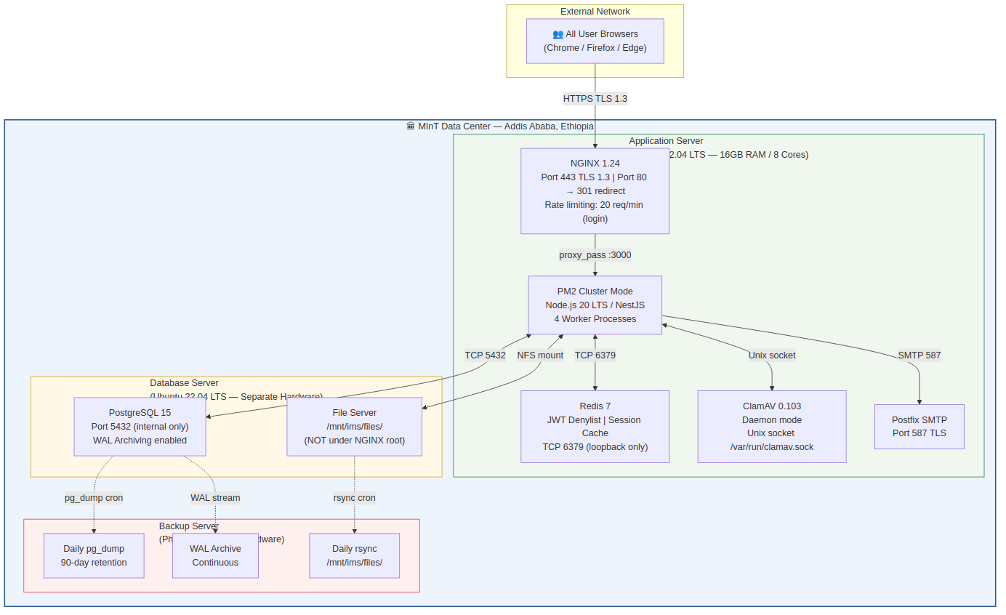
⚑ All hardware depicted above MUST be physically located within the Federal Democratic Republic of Ethiopia and managed by MInT IT (NFR-DAT-001).

8.2 Environment Configuration
Variable | Description | NFR/FR Reference
JWT_PRIVATE_KEY_PATH | Path to RS256 private key file | NFR-SEC-002
JWT_PUBLIC_KEY_PATH | Path to RS256 public key file | NFR-SEC-002
JWT_EXPIRY_MINUTES | Token TTL in minutes (default: 60) | FR-AUTH-003
JWT_LOCKOUT_ATTEMPTS | Failed login limit (default: 5) | FR-AUTH-005
JWT_LOCKOUT_DURATION_MINUTES | Lockout duration (default: 30) | FR-AUTH-005
BCRYPT_COST_FACTOR | bcrypt cost factor (minimum: 12) | NFR-SEC-003
DATABASE_URL | Prisma connection string (never logged) | NFR-REL-005
REDIS_URL | Redis connection string | NFR-SEC-007
FILE_STORAGE_ROOT | Absolute path to /mnt/ims/files/ | FR-DOC-004
CLAMAV_SOCKET_PATH | ClamAV daemon socket path | NFR-SEC-006
SMTP_HOST, SMTP_PORT | On-premise Postfix relay | FR-NOT-002
SMTP_USER, SMTP_PASS | SMTP credentials (never logged) | FR-NOT-002
MAX_FILE_SIZE_MB | Upload limit (default: 10) | FR-APP-004
MAX_STUDENTS_PER_APPLICATION | Bulk app limit (default: 50) | DDD §5.6.1
SUPERVISOR_DEFAULT_MAX_STUDENTS | Default supervisor cap (default: 10) | FR-SUP-007
SESSION_INACTIVITY_TIMEOUT_MINUTES | Inactivity timeout (default: 60) | FR-AUTH-007
RESET_LINK_EXPIRY_MINUTES | Password reset link TTL (default: 60) | FR-AUTH-006
EMAIL_FROM | Sender address for all system emails | FR-NOT-002
APP_TIMEZONE | System timezone (default: Africa/Addis_Ababa) | SRS §2.4

8.3 Process Management and Availability
- PM2 cluster mode: 4 worker processes (configurable via MAX_WORKERS env). PM2 startup: pm2 startup systemd → saves process list to survive reboots
- Graceful shutdown: PM2 sends SIGINT; NestJS enableShutdownHooks() drains in-flight requests via HTTP_TERMINATION_TIMEOUT (default 10s)
- Health check: GET /api/v1/health returns { status: 'ok', db: 'up', redis: 'up', storage: 'up' }. NGINX upstream health_check uses this endpoint
- Auto-restart: PM2 restarts any crashed worker within 100ms; max_restarts: 10 per 30-minute window
- Log rotation: PM2 log rotate module configured with daily rotation, 30-day retention, 50MB max per log file

8.4 Security Hardening
Control | Implementation | NFR Reference
TLS 1.3 enforced | NGINX: ssl_protocols TLSv1.2 TLSv1.3; ssl_ciphers HIGH:!aNULL:!MD5; HTTP → HTTPS 301 | NFR-SEC-001
HSTS header | Strict-Transport-Security: max-age=31536000; includeSubDomains | NFR-SEC-001
Security headers | X-Content-Type-Options: nosniff; X-Frame-Options: DENY; X-XSS-Protection: 1;mode=block | NFR-SEC-005
Content Security Policy | NGINX: Content-Security-Policy header restricting script-src to self | NFR-SEC-005
CSRF protection | NestJS CsrfMiddleware (csurf) with synchronizer token pattern | NFR-SEC-005
SQL injection prevention | Prisma parameterized queries exclusively; no raw string interpolation in DB calls | NFR-SEC-005
Input sanitization | NestJS ValidationPipe(whitelist:true, forbidNonWhitelisted:true) on all endpoints | NFR-SEC-005
AES-256 at rest | Prisma middleware encrypts sensitive PII fields using Node.js crypto AES-256-GCM | NFR-SEC-004
File outside web root | /mnt/ims/files NOT under NGINX document root; access only via FileStorageService.getStream() | NFR-SEC-006
Login rate limiting | NGINX limit_req_zone: 20 req/min per IP on /api/v1/auth/login | NFR-SEC-002
API rate limiting | NestJS ThrottlerModule: 100 req/min per user on all other endpoints | NFR-SEC-002
Audit immutability | REVOKE UPDATE, DELETE ON activity_logs, status_history FROM api_role (Postgres) | NFR-SEC-008
INSA compliance | Formal security assessment checklist review before production deployment | NFR-SEC-009

8.5 Backup and Disaster Recovery
DR Aspect | Design | NFR Reference
Database Backup | Daily pg_dump --format=custom at 01:00 EAT; copied to backup server within 1 hour. WAL archiving continuous. | NFR-REL-002
Backup Retention | 90 days rolling on backup server; automated cron purges older files | NFR-REL-002
File Storage Backup | Daily rsync /mnt/ims/files/ to backup server; incremental; preserves permissions | NFR-REL-002
RTO — 4 hours | Recovery: restore pg_dump (< 1 hour for expected DB size) + remount FS + PM2 restart (< 30 min) | NFR-REL-003
RPO — 24 hours | Daily backup guarantees ≤ 24h loss. WAL archiving reduces RPO to minutes in practice. | NFR-REL-003
DR Testing | Quarterly full DR drill: restore to staging server, verify application functionality end-to-end | NFR-REL-003
Availability | 99.5% minimum during operational hours (06:00–22:00 EAT, Mon–Sat). Maintenance windows outside hours with 48h advance notice. | NFR-REL-001

9. Database Implementation Design

9.1 Prisma Schema — Complete Definition
The following Prisma schema is the authoritative implementation artifact for the IMS database. It directly implements IMS-DDD-001 v1.0 and must be kept in strict synchronization. Migrations are managed via prisma migrate deploy in production.
// prisma/schema.prisma — IMS v2.0 (aligned with IMS-DDD-001 v1.0)
generator client {
provider = "prisma-client-js"
}
datasource db {
provider = "postgresql"
url = env("DATABASE_URL")
}

// ─── IDENTITY & ACCESS ────────────────────────────────────────────────────
model Role {
role_id Int @id @default(autoincrement())
role_name String @unique @db.VarChar(50)
users User[]
@@map("roles")
}

model User {
user_id Int @id @default(autoincrement())
full_name String @db.VarChar(255)
email String @unique @db.VarChar(320)
password_hash String @db.VarChar(255)
role_id Int
account_status String @default("active") @db.VarChar(20)
last_login DateTime?
failed_login_count Int @default(0)
lockout_until DateTime?
created_at DateTime @default(now())
updated_at DateTime @updatedAt
role Role @relation(fields: [role_id], references: [role_id])
login_logs LoginLog[]
student Student?
supervisor Supervisor?
university_users UniversityUser[]
sent_messages Message[] @relation("SentMessages")
received_messages Message[] @relation("ReceivedMessages")
notifications Notification[]
uploaded_docs Document[]
activity_logs ActivityLog[]
status_changes StatusHistory[] @relation("StatusChanger")
@@map("users")
}

model LoginLog {
log_id Int @id @default(autoincrement())
user_id Int
login_time DateTime @default(now())
ip_address String @db.VarChar(45)
status String @db.VarChar(20)
user User @relation(fields: [user_id], references: [user_id])
@@index([user_id, login_time])
@@map("login_logs")
}

// ─── ORGANIZATION ─────────────────────────────────────────────────────────
model University {
university_id Int @id @default(autoincrement())
name String @db.VarChar(255)
contact_email String @db.VarChar(320)
address String @db.Text
created_at DateTime @default(now())
created_by Int
university_users UniversityUser[]
students Student[]
applications Application[]
@@map("universities")
}

model UniversityUser {
university_user_id Int @id @default(autoincrement())
user_id Int
university_id Int
role_title String? @db.VarChar(100)
user User @relation(fields: [user_id], references: [user_id])
university University @relation(fields: [university_id], references: [university_id])
@@unique([user_id, university_id])
@@map("university_users")
}

// ─── STUDENTS ─────────────────────────────────────────────────────────────
model Student {
student_id Int @id @default(autoincrement())
user_id Int? @unique
university_id Int
full_name String @db.VarChar(255)
registration_number String @db.VarChar(100)
email String @db.VarChar(320)
department String @db.VarChar(150)
gpa Float?
status String @default("pending") @db.VarChar(30)
created_at DateTime @default(now())
user User? @relation(fields: [user_id], references: [user_id])
university University @relation(fields: [university_id], references: [university_id])
application_students ApplicationStudent[]
internships Internship[]
submissions Submission[]
attendance Attendance[]
monthly_reports MonthlyReport[]
evaluations Evaluation[]
@@index([university_id])
@@map("students")
}

// ─── APPLICATIONS ─────────────────────────────────────────────────────────
model Application {
application_id Int @id @default(autoincrement())
university_id Int
submitted_by Int
application_letter_path String? @db.VarChar(500)
submission_date DateTime @default(now())
status String @default("pending") @db.VarChar(30)
reviewed_by Int?
reviewed_at DateTime?
remarks String? @db.Text
university University @relation(fields: [university_id], references: [university_id])
application_students ApplicationStudent[]
internships Internship[]
@@index([university_id, status])
@@index([status, submission_date])
@@map("applications")
}

model ApplicationStudent {
id Int @id @default(autoincrement())
application_id Int
student_id Int
status String @default("pending") @db.VarChar(30)
remarks String? @db.Text
application Application @relation(fields: [application_id], references: [application_id])
student Student @relation(fields: [student_id], references: [student_id])
@@unique([application_id, student_id])
@@index([application_id, status])
@@map("application_students")
}

// ─── INTERNSHIPS ──────────────────────────────────────────────────────────
model Internship {
internship_id Int @id @default(autoincrement())
student_id Int
application_id Int
assignment_id Int?
start_date DateTime? @db.Date
end_date DateTime? @db.Date
status String @default("pending_assignment") @db.VarChar(30)
created_at DateTime @default(now())
student Student @relation(fields: [student_id], references: [student_id])
application Application @relation(fields: [application_id], references: [application_id])
assignment Assignment?
milestones Milestone[]
attendance Attendance?
monthly_reports MonthlyReport[]
evaluation Evaluation?
// Partial unique index enforced via migration SQL:
// CREATE UNIQUE INDEX uq_student_active_internship
// ON internships(student_id) WHERE status = 'active';
@@index([student_id, status])
@@map("internships")
}

// ─── SUPERVISION ──────────────────────────────────────────────────────────
model Supervisor {
supervisor_id Int @id @default(autoincrement())
user_id Int @unique
department String @db.VarChar(150)
position String @db.VarChar(150)
max_students Int @default(10)
created_at DateTime @default(now())
user User @relation(fields: [user_id], references: [user_id])
assignments Assignment[]
evaluations Evaluation[]
@@map("supervisors")
}

model Assignment {
assignment_id Int @id @default(autoincrement())
internship_id Int @unique
supervisor_id Int
assigned_by Int
start_date DateTime? @db.Date
end_date DateTime? @db.Date
status String @default("active") @db.VarChar(30)
created_at DateTime @default(now())
internship Internship @relation(fields: [internship_id], references: [internship_id])
supervisor Supervisor @relation(fields: [supervisor_id], references: [supervisor_id])
@@index([supervisor_id, status])
@@map("assignments")
}

// ─── EXECUTION LAYER ──────────────────────────────────────────────────────
model Milestone {
milestone_id Int @id @default(autoincrement())
internship_id Int
title String @db.VarChar(255)
description String? @db.Text
due_date DateTime? @db.Date
status String @default("open") @db.VarChar(30)
created_by Int
created_at DateTime @default(now())
internship Internship @relation(fields: [internship_id], references: [internship_id])
submissions Submission[]
@@index([internship_id, status])
@@map("milestones")
}

model Submission {
submission_id Int @id @default(autoincrement())
milestone_id Int
student_id Int
content String @db.Text
submitted_at DateTime @default(now())
status String @default("submitted") @db.VarChar(30)
milestone Milestone @relation(fields: [milestone_id], references: [milestone_id])
student Student @relation(fields: [student_id], references: [student_id])
review SubmissionReview?
@@index([milestone_id, submitted_at])
@@map("submissions")
}

model SubmissionReview {
review_id Int @id @default(autoincrement())
submission_id Int @unique
reviewer_id Int
feedback String? @db.Text
status String @db.VarChar(30)
reviewed_at DateTime @default(now())
submission Submission @relation(fields: [submission_id], references: [submission_id])
@@map("submission_reviews")
}

// ─── ATTENDANCE & REPORTING ───────────────────────────────────────────────
model Attendance {
attendance_id Int @id @default(autoincrement())
internship_id Int @unique
student_id Int
percentage Float
marked_by Int
updated_at DateTime @updatedAt
internship Internship @relation(fields: [internship_id], references: [internship_id])
student Student @relation(fields: [student_id], references: [student_id])
// CHECK: percentage >= 0 AND percentage <= 100 — enforced via migration
@@map("attendance")
}

model MonthlyReport {
report_id Int @id @default(autoincrement())
internship_id Int
student_id Int
month Int
year Int
summary String @db.Text
submitted_at DateTime @default(now())
reviewed_by Int?
status String @default("submitted") @db.VarChar(30)
internship Internship @relation(fields: [internship_id], references: [internship_id])
student Student @relation(fields: [student_id], references: [student_id])
@@unique([internship_id, month, year])
@@index([internship_id, year, month])
@@map("monthly_reports")
}

// ─── EVALUATION ───────────────────────────────────────────────────────────
model Evaluation {
evaluation_id Int @id @default(autoincrement())
internship_id Int @unique
student_id Int
supervisor_id Int
score Int
grade String @db.VarChar(2)
remarks String @db.Text
submitted_at DateTime @default(now())
status String @default("draft") @db.VarChar(20)
internship Internship @relation(fields: [internship_id], references: [internship_id])
student Student @relation(fields: [student_id], references: [student_id])
supervisor Supervisor @relation(fields: [supervisor_id], references: [supervisor_id])
// CHECK score >= 0 AND score <= 100 enforced via migration
@@map("evaluations")
}

// ─── COMMUNICATION ────────────────────────────────────────────────────────
model Message {
message_id Int @id @default(autoincrement())
sender_id Int
receiver_id Int
message_text String @db.Text
sent_at DateTime @default(now())
read_status String @default("unread") @db.VarChar(10)
sender User @relation("SentMessages", fields: [sender_id], references: [user_id])
receiver User @relation("ReceivedMessages", fields: [receiver_id], references: [user_id])
@@index([sender_id, receiver_id, sent_at])
@@index([receiver_id, read_status])
@@map("messages")
}

model Notification {
notification_id Int @id @default(autoincrement())
user_id Int
title String @db.VarChar(255)
message String @db.Text
type String @db.VarChar(50)
is_read Boolean @default(false)
created_at DateTime @default(now())
user User @relation(fields: [user_id], references: [user_id])
@@index([user_id, is_read])
@@map("notifications")
}

// ─── DOCUMENTS ────────────────────────────────────────────────────────────
model DocumentType {
type_id Int @id @default(autoincrement())
type_name String @unique @db.VarChar(100)
documents Document[]
@@map("document_types")
}

model Document {
document_id Int @id @default(autoincrement())
file_name String @db.VarChar(255)
file_path String @db.VarChar(500)
file_type String @db.VarChar(10)
document_type_id Int
uploaded_by Int
entity_type String @db.VarChar(50)
entity_id Int
uploaded_at DateTime @default(now())
document_type DocumentType @relation(fields: [document_type_id], references: [type_id])
uploader User @relation(fields: [uploaded_by], references: [user_id])
@@index([entity_type, entity_id])
@@map("documents")
}

// ─── AUDIT ────────────────────────────────────────────────────────────────
model StatusHistory {
history_id Int @id @default(autoincrement())
entity_type String @db.VarChar(50)
entity_id Int
old_status String? @db.VarChar(30)
new_status String @db.VarChar(30)
changed_by Int
changed_at DateTime @default(now())
comment String? @db.Text
changer User @relation("StatusChanger", fields: [changed_by], references: [user_id])
@@index([entity_type, entity_id])
@@index([changed_by, changed_at])
@@map("status_history")
}

model ActivityLog {
log_id Int @id @default(autoincrement())
user_id Int
action String @db.VarChar(100)
entity_type String? @db.VarChar(50)
entity_id Int?
ip_address String? @db.VarChar(45)
timestamp DateTime @default(now())
user User @relation(fields: [user_id], references: [user_id])
@@index([user_id, timestamp])
@@index([entity_type, entity_id])
@@map("activity_logs")
}

9.2 Critical Migration SQL Additions
The following SQL statements MUST be included in a custom Prisma migration file to add constraints and triggers not expressible in the Prisma schema DSL:
-- Migration: 001_critical_constraints.sql

-- 1. Single active internship per student (DDD §5.6.3)
CREATE UNIQUE INDEX uq_student_active_internship
ON internships(student_id) WHERE status = 'active';

-- 2. Attendance percentage range check
ALTER TABLE attendance
ADD CONSTRAINT chk_attendance_pct
CHECK (percentage >= 0 AND percentage <= 100);

-- 3. Evaluation score range check
ALTER TABLE evaluations
ADD CONSTRAINT chk_eval_score
CHECK (score >= 0 AND score <= 100);

-- 4. Evaluation grade domain check
ALTER TABLE evaluations
ADD CONSTRAINT chk_eval_grade
CHECK (grade IN ('A', 'B', 'C', 'D', 'F'));

-- 5. Accepted submission immutability trigger
CREATE OR REPLACE FUNCTION prevent_accepted_submission_edit()
RETURNS TRIGGER AS $$
BEGIN
IF OLD.status = 'accepted' THEN
RAISE EXCEPTION 'Cannot modify an accepted submission (id=%). Status is immutable.', OLD.submission_id;
END IF;
RETURN NEW;
END;
$$ LANGUAGE plpgsql;

CREATE TRIGGER trg_submission_accepted_immutable
BEFORE UPDATE ON submissions
FOR EACH ROW EXECUTE FUNCTION prevent_accepted_submission_edit();

-- 6. Revoke UPDATE/DELETE on audit tables from API role
REVOKE UPDATE, DELETE ON activity_logs FROM ims_api_role;
REVOKE UPDATE, DELETE ON status_history FROM ims_api_role;

-- 7. Password hash minimum length (prevent plaintext storage)
ALTER TABLE users
ADD CONSTRAINT chk_password_hash_length
CHECK (LENGTH(password_hash) >= 60);

-- 8. Monthly report uniqueness: one per internship per month/year
-- (already in Prisma schema via @@unique, confirmed here for clarity)
-- UNIQUE INDEX uq_monthly_report ON monthly_reports(internship_id, month, year);

9.3 Data Dictionary
The following table provides field-level definitions for all critical status/enum fields used across the database. These values are enforced at the application layer via NestJS ValidationPipe and as string constants in service classes.
Table.Column | Type / Values | Description
users.account_status | active | inactive | locked | active = can login; inactive = deactivated by admin; locked = failed login lockout
application_students.status | pending | approved | rejected | on_hold | Per-student review status within a bulk application batch
internships.status | pending_assignment | active | completed | evaluated | Lifecycle state of student's internship period
assignments.status | active | reassigned | completed | Supervisor-to-internship assignment lifecycle
milestones.status | open | closed | Supervisor can close a milestone to prevent new submissions
submissions.status | submitted | accepted | revision_required | rejected | Student submission review outcome
monthly_reports.status | submitted | reviewed | approved | returned | Monthly report workflow status
evaluations.status | draft | submitted | published | Supervisor draft → submitted to admin → published to all
documents.file_type | pdf | docx | Permitted upload types only; enforced at API MIME validation
document_types.type_name | cover_letter | transcript | request_letter | recommendation | milestone_attachment | monthly_report_attachment | generated_report | Document category for access control and display grouping
notifications.type | APPLICATION_SUBMITTED | STUDENT_APPROVED | STUDENT_REJECTED | APPLICATION_ON_HOLD | SUPERVISOR_ASSIGNED | SUBMISSION_REVIEWED | MONTHLY_REPORT_REVIEWED | EVALUATION_SUBMITTED | GRADE_PUBLISHED | Event type enum; used for notification icon and email template selection
users.role (via roles.role_name) | admin | university | supervisor | student | RBAC role; determines all access permissions
login_logs.status | success | failed | locked | Authentication attempt outcome for security audit
messages.read_status | unread | read | Message read state for unread count indicator

10. Error Handling and Logging Design

10.1 Error Handling Architecture
All exceptions in the NestJS API are handled through a global exception filter (GlobalHttpExceptionFilter) registered as a NestJS APP_FILTER provider. This ensures consistent JSON error responses regardless of where the exception originates — controller, service, guard, or interceptor.

10.1.1 HTTP Error Response Envelope
// All error responses conform to this structure:
{
"success": false,
"statusCode": 422,
"error": "UnprocessableEntityException",
"message": "State transition not permitted: APPROVED → PENDING",
"field": null, // populated for validation errors
"requestId": "uuid-v4", // correlates with server logs
"timestamp": "2026-05-01T08:30:00Z"
}

// Validation error (422) — field-level detail:
{
"success": false,
"statusCode": 422,
"error": "ValidationError",
"message": "Validation failed",
"fields": [
{ "field": "score", "message": "score must not be greater than 100" },
{ "field": "remarks", "message": "remarks must be longer than or equal to 100 characters" }
],
"requestId": "uuid-v4"
}

10.1.2 Custom Exception Hierarchy
Exception Class | HTTP Code | Usage
BadRequestException (NestJS built-in) | 400 | Malformed request body; missing required fields
UnauthorizedException (NestJS built-in) | 401 | Invalid or expired JWT; denylist hit; no token provided
ForbiddenException (NestJS built-in) | 403 | Valid token but insufficient role for the requested operation
NotFoundException | 404 | Requested resource (internship, student, evaluation) does not exist
ConflictException | 409 | Duplicate operation: e.g., evaluation already published; report already submitted for month
UnprocessableEntityException | 422 | State machine violation: invalid status transition attempted
SupervisorCapacityException | 422 | Supervisor has reached max_students active assignment limit
MalwareDetectedException | 422 | ClamAV scan returned INFECTED or ERROR on uploaded file
FileTypeException | 415 | Uploaded file MIME type not in allowed list (pdf, docx)
InternalServerErrorException | 500 | Unhandled exception; never exposes stack trace in production

10.1.3 Database Transaction Error Handling
All multi-table write operations use Prisma interactive transactions (prisma.$transaction()). On any Prisma exception inside the transaction callback, the transaction is automatically rolled back. The service layer catches PrismaClientKnownRequestError for specific error codes:
try {
await prisma.$transaction(async (tx) => {
await tx.applicationStudent.update({ where: { id }, data: { status: 'approved' } });
await tx.user.create({ data: newStudentUser });
await tx.internship.create({ data: newInternship });
await tx.statusHistory.create({ data: historyRecord });
});
} catch (e) {
if (e instanceof Prisma.PrismaClientKnownRequestError) {
if (e.code === 'P2002') throw new ConflictException('Unique constraint violation');
if (e.code === 'P2003') throw new BadRequestException('Foreign key constraint failed');
if (e.code === 'P2025') throw new NotFoundException('Record not found for update');
}
throw new InternalServerErrorException('Database operation failed');
}

10.2 Logging Strategy

10.2.1 Log Levels and Categories
Level | Environment | Usage
ERROR | All | Unhandled exceptions, database errors, ClamAV failures, SMTP failures, transaction rollbacks
WARN | All | JWT denylist hits, failed login attempts, file type rejection, supervisor capacity reached, near-limit conditions
LOG | All | Application lifecycle (startup, shutdown), significant state transitions, batch job completion
VERBOSE | Development | Incoming request details, service method entry/exit, ORM query parameters
DEBUG | Development | Full request/response dumps, JWT payload, Prisma query logs

10.2.2 Structured Log Format
All logs are structured JSON for compatibility with log aggregation tools (ELK Stack, Loki, or similar if adopted in future). The NestJS logger is replaced with a Winston-based structured logger:
// Log entry structure (JSON — one object per line)
{
"level": "error",
"timestamp": "2026-05-01T08:30:00.123Z",
"requestId": "c7f3a1b2-...",
"userId": 42,
"role": "supervisor",
"ip": "10.0.0.15",
"method": "PATCH",
"path": "/api/v1/evaluations/7/publish",
"statusCode": 422,
"message": "State transition not permitted: DRAFT → PUBLISHED",
"durationMs": 45,
"service": "EvaluationService"
}
⚑ Passwords, password hashes, JWT secrets, and file contents MUST NEVER appear in any log entry. The NestJS logger configuration excludes these fields via a custom sanitizer in the Winston format chain.

10.2.3 AuditInterceptor — Automatic Activity Logging
A NestJS interceptor (AuditInterceptor) is globally registered and automatically writes a record to the activity_logs table for every non-GET API request that succeeds (HTTP 2xx). This provides a complete, immutable record of all state-changing operations without requiring explicit calls in service methods:
@Injectable()
export class AuditInterceptor implements NestInterceptor {
intercept(ctx: ExecutionContext, next: CallHandler): Observable<any> {
return next.handle().pipe(
tap(async () => {
const req = ctx.switchToHttp().getRequest();
if (req.method !== 'GET' && req.user) {
await this.activityLogService.log({
user_id: req.user.userId,
action: `${req.method} ${req.route.path}`,
entity_type: req.params.resource ?? null,
entity_id: Number(req.params.id) ?? null,
ip_address: req.ip,
});
}
}),
);
}
}

11. Performance and Scalability Design

11.1 Performance Requirements Summary
NFR ID | Requirement | Design Mechanism
NFR-PERF-001 | Page response < 3 seconds (95th percentile) under 500 concurrent users | PM2 cluster × 4; DB indexes; NGINX static caching; response compression
NFR-PERF-002 | 500 concurrent authenticated users supported | Stateless JWT (no server session); PostgreSQL connection pool (Prisma default: 10 per worker)
NFR-PERF-003 | 1,000 peak simultaneous users without degradation | PM2 cluster scale; PgBouncer connection pooler (recommended addition for >500 users)
NFR-PERF-004 | 10 MB file upload processed within 15 seconds | Multer streaming (memory); ClamAV scan in pipeline; async file write; non-blocking
NFR-PERF-005 | Database queries < 2 seconds (99th percentile) | 15 targeted indexes; partial unique index; Prisma include/select prevents N+1

11.2 Database Performance Design

11.2.1 Connection Pooling
Prisma uses a built-in connection pool. The default pool size for a Node.js application is num_cpus * 2 + 1. With 4 PM2 workers on an 8-core server, this yields approximately 17 connections per worker = 68 total connections to PostgreSQL. PostgreSQL max_connections should be set to at least 100. For production loads exceeding 500 concurrent users, PgBouncer in transaction-mode pooling is recommended as an additional layer between NestJS and PostgreSQL.

11.2.2 Query Optimization Guidelines
- Always use Prisma's select and include with explicit field lists — never fetch full entities when partial data suffices
- Paginate all list endpoints: default page=1, limit=20; maximum limit=100
- For admin dashboard aggregate queries (application counts by status, grade distributions), use prisma.$queryRaw with pre-tested SQL and result caching (30-second TTL in Redis)
- The N+1 pattern is prevented by using Prisma include for eager loading in list endpoints rather than separate per-record queries
- EXPLAIN ANALYZE must be run on all new complex queries before merging to main branch

11.2.3 Caching Strategy
Cacheable Resource | Cache Layer | TTL | Invalidation
Dashboard KPI aggregates (admin) | Redis (NestJS CacheModule) | 60 seconds | On any application/evaluation write
University list (admin) | Redis | 300 seconds | On university create/update
Supervisor availability hints (load counts) | Redis | 30 seconds | On assignment create/delete
Notification unread count (per user) | Redis | 30 seconds | On notification create/read
NGINX static assets (JS, CSS, images) | NGINX proxy_cache | 7 days | Versioned filenames on deploy

11.3 Scalability Design

11.3.1 Horizontal Scaling Path
The IMS is designed for future horizontal scaling with the following architecture changes (no code changes required):
- Step 1 (current): Single server, PM2 cluster × 4 workers — supports up to ~500 concurrent users
- Step 2: Add NGINX load balancer in front of 2 application servers sharing the same PostgreSQL and NFS-mounted file storage — supports ~1,000 concurrent users
- Step 3: Add PgBouncer for connection pooling between application servers and PostgreSQL — supports ~2,000 concurrent users
- Step 4 (future): Replace LocalFileStorageAdapter with S3-compatible adapter (MinIO on-premise or cloud) via IFileStorageAdapter interface — no service code changes

11.3.2 Scheduled Maintenance Jobs
Job Name | Action | Schedule (EAT) | Module
CompleteExpiredInternships | UPDATE internships SET status='completed' WHERE end_date < NOW() AND status='active' | Daily 01:00 | SupervisorModule
PurgeExpiredTokenDenylist | DELETE FROM token_denylist WHERE expires_at < NOW() | Daily 02:00 | AuthModule
PurgeExpiredPasswordResets | DELETE FROM password_reset_tokens WHERE expires_at < NOW() | Daily 02:30 | AuthModule
ClamAV Database Update | freshclam — update ClamAV virus signatures | Daily 03:00 | System cron
Database Backup | pg_dump + copy to backup server | Daily 01:00 | System cron
File Storage Backup | rsync /mnt/ims/files/ to backup server | Daily 01:30 | System cron
Unlock Expired Lockouts | UPDATE users SET lockout_until=NULL WHERE lockout_until < NOW() | Every 15 min | AuthModule

12. Testing and Monitoring Design

12.1 Testing Strategy

12.1.1 Unit Testing (Jest)
All NestJS service classes are unit-tested using Jest with @nestjs/testing TestingModule. PrismaService and external dependencies (MailService, FileStorageService, ClamAVService) are mocked using jest.mock(). Target coverage: 80%+ line coverage for all service classes. State machine transition logic requires 100% branch coverage.
// Example: ApplicationService unit test
describe('ApplicationService', () => {
describe('approveStudent()', () => {
it('should throw UnprocessableEntityException if status is not PENDING', async () => {
mockPrisma.applicationStudent.findUnique.mockResolvedValue({
id: 1, status: 'approved'
});
await expect(service.approveStudent(1, adminUser))
.rejects.toThrow(UnprocessableEntityException);
});
it('should create user, internship, and status_history in transaction', async () => {
// arrange: mock PENDING application_student
// act: approveStudent()
// assert: prisma.$transaction called; MailService.sendCredentials called
});
});
});

12.1.2 Integration Testing (Supertest)
End-to-end API tests use @nestjs/testing with supertest against a test PostgreSQL database (separate from development and production). Each test suite resets the database to a known seed state using prisma migrate reset. Integration tests cover the complete HTTP lifecycle: request → guard → validation → service → database → response.

12.1.3 Key Test Scenarios
Test Scenario | Type | Expected Outcome
Login with valid credentials | Integration | 200 OK + RS256 JWT returned
Login with invalid password (5th attempt) | Integration | 200 OK attempts 1–4; 429 Too Many Requests on 5th
Access protected endpoint without JWT | Integration | 401 Unauthorized
ROLE_STUDENT accesses /api/v1/users (ADMIN only) | Integration | 403 Forbidden
Submit application with 51 students | Integration | 422 Validation Error: batch size exceeds 50
Submit application with infected file (mocked ClamAV) | Unit | 422 MalwareDetectedException thrown
Approve student — state machine valid (PENDING→APPROVED) | Integration | 200 OK; internship created; email sent
Approve student — state machine invalid (APPROVED→APPROVED) | Integration | 422 UnprocessableEntityException
Assign supervisor at capacity (10 active students) | Integration | 422 SupervisorCapacityException
Student submits ACCEPTED submission for edit | Integration | 422 — trigger prevents update
Publish evaluation — happy path | Integration | 200 OK; evaluation.status=published; notifications sent
Download document as unauthorized user | Integration | 403 Forbidden
POST /api/v1/auth/logout — token rejected on next request | Integration | Second request returns 401 Unauthorized

12.2 Monitoring Design

12.2.1 Health Check Endpoint
// GET /api/v1/health — used by NGINX upstream health_check
// Response (HTTP 200 if all OK, HTTP 503 if any dependency is down):
{
"status": "ok",
"uptime_seconds": 86400,
"checks": {
"database": { "status": "up", "latency_ms": 3 },
"redis": { "status": "up", "latency_ms": 1 },
"storage": { "status": "up", "free_gb": 42.1 },
"clamav": { "status": "up" }
},
"version": "2.0.0"
}

12.2.2 Key Operational Metrics (PM2 + Custom)
- PM2 metrics: CPU usage per worker, heap memory per worker, event loop delay, requests/second, active HTTP connections
- Application metrics: login failures per minute (alert at > 20/min across all users — may indicate brute force attack), active internship count, pending application count, notification queue depth, email delivery failure rate
- Database metrics: PostgreSQL pg_stat_activity for long-running queries (> 5s); pg_stat_user_tables for table bloat; WAL write lag
- Disk metrics: /mnt/ims/files/ usage (alert at 80% capacity); /var/lib/postgresql/15/main/ usage
- Log-based alerts: ERROR-level log entries; ClamAV INFECTED detection; failed email delivery; JWT denylist size exceeding threshold

12.2.3 Alerting Thresholds
Metric | Alert Threshold | Response Action
CPU usage (per worker) | ≥ 85% for > 5 minutes | Investigate; scale workers if sustained
Heap memory (per worker) | ≥ 512 MB | Investigate memory leak; restart worker
API error rate (5xx) | ≥ 1% of requests in 5 min | Alert dev team; check logs for root cause
Login failure rate | ≥ 20 failures/minute | Alert security admin; possible brute force
Database query latency (p99) | ≥ 3 seconds | Run EXPLAIN ANALYZE on slow queries
File storage disk usage | ≥ 80% of volume | Provision additional storage or archive old files
Backup job failure | Any failure | Immediate alert to MInT IT; investigate and retry
ClamAV INFECTED detection | Any occurrence | Log full details; quarantine file; notify admin

Appendix A: Requirements Traceability Matrix

Req ID | Requirement Summary | Design Component(s) | SDD Section
FR-AUTH-001~008 | Authentication, JWT RS256, lockout, session, reset | AuthModule, JwtAuthGuard, TokenDenylistService | §4.7, §6.2
FR-ACCT-001~006 | Account management, auto-provisioning | AccountModule, ApplicationService.provisionStudent() | §6.3.2
FR-APP-001~008 | Bulk application (≤50 students), documents | ApplicationModule, FileStorageService, ClamAVService | §6.3, §5.4
FR-REV-001~006 | Per-student review decisions + audit | ApplicationModule, status_history, AuditService | §6.3, §5.3.6
FR-SUP-001~007 | Supervisor assignment, workload limit | SupervisorModule, assignments table | §6.4, §5.3.4
FR-STU-001~004 | Student dashboard, task viewing | StudentPages (frontend), NotificationModule | §6.9, §7.4.2
FR-MSG-001~005 | Internal messaging, broadcast | MessageModule, messages table | §6.1, §7.2
FR-MIL-001~009 | Milestone + submission + review + lock | MilestoneModule, DB trigger, status_history | §6.5, §5.3.5
FR-EVAL-001~007 | Evaluation, grading, publish, PDF report | EvaluationModule, ReportService | §6.7
FR-DOC-001~005 | Document storage, RBAC access | FileStorageService, documents table | §5.4, §7.3.2
FR-NOT-001~004 | Event-driven notifications + email | NotificationModule, MailService | §6.8
FR-RPT-001~004 | Reporting, audit logs | ReportModule, activity_logs, status_history | §6.1, §8.5
NFR-SEC-001~009 | Security controls (all) | NGINX, AuthModule, bcrypt, ClamAV, AES-256 | §8.4
NFR-PERF-001~005 | Response time, concurrency | PM2 cluster, DB indexes, Redis cache | §8.3, §5.5
NFR-REL-001~005 | Availability, backup, ACID | PM2, PostgreSQL, backup strategy | §8.5
NFR-DAT-001~003 | Data residency — all servers in Ethiopia | On-premise deployment; no external PII APIs | §8.1
NFR-SCA-001~003 | Horizontal scaling, storage migration | Stateless API, IFileStorageAdapter interface | §4.1, §7.3.2
DDD-ATT | Attendance tracking (supervisor-entered %) | AttendanceModule, attendance table | §6.6, §5.3.5
DDD-RPT | Monthly progress reports | MonthlyReportModule, monthly_reports table | §6.1, §5.3.5
DDD-ST | Status history for all entities | status_history table, AuditService | §5.3.6

Appendix B: Technology Stack Summary

Layer | Technology | Version | Authorization Basis
Frontend | React | 18.x | CON-003
Frontend | Next.js | 14.x | CON-003
Frontend | Axios HTTP Client | 1.x | —
Frontend | React Hook Form + Zod | 7.x / 3.x | —
Frontend | Radix UI Primitives | 1.x | NFR-USA-004
Frontend | Zustand (state management) | 4.x | —
API | Node.js | 20 LTS | CON-003
API | NestJS | 10.x | —
API | Prisma ORM | 5.x | DDD v1.0 §2.1
API | Passport.js + passport-jwt | 0.7.x | —
API | class-validator + class-transformer | 0.14.x | —
API | Nodemailer | 6.x | FR-NOT-002
API | Multer | 1.x | FR-APP-003
API | EventEmitter2 | 6.x | FR-NOT-001
API | Puppeteer (PDF generation) | 21.x | FR-EVAL-006
API | csv-stringify | 6.x | FR-RPT-002
API | @nestjs/schedule (cron) | 4.x | SRS §5.2
Database | PostgreSQL | 15.x | CON-003, CON-009
Cache | Redis | 7.x | NFR-SEC-007
Security | ClamAV | 1.x | NFR-SEC-006
Proxy | NGINX | 1.24+ | §8.1
Process Mgr | PM2 | 5.x | §8.3
OS | Ubuntu | 22.04 LTS | SRS §2.4

— End of Software Design Document —
MInT-IMS-SDD-2026-001 | Version 2.0 | May 2026 | IEEE Std 1016-2009 Compliant
Ministry of Innovation and Technology, Federal Democratic Republic of Ethiopia

