作业11
1043220122-林鑫
任务1：
在下面的类定义中，错误的语句是(③)。
class sample
{
public:
sample(int val);//①
~sample();//②
private:
int a=2.5;//③
sample();//④
}

任务2：
下列程序的执行结果是( )
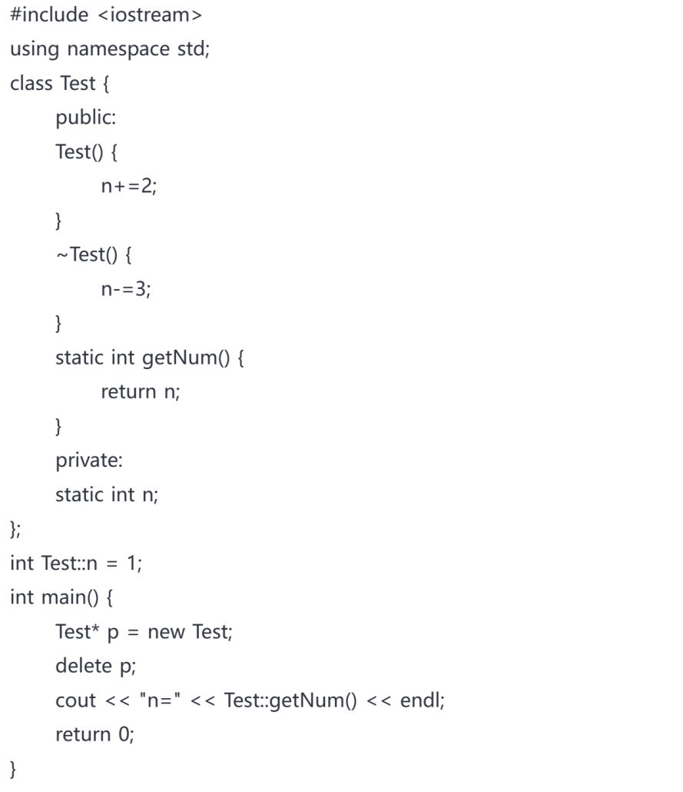
A. n=0
B. n=1
C. n=2
D. n=3
A
任务3：
请补全下面的“TODO”中的拷贝函数的定义和实现，并运行程序，将结果截图
#include<iostream>
using namespace std;

class CAT
{
public:
CAT();
//TODO 拷贝构造函数声明
~CAT();
int GetAge() const { return *itsAge; }
void SetAge(int age){ *itsAge=age; }
protected:
int* itsAge;
};

CAT::CAT()
{
itsAge=new int;
*itsAge =5;
}

//TODO 拷贝构造函数实现

CAT::~CAT()
{
delete itsAge;
itsAge =0;
}

int main()
{
CAT frisky;
cout<<"frisky's age:"<<frisky.GetAge()<<endl;
cout<<"Setting frisky to 6...\n";
frisky.SetAge(6);
cout<<"Creating boots from frisky\n";
CAT boots(frisky); //拷贝构造函数使用
cout<<"frisky's age:"<<frisky.GetAge()<<endl;
cout<<"boots'age:"<<boots.GetAge()<<endl;

cout<<"setting frisky to 7...\n";
frisky.SetAge(7);
cout<<"frisky's age:"<<frisky.GetAge()<<endl;
cout<<"boots'age:"<<boots.GetAge()<<endl;
}//--------------------------
请将TODO部分补全（粘贴在下方），并将运行结果粘贴在下方。
#include<iostream>
using namespace std;

class CAT
{
public:
CAT();
CAT(CAT& s);//TODO 拷贝构造函数声明
~CAT();
int GetAge() const { return *itsAge; }
void SetAge(int age) { *itsAge = age; }
protected:
int* itsAge;
};

CAT::CAT()
{
itsAge = new int;
*itsAge = 5;
}
CAT::CAT(CAT& s)
{
itsAge = new int;
*itsAge = *s.itsAge;
}

//TODO 拷贝构造函数实现

CAT::~CAT()
{
delete itsAge;
itsAge = 0;
}

int main()
{
CAT frisky;
cout << "frisky's age:" << frisky.GetAge() << endl;
cout << "Setting frisky to 6...\n";
frisky.SetAge(6);
cout << "Creating boots from frisky\n";
CAT boots(frisky); //拷贝构造函数使用
cout << "frisky's age:" << frisky.GetAge() << endl;
cout << "boots'age:" << boots.GetAge() << endl;

cout << "setting frisky to 7...\n";
frisky.SetAge(7);
cout << "frisky's age:" << frisky.GetAge() << endl;
cout << "boots'age:" << boots.GetAge() << endl;
}//---
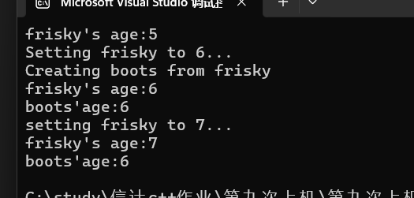
任务4：
你入职了一家银行，发行了一款银行卡（储蓄卡），要求你针对这个银行卡开发一款软件，要求：
- 银行卡具备储蓄卡的基本功能，例如【账户】、【密码】、【余额】、【存款】、【取款】、【改密码】等。
- 针对新用户可以【新办】卡。
- 可以【销毁】卡。
- 支持【换卡】，即把旧卡拷贝到新卡后再销毁旧卡。
- 有【提示】功能，开户、销户、存取款等操作时会有屏幕提示。
- 有【日志】功能，某个卡相关的开户、销户、存取款等操作时会保存日志记录，可以打印出该卡下面的全部日志记录。
请把代码粘贴在下方，并通过几个典型示例把运行结果粘贴在下方。

#include <iostream>
#include <string>
#include <vector>
using namespace std;

class bank {
public:
bank();
bank(const bank& s);
~bank();

string getnewbankid() const { return *id; }
void setnewbankid(string id1) {
*id = id1;
addlog("您的账户是 " + id1);
cout << "您的账户是： " << id1 << endl;
}

string getnewpassword() const { return *password; }
void setnewpassword(string pass) {
*password = pass;
addlog("您的密码更改为 " + pass);
cout << "更改密码成功." << endl;
}

int getbalance() const { return *balance; }
void new_deposit(int amount);
void new_withdrawal(int amount);

static bank openNewAccount();
void printLogs() const;
void printbalance() const;
void changeCard();

private:
void addlog(const string& message);

protected:
string* id;
string* password;
int* balance;
vector<string> logs;
};

// 默认构造函数
bank::bank() {
id = new string("11111");
password = new string("666666");
balance = new int(0);
}

// 拷贝构造函数
bank::bank(const bank& s) {
id = new string(*s.id);
password = new string(*s.password);
balance = new int(*s.balance);
logs = s.logs;
}

// 析构函数
bank::~bank() {
addlog("您已成功销毁此卡");
delete id;
delete password;
delete balance;
}

// 存款
void bank::new_deposit(int amount) {
*balance += amount;
addlog("存款 " + to_string(amount) + " 元");
cout << "您已成功存款: " << amount << " 元" << endl;
}

// 取款
void bank::new_withdrawal(int amount) {
if (amount <= *balance) {
*balance -= amount;
addlog("取款 " + to_string(amount) + " 元");
cout << "您已成功取款 " << amount << " 元" << endl;
}
else {
cout << "余额不足，无法取款!" << endl;
}
}

// 新办卡功能
bank bank::openNewAccount() {
bank newaccount;
newaccount.addlog("创建一个新账户");
cout << "您已成功创建一个新账户" << endl;
return newaccount;
}

// 换卡功能
void bank::changeCard() {
bank newAccount(*this);
addlog("账户已更换为新卡");
cout << "您的账户已成功更换!" << endl;

delete id;
delete password;
delete balance;

id = new string(*newAccount.id);
password = new string(*newAccount.password);
balance = new int(*newAccount.balance);
}

// 打印日志
void bank::printLogs() const {
cout << "账户操作明细:" << endl;
for (const auto& log : logs) {
cout << log << endl;
}
}

// 打印余额
void bank::printbalance() const {
cout << "您当前的余额是: " << *balance << " 元" << endl;
}

// 添加日志
void bank::addlog(const string& message) {
logs.push_back(message);
}

int main() {
bank* now_account = nullptr;
bool running = true;
cout << "请选择您的操作:\n"
<< "1、创建新账户\n"
<< "2、修改密码\n"
<< "3、查询余额\n"
<< "4、存款\n"
<< "5、取款\n"
<< "6、查询明细\n"
<< "7、结束\n"
<< "8、换卡\n";

while (running) {
int a;
cout << endl << "输入操作编号: ";
cin >> a;

switch (a) {
case 1: {
delete now_account; // 删除旧账户
now_account = new bank(bank::openNewAccount()); // 创建新账户
break;
}
case 2: {
if (now_account) {
string newpassword;
cout << "请输入您的新密码: ";
cin >> newpassword;
now_account->setnewpassword(newpassword);
}
else {
cout << "请先创建新账户！" << endl;
}
break;
}
case 3: {
if (now_account) now_account->printbalance();
else cout << "请先创建新账户！" << endl;
break;
}
case 4: {
if (now_account) {
int amount1;
cout << "请输入您想存款的数目: ";
cin >> amount1;
now_account->new_deposit(amount1);
}
else {
cout << "请先创建新账户！" << endl;
}
break;
}
case 5: {
if (now_account) {
int amount2;
cout << "请输入您想取款的数目: ";
cin >> amount2;
now_account->new_withdrawal(amount2);
}
else {
cout << "请先创建新账户！" << endl;
}
break;
}
case 6: {
if (now_account) now_account->printLogs();
else cout << "请先创建新账户！" << endl;
break;
}
case 7: {
running = false;
cout << "操作结束，感谢您的使用!" << endl;
break;
}
case 8: {
if (now_account) {
now_account->changeCard();
}
else {
cout << "请先创建新账户！" << endl;
}
break;
}
default:
cout << "无效的操作编号，请重新输入!" << endl;
}
}
delete now_account; // 退出时清理内存
return 0;
}

