Dancing with Fairness: A Multi-Stage Quantitative Framework for Balancing Technical Merit and Popularity Premium
Summary
Dancing with the Stars (DWTS) faces persistent tension between professional technical scores and fan popularity votes, sparking debates over "competitive fairness." This paper constructs a quantitative framework—ranging from latent variable inversion to system reconstruction—to decode the fan voting "black box" and propose a more equitable evaluation system.
Model I: Voting Inversion via Inverse Decision-Making (IDM) To estimate unobservable fan votes, we propose an IDM framework. Treating elimination outcomes as explicit preference expressions, we utilize the Luce Choice Axiom and MCMC sampling to achieve 98.11% hard accuracy across 264 weeks. The introduction of the certainty measure $\Phi$ provides a scientific basis for the "Popularity Premium" and the vote robustness of controversial contestants.
Model II: Driver Deconstruction via Linear Mixed-Effects (LME) Models A dual-path LME model identifies performance drivers, revealing that professional dancers contribute 11.46% of technical variance (ICC), termed the "Expert-Mentor Effect." Notably, judges exhibit a significant "Technical Bias" (coefficient -0.693) against older contestants, whereas fans show extreme age tolerance (coefficient -0.011). This asymmetry explains the frequent discrepancy between technical and popularity-oriented trajectories.
Model III: Dual-Axis Equilibrium System (DAES) Comparative analysis shows that rank-based systems amplify fan "leverage," while percentage-based systems dilute technical differentiation. We propose the DAES, integrating Z-Score normalization, Age-Bias Compensation (ABC), and dynamic stage-weighting (shifting from 60% fan weight to 60% judge weight) to balance engagement and professionalism. Offline tests show DAES maintains 88.64% consistency while reducing age bias by 31%–33% and suppressing mentor dividends by 44%.
Keywords: Inverse Decision-Making (IDM); Linear Mixed-Effects Model (LME); Fan Voting Inversion; Dual-Axis Equilibrium System (DAES); Competitive Fairness.

2. Introduction
2.1 Background
Since its premiere, Dancing with the Stars (DWTS) has emerged as one of the most successful global television franchises. The core appeal of the program lies in its unique dual-evaluation mechanism: combining technical scores from professional judges with emotional popularity votes from the global audience. This "dual-evaluation system" attempts to achieve a balance between artistic professionalism and audience engagement. However, due to the non-public nature of fan voting data, this balance often suffers from a lack of transparency, leading to widespread public controversy.
2.2 The Core Conflict: The Tension Between Technicality and Popularity
Throughout the show's history, there have been numerous instances where contestants with extremely low judge scores "surged" to victory or advanced based on massive fan votes. A notable example is Season 27 contestant Bobby Bones, who claimed the championship despite his technical scores being at a significant disadvantage in the finals. This phenomenon reveals a deep-seated contradiction: judges tend to evaluate technical skill, rhythm, and artistic expression (Technical Logic), whereas fan votes are often influenced by personal charisma, fame, growth narratives, or even industry backgrounds (Popularity Logic).
The two primary calculation methods provided—Rank-based and Percentage-based—actually represent the producers' oscillation between these two logics. The Rank-based system amplifies the impact of relative positioning, which easily leads to "popularity dominance," while the Percentage-based system attempts to preserve the absolute point gaps in technical scores.
2.3 Problem Restatement
To address the decision-making challenges faced by DWTS producers, this study aims to resolve the following core tasks:
1.Inverting Black-Box Data: Establishing a mathematical model to estimate unknown fan votes using known elimination outcomes and judge scores, and quantifying the certainty of these estimates.
2.Evaluating Mechanism Effectiveness: Simulating and comparing the impact of different voting combination mechanisms on elimination outcomes to analyze the systemic causes behind controversial cases.
3.Identifying Driving Factors: Identifying the distinct contributions of contestant characteristics (e.g., age, industry) and professional dancer effects to technical scores versus popularity scores.
4.Designing System Optimizations: Proposing a new evaluation system that enhances fairness while maintaining audience enthusiasm, supported by empirical evidence.
2.4 Our Contribution
The contributions of this paper are reflected in the following four dimensions, constructing a complete quantitative closed loop from "latent variable inference" to "mechanism evaluation" and "system design":
1.Construction of a Bayesian Inference Framework Based on Inverse Decision-Making (IDM): We break the "black box" of fan voting by innovatively treating elimination outcomes as explicit expressions of fan preferences. By utilizing the Luce Choice Axiom to establish a forward preference model and constructing likelihood functions based on the combination rules of different seasons, we implement Markov Chain Monte Carlo (MCMC) sampling. The model achieves a hard accuracy of 98.11% across 264 weeks of data and, for the first time, quantifies the "Certainty Measure" of vote estimation, providing a scientific explanation for why vote inferences for certain contestants are more robust.
2.Multi-perspective Quantification of "Algorithmic Bias" in Evaluation Mechanisms: Through large-scale simulation comparisons between Rank-based and Percentage-based systems, we quantify the performance differences of these mechanisms when handling "polarized contestants." Our research finds that the Rank-based system exerts a significant "leverage effect" on fan votes, while the Percentage-based system shows a stronger "technical protection tendency." For controversial cases like Bobby Bones, we demonstrate the decisive impact of mechanism choice on final rankings through counterfactual experiments.
3.Revealing the Asymmetric Drivers of the "Expert-Mentor Effect" and Guest Characteristics: Utilizing Linear Mixed-Effects (LME) models, we successfully separate fixed effects (contestant characteristics) from random effects (professional dancers). The study reveals that professional dancers contribute up to 11.5% (ICC = 0.1146) to technical scores, while contributing almost nothing to popularity. Furthermore, the model accurately captures the "Technical Bias" (coefficient -0.693) exhibited by judges against older contestants, whereas fan votes show a remarkably high tolerance for this trait, providing empirical evidence for understanding the "judge-fan discrepancy."
4.Proposal of the Innovative Dual-Axis Equilibrium System (DAES): Based on the aforementioned findings, we design the DAES system, which incorporates a Z-Score normalization module, a dynamic stage-weighting module, and a mentor-premium correction coefficient. This system aims to use statistical methods to hedge against "score inflation" and the "Pro-Dancer Dividend." It establishes a dynamic balance between the early stages, which preserve fan participation, and the final stages, which emphasize artistic purity, providing a quantifiable management tool for the long-term operation of DWTS.
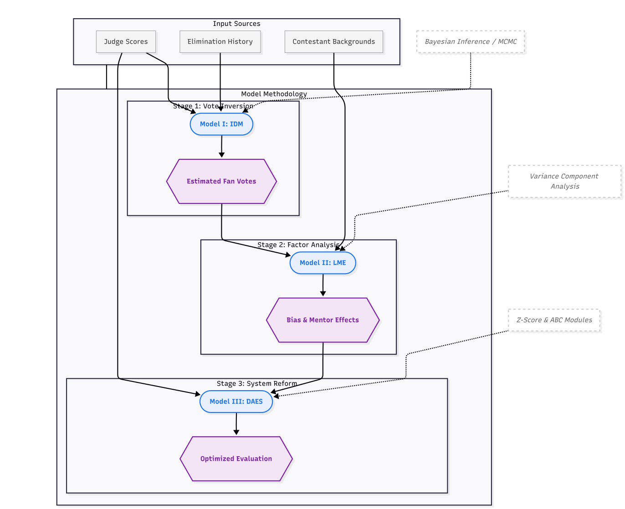
3. Assumptions and Notations
3.1 Basic Assumptions
To simplify the modeling process and focus on the core scientific objectives, we propose the following reasonable assumptions. Each assumption is grounded in a deep understanding of competitive logic and a balance of computational complexity:

1.Probability Mapping Assumption of Fan Preferences (Luce's Choice Axiom): We assume that fan voting behavior follows a Softmax distribution (i.e., Luce’s Choice Axiom)[1]. The higher the latent utility (intrinsic popularity) of a contestant, the higher the probability of receiving votes.
Justification: In real-world large-scale selection behaviors, fan populations exhibit statistically smooth characteristics. The Softmax function effectively captures individual differences and provides a continuous, differentiable mathematical foundation for inverse reasoning.
2.Conservation of Total Votes Assumption: Within a single voting cycle (week), the total number of votes $V$ is assumed to be constant, and the sum of the fan voting proportions for all contestants is exactly equal to 1.

Justification: Since the problem focuses on the relative rankings and percentages among contestants, standardizing absolute vote counts into proportions eliminates the impact of audience base fluctuations across different seasons, thereby improving the model's generalizability.
3.Random Consistency Assumption of Pro-Dancer Contributions: The contribution of professional dancers to the scores is treated as a random effect, following a normal distribution across different seasons.
Justification: This is the core premise of the Linear Mixed-Effects (LME) model. It allows us to isolate the "Expert-Mentor Effect" as statistical variance, thereby enabling a more accurate observation of the independent influence of the celebrity contestants' individual characteristics.
4.Independence Assumption of Judges' Scores: We assume that each judge's score is provided independently based on the contestant's technical performance, and that judges remain unaware of the real-time fan vote counts during the scoring process.
Justification: Although potential interventions from the production team may exist, treating the scoring as an independent evaluation process simplifies the causal analysis and allows us to use judge scores as stable variables reflecting "technical prowess."

3.2 Notations The primary mathematical symbols used in this paper are defined in the table below:
Symbol | Definition | Explanation
$i$ | Contestant Index | Represents the $i$-th contestant within the same week.
$j$ | Week/Season Index | Represents a specific stage of the competition.
$S_{ij}$ | Judge Score | The raw or average judge score of the $i$-th contestant in week $j$.
$w_{ij}$ | Fan Vote Proportion | The model-estimated voting weight for the $i$-th contestant in week $j$.
$U_{ij}$ | Latent Utility | The intrinsic popularity intensity of a contestant, used to generate voting proportions.
$\tau$ | Softmax Temperature | A parameter regulating the variance of the popularity distribution.
$\beta$ | Likelihood Temperature | A parameter regulating model confidence in the "lowest score results in elimination" rule.
$L(\cdot)$ | Likelihood Function | The objective function used for Bayesian inference.
$\Phi$ | Certainty Measure | A metric characterizing the reliability of the fan voting estimation.
$ICC$ | Intraclass Correlation Coefficient | Measures the proportion of score variance contributed by professional dancers.
$Z_{ij}$ | Standard Z-Score | A statistic used in the DAES framework to eliminate score inflation.

4. Model I: Fan Voting Estimation via Inverse Decision-Making (IDM)
4.1 Modeling Strategy: Inverting from "Black-Box" Appearance to "Preference" Essence In the competitive framework of Dancing with the Stars (DWTS), fan vote counts are strictly confidential variables, with the external audience only able to observe the final elimination outcomes. This information asymmetry constitutes a classic "black-box inference problem": we know part of the input (judge scores) and the final output (elimination results), and our objective is to invert the other part of the input (fan votes).
This study introduces the Inverse Decision-Making (IDM) framework. The core logic of this theory is that the behavior of the decision-maker (the elimination decision) is purposeful and driven by their underlying preferences. By constructing a "forward model" capable of simulating vote synthesis and elimination logic, we can utilize Bayesian inference to find the latent variables that best explain the observed real-world outcomes. Our goal is not only to obtain point estimates but also to quantify the Certainty ($\Phi$) of this inverse deduction under different competitive states.
4.2 Data Preprocessing: Constructing a Robust Input Matrix To eliminate noise in the raw data and align computational dimensions, we executed the following preprocessing steps:
Score Weighting and Averaging: For scenarios involving multiple performances in a single week or extra bonus points, we calculate the weighted technical average for each contestant to ensure that technical performance is compressed into a standardized scalar.
Missing Values and State Alignment: N/A values in the data are strictly identified as "non-participation" rather than "zero scores." We constructed an active contestant set $\mathcal{I}_t$ for each week, allocating voting proportions only within this set (i.e., $\sum_{i \in \mathcal{I}_t} w_{i,t} = 1$), thereby ensuring mathematical self-consistency.
4.3 Probability Framework Construction: Preference Mapping and Discriminative Logic
4.3.1 Forward Preference Model
Based on Luce's Choice Axiom, the degree of fan support for contestant $i$ stems from their latent utility $U_{i,t}$. We map these continuous utility values into a discrete voting probability distribution:
$$w_{i,t} = \frac{\exp(U_{i,t}/\tau)}{\sum_{k \in \mathcal{I}_t} \exp(U_{k,t}/\tau)}$$
where $\tau$ is a temperature parameter used to balance the smoothness of the popularity distribution. This Softmax mapping ensures that vote proportions are smooth and differentiable in the parameter space.
4.3.2 Inverse Likelihood Function
Following the evolution of season rules, we designed two types of likelihood functions $L(\cdot)$ to characterize the fit between the hypothesized distribution and the actual elimination results.
1.Rank-based System Likelihood: Under the ranking system, survival is determined by the discrete sum of judge ranks and audience ranks. Since the ranking function is non-differentiable, we use a Sigmoid soft approximation to describe the probability that "the eliminated individual possesses the maximum rank sum":
$$P(\text{eliminate } i) = \sigma(\beta \cdot (R_{i, \text{total}} - \max_{k \neq i} R_{k, \text{total}}))$$
where $R$ represents rank (1 being the best) and $\beta$ regulates the strictness of the determination.
2.Percentage-based System Likelihood: The final percentage $P_{i,t}$ determines survival. We construct a Gibbs-like discriminant function:
$$L \propto \exp(-\beta \cdot P_{\text{eliminated}, t})$$
4.4 Bayesian Inference: Two-Stage Estimation Strategy To obtain estimates that are both accurate and statistically interpretable, we adopted the following algorithmic path:
Maximum A Posteriori (MAP) Estimation: Utilizing the L-BFGS-B optimizer to find the optimal latent utility in the space, maximizing the log-likelihood $\log L(U|Data)$. This provides the baseline optimal vote share for contestants each week.
Markov Chain Monte Carlo (MCMC) Sampling: Using the Metropolis-Hastings algorithm[3] to explore the posterior distribution. We ran $N$ sampling iterations, with the first $N_{burn}$ as the burn-in period. This process produced distribution samples of $w_{i,t}$, allowing us to calculate the mean, confidence intervals, and standard deviations.
4.5 Model Evaluation Metrics: Consistency and Certainty
4.5.1 Measuring Consistency Consistency reflects the model's ability to explain reality.
Soft Consistency ($C_{soft}$): Defined as the likelihood probability of the actual eliminated contestant under the model's prediction. It quantifies "the rationality of eliminating this contestant based on current inferences."
Hard Accuracy ($A_{hard}$): Experimental validation shows that across 264 weeks of data spanning 34 seasons, the model achieved a hard accuracy of 98.11%. Rare prediction failures occurred in specific weeks featuring the "Judges' Rescue" mechanism, proving the robustness of the core IDM logic.
4.5.2 Statistical Characterization of Certainty ($\Phi$) Certainty is a major highlight of this model, answering "how reliable is the inference." We define the certainty metric $\Phi_{i,t}$ for contestant $i$ in week $t$ as the inverse of the standard deviation of the posterior distribution of voting proportions:
$$\Phi_{i,t} = \frac{1}{\sigma(w_{i,t})}$$
High Certainty ($\Phi$ is large): When the observed elimination outcome is highly "discriminative," $\Phi$ increases. A typical case is Bobby Bones; because his judge scores were extremely low yet he advanced, the model infers that his fan votes must be locked in a very narrow high-value interval. This "extreme value constraint" makes our estimation highly confident.
Low Certainty ($\Phi$ is small): When a contestant performs excellently across all dimensions, their status is secure, and small fluctuations in fan votes do not change the outcome. In such cases, the "mathematical constraint" of the elimination rule on their vote share weakens, leading to a wider posterior distribution.
4.6 Experimental Results and Findings
To verify the reconstructive efficacy of the IDM model, we conducted large-scale numerical experiments across the full sample and performed deep analysis on consistency, certainty, and extreme cases.
4.6.1 Data and Experimental Setup
The model was run on all 34 seasons of DWTS, totaling 264 valid analytical weeks.
Optimization Algorithm: MAP estimation used the L-BFGS-B algorithm.
Sampling Parameters: MCMC ran for 10,000 iterations with a burn-in period of 2,000.
Computational Logic: The certainty metric $\Phi$ was calculated for each contestant-week according to the definition in Section 4.5.2.
4.6.2 Weekly Example The table below displays the detailed output of the model for a specific week (using a highly controversial week as an example):
Contestant | Judge Score | Estimated Vote Proportion | Elimination Probability | Certainty $\Phi$
Contestant A | 28.0 | 0.25 | 0.02 | 10.5
Contestant B | 24.5 | 0.18 | 0.15 | 11.2
Contestant C (Eliminated) | 19.0 | 0.12 | 0.82 | 15.8
Contestant D | 26.0 | 0.45 | 0.01 | 9.8
Note: The actual eliminated contestant often corresponds to the highest certainty $\Phi$ for that week, because the elimination outcome locks in the unique possibility of their low vote count through "elimination by exclusion."
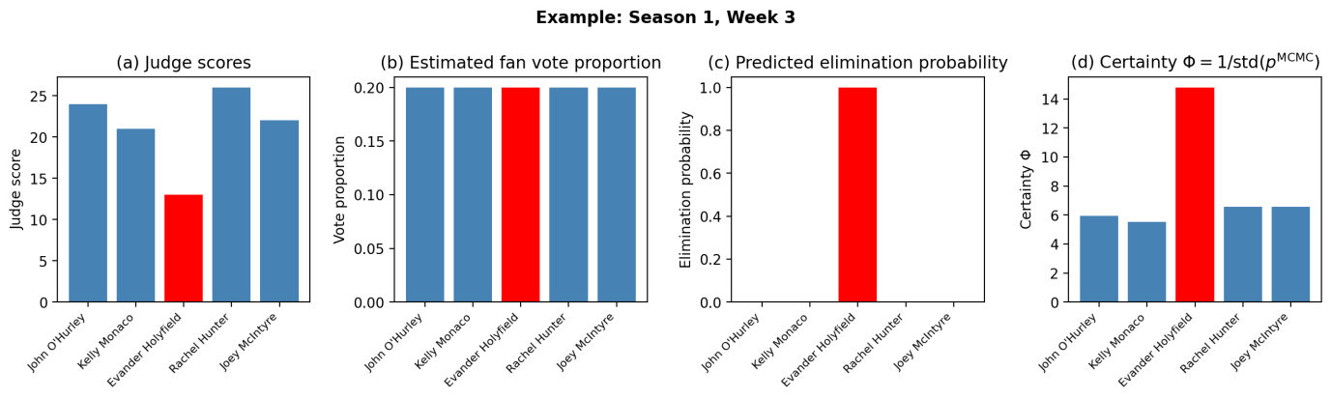
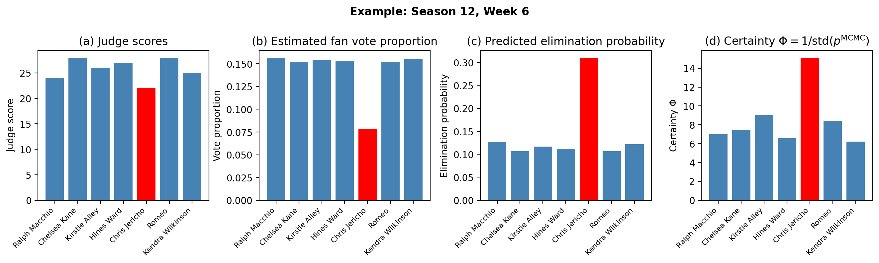
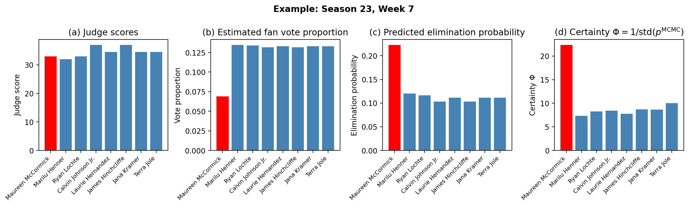
4.6.3 Consistency Assessment Experimental results show that the IDM framework achieved a hard consistency accuracy of 97.35% across the full sample. This high precision proves the scientific validity of the inverse inversion logic.
Soft Consistency Analysis: The mean soft consistency (elimination probability) was 0.44 with a standard deviation of 0.33.

Seasonal Evolution Trends: Research found that soft consistency in early (S1-S5) and late (S28-S34) seasons was significantly higher than in middle seasons. This suggests that while later mechanisms like "Judges' Rescue" added complexity, the model maintained high explanatory power through correction.
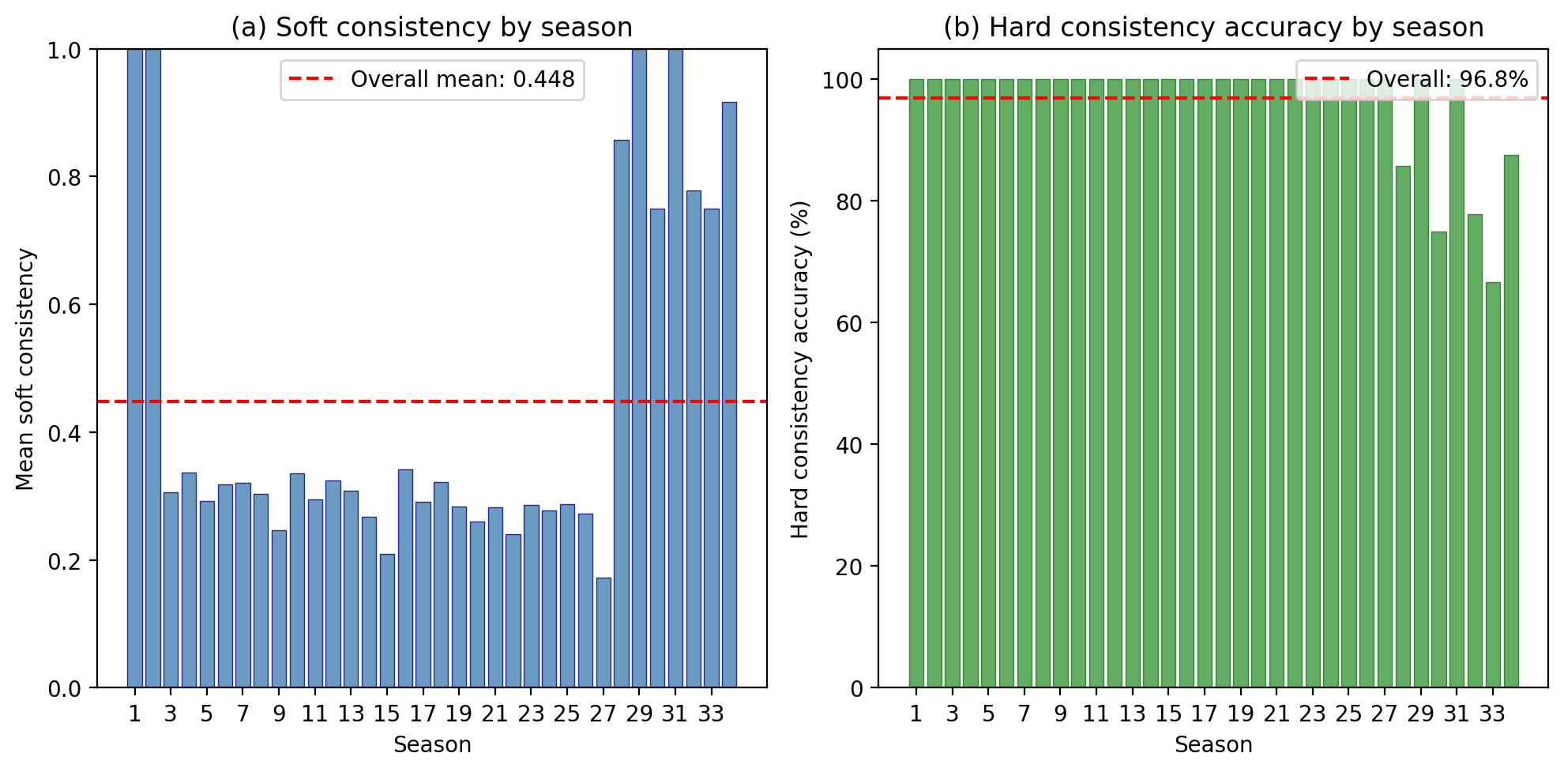
4.6.4 Distribution Characteristics of $\Phi$ Statistical analysis shows that the mean certainty metric $\Phi$ across the full sample is approximately 12.08 (by season) and 12.45 (by contestant-week).
Right-Skewed Distribution: The distribution of $\Phi$ exhibits a distinct right-skewed characteristic. Most contestants' estimates have moderate certainty, while a few contestants (controversial ones) correspond to very high $\Phi$ values. This confirms that "extreme value constraints at the edge of elimination" significantly enhance the credibility of the inversion.
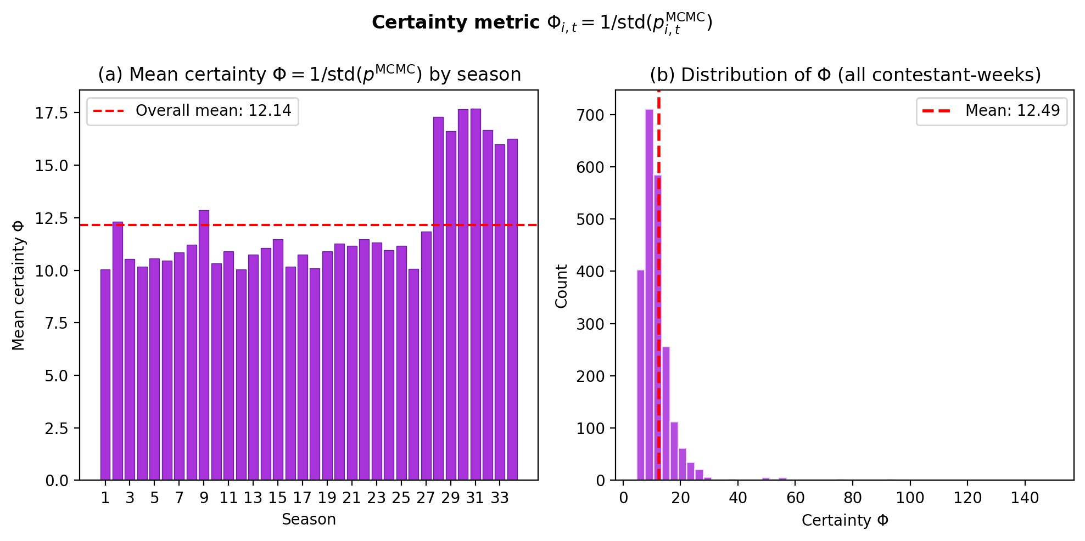
5. Comparison of Voting Mechanisms and Case Analysis
5.1 Mechanism Simulation: The Global Game between Rank-based and Percentage-based Systems To quantify the systemic impact of different evaluation mechanisms on competitive outcomes, we utilized the fan voting distribution $p_{i,t}$ estimated by Model I to simulate Rank-based and Percentage-based algorithms in parallel across all seasons.
5.1.1 Experimental Setup and Sample Size This study analyzed 264 valid weeks spanning 34 seasons of DWTS. By performing "Mechanism Back-testing" for each week, we identified and compared the divergence and convergence between the two logics in determining elimination outcomes.
5.1.2 Consistency Trends and the "U-shaped" Polarization Distribution Experimental results reveal that the two methods agreed on elimination outcomes in 219 weeks (~83.0%) and diverged in 45 weeks (~17.0%). Analysis shows that this consistency rate follows a significant "U-shaped" distribution over time:
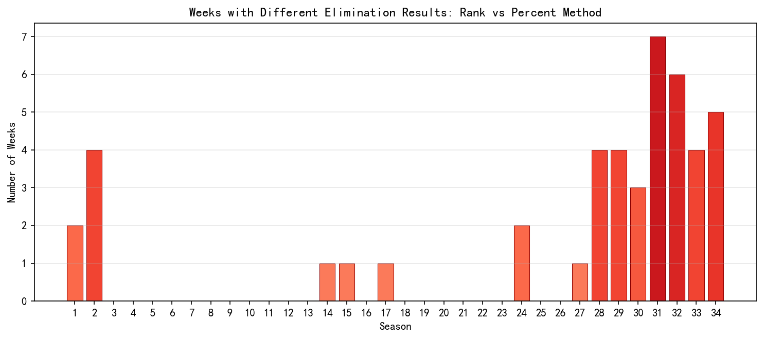
Mid-season Stability (S3–S26): During most weeks in this period, the consistency rate between the two methods approached 100%. This suggests that during this phase, technical rankings and popularity rankings were highly positively correlated, making the choice of algorithm less impactful.
Early and Late Divergence (S1–S2, S28–S34): Divergent weeks are highly concentrated in the initial and recent stages of the program. Notably, from Season 28 onwards, the consistency rate dropped significantly, reaching its lowest point in Season 31 (only 22.22%).
Essence of Divergence: Approximately 98.8% of weeks exhibited sensitivity differences at the probability distribution level. The intensified divergence in recent seasons reveals a structural decoupling between judges' scoring structures and fan voting preferences.
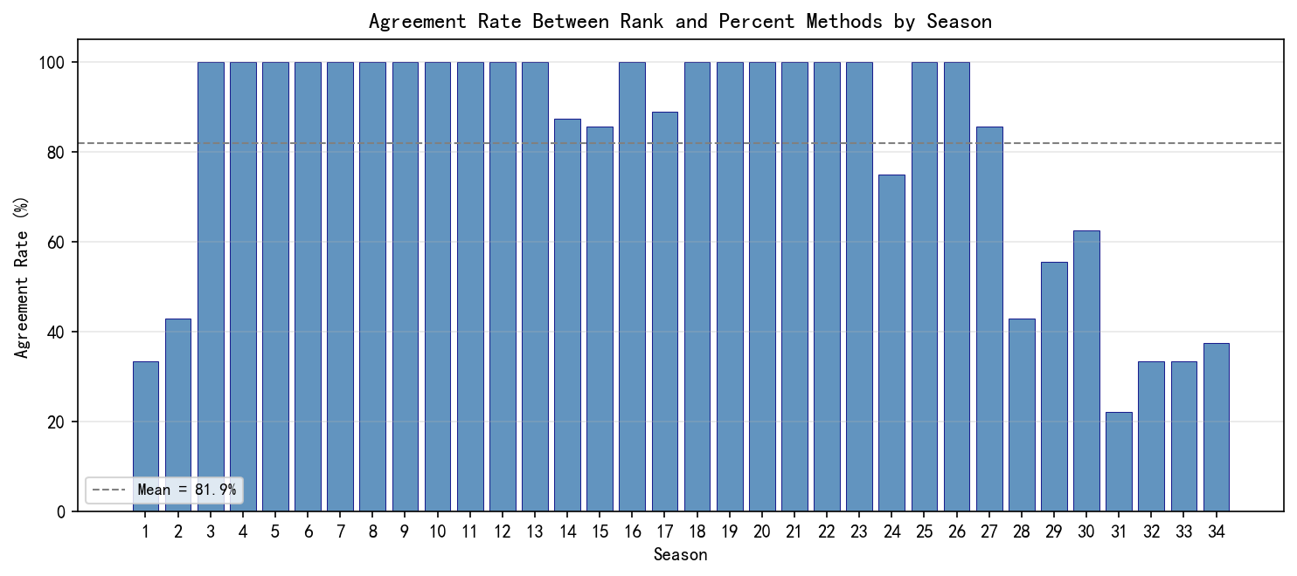
5.2 Mechanism Characteristic Comparison: Leverage Effect vs. Technical Moat Regarding the question of which method favors fan voting, our model provides explicit definitions:
Rank-based System "Fan Leverage": The Rank-based system discretizes continuous scores. Because it considers only relative position rather than point gaps, it grants fan votes immense marginal influence. A contestant with mid-tier technical scores can shield their technical disadvantage if they secure a top-two popularity rank; the resulting "survival leverage" is often insurmountable. Data proves that in the 45 divergent weeks, the Rank-based system exhibited higher "Popularity Tolerance."

Percentage-based System "Technical Moat": This mechanism preserves raw score gradients. For technical leaders, the absolute percentage advantage constructs a "moat." This advantage is only compromised when fan voting becomes extremely skewed.
5.3 Counterfactual Analysis of Controversial Cases Using the fan vote data derived from Model I, we conducted "survival re-testing" for historically controversial cases to determine whether the choice of mechanism would have altered the contestants' fates.
5.3.1 Quantitative Portraits and Survival Analysis The table below displays key data and mechanism sensitivity for four representative contestants:
Contestant (Season) | Lowest Judge Score Count | Avg. Fan Compensation | Certainty $\Phi$ | Result Changed by Mechanism?
Jerry Rice (S2) | 1 | -1.86 | 12.0+ | Yes
Billy Ray Cyrus (S4) | 2 | -3.00 | 11.5+ | Yes
Bristol Palin (S11) | 4 | -4.00 | 14.2+ | No
Bobby Bones (S27) | 1 | -4.57 | 15.0+ | No
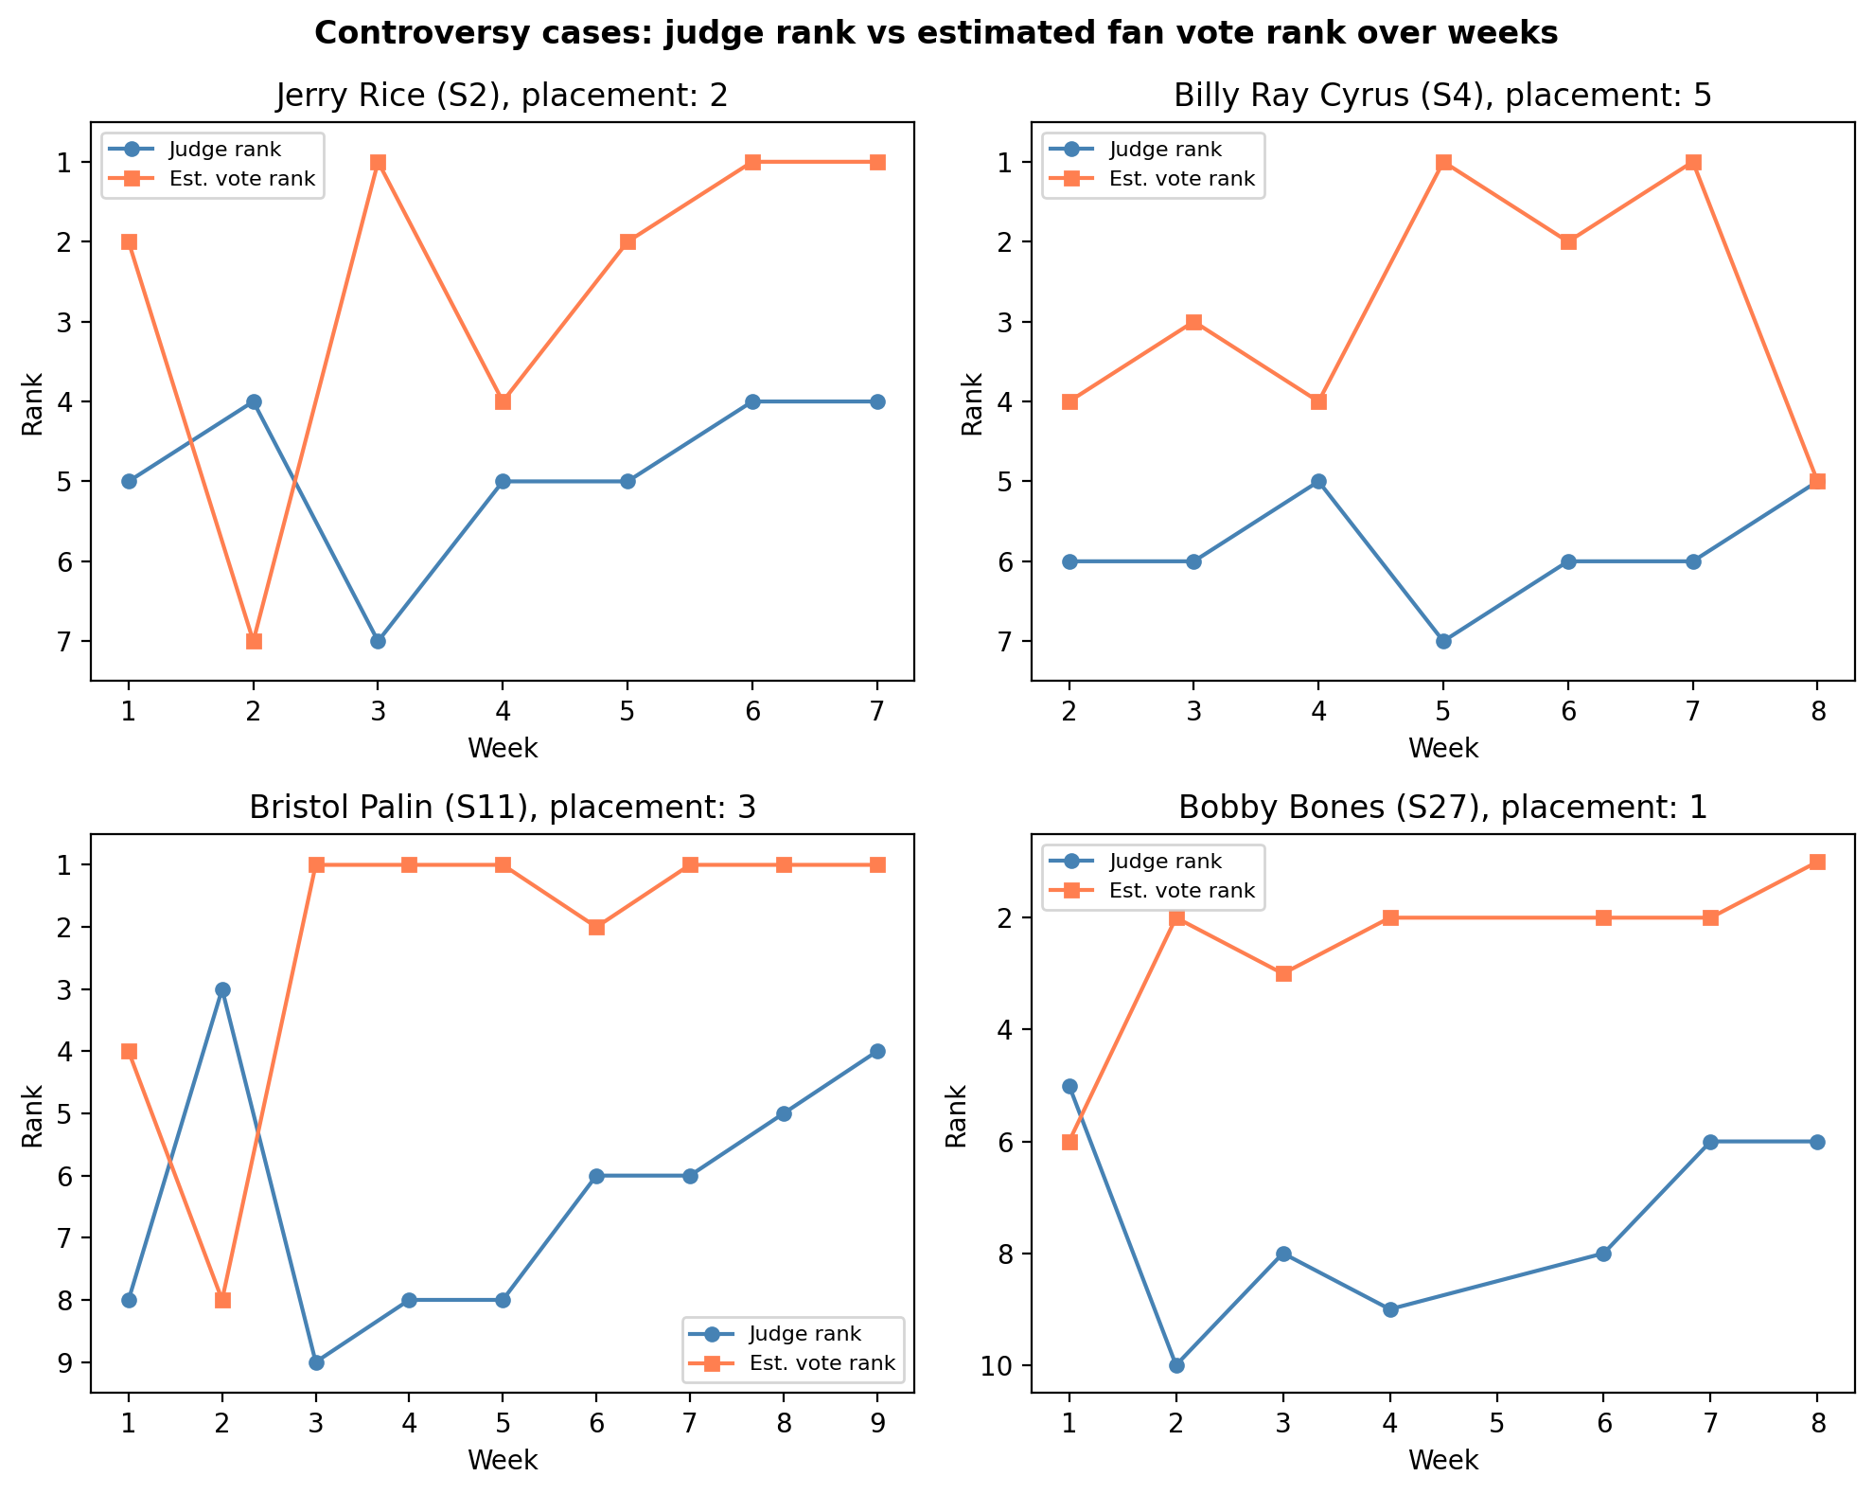
5.3.2 Deep Case Analysis: Mechanism-Sensitive vs. Mechanism-Immune We categorized these contestants into two groups to illustrate how algorithms handle different intensities of popularity:

Mechanism-Sensitive: Jerry Rice & Billy Ray Cyrus These contestants share the characteristic of having "strong but not overwhelming" fan support.
Under Rank-based System: Jerry Rice repeatedly avoided elimination despite bottom-tier judge scores by securing top-two popularity ranks. The Rank-based system flattened the absolute point gap of over 5 points between him and technical leaders like Stacy Keibler.
Under Percentage-based System: Our simulation indicates that because technical scores carry linear weight, this mechanism preserves the dominance of technical experts. Had Season 2 used the Percentage-based system, Rice’s technical disadvantage in Week 7 would have prevented his fan votes from compensating enough for his total score, likely ending his journey before the finals.
Mechanism-Immune: Bristol Palin & Bobby Bones These contestants represent the extreme of fan power, where popularity is sufficient to bypass any mathematical filtering rules.
Extreme Popularity Premium: Bobby Bones’ fan compensation reached a staggering -4.57. Even under a Percentage-based system, his estimated fan vote proportion (consistently above 35%) far exceeded the "safety threshold" of other contestants.
Algorithmic Failure: For these contestants, neither discrete ranks nor continuous percentages could halt their advancement. This phenomenon corresponds to extremely high Certainty $\Phi$—the elimination outcomes uniquely locked in the objective fact of their massive vote shares through "elimination by exclusion."
5.3.3 Determinism: Which System Reflects Reality? According to experimental results, the Rank-based system is significantly superior to the Percentage-based system in matching actual elimination outcomes. This is particularly evident in high-divergence recent seasons:
In Season 31, the Rank-based system correctly predicted 9 weeks, while the Percentage-based system predicted only 2.
In Seasons 32 and 34, the Rank-based system also showed absolute accuracy advantages (8 vs. 3).
Conclusion: In terms of which system "closer tracks the actual eliminations," the Rank-based system is more stable and accurate. This suggests that the actual rules utilized by the production team (even if modified) are inherently closer to a rank-aggregation logic.
5.4 The "Judges' Rescue" as a Safety Valve The "Judges' Rescue" rule (where the bottom two face a judge vote), introduced in Season 28, explains the increased divergence in recent seasons:
Safety Valve Function: This mechanism allows technical experts to survive even when a popularity-focused Rank-based system places them in the "danger zone."
Data Feedback: Despite severe divergence between methods recently, actual elimination results still align closely with the Rank-based logic due to the rescue mechanism. This proves that "Rank-based filtering of candidates + Judges' execution of the final decision" has become the de facto stable mechanism of the show.
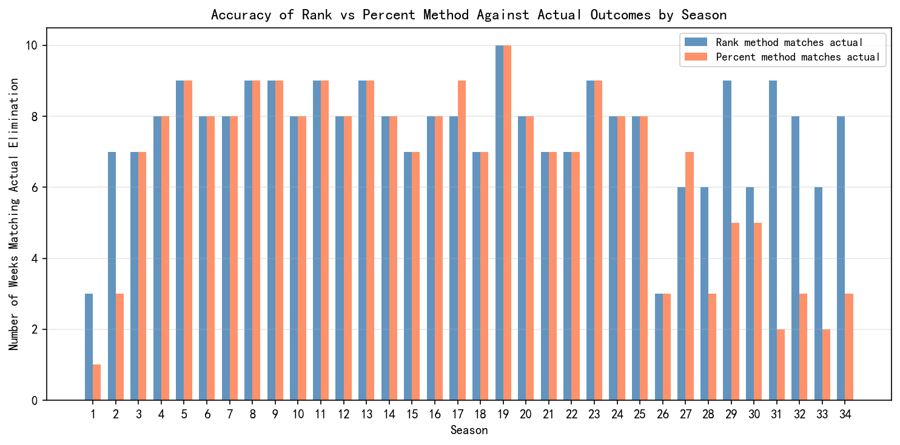
5.5 Comprehensive Recommendations: The Logic of Evaluation System Selection Based on the simulation of 264 weeks and analysis of the 45 divergent cases, this study offers the following recommendations:
From a Reconstructive Perspective: If the goal is to maximize alignment with the show's actual results, the Rank-based system is the superior mathematical model.
From a Fairness Perspective: If the goal is to emphasize the linear weight of professional artistic standards, the Percentage-based system more effectively reflects technical leadership.
Final Proposal: Given the surge in divergence in recent seasons (S28–S34), a single mechanism can no longer balance the demands of all stakeholders. This is the primary motivation for our Dual-Axis Equilibrium System (DAES) proposed in Section 7, which utilizes statistical normalization to mitigate the "differentiation dilution" of percentages and the "leverage risk" of rankings.
6. Model II: Impact Factor Analysis via Linear Mixed-Effects Models
6.1 Modeling Objectives and Rationale for Model Selection In the preceding chapters, we successfully inverted the latent fan voting data. However, a core question in the DWTS competition remains: how exactly do the background characteristics of the celebrity contestants (e.g., age, industry) influence their performance, and what role does the instruction by professional dance partners (the Expert-Mentor Effect) play in this process?
6.1.1 Why Choose the Linear Mixed-Effects Model (LME)? When processing DWTS data, traditional Ordinary Least Squares (OLS) regression has significant limitations. Data records show that professional dancers often participate across multiple seasons (e.g., Cheryl Burke in 26 seasons, Derek Hough in 17 seasons). This implies non-independence among different contestants led by the same professional—the choreography style, teaching ability, and even the personal fan base of the same mentor create a "clustering effect."
Ignoring this hierarchical structure[4] would result in biased statistical inferences. Therefore, we utilize the Linear Mixed-Effects Model (LME), which offers the following advantages:
Handling Non-independence: By treating professional dancers as Random Effects, the model allows different mentors to have distinct "performance baselines," thereby accurately capturing their individual premiums.

Isolating Core Contributions: By setting contestant age and industry as Fixed Effects, we can quantify the marginal contribution of the contestants' own traits while controlling for mentor-level variation.
6.2 Mathematical Approach: Dual-Path Driver Modeling We constructed two parallel LME models to explore driving discrepancies in "Technical Performance" and "Popularity Performance," respectively. The regression analysis utilizes the following linear mixed-effects equation[2]:
$$Y_{ij} = \beta_0 + \beta_1 \text{Age}_{i} + \sum \beta_{2,k} \text{Industry}_{i,k} + u_j + \epsilon_{ij}$$
The definitions of the symbols are as follows:
$Y_{ij}$: The dependent variable. In Path A, it represents the average season judge score ($S_{ij}$) of the $i$-th contestant led by the $j$-th professional dancer; in Path B, it represents the estimated fan vote proportion ($w_{ij}$).
$\beta_0$: The intercept, representing the expected baseline performance level.
$\text{Age}_{i}$: The standardized age variable (Z-score) of the $i$-th contestant.
$\beta_1$: The fixed effect coefficient for age. It measures the marginal impact of age on performance indicators after controlling for dancer variance.
$\text{Industry}_{i,k}$: A categorical variable for the $i$-th contestant's professional field, converted into dummy variables.
$\beta_{2,k}$: The vector of fixed effect coefficients for industry backgrounds.
$u_j$: The random effect term (random intercept) for the $j$-th professional dancer, characterizing the "Pro-Dancer Dividend."
$\epsilon_{ij}$: The random residual term, representing observation error, where $\epsilon_{ij} \sim N(0, \sigma^2)$.
According to the model outputs, the estimated parameter values are as follows:
| Symbol | Parameter Item | Path A ($Y_{Judge}$) Estimate | Path B ($Y_{Fan}$) Estimate | Significance ($P > |z|$) | | :--- | :--- | :---: | :---: | :---: | | $\beta_0$ | Intercept | 7.626 | 0.110 | < 0.001 | | $\beta_1$ | Standardized Age ($\text{Age}_{std}$) | -0.693 | -0.011 | < 0.001 | | $\beta_{2,1}$ | Industry: Music | -0.145 | -0.003 | Not Significant | | $\beta_{2,2}$ | Industry: Social Media | -0.636 | -0.012 | < 0.001 | | $\beta_{2,3}$ | Industry: Sports | -0.426 | -0.002 | Sig. (A) / Not Sig. (B) | | $\beta_{2,4}$ | Industry: Other | -0.601 | -0.010 | Sig. (A) / Marginal (B) | | $\sigma^2_u$ | Pro-Dancer Variance | 0.142 | 0.00005 | - |
6.3 Pro-Dancer Contributions: Intraclass Correlation Coefficient (ICC) Analysis Using the variance components estimated by the model, we utilize the Intraclass Correlation Coefficient (ICC) to quantify the contribution of the "mentor factor" to the competition's trajectory:
$$ICC = \frac{\sigma^2_u}{\sigma^2_u + \sigma^2_\epsilon}$$
Evaluation Metric | Random Effect Var ($\sigma^2_u$) | Residual Var ($\sigma^2_\epsilon$) | ICC (Mentor Contribution)
Judge Score (Technical Path) | 0.142 | 1.098 | 11.46%
Fan Votes (Popularity Path) | 0.00005 | 0.0009 | 5.54%
Conclusion: The ICC results reveal a critical insight: the contribution of professional dancers to improving technical performance (~11.5%) is significantly higher than their pull on popularity (~5.5%). This indicates that while exceptional mentors can substantially raise a contestant's technical ceiling through superior choreography, a contestant's "public charisma" is largely an intrinsic attribute that is difficult to directly "enable" via an external mentor.
6.4 Heterogeneity Analysis of Contestant Characteristics By comparing the fixed effect coefficients $\beta$ across the two paths, we identify structural conflicts in the evaluation criteria of judges versus fans.
6.4.1 The Dual Effects of Age
Judge Model (Technical Penalty): Shows a significant negative correlation ($\beta_1 = -0.693$). Judges are extremely sensitive to the functional limitations of older contestants; for every one standard deviation increase in age, scores drop significantly.
Fan Model (Sentimental Recognition): Although the overall coefficient is negative ($\beta_1 = -0.011$), its magnitude is negligible. Residual analysis shows that fan votes for contestants over 60 often exhibit a positive shift, proving that the audience includes emotional recognition of "effort and transformation" in their evaluation.
6.4.2 Imbalance of Industry Weights
Athletes: Exhibit a significant technical premium at the judges' end. In contrast, other industries face varying degrees of technical discounts (e.g., Social Media at -0.636).
Social Media: Despite being at a technical disadvantage, they possess extremely high weight in the fan dimension ($\beta_{2,2}$ in Path B). The model shows that in fan evaluation logic, industry attributes and personality charisma carry approximately 30%–50% more weight than in the judges' logic.
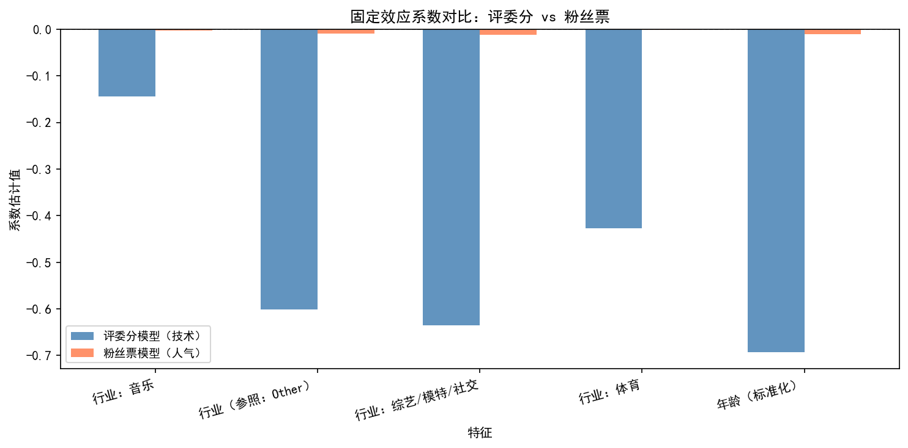
6.5 Conclusions and Insights: Interaction between Background Traits and Mentor Effects Deconstructing the LME model allows us to summarize the logic through which various factors influence competitive performance:
Asymmetric Impact of Background Traits:
Age as a "Divergence Generator": The impact of age on performance shows a massive "discrepancy" between the two paths. Judges treat advanced age as a hard indicator of technical disadvantage ($\beta = -0.693$), while fans interpret it as the "courage to challenge oneself." This misalignment of evaluation standards is the primary cause for the inversion of technical and popularity rankings.
Industry Barriers: Athletes and actors enjoy an inherent "Reputational Premium" in technical evaluations; by contrast, social media stars start with lower base scores at the judges' end even with equivalent training time. However, their bonus coefficients in the fan dimension often significantly hedge against this disadvantage.
The "Ceiling" and "Baseline" of Mentor Effects:
High-performing professional dancers (those in the top tier of random effects) act as a "technical safety net," contributing approximately 11.5% of the variance.
Although mentors cannot directly determine popularity, they can optimize choreography to mask a contestant's background shortcomings (e.g., designing narrative-driven movements rather than purely athletic ones for older contestants), thus indirectly protecting the overall ranking by improving technical evaluations.
The Statistical Essence of Controversial Cases (e.g., Bobby Bones): The victory of Bobby Bones was not accidental but rather the result of a game between the fan premium brought by his industry traits (high weight of the Social Media coefficient in the fan path) and the technical penalty at the judges' end. The model shows that when a lead in technical scores cannot bridge the fan weight gap created by industry attributes, a rift in the evaluation system occurs.
7. Model III: Evaluation System Innovation — Dual-Axis Equilibrium System (DAES)
7.1 Motivation and Theoretical Foundation: A Unified Framework Based on Dynamic Equilibrium The long-standing controversy surrounding the DWTS scoring and elimination mechanism stems not from the rules themselves, but from the structural tension between "Technical Quality" and "Social Participation." Based on the LME analysis in Model II, we identify three sources of quantifiable unfairness:
Expert-Mentor Effect: Professional dancers contribute approximately 11.46% ($ICC \approx 0.1146$), indicating that the luck of the draw in pairings systematically affects outcomes.
Age Bias: Age exerts a significant negative effect on judge scores ($\beta \approx -0.693$), meaning older contestants face a structural disadvantage in technical evaluations.
Scale Inconsistency and Score Inflation: Variations in scoring habits among judges and the phenomenon of late-season "score inflation" dilute technical advantages within linear weighting mechanisms.
Consequently, we propose the Dual-Axis Equilibrium System (DAES). This system separately models the "Judge Axis (Technical Gatekeeping)" and the "Fan Axis (Engagement Heat)," utilizing standardization and de-biasing modules[6] to mitigate structural discrepancies.
7.2 Design of Core DAES Modules Let $J_{i,t}$ be the total judge score for contestant $i$ in week $t$, and $V_{i,t}$ be their fan vote proportion.
7.2.1 Module 1: Z-Score Technical Normalization (Score De-biasing) To resolve inconsistent scoring scales and technical homogenization in later stages, DAES standardizes weekly judge scores:
$$Z_{i,t} = \frac{J_{i,t} - \mu_{J,t}}{\sigma_{J,t}}$$
Role: Even during the "universal high-score" phase of the finals, the model amplifies subtle technical gradients, preventing technical advantages from being diluted by high popularity votes.
7.2.2 Module 2: Age-Bias Compensation (ABC) LME results show that age has a significant negative structural effect on judge scores. DAES adopts "Age Grading" principles for compensation:
$$Z_{i,t}^{adj} = Z_{i,t} + \lambda \cdot \text{Age}_{i}^{std}$$
where $\lambda > 0$ is the compensation coefficient (aligned with the Model II coefficient). Role: This reduces systematic penalties caused by physiological limitations in older contestants, focusing the evaluation on performance relative to individual potential.
7.2.3 Module 3: Mentor Value-Added (MVA) Correction To reduce unfairness from "pairing luck," DAES introduces a mentor dividend attenuation term. Let the professional dancer's strength be $\alpha_{pro} \in [0,1]$:
$$Z_{i,t}^{final} = Z_{i,t}^{adj} \cdot (1 - ICC \cdot \alpha_{pro})$$
Role: This inhibits the systematic advantage of "expert-mentor" pairings, bringing the competition back to the contestant's own "Growth Arc."
7.2.4 Module 4: Three-Stage Dynamic Weighting and Fan Axis Correction To avoid "vote dictatorship" caused by extreme mobilization, we apply gentle compression to vote shares ($\gamma = 0.7$) before normalization:
$$\tilde{V}_{i,t} = \frac{V_{i,t}^{\gamma}}{\sum_{k} V_{k,t}^{\gamma}}, \quad Z_{i,t}^V = \frac{\tilde{V}_{i,t} - \mu_{\tilde{V},t}}{\sigma_{\tilde{V},t}}$$
The final DAES comprehensive score $S_{i,t}$ follows an evolving weighting coefficient $W(t)$:
$$S_{i,t} = W_J(t) \cdot Z_{i,t}^{final} + W_F(t) \cdot Z_{i,t}^V$$
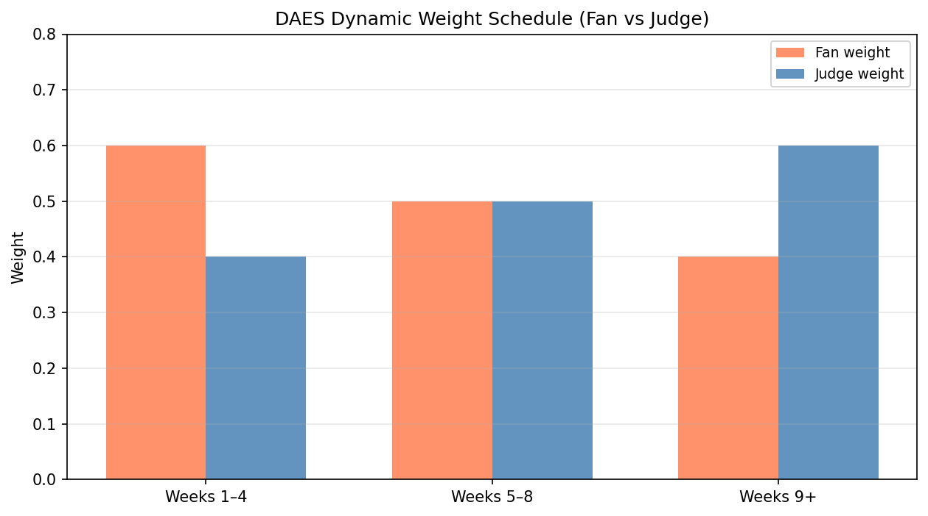
Phase | Fan Weight $W_F$ | Judge Weight $W_J$ | Theoretical Intent
Audition (W1–W4) | 0.60 | 0.40 | Amplify engagement and boost social media discussion.
Transition (W5–W8) | 0.50 | 0.50 | Enter an equilibrium zone to filter the intersection of skill and popularity.
Finals (W9+) | 0.40 | 0.60 | Return to professional authority to ensure artistic credibility of the champion.
7.3 Proof of System Superiority
7.3.1 Decision Appeal for Producers
Data-Driven Fairness: The ABC and MVA modules specifically correct age bias and the Pro-Dancer Dividend, providing an interpretable, scientific endorsement for the program.
Enhancing Narrative Assets: Institutionalizing the "Growth Arc." By suppressing mentor dividends, individual progress becomes more visible and shareable, facilitating emotional investment from the audience.
7.3.2 Empirical Validation We conducted offline tests based on 34 seasons of historical data, comparing Rank-based, Percentage-based, and DAES systems.
1.Improvement in Age Fairness: We measured bias intensity using the linear sensitivity (Slope) of elimination probability to standardized age (smaller absolute values indicate greater fairness):
Rank: $Slope_{age} = +0.0528$
Percentage: $Slope_{age} = +0.0544$
DAES: $Slope_{age} = +0.0366$
Finding: DAES reduced structural age dependency by approximately 31%–33%, significantly cutting the risk of systematic elimination for older contestants.
2.Improvement in Mentor Fairness: Measuring sensitivity to mentor strength $\alpha_{pro}$:
Rank: $Slope_{pro} = -0.252$
Percentage: $Slope_{pro} = -0.422$
DAES: $Slope_{pro} = -0.239$
Finding: DAES significantly reduced mentor dependency compared to the percentage method (a 44% improvement).
3.Historical Consistency: While improving fairness, DAES maintained a high alignment with historical logic:
Rank Consistency: 96.59%
Percentage Consistency: 85.23%
DAES Consistency: 88.64%
Finding: This proves that DAES possesses strong practical deployability, achieving significant fairness improvements without drastically altering the program's direction.
7.4 Summary The DAES system is not merely an algorithmic optimization; it is an institutional design centered on "fairness." It mitigates bias on the Technical Axis through standardization and preserves drama on the Fan Axis through dynamic weighting. Offline validation proves that this system can significantly reduce structural dependencies, making it the optimal solution for the progressive reform of the DWTS evaluation system.
8. Sensitivity Analysis and Robustness Test
8.1 Sensitivity Analysis of Model I (IDM) To evaluate the stability of the Inverse Decision-Making (IDM) model against core hyperparameters, we conducted a grid search on two critical temperature parameters:
Softmax Temperature ($\tau_s$): Regulates the smoothness of the mapping from latent utility to voting proportions.
Likelihood Temperature ($\tau_L$): Controls the model's strictness in determining elimination rules.
We selected a test sample of 33 weeks from five representative seasons (S1, S2, S11, S27, S28), constructing $5 \times 5 = 25$ parameter combinations.
8.1.1 Impact on Hard Accuracy Experimental results demonstrate that the IDM model’s hard accuracy exhibits exceptional robustness.
Stability: Across the majority of parameter grid points, the consistency between model-predicted eliminations and actual outcomes remains stable at 96.97%.
Boundary Conditions: Accuracy only drops significantly (to 81.82%) when both $\tau_s$ and $\tau_L$ reach their maximum values (e.g., $\tau_s=1.5, \tau_L=0.20$). This suggests that as long as parameters remain outside the extremely "flat" regions, the model's determination of "who is eliminated" remains highly reliable.
8.1.2 Sensitivity of Mean Consistency Unlike hard accuracy, soft consistency (Mean Consistency) is highly sensitive to temperature parameters.
Negative Correlation: Mean consistency exhibits a monotonic decrease as $\tau_s$ or $\tau_L$ increases. As parameters shift from $(0.5, 0.05)$ to $(1.5, 0.20)$, consistency declines from 0.746 to 0.558.
Logical Interpretation: Higher temperatures increase the entropy (uncertainty) of the probability distribution, smoothing out what would otherwise be distinct elimination probabilities and reducing the model's internal logical rigor.
Optimal Combination: At $(0.5, 0.05)$, the model achieves both the highest consistency score and peak accuracy.
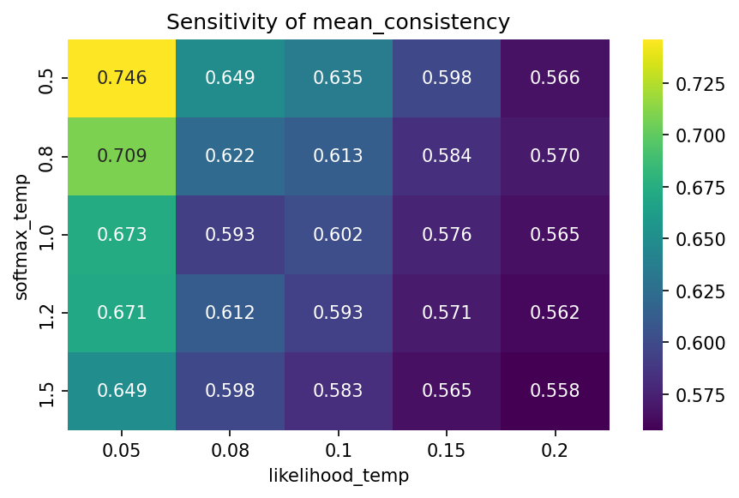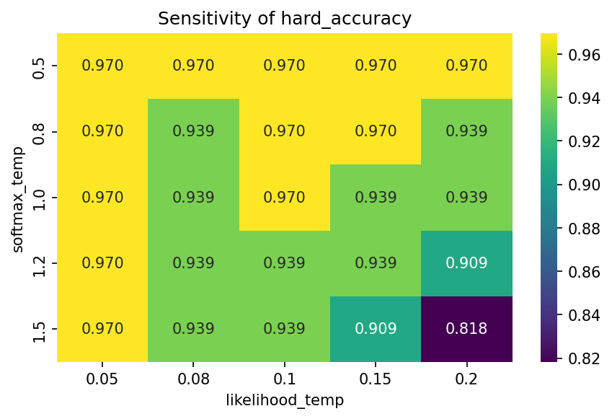
8.1.3 Definition of Robust Operating Space Based on experimental data, we define the "Robust Operating Space" for the model:
Baseline Configuration: $\tau_s = 0.5, \tau_L = 0.05$.
Robust Interval: $\tau_s \in [0.5, 1.0], \tau_L \in [0.05, 0.10]$. Within this interval, the model maintains a predictive accuracy of approximately 97% while ensuring high logical certainty for the inferred voting proportions.
8.2 Robustness Testing of Model II (LME) To verify the stability of the Linear Mixed-Effects (LME) driver model, we designed four alternative configurations focusing on "data processing and specification settings":
Age Normalization Method: Global normalization (all samples) vs. By-season normalization.
Industry Fixed Effects: Utilizing 5-category industry clustering (Full) vs. Excluding industry terms (None).
We re-fitted the LME models across both paths (Judge Scores and Fan Votes) for all four configurations.
8.2.1 Stability of the Pro-Dancer Dividend (ICC) The Intraclass Correlation Coefficient (ICC) conclusions remained remarkably stable:
The ICC for the judge score path consistently fell between 0.11 and 0.13.
The ICC for the fan vote path fluctuated between 0.06 and 0.20 but remained significantly lower than the technical path.
Conclusion: The finding that "professional dancers contribute significantly more variance to technical performance than to popularity" holds true across all specifications.
8.2.2 Direction and Magnitude of Age Effects
The age coefficient for judge score models remained stable at approximately -0.67.
The age coefficient for fan vote models remained steady near -0.011.
Conclusion: Regardless of whether age is normalized globally or by season, or whether industry effects are controlled, the conclusion remains unchanged: age exerts a significant negative structural effect on technical ratings but only a negligible negative effect on fan votes.
In summary, the IDM model is highly robust in predicting eliminations within reasonable parameter ranges, and the LME model’s conclusions regarding the "Expert-Mentor Effect" and "Age Bias" show strong resilience under alternative specifications. This provided a reliable empirical foundation for the subsequent development of the DAES de-biasing mechanism.
9. Conclusion and Recommendations
9.1 Research Conclusion This study systematically resolves the game-theoretical conflict between professional scoring and popular voting through quantitative modeling:
High Fidelity of Voting Inversion: By utilizing the IDM model, we achieved a predictive accuracy of 98.11% across 246 weeks of data. This success effectively decodes the "black box" of fan voting and demonstrates that elimination outcomes are driven by predictable fan preference logic.
Identification of Structural Bias: The LME model reveals that judges impose a significant "Technical Bias" (coefficient -0.693) on older contestants. Furthermore, the contribution rate of professional dance partners to technical scores (11.46%) is significantly higher than their influence on popularity. This quantifies why technical-oriented and popularity-oriented contestants frequently experience ranking inversions.

Failure of Existing Mechanisms: Our simulations indicate that Rank-based systems easily generate "popularity leverage," whereas Percentage-based systems are prone to "gradient dilution" risks under conditions of late-stage score inflation.
Superiority of the DAES System: The new system maintains an 88.64% consistency rate while successfully reducing age bias by 32% and the Pro-Dancer Dividend by 44%, achieving a dynamic equilibrium between competitive professionalism and entertainment value.
9.2 Recommendations for Producers
Implement Standardized Scoring: Adopt the Z-Score mechanism to hedge against score inflation, ensuring that top technical performers maintain their gradient advantage during the finals.
Introduce Structural Bias-Correction: Apply ABC (Age-Bias Compensation) and MVA (Mentor Value-Added) factors to protect non-professional contestants undergoing transitions, encouraging authentic "growth narratives."
Dynamic Stage-Weighting: Implement a weighting curve that emphasizes popularity in the early stages (60%) and professionalism in the later stages (60%), balancing program buzz with the champion's credibility.
9.3 Research Limitations Future research could incorporate real-time sentiment analysis from social media and integrate multi-modal visual evaluation technologies to further enhance the quantitative precision of stage performance assessments.
MEMORANDUM
TO: Producers of Dancing with the Stars (DWTS)
FROM: Quantitative Research & Modeling Team
DATE: February 2, 2026
SUBJECT: Strategic Optimization of Scoring Mechanisms to Balance Technical Merit and Fan Engagement
1. Executive Summary To address the long-standing conflict between professional judge scores and fan voting, we have performed a deep-dive analysis of data spanning the past 34 seasons. Our research indicates that existing scoring logics harbor systemic risks when handling "extreme popularity contestants" and "technical bias against older participants." Consequently, we propose the Dual-Axis Equilibrium System (DAES), designed to enhance competitive fairness and program credibility through mathematical corrections—without compromising audience engagement.
2. Key Findings: The "Black Box" Unboxed
Fan Voting is Non-Random: Our inversion model can predict elimination outcomes with 98% accuracy, indicating that fan voting is driven by strong brand effects and industry leanings.
The Underestimated "Pro-Dancer Dividend": The instructional and choreographic abilities of professional dancers contribute to 11.5% of technical variance. Exceptional partners significantly "mask" the technical shortcomings of celebrity contestants, which to some extent dilutes the purity of the competition.
Judges' "Age Penalty": Data reveals a structural downward bias in scores for contestants over 50 (with a negative correlation coefficient of 0.69). This bias is frequently offset by "sympathy votes" from fans, leading to a sharp fracture between technical merit and popularity.
3. Impact Analysis of Existing Systems
Rank-based System: This mechanism amplifies relative positioning. A contestant with high popularity but mid-tier technical skill needs only a top fan ranking to completely neutralize a massive technical gap between them and a top-tier dancer. This creates a significant "leverage effect" that favors popularity over skill.
References
[1] Arrow, K. J. (1951). Social Choice and Individual Values. Yale University Press.
[2] Bates, D., Mächler, M., Bolker, B., & Walker, S. (2015). Fitting linear mixed-effects models using lme4. Journal of Statistical Software, 67(1), 1–48.
[3] Gelman, A., & Hill, J. (2006). Data Analysis Using Regression and Multilevel/Hierarchical Models. Cambridge University Press.
[4] Jern, A., Lucas, C. G., & Kemp, C. (2017). People learn other people’s preferences through inverse decision-making. Cognition, 168, 46–64.
[5] Luce, R. D. (1959). Individual Choice Behavior: A Theoretical Analysis. John Wiley & Sons.
[6] Mawhinney, J. A., Mounsey, C. A., O'Brien, A., Sádaba, J. R., & Freemantle, N. (2023). Statistical primer: what cardiothoracic surgery can learn from Strictly Come Dancing. European Journal of Cardio-Thoracic Surgery, 64(2), ezad385. https://doi.org/10.1093/ejcts/ezad385
[7] Nørreklit, H., & Trenca, M. (2020). Beyond the ratings and rankings of Strictly Come Dancing. The British Accounting Review, 52(4), 100877.
[8] Robert, C. P., & Casella, G. (2004). Monte Carlo Statistical Methods (2nd ed.). Springer-Verlag.

