https://www.mvtec.com/cn/downloads

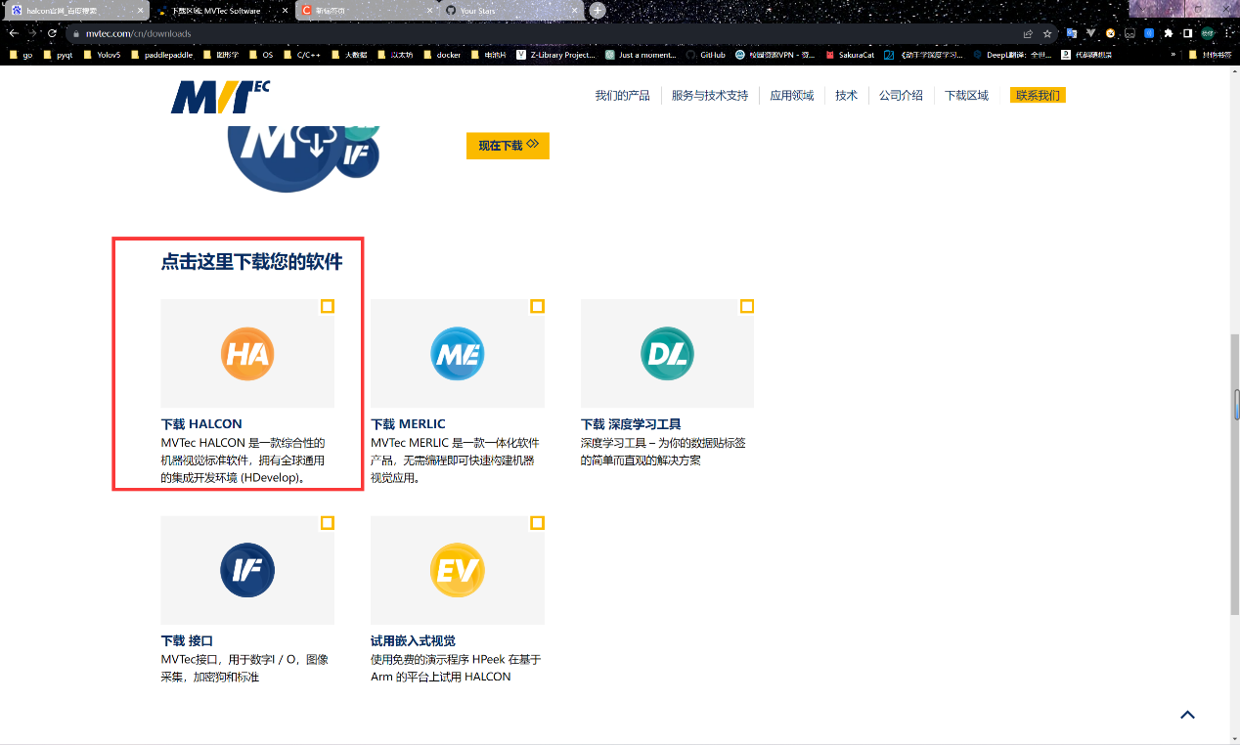

下载这个

https://github.com/lovelyyoshino/Halcon_licenses

破解在这

