Sacramento Crime Visualisation

## Where to find:

The whole visualization project including all source code etc. is located on a *GitHub* repo.

## Dataset:

* Origin: [*https://github.com/pkamin/sacramentocrime/blob/master/SacramentocrimeJanuary2006.csv*](https://github.com/pkamin/sacramentocrime/blob/master/SacramentocrimeJanuary2006.csv)
* Name : Sacramento Crime
* Nr. Items: 7585
* Nr. Attributes: 9
* Size: 0.78mb

## About:

This dataset shows crime statistics from January 2006 in the city of Sacramento USA.

## Tasks:

1. Find out the most dangerous areas around the city of Sacramento.
   1. To get an overview of the dangerous areas in the city, the distribution of all crimes in the dataset should be visualized on a map background.
   2. Distribution of committed crimes should be shown subject to a certain district.
2. Does a correlation exist between the time crimes were committed and the district they were in? Is one district more dangerous than another?
   1. **Addition**: This task has changed a little bit in matters of our first handed in task description. The huge amount of different attribute (crimedescr) values, 300+, caused some troubles and made the visualization mostly confusing. So we decided to change the plan a little and see how the relation between certain districts and a specific time is. The district attribute has only 6 different values and was a little bit easier to handle and visualize.
   2. For the visualization of this task a Stacked Bar Chart visualization should be used to get a quick overview of the different districts an the time.
   3. Certain values (number of crimes) should be shown for each part of a bar and time.

### Approach:

#### Task 1 Map:

#### Task 2 Bars:

So at first the dataset is imported via *d3.csv()* import and during that a few datatypes of attributes like, cdatetime, district, latitude, etc. are set correctly. The datetime needed also a little bit of *d3.timeParse()*, that means we just kept the time values not the date. In order to get the data group by the time and also by the district for a better usage afterwards, we nested the date with *d3.nest()*.

To use the data in a stacked bar chart we had to remap the structure of the given data a little bit, because we had some troubles to get this running with our data specifically with the structure of our data. The remapping also includes the *d3.stack()* operation of the collection for the usage afterwards. Also we changed from our first attempt to show all the different crime descriptions in this visualization to a different approach with the districts which is also very useful.  
  
Next thing was to create the layers for each district a collection of single bars with the correct color respectively and let d3 stack the correctly. These bars are also always showing a tooltip with the appropriate value for better understanding, when hovering over with the mouse. Also the corresponding entry on the legend is highlighted. Other way round the corresponding layer for each time value is highlighted when moving the mouse cursor over an entry of the legend.

Interactions:

* Higlight BarChart -> Legend
* Legend -> BarChart
* Barchart tooltips

Pics:

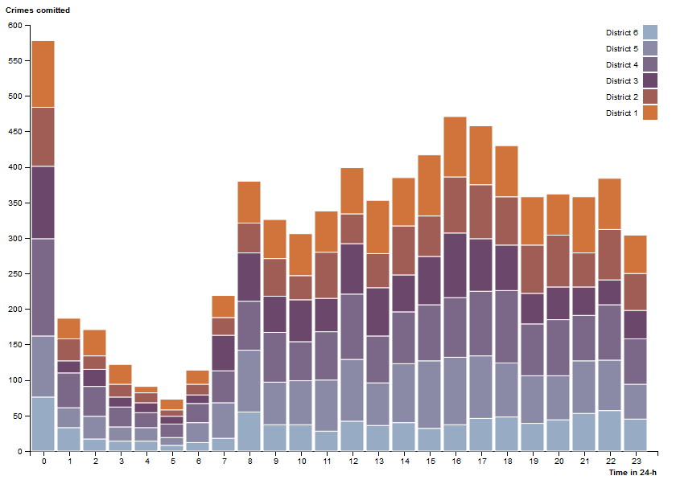

Abbildung 1: Stacked Bar Chart crimes/district/time

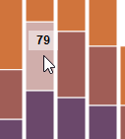

Abbildung : Bar tooltip

#### Cross Interactions

Interactions between both graphs