**Instructions for CLEF 2019 Working Notes in the CEUR-WS Proceedings**

As usually, the CLEF 2019 Labs working notes will be published in the CEUR-WS.org proceedings (<http://ceur-ws.org/>). The electronic Working Notes will be organised according to the Labs. If one group participates in more than one Lab, separate reports are to be submitted. Moreover, for those Labs that are subdivided in several tasks, separate reports for different task(s) are to be provided.

The CLEF 2019 Working Notes will be divided into the following main sections (and sub-sections):

* CENTRE@CLEF 2019 - CLEF/NTCIR/TREC Reproducibility
  + Task 1 – Replicability
  + Task 2 – Reproducibility
  + Task 3 – Generalizability
* CheckThat! - Automatic Identification and Verification of Political Claims
  + Task 1 – Check-Worthiness
  + Task 2 –Evidence and Factuality
* CLEF eHealth
  + Task 1–Multilingual Information Extraction
  + Task 2 –Technologically Assisted Reviews in Empirical Medicine
  + Task 3 –Consumer Health Search
* eRISK - Early Risk Prediction on the Internet
  + Task 1 –Early detection of signs of anorexia
  + Task 2 –Self-harm
  + Task 3–Depression level estimation
* ImageCLEF – Multimedia Retrieval in CLEF
  + Task 1 –ImageCLEFlifelog
  + Task 2 –ImageCLEFsecurity
  + Task 3 –ImageCLEFmedical
  + Task 4 –ImageCLEFcoralReef
* LifeCLEF – Biodiversity identification and prediction
  + Task 1 –GeoLifeCLEF
  + Task 2 –BirdCLEF
  + Task 3 –BirdCLEF
* PAN Lab - Lab on Digital Text Forensics
  + Task 1 –Bots and Gender Profiling
  + Task 2 –Celebrity Profiling
  + Task 3 –Cross-domain Authorship Attribution
  + Task 4 –Style Change Detection
* PIR-CLEF - Evaluation of Personalised Information Retrieval
  + Task 1 –Web Search
  + Task 2 –Medical Search
* ProtestNews –Extracting Protests from News
  + Task 1 –News article classification as protest vs. non-protest
  + Task 2 –Event sentence detection
  + Task 3–Event extraction

When the author logs into easychair they will find a separate "Easychair Track" for each CLEF Lab/Workshop and once they have selected the correct "Easychair Track" for their, as in the figure below.

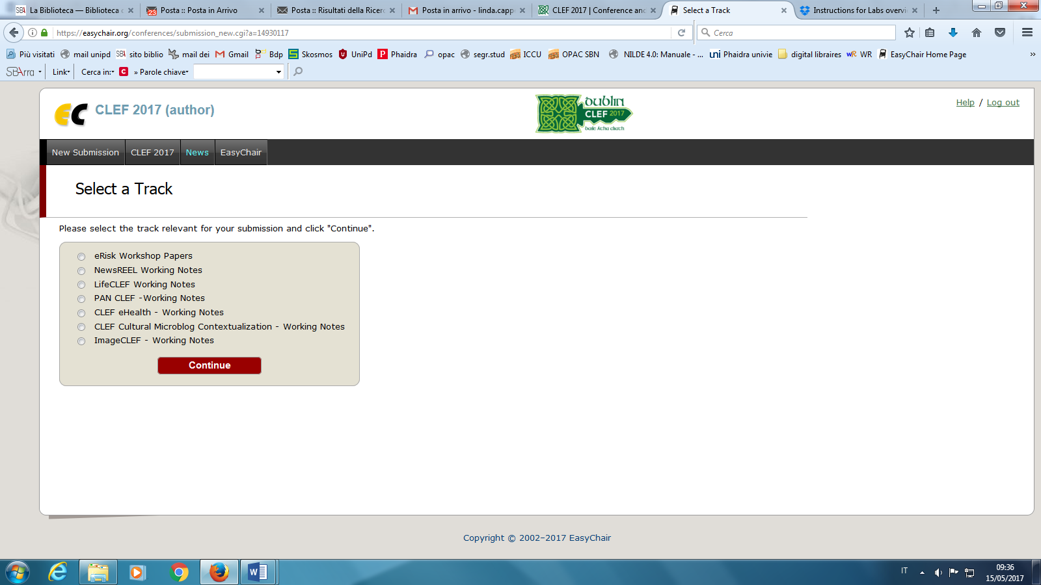

->**Select** the track corresponding to your Lab/Workshop

Afterwards, in the paper upload form, after the keywords, authors will find a checklist with the "Submission Topics" corresponding to the different tasks in that Lab. Pleasemarkthosewhichcorrespond to yourpaper:

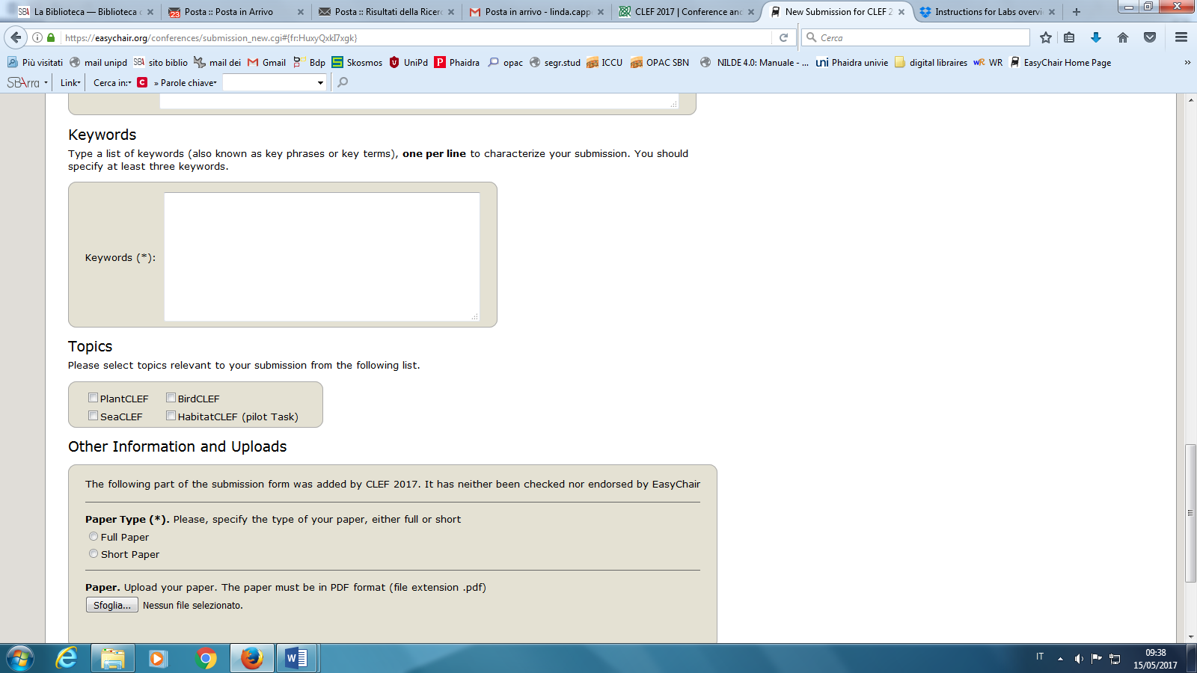

->**Mark** the topic corresponding to the lab tasks which are described in your paper.

For each task to which a group participated, groups are requested to submit a report describing their experiments. In the CEUR-WS working notes, there can be either a single paper for all the tasks to which a group participated or separated papers for each task.The decision on what is the most appropriate way to proceed for a given lab is up to the lab organizers. After the review process, if the paper will have been accepted, authors will be requested to submit the Camera-Ready Version of the paper, according to the reviewers’ recommendations.

For each camera-ready submission, three items are required:

* Zip file containing **all the submission sources**
* PDF file of the submission (**with no page headers/footers/page numbers**)
* PDF file with the scanned and signed copyright agreement (**otherwise, the submission will not be published in the final working notes**).

**Paper Submission**

Submission of papers is to be done electronically through theEasyChair(<https://easychair.org/conferences/?conf=clef2019>).

Using EasyChair for PaperSubmission

1. Authors must log in using their own username and password. If you don't already have an Easychair account, you will find the instructions to obtain one on the same page.
2. Once you have logged in, click on "New Submission", select the correct Lab/Track and Group/Task and then follow the instructions to submit your paper.

**Please, note that for preparing final Working Notes we willuse the metadata of Easychair submission, so pay attention to insert authors names, title and affiliations correctly.**

**Deadlines**

Please remember that the strict deadline for receiving the final electronic versions of all papers is:

1. Working Notes Papers due **24 May 2019**. This is a **STRICT DEADLINE**.
2. CEUR-WS Camera Ready Working Notes Papers due **29 June 2019**. This is a **STRICT DEADLINE**.

All the deadlines are intended to be **MIDNIGHT CEST**.

**Copyright Form**

During the upload of the Camera-Ready version of the accepted papers, a scanned and signed version ofthe CLEF copyright form(it will be provided)must be uploaded with the source and PDF files of the submission (otherwise the submission will not be published in the final working notes).

**GUIDELINES TO PREPARE REPORTS FOR CLEF2019 WORKING NOTES**

The working notes papers are technical reports written in English and describing the participating systems and the conducted experiments. Theyshouldprovide, atleast, the following information:

1. Title
2. Authors
3. Affiliations
4. Email addresses of allauthors
5. Body of text. This should contain information on:
   * tasksperformed
   * mainobjectives of experiments
   * approach(es) used and progress beyond state-of-the-art
   * resourcesemployed
   * resultsobtained
   * analysis of the results
   * perspectives for future work

The papers must be formatted according to Springer Instructions for Authors(<https://www.springer.com/gp/computer-science/lncs/conference-proceedings-guidelines>), either using Word or Latex templates.

MAX LENGTH: no upper page limit is set, as papers are published only electronically, but experience teaches the overwhelmingly long papers are not effective.

If you need to refer to the LNCS proceedings or to the Working Notes as a whole, here is the information about them:

LNCS

Experimental IR Meets Multilinguality, Multimodality, and Interaction.

Proceedings of the Tenth International Conference of the CLEF Association (CLEF 2019)

Editors

Fabio Crestani, Martin Braschler, Jacques Savoy, Andreas Rauber, Henning Müller, David E. Losada, GundulaHeinatz, Linda Cappellato, Nicola Ferro

CEUR-WS

CLEF 2019 Working Notes

Working Notes of CLEF 2019 - Conference and Labs of the Evaluation Forum

Editors

Linda Cappellato, Nicola Ferro, David E. Losada, Henning Müller