**Delta Module 1 – Pre-interview Task**

|  |  |  |  |
| --- | --- | --- | --- |
| First name | Click or tap here to enter text. | Surname | Click or tap here to enter text. |

**Reasons for applying**

|  |
| --- |
| Please outline briefly why you are interested in the Delta Module 1 course and how it might benefit you. Try to be specific. |
| Click or tap here to enter text. |

**Strengths and weaknesses**

|  |
| --- |
| Consider what your strengths and weaknesses in relation to the course are. You may consider your experience, previous education/training, language awareness, reading done, teaching techniques, classroom management skills, teacher qualities, personal qualities etc. |
| Click or tap here to enter text. |

**Knowledge about language**

|  |
| --- |
| Please answer the following questions. Try not to refer to any sources, i.e. rely simply on your knowledge. It’s important that we can assess your knowledge accurately to ensure if you’re accepted, you can cope with the course. |
|  |

**1. Provide the term for each definition.**

**a** the use of grammatical and lexical means to achieve connected text, either spoken or written. These include: reference words e.g. this, the, it; linkers e.g. However, and topic-related lexis

Click or tap here to enter text.

**b** knowledge of not only if something is formally possible in a language, but also whether it is feasible, appropriate, or done in a particular speech community. This includes grammatical, sociolinguistic, discourse and other competences.

Click or tap here to enter text.

**c** the extent to which the items in a test reflect the essential aspects of the theory on which the test is based.

Click or tap here to enter text.

**d** a speech sound produced by narrowing the distance between two articulators so that the airstream is not completely closed but obstructed enough that a turbulent airflow is produced, as in the English /f/, /v/, /s/ and /z/ sounds in *enough*, *valve*, *sister*, and *zoo*.

Click or tap here to enter text.

**e** restrictions on how words can be used together, for example which prepositions are used with particular verbs, or which verbs and nouns are used together.

Click or tap here to enter text.

**f** the process of adding an affix to a word or changing it in some other way according to the rules of the grammar of a language.

Click or tap here to enter text.

**2. Provide a definition and an appropriate brief example or illustration of each of the terms below.**

**a** lexical approach

Click or tap here to enter text.

**b** colligation

Click or tap here to enter text.

**c** diagnostic test

Click or tap here to enter text.

**d** genre

Click or tap here to enter text.

**3. Please answer the questions below the text**

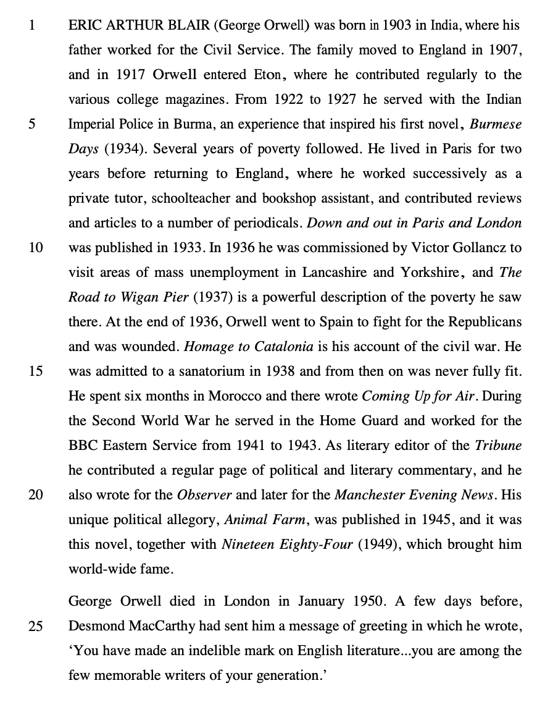

**a** Comment on the **form** and **meaning/use** of the **words** in **bold** as they are used in the text.

i. ERIC ARTHUR BLAIR (George Orwell) **was born** in 1903 (line 1)

Click or tap here to enter text.

ii. He also **wrote** for the Observer (lines 19-20)

Click or tap here to enter text.

iii. A few days before, Desmond MacCarthy **had sent** him a message of greeting (lines 24-25)

Click or tap here to enter text.

vi. you **have made** an indelible mark on English literature (line 26)

Click or tap here to enter text.

**b** Comment on the **use** of **relative clauses and relative pronouns** in the following extracts in the following extracts from the text.

i. Orwell entered Eton, **where** he contributed regularly to the various college magazines. (lines 3-4)

Click or tap here to enter text.

ii. Desmond MacCarthy had sent him a message of greeting **in** **which** he wrote (line 25)

Click or tap here to enter text.

**c** Comment on the **features of connected speech** likely to occur in the following:

• you are among the few memorable writers of your generation. (lines 26-27)

Click or tap here to enter text.

**4. Methodology**

Many teachers believe that they should at all times reduce their own talking time and increase that of their students. What reasons are there for reducing teacher talking time and increasing student talking time? How do learners benefit from teacher talking time in a lesson?

Click or tap here to enter text.