1/ Here are the pain points in our company:

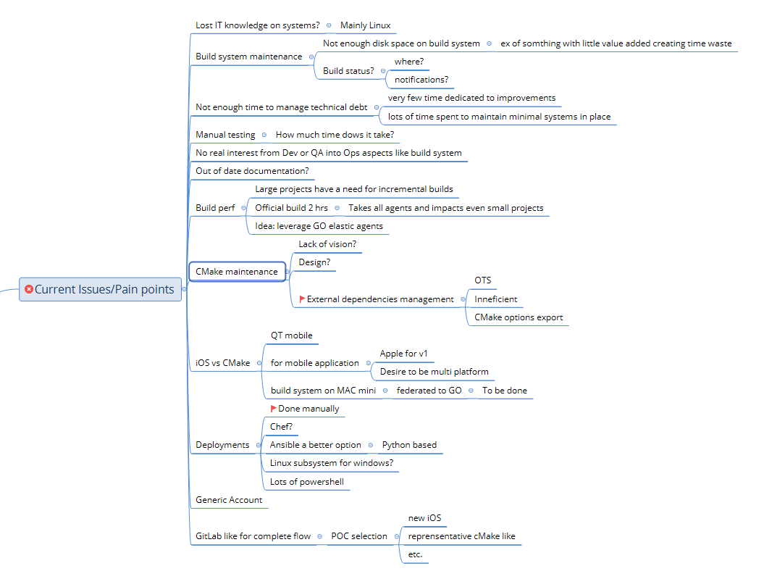

2/ Gaps in tooling:

CI: pipeline orchestrated with GoCD in which we have as stages :

* Build automated : Cmake in C++ projects and Gradle in Java projects
* Unit test : CTest and Dash in C++ projects and junit in java projects
* Static analytics of code : Sonar

CD:

* Docker : Create images and tag them and ship them
* Kubernetes : orchestrate and control docker containers
* Cloud : Microsoft Azure
* For some C++ applications : scripting deployement with powershell and ansible and creating wizards installation with NSIS

Monitoring:

* Splunk: monitor and read logs easily

Plan:

* Rally and moving to Jira
* Agile scrum with sprints of 3 weeks
* Switch to Kanban for documentation writing, doc reviews and doc signatures

Security:

* Perform threat modeling with STRIDE methodology for every release of every product
* Encryption (for example with AES 256) implementation or hashing of all the data to be protected/hidden in the logs and data that we send between the systems
* Pen testing
* Automate testing : SAST, DAST

Here are information about current system and ideas for improvement :

