# AMZN

## Recommendation: BUY

AMZN will increase in price during the next trading period.

## Price History

The chart below is made with the quantmod R package, a widely used package for collecting and visualizing financial data in R. You can learn more about quantmod at the website [www.quantmod.com](rstudio.github.io/DT/).

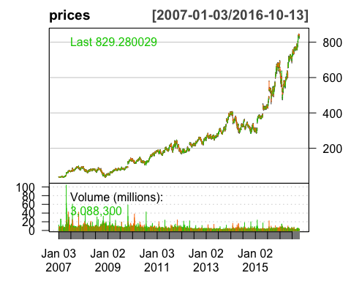

## Method

This forecast was predicted with the *recency algorithm*, a simple---probably useless---method for determining stock prices. The recency algorithm predicts that the next price movement, $M_{j}$, will be in the same direction as the most recent price movement. $M_{i}$.

$$M_{i}=Close_{i}−Open_{i}$$

$$M_{j}=\left\{\begin{matrix}>0, & if M_{i}>0 \\ ≤0, & if M_{i}≤0\end{matrix}\right.$$

## Raw Data

The table below displays the daily price data for the stock. In the next section, we will learn how to make a concise, interactive table with the DT package, a new package for making searchable data tables. You can learn more about the DT package at the website <rstudio.github.io/DT/>.

AMZN.Open AMZN.High AMZN.Low AMZN.Close AMZN.Volume  
2016-10-05 838.00 845.67 836.12 844.36 3450000  
2016-10-06 843.70 847.21 840.60 841.66 2679200  
2016-10-07 845.79 845.95 837.45 839.43 2416500  
2016-10-10 843.25 845.20 840.27 841.71 1818000  
2016-10-11 841.02 841.29 828.35 831.00 3578100  
2016-10-12 834.00 837.67 830.10 834.09 2370100  
2016-10-13 829.00 831.80 821.21 829.28 3088300