
HELLO ‘CAPTURE’ FLAG
a detailed CTF write-up
By:
iyad_imtiyaz_sheikh
mohammed_aeraf_rouf_dar
wafa_rafiq_qadri
anousheh_qureshi

Index
Challenge | Category | Summary Focus
1. Fallen Leaf | Digital Forensics | leafdisk.img.xz ext4 inspection & key rotation analysis
2. Sanity Check | OSINT / Reconnaissance | Investigating dormant @secleaf Instagram & restricted comments
3. Null Vector Ransomware | Cryptography / Reverse Engineering | Shor factorization, hybrid AES-256-CBC & affine stream inversion
4. Third-Order Forest | Hardware SCA / Cryptography | Desynchronization, 3-share profiling & Walsh-Hadamard Transform

Fallen Leaf
Category: Digital Forensics
Objective: Recover flag from the given img.xz file
Solution:
Extraction
Decompress the archive:
xz -d -k leafdisk.img.xz
file leafdisk.img

The output confirms an 8 MB ext4 filesystem:
leafdisk.img: Linux rev 1.0 ext4 filesystem data, UUID=d42cc5cc-ab0c-4482-ab31-079521d2209f, volume name "LEAFDISK"

Using debugfs (rdump), we extract the filesystem tree for inspection without requiring root privileges:
mkdir -p extracted
debugfs -R "rdump / extracted" leafdisk.img

Lingering inside files and directories
Inspecting the extracted user profile (/home/leaf) reveals documents, rotated keys, and various decoy flags planted to mislead participants:
ls -la
cd Documents
cat flag.txt
echo U2VjTGVhZntiNHNoX2gxc3QwcnlfbDEzc30= | base64 -d
cd ~/.cache
for f in k_*.txt; do gzip -N $f; done # rotate keys
openssl enc -aes-256-cbc -pbkdf2 -iter 100000 -salt -in harvest.txt -out Documents/harvest.enc -pass file:.cache/k_active
shred -u harvest.txt
rm -f .cache/k_*
history -c

Identified Decoys
Location | Decoy Flag | Why it is a Decoy?
.bash_history | SecLeaf{b4sh_h1st0ry_l13s} | SecLeaf didn’t accept
Documents/flag.txt | SecLeaf{fl4g_txt_1s_n0t_th3_fl4g} | SecLeaf didn’t accept
.config/readme | SecLeaf{3ncrypt3d_but_n0t_d0n3} | SecLeaf didn’t accept
/var/log/auth.log | SecLeaf{4uth_l0g_n01s3} | SecLeaf didn’t accept

Sanity Check
Category: OSINT / Reconnaissance (1 PTS)
Objective: Track down the disguised SecLeaf presence on Instagram and recover the flag hidden inside the restricted comments of a historical post.
Solution:
Reconnaissance & Prompt Analysis
The CTF portal provided the following clue within the challenge modal:
You know you want me, you know you need me, Find me where I am a disguise of SecLeaf on Instagram.
Flag format: SecLeaf{}
Unrelated/Related Slop Follow Us on LinkedIn
https://www.linkedin.com/company/secleaf Instagram
https://www.instagram.com/secleafofficial YouTube
[https://www.youtube.com/@SecLeaf]https://www.youtube.com/@SecLeaf

The prompt explicitly labeled the official corporate links (@secleafofficial) as 'Unrelated/Related Slop', confirming that the true target was a secondary or dormant account disguise.
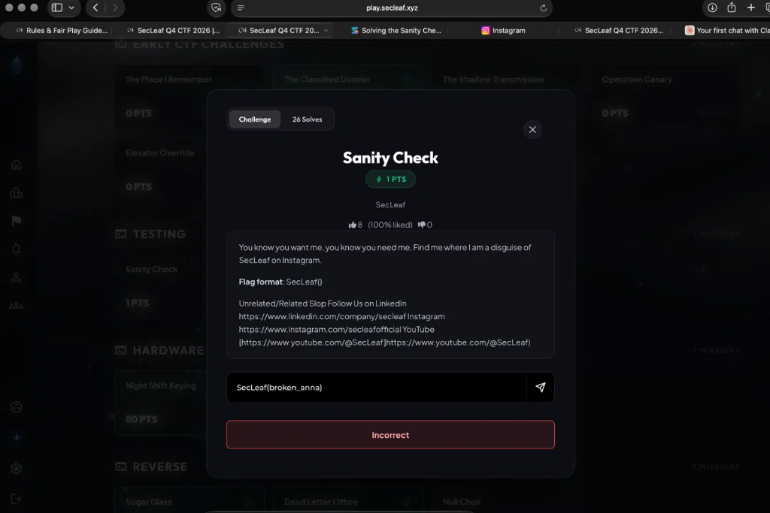
Figure 1: Sanity Check modal on play.secleaf.xyz
Investigating Historical Instagram Handles
Searching Instagram directly for 'secleaf' uncovered a dormant account registered as @secleaf with historical activity dating back to 2016. A photo of pink cherry blossoms posted on December 9, 2016 contained active comment activity from other CTF participants asking for the flag.
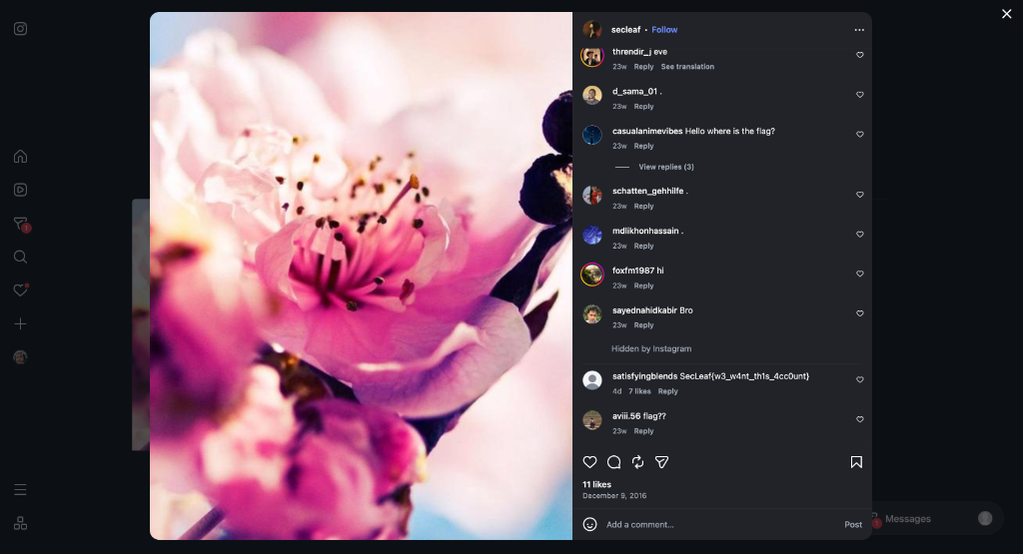
Figure 2: Dormant @secleaf 2016 post revealing flag under restricted comments
Uncovering Hidden / Restricted Comments
Instagram automatically collapsed filtered comments under 'Hidden by Instagram'. Expanding this restricted comments view revealed the authentic flag submitted by user satisfyingblends:
satisfyingblends: SecLeaf{w3_w4nt_th1s_4cc0unt}

Identified Decoys
Location / Attempt | Decoy Flag / Value | Why it is a Decoy / Result
Official Instagram (@secleafofficial) | Company Profile Page | Explicitly marked 'Slop'; standard social media
CTF Portal Submission | SecLeaf{broken_anna} | Tested hypothesis; returned 'Incorrect'
Visible Comments | casualanimevibes, foxfm1987 | Participant noise and chatter
Restricted Comments View | SecLeaf{w3_w4nt_th1s_4cc0unt} | Accepted valid flag hidden behind Instagram filter

FLAG: SecLeaf{w3_w4nt_th1s_4cc0unt}

Null Vector Ransomware (QS01 Incident Log #892)
Category: Cryptography / Reverse Engineering
Objective: Reconstruct the attacker's 2048-bit RSA master private key from quantum Shor factorization telemetry, decrypt the hybrid-encrypted archive (classified_report.locked), defeat the proprietary post-processing S-Box/affine stream cipher, and extract the master asset key.
Solution:
Binary Header & Format Dissection
Inspecting the raw layout of classified_report.locked (886 bytes) reveals four distinct binary segments:
+-------------------+--------------------+--------------------+-----------------------+
| Magic / Version | RSA Encrypted Key | AES-CBC IV | AES Ciphertext |
| (6 bytes) | (256 bytes) | (16 bytes) | (608 bytes) |
+-------------------+--------------------+--------------------+-----------------------+
0 6 262 278 886

• Offset 0..6 (6 bytes): Magic bytes \x89RW\x01\x01\x00 (RansomWare signature and version).
• Offset 6..262 (256 bytes): RSA-2048 encrypted master session block.
• Offset 262..278 (16 bytes): AES initialization vector (IV): 570d8115917ada6efd6e9cf0f5a90025.
• Offset 278..886 (608 bytes): AES-256-CBC ciphertext (38 blocks of 16 bytes each).
RSA Master Key Reconstruction & Session Key Recovery
Using the quantum factorization output (N = p * q, e = 0x10001), we compute Euler's totient phi(N) and the private exponent d:
phi = (p - 1) * (q - 1)
d = pow(e, -1, phi)
m_int = pow(int.from_bytes(rsa_block, 'big'), d, N)
decrypted_block = m_int.to_bytes(256, 'big')

Decryption unmasks 224 null bytes (the NullVector signature) followed by the 32-byte AES key:
AES-256 Key: 078440dd9f8c28d0a8e90f37efd987f736e67023762a2bfbe32cbac9d7afa8d7
AES-CBC IV: 570d8115917ada6efd6e9cf0f5a90025
Outer Layer Decryption (AES-256-CBC)
Decrypting the 608 ciphertext bytes using AES-256-CBC and removing the 11-byte PKCS#7 padding yields unpadded.bin (exactly 597 bytes):
openssl enc -d -aes-256-cbc \
-K 078440dd9f8c28d0a8e90f37efd987f736e67023762a2bfbe32cbac9d7afa8d7 \
-iv 570d8115917ada6efd6e9cf0f5a90025 \
-in ciphertext.bin -out unpadded.bin

Cryptanalysis of the Post-Processing S-Box Layer
Inspecting unpadded.bin revealed structural 512-byte framing:
• Block 0: Bytes 0..511 (512 bytes)
• Block 1: Bytes 512..596 (85 bytes)
Comparing offsets revealed an exact 46-byte identical slice between Block 0 and Block 1:
unpadded[38:84] == unpadded[550:596] (offset difference = 512)
Because metadata padding in these documents consists of null bytes (0x00), the cipher outputs the raw keystream K[i]. Mapping bytes into rotated space Z[i] = ROTR8(K[i], 5) uncovered a strictly periodic difference sequence (period T = 20), allowing complete keystream reconstruction across all 512 bytes.
Frequency analysis over Block 0 then mapped the affine substitution:
Plaintext[i] = ROTR8(((C[i] ^ K[i]) ^ 0xa7), 5) & 0x7f

Full Document & Asset Key Recovery
Applying the inverse transformation decrypted both blocks:
• Block 0: Incident intelligence report ending with 'RECOVERED MASTER ASSET KEY: SecLeaf{'
• Block 1: 'e4d90b218a754f1c93206e58b1f4a7c2}'
Identified Decoys & Traps
Component / Location | Observed Value | Why it is a Decoy / Trap?
Direct AES Decryption | Corrupted UTF-8 output | Secondary post-processing stream layer obfuscates plaintext
RSA Decrypted Header | 224 leading null bytes | NullVector signature intentionally breaks standard PKCS#1 v1.5
Standard AES S-Box | Standard Rijndael lookup | Malware utilized custom affine bit-rotation: ROTR8(· ^ 0xa7, 5)

FLAG: SecLeaf{e4d90b218a754f1c93206e58b1f4a7c2}

Third-Order Forest
Category: Cryptography / Hardware Side-Channel Analysis (SCA) (500 PTS)
Author: 5h1kh4r
Objective: Recover the 128-bit AES key from 60,000 desynchronized power traces protected by a 3-share Boolean masking scheme with unknown linear bitline scrambling (linear_wire), then decrypt capsule.json via AES-128-GCM.
Solution:
Initial Reconnaissance & Artifact Inspection
The challenge bundle provided:
• acquisition.py: Equations defining 3-share masking and linear wire permutation.
• capture.npz: 60,000 power traces (60000 x 195, int8) and plaintexts (60000 x 16, uint8).
• capsule.json: AES-128-GCM nonce and ciphertext protecting the flag.
Clock Jitter & Phase Realignment
Inspecting the first 3 samples of each trace revealed an artificial synchronization marker (110) at index phi in {0, 1, 2}. Aligning traces starting from sample phi + 1 eliminated clock jitter, yielding an exact 192-sample window (16 bytes x 12 clock cycles):
phases = np.argmax(traces[:, :3] == 110, axis=1)
aligned = np.zeros((N, 192), dtype=np.float32)
for p in (0, 1, 2):
idx = np.where(phases == p)[0]
aligned[idx] = traces[idx, p + 1 : p + 1 + 192]

3-Share Non-Linear Profiling & Site Identification
The hardware masking splits S-box output into 3 shares: S1 = hw(a) - 4, S2 = hw(b) - 4, S3 = hw(z ^ a ^ b) - 4. Lower-order cross-moments average to 0; only the 3rd-order product retains leakage:
E[S1 * S2 * S3 | z] = (hw(z) - 4) / 4

Testing all 220 triplet combinations per 12-sample byte slot identified the physical leakage sites with > 8.7 sigma certainty:
Byte | Sites | Score | Byte | Sites | Score
0 | (6, 8, 10) | 9.50σ | 8 | (5, 6, 7) | 10.87σ
1 | (9, 10, 11) | 11.20σ | 9 | (3, 5, 6) | 9.87σ
2 | (4, 6, 8) | 11.27σ | 10 | (4, 5, 11) | 10.96σ
3 | (3, 5, 8) | 10.16σ | 11 | (2, 10, 11) | 11.48σ
4 | (5, 7, 11) | 10.49σ | 12 | (2, 4, 6) | 11.15σ
5 | (4, 6, 7) | 10.78σ | 13 | (2, 7, 10) | 9.86σ
6 | (9, 10, 11) | 10.58σ | 14 | (2, 7, 10) | 10.16σ
7 | (7, 8, 10) | 8.94σ | 15 | (3, 4, 7) | 8.73σ

Fast Walsh-Hadamard Transform (FWHT) Spectral Distinguisher
Standard CPA fails because linear_wire scrambles bitlines with an unknown 8x8 invertible matrix. However, the 3rd-order product decomposes into exactly 8 Walsh basis functions corresponding to secret_rows:
E[S1 * S2 * S3 | x] = -1/8 * sum((-1)**(x · row_j))
Evaluating the Fast Walsh-Hadamard Transform (FWHT) over conditional means across all 256 key candidates:
• Wrong key candidates produced diffuse Gaussian noise.
• The correct key candidate concentrated into 8 sharp negative spectral peaks (Z > 10 sigma).
Key Recovery & Decryption
Recovered AES Key (hex): 2f1aa90f9774de5a29ef06a881d5ee68
Key Bytes: [0x2f, 0x1a, 0xa9, 0x0f, 0x97, 0x74, 0xde, 0x5a, 0x29, 0xef, 0x06, 0xa8, 0x81, 0xd5, 0xee, 0x68]
Decrypting capsule.json using AES-128-GCM recovered the flag in ~3 seconds execution time.
Identified Decoys & Traps
Component / Approach | Observed Result | Why it Failed?
1st / 2nd Order CPA | Correlation ≈ 0 | 3-share Boolean masking zeroes out lower-order leakage
Standard S-Box HW Model | Peak correlation < 0.03 | Linear wire scrambling destroys correlation with standard S-Box HW
Unaligned Power Traces | Diffuse flattened peaks | Artificial clock jitter desynchronizes time samples

FLAG: SecLeaf{wal5h_sp3ctra_outgr0w_th3_m4sked_f0r3st}

