**Name : Anoushka Shinde**

**Roll No : 19102B0058**

**Branch/Div : CMPN/B**

**Subject : Audit Course Level 1 Task.**

**Project Name : Projectwebsite**

|  |  |
| --- | --- |
| Front End Tools | HTML 5, CSS3 |
| Project Leader | Anoushka Shinde |
| Project Language | English |
| Country | India |
| Reference sites | www.w3schools.com |
| Github Repository Link | https://github.com/anoushka101/Auditcourse |

**Project Description :** This is a coffee shop website which is fully responsive with the help of html and css. Before visiting the shop one can visit this website to see what all the store has to offer and then decide if they want to visit said store or no.

**Screenshots:**

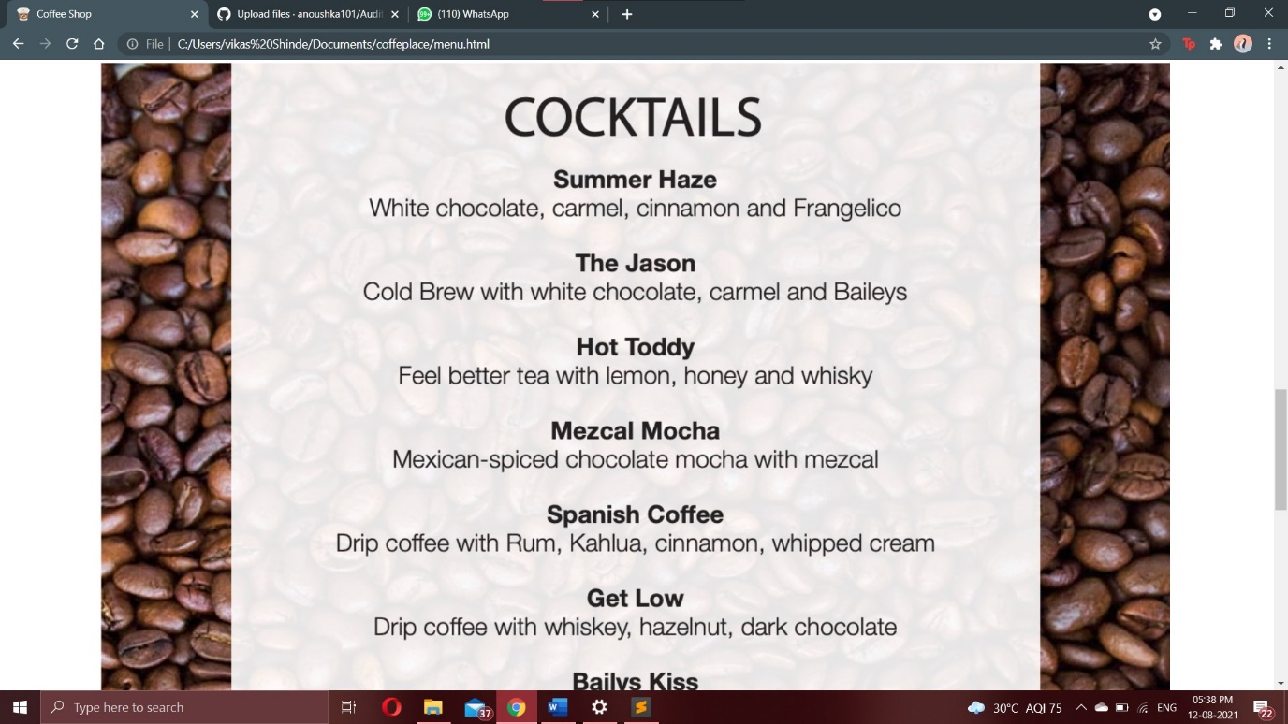

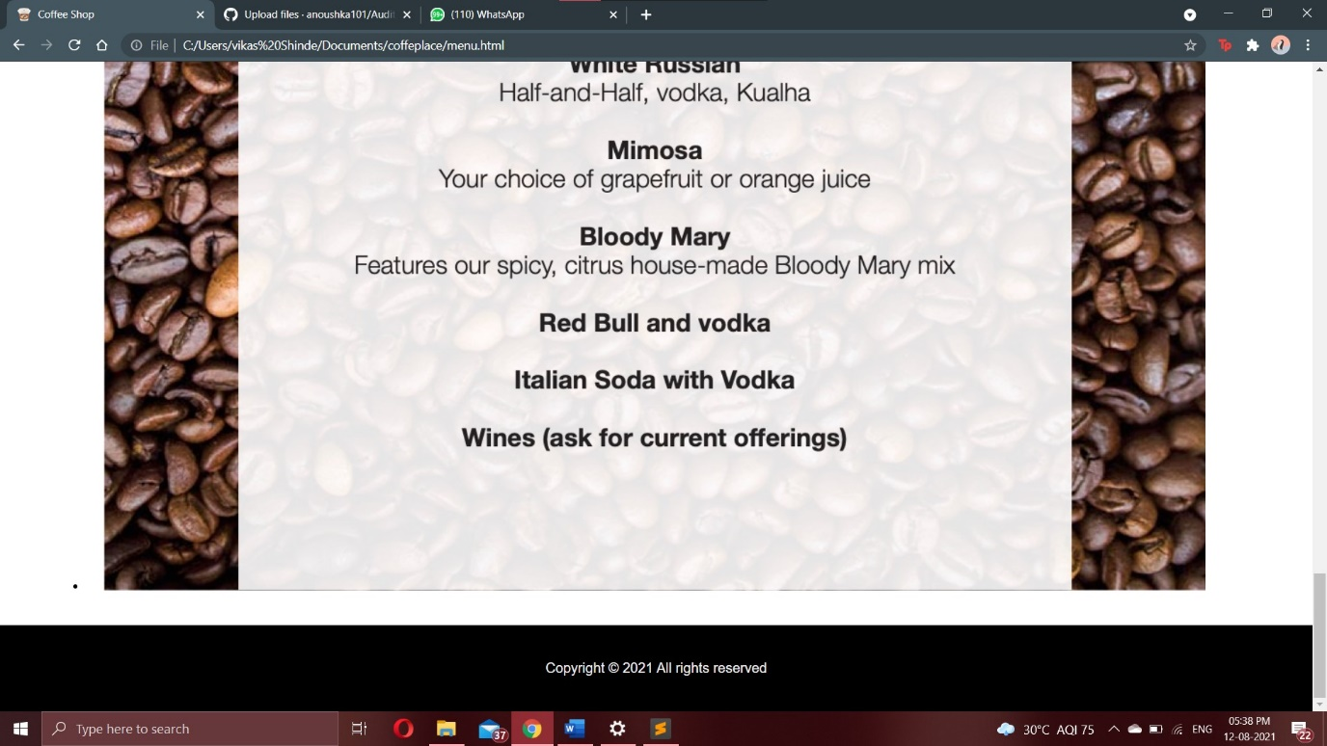

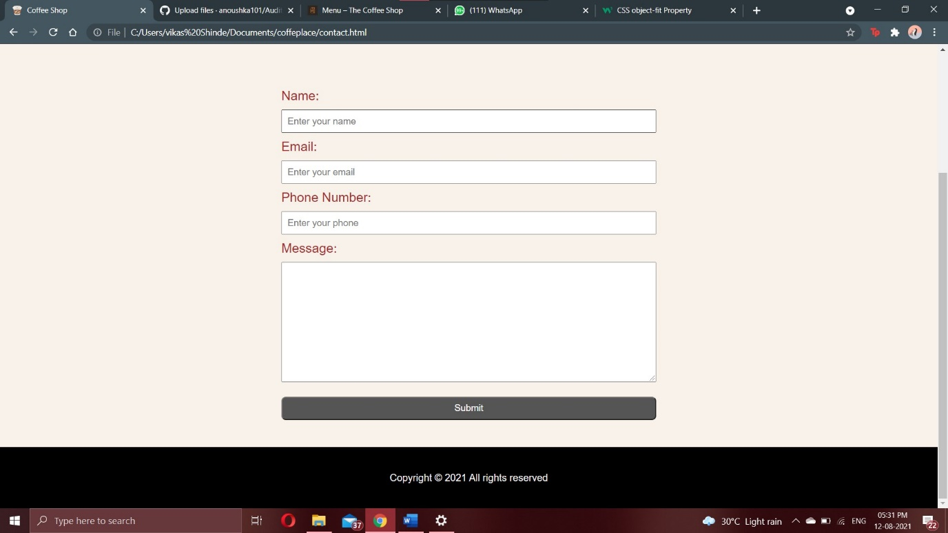

**Repository Link Here : https://anoushka101.github.io/Auditcourse/index.html**