Overview of React JWT Authentication example
We will build a React application in that:
- There are Login/Logout, Signup pages.
- Form data will be validated by front-end before being sent to back-end.
- Depending on User’s roles (admin, moderator, user), Navigation Bar changes its items automatically.
Here are the screenshots:
– Signup Page:
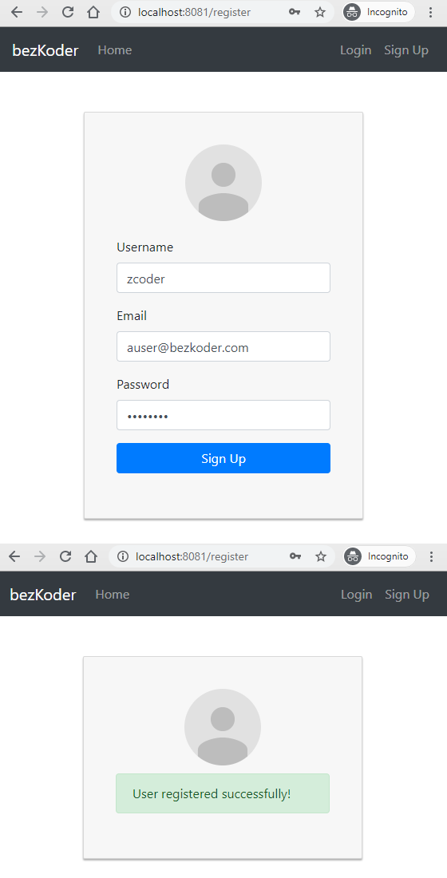
– Form Validation Support:
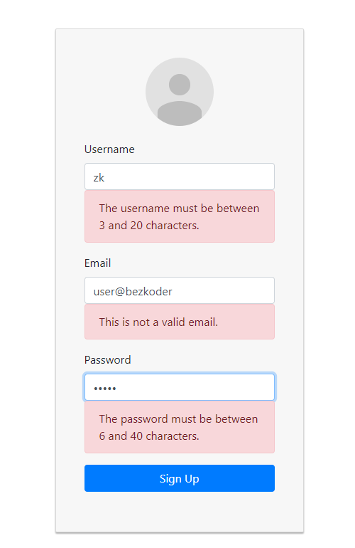
– Login Page:
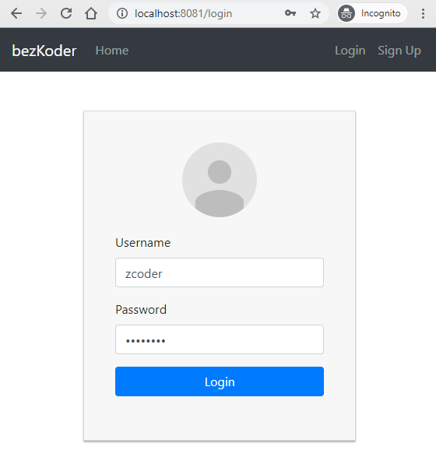
– Profile Page (for successful Login):
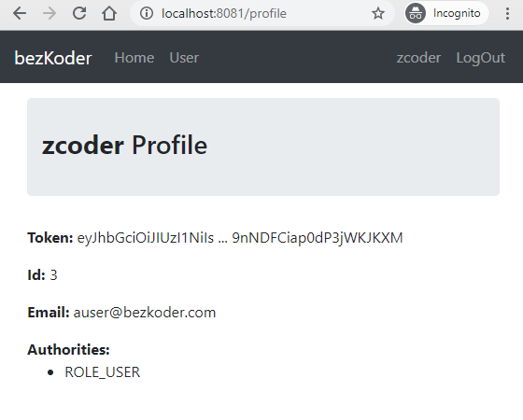
– For Moderator account login, the navigation bar will change by authorities:
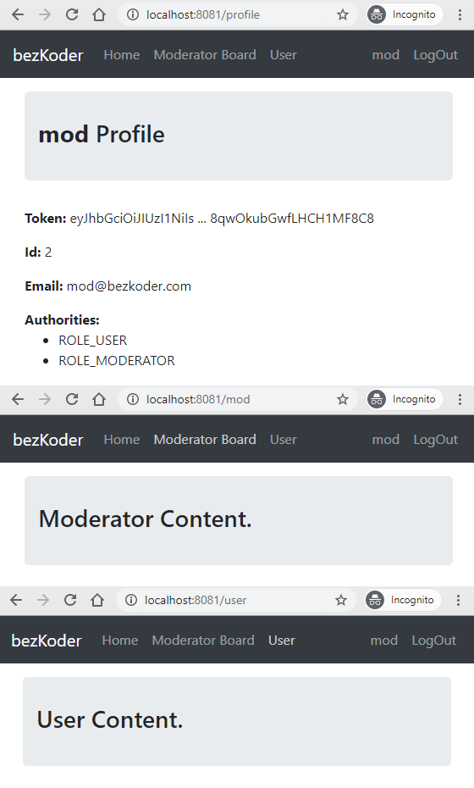
– Check Browser Local Storage:
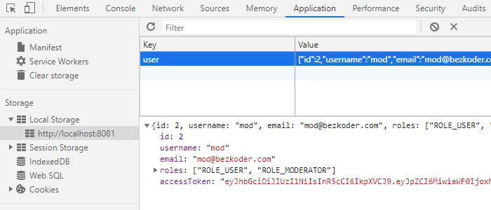
If you want to add refresh token, please visit:
React Refresh Token with JWT and Axios Interceptors

User Registration and User Login Flow
For JWT Authentication, we’re gonna call 2 endpoints:
- POST api/auth/signup for User Registration
- POST api/auth/signin for User Login
The following flow shows you an overview of Requests and Responses that React Client will make or receive. This React Client must add a JWT to HTTP Header before sending request to protected resources.
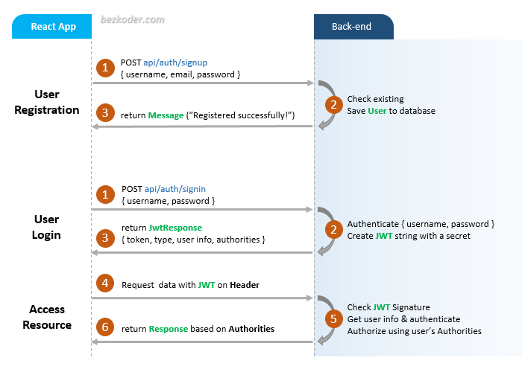
You can find step by step to implement these back-end servers in following tutorial:
- Spring Boot JWT Authentication with Spring Security, MySQL
- Spring Boot JWT Authentication with Spring Security, PostgreSQL
- Spring Boot JWT Authentication with Spring Security, MongoDB
- Node.js JWT Authentication & Authorization with MySQL
- Node.js JWT Authentication & Authorization with MongoDB
- Node.js JWT Authentication & Authorization with PostgreSQL

Demo Video
This is full React + Node.js Express JWT Authentication & Authorization demo (with form validation, check signup username/email duplicates, test authorization with 3 roles: Admin, Moderator, User):
And this is using Spring Boot Server:

React Component Diagram with Router, Axios & LocalStorage
Let’s look at the diagram below.
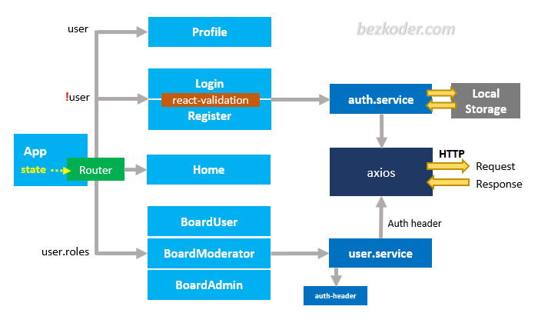
– The App component is a container with React Router (BrowserRouter). Basing on the state, the navbar can display its items.
– Login & Register components have form for data submission (with support of react-validation library). They call methods from auth.service to make login/register request.
– auth.service methods use axios to make HTTP requests. Its also store or get JWT from Browser Local Storage inside these methods.
– Home component is public for all visitor.
– Profile component displays user information after the login action is successful.
– BoardUser, BoardModerator, BoardAdmin components will be displayed by state user.roles. In these components, we use user.service to access protected resources from Web API.
– user.service uses auth-header() helper function to add JWT to HTTP header. auth-header() returns an object containing the JWT of the currently logged in user from Local Storage.

Technology
We’re gonna use these modules:
- React 18/17
- react-router-dom 6.4.0
- axios 0.27.2
- react-validation 3.0.7
- Bootstrap 4
- validator 13.7.0

Project Structure
This is folders & files structure for this React application:
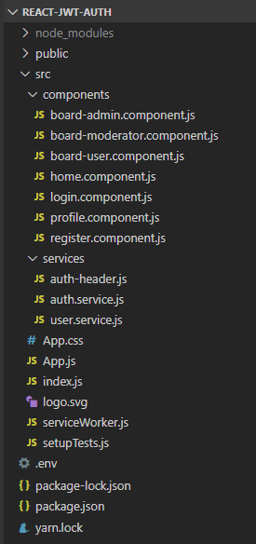
With the explanation in diagram above, you can understand the project structure easily.

Setup React.js Project
Open cmd at the folder you want to save Project folder, run command:
npx create-react-app react-jwt-auth

Add React Router
– Run the command: npm install react-router-dom.
– Open src/index.js and wrap App component by BrowserRouter object.
import React from "react";
import { createRoot } from "react-dom/client";
import { BrowserRouter } from "react-router-dom";

import App from "./App";

const container = document.getElementById("root");
const root = createRoot(container);

root.render(
<BrowserRouter>
<App />
</BrowserRouter>
);

Import Bootstrap
Run command: npm install bootstrap@4.6.2.
Open src/App.js and modify the code inside it as following-
import React, { Component } from "react";
import "bootstrap/dist/css/bootstrap.min.css";

class App extends Component {
render() {
// ...
}
}

export default App;

Create Services
We’re gonna create two services in src/services folder:

services
auth-header.js
auth.service.js (Authentication service)
user.service.js (Data service)

Before working with these services, we need to install Axios with command:
npm install axios

Authentication service
The service uses Axios for HTTP requests and Local Storage for user information & JWT.
It provides following important methods:
- login(): POST {username, password} & save JWT to Local Storage
- logout(): remove JWT from Local Storage
- register(): POST {username, email, password}
- getCurrentUser(): get stored user information (including JWT)
import axios from "axios";

const API_URL = "http://localhost:8080/api/auth/";

class AuthService {
login(username, password) {
return axios
.post(API_URL + "signin", {
username,
password
})
.then(response => {
if (response.data.accessToken) {
localStorage.setItem("user", JSON.stringify(response.data));
}

return response.data;
});
}

logout() {
localStorage.removeItem("user");
}

register(username, email, password) {
return axios.post(API_URL + "signup", {
username,
email,
password
});
}

getCurrentUser() {
return JSON.parse(localStorage.getItem('user'));;
}
}

export default new AuthService();

Data service
We also have methods for retrieving data from server. In the case we access protected resources, the HTTP request needs Authorization header.
Let’s create a helper function called authHeader() inside auth-header.js:
export default function authHeader() {
const user = JSON.parse(localStorage.getItem('user'));

if (user && user.accessToken) {
return { Authorization: 'Bearer ' + user.accessToken };
} else {
return {};
}
}
The code above checks Local Storage for user item. If there is a logged in user with accessToken (JWT), return HTTP Authorization header. Otherwise, return an empty object.

Note: For Node.js Express back-end, please use x-access-token header like this:
export default function authHeader() {
const user = JSON.parse(localStorage.getItem('user'));

if (user && user.accessToken) {
// for Node.js Express back-end
return { 'x-access-token': user.accessToken };
} else {
return {};
}
}

Now we define a service for accessing data in user.service.js:
import axios from 'axios';
import authHeader from './auth-header';

const API_URL = 'http://localhost:8080/api/test/';

class UserService {
getPublicContent() {
return axios.get(API_URL + 'all');
}

getUserBoard() {
return axios.get(API_URL + 'user', { headers: authHeader() });
}

getModeratorBoard() {
return axios.get(API_URL + 'mod', { headers: authHeader() });
}

getAdminBoard() {
return axios.get(API_URL + 'admin', { headers: authHeader() });
}
}

export default new UserService();
You can see that we add a HTTP header with the help of authHeader() function when requesting authorized resource.

Create React Components for Authentication
In src folder, create new folder named components and add several files as following:

components
login.component.js
register.component.js
profile.component.js

Form Validation overview
Now we need a library for Form validation, so we’re gonna add react-validation library to our project.
Run the command: npm install react-validation validator
To use react-validation in this example, you need to import following items:
import Form from "react-validation/build/form";
import Input from "react-validation/build/input";
import CheckButton from "react-validation/build/button";

import { isEmail } from "validator";
We also use isEmail() function from validator to verify email.
This is how we put them in render() method with validations attribute:
const required = value => {
if (!value) {
return (
<div className="alert alert-danger" role="alert">
This field is required!
</div>
);
}
};

const email = value => {
if (!isEmail(value)) {
return (
<div className="alert alert-danger" role="alert">
This is not a valid email.
</div>
);
}
};

render() {
return (
...
<Form
onSubmit={this.handleLogin}
ref={c => {this.form = c;}}
>
...
<Input
type="text"
className="form-control"
...
validations={[required, email]}
/>

<CheckButton
style={{ display: "none" }}
ref={c => {this.checkBtn = c;}}
/>
</Form>
...
);
}
We’re gonna call Form validateAll() method to check validation functions in validations. Then CheckButton helps us to verify if the form validation is successful or not. So this button will not display on the form.
this.form.validateAll();

if (this.checkBtn.context._errors.length === 0) {
// do something when no error
}
This is another way to implement Form Validation:
React Form Validation example with Formik and Yup

Support Router functions
From the react-router-dom v6, the support for history has been deprecated. So we need a wrapper (HOC) that can use new useful hooks.
In src folder, create common/with-router.js file with following code:
import { useLocation, useNavigate, useParams } from "react-router-dom";

export const withRouter = (Component) => {
function ComponentWithRouterProp(props) {
let location = useLocation();
let navigate = useNavigate();
let params = useParams();
return <Component {...props} router={{ location, navigate, params }} />;
}
return ComponentWithRouterProp;
};

Login Page
This page has a Form with username & password.
– We’re gonna verify them as required field.
– If the verification is ok, we call AuthService.login() method, then direct user to Profile page: this.props.router.navigate("/profile");, or show message with response error.
login.component.js
import React, { Component } from "react";
import Form from "react-validation/build/form";
import Input from "react-validation/build/input";
import CheckButton from "react-validation/build/button";

import AuthService from "../services/auth.service";

import { withRouter } from '../common/with-router';

const required = value => {
if (!value) {
return (
<div className="alert alert-danger" role="alert">
This field is required!
</div>
);
}
};

class Login extends Component {
constructor(props) {
super(props);
this.handleLogin = this.handleLogin.bind(this);
this.onChangeUsername = this.onChangeUsername.bind(this);
this.onChangePassword = this.onChangePassword.bind(this);

this.state = {
username: "",
password: "",
loading: false,
message: ""
};
}

onChangeUsername(e) {
this.setState({
username: e.target.value
});
}

onChangePassword(e) {
this.setState({
password: e.target.value
});
}

handleLogin(e) {
e.preventDefault();

this.setState({
message: "",
loading: true
});

this.form.validateAll();

if (this.checkBtn.context._errors.length === 0) {
AuthService.login(this.state.username, this.state.password).then(
() => {
this.props.router.navigate("/profile");
window.location.reload();
},
error => {
const resMessage =
(error.response &&
error.response.data &&
error.response.data.message) ||
error.message ||
error.toString();

this.setState({
loading: false,
message: resMessage
});
}
);
} else {
this.setState({
loading: false
});
}
}

render() {
return (
<div className="col-md-12">
<div className="card card-container">
<img
src="//ssl.gstatic.com/accounts/ui/avatar_2x.png"
alt="profile-img"
className="profile-img-card"
/>

<Form
onSubmit={this.handleLogin}
ref={c => {
this.form = c;
}}
>
<div className="form-group">
<label htmlFor="username">Username</label>
<Input
type="text"
className="form-control"
name="username"
value={this.state.username}
onChange={this.onChangeUsername}
validations={[required]}
/>
</div>

<div className="form-group">
<label htmlFor="password">Password</label>
<Input
type="password"
className="form-control"
name="password"
value={this.state.password}
onChange={this.onChangePassword}
validations={[required]}
/>
</div>

<div className="form-group">
<button
className="btn btn-primary btn-block"
disabled={this.state.loading}
>
{this.state.loading && (
<span className="spinner-border spinner-border-sm"></span>
)}
<span>Login</span>
</button>
</div>

{this.state.message && (
<div className="form-group">
<div className="alert alert-danger" role="alert">
{this.state.message}
</div>
</div>
)}
<CheckButton
style={{ display: "none" }}
ref={c => {
this.checkBtn = c;
}}
/>
</Form>
</div>
</div>
);
}
}

export default withRouter(Login);

Register Page
This page is similar to Login Page.
For Form Validation, there are some more details:
- username: required, between 3 and 20 characters
- email: required, email format
- password: required, between 6 and 40 characters
We’re gonna call AuthService.register() method and show response message (successful or error).
register.component.js
import React, { Component } from "react";
import Form from "react-validation/build/form";
import Input from "react-validation/build/input";
import CheckButton from "react-validation/build/button";
import { isEmail } from "validator";

import AuthService from "../services/auth.service";

const required = value => {
if (!value) {
return (
<div className="alert alert-danger" role="alert">
This field is required!
</div>
);
}
};

const email = value => {
if (!isEmail(value)) {
return (
<div className="alert alert-danger" role="alert">
This is not a valid email.
</div>
);
}
};

const vusername = value => {
if (value.length < 3 || value.length > 20) {
return (
<div className="alert alert-danger" role="alert">
The username must be between 3 and 20 characters.
</div>
);
}
};

const vpassword = value => {
if (value.length < 6 || value.length > 40) {
return (
<div className="alert alert-danger" role="alert">
The password must be between 6 and 40 characters.
</div>
);
}
};

export default class Register extends Component {
constructor(props) {
super(props);
this.handleRegister = this.handleRegister.bind(this);
this.onChangeUsername = this.onChangeUsername.bind(this);
this.onChangeEmail = this.onChangeEmail.bind(this);
this.onChangePassword = this.onChangePassword.bind(this);

this.state = {
username: "",
email: "",
password: "",
successful: false,
message: ""
};
}

onChangeUsername(e) {
this.setState({
username: e.target.value
});
}

onChangeEmail(e) {
this.setState({
email: e.target.value
});
}

onChangePassword(e) {
this.setState({
password: e.target.value
});
}

handleRegister(e) {
e.preventDefault();

this.setState({
message: "",
successful: false
});

this.form.validateAll();

if (this.checkBtn.context._errors.length === 0) {
AuthService.register(
this.state.username,
this.state.email,
this.state.password
).then(
response => {
this.setState({
message: response.data.message,
successful: true
});
},
error => {
const resMessage =
(error.response &&
error.response.data &&
error.response.data.message) ||
error.message ||
error.toString();

this.setState({
successful: false,
message: resMessage
});
}
);
}
}

render() {
return (
<div className="col-md-12">
<div className="card card-container">
<img
src="//ssl.gstatic.com/accounts/ui/avatar_2x.png"
alt="profile-img"
className="profile-img-card"
/>

<Form
onSubmit={this.handleRegister}
ref={c => {
this.form = c;
}}
>
{!this.state.successful && (
<div>
<div className="form-group">
<label htmlFor="username">Username</label>
<Input
type="text"
className="form-control"
name="username"
value={this.state.username}
onChange={this.onChangeUsername}
validations={[required, vusername]}
/>
</div>

<div className="form-group">
<label htmlFor="email">Email</label>
<Input
type="text"
className="form-control"
name="email"
value={this.state.email}
onChange={this.onChangeEmail}
validations={[required, email]}
/>
</div>

<div className="form-group">
<label htmlFor="password">Password</label>
<Input
type="password"
className="form-control"
name="password"
value={this.state.password}
onChange={this.onChangePassword}
validations={[required, vpassword]}
/>
</div>

<div className="form-group">
<button className="btn btn-primary btn-block">Sign Up</button>
</div>
</div>
)}

{this.state.message && (
<div className="form-group">
<div
className={
this.state.successful
? "alert alert-success"
: "alert alert-danger"
}
role="alert"
>
{this.state.message}
</div>
</div>
)}
<CheckButton
style={{ display: "none" }}
ref={c => {
this.checkBtn = c;
}}
/>
</Form>
</div>
</div>
);
}
}

Profile Page
This page gets current User from Local Storage by calling AuthService.getCurrentUser() method and show user information (with token).
If the user is not logged in, redirect to /home page.
profile.component.js
import React, { Component } from "react";
import { Navigate } from "react-router-dom";
import AuthService from "../services/auth.service";

export default class Profile extends Component {
constructor(props) {
super(props);

this.state = {
redirect: null,
userReady: false,
currentUser: { username: "" }
};
}

componentDidMount() {
const currentUser = AuthService.getCurrentUser();

if (!currentUser) this.setState({ redirect: "/home" });
this.setState({ currentUser: currentUser, userReady: true })
}

render() {
if (this.state.redirect) {
return <Navigate to={this.state.redirect} />
}

const { currentUser } = this.state;

return (
<div className="container">
{(this.state.userReady) ?
<div>
<header className="jumbotron">
<h3>
<strong>{currentUser.username}</strong> Profile
</h3>
</header>
<p>
<strong>Token:</strong>{" "}
{currentUser.accessToken.substring(0, 20)} ...{" "}
{currentUser.accessToken.substr(currentUser.accessToken.length - 20)}
</p>
<p>
<strong>Id:</strong>{" "}
{currentUser.id}
</p>
<p>
<strong>Email:</strong>{" "}
{currentUser.email}
</p>
<strong>Authorities:</strong>
<ul>
{currentUser.roles &&
currentUser.roles.map((role, index) => <li key={index}>{role}</li>)}
</ul>
</div>: null}
</div>
);
}
}

Create React Components for accessing Resources
These components will use UserService to request data from API.

components
home.component.js
board-user.component.js
board-moderator.component.js
board-admin.component.js

Home Page
This is a public page that shows public content. People don’t need to log in to view this page.
home.component.js
import React, { Component } from "react";

import UserService from "../services/user.service";

export default class Home extends Component {
constructor(props) {
super(props);

this.state = {
content: ""
};
}

componentDidMount() {
UserService.getPublicContent().then(
response => {
this.setState({
content: response.data
});
},
error => {
this.setState({
content:
(error.response && error.response.data) ||
error.message ||
error.toString()
});
}
);
}

render() {
return (
<div className="container">
<header className="jumbotron">
<h3>{this.state.content}</h3>
</header>
</div>
);
}
}

Role-based Pages
We’re gonna have 3 pages for accessing protected data:
- BoardUser page calls UserService.getUserBoard()
- BoardModerator page calls UserService.getModeratorBoard()
- BoardAdmin page calls UserService.getAdminBoard()
I will show you User Page for example, other Pages are similar to this Page.
board-user.component.js
import React, { Component } from "react";

import UserService from "../services/user.service";

export default class BoardUser extends Component {
constructor(props) {
super(props);

this.state = {
content: ""
};
}

componentDidMount() {
UserService.getUserBoard().then(
response => {
this.setState({
content: response.data
});
},
error => {
this.setState({
content:
(error.response &&
error.response.data &&
error.response.data.message) ||
error.message ||
error.toString()
});
}
);
}

render() {
return (
<div className="container">
<header className="jumbotron">
<h3>{this.state.content}</h3>
</header>
</div>
);
}
}
You can simplify import statement with:
Absolute Import in React

Add Navbar and define Routes
Now we add a navigation bar in App component. This is the root container for our application.
The navbar dynamically changes by login status and current User’s roles.
- Home: always
- Login & Sign Up: if user hasn’t signed in yet
- User: AuthService.getCurrentUser() returns a value
- Board Moderator: roles includes ROLE_MODERATOR
- Board Admin: roles includes ROLE_ADMIN
src/App.js
import React, { Component } from "react";
import { Routes, Route, Link } from "react-router-dom";
import "bootstrap/dist/css/bootstrap.min.css";
import "./App.css";

import AuthService from "./services/auth.service";

import Login from "./components/login.component";
import Register from "./components/register.component";
import Home from "./components/home.component";
import Profile from "./components/profile.component";
import BoardUser from "./components/board-user.component";
import BoardModerator from "./components/board-moderator.component";
import BoardAdmin from "./components/board-admin.component";

class App extends Component {
constructor(props) {
super(props);
this.logOut = this.logOut.bind(this);

this.state = {
showModeratorBoard: false,
showAdminBoard: false,
currentUser: undefined,
};
}

componentDidMount() {
const user = AuthService.getCurrentUser();

if (user) {
this.setState({
currentUser: user,
showModeratorBoard: user.roles.includes("ROLE_MODERATOR"),
showAdminBoard: user.roles.includes("ROLE_ADMIN"),
});
}
}

logOut() {
AuthService.logout();
this.setState({
showModeratorBoard: false,
showAdminBoard: false,
currentUser: undefined,
});
}

render() {
const { currentUser, showModeratorBoard, showAdminBoard } = this.state;

return (
<div>
<nav className="navbar navbar-expand navbar-dark bg-dark">
<Link to={"/"} className="navbar-brand">
bezKoder
</Link>
<div className="navbar-nav mr-auto">
<li className="nav-item">
<Link to={"/home"} className="nav-link">
Home
</Link>
</li>

{showModeratorBoard && (
<li className="nav-item">
<Link to={"/mod"} className="nav-link">
Moderator Board
</Link>
</li>
)}

{showAdminBoard && (
<li className="nav-item">
<Link to={"/admin"} className="nav-link">
Admin Board
</Link>
</li>
)}

{currentUser && (
<li className="nav-item">
<Link to={"/user"} className="nav-link">
User
</Link>
</li>
)}
</div>

{currentUser ? (
<div className="navbar-nav ml-auto">
<li className="nav-item">
<Link to={"/profile"} className="nav-link">
{currentUser.username}
</Link>
</li>
<li className="nav-item">
<a href="/login" className="nav-link" onClick={this.logOut}>
LogOut
</a>
</li>
</div>
) : (
<div className="navbar-nav ml-auto">
<li className="nav-item">
<Link to={"/login"} className="nav-link">
Login
</Link>
</li>

<li className="nav-item">
<Link to={"/register"} className="nav-link">
Sign Up
</Link>
</li>
</div>
)}
</nav>

<div className="container mt-3">
<Routes>
<Route path="/" element={<Home />} />
<Route path="/home" element={<Home />} />
<Route path="/login" element={<Login />} />
<Route path="/register" element={<Register />} />
<Route path="/profile" element={<Profile />} />
<Route path="/user" element={<BoardUser />} />
<Route path="/mod" element={<BoardModerator />} />
<Route path="/admin" element={<BoardAdmin />} />
</Routes>
</div>
</div>
);
}
}

export default App;

Logout when the Token is expired
There are two ways. For more details, please visit:
React – How to Logout when JWT Token is expired

Add CSS style for React Components
Open src/App.css and write some CSS code as following:
label {
display: block;
margin-top: 10px;
}

.card-container.card {
max-width: 350px !important;
padding: 40px 40px;
}

.card {
background-color: #f7f7f7;
padding: 20px 25px 30px;
margin: 0 auto 25px;
margin-top: 50px;
-moz-border-radius: 2px;
-webkit-border-radius: 2px;
border-radius: 2px;
-moz-box-shadow: 0px 2px 2px rgba(0, 0, 0, 0.3);
-webkit-box-shadow: 0px 2px 2px rgba(0, 0, 0, 0.3);
box-shadow: 0px 2px 2px rgba(0, 0, 0, 0.3);
}

.profile-img-card {
width: 96px;
height: 96px;
margin: 0 auto 10px;
display: block;
-moz-border-radius: 50%;
-webkit-border-radius: 50%;
border-radius: 50%;
}

