**Research Universities and Regional Growth**

Arthur Novaes de Amorim (University of Calgary) and

Alexander Whalley (University of Calgary)

**Abstract**

We have recently witnessed a stark divergence in the geography of jobs. While some areas have emerged as high technology clusters, others have fallen behind. As two of the driving forces behind this divergence – education and innovation – are produced by research universities many policymakers look to these institutions to deliver local economic growth. In this paper, we discuss when and how research universities can be anchor institutions for a local economic development strategy. The evidence demonstrates that universities do cause local economic development – increasing wages and jobs – over the medium term. Yet because university outputs – graduates and ideas – are highly mobile the effects of research university activity over the longer term remain an open question.

1. **Introduction**

Every day, policy makers from around the world come to Silicon Valley to uncover the secret sauce behind the world’s most prominent technology cluster. They see tremendous success in attracting talent, innovation, and capital. They also see the central role played by world class universities like Stanford and University of California, Berkeley in the Bay Area’s economic success. They wonder whether building world-class research universities in their regions could generate many high-paying jobs.

Universities can drive regional economic growth if they make their region more productive. That innovation is central to productivity has a long history. Early empirical work argues that the national stock of knowledge is important for national growth (Adams 1990) and academic research has real effects (Jaffe 1989). More recently a local bias in knowledge diffusion has been found (Jaffe, Trajtenberg, and Henderson (1993)). Economists’ discussions since Marshal (1890) have emphasized how local knowledge spillovers in cities can enhance productivity. It is natural to look universities – institutions designed to “create and spill” knowledge – as potential sources of regional productivity. Universities produce both graduates and ideas that can enhance a region’s knowledge stock, making it more productive and attracting high paying jobs.

How different are locations with and without research universities? Thinking about regions like Silicon Valley suggests that research universities are closely tied to economic success. Yet many areas with world-class universities in the United States – such as New Haven (with Yale) or Chicago (with the University of Chicago) – do not have leading technology clusters.

The presence of Stanford and Berkeley are not the only reasons for the Bay Area’s economic success. Deep pools of venture capital, government research labs, fantastic weather, and a culture of entrepreneurship have also been central. Teasing out the role of research universities alone from all these other factors is a tall task. In the last few decades new methods and data have allowed economists to make significant progress on measuring the causal effects of research universities. In this paper we assess the evidence and lessons for policy makers.

A central measurement challenge is that research university activity does not happen randomly. The presence of local federal research– such as in Washington, London, or Beijing – can make an area attractive to university researchers. A wealthy donor base as in New York city or Boston can found and fund world-class research universities. The same factors that lead research universities to thrive also lead local economies to thrive, so how can we separate out the role of research universities alone?

Fortunately, the data and tool kits available for researchers to make progress on this very tough question has expanded. The so-called credibility revolution in empirical economics has provided the tools needed to obtain estimates of the causal effects of universities. Many opportunities arise in the use of natural experiments – where university activity changes for reasons unrelated to a local economy. These experiments can include where a university is founded, when its research activity expands, or how university spending can be tied to national economic trends reflected in the stock market. It is not just the development of effective methods that have allowed researchers to progress. The increasing availability of highly granular spatial economic data over long time horizons has made it possible for these methods to be implemented.

Before diving into questions about methodology we look at what simple data tabulations say. Figure 1 provides a first look at how counties in the United States with and without a research university differ in terms of industry composition. We can see counties with a research university have a larger share of the labor force in scientific services, information, management, and finance/insurance. Workers in these sectors are typically well paid. For instance, average labor income for full-time employed workers in scientific services in 2019 was nearly $100,000, in contrast with approximately $50,000 in construction.[1]

**Figure 1: Labor Force Sectoral Mix, by Presence of Research University**

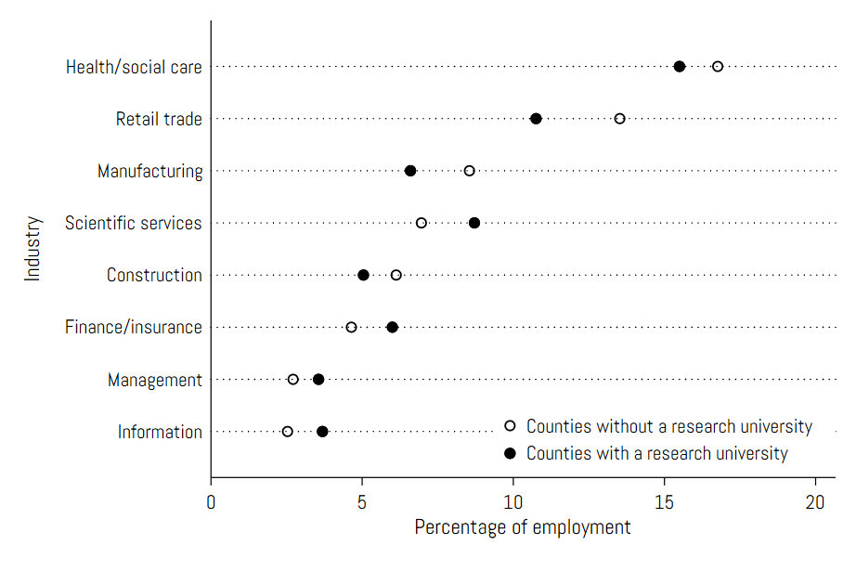

Notes: data sourced from the 2018 County Business Patterns (U.S. Census Bureau, 2020). The figure presents the county average of employment shares in select sectors, defined by 2-digit NAICS codes, for counties with and without a research university, defined as a doctoral university with highest, higher, or moderate research activity in the 2015 Carnegie Classification. Since not all sectors are included in the figure, employment shares do not some up to 100 percent.

Where are leading research universities located and how are their locations related to per capita income? In Figure2 we show a choropleth map of per capita income in 2015 for metropolitan areas with and without research universities. Many familiar patterns are visible. California features both high-income counties and research universities. Similar clusters are observed along the East Coast corridor from Washington DC to Boston. At the same time, we see fewer high income-research university locations in the Midwest and South. Indeed, much of the map reflects the weak cross-sectional correlation between research university presence and labor income documented in Kantor and Whalley (2014).

**Figure 2: Per Capita Income and Research University Presence**

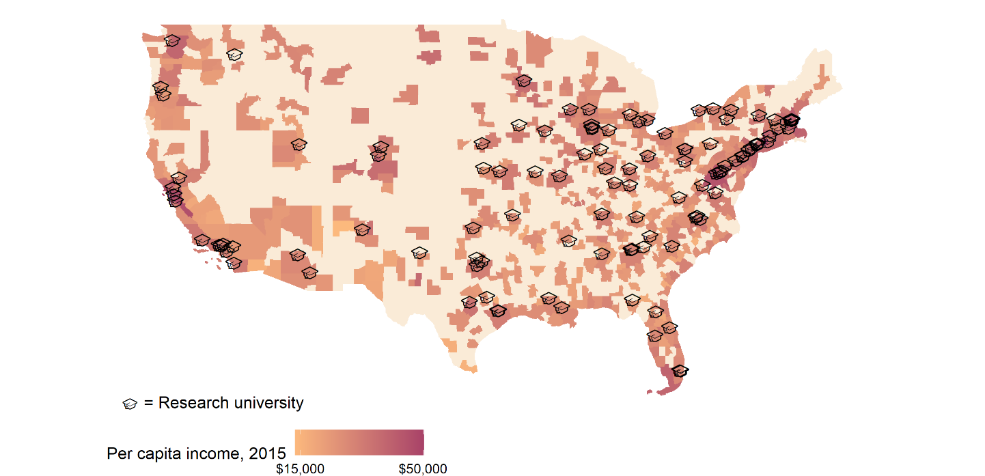

Notes: per capita income data sourced from the American Community Survey, retrieved from IPUMS NHGIS (Manson et al., 2020). The map presents average per capita income gradients at the MSA level. A research university is defined as a doctoral university with highest, higher, or moderate research activity in the 2015 Carnegie Classification.

To think through why research universities may or may not create high-paying local jobs we discuss how two outputs of universities are linked to local economic growth. Regions with concentrations of highly skilled workers and entrepreneurs have been particularly successful. As research universities produce millions of skilled graduates and innovations every year, it may be natural to look to them as a driving force behind knowledge hubs.

Yet university graduates and ideas are very mobile. Many graduates will consider jobs across the country or even internationally. If they move so does the human capital produced by the university. Ideas and innovations are also highly mobile. It is very easy for an interested researcher in the UK to read a patent invented in Canada for example. Still, ideas and workers are not fully mobile. Exactly how mobile they are is central to what the regional effects of research universities might be. In the last section of the paper, we consider this question of mobility and implications for what we can learn from local effects of universities.

1. **Skills and Innovation in Regional Growth**

The natural starting point for understanding how research universities affect local labor markets is to understand how their outputs – graduates and ideas – matter. That both skills and ideas are closely tied to productivity suggests that they would both predict regional success. Much research has shown spillovers from human capital (Glaeser and Mare, 2001; Moretti, 2004a; Shapiro, 2006), ideas (Audretsch and Feldman, 1996; Zucker, Darby, and Brewer, 1998; Moretti, 2019) and entrepreneurship (Glaeser, Kerr and Kerr, 2015) are locally biased.[2]

To visualize these effects in the data, we first examine how initial levels of education – here measured in 2010 – predict population and labor income growth between 2010-2019. In Figure3 we look at data from large urban counties in the United States. We see a clear upward relationship where locations with a larger fraction of university graduates in 2010 have experienced higher populational growth between 2010 and 2019. A similar relationship is apparent in Figure4, looking at per capita income growth. Common to both figures is that locations with high initial levels of education and high population or income growth rates, such as Loudoun county, VA and San Francisco, CA, employ heavily on high-tech industries. On the other end of the spectrum, we have declining regions with a low-skilled population – such as Detroit in Wayne county, MI – with a long history of manufacturing and trade.

**Figure 3: Population Growth and the Initial Percentage of College Graduates, 2010-2019**

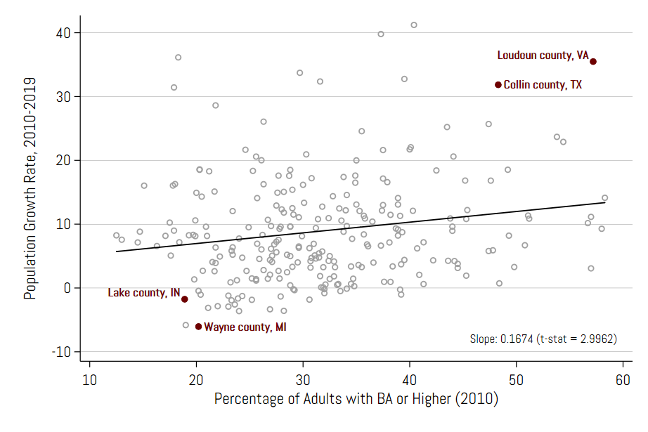

Notes: population data sourced from the American Community Survey (ACS), retrieved from IPUMS NHGIS (Manson et al., 2020). Each bubble represents a large urban county, defined as a county with a population greater than 250,000 in 2010. BA represents attainment of a bachelor’s degree. 2010 population and percentage of adults with a BA or higher are constructed from the 2006-2010 5-year Public Use Microdata Samples of the ACS. 2019 population is similarly constructed from the 2015-2019 5-year Public Use Microdata Samples.

**Figure 4: Per Capita Income Growth and the Initial Percentage of College Graduates, 2010-2019**

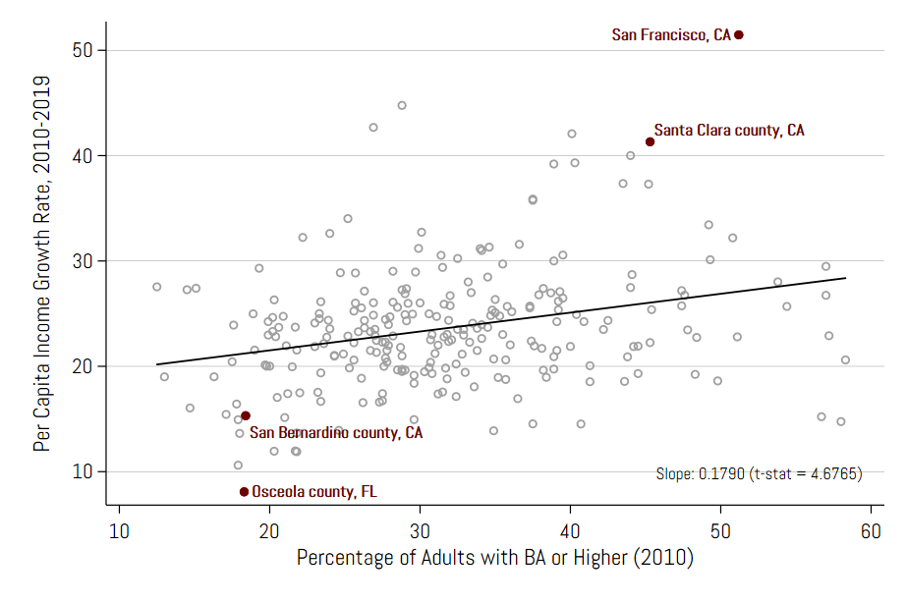

Notes: per capita income data sourced from the American Community Survey (ACS), retrieved from IPUMS NHGIS (Manson et al., 2020). Each bubble represents a large urban county, defined as a county with a population greater than 250,000 in 2010. BA represents attainment of a bachelor’s degree. 2010 per capita income and percentage of adults with a BA or higher are constructed from the 2006-2010 5-year Public Use Microdata Samples of the ACS. 2019 per capita income is similarly constructed from the 2015-2019 5-year Public Use Microdata Samples.

Next, we examine how idea generation in a location – proxied by U.S. patent grants in 2010 – predict population and per capita income growth between 2010-2019. In Figure5 we see a positive albeit weak relationship between patent intensity and population growth in a county. A similar but stronger relationship is revealed in Figure 6 for income per capita.[3] Analogous to figures Figure 3 and Figure 4, counties with higher patent intensity and population and income growth rates also have an economy biased towards high-skilled sectors.

**Figure 5: Population Growth and Initial Patent Intensity, 2010-2019**

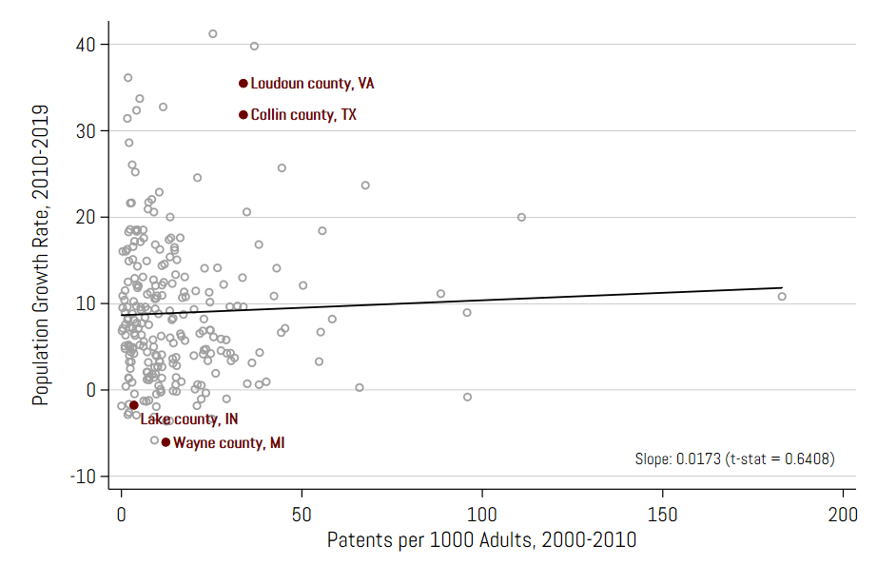

Notes: population data sourced from the American Community Survey (ACS), retrieved from IPUMS NHGIS (Manson et al., 2020). Each bubble represents a large urban county, defined as a county with a population greater than 250,000 in 2010. Patent data represent patent grants from the U.S. Patent and Trademark Office for which inventors have been geolocated by Li et al. (2014). 2010 population is constructed from the 2006-2010 5-year Public Use Microdata Samples of the ACS. 2019 population is similarly constructed from the 2015-2019 5-year Public Use Microdata Samples.

**Figure 6: Per Capital Income Growth and Initial Patent Intensity, 2010-2019**

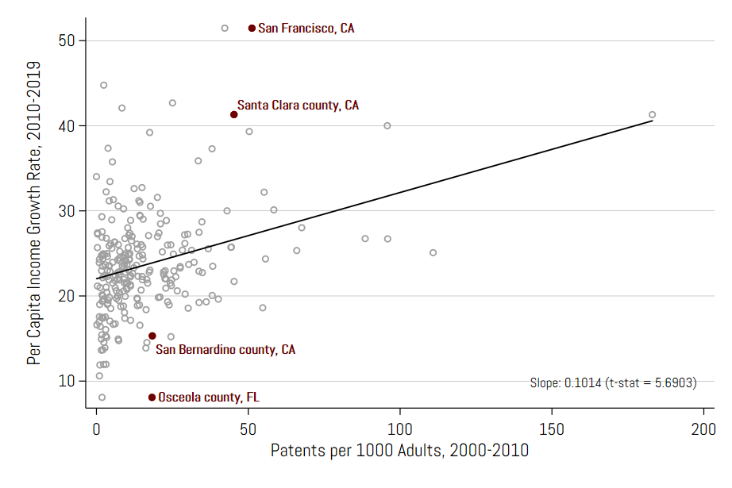

Notes: per capita income data sourced from the American Community Survey (ACS), retrieved from IPUMS NHGIS (Manson et al., 2020). Each bubble represents a large urban county, defined as a county with a population greater than 250,000 in 2010. Patent data represent patent grants from the U.S. Patent and Trademark Office for which inventors have been geolocated by Li et al. (2014). 2010 per capita income is constructed from the 2006-2010 5-year Public Use Microdata Samples of the ACS. 2019 per capita income is similarly constructed from the 2015-2019 5-year Public Use Microdata Samples.

Skills and innovation are highly correlated as much innovation is conducted by the highly skilled. This is illustrated by the examples shown in Figure 3-Figure 6; locations with a high concentration of college-educated workers have a stronger presence of high-tech industries where idea generation matters the most. Which among skill and innovation are more predictive of economic success? We conduct a simple regression to see. We estimate the model:

$Δy_{i}=β_{1}+ β_{2}{Skill}_{i}+ β_{3}{Patent}_{i}+ε_{i},$ (1)

where $Δy_{i}$ is the change in the outcome variable – either population or income per capita – in county *i* between 2010 and 2019, ${Skill}_{i}$ is the percentage of college-educated workers in county *i* in 2010, ${Patent}_{i}$ is the patents per capita over the 2000-2010 decade in county *i*, and $ε_{i}$ is the error term.

We present the results for population growth in Table1– panel A and per capita income growth in Table1 – panel B. We would expect both $β_{2}$ and $β_{3}$ to be positive as higher levels of skill and innovation likely predict higher levels of growth. This is what we see separately in columns (1) and (2) for both outcomes, though the estimated coefficient $β_{3}$ is not statistically significant for predicting population growth. When including both initial skill and innovation levels, column (3) reveals that only the initial skill-growth correlation remains statistically significant.

**Table 1: University Graduates, Innovation Concentration and Regional Growth**

|  |  |  |  |
| --- | --- | --- | --- |
| C | (1) | (2) | (3) |
| *Panel A: Dep. Var. = Population Growth, 2010-2019* | |  |  |
| % with BA or higher, 2010 | 0.167 |  | 0.2 |
|  | (0.056) |  | (0.065) |
| Patents per 1000 Adults, 2000-2010 |  | 0.017 | -0.031 |
|  |  | (0.027) | (0.031) |
| R2 | 0.035 | 0.002 | 0.039 |
| Observations | 252 | 252 | 252 |
| *Panel B: Dep. Var. = Per Capita Income Growth, 2010-2019* | | |  |
| % with BA or higher, 2010 | 1.148 |  | 1.185 |
|  | (0.116) |  | (0.134) |
| Patents per 1000 Adults, 2000-2010 |  | 0.249 | -0.035 |
|  |  | (0.063) | (0.064) |
| R2 | 0.282 | 0.059 | 0.283 |
| Observations | 252 | 252 | 252 |

Notes: standard errors shown in parentheses. Overall population, college educated population, and per capita income data sourced from the American Community Survey (ACS), retrieved from IPUMS NHGIS (Manson et al., 2020). Demographic variables are constructed from the 2006-2010 and 2015-2019 5-year Public Use Microdata Samples of the ACS. Patent data represent patent grants from the U.S. Patent and Trademark Office for which inventors have been geolocated by Li et al. (2014). BA represents attainment of a bachelor’s degree. Columns (1) and (2) estimate univariate regressions of the specified dependent variable on initial skill level – measured by the percentage of the county population with a BA or higher – and patent intensity – measured by the county sum of patents between years 2000 and 2010 – respectively. Column (3) estimates the multivariate regression corresponding to equation (1), which includes both independent variables for initial skill level and patent intensity.

The results in this section suggest that universities could be an engine for local growth through the supply of either university graduates or ideas. To understand whether universities are indeed a driving force for regional growth requires moving beyond these simple correlations to causal estimation. We turn to the evidence on this question next.

1. **Short-Term University Effects**

Clearly, higher level of university-related outcomes such as skills and ideas are correlated with high levels of regional growth in income and population. We might then expect that research universities producing both university graduates and ideas would also positively affect local labor markets. We assess that evidence next.

Valero and Van Reenen (2019) utilize a new dataset using UNESCO source materials on the location of nearly 15,000 universities in about 1,500 regions across 78 countries. Their estimates imply that a 10% increase in a region's number of universities per capita is associated with 0.4% higher future GDP per capita in that region. They show that the relationship between GDP per capita and universities is not simply driven by the direct expenditures of the university, its staff, and students. Part of the effect of universities on growth is mediated through an increased supply of human capital and greater innovation.

How do these localized university knowledge spillovers actually translate into broad-based regional labor market effects? Kantor and Whalley (2014) address this question directly by examining the impact of increases in university expenditures on local non-education labor income. As mentioned before, the main empirical challenge in estimating the impact that universities have on their local economies is that university activity is not randomly assigned: universities might be more likely to locate and expand in places that are (for unrelated reasons) on a stronger or weaker economic growth trajectory.

To deal with this econometric challenge, Kantor and Whalley (2014) exploit a natural experiment. Specifically, the authors consider significant and sudden changes, or shocks, to universities’ endowment levels that are caused by fluctuations in stock market values. US universities typically spend a constant fraction of the market value of their endowments every year. Therefore, sudden shocks to the stock market determine how much a university will be able to spend from its endowment in any given year. Given that shocks to stock market returns occur at the national or international level and that prior levels of university endowments are not affected by future economic activity in the university’s county, the authors use these shocks to examine random variation in university expenditures on research and other activities.

Taking this approach, Kantor and Whalley (2014) find that increases in university research activity result in productivity spillovers to other industries. The estimates indicate that a $1.00 increase in university spending generates an $0.89 increase in noneducation labor income in the county in which the university is located. The results further show that this effect persists for at least five years, which suggests that the impact of research expenditures goes beyond a short-run boost to local labor demand.

While the average spillover effect is rather modest, the authors further investigate whether the magnitude of the effect varies with the intensity of university research or the strength of economic links between universities and local industries. Knowledge spillovers are found to be significantly larger for universities that have a greater focus on research, for industries that share a labor market with universities, and for industries that use knowledge more intensively.

These findings are in line with previous research showing that knowledge spillovers tend to be concentrated in particular industries such as pharmaceuticals or electronics and are not broad-based (Jaffe 1989). In the models estimating the spillover effect over five years, the estimates indicate that firms in industries that are technologically closer to university research, in the sense that they share a labor market with higher education and are more likely to cite university patents, enjoy a spillover that is double that of the typical firm.

Using an alternative econometric strategy, Hausman (2017) arrives at a similar conclusion. Specifically, the author investigates whether an increase in university innovation leads to local economic growth. Hausman finds that the passage of the Bayh-Dole Act in 1980, which incentivized universities to commercialize new innovations, resulted in wage and employment growth for communities near the universities, and specifically for those industries that were more closely related to the technological strengths of the nearby university. Hausman (2017) finds that large numbers of small unit firms entered the university area, possibly as a result of spin-offs from new university ideas. However, she finds that most of the employment gains came from new establishments of existing firms in university-related industries.

Hausman’s findings suggest that highly localized university knowledge spillovers may not only make existing firms in the area more productive, but may also attract new firms wanting to gain access to these spillovers. Altogether, research has shown that universities can affect the stock of local human capital and spur economic development in their communities as long as they focus on academic research in areas that are relevant to local industry.

Most of the research to date has focused on the effect of expanding higher education activity, through either research expenditures or increases in degree production. This research is less informative regarding the effects of opening a new university. Furthermore, the literature has primarily focused on metropolitan areas and urban counties, and not on rural areas. The effects of higher education expansions can be quite different in these latter areas, particularly since university knowledge spillovers are larger when research is focused in areas relevant to industry fundamentals (Kantor and Whalley 2014).

The example of the University of California, Merced (UC Merced) is informative. UC Merced is the first American research university built in the 21st century (2005 marked the year of its official grand opening), and it provides an excellent opportunity to test whether establishing a new university in a relatively small and less-educated local economy can bring economic prosperity to the region.

A recent study by Lee (2019) finds that the university has generated only a modest impact on the local economy by increasing local employment. Job creation was large for the service sector but was not significant for either the manufacturing or high-skilled sectors, leading the author to conclude that the establishment of a new university in the 21st century is likely insufficient to yield robust agglomeration economies. The opening of UC Merced did induce a local labor demand shock, which resulted a fiscal multiplier effect. However, at least in the short run the university has not generated the knowledge spillovers required to induce a meaningful increase in its region’s stock of human capital.

Lee (2019) explains that his findings are consistent with the findings of Kantor and Whalley (2014): although Kantor and Whalley find evidence of localized spillovers from university activity, the effects are larger in those industries that use knowledge more intensively. Given that the initial industrial composition in Merced was not concentrated in high-tech industries, workers in neighboring firms might not have benefited as much from the opening of a research university.

The short-term effects of universities while meaningful are not especially large relative to other local shocks. But the impact of a university may grow over time. Some think it does. Senator Daniel Patrick Moynihan was said to have quipped“If you want to build a world class city, build a great university and wait 200 years”. Recent research has made some progress in this regard.

1. **Long-Term Effects of Universities**

The increasing availability of detailed micro-geographic data over long time horizons has enabled researchers to estimate the impact of important natural experiments. Kantor and Whalley (2019) examine how nearby agricultural research conducted at universities affects the productivity of farmers over the long term. They propose that the establishment of federal agricultural experiment stations in the late nineteenth century serves as a source of exogenous variation in the location of knowledge production. Because the stations were opened at predetermined land-grant university locations in response to nationwide concerns about agriculture, they created a positive shock to research virtually independent of local economic conditions. Furthermore, detailed historical productivity data allow research proximity effects to be estimated over a time horizon possible in few other contexts.

Experiment station researchers discovered biological innovations (i.e., new and improved crop varieties) and diffused advanced farming practices (i.e., appropriate fertilizer intensity and crop rotations) that powered productivity growth in agriculture. That knowledge, often diffused through social interaction, suggests a strong role for proximity-based knowledge transfer.

Kantor and Whalley (2019)’s analysis begins by examining how proximity to experiment station research affected land productivity. They find that research proximity effects started out small and grew, peaking between 20 and 30 years after the experiment stations opened. While research expenditures continued to grow, research proximity effects declined, however, dying out 30–50 years after station opening.

To understand why university proximity effects die out, Kantor and Whalley (2019) use newly collected data on the results of over 10,000 experiments conducted at the stations to develop a measure of where and when experiment stations achieved a significant crop innovation. The crop innovation data allow them to examine whether technology diffused more quickly after 1920 when cars and telephones were widely available and the agricultural extension program was in nearly every county. They find that the diffusion of crop innovations was much quicker in the post-1920 period. Before 1920, proximity to station crop innovations was important 20 years after the discovery. After 1920, however, they find little evidence that proximity to station innovations had any effect on productivity. The increased speed of innovation diffusion largely explains the reduction in research proximity effects they find, suggesting an important role for reduced transportation costs in the dying out of proximity effects.

Subsequent work has looked not at productivity, but innovation and population movements. Andrews (2021) uses a similar approach based on site selection decisions for a subset of U.S. colleges to identify "runner-up" locations that were strongly considered to become the sites of new colleges but were ultimately not chosen for reasons as good as random assignment. Using these runner-up counties as counterfactuals to those that had a land-grant university established, he finds that establishing a new college causes 45% more patents per year. However, controlling for county population explains most of this observed increase. This suggests that migration rather than changes in the research intensity of a community explains most of the patent effect.

Andrews (2021) then links the patent records to a novel dataset of college yearbooks, revealing that only 12% of patents in a college's county come from individuals directly affiliated with that college as either alumni or faculty. In addition, college counties do not appear to attract especially skilled migrants. To understand the role of knowledge spillovers from universities in explaining his results he examines the impacts of other types of large public infrastructure that produce little knowledge. He finds that the impacts of these other types of institutions on patenting is statistically indistinguishable from the effects of universities. Thus, while universities do have long term effects on local patenting the results seem to be driven by the migration of workers to those locations with a similar order of magnitude to other types of infrastructure.

Other studies of the longer-term effects of universities find different effects, however. The results obtained by Kantor and Whalley (2019) and Andrews (2021) differ from those of Liu (2015), who documents long-lasting spillovers on manufacturing productivity following the establishment of land-grant colleges in the late 19th century. Liu (2015) treats the designation of land-grant universities in the 1860s as a natural experiment after controlling for the confounding factors with a combination of synthetic control methods and event-study analyses. He finds that the designation increased local population density by 6 percent within 10 years and 45 percent in 80 years. He also shows that, the designation did not change the relative size of local manufacturing sector. The designation enhanced local manufacturing output per worker by 57 percent in 80 years while the short-run effects were negligible. One reason for the difference may be agglomeration forces may play a far more important role in manufacturing than agriculture.

Another possibility for differing short- and long-term effects of universities is their effect on the industrial composition of a location. Lee (2021) asks whether a new technology-oriented research university start a virtuous cycle by inducing industrial agglomeration. He studies the effect of the opening of the Ulsan National Institute of Science and Technology (UNIST) in 2009 on local industrial specialization. His analysis reveals that the opening of the university increased manufacturing employment through the entry of new firms between 2009 and 2016. These new firms were mainly found in industries technologically close to the university’s research. The number of firms in closely connected industries increased more than 30% compared with little change in less-related industries. Overall, his results suggest that a university can lead to local industrial specialization toward industries more closely related to that university’s innovative strengths. This industrial specialization response could be one reason long-term effects are more pronounced in manufacturing.

1. **Mobility and Aggregate Effects**

We have strong evidence on the local effects of universities. These studies are often compelling as they use highly granular data coupled with a credible identification strategy. However, they are not necessarily informative on the nationwide effects of universities. The reason is that workers, firms, and goods are mobile. Mobile production factors and university outputs may affect not just local labor markets, but also labor markets further away.

In theory, universities can influence the stock of human capital in a region by increasing both the supply of and the demand for college graduates (Abel and Deitz, 2012). At first glance, it may seem obvious that colleges and universities directly increase the supply of college graduates in their regions. After all, one of the key roles of a university is that of an educational institution. However, a closer look at the literature reveals that the impact of universities on the supply of college graduates in a region could be small for certain areas. For instance, if a region’s local labor market is not robust enough to create job opportunities for newly minted graduates, alumni might not remain in the area.

In Figure7 we look at how regional production of college graduates relates to the change in population of high skilled workers. In this graph, any points on the 45-degree line represent equality between the production and flow of college graduates. “Brain gain” counties above the 45-degree line produce less college graduates than the change in the number of college graduates in the population. “Brain drain” counties below this line produce more college graduates than the change in the number of college graduates in the population.

**Figure 7: Production and Employment of College Graduates**

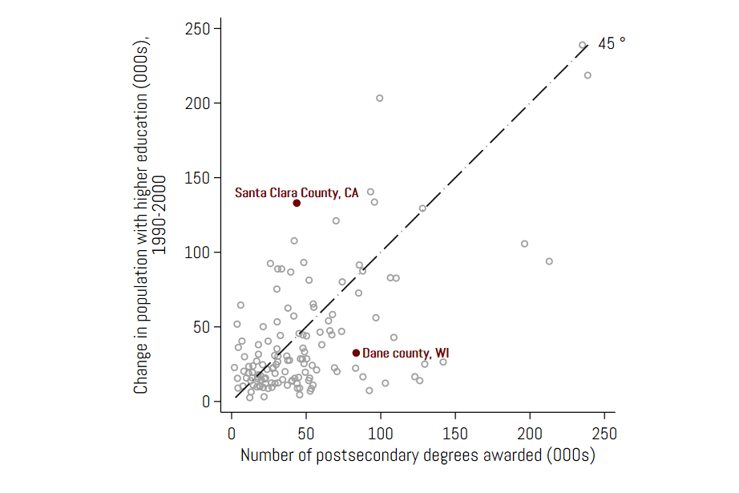

Notes: data on postsecondary degrees awarded sourced from the Integrated Postsecondary Education Data System (U.S. Department of Education, 2000). The figure shows the relationship between production of higher education degrees and the flow of individuals with higher education. The total number of postsecondary degrees awarded in a county in 2000 is known, whereas the 1990-1999 totals are assumed to be the same as in 2000. County-level data for population with higher education in 1990 and 2000 are sourced respectively from the 1990 and 2000 U.S. Census, and are retrieved from IPUMS NHGIS (Manson et al., 2020).

It is immediately apparent from Figure7 that few regions produce and employ exactly the same numbers of college graduates. Places like Silicon Valley (Santa Clara County, California) at the heart of the tech industry import significant numbers of college graduates. Locations with a large state university but not major employment centers like Madison Wisconsin (Dane County, Wisconsin) produce many more college graduates than they employ.

In many cases, major employment centers may also struggle to retain locally-trained high-skilled workers. The map in Figure 8 shows large markets such as Boston and New York – home to many well-known universities – suffer deep deficits in employing their graduates locally. College graduates often migrate to locations with labor markets demanding their very specific skill sets (CBRE, 2019).

**Figure 8: Spatial Differences in Production and Employment of College Graduates**

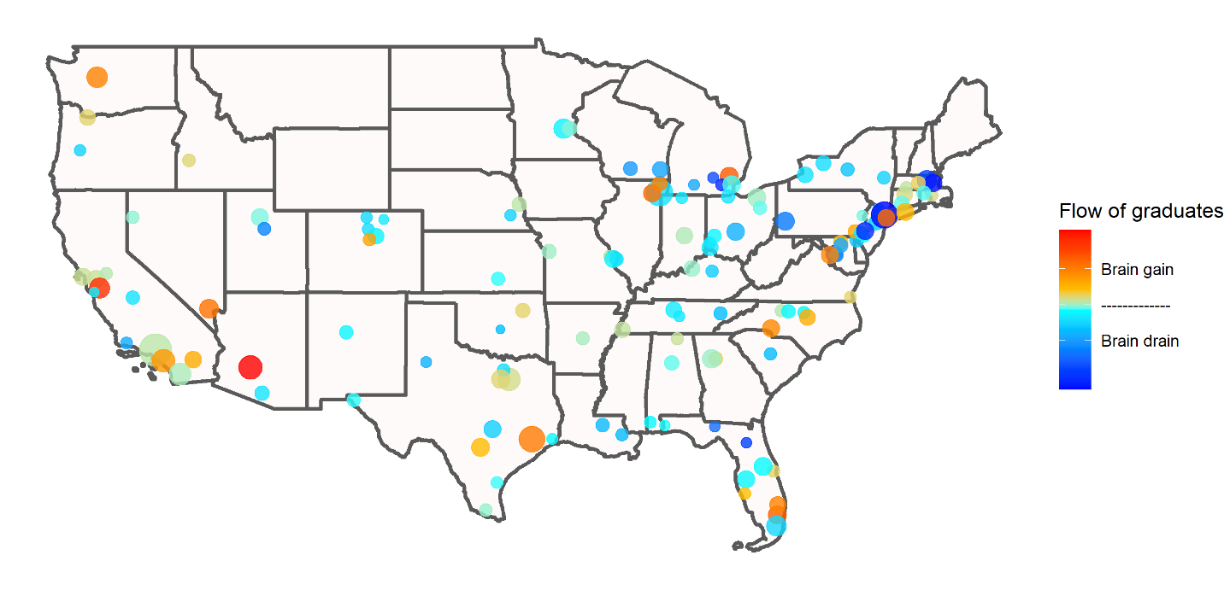

Notes: color gradient on the bubbles show the difference between flow of individuals with higher education and postsecondary degrees awarded at a county. This difference ranges roughly from a 100,000 deficit (in New York) to a 100,000 surplus (in Maricopa county, AZ) in the inflow of college-trained individuals relative to local production of graduates. The bubble size is proportional to total employment in the county, and ranges from 70,000 in Cleveland County, OK, to 4,000,000 in the County of Los Angeles. Bubble locations represent county centroids. The map shows the spatial distribution of counties where the inflow of individual with higher education is greater than the production of higher education degrees (denoted brain gain) and counties where this inflow is less than degree production (brain drain). See Figure 7 for details on data sources used for postsecondary degrees and higher education flows.

College-educated workers are highly mobile and more likely than their less-educated peers to migrate in search of better jobs (Bound et al. 2004; Moretti and Wilson 2014; Wozniak 2010). Therefore, areas with strong local labor demand may both retain their graduates and attract graduates from other locations, while regions with less-robust labor demand may struggle to retain their graduates.

When migration responses to non-local shocks are significant, the local labor market effects of a university may be significantly larger than nationwide effects (Moretti, 2010). While no work to date has explored the full general equilibrium effects of research universities, there is ongoing work exploring how local and national effects of innovation policy may differ.

Kantor and Whalley (2021) examine the effect of the establishment and growth of National Aeronautics and Space Administration (NASA) in response to the Space Race. The Space Race is one of the largest public R&D projects ever undertaken, and projects led by NASA potentially ignited a number of developments in telemetry, integrated circuits, cryogenics, and computer simulation that had real economic value.

The authors argue that public R&D reduced unit costs for firms receiving a government contract, leading to local labor market effects from the expansion of production and employment. Furthermore, local patents associated with NASA-sponsored research increased manufacturing value added. On the other hand, market-level patents – i.e. those with a reach beyond local – *reduced* value added, echoing the importance of inter-regional migration effects.

Finally, Kantor and Whalley (2021) compute the implied multiplier of NASA spending on manufacturing to provide an estimate of the national impact of government spending on space research. Their preferred estimate of the implied multiplier counting only local effects – the local multiplier – is 7.2. Counting both local and market effects to capture the national multiplier gives a preferred estimate of the implied multiplier of 2.4. Thus, the local multiplier is more than twice the national multiplier. Their study represents a cautionary tale of scaling up local multipliers to the national level without accounting for migration.

The mobility of both outputs of universities is likely to be important for determining what can be learned from local estimates. Adams (2002) uses data from U.S. R&D laboratories to quantify spatial aspects of learning about universities and firms. His findings suggest that academic knowledge spillovers are particularly localized because proximity is an important factor in university-industry collaboration. Indeed, the possibility that knowledge is less mobile than graduates suggests that research universities have a larger local impact through idea production. This possibility has led some to propose knowledge transfer as a primary policy to extract local job creation from research universities (Baron, Kantor and Whalley, 2018).

1. **Conclusion**

We conclude that universities can have important effects on local labor markets. The evidence we reviewed suggests ideas and human capital produced by research universities spur local benefits over the medium term. Policymakers behind the major public investments of University of California – Merced and Cornell NYC can take comfort in these findings.

Whether research universities can provide a basis for a long-term strategy to create and attract good jobs remains an open question. Because skilled workers and ideas are mobile it is unclear whether the gains from research universities will accrue nationally or only locally. Having a local labor market that provides opportunities for new graduates and ideas seem to matter. Still, more research is needed for a more definitive answer.

**References:**

Abel, Jaison R., and Richard Deitz (2012) “Do Colleges and Universities Increase Their Region’s Human Capital?” *Journal of Economic Geography* 12 (3): 667–91.

Adams, James D. (1990) “[Fundamental stocks of knowledge and productivity growth](https://www.journals.uchicago.edu/doi/abs/10.1086/261702),” *Journal of Political Economy*, 98(4): 673-702.

Adams, James D. (2002) “[Comparative Localization of Academic and Industrial Spillovers](https://academic.oup.com/joeg/article-abstract/2/3/253/1173598),” *Journal of Economic Geography*, 2(3): 253-278.

Andrews, Michael (2020) “[**How Do Institutions of Higher Education Affect Local Invention? Evidence from the Establishment of U.S. Colleges**](https://drive.google.com/file/d/1-980scfaT_sZKzUvlyNefQ4uUrbBhvCo/view?usp=sharing)”, Working Paper, University of Maryland – Baltimore County.

Andrews, Michael and Alexander Whalley (2021) “150 Years of the Geography of Innovation” *Regional Science and Urban Economics*, Forthcoming.

Audretsch, David B. and Maryann Feldman (1996) “R&D Spillovers and the Geography of Innovation and Production.” *American Economic Review*, 86(3):630-640.

Baron, E. Jason, Shawn Kantor and Alexander Whalley (2018)” Extending the Reach of Research Universities: A Proposal for Productivity Growth in Lagging Communities,” *The Hamilton Project - Brookings Institution*, Policy Proposal 2018-11.

Bound, John, Jeffrey Groen, Gabor Kezdi, and Sarah Turner (2004) “Trade in University Training: Cross-State Variation in the Production and Stock of College-Educated Labor.” *Journal of Econometrics* 121 (1–2): 143–73

CBRE (2019) “Scoring Tech Talent in North America,” *CBRE*. Retrieved from <https://www.cbre.ca/en/research-and-reports/Scoring-Tech-Talent-in-North-America-2018>.

Glaeser, Edward L., Jose A. Scheinkman and Andrei Shleifer (1995) “Economic Growth in a Cross-Section of Cities*.” Journal of Monetary Economics* 36(1):117-143.

Glaeser, Edward L. and Matthew E. Kahn (2001) “Decentralized Employment and the Transformation of the American City.” *Brookings/Wharton Papers on Urban Affairs* 2.

Glaeser, Edward L. and David Mare (2001) “Cities and Skills.” Journal of Labor Economics 19(2):316-342.

Glaeser, Edward L., and Joshua D. Gottlieb (2009) “The Wealth of Cities: Agglomeration Economies and Spatial Equilibrium in the United States." *Journal of Economic Literature*, 47 (4): 983-1028.

# Glaeser, Edward L., Sari Pekkala Kerr and William R. Kerr (2015) “Entrepreneurship and Urban Growth: An Empirical Assessment with Historical Mines,” *Review of Economics and Statistics*, May, 97(2): 498-520.

Hausman, Naomi (2020) “[University Innovation and Local Economic Growth](https://papers.ssrn.com/sol3/papers.cfm?abstract_id=3793020),”  *Review of Economics and Statistics,* forthcoming.

Helsley, Robert W. and William C. Strange (2004) “Knowledge Barter in Cities,” *Journal of Urban Economics* 56(2): 327-345.

Jaffe, Adam (1989) *“*Real effects ofacademic research,” *American Economic Review*, 79(5): 957 – 70.

Jaffe, Adam B., Manuel Trajtenberg, and Rebecca Henderson (1993) “Geographic Localization of Knowledge Spillovers as Evidenced by Patent Citations,” Quarterly Journal of Economics, 108(3): 577–598.

Kantor, Shawn and Alexander Whalley (2014) “Knowledge Spillovers from Research Universities: Evidence from Universities,” *Review of Economics and Statistics*,

Kantor, Shawn and Alexander Whalley (2019) “Research Proximity and Productivity: Long-Term Evidence from Agriculture,” *Journal of Political Economy*, 127(2): 819-854.

Kantor, Shawn and Alexander Whalley (2021) “Moonshoot: Public R&D and Economic Development,” working paper, University of Calgary.

Kerr, William R. and Frederic Robert-Nicoud (2020) “[Tech Clusters,](http://doi.org/10.1257/jep.34.3.50)" *Journal of Economic Perspectives*, 34(3): 50-76.

Lee, Jongkwan (2019) “The Local Economic Impact of a Large Research University: Evidence from UC Merced,” ***Economic Inquiry***, 57(1): 316-332.

Lee, Jongkwan (2021) “The Role of a University in Cluster Formation: Evidence from a National Institute of Science and Technology in Korea,” ***Regional Science and Urban Economics,*** 86.

Li, Jing, Shimeng, Liu, and Yifan Wu (2021) Identifying Spillovers from Universities: Quasi-experimental Evidence from Urban China,” Working Paper, Jinan University.

Li, Guan-Cheng, Ronald Lai, Alexander D’Amour, David M. Doolin, Ye Sun, Vetle I. Torvik, Z. Yu Amy, and Lee Fleming (2014) "Disambiguation and co-authorship networks of the US patent inventor database (1975–2010)," *Research Policy*, 43(6): 941-955. <https://doi.org/10.7910/DVN/5F1RRI>.

Liu, Shimeng (2015) “Spillovers from Universities: Evidence from the Land-Grant Program,” Journal of Urban Economics 87, 25–41.

Manson, Steven, Jonathan Schroeder, David Van Riper, Tracy Kugler, and Steven Ruggles (2020) “IPUMS National Historical Geographic Information System: Version 15.0 [dataset],” IPUMS, Minneapolis, MN*.* Retrieved from <https://data2.nhgis.org/main>.

Marshall, Alfred (1890) *Principles of Economics*. London: Macmillan and Co.

Moretti, Enrico (2004a) “Estimating the Social Return to Higher Education: Evidence from Longitudinal and Repeated Cross-Sectional Data.” *Journal of Econometrics* 121(1-2): 175-212.

Moretti, Enrico (2004b) “Workers' Education, Spillovers, And Productivity: Evidence From Plant-Level Production Functions," *American Economic Review*, 94(3): 656-690.

Moretti, Enrico (2004) "Human capital externalities in cities," Handbook of Regional and Urban Economics, in: J. V. Henderson & J. F. Thisse (ed.), *Handbook of Regional and Urban Economics*, edition 1, volume 4, chapter 51, pages 2243-2291.

Moretti, Enrico (2010) “Local multipliers.” *American Economic Review,* Paper & Proceedings,

100(2): 373–77.

Moretti, Enrico (2012) *The New Geography of Jobs,* Mariner Books.

# Moretti, Enrico (2021) “The Effect of High-Tech Clusters on the Productivity of Top Inventors,” Working Paper 26270, National Bureau of Economic Research.

Moretti, Enrico, and Daniel J. Wilson (2014) “State Incentives for Innovation, Star Scientists and Jobs: Evidence from Biotech,” *Journal of Urban Economics* 79: 20–38.

Shapiro, Jesse M. (2006) “Smart Cities: Quality of Life, Productivity, and the Growth Effects of Human Capital,” *Review of Economics and Statistics* 88(2): 324-335.

U.S. Census Bureau (2020a) “2018 County Business Patterns,” U.S. Census Bureau. Retrieved from <https://www.census.gov/data/datasets/2018/econ/cbp/2018-cbp.html>.

Valero, Anna, John Van Reenen (2019) “The economic impact of universities: Evidence from across the globe,” *Economics of Education Review*, 68: 53-67.

Zucker, Lynne G., Michael R. Darby, and Marilynn B. Brewer (1998) “Intellectual Human Capital and the Birth of U.S. Biotechnology Enterprises,” *American Economic Review*, 88(1): 290–306.

Weinzierl, Matthew (2018) “Space, the final economic frontier,” *Journal of Economic Perspectives*, 32(2): 173-92.

Wozniak, Abigail (2010) “Are College Graduates More Responsive to Distant Labor Market Opportunities?” *Journal of Human Resources* 45(4): 944–70.

1. Average labor income calculated using the 2015-2019 5-year sample of the American Community Survey, retrieved from IPUMS NHGIS (Manson et al., 2020).
2. See Kerr, and Robert-Nicoud (2020) for a discussion of the recent evidence of local bias on technology clusters.
3. These correlations using very recent data are similar to those reported in Glaeser and Gottlieb (2009). However, as patterns of innovation have changed significantly over time (Andrews and Whalley, 2021) correlations with population growth or per capita income growth over the very long run may look quite different.