**FIT5195 S1 2020 – Take Home Test**

1. Task 1 The star schema diagram

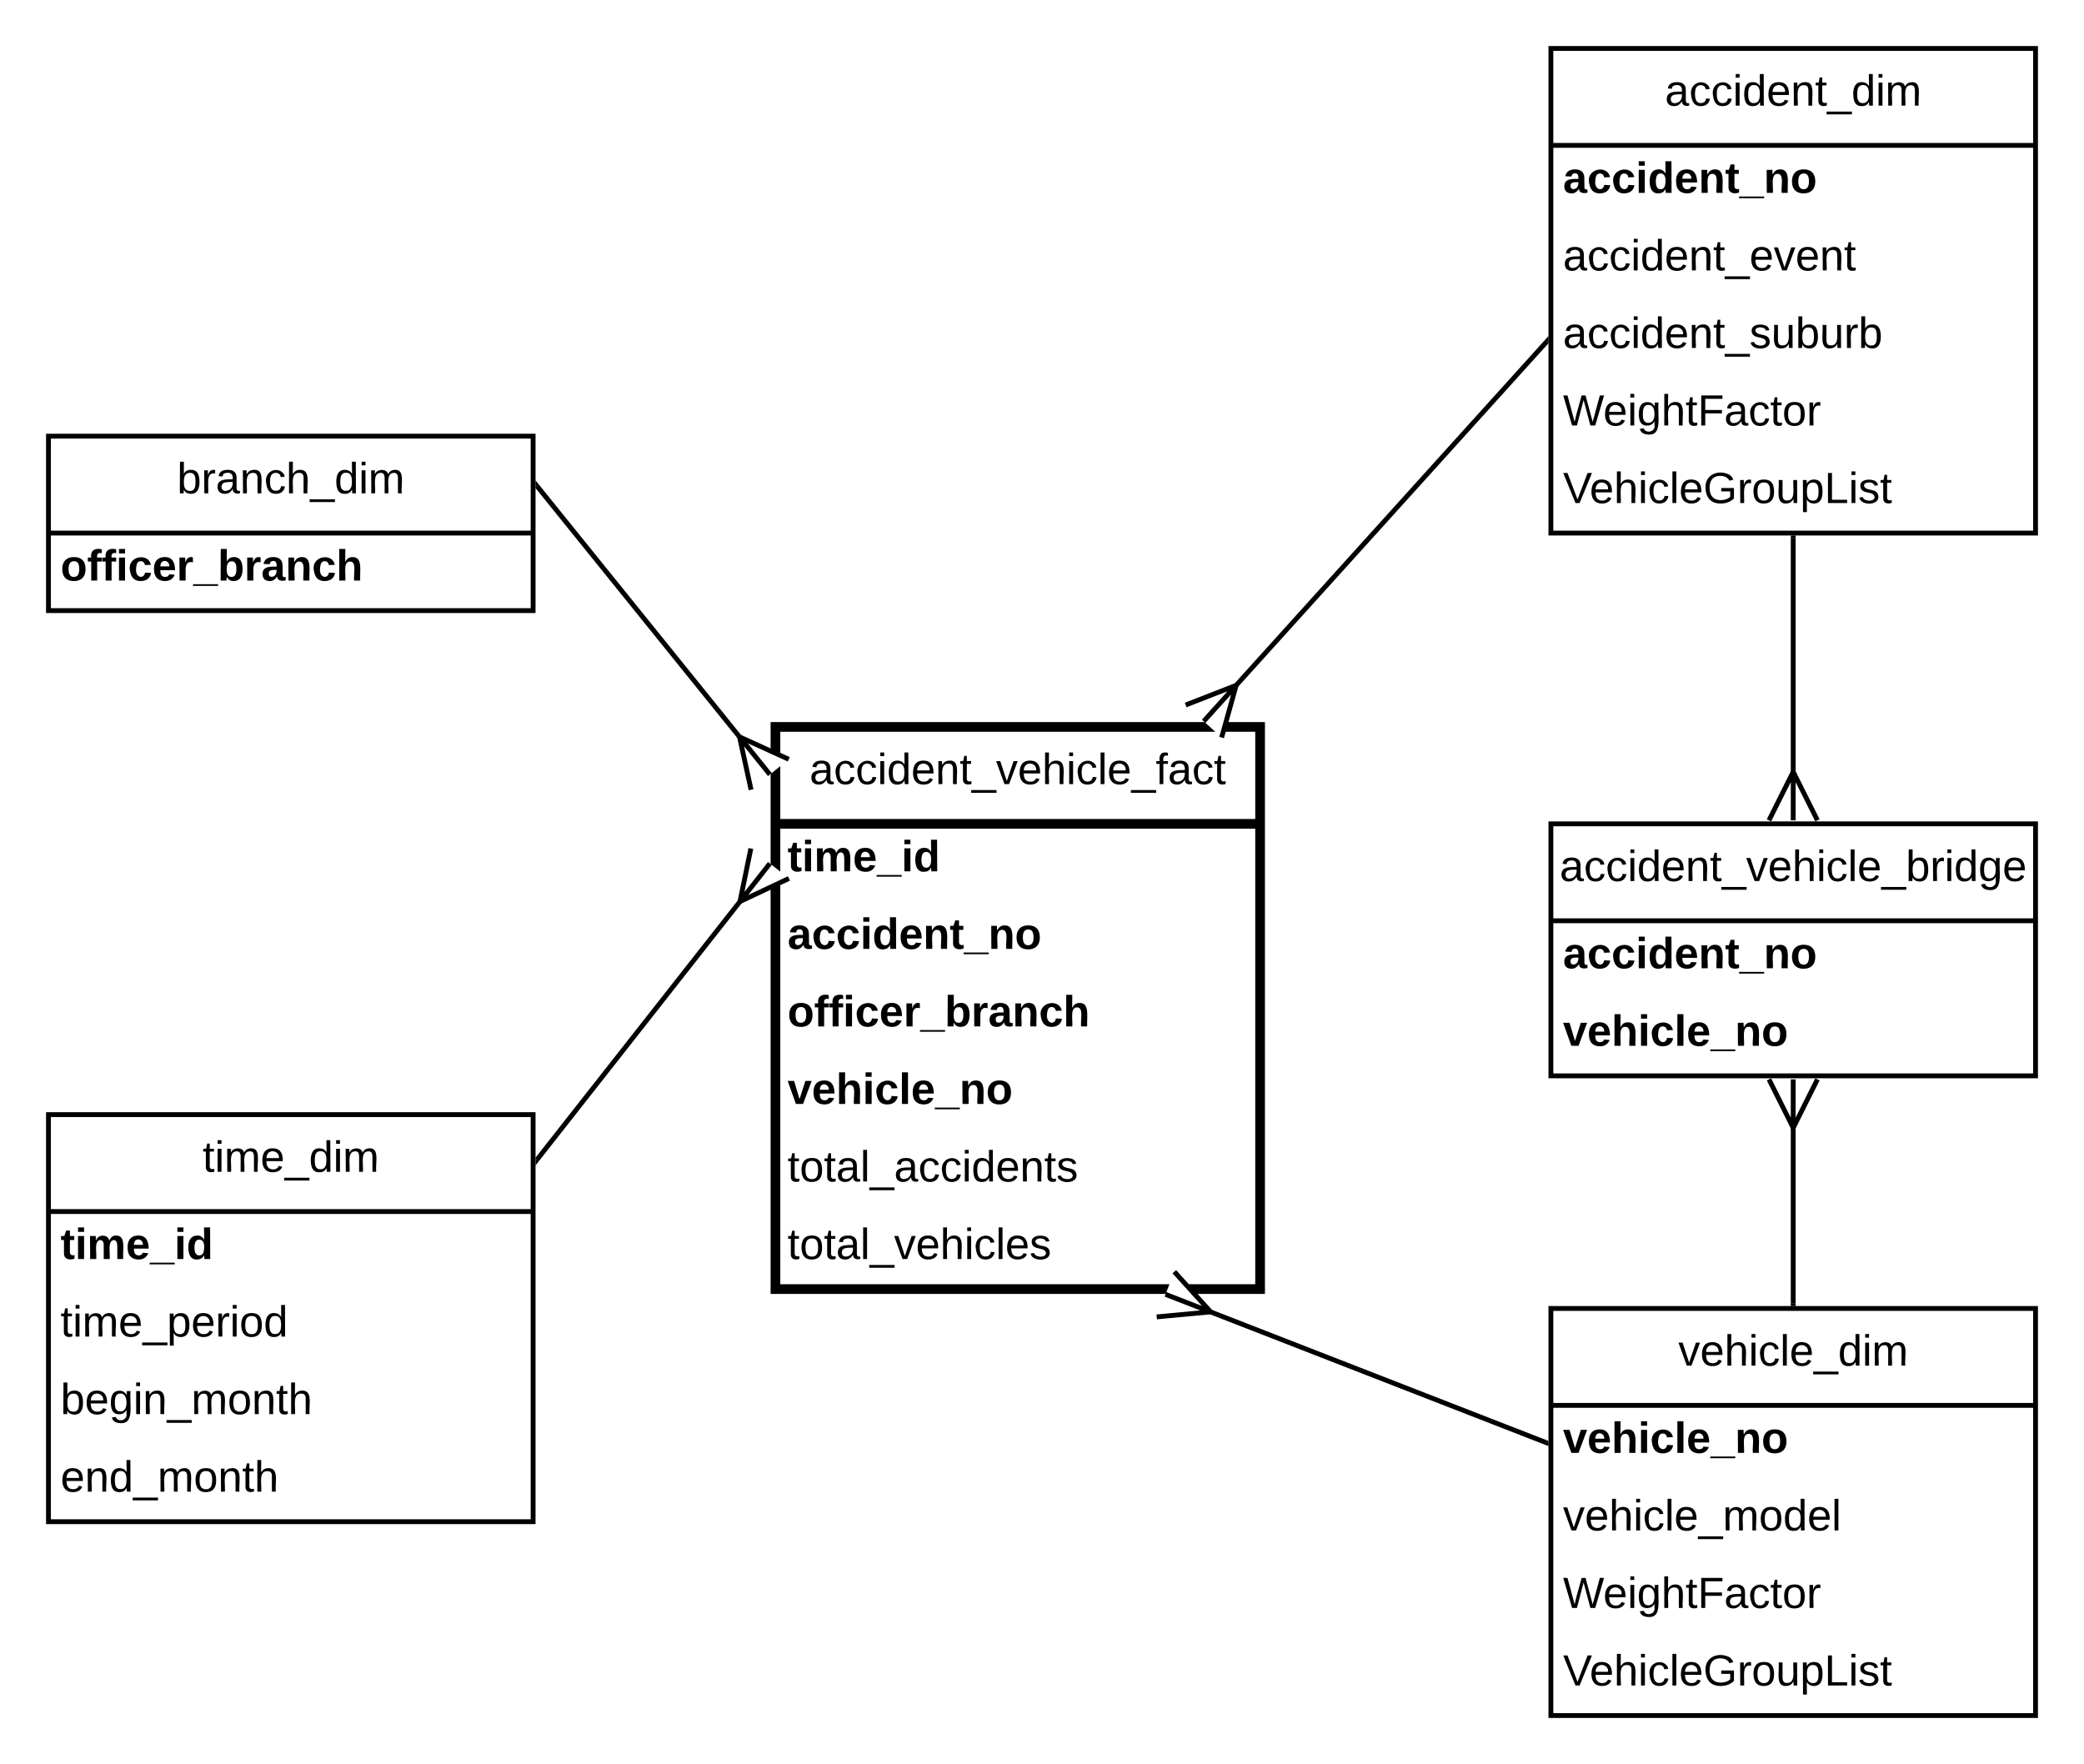

2. Task 2 The Two-Column Table Methodology illustration

-- time dimension

|  |  |  |
| --- | --- | --- |
| time_id | total_accidents | total_vehicles |
| 1 | 18 | 18 |
| 2 | 10 | 10 |

-- vehicle dimension

|  |  |  |
| --- | --- | --- |
| Vehicle_no | total_accidents | total_vehicles |
| VC024 | 1 | 1 |
| VC021 | 1 | 1 |

-- accident dimension

|  |  |  |
| --- | --- | --- |
| Accident_no | total_accidents | total_vehicles |
| A003 | 2 | 2 |
| A021 | 1 | 1 |

-- vehicle dimension

|  |  |  |
| --- | --- | --- |
| Vehicle_no | total_accidents | total_vehicles |
| VC025 | 1 | 1 |
| VT013 | 1 | 1 |

3. Task 3 The SQL commands to create the dimension and fact tables, as well as the contents of these tables

-- time dimension table

drop table time_dim cascade constraints purge;

create table time_dim

(time_id number,

time_desc varchar2(10),

begin_time date,

end_time date);

-- Insert lighting periods into the table as (daytime: 06:00 - 17:59 and nighttime 18:00 - 5:59)

-- instead of lighting periods (daytime: 6AM - 5:59PM and nighttime 6PM - 5:59AM)

insert into time_dim values (

1,

'daytime',

to_date('10/04/2020 06:00', 'dd/mm/yyyy hh24:mi'),

to_date('22/04/2020 17:59', 'dd/mm/yyyy hh24:mi')

);

insert into time_dim values (

2,

'nighttime',

to_date('10/04/2020 18:00', 'dd/mm/yyyy hh24:mi'),

to_date('22/04/2020 05:59', 'dd/mm/yyyy hh24:mi')

);

select * from time_dim;

-- branch dimension table

drop table branch_dim cascade constraints purge;

create table branch_dim as

select distinct officer_branch

from accident.police_officer;

select * from branch_dim;

-- accident dimension table

drop table accident_dim cascade constraints purge;

create table accident_dim as

select a.accident_no,

a.accident_event,

a.accident_suburb,

1.0/count(r.vehicle_no) as WeightFactor,

listagg(r.vehicle_no, '_') Within Group (Order By r.vehicle_no) As VehicleGroupList

from accident.accident a,

accident.accident_record r

where a.accident_no = r.accident_no

group by a.accident_no,

a.accident_event,

a.accident_suburb;

select * from accident_dim;

-- accident vehicle bridge table

drop table accident_vehicle_bridge cascade constraints purge;

create table accident_vehicle_bridge as

select *

from accident.accident_record;

select * from accident_vehicle_bridge;

-- vehicle dimension table

drop table vehicle_dim cascade constraints purge;

create table vehicle_dim as

select v.vehicle_no,

v.vehicle_model,

1.0/count(r.accident_no) as WeightFactor,

listagg(r.accident_no, '_') Within Group (Order By r.accident_no) As AccidentGroupList

from accident.vehicle v,

accident.accident_record r

where v.vehicle_no = r.vehicle_no

group by v.vehicle_no,

v.vehicle_model;

select * from vehicle_dim;

-- accident fact temporary table

drop table accident_fact_temp cascade constraints purge;

create table accident_fact_temp as

select ac.accident_date_time,

v.vehicle_no,

ac.accident_no,

p.officer_branch,

count(ac.accident_no) as total_accidents,

count(v.vehicle_no) as total_vehicles

from accident.accident ac,

accident.vehicle v,

accident.police_officer p,

accident.accident_record r

where ac.accident_no = r.accident_no

and v.vehicle_no = r.vehicle_no

and ac.officer_id = p.officer_id

group by ac.accident_date_time,

v.vehicle_no,

ac.accident_no,

p.officer_branch;

alter table accident_fact_temp add (

time_id number

);

-- Insert lighting periods into the table as (daytime: 06:00 - 17:59 and nighttime 18:00 - 5:59)

-- instead of lighting periods (daytime: 6AM - 5:59PM and nighttime 6PM - 5:59AM)

update accident_fact_temp set time_id =

(case

when to_char(accident_date_time, 'hh24.mi') >= 06.00 and to_char(accident_date_time, 'hh24.mi') <= 17.59 then 1

when to_char(accident_date_time, 'hh24.mi') >= 18.00 and to_char(accident_date_time, 'hh24.mi') <= 24.00 then 2

when to_char(accident_date_time, 'hh24.mi') >= 00.00 and to_char(accident_date_time, 'hh24.mi') <= 05.59 then 2

end);

select * from accident_fact_temp;

-- accident vehicle fact table

drop tale accident_vehicle_fact cascade constraints purge;

create table accident_vehicle_fact as

select time_id,

vehicle_no,

accident_no,

officer_branch,

total_accidents,

total_vehicles

from accident_fact_temp;

select * from accident_vehicle_fact;

4. Task 4 The SQL commands to answer the queries and the query results

-- a Show the total number of accidents happening by different locations and by different

-- lighting periods (daytime: 6AM - 5:59PM and nighttime 6PM - 5:59AM).

select t.time_desc,

sum(f.total_accidents) as total_accidents

from accident_vehicle_fact f,

time_dim t

where t.time_id = f.time_id

group by t.time_desc;

-- b Show the total number of accidents by each vehicle model

select v.vehicle_model,

sum(f.total_accidents) as total_accidents

from vehicle_dim v,

accident_vehicle_fact f

where v.vehicle_no = f.vehicle_no

group by v.vehicle_model;

-- c Show the number of vehicles involved in every accident event on different locations

select a.accident_event,

a.accident_suburb,

sum(total_vehicles) as total_vehicles

from accident_dim a,

accident_vehicle_fact f

where a.accident_no = f.accident_no

group by a.accident_event,

a.accident_suburb;

-- d Show the number of accidents taken care of by different police officer branches.

select officer_branch,

sum(total_accidents) as total_accidents

from accident_vehicle_fact

group by officer_branch;

5. Task 5 The additional two questions with the SQL commands, query result, and your explanation

-- additional question 1

-- Show the number of accidents happening taken care of by

-- different police officer branches and by different lighting periods

select t.time_desc,

f.officer_branch,

sum(f.total_accidents) as total_accidents

from time_dim t,

accident_vehicle_fact f

where t.time_id = f.time_id

group by t.time_desc,

f.officer_branch;

-- Explain:

-- Victorian Roads and Safety (VicR&S) want to know the number of accidents that officer branches

-- take care of at different periods because there are many accidents happening at day time and

-- they want to arrange the more exact number of police staff at this time

-- additional question 2

-- Show the number of accidents happening taken care of by

-- different police officer branches, by different lighting periods

-- and by each different vehicle models

select * from accident_vehicle_fact;

select t.time_desc,

f.officer_branch,

v.vehicle_model,

sum(f.total_accidents) as total_accidents

from time_dim t,

accident_vehicle_fact f,

vehicle_dim v

where t.time_id = f.time_id

and v.vehicle_no = f.vehicle_no

group by t.time_desc,

f.officer_branch,

v.vehicle_model;

-- Explain:

-- Explain:

-- Victorian Roads and Safety (VicR&S) want to know the number of accidents that officer branches

-- take care of at different periods because there are many accidents happening at day time and

-- they want to arrange the more exact number of police staff at this time. Also, they want to know

-- which vehicle model is the main cause