Collaborative To-Do List Application
Deliverable 2 — Core Functionality Implementation
Course: MSCS-632 Residency (Day 2)
Team: An Phan; Vatsalkumar Mukeshkumar Dholakiya
Repository: github.com/anphan7/MSCS-632-Residency

1. Summary
The core application is complete and operational in both languages. We built one React frontend and two interchangeable backends — Java (Javalin) and JavaScript (Node/Express) — that implement the identical REST contract, so the same UI runs against either backend. Each backend stores tasks in memory and persists to its own JSON file, and each demonstrates its language's concurrency model through a shared /simulate endpoint.

2. What works
- Multiple users with a user switcher; tasks are assigned per user and filterable by assignee.
- Add, edit, delete tasks; mark tasks complete or pending.
- Task categories (Work / Personal / Urgent) and status tracking, with category and status filters.
- File-based persistence: each backend reads/writes its own tasks.json and reloads on restart.
- Concurrency demo (/simulate): fires 100 simultaneous edits at one task and confirms the store stays consistent.
- The same React app was verified against BOTH backends (Node on :4000, Java on :4001) with identical behavior and zero browser-console errors.

3. Language-specific features integrated
Concern | Java (Javalin) | JavaScript (Node/Express)
Paradigm | OOP classes: Task, User, TaskRepository, TaskService | Modules + factory functions; plain objects
Concurrency | Real threads (ExecutorService) + ReentrantReadWriteLock | Single-threaded event loop + async/await + Promise.all
Safe writes | Read-modify-write-persist atomic inside the write lock | Atomic in-memory mutation + serialized promise write queue
Data / JSON | POJOs serialized with Jackson | Native JSON via fs.promises
Build / run | Gradle (./gradlew run), JDK 17+ | npm (npm start), Node 18+

4. Testing & debugging
- Node: 5 automated tests pass (node:test) — CRUD, validation (400 on missing title), status filtering, and a concurrency test firing 100 simultaneous edits that confirms no duplication or corruption.
- Java: 2 automated tests pass (JUnit 5) — a JavalinTest API test and a concurrency test running 200 threaded toggles that confirms exactly one consistent task survives.
- Cross-backend: the React app was driven through the full feature flow against both backends in a real browser; behavior was identical and the console was error-free.
- Known minor item: a task added in the first moment before the user list finishes loading can receive the wrong assignee; scheduled for the Day-3 polish pass. Not a core-functionality blocker.

5. Screenshots
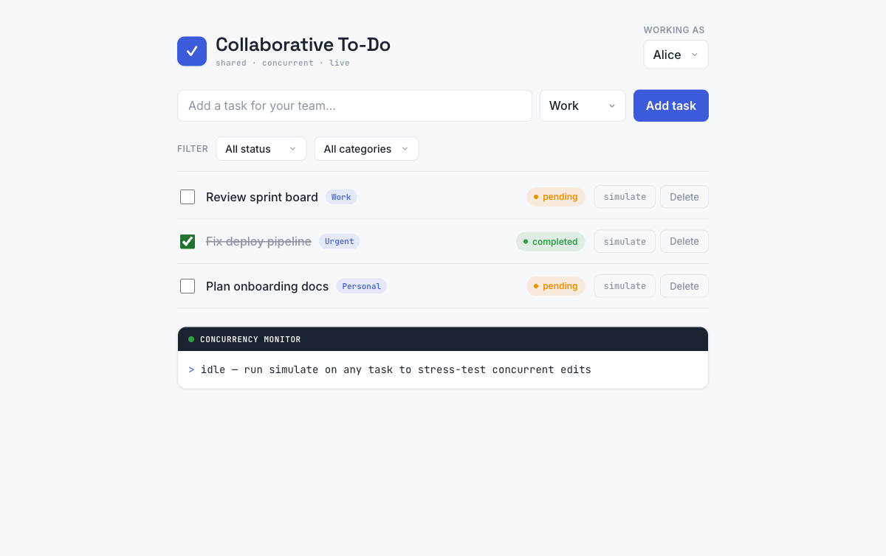
Figure 1. The application with tasks across categories; one completed. The dark bar is the concurrency monitor.
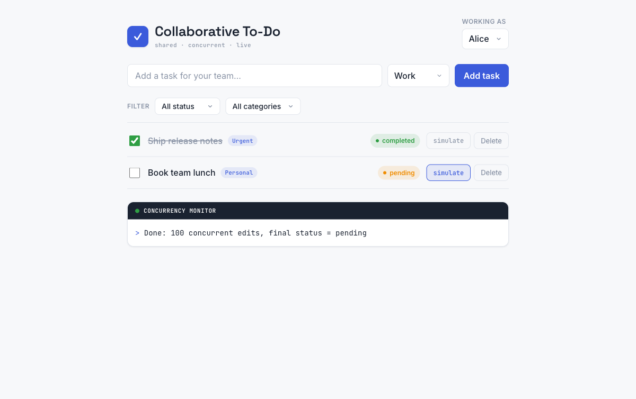
Figure 2. After running the concurrency demo: “Done: 100 concurrent edits, final status = pending.”
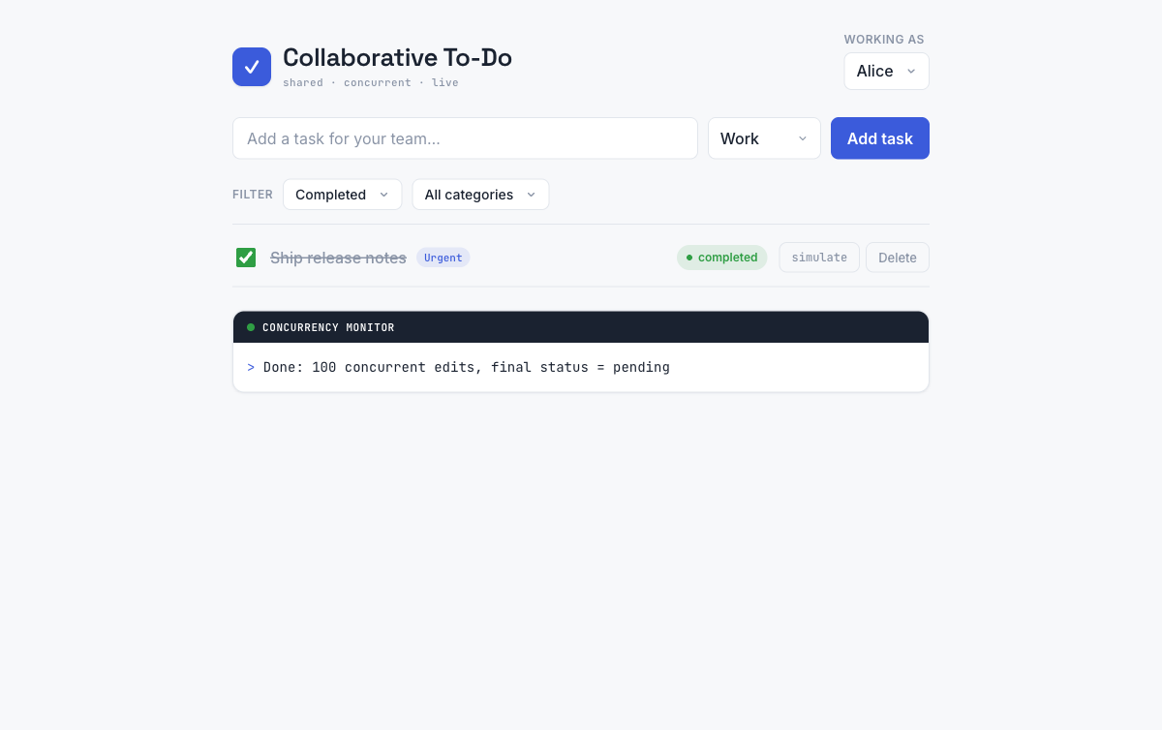
Figure 3. The task list filtered by status.

6. Repository & README
All code lives in the GitHub repository above. The repository includes a detailed README.md with the architecture, the shared REST contract, prerequisites, and exact build/compile/run instructions for the Node backend, the Java backend, and the React frontend — including how to switch which backend the frontend targets via VITE_API_URL, and how to run both test suites.

