SDNFV – Lab 1

109550122 王宇晨

Part 1:

1.

org.onosproject.optical-model

org.onosproject.hostprovider

org.onosproject.lldpprovider

org.onosproject.openflow-base

2. No, because I haven’t activate the Reactive Forwarding app (org.onosproject.fwd) yet.

3. 6653

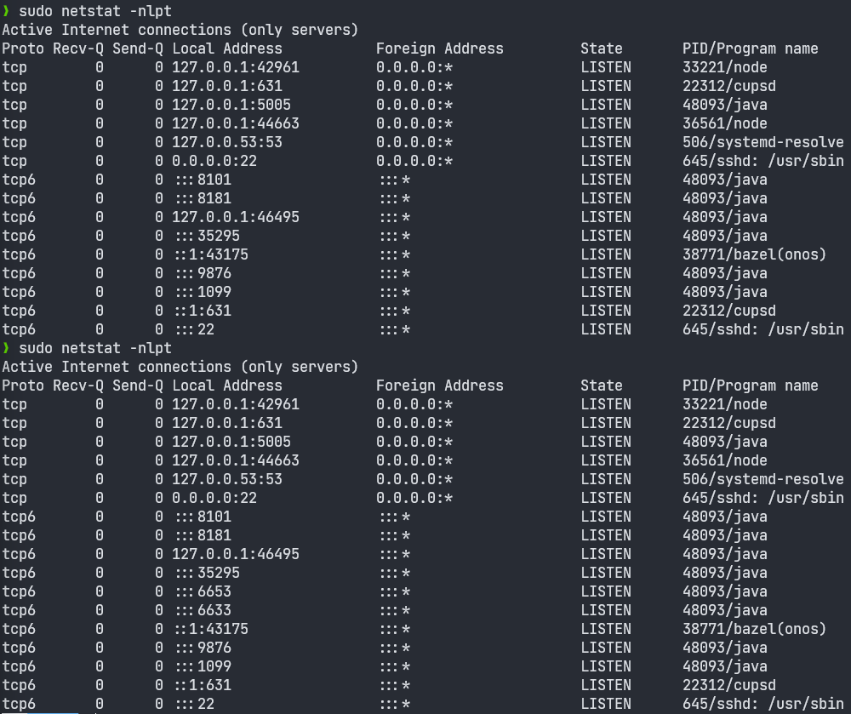

4. org.onosproject.openflow-base/org.onosproject.optical-model

Part 2:

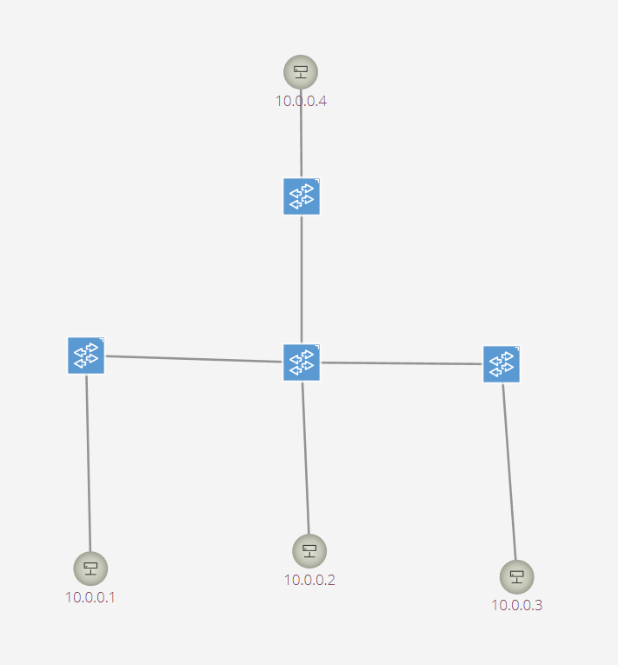

I wrote a Python script to build the topology and the hosts can ping each other

Part 3:

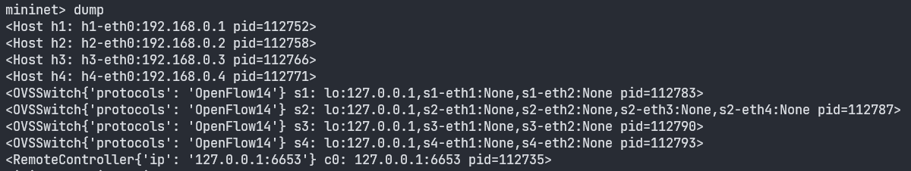

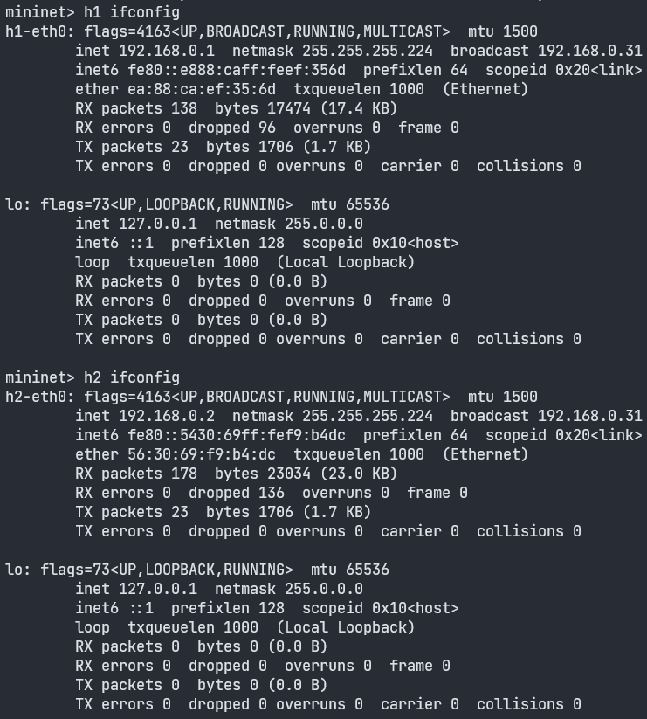

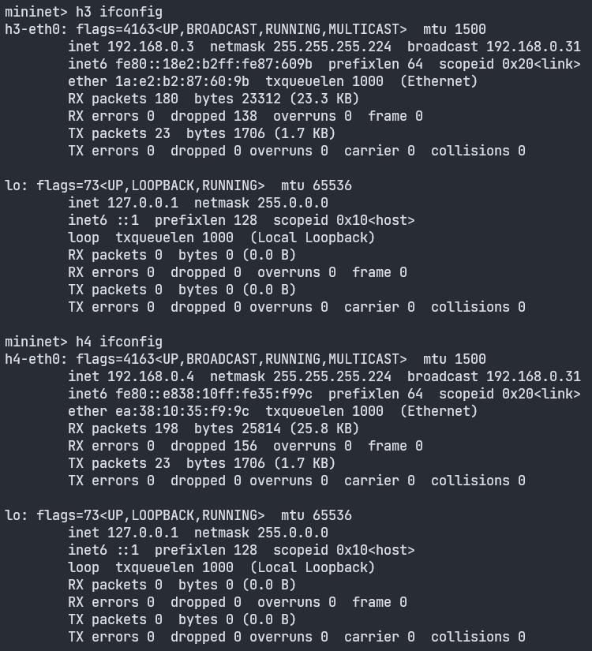

I wrote a Python script to build the topology, set the IP addresses and the netmask of the hosts and the hosts can ping each other

What I have learned or solved:

I have learned basic knowledge of ONOS, mininet and creating topology with desired IP addresses/netmask of the hosts.