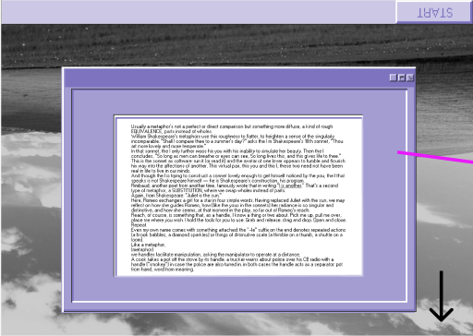

Usually a metaphor’s not a perfect or direct comparison but something more diffuse, a kind of rough EQUIVALENCE, parts instead of wholes.

William Shakespeare’s metaphors use this roughness to flatter, to heighten a sense of the singularly incomparable. “Shall I compare thee to a summer’s day?” asks the I in Shakespeare’s 18th sonnet, “Thou art more lovely and more temperate.”

In that sonnet, the I only further woos his you with his inability to simulate her beauty. Then the I concludes, “So long as men can breathe or eyes can see, So long lives this, and this gives life to thee.”

This is the sonnet as software: run it (or read it) and the avatar of one lover appears to fumble and flourish his way into the affections of another. This virtual pair, this you and this I, these two need not have been real in life to live in our minds.

And though the I is trying to construct a sonnet lovely enough to get himself noticed by the you, the I that speaks is not Shakespeare himself — he is Shakespeare’s construction, his program.

Rimbaud, another poet from another time, famously wrote that in writing “I is another.” That’s a second type of metaphor, a SUBSTITUTION, where we swap wholes instead of parts.

Again, from Shakespeare: “Juliet is the sun.”

Here, Romeo exchanges a girl for a star in four simple words. Having replaced Juliet with the sun, we may reflect on how she guides Romeo, how (like the yous in the sonnets) her radiance is so singular and distinctive, and how she seems, at that moment in the play, so far out of Romeo’s reach.

Reach, of course, is something that, as a handle, I know a thing or two about. Pick me up, pull me over, place me where you wish. I hold the tools for you to use. Grab and release. drag and drop. Open and close. Repeat.

Even my own name comes with something attached: the “-le” suffix on the end denotes repeated actions (a brook babbles, a diamond sparkles) or things of diminutive scale (a thimble on a thumb, a shuttle on a loom).

Like a metaphor,  
(metaphor)

we handles facilitate manipulation, asking the manipulator to operate at a distance.

A cook takes a pot off the stove by its handle. a trucker warns about police over his CB radio with a handle (“smokey”) in case the police are also tuned in. in both cases the handle acts as a separator: pot from hand, word from meaning.

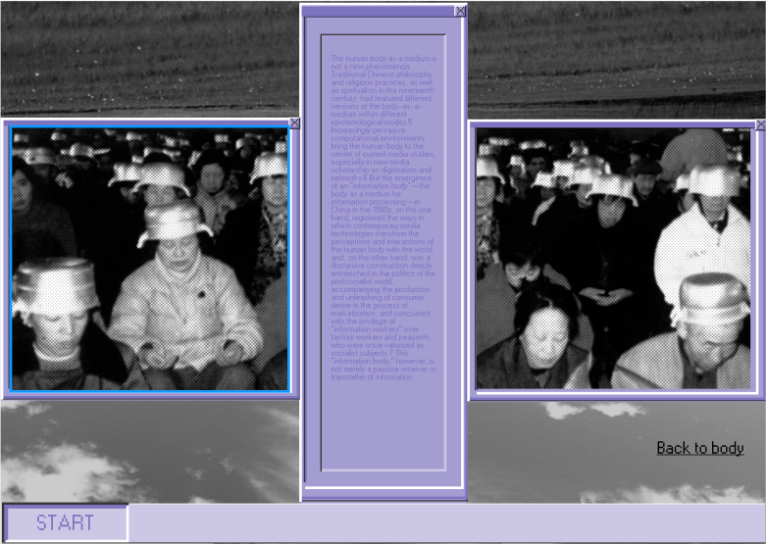 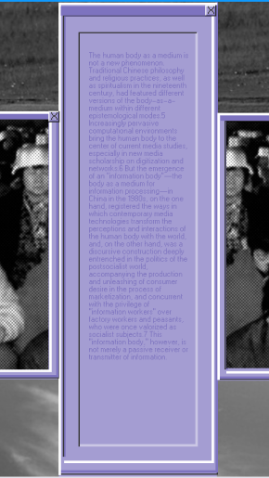

The human body as a medium is not a new phenomenon. Traditional Chinese philosophy and religious practices, as well as spiritualism in the nineteenth century, had featured different versions of the body-as-a-medium within different epistemological modes.5 Increasingly pervasive computational environments bring the human body to the center of current media studies, especially in new media scholarship on digitization and networks.6 But the emergence of an “information body”—the body as a medium for information processing—in China in the 1980s, on the one hand, registered the ways in which contemporary media technologies transform the perceptions and interactions of the human body with the world, and, on the other hand, was a discursive construction deeply entrenched in the politics of the postsocialist world, accompanying the production and unleashing of consumer desire in the process of marketization, and concurrent with the privilege of “information workers” over factory workers and peasants, who were once valorized as socialist subjects.7 This “information body,” however, is not merely a passive receiver or transmitter of information.

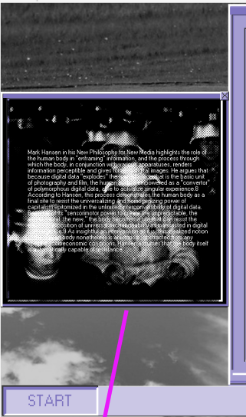

Mark Hansen in his New Philosophy for New Media highlights the role of the human body in “enframing” information, and the process through which the body, in conjunction with various apparatuses, renders information perceptible and gives forms to digital images. He argues that because digital data “explodes” the framed image that is the basic unit of photography and film, the human body is empowered as a “convertor” of polymorphous digital data, able to actualize singular experience.8 According to Hansen, this process demonstrates the human body as a final site to resist the universalizing and homogenizing power of capitalism epitomized in the unlimited interconvertibility of digital data. Because of its “sensorimotor power to create the unpredictable, the experimental, the new,” the body becomes a site that can resist the capitalist imposition of universal exchangeability as manifested in digital convergence.9 As insightful an intervention as it is, this idealized notion of the human body nonetheless is ahistorical, abstracted from any specific socioeconomic conditions. Hansen assumes that the body itself is automatically capable of resistance.

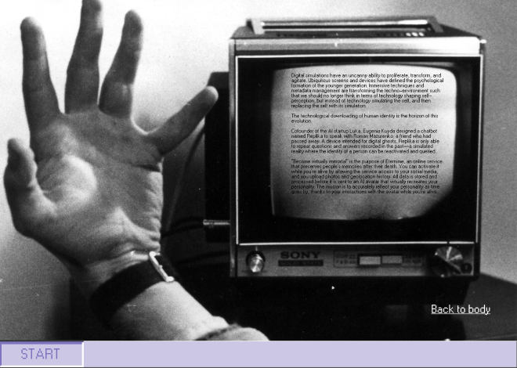

Digital simulations have an uncanny ability to proliferate, transform, and agitate. Ubiquitous screens and devices have defined the psychological formation of the younger generation. Immersive techniques and metadata management are transforming the techno-environment such that we should no longer think in terms of technology shaping self-perception, but instead of technology simulating the self, and then replacing the self with its simulation.  
  
The technological downloading of human identity is the horizon of this evolution.  
  
Cofounder of the AI startup Luka, Eugenia Kuyda designed a chatbot named Replika to speak with Roman Mazurenko, a friend who had passed away. A device intended for digital ghosts, Replika is only able to repeat questions and answers recorded in the past—a simulated reality where the identity of a person can be reactivated and queried.  
  
“Become virtually immortal” is the purpose of Eternime, an online service that preserves people’s memories after their death. You can activate it while you’re alive by allowing the service access to your social media, and you upload photos and geolocation history. All data is stored and processed before it is sent to an AI avatar that virtually recreates your personality. The mission is to accurately reflect your personality as time goes by, thanks to your interactions with the avatar while you’re alive.