Website for study

Version <1.0>

Revision History

|  |  |  |  |
| --- | --- | --- | --- |
| **Date** | **Version** | **Description** | **Author** |
| 09/11/2022 | 1.0 |  | PTAn, NTBHa, TKDuy |
| 16/11/2022 | 1.0 |  | PTAn, NTBHa, TKDuy |
|  |  |  |  |
|  |  |  |  |

Table of Contents

1. Use-case Model 4

2. Use-case Specifications 6

2.1 Use-case: Register 6

2.2 Use-case: Create – Edit – Delete notes 6

2.3 Use-case: Reminders 6

2.4 Use-case: Create – Edit – Delete TODO List. 7

2.5 Use-case: Pomodoro timer 7

# Use-case Model

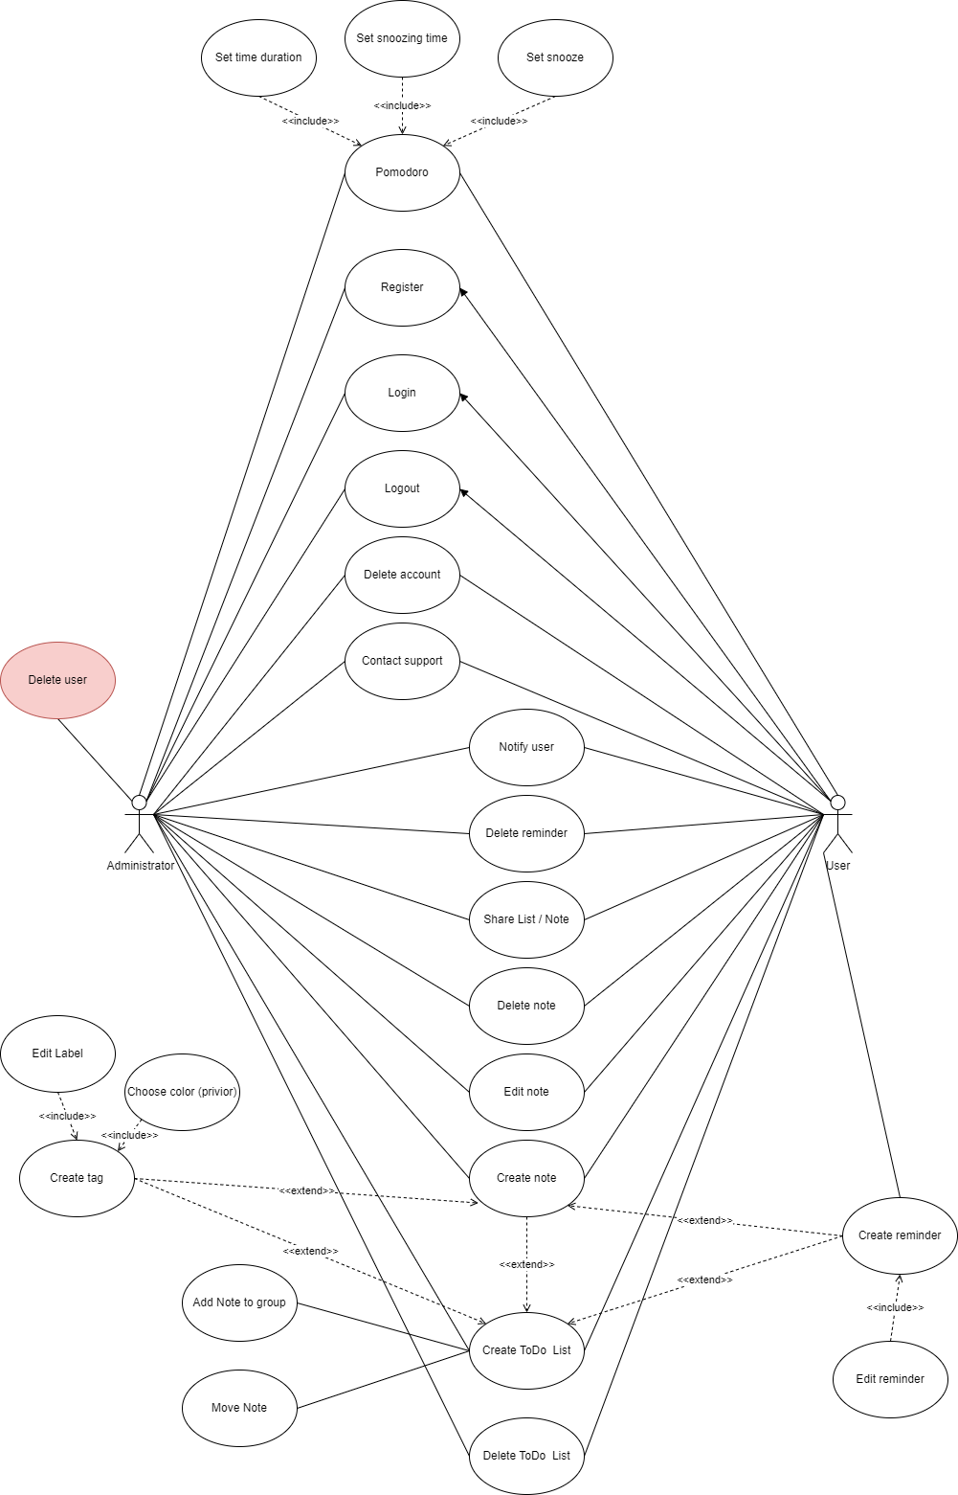

# Use-case Specifications

## Use-case: Register

|  |  |
| --- | --- |
| Use case Name | Register |
| Brief description | This use case describes how the user can register, login, logout |
| Actors | User |
| Basic Flow | 1. At the homepage, the user click on Signin or Signup 2. User fill the Signin or Signup form 3. User submit 4. System check if information is valid 5. System finish Signin or Signup if valid |

## Use-case: Create – Edit – Delete notes

|  |  |
| --- | --- |
| Use case Name | Create – Edit – Delete notes. |
| Brief description | This use case describes how the user and administrator do with notes. |
| Actors | User, Administrator |
| Basic Flow | 1. At the homepage, the user click to the “Notes” button. 2. System displays the place to write and edit notes. 3. User clicks ‘Done’ button to add new notes. 4. Or clicks ‘Delete’ or ‘Edit’ button to edit or delete notes. 5. System displays the result. |
| Alternative Flows | **Alternative flow 1: Users did not edit the note although they choose to edit**  Continue to save normally. |
| Pre-conditions | User goes to the study web and have an account. |
| Post-conditions | The user successfully adds new notes or delete or edit to the list of notes on account. |

## Use-case: Reminders

|  |  |
| --- | --- |
| Use case Name | Create – edit reminders |
| Brief description | This use case describes how the user and administrator create (edit) reminders. |
| Actors | User, Administrator |
| Basic Flow | 1. At the homepage, the user clicks on the “Reminder” button. 2. System displays the reminder page 3. User set reminder’s name, deadlines,… 4. User clicks the “Done” button, and then clicks the “Add” button. 5. If the user wants to edit, also choose the “Reminder” button, then click on the reminder wants to edit, edit and click the “Done” button. |
| Alternative Flows | **Alternative flow 1:** The user created a reminder and forgot to click the “Add” button.  **Alternative flow 2:** The user edited a reminder andforgot to click the “Done” button. |
| Pre-conditions | User access to the website |
| Post-conditions | The user successfully adds a new reminder (or edit reminder) in the personal page. |

## Use-case: Create – Edit – Delete TODO List.

|  |  |
| --- | --- |
| Use case Name | Create – Edit – Delete TODO List. |
| Brief description | This use case describes how the user and administrator do with notes. |
| Actors | User, Administrator |
| Basic Flow | 1. At the homepage, the user click to the “List” button. 2. System displays a new list. 3. User can rename list and create tag. 4. User clicks ‘Add’ button to create new note or move old note to list. 5. User clicks ‘Done’ button to final. 6. Or clicks ‘Delete’ button to delete list. 7. System displays the result. |
| Alternative Flows | **Alternative flow 1: Users did not add note although they choose to add**  Continue to save normally.  **Alternative flow 2: Users did not add note after create new list**  Continue to save normally.  **Alternative flow 3: Users join or move notes to new list**  Move notes from old list to new list |
| Pre-conditions | User goes to the study web and have an account. |
| Post-conditions | The user successfully create todo list or delete todo list or add/move notes to list or update to the list of notes on account. |

|  |  |
| --- | --- |
| Use case Name | Set, Pomodoro timer |
| Brief description | This use case describes how the user and administrator use Pomodoro timer |
| Actors | User, Administrator |
| Basic Flow | 1. At the homepage, the user click to the “Pomodoro” button. 2. System displays the timer page 3. User set Time Duration,... 4. User click Start 5. The timer start to run. |
| Alternative Flows | **Alternative flow 1: User does not star the timer and exit** |
| Pre-conditions | User access to the website |
| Post-conditions | Pomodoro timer runs and go off when the time comes. |

## Use-case: Pomodoro timer