**МИНИСТЕРСТВО НАУКИ И ВЫСШЕГО ОБРАЗОВАНИЯ РОССИЙСКОЙ ФЕДЕРАЦИИ**

**Федеральное государственное бюджетное образовательное учреждение**

**высшего образования**

**«Чувашский государственный университет имени И.Н. Ульянова»**

**Факультет информатики и вычислительной техники**

**Кафедра вычислительной техники**

***Технология разработки ПО***

**Лабораторная работа №7**

**«Создание физической модели данных»**

Авиаперевозки

**Выполнил:**

студент группы ИВТ-41-20

Галкин Д.С.

**Проверил:**

Ржавин В.В.

Чебоксары 2023

Цель работы: разработать физическую модель данных

**Диаграмма физической модели:**

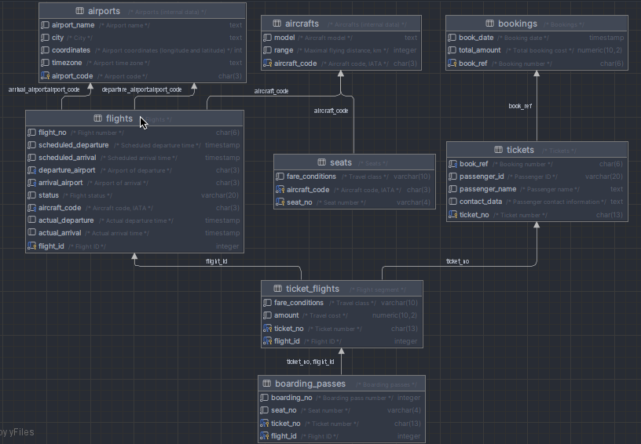

**Тексты разработанных триггеров и хранимых процедур:**

* Логирование
  + Создание дополнительной таблицы

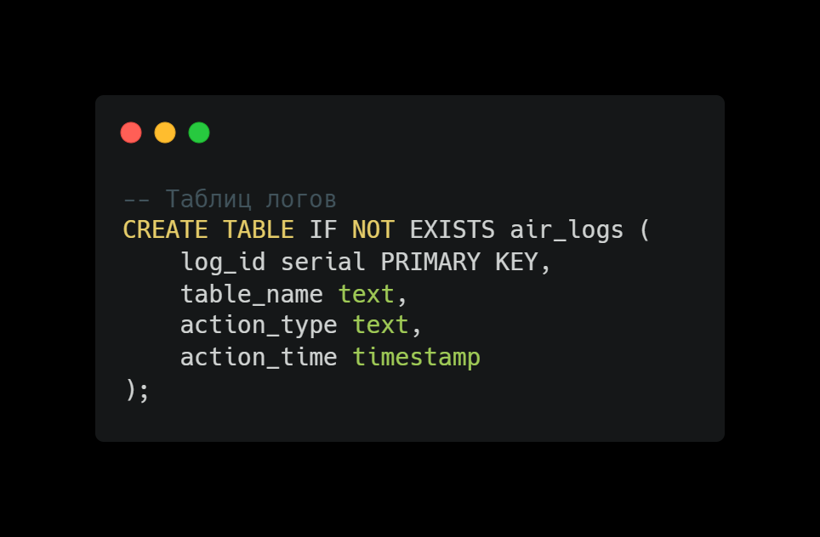

* + Реализация хранимой процедуры

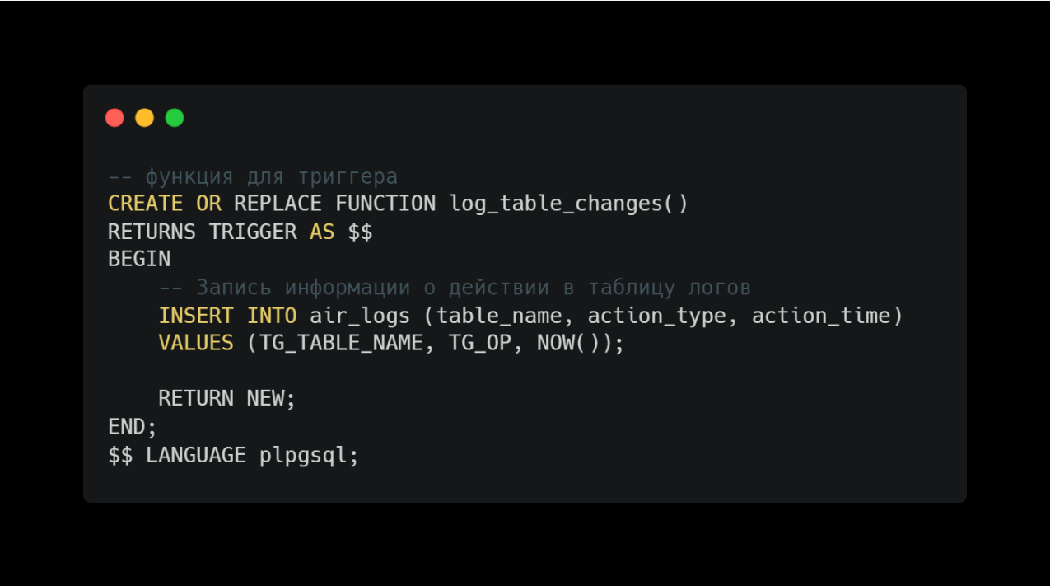

* + Триггеры логов для всех таблиц

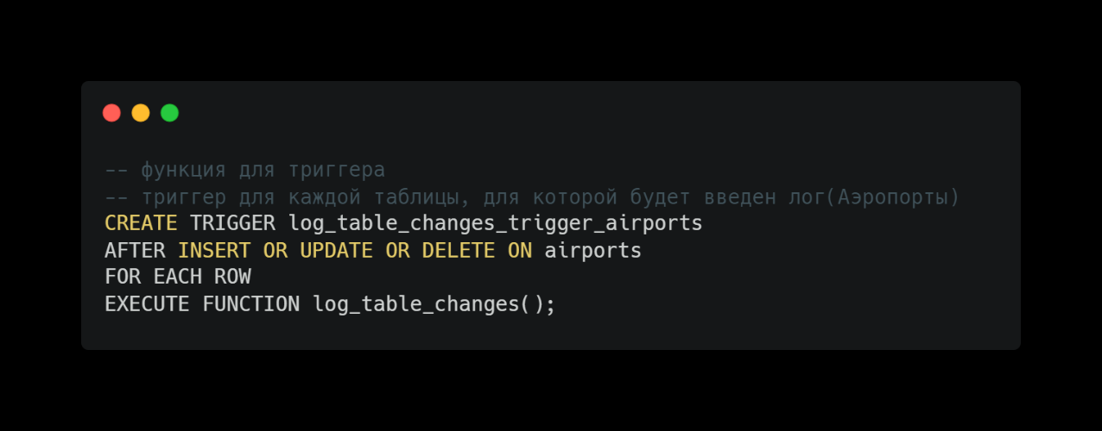

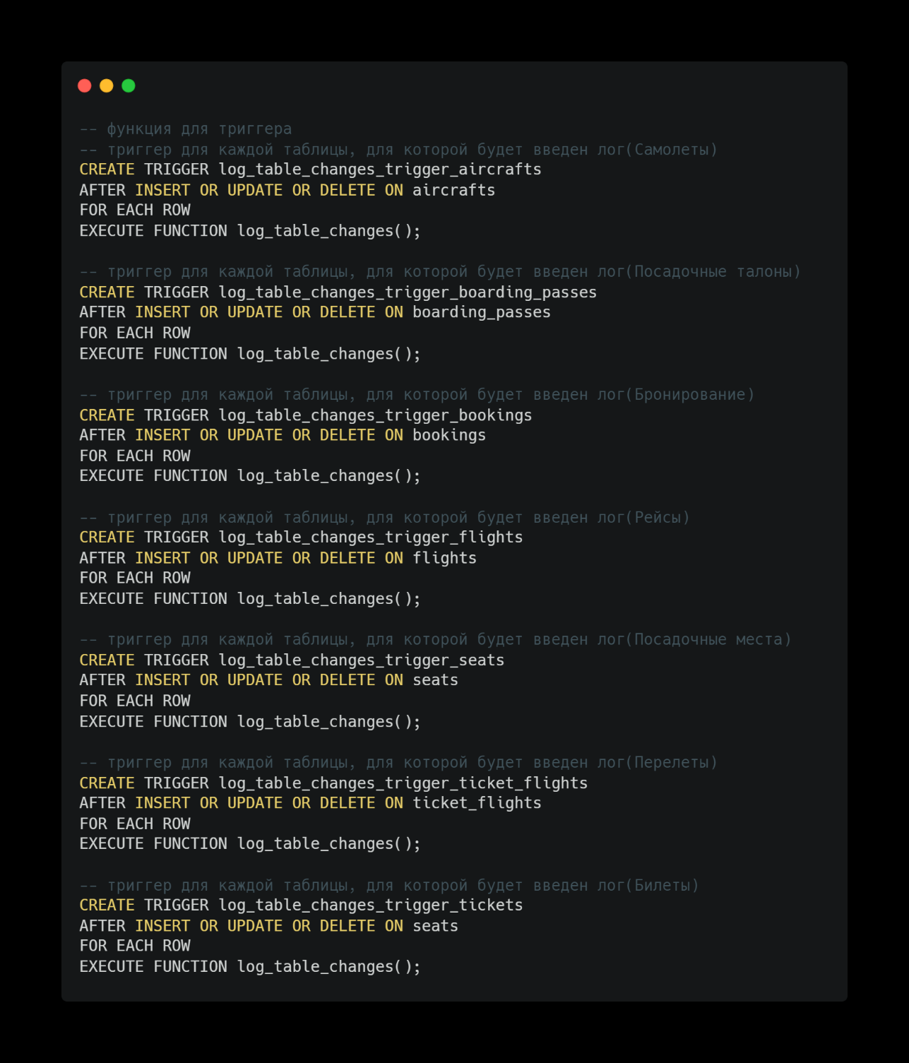

* Перевод типа Jsonb в текст
  + Настраиваем локализацию

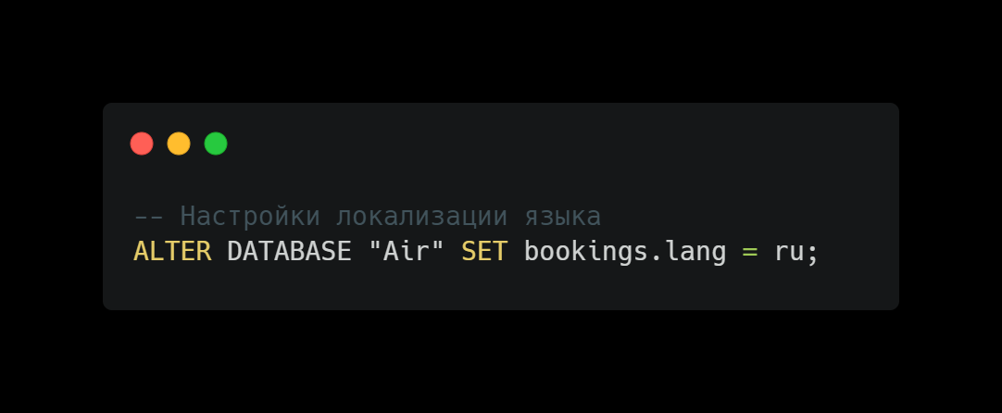

* + Создаем хранимую процедуру

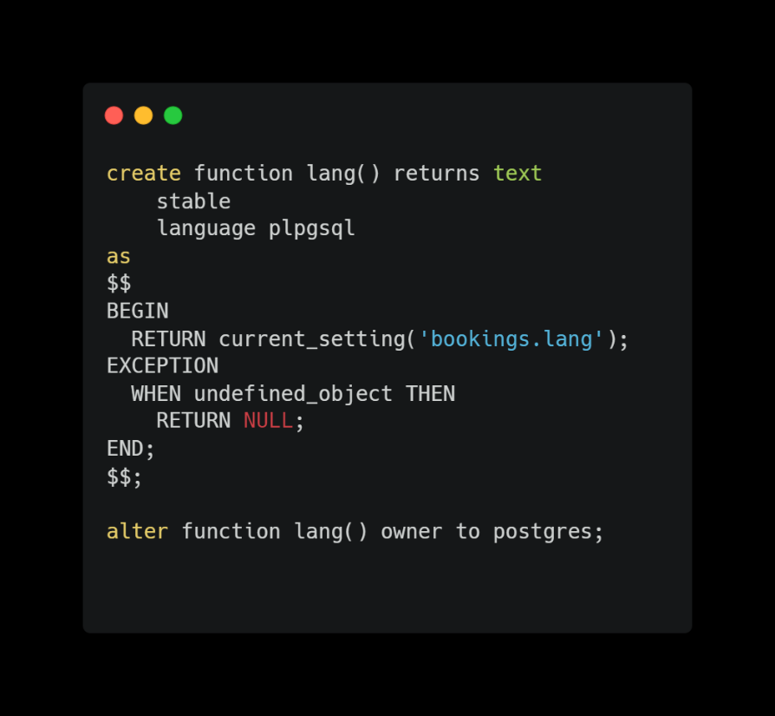

* + Создаем View(aircrafts)

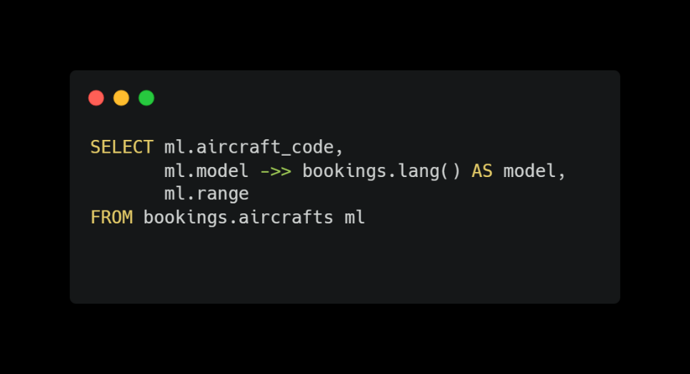

* + Создаем View(airports)

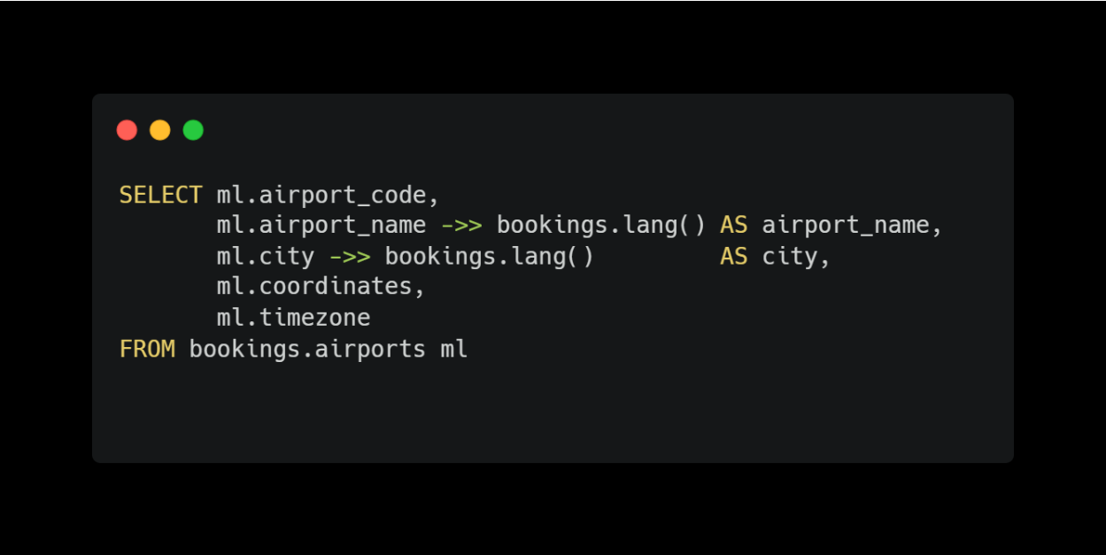

**PostgreSQL-код для создания базы данных в DataGrip:**

-- Database generated with pgModeler (PostgreSQL Database Modeler).  
-- pgModeler version: 1.1.0-alpha  
-- PostgreSQL version: 15.0  
-- Project Site: pgmodeler.io  
-- Model Author: ---  
-- -- object: pg_database_owner | type: ROLE --  
-- -- DROP ROLE IF EXISTS pg_database_owner;  
-- CREATE ROLE pg_database_owner WITH   
-- INHERIT  
-- PASSWORD '********';  
-- -- ddl-end --  
--   
  
-- Database creation must be performed outside a multi lined SQL file.   
-- These commands were put in this file only as a convenience.  
--   
-- object: "Air_test" | type: DATABASE --  
-- DROP DATABASE IF EXISTS "Air_test";  
CREATE DATABASE "Air_test"  
 ENCODING = 'UTF8'  
 LC_COLLATE = 'English_United States.1251'  
 LC_CTYPE = 'English_United States.1251'  
 TABLESPACE = pg_default  
 OWNER = postgres;  
-- ddl-end --  
  
  
SET check_function_bodies = false;  
-- ddl-end --  
  
-- object: bookings | type: SCHEMA --  
-- DROP SCHEMA IF EXISTS bookings CASCADE;  
CREATE SCHEMA bookings;  
-- ddl-end --  
ALTER SCHEMA bookings OWNER TO postgres;  
-- ddl-end --  
COMMENT ON SCHEMA bookings IS E'Airlines demo database schema';  
-- ddl-end --  
  
-- Appended SQL commands --  
ALTER TABLE bookings  
ADD COLUMN test_amount type_amount;  
-- ddl-end --  
  
SET search_path TO pg_catalog,public,bookings;  
-- ddl-end --  
  
-- object: bookings.lang | type: FUNCTION --  
-- DROP FUNCTION IF EXISTS bookings.lang() CASCADE;  
CREATE FUNCTION bookings.lang ()  
 RETURNS text  
 LANGUAGE plpgsql  
 STABLE   
 CALLED ON NULL INPUT  
 SECURITY INVOKER  
 PARALLEL UNSAFE  
 COST 100  
 AS $$  
BEGIN  
 RETURN current_setting('bookings.lang');  
EXCEPTION  
 WHEN undefined_object THEN  
 RETURN NULL;  
END;  
$$;  
-- ddl-end --  
ALTER FUNCTION bookings.lang() OWNER TO postgres;  
-- ddl-end --  
  
-- object: bookings.now | type: FUNCTION --  
-- DROP FUNCTION IF EXISTS bookings.now() CASCADE;  
CREATE FUNCTION bookings.now ()  
 RETURNS timestamp with time zone  
 LANGUAGE sql  
 IMMUTABLE   
 CALLED ON NULL INPUT  
 SECURITY INVOKER  
 PARALLEL UNSAFE  
 COST 100  
 AS $$  
SELECT '2017-08-15 18:00:00'::TIMESTAMP AT TIME ZONE 'Europe/Moscow';  
$$;  
-- ddl-end --  
ALTER FUNCTION bookings.now() OWNER TO postgres;  
-- ddl-end --  
COMMENT ON FUNCTION bookings.now() IS E'Point in time according to which the data are generated';  
-- ddl-end --  
  
-- object: bookings.aircrafts | type: TABLE --  
-- DROP TABLE IF EXISTS bookings.aircrafts CASCADE;  
CREATE TABLE bookings.aircrafts (  
 aircraft_code character(3) NOT NULL,  
 model text NOT NULL,  
 range integer NOT NULL,  
 CONSTRAINT aircrafts_range_check CHECK ((range > 0)),  
 CONSTRAINT aircrafts_pkey PRIMARY KEY (aircraft_code)  
);  
-- ddl-end --  
COMMENT ON TABLE bookings.aircrafts IS E'Aircrafts (internal data)';  
-- ddl-end --  
COMMENT ON COLUMN bookings.aircrafts.aircraft_code IS E'Aircraft code, IATA';  
-- ddl-end --  
COMMENT ON COLUMN bookings.aircrafts.model IS E'Aircraft model';  
-- ddl-end --  
COMMENT ON COLUMN bookings.aircrafts.range IS E'Maximal flying distance, km';  
-- ddl-end --  
ALTER TABLE bookings.aircrafts OWNER TO postgres;  
-- ddl-end --  
  
-- object: bookings.airports | type: TABLE --  
-- DROP TABLE IF EXISTS bookings.airports CASCADE;  
CREATE TABLE bookings.airports (  
 airport_code character(3) NOT NULL,  
 airport_name text NOT NULL,  
 city text NOT NULL,  
 coordinates point NOT NULL,  
 timezone text NOT NULL,  
 CONSTRAINT airports_data_pkey PRIMARY KEY (airport_code)  
);  
-- ddl-end --  
COMMENT ON TABLE bookings.airports IS E'Airports (internal data)';  
-- ddl-end --  
COMMENT ON COLUMN bookings.airports.airport_code IS E'Airport code';  
-- ddl-end --  
COMMENT ON COLUMN bookings.airports.airport_name IS E'Airport name';  
-- ddl-end --  
COMMENT ON COLUMN bookings.airports.city IS E'City';  
-- ddl-end --  
COMMENT ON COLUMN bookings.airports.coordinates IS E'Airport coordinates (longitude and latitude)';  
-- ddl-end --  
COMMENT ON COLUMN bookings.airports.timezone IS E'Airport time zone';  
-- ddl-end --  
ALTER TABLE bookings.airports OWNER TO postgres;  
-- ddl-end --  
  
-- object: bookings.boarding_passes | type: TABLE --  
-- DROP TABLE IF EXISTS bookings.boarding_passes CASCADE;  
CREATE TABLE bookings.boarding_passes (  
 ticket_no character(13) NOT NULL,  
 flight_id integer NOT NULL,  
 boarding_no integer NOT NULL,  
 seat_no character varying(4) NOT NULL,  
 CONSTRAINT boarding_passes_pkey PRIMARY KEY (ticket_no,flight_id)  
);  
-- ddl-end --  
COMMENT ON TABLE bookings.boarding_passes IS E'Boarding passes';  
-- ddl-end --  
COMMENT ON COLUMN bookings.boarding_passes.ticket_no IS E'Ticket number';  
-- ddl-end --  
COMMENT ON COLUMN bookings.boarding_passes.flight_id IS E'Flight ID';  
-- ddl-end --  
COMMENT ON COLUMN bookings.boarding_passes.boarding_no IS E'Boarding pass number';  
-- ddl-end --  
COMMENT ON COLUMN bookings.boarding_passes.seat_no IS E'Seat number';  
-- ddl-end --  
ALTER TABLE bookings.boarding_passes OWNER TO postgres;  
-- ddl-end --  
  
-- object: bookings.bookings | type: TABLE --  
-- DROP TABLE IF EXISTS bookings.bookings CASCADE;  
CREATE TABLE bookings.bookings (  
 book_ref character(6) NOT NULL,  
 book_date timestamp NOT NULL,  
 total_amount numeric(10,2) NOT NULL,  
 CONSTRAINT bookings_pkey PRIMARY KEY (book_ref)  
);  
-- ddl-end --  
COMMENT ON TABLE bookings.bookings IS E'Bookings';  
-- ddl-end --  
COMMENT ON COLUMN bookings.bookings.book_ref IS E'Booking number';  
-- ddl-end --  
COMMENT ON COLUMN bookings.bookings.book_date IS E'Booking date';  
-- ddl-end --  
COMMENT ON COLUMN bookings.bookings.total_amount IS E'Total booking cost';  
-- ddl-end --  
ALTER TABLE bookings.bookings OWNER TO postgres;  
-- ddl-end --  
  
-- object: bookings.flights_flight_id_seq | type: SEQUENCE --  
-- DROP SEQUENCE IF EXISTS bookings.flights_flight_id_seq CASCADE;  
CREATE SEQUENCE bookings.flights_flight_id_seq  
 INCREMENT BY 1  
 MINVALUE 1  
 MAXVALUE 9223372036854775807  
 START WITH 1  
 CACHE 1  
 NO CYCLE  
 OWNED BY NONE;  
  
-- ddl-end --  
ALTER SEQUENCE bookings.flights_flight_id_seq OWNER TO postgres;  
-- ddl-end --  
  
-- object: bookings.flights | type: TABLE --  
-- DROP TABLE IF EXISTS bookings.flights CASCADE;  
CREATE TABLE bookings.flights (  
 flight_id integer NOT NULL DEFAULT nextval('flights_flight_id_seq'::regclass),  
 flight_no character(6) NOT NULL,  
 scheduled_departure timestamp NOT NULL,  
 scheduled_arrival timestamp NOT NULL,  
 departure_airport character(3) NOT NULL,  
 arrival_airport character(3) NOT NULL,  
 status character varying(20) NOT NULL,  
 aircraft_code character(3) NOT NULL,  
 actual_departure timestamp,  
 actual_arrival timestamp,  
 CONSTRAINT flights_pkey PRIMARY KEY (flight_id)  
);  
-- ddl-end --  
COMMENT ON TABLE bookings.flights IS E'Flights';  
-- ddl-end --  
COMMENT ON COLUMN bookings.flights.flight_id IS E'Flight ID';  
-- ddl-end --  
COMMENT ON COLUMN bookings.flights.flight_no IS E'Flight number';  
-- ddl-end --  
COMMENT ON COLUMN bookings.flights.scheduled_departure IS E'Scheduled departure time';  
-- ddl-end --  
COMMENT ON COLUMN bookings.flights.scheduled_arrival IS E'Scheduled arrival time';  
-- ddl-end --  
COMMENT ON COLUMN bookings.flights.departure_airport IS E'Airport of departure';  
-- ddl-end --  
COMMENT ON COLUMN bookings.flights.arrival_airport IS E'Airport of arrival';  
-- ddl-end --  
COMMENT ON COLUMN bookings.flights.status IS E'Flight status';  
-- ddl-end --  
COMMENT ON COLUMN bookings.flights.aircraft_code IS E'Aircraft code, IATA';  
-- ddl-end --  
COMMENT ON COLUMN bookings.flights.actual_departure IS E'Actual departure time';  
-- ddl-end --  
COMMENT ON COLUMN bookings.flights.actual_arrival IS E'Actual arrival time';  
-- ddl-end --  
ALTER TABLE bookings.flights OWNER TO postgres;  
-- ddl-end --  
  
-- object: bookings.seats | type: TABLE --  
-- DROP TABLE IF EXISTS bookings.seats CASCADE;  
CREATE TABLE bookings.seats (  
 aircraft_code character(3) NOT NULL,  
 seat_no character varying(4) NOT NULL,  
 fare_conditions character varying(10) NOT NULL,  
 CONSTRAINT seats_fare_conditions_check CHECK (((fare_conditions)::text = ANY (ARRAY[('Economy'::character varying)::text, ('Comfort'::character varying)::text, ('Business'::character varying)::text]))),  
 CONSTRAINT seats_pkey PRIMARY KEY (aircraft_code,seat_no)  
);  
-- ddl-end --  
COMMENT ON TABLE bookings.seats IS E'Seats';  
-- ddl-end --  
COMMENT ON COLUMN bookings.seats.aircraft_code IS E'Aircraft code, IATA';  
-- ddl-end --  
COMMENT ON COLUMN bookings.seats.seat_no IS E'Seat number';  
-- ddl-end --  
COMMENT ON COLUMN bookings.seats.fare_conditions IS E'Travel class';  
-- ddl-end --  
ALTER TABLE bookings.seats OWNER TO postgres;  
-- ddl-end --  
  
-- object: bookings.ticket_flights | type: TABLE --  
-- DROP TABLE IF EXISTS bookings.ticket_flights CASCADE;  
CREATE TABLE bookings.ticket_flights (  
 ticket_no character(13) NOT NULL,  
 flight_id integer NOT NULL,  
 fare_conditions character varying(10) NOT NULL,  
 amount numeric(10,2) NOT NULL,  
 CONSTRAINT ticket_flights_pkey PRIMARY KEY (ticket_no,flight_id)  
);  
-- ddl-end --  
COMMENT ON TABLE bookings.ticket_flights IS E'Flight segment';  
-- ddl-end --  
COMMENT ON COLUMN bookings.ticket_flights.ticket_no IS E'Ticket number';  
-- ddl-end --  
COMMENT ON COLUMN bookings.ticket_flights.flight_id IS E'Flight ID';  
-- ddl-end --  
COMMENT ON COLUMN bookings.ticket_flights.fare_conditions IS E'Travel class';  
-- ddl-end --  
COMMENT ON COLUMN bookings.ticket_flights.amount IS E'Travel cost';  
-- ddl-end --  
ALTER TABLE bookings.ticket_flights OWNER TO postgres;  
-- ddl-end --  
  
-- object: bookings.tickets | type: TABLE --  
-- DROP TABLE IF EXISTS bookings.tickets CASCADE;  
CREATE TABLE bookings.tickets (  
 ticket_no character(13) NOT NULL,  
 book_ref character(6) NOT NULL,  
 passenger_id character varying(20) NOT NULL,  
 passenger_name text NOT NULL,  
 contact_data text,  
 CONSTRAINT tickets_pkey PRIMARY KEY (ticket_no)  
);  
-- ddl-end --  
COMMENT ON TABLE bookings.tickets IS E'Tickets';  
-- ddl-end --  
COMMENT ON COLUMN bookings.tickets.ticket_no IS E'Ticket number';  
-- ddl-end --  
COMMENT ON COLUMN bookings.tickets.book_ref IS E'Booking number';  
-- ddl-end --  
COMMENT ON COLUMN bookings.tickets.passenger_id IS E'Passenger ID';  
-- ddl-end --  
COMMENT ON COLUMN bookings.tickets.passenger_name IS E'Passenger name';  
-- ddl-end --  
COMMENT ON COLUMN bookings.tickets.contact_data IS E'Passenger contact information';  
-- ddl-end --  
ALTER TABLE bookings.tickets OWNER TO postgres;  
-- ddl-end --  
  
-- object: bookings.type_amount | type: DOMAIN --  
-- DROP DOMAIN IF EXISTS bookings.type_amount CASCADE;  
CREATE DOMAIN bookings.type_amount AS numeric(10,2);  
-- ddl-end --  
ALTER DOMAIN bookings.type_amount OWNER TO postgres;  
-- ddl-end --  
  
-- object: boarding_passes_ticket_no_fkey | type: CONSTRAINT --  
-- ALTER TABLE bookings.boarding_passes DROP CONSTRAINT IF EXISTS boarding_passes_ticket_no_fkey CASCADE;  
ALTER TABLE bookings.boarding_passes ADD CONSTRAINT boarding_passes_ticket_no_fkey FOREIGN KEY (ticket_no,flight_id)  
REFERENCES bookings.ticket_flights (ticket_no,flight_id) MATCH SIMPLE  
ON DELETE NO ACTION ON UPDATE NO ACTION;  
-- ddl-end --  
  
-- object: flights_aircraft_code_fkey | type: CONSTRAINT --  
-- ALTER TABLE bookings.flights DROP CONSTRAINT IF EXISTS flights_aircraft_code_fkey CASCADE;  
ALTER TABLE bookings.flights ADD CONSTRAINT flights_aircraft_code_fkey FOREIGN KEY (aircraft_code)  
REFERENCES bookings.aircrafts (aircraft_code) MATCH SIMPLE  
ON DELETE NO ACTION ON UPDATE NO ACTION;  
-- ddl-end --  
  
-- object: flights_arrival_airport_fkey | type: CONSTRAINT --  
-- ALTER TABLE bookings.flights DROP CONSTRAINT IF EXISTS flights_arrival_airport_fkey CASCADE;  
ALTER TABLE bookings.flights ADD CONSTRAINT flights_arrival_airport_fkey FOREIGN KEY (arrival_airport)  
REFERENCES bookings.airports (airport_code) MATCH SIMPLE  
ON DELETE NO ACTION ON UPDATE NO ACTION;  
-- ddl-end --  
  
-- object: flights_departure_airport_fkey | type: CONSTRAINT --  
-- ALTER TABLE bookings.flights DROP CONSTRAINT IF EXISTS flights_departure_airport_fkey CASCADE;  
ALTER TABLE bookings.flights ADD CONSTRAINT flights_departure_airport_fkey FOREIGN KEY (departure_airport)  
REFERENCES bookings.airports (airport_code) MATCH SIMPLE  
ON DELETE NO ACTION ON UPDATE NO ACTION;  
-- ddl-end --  
  
-- object: seats_aircraft_code_fkey | type: CONSTRAINT --  
-- ALTER TABLE bookings.seats DROP CONSTRAINT IF EXISTS seats_aircraft_code_fkey CASCADE;  
ALTER TABLE bookings.seats ADD CONSTRAINT seats_aircraft_code_fkey FOREIGN KEY (aircraft_code)  
REFERENCES bookings.aircrafts (aircraft_code) MATCH SIMPLE  
ON DELETE CASCADE ON UPDATE NO ACTION;  
-- ddl-end --  
  
-- object: ticket_flights_flight_id_fkey | type: CONSTRAINT --  
-- ALTER TABLE bookings.ticket_flights DROP CONSTRAINT IF EXISTS ticket_flights_flight_id_fkey CASCADE;  
ALTER TABLE bookings.ticket_flights ADD CONSTRAINT ticket_flights_flight_id_fkey FOREIGN KEY (flight_id)  
REFERENCES bookings.flights (flight_id) MATCH SIMPLE  
ON DELETE NO ACTION ON UPDATE NO ACTION;  
-- ddl-end --  
  
-- object: ticket_flights_ticket_no_fkey | type: CONSTRAINT --  
-- ALTER TABLE bookings.ticket_flights DROP CONSTRAINT IF EXISTS ticket_flights_ticket_no_fkey CASCADE;  
ALTER TABLE bookings.ticket_flights ADD CONSTRAINT ticket_flights_ticket_no_fkey FOREIGN KEY (ticket_no)  
REFERENCES bookings.tickets (ticket_no) MATCH SIMPLE  
ON DELETE NO ACTION ON UPDATE NO ACTION;  
-- ddl-end --  
  
-- object: tickets_book_ref_fkey | type: CONSTRAINT --  
-- ALTER TABLE bookings.tickets DROP CONSTRAINT IF EXISTS tickets_book_ref_fkey CASCADE;  
ALTER TABLE bookings.tickets ADD CONSTRAINT tickets_book_ref_fkey FOREIGN KEY (book_ref)  
REFERENCES bookings.bookings (book_ref) MATCH SIMPLE  
ON DELETE NO ACTION ON UPDATE NO ACTION;  
-- ddl-end --  
  
-- object: "grant_CU_26541e8cda" | type: PERMISSION --  
GRANT CREATE,USAGE  
 ON SCHEMA public  
 TO pg_database_owner;  
-- ddl-end --  
  
-- object: "grant_U_cd8e46e7b6" | type: PERMISSION --  
GRANT USAGE  
 ON SCHEMA public  
 TO PUBLIC;  
-- ddl-end --

**Вывод**: в ходе выполнения данной лабораторной работы я разработал логическую модель данных «Авиоперевозки» в PGModeler.