anqi_study_deno_20220928anqi_study_deno_20220928

Contents

1 deno commands 1

1.1 deno 1

1.2 anqi: Test -V, -version, and -v (not exists) 2

1.3 anqi: how to use –unstable? 2

1.3.1 Run 2

1.3.2 Compare them with WinMerge 2

1.3.3 Others 2

1.4 deno -h bench VS deno bench -h VS deno help bench 3

1.4.1 Run 3

1.4.2 Compare them with WinMerge 3

1.4.3 Conclusion 4

1.5 Get the help info of other subcommands 4

1.5.1 deno <subcommands> -h 4

1.5.2 deno help <subcommands> 4

1.5.3 Conclusion 5

1.6 Compare by categories 5

1.6.1 Run 5

1.6.2 Compare with WinMerge 6

1.7 Others 6

2 subcommands 6

2.1 deno bench 6

2.2 deno upgrade 6

3 Make categories and continue tomorrow 8

# deno commands

## deno

Deno 1.25.4+9a9dd12

exit using ctrl+d, ctrl+c, or close()

> for (let i = 1; i < 10; ++i) { for (let j = i; j <= 9; ++j) { console.log(`${i} * ${j} = ${ i * j }`); } }

1 * 1 = 1

1 * 2 = 2

1 * 3 = 3

1 * 4 = 4

1 * 5 = 5

1 * 6 = 6

1 * 7 = 7

1 * 8 = 8

1 * 9 = 9

2 * 2 = 4

2 * 3 = 6

2 * 4 = 8

2 * 5 = 10

2 * 6 = 12

2 * 7 = 14

2 * 8 = 16

2 * 9 = 18

3 * 3 = 9

3 * 4 = 12

3 * 5 = 15

3 * 6 = 18

3 * 7 = 21

3 * 8 = 24

3 * 9 = 27

4 * 4 = 16

4 * 5 = 20

4 * 6 = 24

4 * 7 = 28

4 * 8 = 32

4 * 9 = 36

5 * 5 = 25

5 * 6 = 30

5 * 7 = 35

5 * 8 = 40

5 * 9 = 45

6 * 6 = 36

6 * 7 = 42

6 * 8 = 48

6 * 9 = 54

7 * 7 = 49

7 * 8 = 56

7 * 9 = 63

8 * 8 = 64

8 * 9 = 72

9 * 9 = 81

undefined

> help

Uncaught ReferenceError: help is not defined

at <anonymous>:2:1

> let a = 0; const A = 1; console.log(a + A);

1

undefined

> let b = 2

undefined

> console.log(b + A);

3

undefined

> close()

P:\anqi\Desktop\tech\deno\help\20220928>deno -q

Deno 1.25.4+9a9dd12

exit using ctrl+d, ctrl+c, or close()

> console.log('test');

test

undefined

> close()

P:\anqi\Desktop\tech\deno\help\20220928>deno --unstable

Deno 1.25.4+9a9dd12

exit using ctrl+d, ctrl+c, or close()

> console.log('test');

test

undefined

> close()

## anqi: Test -V, -version, and -v (not exists)

P:\anqi\Desktop\tech\deno\help\20220928>deno -V && deno --version && deno -v

deno 1.25.4+9a9dd12

deno 1.25.4+9a9dd12 (canary, x86_64-pc-windows-msvc)

v8 10.7.193.3

typescript 4.8.3

error: Found argument '-v' which wasn't expected, or isn't valid in this context

If you tried to supply `-v` as a value rather than a flag, use `-- -v`

USAGE:

deno [OPTIONS] [SUBCOMMAND]

For more information try --help

AnQi: ‘-v’ is wrong, ‘-V’ or ‘-version’ are ok. Why use ‘-V’ not ‘-v, maybe because of NodeJs?

P:\anqi\Desktop\tech\deno\help\20220928>node -v

v16.15.1

P:\anqi\Desktop\tech\deno\help\20220928>node -V

node: bad option: -V

## anqi: how to use –unstable?

### Run

deno -h >00_deno_h.txt & deno -h --unstable>00_deno_h_unstable.txt

### Compare them with WinMerge

They are the same.

### Others

deno help>00_deno_help.txt

Compared to 00_deno_h.txt, 00_deno_help.txt has more details, and the formatter is not same.

For more, see 00_deno_h_VS_00_deno_help.htm

## deno -h bench VS deno bench -h VS deno help bench

### Run

P:\anqi\Desktop\tech\deno\help\20220928>md compare & cd compare && deno -h bench>01_deno_h_bench.txt & deno bench -h>01_deno_bench_h.txt & deno help bench>01_deno_help_bench.txt

### Compare them with WinMerge

01_deno_h_bench.txt is same to 00_deno_h.txt

01_deno_bench_h.txt is similar to 01_deno_help_bench.txt, but the 01_deno_help_bench.txt has more details. Such as:

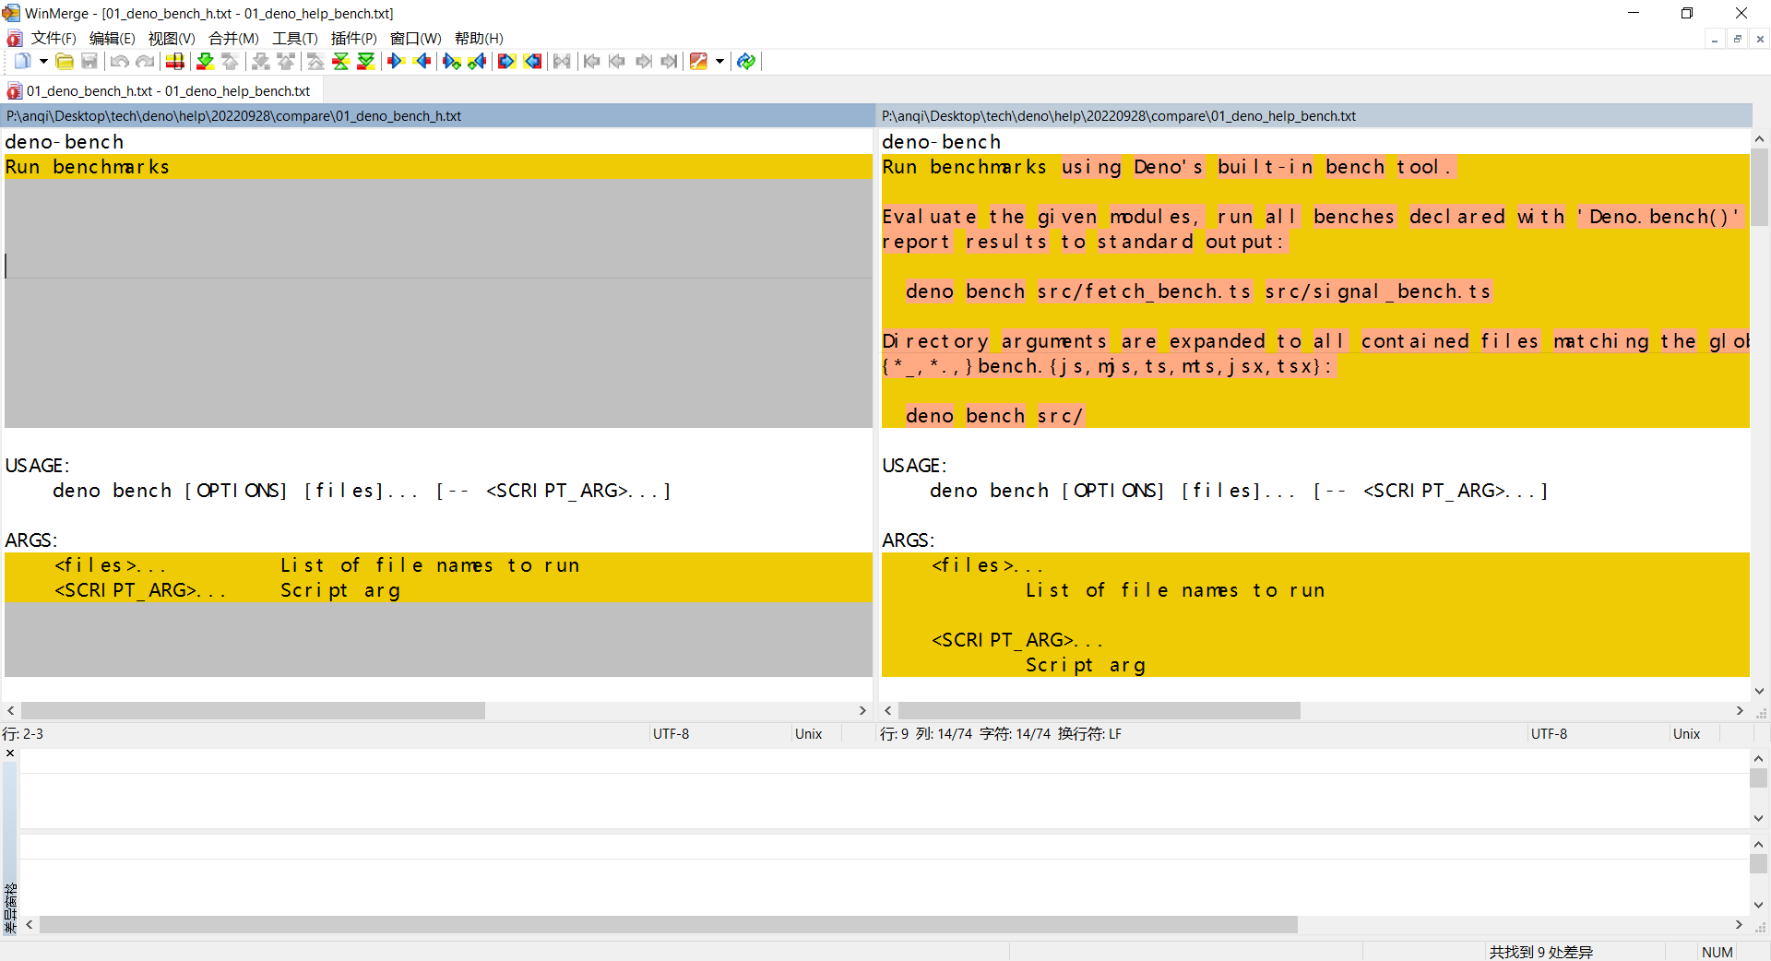

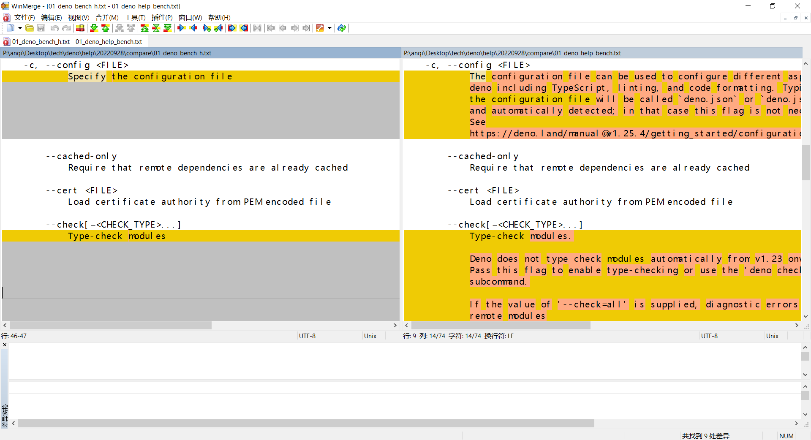

For more, see 01_deno_bench_h_VS_01_deno_help_bench.htm

### Conclusion

We can use ‘deno help <subcommands>’ for full info, and ‘deno <subcommands> -h’ for simple info.

Don’t use ‘deno -h <subcommands>’!

## Get the help info of other subcommands

### deno <subcommands> -h

P:\anqi\Desktop\tech\deno\help\20220928\compare>deno bundle -h >02_deno_bundle_h.txt

P:\anqi\Desktop\tech\deno\help\20220928\compare>deno cache -h >03_deno_cache_h.txt

P:\anqi\Desktop\tech\deno\help\20220928\compare>deno check -h >04_deno_check_h.txt

P:\anqi\Desktop\tech\deno\help\20220928\compare>deno compile -h >05_deno_compile_h.txt

P:\anqi\Desktop\tech\deno\help\20220928\compare>deno completions -h >06_deno_completions_h.txt

P:\anqi\Desktop\tech\deno\help\20220928\compare>deno coverage -h >07_deno_coverage_h.txt

P:\anqi\Desktop\tech\deno\help\20220928\compare>deno doc -h >08_deno_doc_h.txt

P:\anqi\Desktop\tech\deno\help\20220928\compare>deno eval -h >09_deno_eval_h.txt

P:\anqi\Desktop\tech\deno\help\20220928\compare>deno fmt -h >10_deno_fmt_h.txt

P:\anqi\Desktop\tech\deno\help\20220928\compare>deno help -h >11_deno_help_h.txt

error: The subcommand '-h' wasn't recognized

USAGE:

deno <subcommands>

For more information try --help

P:\anqi\Desktop\tech\deno\help\20220928\compare>deno info -h >12_deno_info_h.txt

P:\anqi\Desktop\tech\deno\help\20220928\compare>deno init -h >13_deno_init_h.txt

P:\anqi\Desktop\tech\deno\help\20220928\compare>deno install -h >14_deno_install_h.txt

P:\anqi\Desktop\tech\deno\help\20220928\compare>deno lint -h >15_deno_lint_h.txt

P:\anqi\Desktop\tech\deno\help\20220928\compare>deno lsp -h >16_deno_lsp_h.txt

P:\anqi\Desktop\tech\deno\help\20220928\compare>deno repl -h >17_deno_repl_h.txt

P:\anqi\Desktop\tech\deno\help\20220928\compare>deno run -h >18_deno_run_h.txt

P:\anqi\Desktop\tech\deno\help\20220928\compare>deno task -h >19_deno_task_h.txt

Warning deno task is unstable and may drastically change in the future

error: No config file found

P:\anqi\Desktop\tech\deno\help\20220928\compare>deno test -h >20_deno_test_h.txt

P:\anqi\Desktop\tech\deno\help\20220928\compare>deno types -h >21_deno_types_h.txt

P:\anqi\Desktop\tech\deno\help\20220928\compare>deno uninstall -h >22_deno_uninstall_h.txt

error: No installation found for -h

P:\anqi\Desktop\tech\deno\help\20220928\compare>deno upgrade -h >23_deno_upgrade_h.txt

P:\anqi\Desktop\tech\deno\help\20220928\compare>deno vendor -h >24_deno_vendor_h.txt

### deno help <subcommands>

P:\anqi\Desktop\tech\deno\help\20220928\compare>deno help bundle >02_deno_help_bundle.txt

P:\anqi\Desktop\tech\deno\help\20220928\compare>deno help cache >03_deno_help_cache.txt

P:\anqi\Desktop\tech\deno\help\20220928\compare>deno help check >04_deno_help_check.txt

P:\anqi\Desktop\tech\deno\help\20220928\compare>deno help compile >05_deno_help_compile.txt

P:\anqi\Desktop\tech\deno\help\20220928\compare>deno help completions >06_deno_help_completions.txt

P:\anqi\Desktop\tech\deno\help\20220928\compare>deno help coverage >07_deno_help_coverage.txt

P:\anqi\Desktop\tech\deno\help\20220928\compare>deno help doc >08_deno_help_doc.txt

P:\anqi\Desktop\tech\deno\help\20220928\compare>deno help eval >09_deno_help_eval.txt

P:\anqi\Desktop\tech\deno\help\20220928\compare>deno help fmt >10_deno_help_fmt.txt

P:\anqi\Desktop\tech\deno\help\20220928\compare>deno help help >11_deno_help_help.txt

P:\anqi\Desktop\tech\deno\help\20220928\compare>deno help info >12_deno_help_info.txt

P:\anqi\Desktop\tech\deno\help\20220928\compare>deno help init >13_deno_help_init.txt

P:\anqi\Desktop\tech\deno\help\20220928\compare>deno help install >14_deno_help_install.txt

P:\anqi\Desktop\tech\deno\help\20220928\compare>deno help lint >15_deno_help_lint.txt

P:\anqi\Desktop\tech\deno\help\20220928\compare>deno help lsp >16_deno_help_lsp.txt

P:\anqi\Desktop\tech\deno\help\20220928\compare>deno help repl >17_deno_help_repl.txt

P:\anqi\Desktop\tech\deno\help\20220928\compare>deno help run >18_deno_help_run.txt

P:\anqi\Desktop\tech\deno\help\20220928\compare>deno help task >19_deno_help_task.txt

P:\anqi\Desktop\tech\deno\help\20220928\compare>deno help test >20_deno_help_test.txt

P:\anqi\Desktop\tech\deno\help\20220928\compare>deno help types >21_deno_help_types.txt

P:\anqi\Desktop\tech\deno\help\20220928\compare>deno help uninstall >22_deno_help_uninstall.txt

P:\anqi\Desktop\tech\deno\help\20220928\compare>deno help upgrade >23_deno_help_upgrade.txt

P:\anqi\Desktop\tech\deno\help\20220928\compare>deno help vendor >24_deno_help_vendor.txt

### Conclusion

‘help’ is not belongs to subcommands.

## Compare by categories

Get the help info, and output to two difference categories, and then compare them.

### Run

P:\anqi\Desktop\tech\deno\help\20220928\compare>md ~-h help~

P:\anqi\Desktop\tech\deno\help\20220928\compare>deno bench -h >~-h\01_deno-bench.txt & deno help bench >help~\01_deno-bench.txt

P:\anqi\Desktop\tech\deno\help\20220928\compare>deno bundle -h >~-h\02_deno-bundle.txt & deno help bundle >help~\02_deno-bundle.txt

P:\anqi\Desktop\tech\deno\help\20220928\compare>deno cache -h >~-h\03_deno-cache.txt & deno help cache >help~\03_deno-cache.txt

P:\anqi\Desktop\tech\deno\help\20220928\compare>deno check -h >~-h\04_deno-check.txt & deno help check >help~\04_deno-check.txt

P:\anqi\Desktop\tech\deno\help\20220928\compare>deno compile -h >~-h\05_deno-compile.txt & deno help compile >help~\05_deno-compile.txt

P:\anqi\Desktop\tech\deno\help\20220928\compare>deno completions -h >~-h\06_deno-completions.txt & deno help completions >help~\06_deno-completions.txt

P:\anqi\Desktop\tech\deno\help\20220928\compare>deno coverage -h >~-h\07_deno-coverage.txt & deno help coverage >help~\07_deno-coverage.txt

P:\anqi\Desktop\tech\deno\help\20220928\compare>deno doc -h >~-h\08_deno-doc.txt & deno help doc >help~\08_deno-doc.txt

P:\anqi\Desktop\tech\deno\help\20220928\compare>deno eval -h >~-h\09_deno-eval.txt & deno help eval >help~\09_deno-eval.txt

P:\anqi\Desktop\tech\deno\help\20220928\compare>deno fmt -h >~-h\10_deno-fmt.txt & deno help fmt >help~\10_deno-fmt.txt

P:\anqi\Desktop\tech\deno\help\20220928\compare>deno help -h >~-h\11_deno-help.txt & deno help help >help~\11_deno-help.txt

error: The subcommand '-h' wasn't recognized

USAGE:

deno <subcommands>

For more information try --help

P:\anqi\Desktop\tech\deno\help\20220928\compare>deno info -h >~-h\12_deno-info.txt & deno help info >help~\12_deno-info.txt

P:\anqi\Desktop\tech\deno\help\20220928\compare>deno init -h >~-h\13_deno-init.txt & deno help init >help~\13_deno-init.txt

P:\anqi\Desktop\tech\deno\help\20220928\compare>deno install -h >~-h\14_deno-install.txt & deno help install >help~\14_deno-install.txt

P:\anqi\Desktop\tech\deno\help\20220928\compare>deno lint -h >~-h\15_deno-lint.txt & deno help lint >help~\15_deno-lint.txt

P:\anqi\Desktop\tech\deno\help\20220928\compare>deno lsp -h >~-h\16_deno-lsp.txt & deno help lsp >help~\16_deno-lsp.txt

P:\anqi\Desktop\tech\deno\help\20220928\compare>deno repl -h >~-h\17_deno-repl.txt & deno help repl >help~\17_deno-repl.txt

P:\anqi\Desktop\tech\deno\help\20220928\compare>deno run -h >~-h\18_deno-run.txt & deno help run >help~\18_deno-run.txt

P:\anqi\Desktop\tech\deno\help\20220928\compare>deno task -h >~-h\19_deno-task.txt & deno help task >help~\19_deno-task.txt

Warning deno task is unstable and may drastically change in the future

error: No config file found

P:\anqi\Desktop\tech\deno\help\20220928\compare>deno test -h >~-h\20_deno-test.txt & deno help test >help~\20_deno-test.txt

P:\anqi\Desktop\tech\deno\help\20220928\compare>deno types -h >~-h\21_deno-types.txt & deno help types >help~\21_deno-types.txt

P:\anqi\Desktop\tech\deno\help\20220928\compare>deno uninstall -h >~-h\22_deno-uninstall.txt & deno help uninstall >help~\22_deno-uninstall.txt

error: No installation found for -h

P:\anqi\Desktop\tech\deno\help\20220928\compare>deno upgrade -h >~-h\23_deno-upgrade.txt & deno help upgrade >help~\23_deno-upgrade.txt

P:\anqi\Desktop\tech\deno\help\20220928\compare>deno vendor -h >~-h\24_deno-vendor.txt & deno help vendor >help~\24_deno-vendor.txt

### Compare with WinMerge

For more, please the “99 deno ~subcommands~ -h VS deno help ~subcommands~.htm” and “99 deno ~subcommands~ -h VS deno help ~subcommands~.files\*.htm”.

## Others

Now, I don’t know how to show the ENVIRONMENT VARIABLES, or set them.

# Study some subcommands

## deno bench

P:\anqi\Desktop\tech\deno\help\20220928>deno bench

error: No bench modules found

P:\anqi\Desktop\tech\deno\help\20220928>deno bench P:\anqi\Desktop\tech\deno\codes\netsaur\netsaur-main\examples\bench.ts

error: error sending request for url (https://raw.githubusercontent.com/denosaurs/neo/main/backend/util/data.ts): error trying to connect: dns error: The requested name is valid, but no data of the requested type was found. (os error 11004)

at <file:///P:/anqi/Desktop/tech/deno/codes/netsaur/netsaur-main/deps.ts:9:8>

anqi: delay the study.

## deno upgrade

P:\anqi\Desktop\tech\deno\help\20220928>deno upgrade && deno -V

Looking up latest version

error: error sending request for url (https://github.com/denoland/deno/releases/latest): connection error: connection reset

Caused by:

0: connection error: connection reset

1: connection reset

P:\anqi\Desktop\tech\deno\help\20220928>deno upgrade && deno -V

Looking up latest version

error: error sending request for url (https://github.com/denoland/deno/releases/latest): connection error: connection reset

Caused by:

0: connection error: connection reset

1: connection reset

P:\anqi\Desktop\tech\deno\help\20220928>ping www.baidu.com -t

Pinging www.a.shifen.com [14.215.177.38] with 32 bytes of data:

Reply from 14.215.177.38: bytes=32 time=22ms TTL=54

Reply from 14.215.177.38: bytes=32 time=22ms TTL=54

Reply from 14.215.177.38: bytes=32 time=21ms TTL=54

Reply from 14.215.177.38: bytes=32 time=22ms TTL=54

Reply from 14.215.177.38: bytes=32 time=21ms TTL=54

Reply from 14.215.177.38: bytes=32 time=22ms TTL=54

Reply from 14.215.177.38: bytes=32 time=21ms TTL=54

Reply from 14.215.177.38: bytes=32 time=22ms TTL=54

Reply from 14.215.177.38: bytes=32 time=21ms TTL=54

Reply from 14.215.177.38: bytes=32 time=21ms TTL=54

Reply from 14.215.177.38: bytes=32 time=22ms TTL=54

Reply from 14.215.177.38: bytes=32 time=21ms TTL=54

Reply from 14.215.177.38: bytes=32 time=22ms TTL=54

Reply from 14.215.177.38: bytes=32 time=22ms TTL=54

Reply from 14.215.177.38: bytes=32 time=22ms TTL=54

Reply from 14.215.177.38: bytes=32 time=21ms TTL=54

Reply from 14.215.177.38: bytes=32 time=22ms TTL=54

Ping statistics for 14.215.177.38:

Packets: Sent = 17, Received = 17, Lost = 0 (0% loss),

Approximate round trip times in milli-seconds:

Minimum = 21ms, Maximum = 22ms, Average = 21ms

Control-C

^C

P:\anqi\Desktop\tech\deno\help\20220928>ping github.com -t

Pinging github.com [20.205.243.166] with 32 bytes of data:

Request timed out.

Request timed out.

Request timed out.

Request timed out.

Request timed out.

Ping statistics for 20.205.243.166:

Packets: Sent = 5, Received = 0, Lost = 5 (100% loss),

Control-C

^C

P:\anqi\Desktop\tech\deno\help\20220928>ping www.baidu.com && ping github.com && ping www.baidu.com

Pinging www.a.shifen.com [14.215.177.38] with 32 bytes of data:

Reply from 14.215.177.38: bytes=32 time=22ms TTL=54

Reply from 14.215.177.38: bytes=32 time=21ms TTL=54

Reply from 14.215.177.38: bytes=32 time=22ms TTL=54

Reply from 14.215.177.38: bytes=32 time=22ms TTL=54

Ping statistics for 14.215.177.38:

Packets: Sent = 4, Received = 4, Lost = 0 (0% loss),

Approximate round trip times in milli-seconds:

Minimum = 21ms, Maximum = 22ms, Average = 21ms

Pinging github.com [20.205.243.166] with 32 bytes of data:

Request timed out.

Request timed out.

Request timed out.

Request timed out.

Ping statistics for 20.205.243.166:

Packets: Sent = 4, Received = 0, Lost = 4 (100% loss),

P:\anqi\Desktop\tech\deno\help\20220928>ping www.baidu.com & ping github.com & ping www.baidu.com

Pinging www.a.shifen.com [14.215.177.38] with 32 bytes of data:

Reply from 14.215.177.38: bytes=32 time=22ms TTL=54

Reply from 14.215.177.38: bytes=32 time=21ms TTL=54

Reply from 14.215.177.38: bytes=32 time=22ms TTL=54

Reply from 14.215.177.38: bytes=32 time=22ms TTL=54

Ping statistics for 14.215.177.38:

Packets: Sent = 4, Received = 4, Lost = 0 (0% loss),

Approximate round trip times in milli-seconds:

Minimum = 21ms, Maximum = 22ms, Average = 21ms

Pinging github.com [20.205.243.166] with 32 bytes of data:

Request timed out.

Request timed out.

Request timed out.

Request timed out.

Ping statistics for 20.205.243.166:

Packets: Sent = 4, Received = 0, Lost = 4 (100% loss),

Pinging www.a.shifen.com [14.215.177.38] with 32 bytes of data:

Reply from 14.215.177.38: bytes=32 time=21ms TTL=54

Reply from 14.215.177.38: bytes=32 time=21ms TTL=54

Reply from 14.215.177.38: bytes=32 time=22ms TTL=54

Reply from 14.215.177.38: bytes=32 time=21ms TTL=54

Ping statistics for 14.215.177.38:

Packets: Sent = 4, Received = 4, Lost = 0 (0% loss),

Approximate round trip times in milli-seconds:

Minimum = 21ms, Maximum = 22ms, Average = 21ms

# Make categories and continue tomorrow

P:\anqi\Desktop\tech\deno\help\20220928>md 01_deno_bench

P:\anqi\Desktop\tech\deno\help\20220928>md 02_deno_bundle

P:\anqi\Desktop\tech\deno\help\20220928>md 03_deno_cache

P:\anqi\Desktop\tech\deno\help\20220928>md 04_deno_check

P:\anqi\Desktop\tech\deno\help\20220928>md 05_deno_compile

P:\anqi\Desktop\tech\deno\help\20220928>md 06_deno_completions

P:\anqi\Desktop\tech\deno\help\20220928>md 07_deno_coverage

P:\anqi\Desktop\tech\deno\help\20220928>md 08_deno_doc

P:\anqi\Desktop\tech\deno\help\20220928>md 09_deno_eval

P:\anqi\Desktop\tech\deno\help\20220928>md 10_deno_fmt

P:\anqi\Desktop\tech\deno\help\20220928>md 11_deno_help

P:\anqi\Desktop\tech\deno\help\20220928>md 12_deno_info

P:\anqi\Desktop\tech\deno\help\20220928>md 13_deno_init

P:\anqi\Desktop\tech\deno\help\20220928>md 14_deno_install

P:\anqi\Desktop\tech\deno\help\20220928>md 15_deno_lint

P:\anqi\Desktop\tech\deno\help\20220928>md 16_deno_lsp

P:\anqi\Desktop\tech\deno\help\20220928>md 17_deno_repl

P:\anqi\Desktop\tech\deno\help\20220928>md 18_deno_run

P:\anqi\Desktop\tech\deno\help\20220928>md 19_deno_task

P:\anqi\Desktop\tech\deno\help\20220928>md 20_deno_test

P:\anqi\Desktop\tech\deno\help\20220928>md 21_deno_types

P:\anqi\Desktop\tech\deno\help\20220928>md 22_deno_uninstall

P:\anqi\Desktop\tech\deno\help\20220928>md 23_deno_upgrade

P:\anqi\Desktop\tech\deno\help\20220928>md 24_deno_vendor