# Show the version of git. Create and enter the directory git-init, and then execute the git-init command.

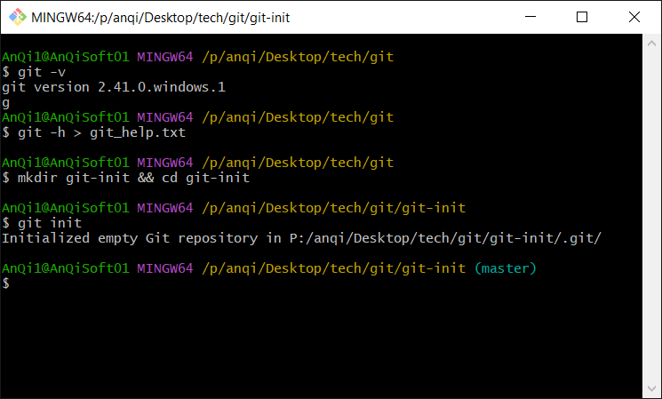

# Display the contents of .git/config.

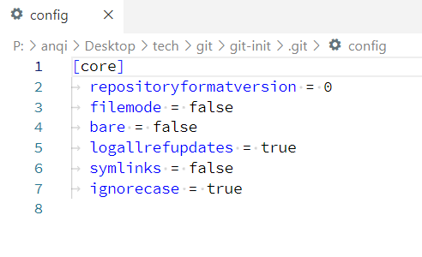

# Create a new repository called "git-init" on github.

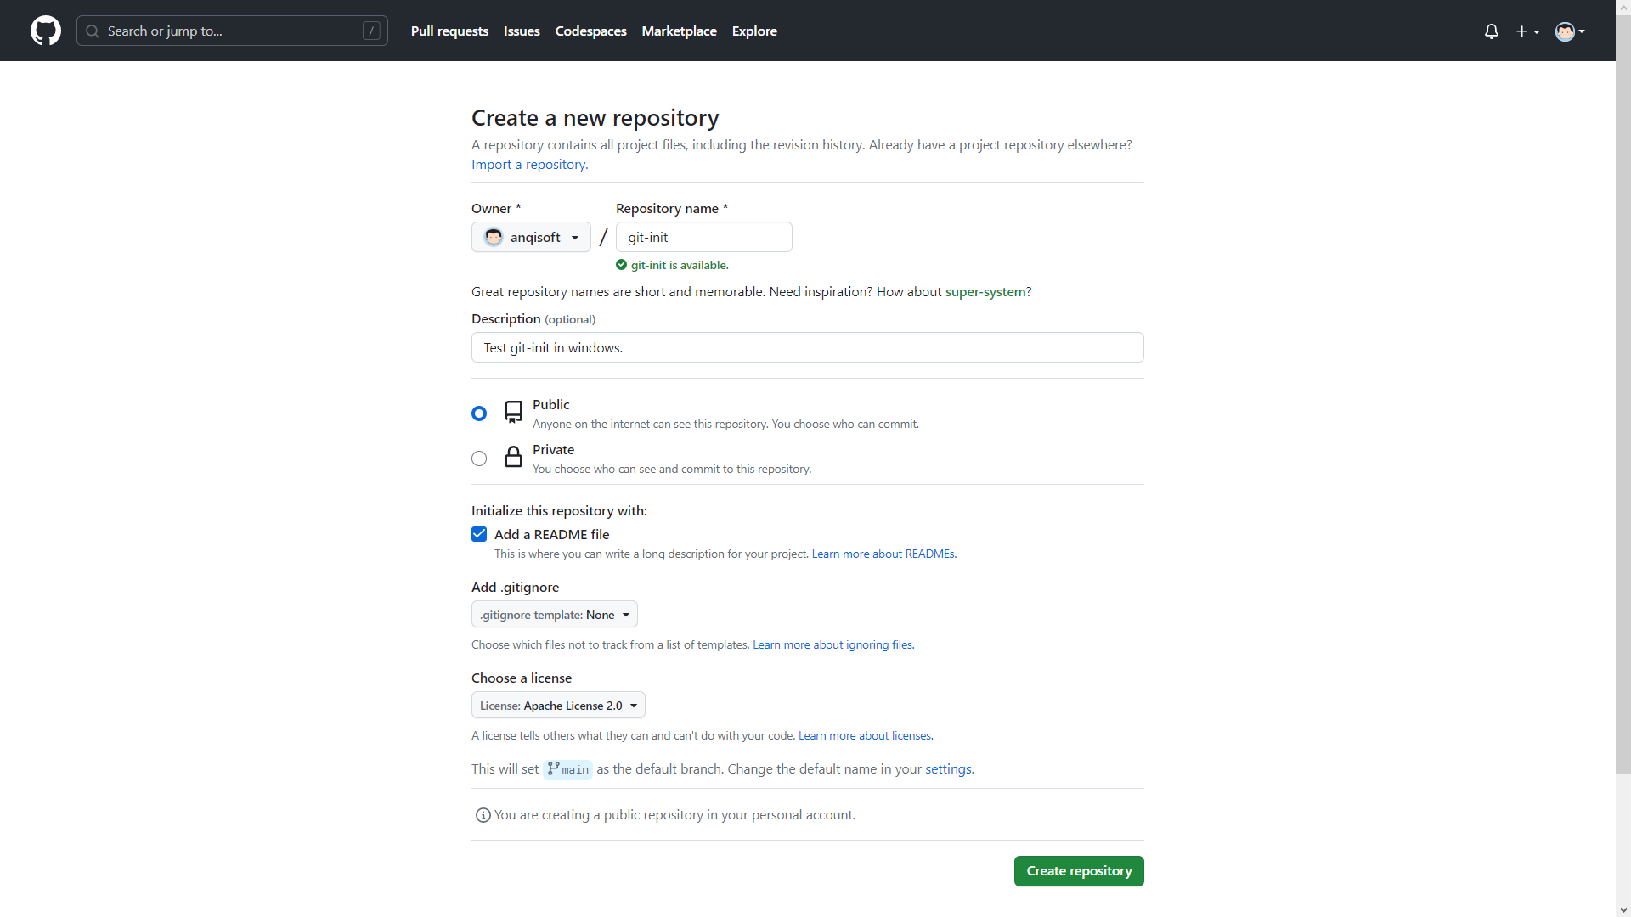

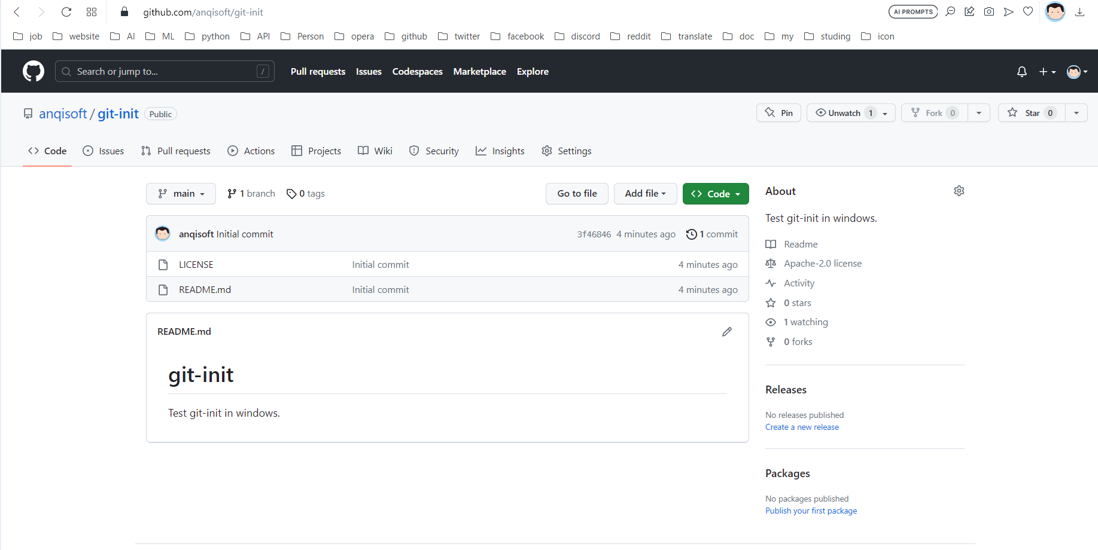

# Connect to the remote library in ssh mode and pull all the latest content.

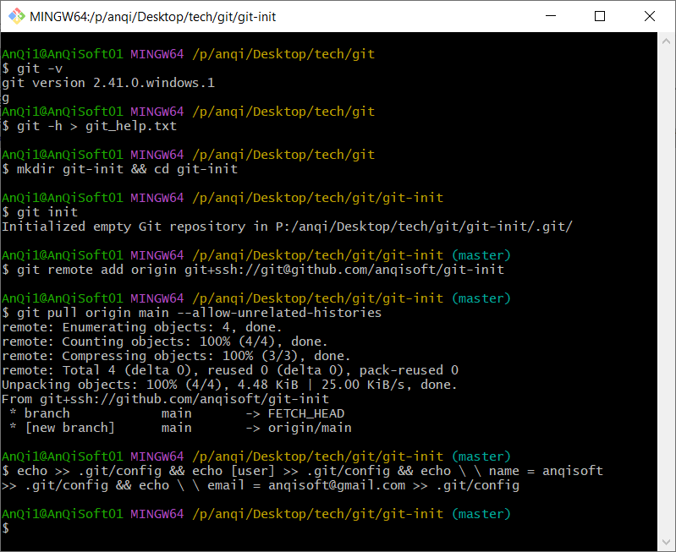

# Try to submit directly with git push origin main, it prompts an error; and then submit with git push origin master, a master branch will be added to the library instead of directly submitting to the default main branch.

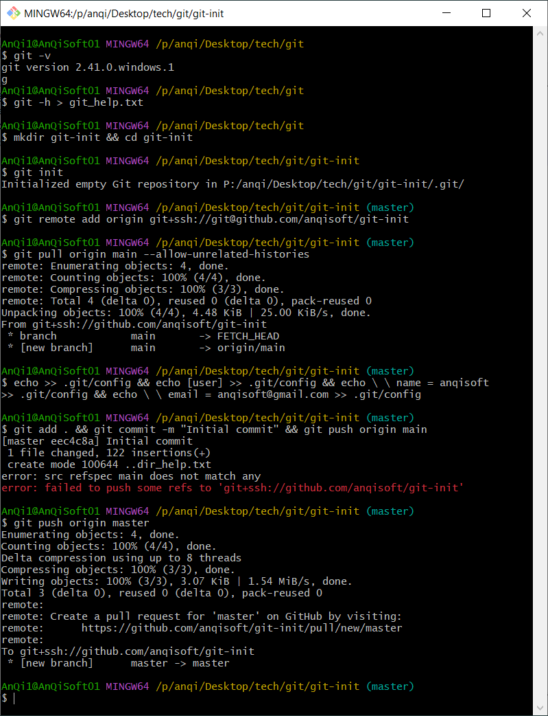

# A master branch will be added to the library instead of submitting directly to the default main branch.

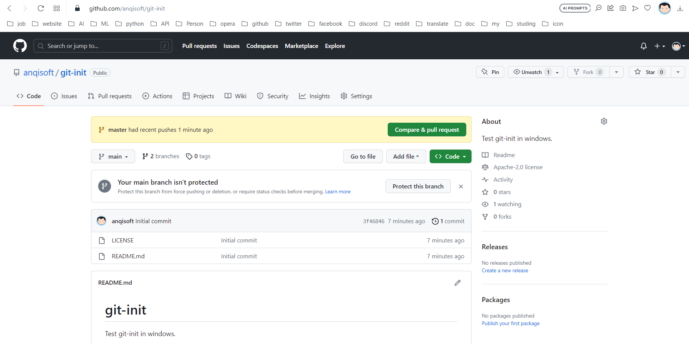

Note: If you don't want to add a master branch and submit directly to the main branch, you need to use the command instead: git push origin master:main.