Initial 16 points locations:

Training State: [-5,5]*[-5,5]

1. x0 located on the boundary of the training states:
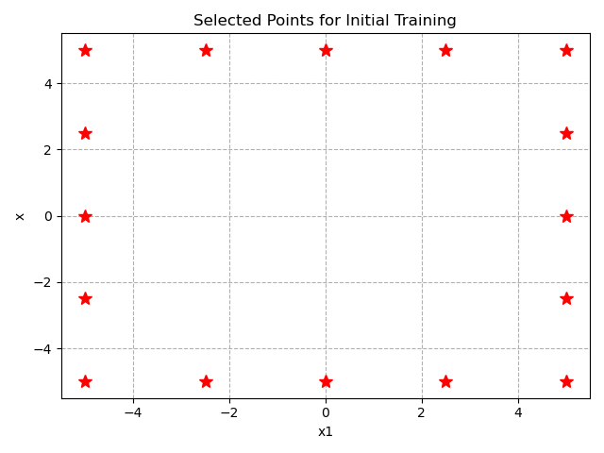
Training Loss:
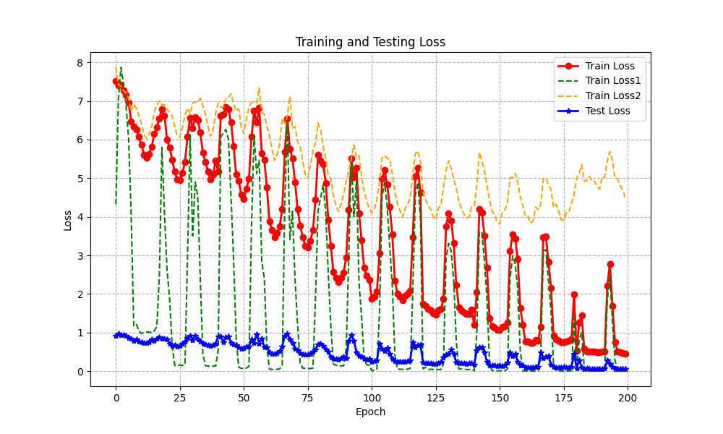
NO: early stopping, change w1, w2 linearly
PI=23.06

Running time for each trial: 51.36s.
Trials # | 1 | 2 | 3 | 4 | 5
PI | 23.06 | 38.52 | 34.02 | 67.57 | 20.00
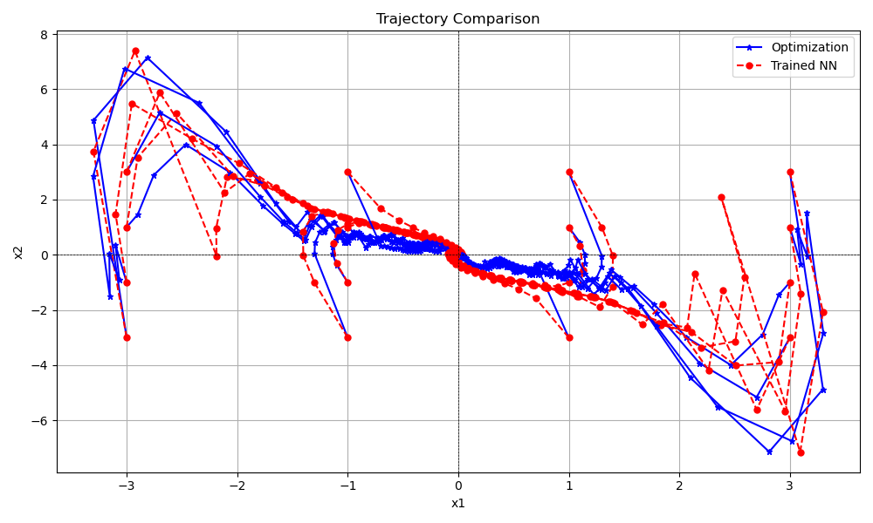
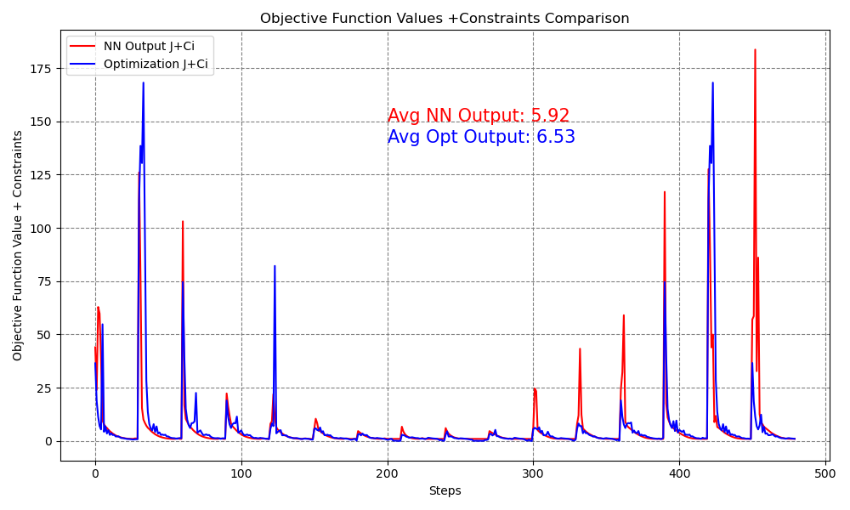
-- Give 16 initial points (uniformly sampled), run 30 steps, NN output objective function + constraints VS Optimization solutions:

2. located uniformly on the training states:
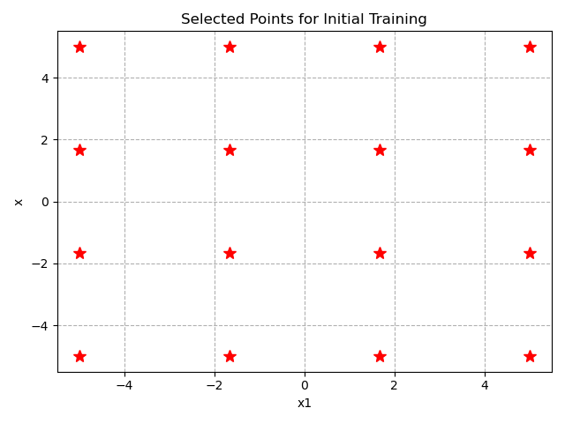
Running Loss:
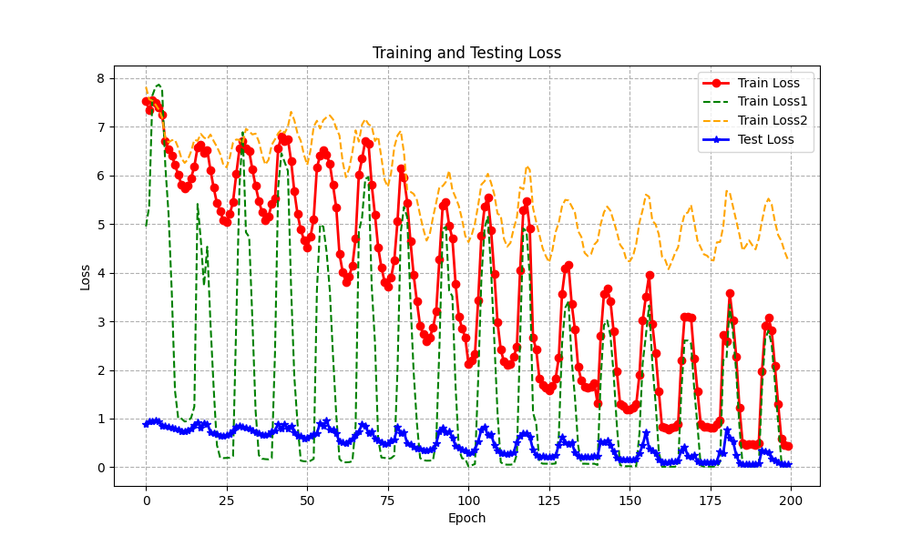
NO: early stopping, w1, s2 change linearly
PI=25.73

Running time for each trial: 51.07s.
Trials # | 1 | 2 | 3 | 4 | 5
PI | 34.28 | 23.69 | 52.93 | 76.62 | 25.73

There is around 5 seconds training time reducing when early stopping method is applied. Need more trials to evaluate its affects on the final neural controllers.

-- Give 16 initial points (uniformly sampled), run 30 steps, NN output objective function + constraints VS Optimization solutions:

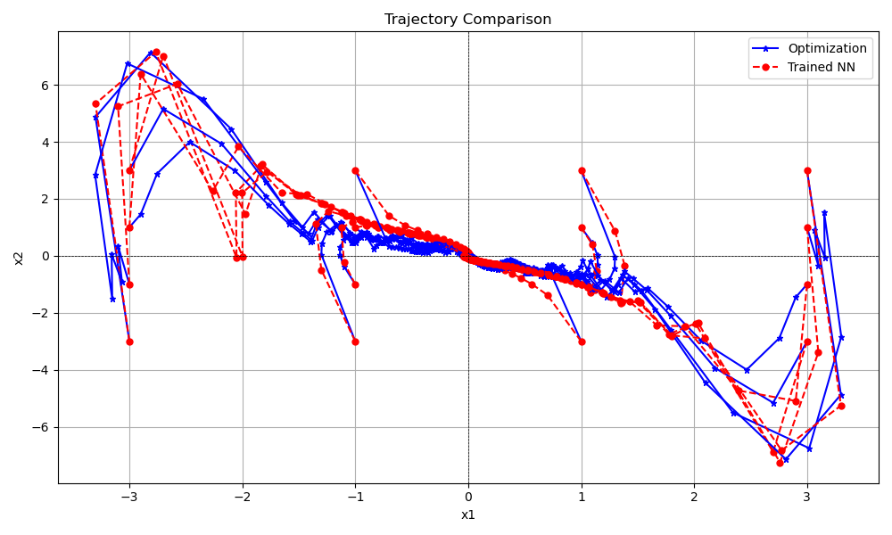
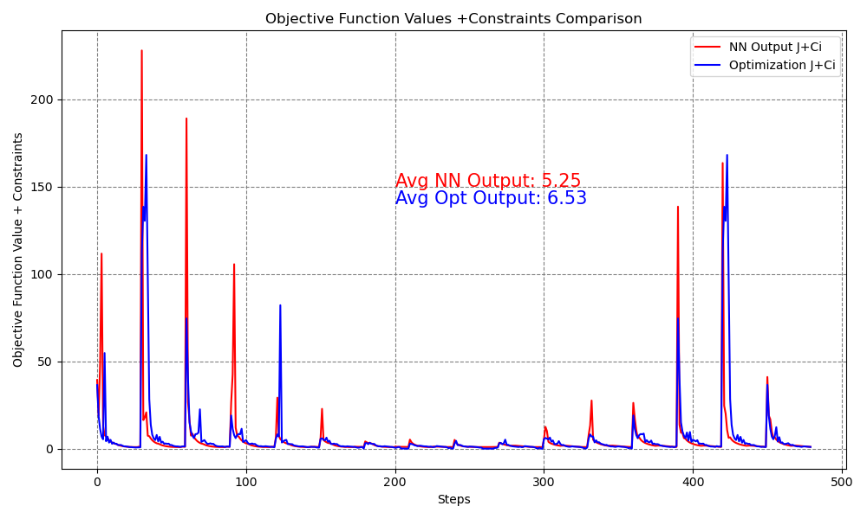

3. most of points near equilibrium point:
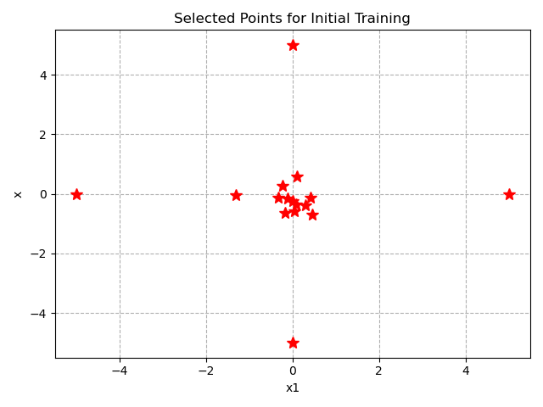

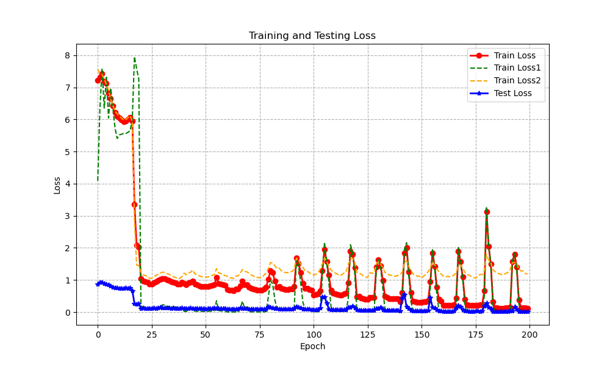
Running time for each trial: 51.36s.
Trials # | 1 | 2 | 3 | 4 | 5
PI | 72.89 | 155.29 | 33.80 | 30.34 | 103.69
(Above numbers are results filtered the trajectories outside the operation region).
Red trials mean that the training failed: some trajectories diverged.
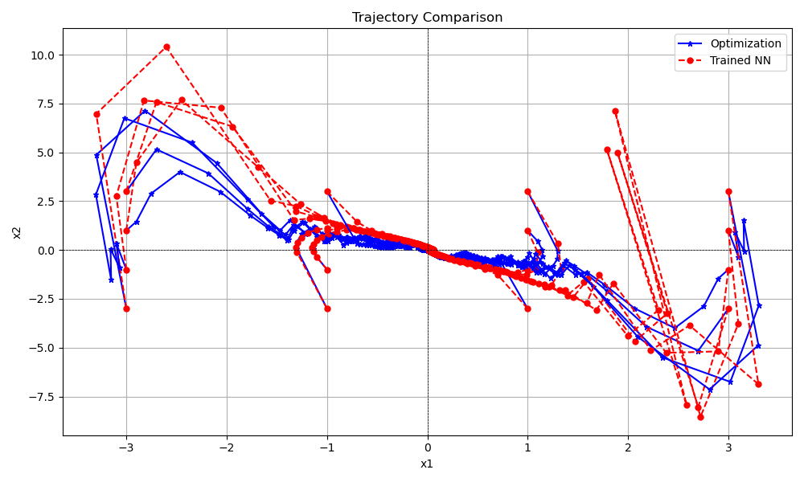
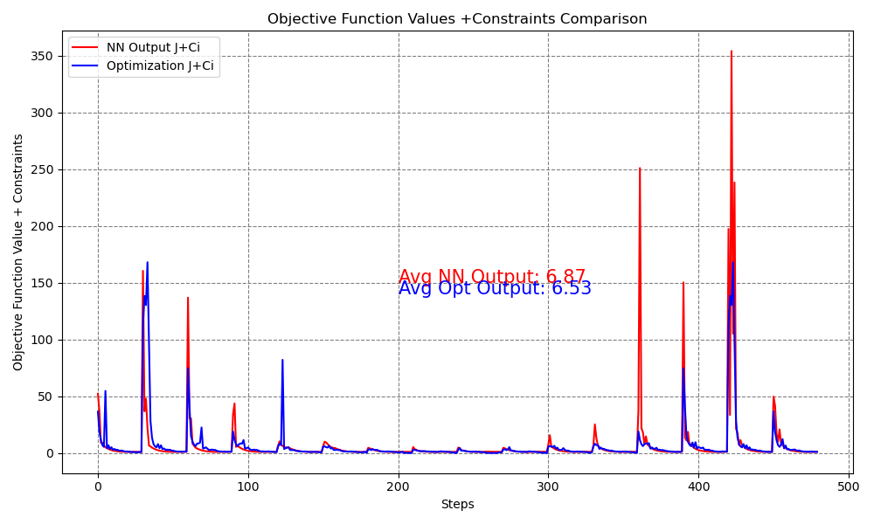
PI=30.34

When PI=33.80:
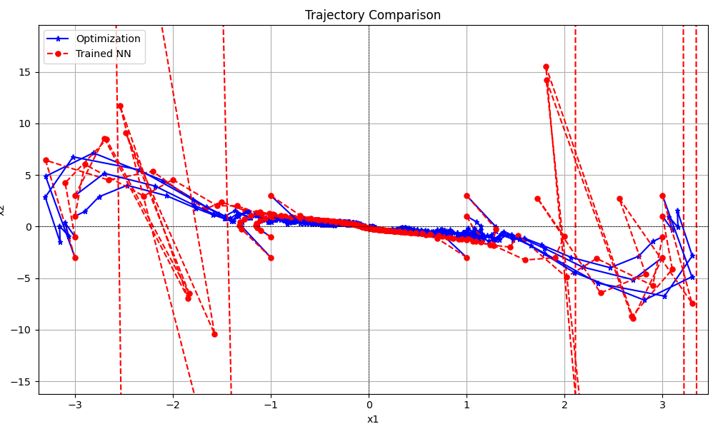
GUESS: Main results from NON normalization operation for input/output data

Summary:

1. initial points far away from the equilibrium point provide more information, training process has more change to have a better result.

2. Dense sampling near the equilibrium point is not a wise decision, as the solution is relative small, if the NN input/output has no normalization, those sampled data points cannot give enough information when training a NN.

