Food Box

The code for the project is hosted on: <https://github.com/>

Project Developer: **Arun Rawat**

***Sprint Planning***

**Sprint 1:**

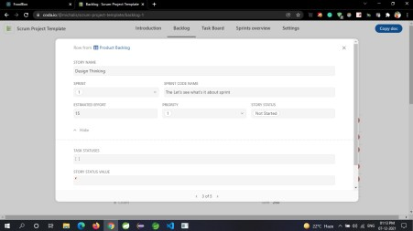

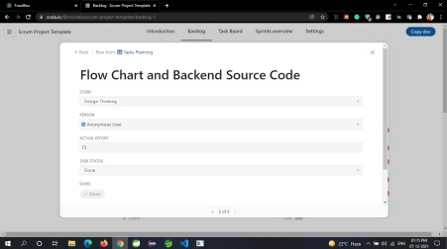

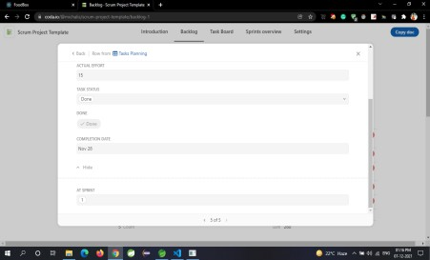

**Sprint 2:**

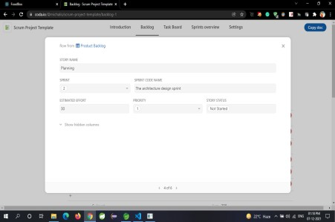

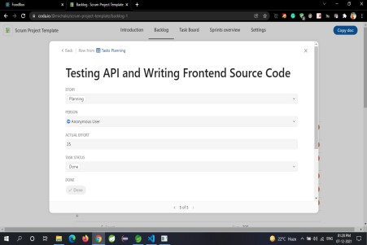

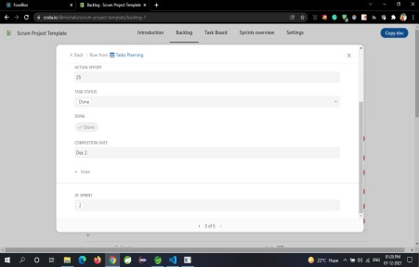

**Sprint 3:**

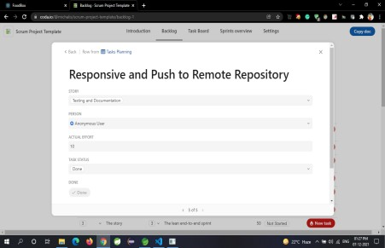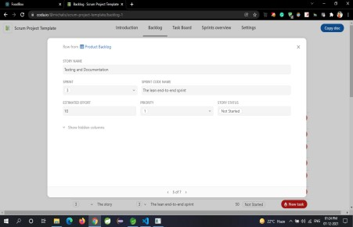

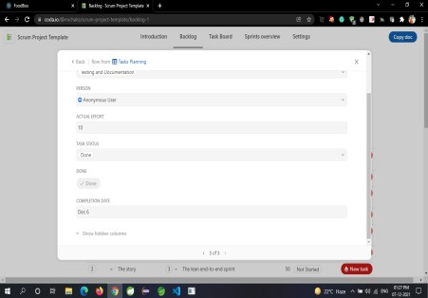

***Core Concepts Used in the Project***

* Java
* Spring Boot
* JPA
* Postman
* MySQL database
* React Js
* Bootstrap, HTML, CSS
* Redux
* GitHub

***Application API on Postman***

