***Flyaway***

**Sprint Planning and task completion for the Project**

* Project was planned and completed in 1 sprint.
* Creating the flow of the application
* Initialized the Git repository and pushed code to GitHub
* Written the Java program to fulfil the requirements of the project
* Testing the program on various user inputs
* Creating this specification document

**Core Concepts:**

Creating Servlets, JSP, HTML, MySQL, JDBC, Core Java, CSS and Exception Handling

**Demonstrating the product capabilities, appearance, and user interactions:**

**Step 1: Creating a new project in Eclipse**

We start by creating a new Eclipse Dynamic Web Project:

* Open the [New Project] dialog box, e.g. by using File > New > Project...
* Select Web > Dynamic Web Project and click Next.
* Choose a Project Name (e.g. Guestbook).
* Select Apache Tomcat v6.0 as the Target runtime. Note: You may have to add Tomcat 6 as a new server by clicking the New Runtime... button. Follow the instructions and specify the path to Tomcat 6 (which has to be downloaded separately) .
* Click the Finish button to create the dynamic web project.

**Step 2: Writing a program in Java for the entry point of the application (Index.jsp)**

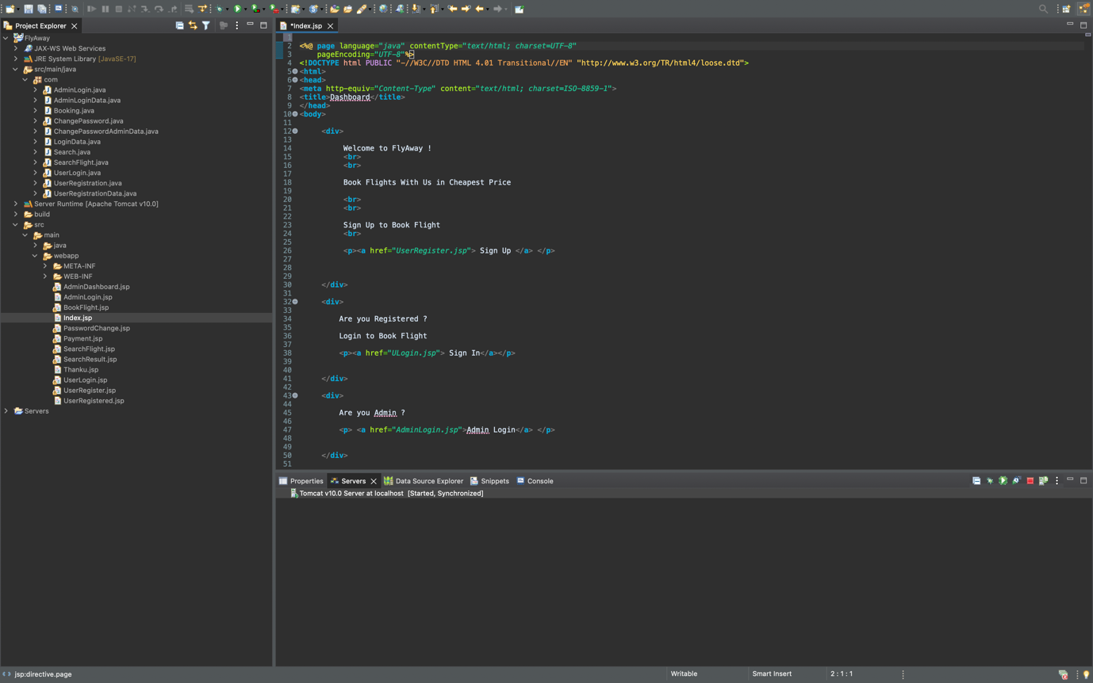

**Unique Selling Points of the Application:**

1. The application is designed to keep on running and taking user inputs even after exceptions occur. To terminate the application, appropriate option needs to be selected.

2. The application is designed to take input from the Signup and login forms

3. The application also allows user to CRUD in DBS.

4. The application is designed with modularity in mind. Even if one wants to update the path, they can change it through the source code.

**Conclusion:**

Further improvements can be made on the application which include:

Adding Bootstrap, JavaScript, CSS designs and attributes to make the forms responsive for the user.

Adding Flights database with multiple locations for Airports and adding more variables to make the DBMS easier to manipulate the data.