Chapter 5

Multiplexer and Switching Concepts

Outline

5.1 Types of Multiplexers TDM, FDM, SPM, CDM and WDM
5.2 Telephone System Operation
5.3 Digitizing Voice
5.4 T1 Links
5.5 Switching Concepts

Objectives

After Completing this chapter, you should be able to:

- Explain the operation of multiplexers and demultiplexers
- List the types of multiplexer and their operations
- Discuss how a telephone system operates
- Tell how pulse code modulation converts voice to digital signals
- Explain T1 Link technology and how to calculate its data rate

Discuss switching concepts
- List the types of switching methods

Introduction

Long-distance transmission lines are expensive, so a method which allows several devices to share one transmission line is necessary to defray the cost of wiring. The multiplexer provides a solution to this problem. Figure 5.1 shows four terminals sharing one transmission line to send information to the host computer by using a multiplexer instead of four transmission lines.

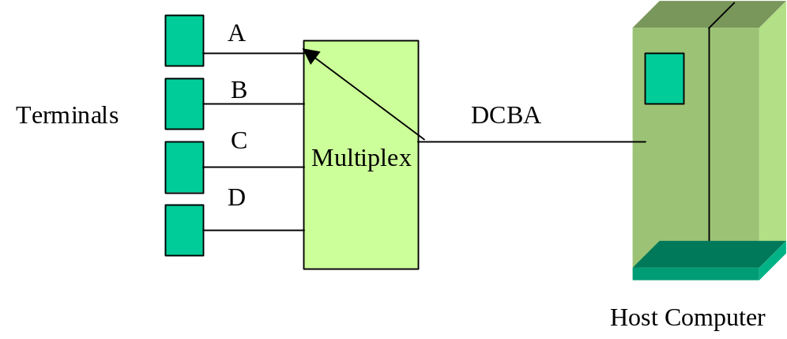

Figure 5.1: Application of multiplexer

A multiplexer (MUX) is a device which combines several low-speed data channels and transmits all the data on a single high-speed channel. A common application of multiplexing is long- distance communication using high speed point-to-point links for transferring large quantities of voice signals and data between users. Figure 5.2 shows the basic architecture of a multiplexer. A multiplexer that has N inputs and one output is called an N-to-1 multiplexer. Figure 5.2 shows a 4-to-1 Multiplexer. The internal switch selects one input line at a time and transfers the input to the output. When the switch is in position A, it transfers input A to the output, then the switch moves to position B and transfer input B to the output. This method continues until the switch moves to position D and transfers input D to the output. After this function is completed, the switch starts over from input A.

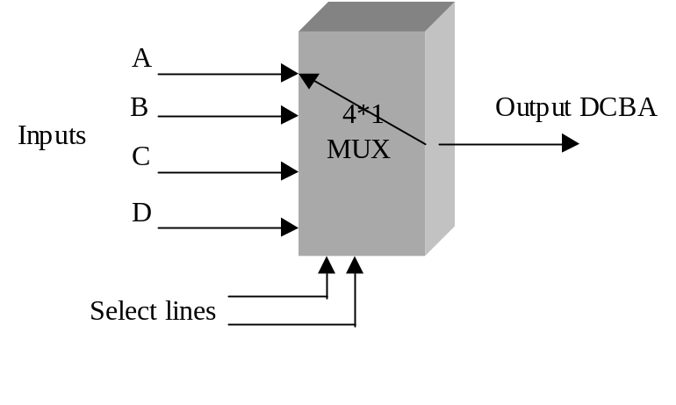 Figure 5.2: 4-to1 multiplexer

The opposite of a multiplexer is a demultiplexer (DMUX), as shown in Figure 5.3. The switch moves to send each input to the appropriate output. A DMUX has one input and N outputs - this is called a 1-to-N demultiplexer. When the switch is in position 0, it transfers A to output port 0, then moves to output port 1 and transfers B to this port. This process continues until the switch moves to output port 3 and transfers D to port 3. Once the cycle is complete, the transfer of data starts over from port 0.

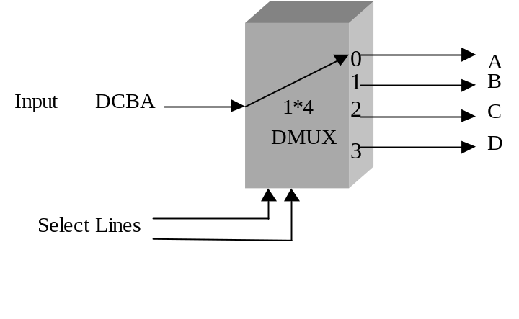

Figure 5.3: 1-to-4 demultiplexer

5.1 Types of Multiplexers

Multiplexers are categorized into the following types, where each type has a specific application.

- Time Division Multiplexing (TDM)
- Frequency Division Multiplexing (FDM)
- Statistical Packet Multiplexing (SPM)
- Fast Packet Multiplexing (FPM)
- Code Division Multiplexing (CDM)
- Wavelength Division Multiplexing (WDM)

Time Division Multiplexing (TDM)

In Time Division Multiplexing (TDM), multiple digital signals can be carried on a single transmission path by interleaving each input of the multiplexer. A TDM operates with a preassigned equal time slot to each input. It divides the bandwidth of the multiplexer’s output into fixed segments and each input to the MUX is given a fixed unit of time. First, information from input one is transmitted, then from input number two, and so on in a regular sequence, as shown in Figure 5.4.

One disadvantage of TDM is that the bandwidth of any one input is not available to other inputs when that input to the TDM is inactive. In figure 5.4, the inputs to B and D are inactive at the time t1 and t2, and the outputs in frame #2 and #3 have idle times. Another disadvantage of TDM is that it is not able to change the bandwidth of the input dynamically, and therefore cannot transport a combination of voice, fax, and data.

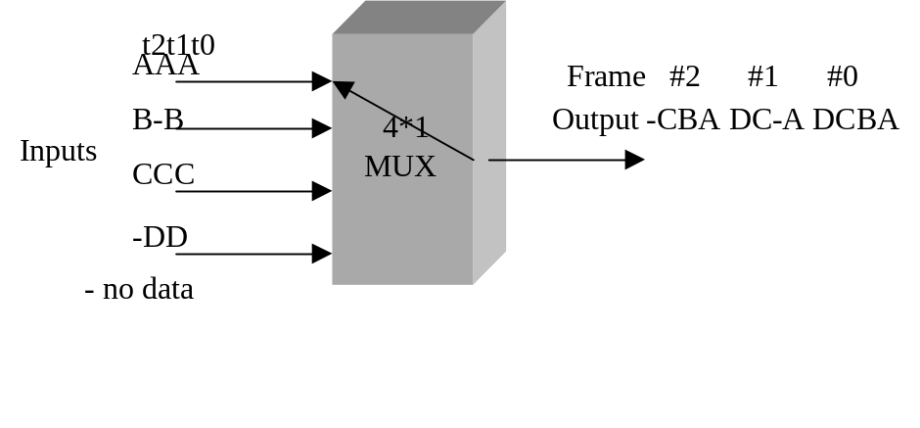
Figure 5.4: TDM multiplexer

Frequency Division Multiplexing

Frequency Division Multiplexing (FDM) divides the bandwidth of a transmission line into channels where each channel transmits specific information. Figure 5.5 shows the multiplexing of several TV channels using FDM. The bandwidth of a coaxial cable is about 500 MHz and it can carry 80 TV channels. Each TV channel is assigned a different frequency, each using 6 MHz of bandwidth. Therefore, FDM combines several signals for transmission on a single transmission line.

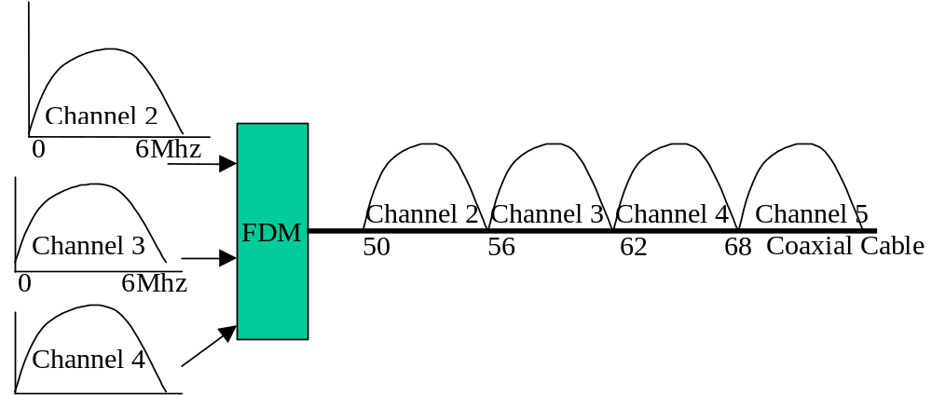

Figure 5.5: Frequency division multiplexing (FDM)

Statistical Packet Multiplexing

Statistical Packet Multiplexing (SPM) dynamically allocates bandwidth to the active input channels, resulting in very efficient bandwidth utilization. In SPM, an idle channel does not receive any time allocation, as shown in Figure 5.6. SPM uses a store-and-forward mechanism in order to detect and correct any error from incoming packets.

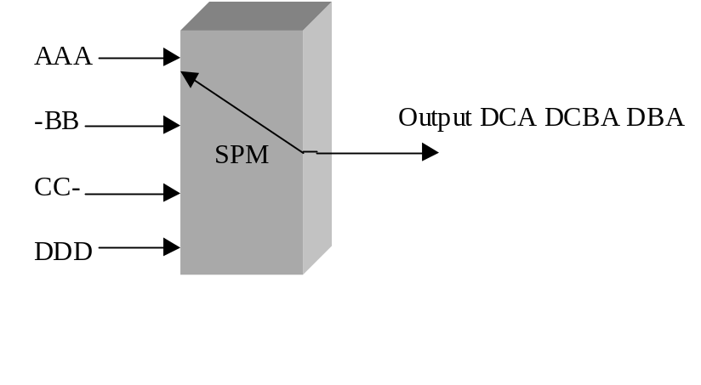 Figure 5.6: Statistical Packet Multiplexer

Fast Packet Multiplexing

Fast packet multiplexing (FPM) uses the same method as SPM and can assign maximum bandwidth to any input needed. FPM does not use a store and forward mechanism, and therefore cannot perform error detection and correction. FPM will forward a packet before it has been completely received by the multiplexer.

Code Division Multiplexing (CDM)

In Time Division Multiplexing (TDM) each end user is allocated a time slot for transmission. For instance, if 10 users are connected to a TDM and bandwidth of transmission link is 10 Mbps, then each user can transmit at the rate of 1 Mbps only. One disadvantage of TDM is that user must wait for its turn to transmit its information. CDM is similar to TDM but allows all users transmit simultaneously.

CDM Operation: In CDM each bit time is divided into multiple bits that are called chip bits. This is done by multiplying logic 1 with a chip sequence or by assigning chip bits to each node to represent logic 1. Table 5.1 shows the chip bits that are assigned to each node to represent logic 1. The complement of the chip bits represents logic zero. Chip bits can be represented by a bipolar value so that +1 represents logic 1 and -1 represents logic zero.

Table 5.1 Chip Bits for Node A and B

End node | Chip bits for logic 1 | Bipolar representation of chip bits
A | 0101 | -1+1-1+1
B | 1100 | +1+1-1-1

Characteristic of chip bits: In general, the chip bits for A can be represented by
A = (A ₄ A ₃ A ₂ A ₁) and the chip sequence for B can be represented by B = B₄ B₃ B₂ B_{1.} One property of chip bits is that the inner product of two different chip bits is zero and inner product of the two identical chip bits is one.

The inner product A and B is represented by 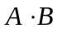, and is defined by equation 5.1:

Therefore, 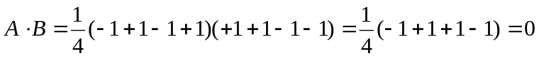.
And the inner product A with itself 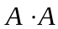 is:

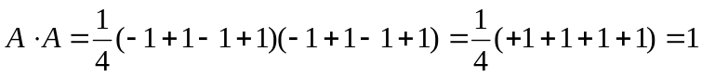

CDM Architecture: Figure 5.7 shows the general architecture of CDM with three inputs and one output. The nodes A, B, and C are the inputs, and the chip bits for each input are 4 bits. The chip bits of the input are added, and the result is transmitted over the communication link. At the receiver side, the inner product of the sum of the chip bits and chip sequence of the input node, result in the data bits of the input node.



Figure 5.7: General architecture of code division multiplexing

Example 5.1
Table 5.2 shows data to be transmitted by the nodes A, B, and C, and their chip sequences.

- Find the output of CDM.
- Find the data bit that is transmitted by node A at the receiver side.

Table 5.2: Chip bits and Data bits for Node A, B, and C

Node | Chip Sequence | Data to be transmitted
A | -1-1-1-1 | 101
B | -1+1-1+1 | 110
C | +1+1-1-1 | 001

The chip sequence for each data node is represented by Table 5.3.

Table 5.3: Chip bits for Data of Node A, B, and C

Node A | -1- 1- 1- 1 = (1) | +1+1+1+1 = (0) | -1-1-1-1 = (1)
Node B | -1+1-1+ 1= (1) | -1+1-1+1= (1) | +1-1+1-1 = 0
Node C | -1-1+1-+1 = (0) | -1-1+1+1= (0) | +1+1-1-1= (1)
Sum | -3- 1--1+1 | -1+1+1+3 | +1-1-1 -3

The Sum of data is then transmitted to the receiver side. At the receiver side, the receiver uses the chip sequence of a specific node to recover the original data by using the inner product. In order to recover user A’s data, the inner product of A and the Sum is shown by Table 5.4 where +1 represents 1 and -1 represents 0.

Table 5.4: Inner Product of Sum and A input

Sum | -3-1--1+1 | -1+1+1+3 | +1-1-1-3
Node A | -1-1-1-1 | -1-1-1-1 | -1-1-1-1
Inner Product | (+3-1+1-1)/4= +1 | (+1-1-1-3) /4= -1 | (-1+1+1+3)/4 = +1

Wavelength Division Multiplexing

Wavelength Division Multiplexing (WDM) is used to transmit multiple rays of light with different wavelengths in one optical cable in order to increase the capacity of the optical cable, rather than using multiple optical cables. The concept of wave division multiplexing is similar to frequency division multiplexing. Figure 5.8 shows two optical rays with different wavelengths multiplexed and transmitted over an optical fiber cable.

1310 nm
1310 nm
Optical Channel
Optical
MUX
Optical
DeMUX
1330 nm
1330 nm

Figure 5.8: Schematic diagram representing a simple form of WDM.

Components of a WDM: The components of a WDM are: Optical Transponder, Optical Multiplexer, Optical Amplifier, and Optical Demultiplexer.

Optical Transponder: The function of an optical transponder is to change the incoming ray’s wavelength to another wavelength. Figure 5.9 shows the block diagram of an optical transponder.

Optical
Electrical
Optical

Figure 5.9: Block diagram of an optical transponder.

There are two types of WDM known as Dense Wavelength Division Multiplexing (DWDM) and Coarse Wave Division Multiplexing (CWDM).

Dense Wavelength Division Multiplexing (DWDM): In DWDM, the wavelengths of the optical signals are close together. Current DWDM can transmit 60 to 80 wavelengths per channel with the wavelength spacing about 0.8 nm.

Coarse Wavelength Division Multiplexing (CWDM): CWDM can transmit 4 to 8 wavelengths of optical signals which are spaced 20nm apart from each other. The ITU specifies 18 channels using wavelengths from 1270-1610 nm for CWDM however, some channels are not useable due to high signal attenuation. Figure 5.10 shows three optical rays with the same wavelengths connected to three optical transponders. The optical transponders change the wavelength of the incoming signals and are connected to the MUX. The outputs of the DeMUX are connected to the three optical transponders in order to convert the signal wavelength back to their original values.

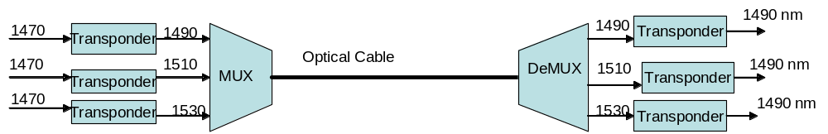

Figure 5.10: Coarse division multiplexing

5.2 Telephone System Operation

The wired telephone system transmits information in analog form from the telephone set to the central office (CO). At the CO, the analog signal is converted to a digital signal, which is
transferred to the next central office as shown in figure 5.11. This digital signal is then
converted to an analog signal and transmitted to the user. The method of conversion from
analog to digital is called Pulse Code Modulation (PCM).

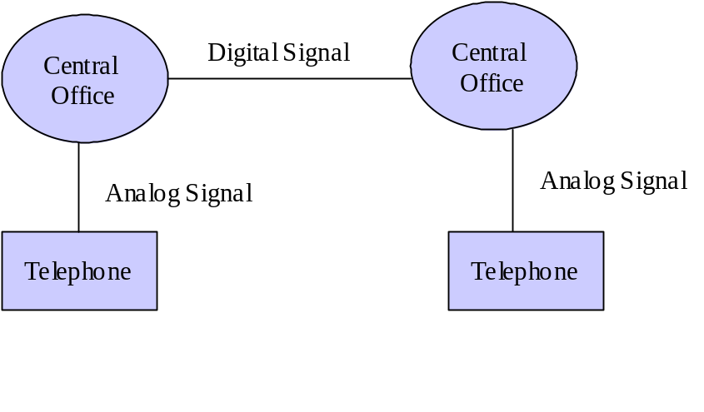
Figure 5.11: Telephone system architecture

5.3 Digitizing Voice

Voice is an analog signal. In the central office of the telephone company, it is digitized by a device called a codec (coder-decoder). The function of a codec is to digitize the voice signal and convert an already digitized signal to analog. According to the Nyquist theorem, in order to convert an analog signal into a digital signal, the analog signal must be sampled at least at the rate of two times the highest frequency of the analog signal. The voice signal must be sampled at 8000 samples per second because human speech is below 4000Hz, as shown in Figure 5.12. This method is called Pulse Amplitude Modulation (PAM).

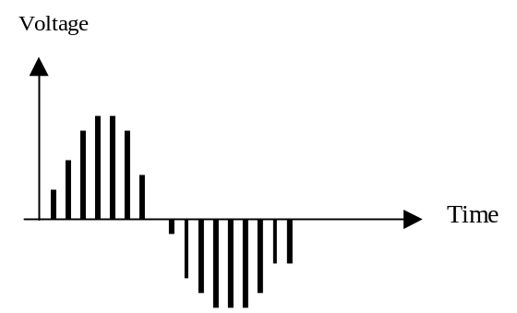
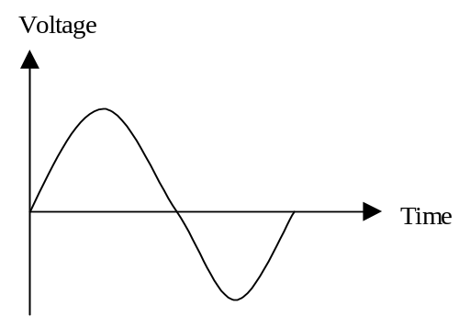

Analog Signal Pulse Amplitude Modulation

Figure 5.12: Analog signal and pulse amplitude modulation (PAM)

Each PAM sample is represented by eight bits. In Figure 5.13 it is represented by four bits. Remember, this method of converting voice to digital signal is called pulse code modulation (PCM). Since voice is digitized at the rate of 8000 samples per second and each sample is represented by 8 bits, the data rate of the human voice is 8000*8 = 64kbps.
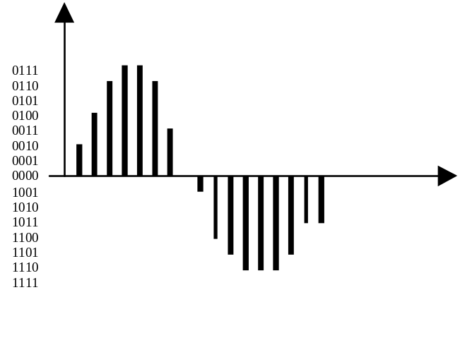
Figure5.13: Binary value for each PAM

5.4. T1 Links

Long-distance carriers use TDM to transmit voice signals over high-speed links. One of the applications of TDM is the T1 link. A T1 link carries a level-1 digital signal (DS-1). A DS-1 is generated by multiplexing 24 voice digital signals (Digital Signal level-0 or DS-0), as shown in Figure 5.14. Pulse code modulation (PCM) is used to convert each analog signal to a digital signal. Each frame is made of 24 * 8 bits = 192 bits, with one extra bit added to separate each frame, making each frame 193 bits. Each frame represents 1/ 8000th of a second. Therefore, the data rate of T1 link is 193 * 8000 = 1.544 Mbps.
Table 5.1 shows TDM carrier standards for North America. Look at the table and you will see that a DS-2 can carry 96 voice channels with 168 Kbps overhead. Therefore, the data rate for DS-2 is 6.312 Mbps (96 * 64Kbps + 168 Kbps overhead). Figure 5.15 shows the DS-1 frame format where the 1-bit gap is used to separate each frame.

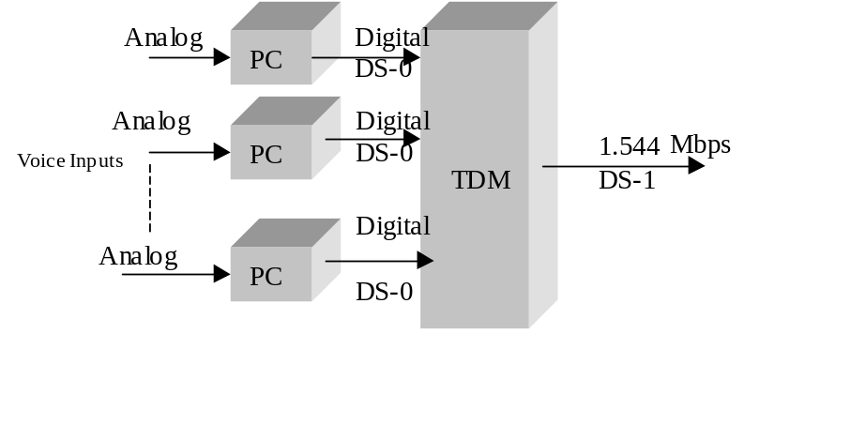
Figure 5.14: Architecture of T1 Link

Figure 5.15: DS-1 frame format

Table 5.5: TDM carrier standards for North America.

Frame Format | Line | Number of Voice Channels | Data Rates (Mbps )
DS-1 | T1 | 24 | 1.544
DS-1C | T-1C | 48 | 3.152
DS-2 | T2 | 96 | 6.312
DS-3 | T3 | 672 | 44.736
DS-4 | T4 | 4032 | 274.176

5.5 Switching Concepts

A communication network that has more than two computers must establish links between computers in order for them to be able to communicate with each other. One way to connect these computers is via fully connected network or (mesh), shown in Figure 5.16.
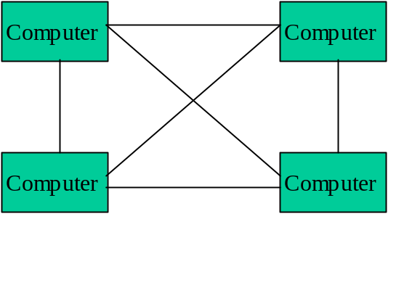
Figure 5.16: Fully-connected network
The advantage of this method is that all stations can communicate with each other. The disadvantage is the large number of connections required when the number of stations is greater than four. To overcome this disadvantage, a device called a switch is used to connect stations, as shown in Figure 5.17.
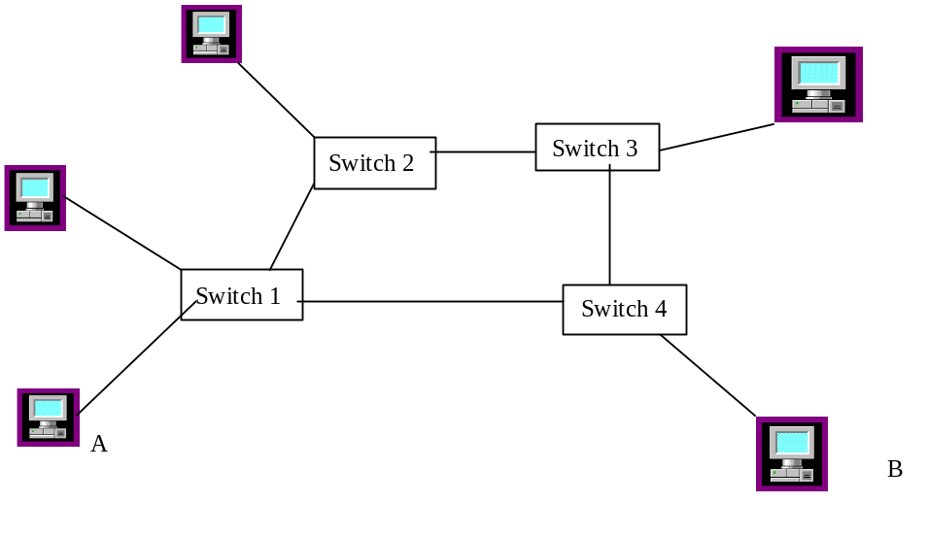

Figure 5.17: Stations are connected by switches

The following types of Switching are used in networking:

- Circuit Switching
- Message Switching
- Packet Switching

Circuit Switching

In Circuit Switching, also called a connection-oriented circuit, a physical connection must be established for the duration of the transmission, such as in a telephone system. The application of circuit switching is for real time communications. By dialing a telephone system, a connection is established, communication begins, and disconnection occurs at the end of the communication. Figure 5.18 shows circuit switching with multiple stations.
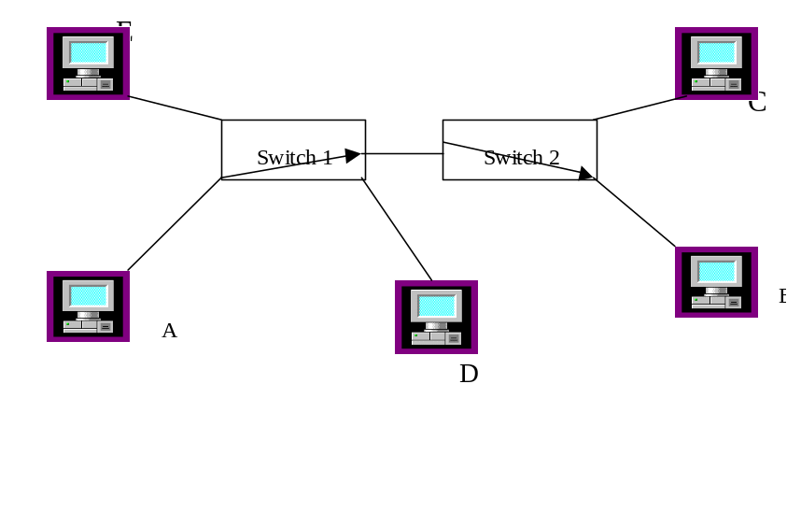

Figure 5.18: Circuit switching

Advantages of Circuit Switching: Circuit switching is used for real time communication. There is no delay or congestion in the communication link because a physical connection exits between the source and the destination.

Disadvantage of Circuit Switching: In circuit switching, only two stations can use the communication link at the same time therefore, it is not cost effective. For example, in Figure 5.18, if station A and B are communicating with each other, station D cannot communicate with station C. Station D must wait until A and B have finished their communication, then D may start communicating with C. In addition, if two stations such as A and B want to make a connection with C at the same time, a contention will occur and both station must wait.

Message Switching

In message switching, station A sends its message to the switch, the switch stores that message and then forwards it to the destination. The disadvantage of message switching is that the switch needs to have a large buffer to store incoming messages from other links.

Packet Switching

Figure 5.19 shows a network with several switches. Assume source A has a message and wants to transfer it to destination B. Source A divides the message into packets and sends each packet, possibly by a different route. This process is known as Packet Switching. Each packet goes to the switch, which stores the packet and looks at the routing table inside the switch to find the next switch or destination. Each packet may take a different route and be received at the destination out of order. To prevent mistakes in reassembling the packets, each packet is given a sequence number which will be used by the destination to put the packets back in order.
In figure 5.19 the source divides the message into 3 packets: A, B, and C. Then, the source transmits packet A to switch #1. Switch #1 stores packet A, looks at the congestion on all outgoing links, and finds that the link to switch #2 is the least congested. Switch #1 then sends packet A to switch #2. Switch #2 stores the packet and finds out from its routing table that packet A must go to Switch #4. Switch 2 then forwards the packet to switch# 4 and switch #4 forwards packet A to switch #5. Packet B and C take different routes, and as such, the packets might be received out of order. The destination uses the sequence numbers of the packets to put them in proper order. Packet switching is used to send information across the internet. This type of service is also called a connection-less oriented circuit.

Virtual Circuit

Virtual Circuits are a type of packet switching which operate on the same concept as packet switching, but the routing of the packets is specified before transmission. As seen in figure 5.19, the source specifies the route, which is represented by dotted lines. Therefore, all the packets from source A go via the dotted line. By using this method, all packets will be received at the destination in the proper order.

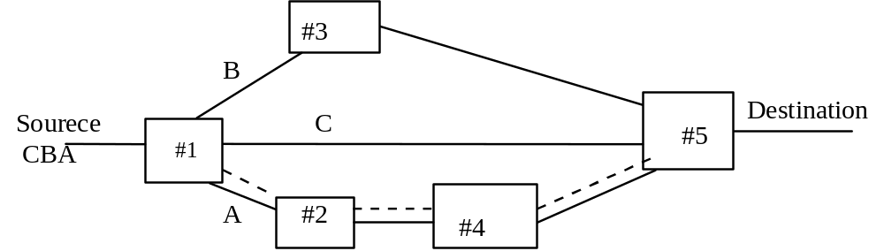

------ virtual connection

Figure 5.19: Packet switching and virtual circuit

Summary

- A multiplexer is used to share medium among several users.
- In Time Division multiplexing(TDM), the users are assigned equal time to use the digital channel.
- Frequency Division Multiplexing (FDM) is used for analog transmission, with the bandwidth of the analog channel divided into smaller channels
- In Statistical TDM the bandwidth is dynamically allocated to active users
- Code Division Multiplexing allows all user to transmit simultaneously
- Wavelength Division Multiplexing is used for transmitting multiple ray of lights with different wavelengths over one optical cable
- The Pulse Code Modulation (PCM) method is used in the central switch to convert human voice to digital signal.
- The bandwidth of human voice is 4000Hz and it is digitized at the rate of 64kbps.
- A T1 link is a special digital transmission line which has 24 inputs (each input 64kbps Voice channel) and one output, with a data rate of 1.544 Mbps
- There are three types of switching used in networking: Circuit Switching, Packet Switching and virtual circuit.
- A message is divided into pieces. Each piece is called a packet
- Packet Switching treats each packet of a message separately.
- In Circuit switching a physical connection must be established between the source and destination before transmitting information.
- A Virtual circuit is a type of packet switching. In a virtual circuit all packets of a message are transmitted in a specific path called a virtual path

Key Terms

Circuit Switching Packet Switching
Coarse Wave Division Multiplexing (CWDM) Pulse Code Modulation (PCM)
Code Division Multiplexing (CDM) Statistical Packet Multiplexing (SPM)
Codec T1 Link
Demultiplexer Time Division Multiplexing (TDM)
Dense Wave Division Multiplexing (DWDM) Transponder
Fast Packet Multiplexer (FPM) Virtual Circuit
Frequency Division Multiplexing (FDM) Wavelength Division Multiplexing (WDM)
Multiplexer

Review Questions
- Multiple Choice Questions

- Several devices can share one transmission line by using a ____________.
- multiplexer
- demultiplexer
- BUS
- CPU

- ___________ divides the bandwidth of a transmission line into channels.
- TMD
- FDM
- SPM
- FSPM

- Code division multiplexing allows the users to transmit _________

- In assigned time slot
- One at the time
- Simultaneously
- None of the above
- Wave division multiplexing is used for ________

- Optical signals
- Analog signals
- Digital Signals
- Radio frequency signals

- Function of an Optical Transponder is to _________

- Change Optical signals to electrical signals
- Change the power of an optical signal
- Change the wavelength of an optical signal
- Change electrical signal to optical

- ____________ dynamically allocates bandwidth to active inputs.
- TDM and FDM
- SPM and FPM
- FPM and TDM
- FDM and SPM

- What is channel bandwidth of telephone system for human voice ?
- 4000Hz
- 400Hz
- 40Hz
- 4Hz

- One of the applications of TDM is __________ link.
- DSL
- T1
- cable modem
- LAN

9. Virtual circuit is a type of ______
a. Circuit switching
b. Packet switching
c. a&b
d. Message Switching

10. Pulse Code Modulation is used to convert
a. digital to analog
- analog to digital
- digital to digital
- analog to analog

11. Which of the following switching methods does deliver packets in order?
- packet switching
- virtual circuits
- circuit switching
- b&c

12. The bandwidth of a telephone system is

- 3Khz
- 4KHz
- 8Khz
- 40Khz

Review Questions

1. Show an 8-to-1 MUX and 1-to-8 DMUX.
- List the types of Multiplexers.
- Explain TDM operation.
- Describe Statistical Packet Multiplexer.
- What is difference between CDM and TDM
- What is an application of WDM?
- What are types of WDM?
- What is the function of an optical transponder?
- What is the type of signal used between two central switches of a telephone system?
- What is the function of a Codec?
- What does PCM stand for and what is its application?
- Why must the human voice be sampled at the rate of 8000 samples per second?
- How many voice channels does a T1 Link carry?
14. What type of Multiplexer is used in T1 link?
15. What is the data rate of human voice and why?
- What is the data rate of a T1 link?
17. What is difference between DS-1 and a T1 link?
- What is the data rate of a T3 link?
- How many voice channels can be carried by T3 Link?
20. Explain the following switching operations

a. Circuit Switching
b. Message Switching
c. Packet Switching
d. Virtual Circuit

- Show the frame format of T1 link
- Why data rate of T1 link is 1.54 Mbps?

- The following inputs are connected to a 4*1 Statistical Multiplexer, show the outputs of Multiplexer

Input #1 A-A-A
Input #2 BBB-B
Input #3 - CC- -
Input #4 DD-D

24. What is the sampling rate of a signal with the highest frequency of 1000Hz?

25. Using chip sequence on table 3 to find data transmitted for Node C at the receiver side assume the nodes A, B, and C transmit following Data.

Node A | 111
Node B | 010
Node C | 001

