Chapter 7

Modem, DSL, Cable Modem, and FTTH

Outline

7.1 Modem
7.2 Digital Subscriber Line (DSL)
7.3 Cable Modem
7.4 Integrated Services Digital Network (ISDN)

Objectives After completing this chapter, you should be able to:

• Discuss modem operation and the methods of signal modulation
• Explain the operation of a 56K modem
• Understand the technology of Digital Subscriber Line (DSL) and xDSL
• Explain cable modem technology
- Have a clear understanding of modem technology

Introduction

In order for two computers to communicate with each other, a link between them is required. If these computers are some distance from each other, it is not cost effective to use a cable and link them together. A cheaper alternative is to use a telephone or cable TV line to provide the link. The device that enables users to establish a link between computer using a telephone line is called a modem. The types of modems that use telephone lines are dial up modems , the Integrated Services Digital Network (ISDN modem), and Digital Subscriber Line (DSL modem).
Currently, about 63 million households have cable T.V services , the same wire that brings T.V signals to your house is a cable that can also provide Internet access with speed of 100 times faster than a dial up modem. The device that enables computers to access the Internet by cable TV lines is called a cable modem.

7.1 Modem

To link computers for communication over traditional telephone wires, a modem must be used, as shown in Figure 7.1. A traditional telephone network operates with analog signals, whereas computers work with digital signals. Therefore a device is required to convert the computer’s digital signal to an analog signal compatible with the phone line (modulation). This device must also convert the incoming analog signal from phone line to digital (demodulation). Such a device is called a modem; its name derived from this process of modulation/demodulation.
A modem also is known as Data Communication Equipment (DCE), which is used to connect computer or data terminal to a network. Logically , a PC or data terminal also is called Data Terminal Equipment (DTE).
There are three types of modems. An internal modem is an expansion card that plugs into an ISA or PCI Bus inside the computer. It connects to a phone line by RJ-11 connector. There is also an external modem available. Its circuitry is housed is in a separate casing and it typically uses a DB9 connector to attach to one of the computer’s serial ports. The third type is used in Laptop and notebook computers and consists of a PCMCIA card that houses the entire circuitry for the modem.

A modem’s transmission speed can be represented by either a data rate or baud rate. The data rate is the number of bits which a modem can transmit in one second. The baud rate is the number of signals which a modem can transmit in one second.

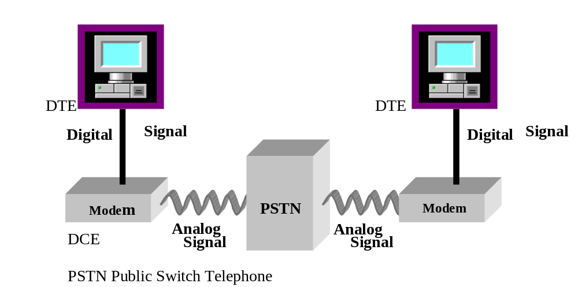

Figure 7.1 Connection of two computers using a modem

Modulation Methods

The carrier signal on a telephone line has a bandwidth of 4000 Hz. Figure 7.2 shows one cycle of a telephone carrier signal. The following types of modulation are used to convert digital signals to analog signals:
- Amplitude Shift Keying (ASK)
- Frequency Shift Keying (FSK)
- Phase Shift Keying (PSK)
- Quadrature Amplitude Modulation ( QAM)

Voltage

180
270
0 90
360

Degree

Figure 7.2: Telephone carrier signal

Amplitude Shift Keying (ASK) In Amplitude Shift Keying (ASK), the amplitude of the signal changes. This also referred to as Amplitude Modulation (AM).The receiver recognizes these modulation changes as voltage changes, as shown in Figure 7.3. The smaller amplitude is represented by zero and the larger amplitude is represented by one. Each cycle is represented by one bit, with the maximum bits per second determined by the speed of the carrier signal . In this case, the baud rate is equal to the number of bits per second.
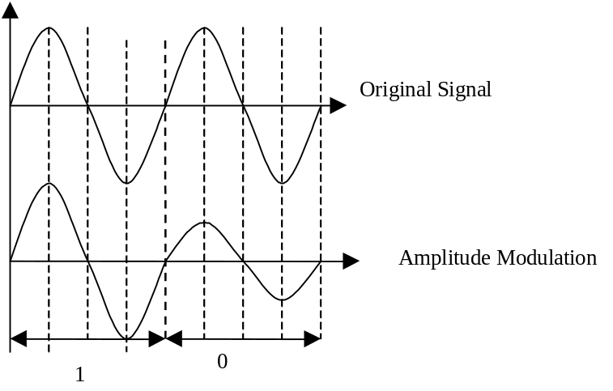

Figure 7.3 Amplitude shift keying (ASK).

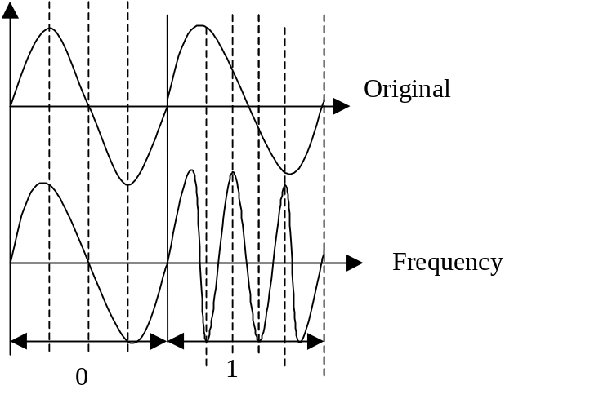 Frequency Shift Keying With Frequency Shift Keying ( FSK) , a zero is represented by no change to the frequency of the original signal, while a one is represented by a change to the frequency of original signal. This is shown in Figure 7.4. Frequency modulation is a term used in place of FSK.

Figure 7.4: Frequency shift keying (FSK)

Phase Shift Keying (PSK) Using the Phase Shift Keying (PSK) modulation method, the phase of the signal is changed to represent ones and zeros. Figure 7.5 shows a 90-degree phase shift. Figure 7.6 (a), (b), and (c) show the original signals with a 90-degree shift, a 180-degree shift and a 270- degree shift, respectively. In Figure 7.9 , note that the original signal can be represented with four different signals: no shift, 90º shift, 180º shift and 270º shift. Therefore, each signal can represent by a two-bit binary number, as shown in Table 7.1

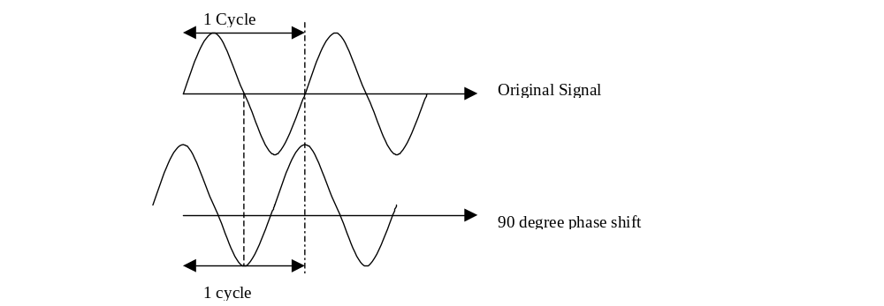

Figure 7.5 90 degree phase shift

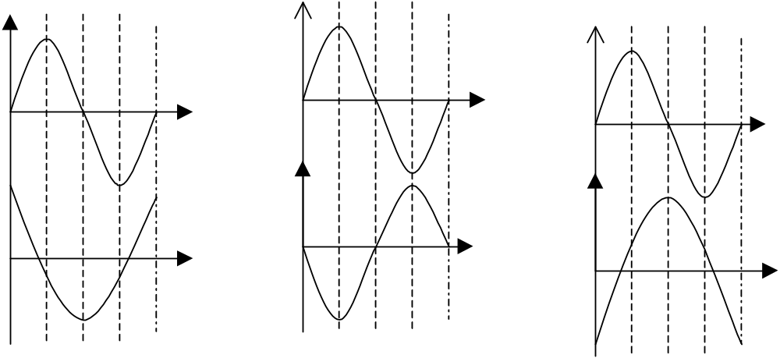

a. 90 degree shift b. 180 degree shift c. 270 degree shift

Figure 7.6 Phase shift for 90, 180 and 270 degrees

The modem’s speed using a 90-degree phase shift is 2*4000, which is equal to 8Kbps. To increase the speed of the modem, the original signal can be shifted 45-degrees to generate eight distinct signals. Each signal can represented by three bits. Therefore, the speed of the modem is increased to 3*4000, which is equal to 12Kbps.
The relation between phase and the binary representation of each phase can plotted on a coordinate system called a constellation diagram. Figure 7.7 is a constellation diagram showing the four distinct signals of a 90-degree shift, with each signal represented by two bits. Figure 7.8 shows constellation diagram using 45- degree shift and 3-bit representation (8-PSK).

Table 7.1 Phase shift and Binary Value

Phase Shift | Binary value
No Shift | 00
90º | 01
180º | 10
270º | 11

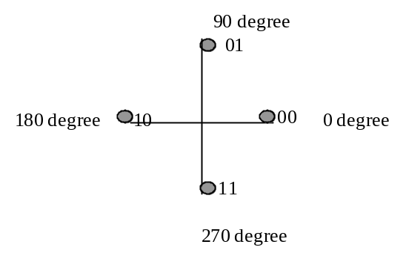

Figure 7.7: Constellation diagram for table 7.1

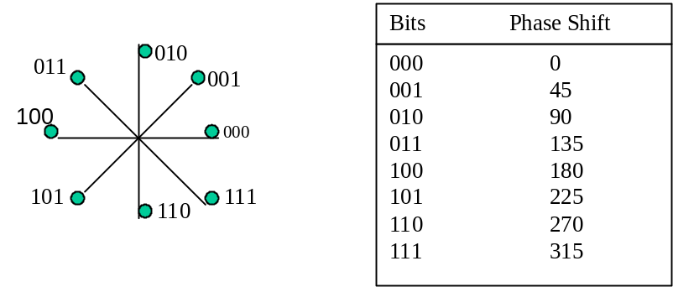

Figure 7.8 Constellation diagram for 8-PSK

Quadrature Amplitude Modulation (QAM) One method to increase the transmission speed of a modem is to combine PSK and ASK modulation. This hybrid modulation technique is called Quadrature Amplitude Modulation (QAM) and is shown in Figure 7.9. Here we see the combination of four phases and two amplitudes which generates eight different signals called 8-QAM. Table 7.2 shows the binary value of each signal and provides a constellation diagram for 8-QAM. The data rate of this modem is 3 bits*4K= 12K bps.

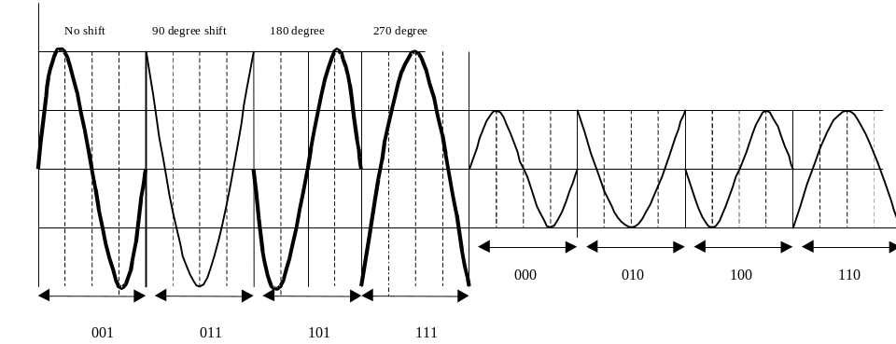

Figure 7.9 8-QAM Modulation
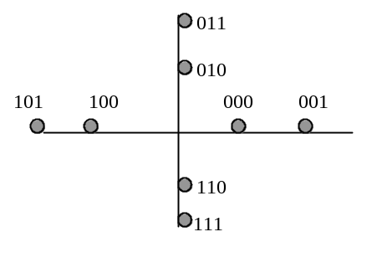

Figure 7.10 Constellation diagram for 8-QAM

Table 7.2 Binary Value for 8QAM

Shift | Amplitude | Binary Value
No | A1 | 000
No | A2 | 001
90º | A1 | 010
90º | A2 | 011
180º | A1 | 100
180º | A2 | 101
270º | A1 | 110
270º | A2 | 111

Modem Standards

The International Telecommunication Union (ITU) is responsible for developing standards for modems. Currently, most modem manufacturers produce modems with a transmission speed of up to 56kbps. Following are some modem standards and their respective speeds.

Name Speed
V.90 or X2 56kbps receiving
33.6 kbps transmitting
V.36 48kbps
V.34 28.8 kbps
V.33 14.4kbps
V.32 14.4 kbps
V.26 bis* 1200, 2400 bps
V.22bis* 1200

*bis means the modem has a switch and works with two different data rates.

V.90 ( 56 Kbps) Modem

The maximum theoretical data rate for a modem, as set by the ITU, is 33.6 kbps. Several manufacturers have, however, developed 56kbps modems. The 56k modem was designed for one-end digital connection from the server to the Public Switch Telephone Network (PSTN); the subscriber side (the line that connects to the actual modem) remains analog. Figure 7.11 shows an application of a 56k modem in which the server is connected to the PSTN without any modem and transmits information as a digital signal to the PSTN. At the central switch, digital information is converted to an analog signal and transmitted to the subscriber side. Only one side uses the modem, which will reduce the signal/noise ratio caused by conversion, and allows the server to transmit data at a rate of 56kbps. At the user side the information is converted from digital to analog and transmitted to the central switch. These conversions produce noise and reduce the speed of the modem to 33.6kbps.

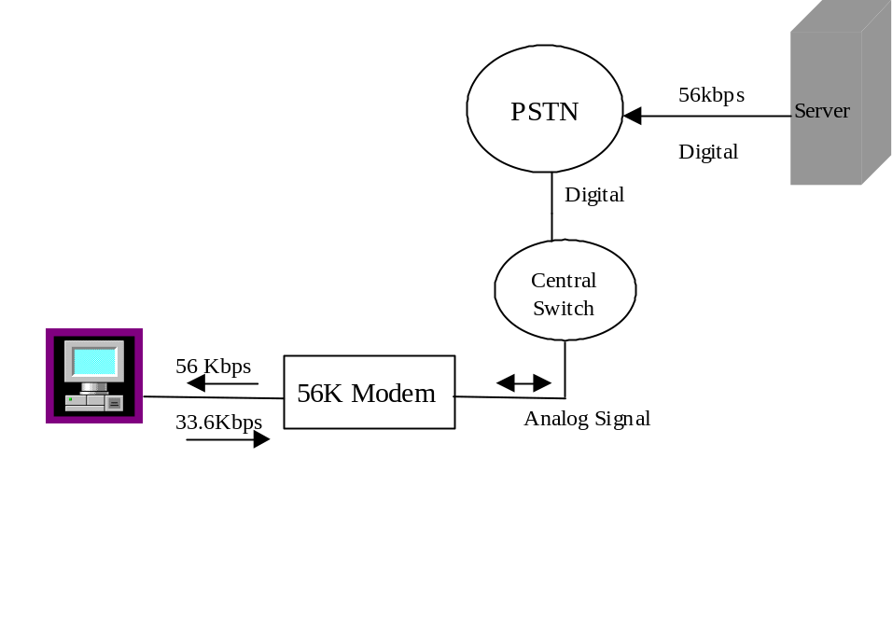

Figure 7.11 56K modem connection

7.2. Digital Subscriber Line

The Digital Subscriber Line (DSL) is the latest modem technology, using twisted pair wires to deliver data and voice at speeds ranging from 64kbps to 50 Mbps. DSL uses current telephone wire (UTP) to transfer information at higher data rates than a modem. Currently, a modem transfers data at 56kbps, and networking technology transfers data at the rate of 10 to 1000 Mbps. Therefore, modems are becoming far too slow for transferring information across the Internet. DSL uses standard phone twisted-pair cable to transfer analog signals with Plain Old Telephone Service (POTS) and digital signals for data. DSL is implemented using several different technologies called xDSL.

Asymmetrical DSL: ADSL supports voice and data simultaneously. The data rate from service provider to the user is 6 Mbps and is 786kbps from the user to the service provider (telephone switch).

High bit rate DSL: HDSL supports data or voice, but not simultaneously, with a data rate of 768kbps.

Symmetrical DSL: SDSL supports voice and data simultaneously, with a data rate of 768kbps in both directions.

Very high speed DSL: VDSL provides 25 to 50 Mbps to the user (down stream), and 1.5 to 3 Mbps from the user to the service provider (upstream)

Asymmetrical Digital Subscriber Line

Asymmetrical Digital Subscriber Line (ADSL) is a new modem, which uses an existing twisted-pair telephone line to access the Internet for transferring information such as multimedia. ADSL transfers data at a higher rate downstream (from the telephone company switch) to the subscriber than upstream (from subscriber to telephone company switch). The upstream and downstream data rate is a factor of the distance between the telephone company switch and the subscriber. The downstream data rate is between 1.5 to 8Mbps and upstream data rate is between 16kbps to 640kbps, as shown in Figure 7.12. The advantage of ASDL is that it uses the present twisted-pair wire of telephone lines to transmit data in the range of 6 to 8 Mbps. It is important to note that ADSL does not affect the current telephone voice channel.

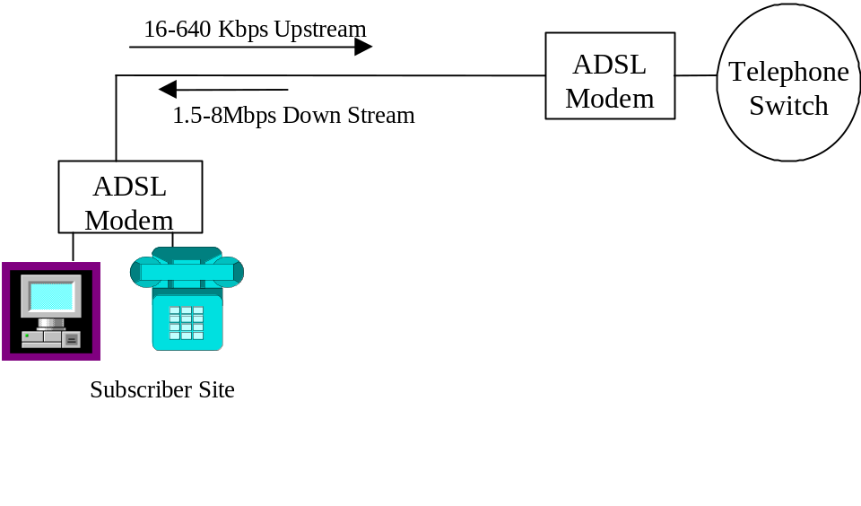
Figure 7.12 ADSL modem connection

ADSL Modem Technology

ADSL uses Discrete Multi-Tone (DMT) encoding methods which use FDM to divide the bandwidth of the channel into multiple subchannels, with each channel transmitting information using QAM modulation. The twisted- pair cable used in telephone wire has a frequency spectrum of 1.1 MHz. Figure 7.13 shows the frequency spectrum of ADSL. DMT uses the frequency spectrum from 26kHz and 1.1 MHz for broadband data. For POTS it uses the frequency spectrum from 0 to 4 kHz. The frequency spectrum from 26kHz to 138Khz is used for upstream transmission , and the frequency spectrum from 138 kHz to 1.1 MHz is used for downstream transmission, as shown in Figure 7.13. The frequency spectrum above 26 kHz is divided into 249 independent subchannels, each containing 4.3 kHz bandwidth. Each sub-frequency is an independent channel and has its own stream of signals. The lower 4kHz channel is separated by an analog circuit and used in POTS; 25 channels are used for upstream transmissions, and 224 channels are used for downstream transmissions. Figure 7.14 shows the ADSL modem Architecture. The function of the POTS filter is to separate the voice channel from data channel.

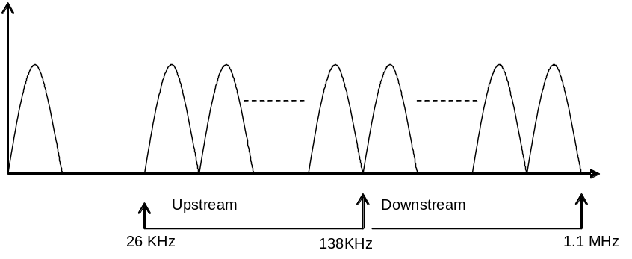

Figure 7.13: Frequency spectrum of ADSL

Each subchannel can modulate from 0 to 15 bits per signal. This allows up to
60 kbps per channel (15*4kHz ). Therefore, the data rate is calculated by:
Data Rate = number of channels * Number of bits/channel * frequency of channel
Using the above equation, the upstream and downstream data rate can be computed as follows:
Maximum Upstream Data Rate = 25 * 15 * 4.3khz= 1.6 Mbps
and Maximum Downstream Data Rate = 224 * 15 * 4.3khz= 14.4 Mbps

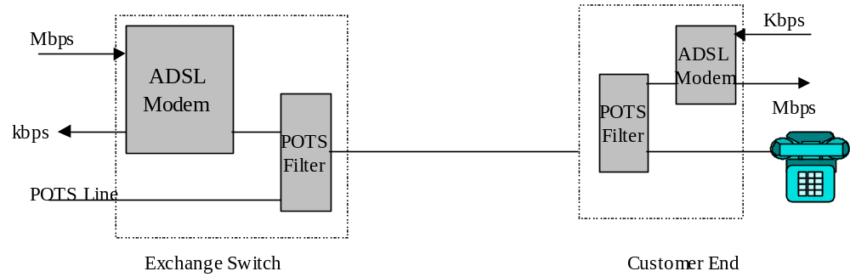
Figure 7.14: ADSL modem architecture

The data rate of an ADSL modem is a factor of the distance between the subscriber and the telephone switch. Table 7.3 shows the data rate vs. distance for ADSL modem.

Table 7.3 Data rate of ADSL Modem verses Distance

Data Rate | Wire Gage | Distance
1.5-2 Mbps | 24 AWG | 5.5 Km or 18000 ft
1.5-2 Mbps | 26 AWG | 4.6 Km or 15000 ft
6.1 Mbps | 24 AWG | 3.7 Km or 12000 ft
6.1 Mbps | 26 AWG | 2.7 Km or 9000 ft

Rate Adaptive Asymmetric DSL

Rate Adaptive Asymmetric DSL ( RADSL) offers downstream transmission of 7.0 Mbps and upstream transmission of 1.0 Mbps. The rate of RADSL is dynamically adapted by the condition of the line.
Before transmitting information, RADSL makes an initial test to check the condition of the channels. Some of the channels may not be used due to the presence of strong noise. Table 7.4 shows xDSL and cable distance.

Table 7.4 xDSL and Cable Distance

Technology | Cable Distance  In Feet | Data Rate  Downstream/upstream
ADSL | 3000 | 9 Mbps/ 1 Mbps
ADSL | 5000 | 8.448 Mbps/ 1Mbps
ADSL | 9000 | 7 Mbps/ 1Mbps
ADSL | 12000 | 6.312 Mbp/ 640Kbps
ADSL | 18000 | 1.544 Mbps/16-64Kbps
HDSL | 5000 | 1.544 Mbps/1.544 Mbps
HDSL | 12000 | 1.544 Mbps/1.544Mbps
RADSL | 3000 | 12Mbps/1Mbps
RADSL | 9000 | 7 Mbps/ 1Mbps
RADSL | 12000 | 6 Mbps/ 1Mbps
RADSL | 18000 | 1 Mbps/ 128 Kbps
UDSL | 0-15000 | 2 Mbps/ 2Mbps
UDSL | 15000-18000 | 1 Mbps/ 1Mbps
VDSL | 1000 | 51.84 Mbps/ 2.3 Mbps
VDSL | 3000 | 25.82 Mbps / 2.3 Mbps
VDSL | 4000 | 12.98 Mbps/ 1.6 Mbps

Source Data communication Magazine April 1998

7.3 Cable Modem

The Cable Modem is another technology used for remote connection to the Internet. Residential access to the Internet is growing, and current Modem technology can transfer data only at 56kbps. Local telephone companies also offer a service known as Basic Rate ISDN, which has a transmission rate of 128kbps. The cable modem offers high- speed access to the Internet using a media other than phone lines.

Cable TV System Architecture

Cable TV is designed to transmit broadband TV signals to homes using coaxial and fiber optic cable. Figure 7.15 shows the full coaxial cable TV system architecture. As shown in this diagram, cable TV uses Tree and Branch Bus Topology . The tree and branch cable is constructed of 75 ohms coaxial cable connected to the trunk cable.
The head end transmits TV signals over a trunk cable to a group of subscribers. The medium can be either coaxial or fiber optic cable. The function of a coaxial amplifier is to amplify the signal, and it works in either direction. Feeder and drop cables are both coaxial cables. The drop cable is the part of a cable system that connects the subscriber to the feeder cable. Feeder cables are connected to trunk cable to cover a large area. The maximum distance between head end and subscriber is 10 to 15 km. The maximum number of cascaded amplifiers is 35 and the maximum number of connections are 125,000.
A TV signal transmitting two of frequency bands : VHF (Very- High Frequency) and UHF (Ultra-High Frequency). The VHF channels use lower frequencies to generate stronger signals needed to transmit longer distances. The VHF channels start at channel 2 with frequency of 54 MHz and end at channel 13 with frequency of 216MH.. The VHF channels use the frequency range of 54 MHz up to 216 MHz. UHF channels start at channel 14, with a frequency of 470 MHz and end at channel 83 with frequency of 890 MHZ. Each TV channel occupies 6 MHz of the TV radio frequency (RF) spectrum.

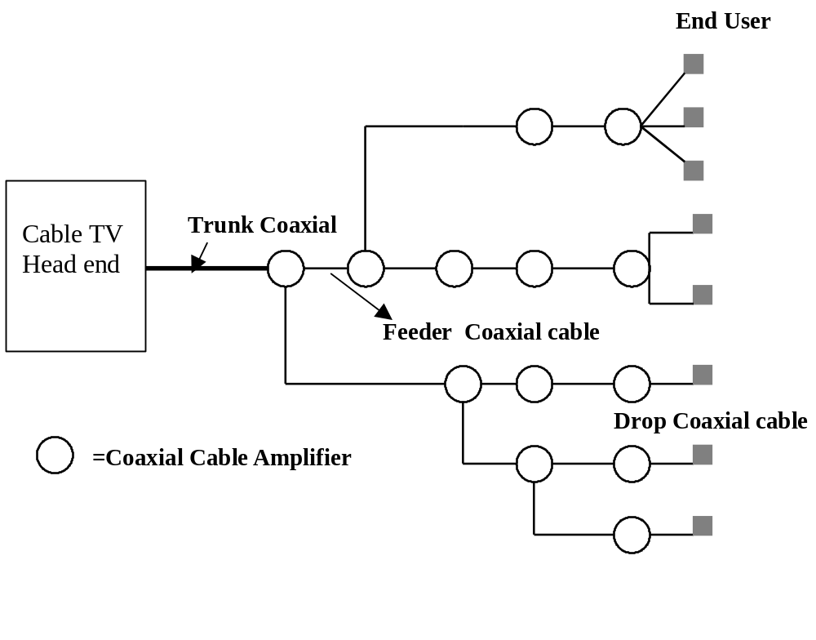

Figure 7.15 Full coaxial cable TV system architecture

The Bandwidth of Coaxial cable is 500 MHz, with each TV channel requiring 6MHz of bandwidth. The number of TV channels that can be transmitted is (500-54)/6 = 75 channels. In order to increase the bandwidth of cable TV, cable TV Corporations use Hybrid Fiber Cable (HFC), which is combination of fiber-optic cable and coaxial cable, as shown in Figure 7.16. The bandwidth of a cable TV system using HFC cable is 750 MHz to 1GHz. Therefore the number of channels computed by (750-54/6 =110 channels. The TV signal is transmitted to a fiber node using optical cable. The fiber node converts the optical signal to electrical signal , and also converts electrical to optical. The coaxial amplifiers are two-way devices used to amplify the incoming signal. The maximum distance from head end to end user is 80 km and the maximum number of end user per fiber node connection is between 500 to 3000 (depending on the vendor). A channel between 5MHz to 42MHz is used to carry upstream signals (from subscriber to the head end)

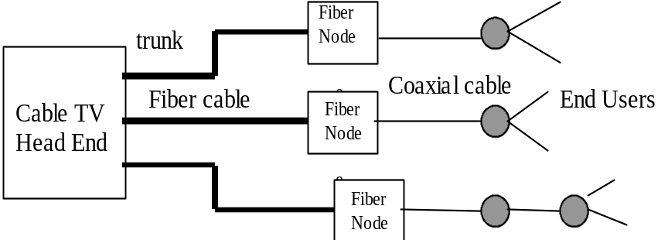

Figure 7.16. HFC cable TV architecture

Cable Modem Technology

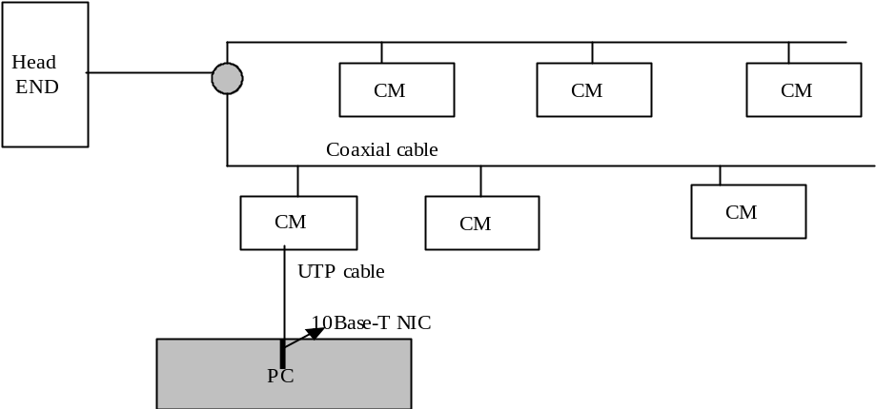 Figure 7.17 shows the components of a cable network consisting of a coaxial cable, head end, and a cable modem. The connection between cable modem and user is 10Base-T. The user requires a 10Base-T NIC card to be able to use the cable modem. A cable modem can support more than one station using a router, as shown in Figure 7.18

Figure 7.17 Block diagram of a cable network

A cable modem uses 64-QAM or 256-QAM modulation techniques to transmit information from the head end to the cable modem (down stream transmission). If a cable modem uses 256-QAM, this means 8 bits per signal and each signal is transmitted at 6 MHz. Theoretically the data rate of a cable modem is:

8 * 6Mhz = 48 Mbps

By using 64 QAM modulation, the data rate becomes;

6*6Mhz = 36 Mbps

Upstream transmission (from cable modem to head end) uses a 600kHz channel between 5 to 42 MHz. This low frequency is close to the CB radio frequency. The Quadrature Phase Shift Keying (QPSK) modulation method is used.. The data rate of the cable modem for up stream transmission becomes:

2*600khz = 1200 kbps.

Downstream and upstream bandwidth are shared by 500 to 5000 cable modem subscribers . If 100 subscribers are sharing a 36 Mbps connection each user will receive a data at rate of 360Kbps. A cable modem provides a constant connection (like a LAN); it does not require any dialing. The cable modem head end communicates with the cable modem, and when the cable modem is commanded by cable modem head end, the modem will select an alternate channel for upstream transmission.
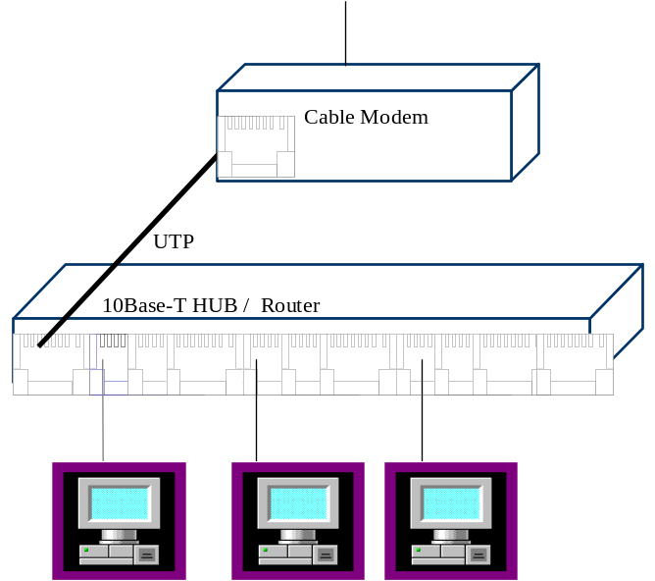

Figure 7.18 Connection of more than one station to a cable modem

IEEE 802.14

A cable modem operates at the physical and data link layers of the OSI model. The IEEE 802.14 standard provides a network logical reference model for the media access control (MAC) and physical layer. The following are general requirements defined for cable modem by IEEE802.14 :

- Cable modems must support symmetrical and asymmetrical transmission in both directions
- Support of Operation, Administration and Maintenance (OAM) functions
- Support the maximum 80 km distance for transmission from head end to the user
- Support a large number of users
- MAC layer should support multiple types of service, such as data, voice, and images
- MAC layer must support unicast, multicast, and broadcast service
- MAC layer should support fair arbitration for accessing the network

7.4 The Integrated Services Digital Network

The Integrated Services Digital Network ( ISDN) is a set of digital transmission standards which are used for end-to-end digital connectivity. ISDN supports voice and data. The integration of different services has become an ISDN hallmark. In the past, video, audio, voice and data services required at least four separate networks. ISDN integrates voice, data, video and audio over the same network. ISDN uses a digital signal which is less vulnerable to noise compared to the analog signal used by a modem.
ISDN brings the digital network to users. There are two types of ISDN: Narrowband ISDN (N-ISDN) and Broadband ISDN (B-ISDN).
The International Telecommunications Union (ITU), formerly known as CCITT, has defined standards for ISDN that provide end-to-end digital connection to support a wide range of services including voice and non-voice transmission. ISDN offers digital transmission over existing telephone wiring as provided by telephone companies. ISDN offers the Basic Rate Interface (BRI) and Primary Rate Interface (PRI).

7.4.1 Basic Rate Interface (BRI)

The Basic Rate Interface is made of two B-channels (bearer) and one D-channel. Therefore, the total rate is 2B+D. B-channels are 64Kbps and can be used for voice and data communications. The D-channel is 16Kbps and is used for call initialization and signalling connection. Figure 7.19 shows ISDN Basic Rate Interface (BRI).

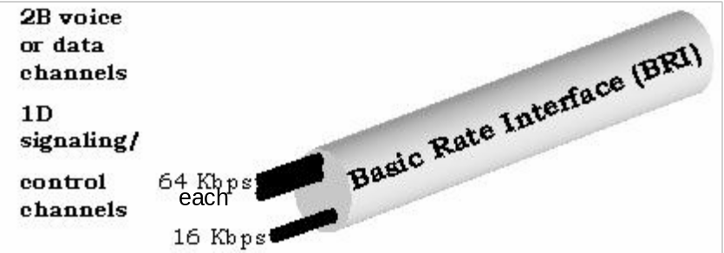

Figure 7.19. ISDN Basic Rate Interface

Application of thr Basic Rate Interface (BRI)

ISDN can carry multiple services; voice, video and data on a single telephone line over existing twisted pair copper wire. ISDN's BRI uses two 64Kbps B-channels and one 16 Kbps D channel. By combining two B-channels, the total data transmission rate is 128Kbps. Figure 7.20 shows an application of BRI in ISDN.
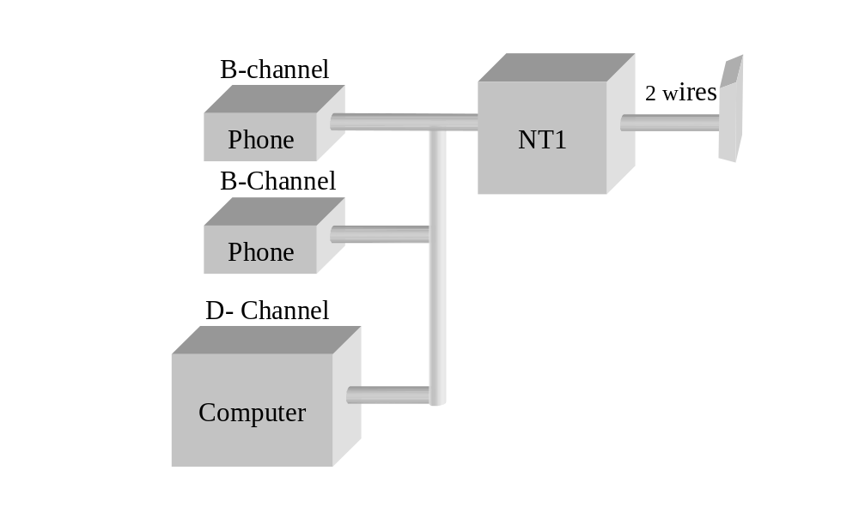A Network Terminator1 ( NT1 ) and a power supply are required for every ISDN line. The NT1 is a device that is physically connected to the ISDN line. A special terminal adapter can combine the two B-channels to be used as a 128Kbps channel and then be connected to the computer.

Figure 7.20: Application of Basic rate interface

The NT1 Device works as multiplexer and demultiplexer . Figure 7.21 shows the frame format of ISDN Basic Rate Interface. The size of a frame is 48 bits.
Frame size = 4*8 + 4 + 12 bits overhead .

8 bits 1bit 8 bits 1bit 8 bits 1bit 8 bits 1bit
B1 | D | B2 | D | B1 | D | B2 | D

Figure7.21. ISDN BRI Frame Format

7.4.2 Primary Rate Interface (PRI)

The Primary Rate Interface (PRI) in the North America has 23 B-channels and one 64K D-channel or 23 B + D. 23B + D channels have a total bandwidth of 1.544Mbps and are designed to replace T1 links. PRI in Europe uses 30 B-channels and one D-channel or 30B+D with total rate of 2.048 Mbps as shown in figure 7.22.

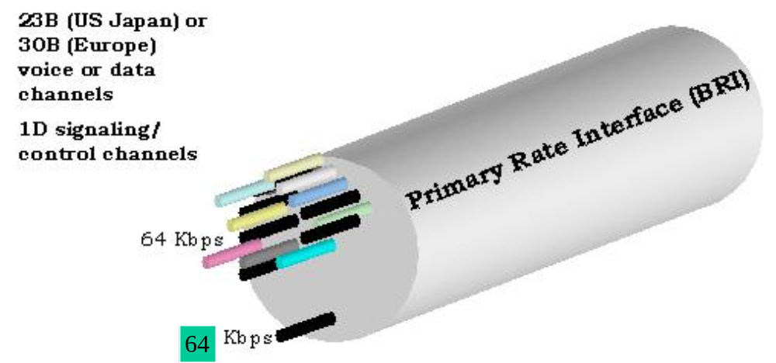
Figure 7.22: ISDN Primary Rate Interface

Application of Primary Rate Interface (PRI)

An application of PRI is to connect two central switches together or use it as a T1 link, as shown in figure 7.23.The devices which handle switching and multiplexing (such as PBX) are called Network Terminator type 2 (NT2 ) . ISDN Primary Rate Interface (PRI) can connect the customer directly through an NT2 device while ISDN BRI requires NT1 device.
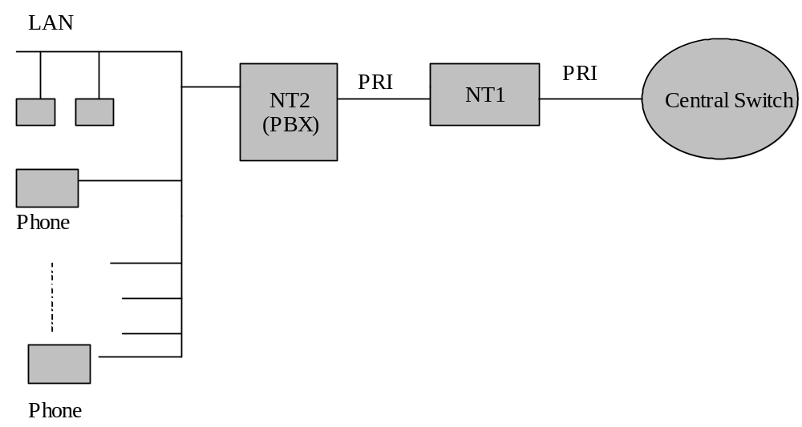

Figure 7.23: ISDN PRI application

Four types of modem technology have been presented: dial up modem, DSL, cable modem and ISDN modem . There are some features of each which you need to remember.

The maximum data rate for dial up modem is 56 kbps. The maximum data rate for an ISDN modem is 128 kbps, and the cable modem data rate is variable and depends on how many users are accessing the link at the same time. Also a cable modem link is shared with others users, making security and privacy an issue to take into account.

The xDSL modem is the latest technology , this modem uses the telephone line and can transmit data at higher rate than an ISDN modem, or dial-up modem. One of the biggest advantage of the xDSL modem over cable modem is security and privacy. The XDSL modem is more cost effective , since it can replace the expensive T1 link. Because it is cost effective , it can be used for connecting libraries and school to Internet. The CATV coaxial cable can carry a much higher bandwidth than POST and UTP

FTTH (Fiber to The Home)
FTTC Fiber to the curb
FTTN Fiber to the node
FTTH Fiber to the home
FTTP fiber to premises
The demand of Digital TV such IPTV and HDTV in the houses are growing fast, most Service providers offers bundle services that include HDTV, Phone and Internet. How much bandwidth is needed to able support Standard Digital TV , HDTV and , Phone and Internet at a home
Standard Digital TV (SDTV) display an image at the rate of 24 f/s (frames per second) and this rate is variable based on the country , in European country this rate is 25 f/s and north America is 30 f/s. The SDTV frame is made of 650* 480 pixels, to display a pixel requires two bytes, therefore the total bytes for display a frame is
30 frame/second * 650 * 450* 16 bits =140.4 Mbps
HDTV ( high definition TV ) frame made of 1920* 1080 pixels and uses 3 bytes for displaying a pixel in color , therefore the required bandwidth for HDTV is

30 f/s * 1920*1080 pixels * 24 = 1493 Mbps
The Central Head End (CO) compress each frame before transmission, the most popular compression algorithms are MPEG-2 with typical compression ratio of 50/1 and MPEG-4 with compression ratio of 100 /1
SDTV uses MPEG- 2 then the bandwidth requirement is 140.5 / 50 = 3 Mpbs
HDTV uses MPEG-4 then the bandwidth requirement for HDTV is 15 Mbps
Internet user require 2 Mbps
The bandwidth requirement for a house with two HDTVs, One SDTV , 4 internet users and Phone is
2*15 + 3 + 4*2 = 41 Mbps
The bandwidth retirement of VOP is 100kpbs that is negligible

In order service provider to provide 41bps bandwidth then FTHH technology must be used

FTTH Architecture
FTTH uses 100% fiber to the home and can be point to point (P2P) Architecture (sometimes is called All Optical Ethernet Network (AOEN)) and Passive Optical Network. Figure 1 show P2P Optical
network, where Central Office ( CO) has direct connections to each house by fiber cable.

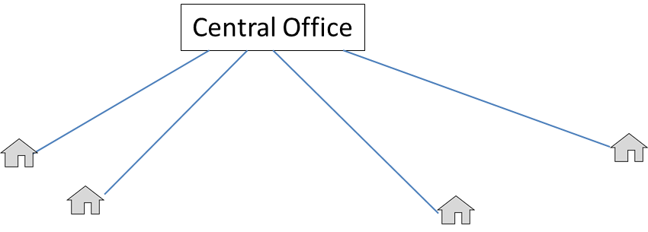

Passive Optical Networks:
Passive optical network (PON) uses single fiber from central office then it spitted by passive optical splitter as shown in figure 2. The function of splitter is to broadcast incoming ray to the outputs of Splitter. the maximum length of feeder cable is 30000 feet (9000 meters) , the splitter is a passive splitter means does not require any power, the maximum length of fiber cable from splitter to the home 3000 feet ( 900 meters). The splitter input to outputs ratio can be 1/2, 1/4, 1/8, 1/16 and 1/32
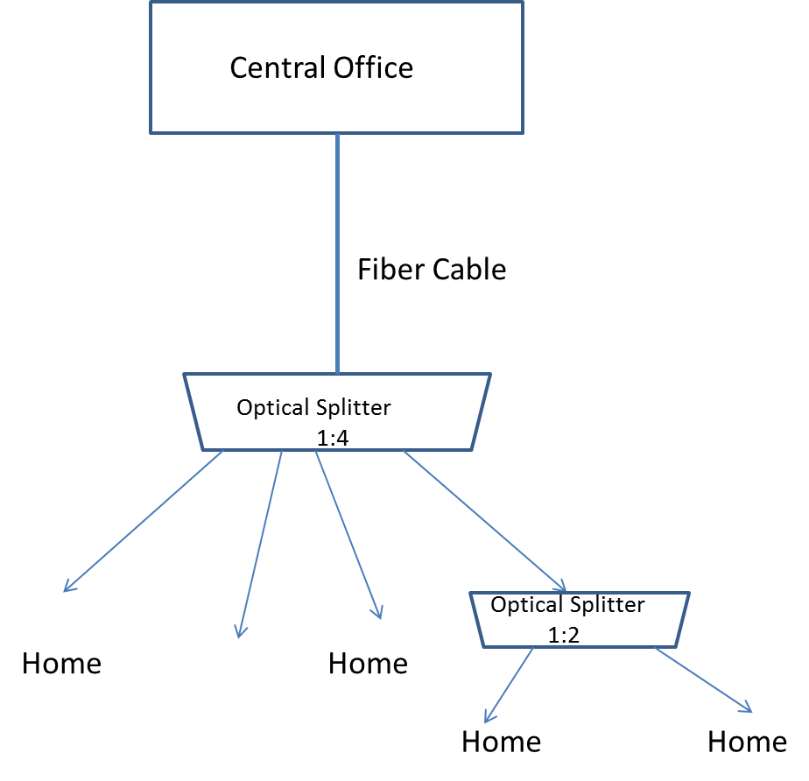

The splitter will reduce power of the signal and it is function of number of the outputs, the loss of the signal is represented by decibel and following Equation can be used to determine the loss of signal
Loss = 3db * N/2 where N is number of outputs of the splitter

Most FFTH offers triple services such as Voice, Video and Internet. The signals transmitted upstream and downstream by using different wavelength. There are three technologies that developed by standard bodies for FTHH and they are:
B-PON: Broadband Passive Optical Network
E-PON: Ethernet Passive optical Network
G-PON: Gigabit Passive Optical Network

Table 1 shows standards for FTTH

Technology | B-PON | G-PON | E-PON
Standard Body | ITU G.983 | ITU G.984 | IEEE902.3ah
Data Rate | 155.52 Mbps upstream  155.52 or 622.08 Downstream | 2.44 Gbps Upstream and Down Stream | 1 Gbps Upstream and Down stream
Distance from OLT to ONU | 20Km | 10 to 20Km | 10 and 20km
Data format | ATM | ARM | Ethernet
Foreword Error Correction | Reed–Solomon error correction | Reed–Solomon error correction | None
Encryption | AES-128 | AES-128 | none

Summary

The function of a Modem is to convert analog signal to digital and digital signal to analog
- Modulation is used to convert a digital signal to analog
- Modulation Methods are: Amplitude Shift Keying (ASK) , Frequency Shift Keying, (FSK), Phase Shift Keying (PSK) and Quadrature Amplitude Modulation (QAM)
- Amplitude Shift Keying (ASK) changes the amplitude of carrier signals in order to represent a digital signal.
- Frequency Shift Keying (FSK) changes the frequency of carrier signals in order to represent a digital signal.
- Phase Shift Keying (PSK) changes the phase of carrier signal
- QAM modulation is a combination of ASK and PSK, used in high-speed modems.
- Baud rate is the number of signals per second that a modem can transmit.
- Data rate is the number of bits per second that a modem can transmit.
- Digital Subscriber Line (DSL) is a type of modem that can transfer data at higher speed than modem.
- DSL technology divides the bandwidth of UTP cable into 250 channels. The bandwidth of each channel is 4kHz. The first channel is used for telephone, and other channels are used for transmitting information.
- Types of DSL are: ADSL, SDSL, HDSL, and VDSL
- ADSL can transfer data downstream at rates of 1.5 to 8 Mbps
- ADSL can transfer data upstream at rates of 16 to 640Kbps.
- Cable Modems use a cable TV network to connect residential computers to the Internet.
- The Head end of a Cable TV system uses TV channels to transmit information to a cable Modem at the subscriber site.
- Each cable TV channel requires 6 MHz bandwidth.
- Connecting a computer to a cable modem requires 10Base-T network card.
- More than one station can be connected to a cable modem by using a hub or repeater.
- Cable modem operates in layer1, layer2 and layer3 of the OSI model
- IEEE 802.14 has developed the standard for cable modems.
- Integrated Digital Network (ISDN) provides end to end digital connection.
- Narrowband ISDN offers Basic Rate Interface (BRI) and Primary Rate Interface (PRI)
- The Basic Rate Interface (BRI) is made of two B channels and one-D channel. B-channel data rate is 64Kbps and D-channel is 16Kbps.
- The Primary Rate Interface (PRI) made of 23 B-channels and one 64K D-channel in the U.S.A.
- The BRI offers to the telephone subscriber line two telephone lines and one data line. The two telephone lines can be combined and used as a 128Kbps data line.
- Application of PRI is to connect Two Central Switches together or it can be used as a T1 link.
- Network Termination Device Type 1 (NT1) is connected to a subscriber telephone line in order to provide service for two telephones and one computer.

Key Terms

Hybrid Fiber Cable (HFC)
10BaseT Head End
Amplitude Shift Keying (ASK) IEEE 802.14 Standards
Asymmetrical Digital Subscriber Line Integrated Services Digital Network
Basic Rate Interface (BRI) (ISDN)
Baud Rate Internal Modem
Broadband ISDN (B-ISDN) Modem
Cable modem Modulation
Coaxial Amplifier Narrowband
Constellation Diagram Narrowband ISDN (N-ISDN)
Data Rate Network Terminator Type 1
Demodulation Phase Shift Keying (PRI)
Digital Subscriber Line (DSL) Quadrature Amplitude Modulation
Downstream (QAM)
Drop Cable Trunk Cable
External Modem Upstream
Feeder Cables
Frequency Shift Keying (FSK

Multiple choice questions
- A modem converts____________.
- analog signal to digital
- digital signal to analog
- a & b
- analog to analog

- ____________ is responsible for developing standards for modems.
- ITU
- IEEE
- EIA
- ISO

- The maximum theoretical data rate for a modem is ___________
- 33.6 Kbps
- 56 Kbps
- 28 Kbps
- 24 Kbps

- ____________ is the latest technology in modems.
- DSL
- Cable modem
- dial up modem
- LAN

- ADSL uses ____________ encoding.
- QAM
- DMT
- PSK
- FDM

- Cable TV is designed to transmit a ________ signal
- Baseband
- Broadband
- Digital
- Optical signal

- What is the data rate of a communication channel with bandwidth of 40khz and each signal is represented by 4 bits?
- 40Kbps
- 80Kbps
- 160Kbps
- 10 K bps

- QAM modulation is a combination of
- ASKand FSK
- ASK and PSK
- PSK and FSK
- None of the above

- Which of the following devices uses twisted pair cable?
- Cable Modem
- DSL modem
- 10Base-2
- 10Base5

- What type of modulation method is used in cable modems for down stream transmission?
- DMT
- QAM
- QPSK
- ASK

- What type of modulation is used in cable modems for upstream transmission?

- QAM
- DMT
- QPSK
- FSK

12. DSL operates with________.
- analog signal
- digital signal
- optical signal
- basedband

- What is the bandwidth of each TV channel?_______
- 4 MHz
- 2 MHz
- 6 MHz
- 1 MHz

- What is the lowest frequency of TV Channel 2 ?_______
- 40 MHz
- 54 MHz
- 60 MHz
- 30 MHz

Review Questions

- What does a Modem stand for?
- Explain the function of modem.
- Define data rate.
- Define baud rate.
- Explain ASK modulation.
- Explain FSK modulation.
- Explain PSK modulation.
- The speed of Modem is represented by________?
- What is the speed of modems currently being produced?
- Explain 56K modem operation.
- Distinguish between data rate and baud rate

- Draw a constellation diagram for 32QAM using 2 amplitudes
- What does DSL stand for?
- What does ADSL stand for?
- Explain ADSL operation.
- What type of Modulation is used for ADSL ?
- Explain xDSL?
- Why can ADSL transfer information faster than a modem?
- Is ADSL dependent on length of cable?
- What type of cable is used for ADSL?
- What are the components of a cable TV system?
- What does HFC stand for?
- What is bandwidth of a TV channel?
- What type of modulation is used in cable TV modems for upstream transmission?
- What is the type of modulation is used in cable TV for downstream transmission?
- What type of NIC is used in a computer connected to cable TV Modem?
- List the devices which can be connected to a cable Modem

- What is baud rates of ASK with data rate 600 bits per second?
- What is the data rate of a modem using frequency shift keying with the baud rate of 300 signal per second?
- What is data rate of a QAM signal with baud rate of 1200 and each signal represented by 4 bits?

- Calculate number of the bits represented by each signal for a PSK signal with data rate of 2400 bps and baud rate of 600
- How many bits per signal can be represented by 32 QAM signal?

- Calculate the baud rate of a 32 QAM signal with data rate of 25Kbps

- What does ISDN stand for?
- List the types of ISDN.
- How many channel does Basic Rate Interface have?
- List the data rates of the B channel and D channel for BRI.
- How many devices can be connected to BRI ISDN?
- What is the data rate of the D channel for PRI?

