Chapter 8

Ethernet and Fast Ethernet Networking Technology

Outline

8.1 Ethernet Operation
8.2 IEEE 802.3 Frame Format
8.3 Ethernet Characteristics
8.4 Ethernet Cabling and Components
8.5 Fast Ethernet Networking Technology
8.6 Fast Ethernet Repeaters

Objectives: After completing this chapter, you should be able to:

Describe Ethernet access methods
- Discuss the function of each field in the Ethernet frame format
- Distinguish between Unicast address, Multicast address, and Broadcast address
- Explain the different types of Ethernet media
- Discuss Fast Ethernet technology
• Distinguish between the different types of Fast Ethernet media
- Explain the differences and similarities between 100BaseT4, 100BaseTX and 100BaseFX
• Distinguish between different types of repeaters and know the maximum network diameter

Introduction

Ethernet was invented by the Xerox Corporation in 1972. It was further modified by Digital, Intel, and Xerox in 1980, which lead to Ethernet version I or DIX (Digital, Intel, and Xerox). At that time, the IEEE (Institute of Electrical and Electronic Engineers) was assigned to develop a standard for Local Area Networks. The committee that standardized Ethernet, Token Ring, Fiber optic, and other LAN technologies named this family of LAN standards "802". The IEEE developed the standards for Ethernet in 1984 and named them “IEEE 802.3”. Ethernet uses the bus topology physically and the star topology logically. It is still widely used as it is the least expensive LAN to implement. Figure 8.1 shows Ethernet Bus topology.

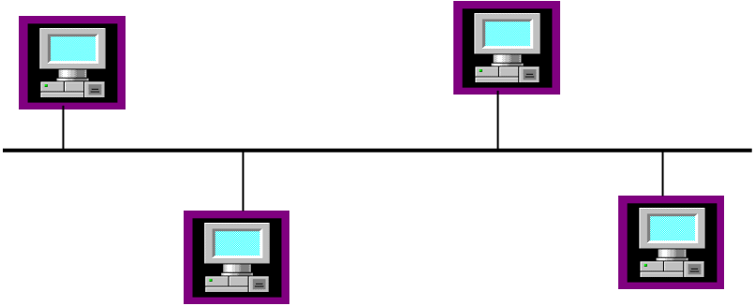

Figure 8.1 Ethernet bus topology

Figure 8.2 shows how Ethernet fits into the OSI model. The data link layer is divided into two sublayers, the Logical Link Control (LLC) and the Media Access Control (MAC) layers. The function of the LLC is to establish a logical connection between source and destination. The IEEE standard for the LLC is IEEE 802.2. The function of the Media Access Control is to access the network, which uses CSMA/CD (Carrier Sense and Multiple Access with Collision Detection).

Network Layer

Logical Link
Control (LLC)
IEEE 802.2

Data link layer

Media Access
Control (MAC)
IEEE 802.3

Physical Layer

Figure 8.2 Ethernet reference model

8.1 Ethernet Operation

Each network card has a unique physical address. When a station transmits a frame on the bus, all stations connected to the network will copy the frame. Each station checks the address of the frame, and if it matches the station’s NIC address, it accepts the frame. Otherwise the station discards the frame.
In an Ethernet network, each station uses the CSMA/CD protocol to access the network in order to transmit information. CSMA/CD works as follows:

- If a station wants to transmit, the station senses the channel (listens to the channel). If there is no carrier, the station transmits and checks for a collision as described in part 2. If the channel is in use, the station keeps listening until the channel becomes idle. When the channel becomes idle, the station starts transmitting again.

- If two stations transmit frames at the same time on the bus, the frames will collide. The station which first detected the collision sends a jamming code on the bus (a jam signal is 32 bits of all ones), in order to inform the other stations that there is a collision on the bus.

3. The two stations which were involved in the collision wait according to a back-off algorithm (a method used to generate random waiting times for stations that were involved in a collision), then start retransmission. Figure 8.3 shows the flowchart of CSMA/CD.

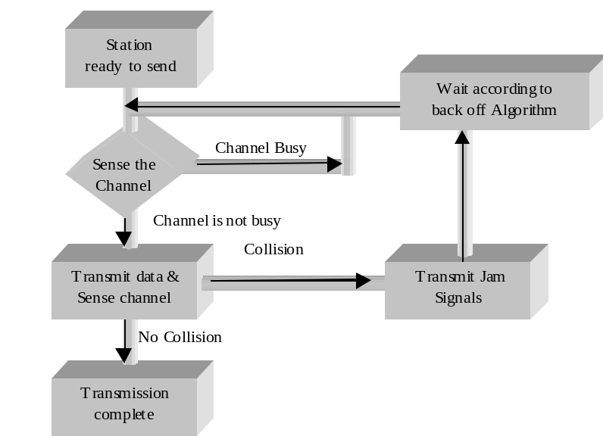

Figure 8.3 CSMA/CD flowchart

8.2 Ethernet Frame formats

A block of data transmitted on the network is called a frame. There are two types Ethernet frame formats. IEEE 802.3 frame format and Ethernet II frame format are shown in figure 8.4 and figure 8.5 respectively.

IEEE 802.3 Frame Format

1 byte 1 byte 1-2 bytes 42-1497 bytes
DSAP | SSAP | Control | Information

LLC Frame Format
Fields in Bytes
7 1 6 6 2 0-1500 0-46 4
Preamble | SFD | DA | SA | Length | Data Unit | Pad | FCS

MAC frame format

Figure 8.4: IEEE 802.3 MAC and LLC frame formats

Most network manufacturers conform to the IEEE standards. The items listed below describe each field of the IEEE 802.3 frame format.

Preamble: The preamble provides signal synchronization and consists of seven bytes of alternating 1 and 0 bits.

Start of Frame Delimiter (SFD): The SFD represents the start of frame and is always set to 10101011.

Destination Address (DA): The destination address is the six-byte (48 bits) hardware address of a recipient station. This address is a unique address as no two are the same in the entire world. The hardware address of the Network Interface Card (NIC) is also called a MAC address (media access control) or physical address. The IEEE oversees the physical addresses of NICs world-wide by assigning 22 bits of physical address to the manufacturers of network interface cards. The 46-bit address is burned into the Read Only Memory (ROM) of each NIC and is called the universal administered address. Figure 8.5 shows the format of the destination address with the following types of addresses:

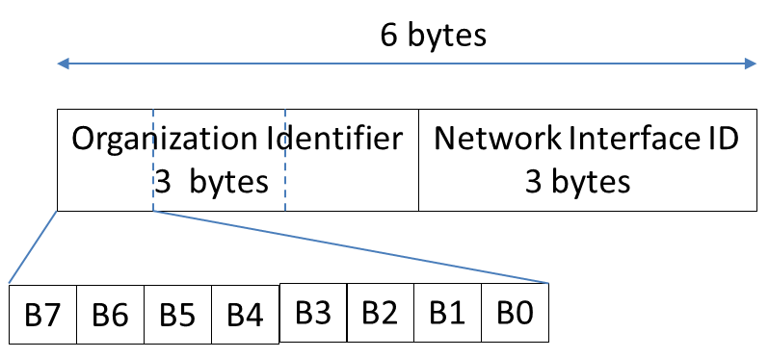

B0 = 0 Unicast address
B0 =1 Multicast Address
B1 = 0 Globally Unique address
B1 =1 Address locally administrated

Figure 8.5: Format of physical address

• Unicast: Recipient is an individual station.
• Multicast: Recipients are a group of stations.
• Broadcast: Recipients are all stations in the network. The 48-bit destination address is set to all ones, meaning that the DA address is FFFFFFFFFFFF in Hex, for a broadcast address.

Source Address (SA): The SA shows the address of the source from which the frame originated.

Length Field: The two-byte field defines the number of bytes in the data field.

Data Field: According to Figure 8.4, the data field contains the actual information. The IEEE specifies that the minimum size of data field must be 46 bytes, and the maximum size is 1500 bytes.

Destination Service Access Point (DSAP): The MAC layer passes information to the LLC layer, which must then determine which protocol the incoming information belongs to, such as IP, NetWare or DecNet.

Source Service Access Point (SSAP): The SSAP determines which protocol is sent to the destination protocol, such as IP or DecNet.

Control Field: The control field determines the type of information in the information field, such as the supervisory frame, the unnumbered frame, and the information frame.
Pad Field: If the information in the data field is less than 46 bytes, extra information is added in the pad field to increase the size to 46 bytes.

Frame Check Sequence (FCS): The FCS is used for error detection to determine if any information was corrupted during transmission. IEEE uses CRC-32 for error detection.

IEEE Ethernet II Frame Format

Starting Delimiter (1 byte) | Destination Address (6 bytes) | Source Address (6 bytes) | Protocol Type (2 bytes) | Information field  46-1500 | Frame Check Sequence (4 bytes)

Figure 8.5: Ethernet II frame format

The Preamble, SFD, DA, SA, PAD, and FCS fields of the Ethernet II frame format are similar to those of IEEE 802.3.

Protocol Type: The Protocol Type field which defines the type of protocol generation information. The following are some of the protocol type numbers.
- 0×0800 IP Internet Protocol (IPv4)
- 0×0806 Address Resolution Protocol (ARP)
- 0×8035 Reverse Address Resolution Protocol (RARP)
- 0x809B AppleTalk (Ethertalk)
- 0x80F3 Appletalk
- 0×8100 (identifies IEEE 802.1Q tag)
- 0×8137 Novell IPX (alt) 0×8138 Novell
- 0x86DD Internet Protocol, Version 6 (IPv6)
- 0×8847 MPLS unicast
- 0×8848 MPLS multicast
- 0×8863 PPPoE Discovery Stage
- 0×8864 PPPoE Session Stage

8.3 Ethernet Characteristics

The gap between each frame should not be less than 9.6 msec. A station can have a maximum of ten successive collisions. The size of the jam signal is 32 bits of all 1's. The maximum size of the frame is 1512 bytes including the header. Slot time is the propagation delay of the smallest frame. The smallest frame is 512 bits and each bit time is 10⁻⁷ seconds, therefore the propagation delay is 512-bit time.

Table 8.1 Ethernet Characteristics

Data Rate | 10 Mbps
Encoding | Manchester Encoding
Slot time or Propagation delay | 512-bit time
Interframe Gap | 9.6 msec
Backoff limit | 10
Jam Size | 32 bits
Maximum size | 1512 bytes
Minimum frame size | 64 bytes

8.4 Ethernet Cabling and Components

The Ethernet network uses UTP media and is called 10BaseT. Figure 8.6 illustrates the port of a NIC which is used to connect a computer to a network.

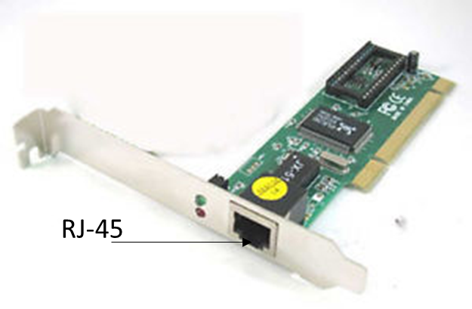
Figure 8.6 Network Interface Card (NIC)

10 BaseT

10 BASE-T

Data Rate T represents Twisted Pair
10 Mbps Baseband Twisted Pair

10BaseT uses a UTP cable as transmission media and all stations are connected to a repeater or hub, as shown in Figure 8.7. The function of repeater (hub) is to accept frames from one port and retransmit the frames to all the other ports. Table 8.2 shows the pin connection of an RJ-45 connector.

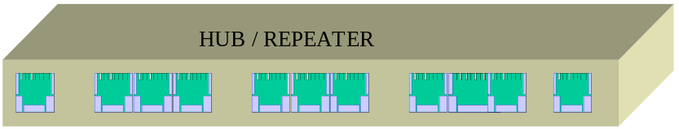

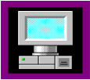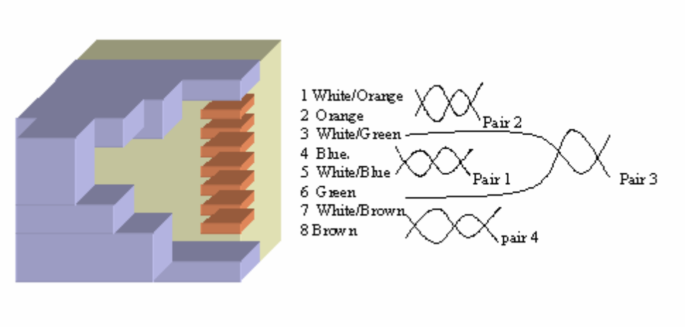

Figure 8.7: 10 Base-T connections

Table 8.2 RJ-45 connector pins

PIN | Signals
1 | RD+ pair 2
2 | RD- pair 2
3 | TD+ pair 3
4 | NC pair1
5 | NC pair1
6 | TD- pair 3
7 | NC pair 4
8 | NC pair 4

The specifications of 10 BaseT are as follows:

- The maximum length of one segment is 100 meters.
- The transceiver for 10BaseT is built into the NIC.
- Devices are connected to a 10BaseT HUB in a physical star topology (electrically, they are in a Bus topology)
- 10 BaseT topology allows a maximum of four connected repeaters, with a maximum diameter of 500m.

UTP Cable

There are two types of UTP cable used in networking. They are Cross Over and Straight Through Cables as show in figure 8.8.

A straight-thru cable has identical ends and it is used as a patch cord in Ethernet connections. A crossover is used to connect two Ethernet devices without a hub or for connecting two hubs.

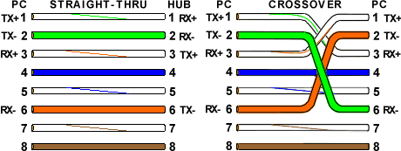

Figure 8.8: Image of Straight and Cross over cables

Table 8.3 shows the applications of Straight and Cross Over cables

Device Type | Device Type | UTP cable Type
Switch | PC | Straight Through
Router | PC | Straight Through
Switch | Switch | Cross Over
PC | PC | Cross Over
Router | Router | Cross Over

8.5 Fast Ethernet Networking Technology

Introduction

A group of leading network corporations formed a consortium to draft specifications for Fast Ethernet. This consortium proposed several of these specifications to the IEEE and IEEE 802.3u committee, which ultimately approved the standard for Fast Ethernet in 1995.
Fast Ethernet is an extension of the Ethernet standard, with a data rate of 100 Mbps, using the Ethernet protocol. The goal of Fast Ethernet is to increase the bandwidth of Ethernet networks while using the same CSMA/CD transmission protocol. Using the same protocol for Fast Ethernet allows users to connect an existing 10BaseT LAN to a 100BaseT LAN with switching devices. Figure 8.9 shows the Fast Ethernet protocol architecture.

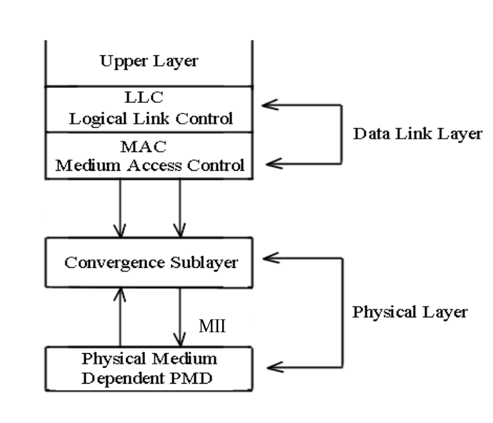

Figure 8.9 Fast Ethernet protocol architecture
The role of the Convergence Sublayer (CS) is to interface the MAC sublayer to the Physical Medium Dependent (PMD) sublayer in order to transmit with a higher bit rate, using different media. The Media Independent Interface (MII) is defined as the interface between the CS layer and the PMD layer.

8.5.1 Fast Ethernet Media Types

One of the most popular media for a Fast Ethernet network is unshielded twisted-pair wire, because it is easy to work with and it is a less expensive medium. The IEEE has approved specifications for the following three types of media for Fast Ethernet:

- 100BaseT4
- 100BaseTX
- 100BaseFX

100BaseTX

100BaseTX

Data Rate Type of Bandwidth T represents Twisted-pair
100 Mbps Base band X indicates either 2 pair UTP
or 1 pair STP

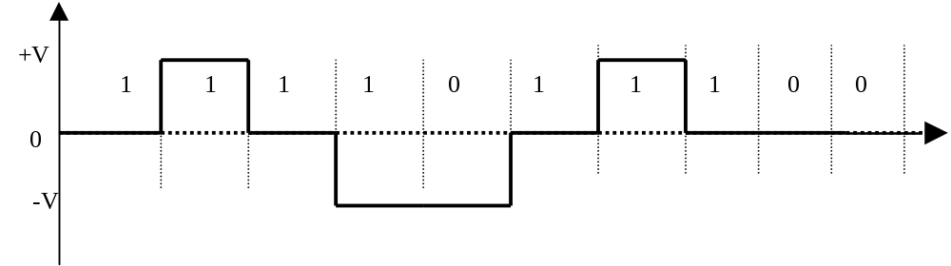
100BaseTX technology supports 100 Mbps over two pairs of Cat–5 UTP cables. Cat-5 UTP cable is the most common media for transmission and is designed to handle frequencies up to 100 MHz. Manchester encoding, which is used for 10BaseT, is not suitable for 100BaseT, because it doubles the frequency of the original signal. 100BaseT uses 4B/5B encoding with Multiple Level Transition-3 (MLT-3) levels for signal encoding. Figure 8.10 shows (0E)₁₆ converted to 10 bits 1111011100 using Table 8.4 and then converted to MLT-3. MLT-3 reduces the frequency of the signal by a factor of four.

Figure 8.10 MLT-3 signal for binary Value 11110 11100.
MLT encoding uses three voltage levels: +V, -V, and Zero. The MLT encoding rules are as follows:

- If the next bit of the original signal is zero, then the next output is the same as the preceding value.
- If the next bit of original signal is one, then the next output value has a transition (high to low or low to high).

- If the preceding output was either +V or –V, then the next output value is zero.
- If the preceding output was zero, then the next output is nonzero (it is the opposite sign of the last none-zero output).

100BaseFX

100BaseFX

Data Rate Type of Bandwidth F represents Fiber Optic
100 Mbps Base band

100BaseFX technology transfers data at a rate of 100 Mbps using fiber-optic media for transmission. The standard cable for 100BaseFX is one pair of multimode fiber-optic cables with a 62.5 micron core and 125 micron cladding. The EIA recommends a SC plug-style connector. The SC connector uses push-on and push-off to connect and disconnect from the repeater. Figure 8.11 illustrates how 100BaseFX connects to a repeater.

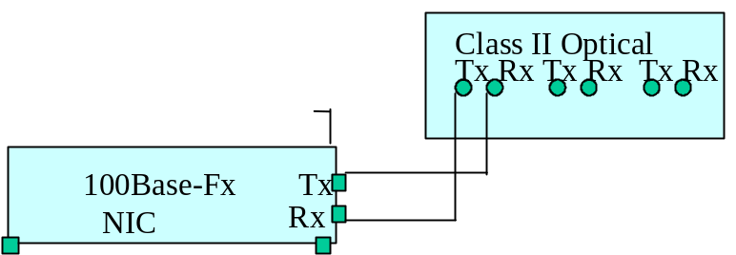

Figure 8.11 100BaseFX connection to a repeater

100BaseFX uses 4B/5B encoding with NRZ-I signal encoding. In this type of encoding, four bits of information are converted to five bits, as shown in Table 8.4, and the five bits are converted to NRZ-I digital signals. These signals are then converted to an optical ray for transmission over the fiber-optic cable to the receiver.
At the receiver side, the optical signal is sampled every eight nanoseconds. If there is a change of light (from on to off or from off to on) in the sample, it is represented as a binary one. If there is no change of the light, it is represented by binary zero.
The conversion from four bits to five bits changes the data rate from 100 Mbps to 125 Mbps respectively. NRZ-I digital encoding reduces the frequency of transmission by half.

Table 8.4 4B/5B Encoding

4 bits  Binary | 5 bits Symbol |  | 5 bits symbol
0000  0001  0010  0011  0100  0101  0110  0111  1000  1001  1010  1011  1100  1101  1110  1111 | 11110  01001  10100  10101  01010  01011  01110  01111  10010  10011  10110  10111  11010  11011  11100  11101 | Idle  Halt  J  K  T  Set  Reset  Quiet | 11111  00100  11000  10001  01101  11001  00111  00000

8.6 Fast Ethernet Repeaters

Repeaters are used to expand the network diameter. There are two types of repeaters used in Fast Ethernet: Class I repeater and a Class II repeater.

Class I Repeater

A Class I repeater converts line signals from the incoming port to digital signals. This conversion allows different types of Fast Ethernet Technology to be connected to LAN segments. For example, it is possible to connect a 100BaseTX station to a 100BaseFX station by using a Class I Repeater, which has a larger internal delay. Only one Class I repeater can be used in a Fast Ethernet segment, as shown in Figure 8.12.

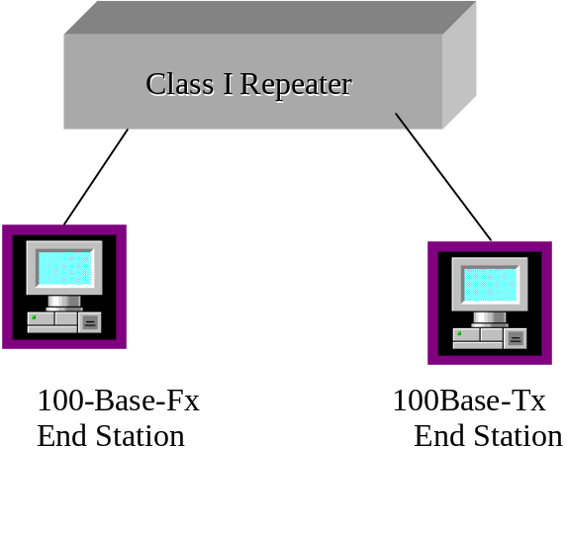
Figure 8.12 Class I Repeater

Class II Repeater

A Class II repeater repeats the incoming signal and sends it to every other port on the repeater. Class II repeaters are used to connect the same media to the collision domain, meaning all stations connected to the repeater are of the same type, such as 100BaseTX. Only two Class II repeaters are permitted in one Fast Ethernet segment, as shown in Figure 8.13.
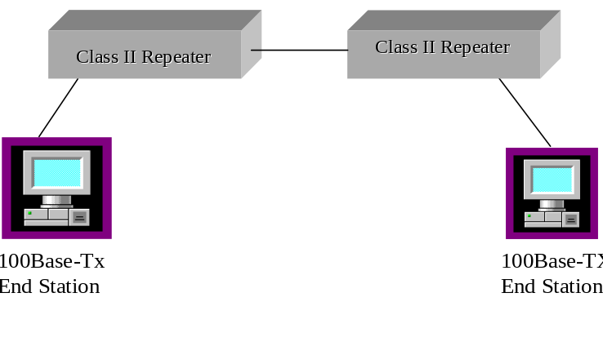Figure 8.13 Application of a Class II repeater

Table 8.5 Maximum Network Diameter

Repeater Type | 100BaseTX  or  100 Base-T4 | 100BaseFX
Host to Host Connection (without Repeater) | Host to H 100 meters | 412 m
One Class I Repeater | 200 m | 272 m
One Class II Repeater | 200 m | 320 m
Two Class II repeaters | 205 m | N/A

Summary

- Ethernet or IEEE802.3 uses bus topology.
- In the bus topology, the medium is shared by all stations.
- Ethernet uses Carrier Sense Multiple Access/ Collision Detection (CSMA/CD) to access the network.
- Ethernet data rate is 10 Mbps.
- The maximum size of an Ethernet frame is 1512 bytes.
- An Ethernet network card comes with three types of connectors: RJ-45, BNC, and DIX
- 10BaseT is a medium with these features: 10Mbps, baseband, and using UTP cable with RJ-45 connectors.
- 10BaseT requires a repeater or hub.
- A Unicast address tells you that the recipient of the frame is an individual station
- A Multicast address indicates that the recipient of the frame is a group of stations.
- A Broadcast address means the recipient of the frame is every station in the network.
- There is a maximum of four repeaters allowed for use in Ethernet.
- The data rate of Fast Ethernet is 100 Mbps.
- Fast Ethernet uses three types of media: 100BaseT4, 100BaseTX and 100BaseFx.
- Fast Ethernet uses the same frame format as Ethernet
- 100BaseT4 uses four pairs of Cat-3 UTP wires, 100BaseTX uses two pairs of Cat-5 UTP wires, 100BaseFX uses fiber-optic cable.
- Fast Ethernet uses Class I repeaters to connect NIC cards with different types of media.
- Fast Ethernet uses Class II repeaters to connect stations having the same type of network Interface Card.
- In fast Ethernet, only one Class I repeater is allowed.
- Fast Ethernet can use only two Class II repeaters.

Key Terms

Broadcast Repeater
CSMA/CD Unicast
Destination Address (DA) Source Address (SA)
Destination Service access Point (DSAP) Source Service Access Point (SSAP)
Ethernet Frame Format IEEE 802.3

LLC Frame Format
Logical Link Control (LLC)
Media Access Control (MAC)
Multicast
Bit Time Fast Ethernet Access Method
Class I Repeater Fast Ethernet Frame Format
Class II Repeater IEEE 802.3u
Convergence Sublayer (CS) Media Independent Interface (MII)
Fast Ethernet Multi-Level Transition (MLT-3)
100 BaseFx Propagation Delay
100BaesT4
100BaseTx

Review Questions

Multiple Choice Questions

- __________ is the least expensive LAN.
- Ethernet
- Token Ring
- a and b
- Gigabit Ethernet

- The standard for Ethernet is _________.
- IEEE 802.3
- IEEE 802.4
- IEEE 802.5
- IEEE 802.2

- Ethernet uses __________ to access channel.
- CSMA/CD
- token passing
- demand priority
- full-duplex

- A destination address has _____________bytes
- 2
- 3
- 6
- 8

- Ethernet uses ___________ encoding.
- Manchester
- Differential Manchester
- NRZ
- NRZ-I

- Multiple choice questions
- Fast Ethernet uses _________
- a. IEEE 802.2
- b. IEEE 802.5
c. IEEE 802.3u
- d. IEEE 802.4

- The goal of Fast Ethernet is to increase __________.
- the number of stations in a network
- the frequency of signals
- bandwidth in a network
- network diameter

- The role of __________ is to interface the MAC sublayer to the physical medium dependent.
- 100BaseT4
- 100BaseTX
- convergence sub-layer
- LLC

- ___________ is the most popular media for Fast Ethernet.
- UTP
- STP
- Fiber-optics
- Coaxial cable

- The data rate of 100 base-TX is __________ Mbps.
- 100
- 10
- 200
- 1000

- 100BaseFX uses __________ cable.
- UTP
- STP
- coaxial
- fiber-optic

- There are __________ types of repeaters.
- five
- two
- three
- four

- The maximum distance between two repeaters using UTP cable is __________ meters.
- 10
- 5
- 100
- 200

- Fast Ethernet’s data rate is ___________ Mbps.
- 100
- 10
- 400
- 200

10. What type of access method is used in Fast Ethernet?
- Token
- CSMA/CD
- Demand priority
- Full-duplex

11. How many Class I repeaters can be used for Fast Ethernet?
- 1
- 2
- 3
- 4

- How many Class II repeaters can be used for Fast Ethernet?
- 1
- 2
- 3
- 4

Short Answer Questions

1. Define the following term:
a. 10BaseT

- What do UTP and STP stand for?
- What is 10BaseT topology?
5. What is a network segment?
6. Show Ethernet II frame format and function of each field
7. Explain the function of a repeater or a hub
8. Show the IEEE 802.3 frame formats and function of each field.
9. Describe the access method for Ethernet.
10. What does CSMA/CD stand for?
11. What is IEEE 802.2?
12.
13. What is a MAC Address?
15. Explain collisions in Ethernet.
- What is a jam signal?
- Explain broadcast addresses.
18. Describe unicast addresses.
- What is the size a network interface card address?
20. What is the application of CRC (Cyclic Redundancy Check)?

25. What is the maximum size of a frame for IEEE 802.3?
26. How many bits of a network address represent the manufacturer ID?
27. How do computers distinguish one another on an Ethernet network?
28. What happens when two or more computers simultaneously transmit frames on an Ethernet network?
29. What is the function of the FCS field in the Ethernet frame format?
30. What is the function of the back-off algorithm in an Ethernet network?
31. What is the function of the length field in an Ethernet frame?
32a. What is function of Protocol type in Ethernet II frame format

- List the IEEE sublayers of the data link layer
34. What is function of the PAD field in IEEE 802.3 frame format?
- Explain the following terms:

- 100Base4T
b. 100BaseTX
- 100BaseFX

- What is the cable type of 100BaseTX?
3. What is the difference between 100BaseTX and 100BaseT4?
4. What is the application of a Class I repeater?
- What is the application of a Class II repeater?
6. What is the maximum network diameter using two Class II repeaters in a 100BaseT network?
- Name the IEEE committee that developed the standard for Fast Ethernet.
- Identify and explain the access method for Fast Ethernet.
- What is the function of the convergence sublayer?
- What are the types of media used for Fast Ethernet?
- What type of signal encoding is used for 100BaseT4?
- What type of signal encoding is used for 100BaseFX?
- Convert 84 Hex to 5 bit symbols and then show the corresponding MLT digital signals.
- Show the binary value for ternary code 0-+-+0 ternary code.

