Jason Anrico

File and Message Transfer

**Introduction**

In this lab I created an application with python to receive files. Unfortunately, I couldn’t get the messaging portion to work. I edited and created protocols and assigned them to sending a message. I created my protocols HEAD_MSGREQUEST and HEAD_MSGREC but apparently the global name head isn’t defined when it was already used? On the client side I get an Attribute error ‘module’ object has no attribute ‘HEAD_MESGREQUEST’ when I created it? I’m genuinely just confused at this point. I added in necessary components like a sendMsg and getMessage function to the client side and server side. All the Server ports and download paths have been renamed to fit my computer. Id really like to know what part I’m missing here.

These are the changes I made:

Client.py

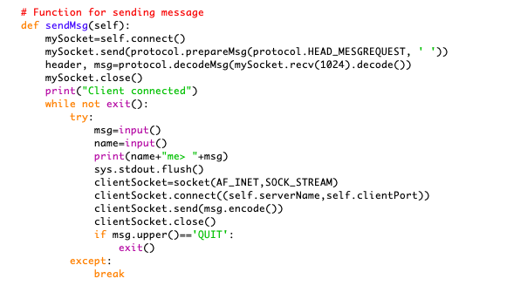

Server.py

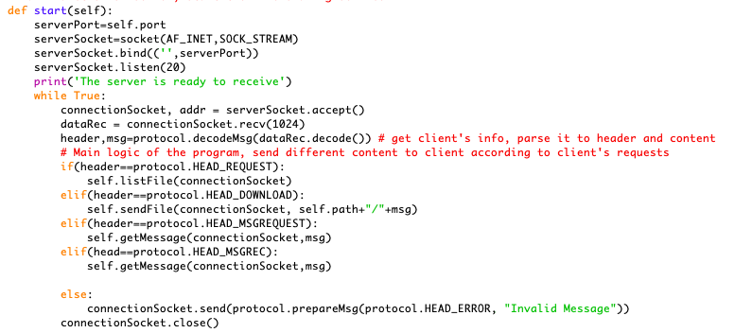

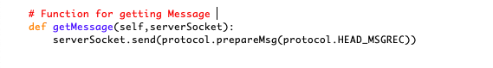

protocol.py

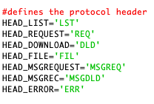

server.config

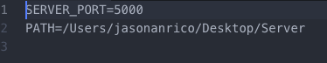

client.config

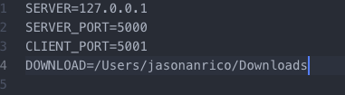

But if someone were to use this program to download a file they can and ill show the steps (including my error messages, hopefully I can receive some feedback on it because its really bothering me)

**Instructions**

* First I ran this in my **Macs** terminal:
* Since this this folder directory was on my desktop:
  + I run the command cd desktop/Server (Server is the name of the folder all the files are in)
* Once you change directories you can open a new tab in shell with “Profile Basic”
  + This should still leave you in the Server directory
* In one shell run command python Server.py
  + This will start the server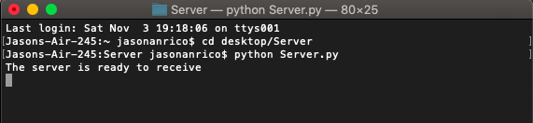
* In the second shell run the command python client.py
  + This will start the client side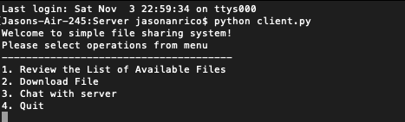
* Do exactly as the program tells you
  + 1.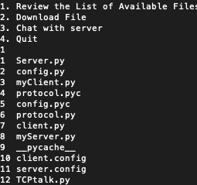
  + 2.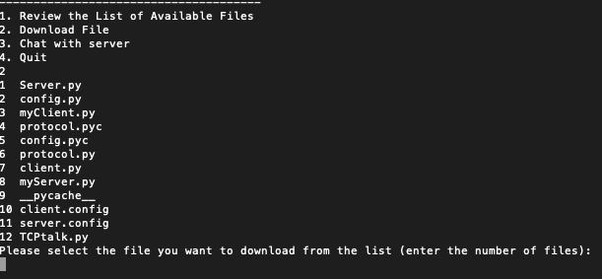
  + /Users/jasonanrico/Desktop/Screen Shot 2018-11-03 at 11.14.19 PM.png
  + I choose number 3 and received a file called myClient.py

Ill now show the messaging portion and show the output errors I get

* As you can see I added 4 option instead of three.
* My goal was to have the user press 3 and be able to send a message but it didn’t work out that way
* 