ArduinoGirls
Beginner analog and digital electronics tutorials.

Schematic Symbols

Symbol | Name | What it Does | Units | Notes
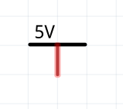 | Power source ;  also known as Vcc | Provides energy (+) | Volts (V)
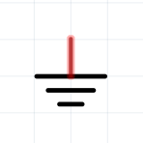 | Ground ;  also known as Gnd | Provides energy (-) | Volts (V)
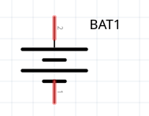 | Power source (+ and – terminals) | Provides energy | Volts (V) | The “longer” end of the symbol is positive, the “shorter” negative.
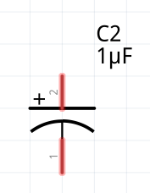 | Capacitor | Stores energy temporarily | Farads (F) | Some capacitors (electrolytic, metallic) are polarized (direction matters!) and are marked as such. Ceramic capacitors are not direction sensitive.
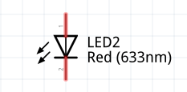 | Light Emitting Diode (LED) | Shines light |  | Direction matters – the “longer” leg (the “base” of the triangular symbol) is positive
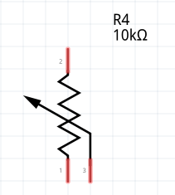 | Potentiometer | Allows to regulate resistance by turning a knob | Ohms ( Ω ) | The “center” terminal is what changes “value”. Direction does not matter.
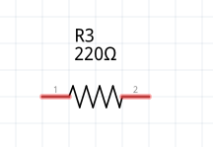 | Resistor | Resists current flow | Ohms ( Ω ) | Direction does not matter. Resistor value is color-coded on it with colored stripes.
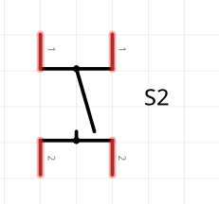 | (Push) Button | Switches things on and off |  | Can be sticky (press and it stays on) or not. Direction does not matter.

Units and Stuff
Name | Unit | What it Is
Voltage | Volt (V)
Current | Ampere (A)
Resistance | Ohm (Ω)
Capacitance | Farad (F) | How much energy is can fit into a capacitor

LED With A Switch
Shiny!
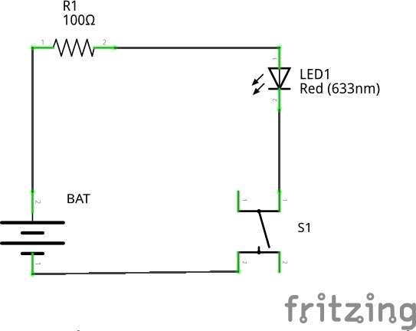

Materials
ID | Storage Ref | Notes
R1 |  | Anywhere from 50 … 300 Ω is fine
LED1 | CAT 050 or CAT 056 or CAT 044 | Any color
BAT | CAT 039 | 3V CR2450 coin cell
S1 | CAT 009 or CAT 010 | Any switch

- Why is the resistor needed?
- What happens when we increase or decrease the resistor’s value?
- What happens if the LED is inserted in the wrong direction?

LED With a Potentiometer
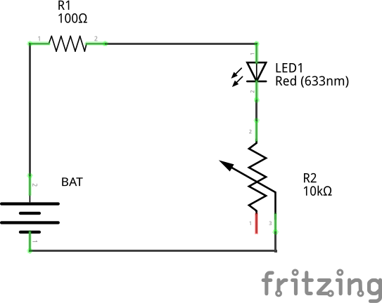

Materials
ID | Storage Ref | Notes
R1 |  | Anywhere from 50 … 300 Ω is fine
LED1 | CAT 050 or CAT 056 or CAT 044 | Any color
BAT | CAT 039 | 3V CR2450 coin cell
R2 | CAT 045 + CAT 049

LED with a Capacitor
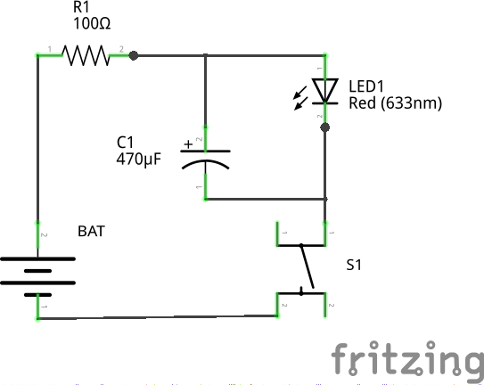

Materials
ID | Storage Ref | Notes
R1 |  | Anywhere from 50 … 300 Ω is fine
LED1 | CAT 050 or CAT 056 or CAT 044 | Any color
BAT | CAT 039 | 3V CR2450 coin cell
S1 | CAT 009 or CAT 010 | Any switch
C1 |  | Polarization (direction) matters!

What happens when we use a larger capacitor?

Blinking LED (aka Hello World)
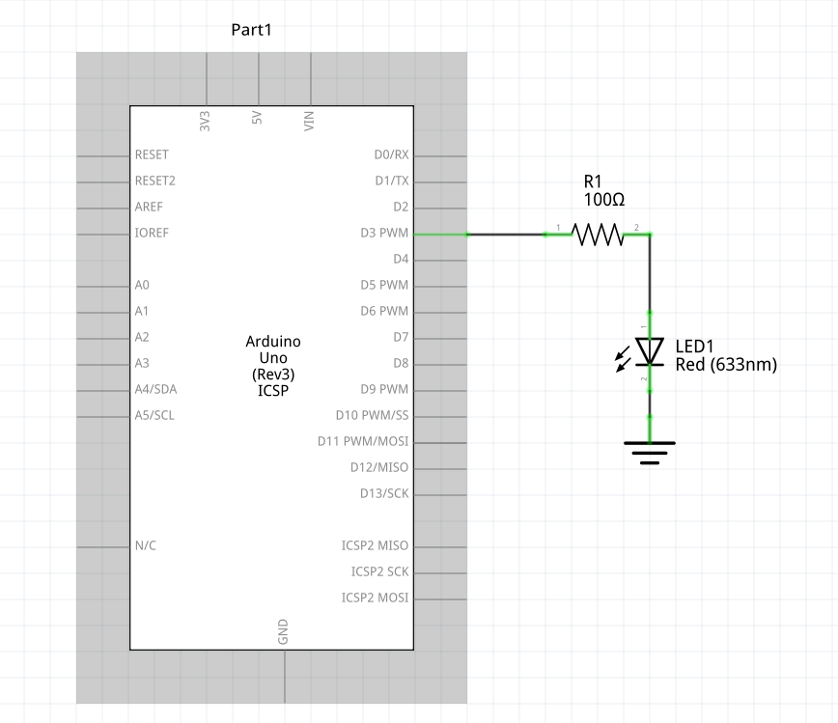

Materials
ID | Storage Ref | Notes
R1 |  | Anywhere from 50 … 300 Ω is fine
LED1 | CAT 050 or CAT 056 or CAT 044 | Any color

Spec
Program the Arduino such that it would blink a LED connected to one of the Digital pins (see: blink.ino)
Experiment with with different timings. Write a SOS blinker (see: sos.ino)

Darkness Warning
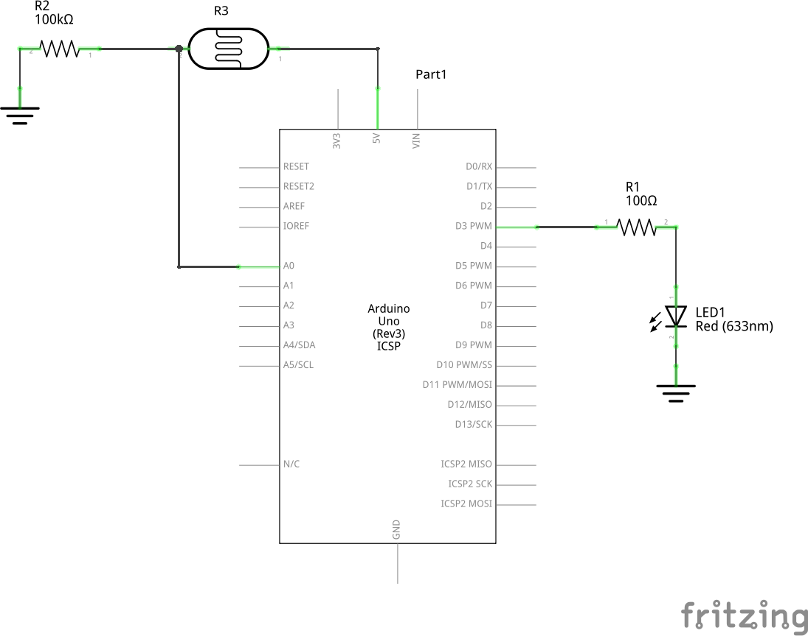

Materials
ID | Storage Ref | Notes
R1 |  | Anywhere from 50 … 300 Ω is fine
LED1 | CAT 050 or CAT 056 or CAT 044 | Any color
R2
R3 | CAT 033 | LDR, polarity does not matter

Spec
Connect a light sensor and a LED with the Arduino. Program the Arduino to warn (by lighting the LED) when it’s getting darker.

