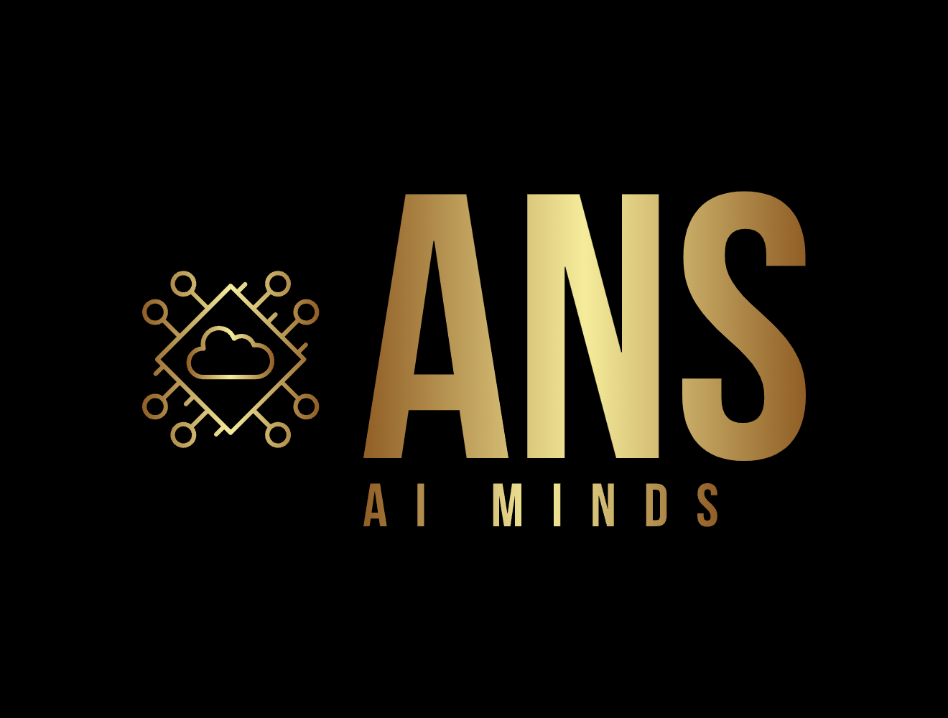

# ANS AI MINDS

## Acknowledgment Form

I hereby acknowledge that I have read, understood, and agreed to comply with the policies and guidelines set forth by **ANS AI MINDS**.   
I understand that failure to adhere to these policies may result in appropriate action as per company policies.  
  
Furthermore, I authorize **ANS AI MINDS** or any of its designated representatives to verify any necessary information related to my background,   
including but not limited to education and employment details. I release all parties providing such information from any liability in doing so.  
  
I confirm that all information furnished by me is accurate and truthful to the best of my knowledge.   
I understand that any misrepresentation or false information provided by me may lead to corrective action,   
including possible termination of my association with **ANS AI MINDS**.

**Full Name** (In Capital Letters Only): ________________________

**Date** (DD/MM/YYYY): ________________________

**Signature**: ________________________