ACCUKNOX Assignment 1

Problem Statement 1
Anish Sarkar
B.Tech (AI & ML), Netaji Subhash Engineering College, Kolkata
Repos referenced:
• Schizophrenia EEG – https://github.com/ans036/Schizophrenia_EEG
• Chronic disease DB – https://github.com/ans036/chronic-disease-burden-sqlite

Question 1: API to SQLite ETL
Start by pulling books from the API. Once you get that data, slip it into an SQLite database. After it sits there for a moment, grab pieces from the storage and show them on screen.
A single record shows up? That kind of thing might pop into a live work - suddenly it's a small ETL task: grab data from a web API, check for errors, store it in SQLite, then pull the saved version to confirm everything matches. Feels familiar, actually - back when I worked at Doyen Diagnostics, handling individual patient entries involved much the same logic, only simpler, without classification in sight.
Assumptions
• Endpoint: https://api.example.com/books
• Response shape:
[
"Clean Code by Robert C. Martin published in 2008"
"Deep Learning by Ian Goodfellow comes 2016"
]
Schema and approach
A fresh table takes shape, built with a uniqueness rule in place - this way, running the code again won't cause problems.
CREATE TABLE IF NOT EXISTS books (
id INTEGER PRIMARY KEY AUTOINCREMENT,
title TEXT NOT NULL,
author TEXT NOT NULL,
year INTEGER,
UNIQUE(title, author)
);
At a high level:
• Send a request through the API using requests.
• Clean the JSON by removing whitespace, converting the year to an integer, then dropping any rows that are blank.
• Place data in SQLite with INSERT OR IGNORE.
• Print out each piece clearly so it's easy to read.
Code
import requests
import sqlite3
from contextlib import closing

API_URL = "https://api.example.com/books"
DB_PATH = "books.db"

def fetch_books_from_api(url: str):
resp = requests.get(url, timeout=10)
resp.raise_for_status()
data = resp.json()

books = []
for item in data:
title = (item.get("title") or "").strip()
author = (item.get("author") or "").strip()
year = item.get("year")
year = int(year) if year is not None else None
if author and title:
books.append((title, author, year))
return books

def init_db(db_path: str):
with closing(sqlite3.connect(db_path)) as conn, conn:
conn.execute(
"""
CREATE TABLE IF NOT EXISTS books (
id INTEGER PRIMARY KEY AUTOINCREMENT,
title TEXT NOT NULL,
author TEXT NOT NULL,
year INTEGER,
UNIQUE(title, author)
)
"""
)

def insert_books(db_path: str, books):
with closing(sqlite3.connect(db_path)) as conn, conn:
conn.executemany(
"""
INSERT OR IGNORE INTO books (title, author, year)
VALUES (?, ?, ?)
""",
books,
)

def get_books(db_path: str):
with closing(sqlite3.connect(db_path)) as conn:
cur = conn.execute(
"SELECT title, author, year FROM books ORDER BY year DESC"
)
return cur.fetchall()

# Main function begins execution here.
init_db(DB_PATH)
books = fetch_books_from_api(API_URL)
insert_books(DB_PATH, books)

print("Books in database:")
for title, author, year in get_books(DB_PATH):
print(f"- {title} by {author} ({year})")

if __name__ == "__main__":
main()

Question 2: Fetch Student Scores, Compute Average, Plot Bar Chart
When dealing with any sort of table-like data, pandas plus matplotlib becomes my go-to choice. This exact combination showed up in my Schizophrenia EEG work, where I looked at how features spread out. It made another appearance in a highway-traffic project, handling differences between machine learning runs.
Assumptions
• Endpoint found at https://api.example.com/student-scores
• Response:
[
{"student": "Alice", "score": 88}
{"student": "Bob", "score": 76}
{"student": "Charlie", "score": 92}
]
Steps
• Get JSON using requests.
• Turn it into a DataFrame, remove any rows with empty values, then turn score fields into real numbers.
• Calculate then display the average score.
• A picture forms when students line up along the horizontal axis, each labeled once from left to right. Points rise vertically on the vertical axis, labeled score from bottom to top. Each dot places one student above another, linking their name to a single point across the graph. The drawing saves as scores.png, storing visuals without words.
Code
import requests
import pandas as pd
import matplotlib.pyplot as plt

SCORES_API = "https://api.example.com/student-scores"

def load_scores(url: str) -> pd.DataFrame:
resp = requests.get(url, timeout=10)
resp.raise_for_status()
data = resp.json()
df = pd.DataFrame(data)
df["score"] = pd.to_numeric(df["score"], errors="coerce")
df = df.dropna(subset=["score"])
return df

def plot_scores(df: pd.DataFrame, output_path: str = "scores.png"):
plt.figure(figsize=(8, 4))
plt.bar(df["student"], df["score"], color="steelblue")
plt.xlabel("Student")
plt.ylabel("Score")
plt.title("Student Test Scores")
plt.ylim(0, 100)

for idx, val in enumerate(df["score"]):
plt.text(idx, val + 1, f"{val:.0f}", ha="center", fontsize=8)

plt.tight_layout()
plt.savefig(output_path, dpi=150)
plt.close()

# Running the main function.
df = load_scores(SCORES_API)
average_score = df["score"].mean()
print(f"Average score: {average_score:.2f}")
plot_scores(df)

if __name__ == "__main__":
main()
Figure 1: Student Test Scores Bar Chart

Question 3: Read Users from CSV and Insert into SQLite
Starting with CSV moving to SQLite happens often - in EEG data, traffic records, or patient logs. Since rules are minimal, using plain csv alongside sqlite3 covers everything just fine.
Assumptions
• CSV file: users.csv
• Columns: name is required, email must be present.
Plan
• Open users.csv by parsing it with csv.DictReader.
• Clean name and email (strip whitespace, lowercase email).
• Start by setting up a table called users - make sure email has a unique value across every row. This keeps imports from creating duplicate entries even when data overlaps during upload.
• Insert ignore to avoid duplicates.
Code
import csv
import sqlite3
from contextlib import closing
from pathlib import Path

CSV_FILE = Path("users.csv")
DB_PATH = "users.db"

def init_user_db(db_path: str):
with closing(sqlite3.connect(db_path)) as conn, conn:
conn.execute(
"""
CREATE TABLE IF NOT EXISTS users (
id INTEGER PRIMARY KEY AUTOINCREMENT,
name TEXT NOT NULL,
email TEXT NOT NULL UNIQUE
)
"""
)

def read_users_from_csv(csv_path: Path):
users = []
with csv_path.open("r", newline="", encoding="utf-8") as f:
reader = csv.DictReader(f)
for row in reader:
name = (row.get("name") or "").strip()
email = (row.get("email") or "").strip().lower()
if name and email:
users.append((name, email))
return users

def insert_users(db_path: str, users):
with closing(sqlite3.connect(db_path)) as conn, conn:
conn.executemany(
"INSERT OR IGNORE INTO users (name, email) VALUES (?, ?)",
users,
)

# Main function begins execution here.
if not CSV_FILE.exists():
raise FileNotFoundError(f"{CSV_FILE} missing")

init_user_db(DB_PATH)
users = read_users_from_csv(CSV_FILE)
insert_users(DB_PATH, users)
print(f"Processed {len(users)} users from CSV, skipping duplicates.")

if __name__ == "__main__":
main()

Question 4: Most Complex Python Code
Most complex Python code
A choice might go to the Schizophrenia Classification via EEG work, seen as the most intricate Python effort seen until now. This setup involves a chain of tasks:
• From EEG data, the code pulls out PSD/DE/SE traits along with roughly 50,000 heatmaps across the scalp surface.
• A single Chrononet-derived CNN handles patient classification, guided by training, validation, and experiment scripts.
• Reaches around 99% classification accuracy on the training dataset, with 93% accuracy on cross-validation/test sets reported in my resume.
Found it here: https://github.com/ans036/Schizophrenia_EEG
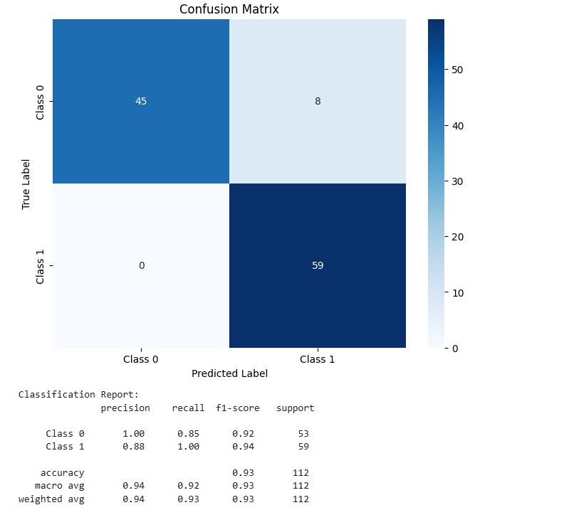
Figure 2: Schizophrenia EEG Classification - Confusion Matrix and Performance Metrics

Question 5: Most Complex Database Code
Most complex database code
This little tool for tracking chronic diseases stands out in how cleanly it's put together. A clear example of organized database work shows up here:
https://github.com/ans036/chronic-disease-burden-sqlite
A schema takes shape - not fantasy but real form using SQLite: patients, clinicians, long-term health issues, office visits, test results, predicted risks, warning flags. Tools pop into place - Python code fills them up with mock patient details, builds a scoring system using clear rules about illness weight, triggers alerts when thresholds break. This setup echoes work I did during an internship at Doyen Diagnostics, where numbers flowed through similar fields, though there I linked models to reality, not just framed the storage behind decisions.
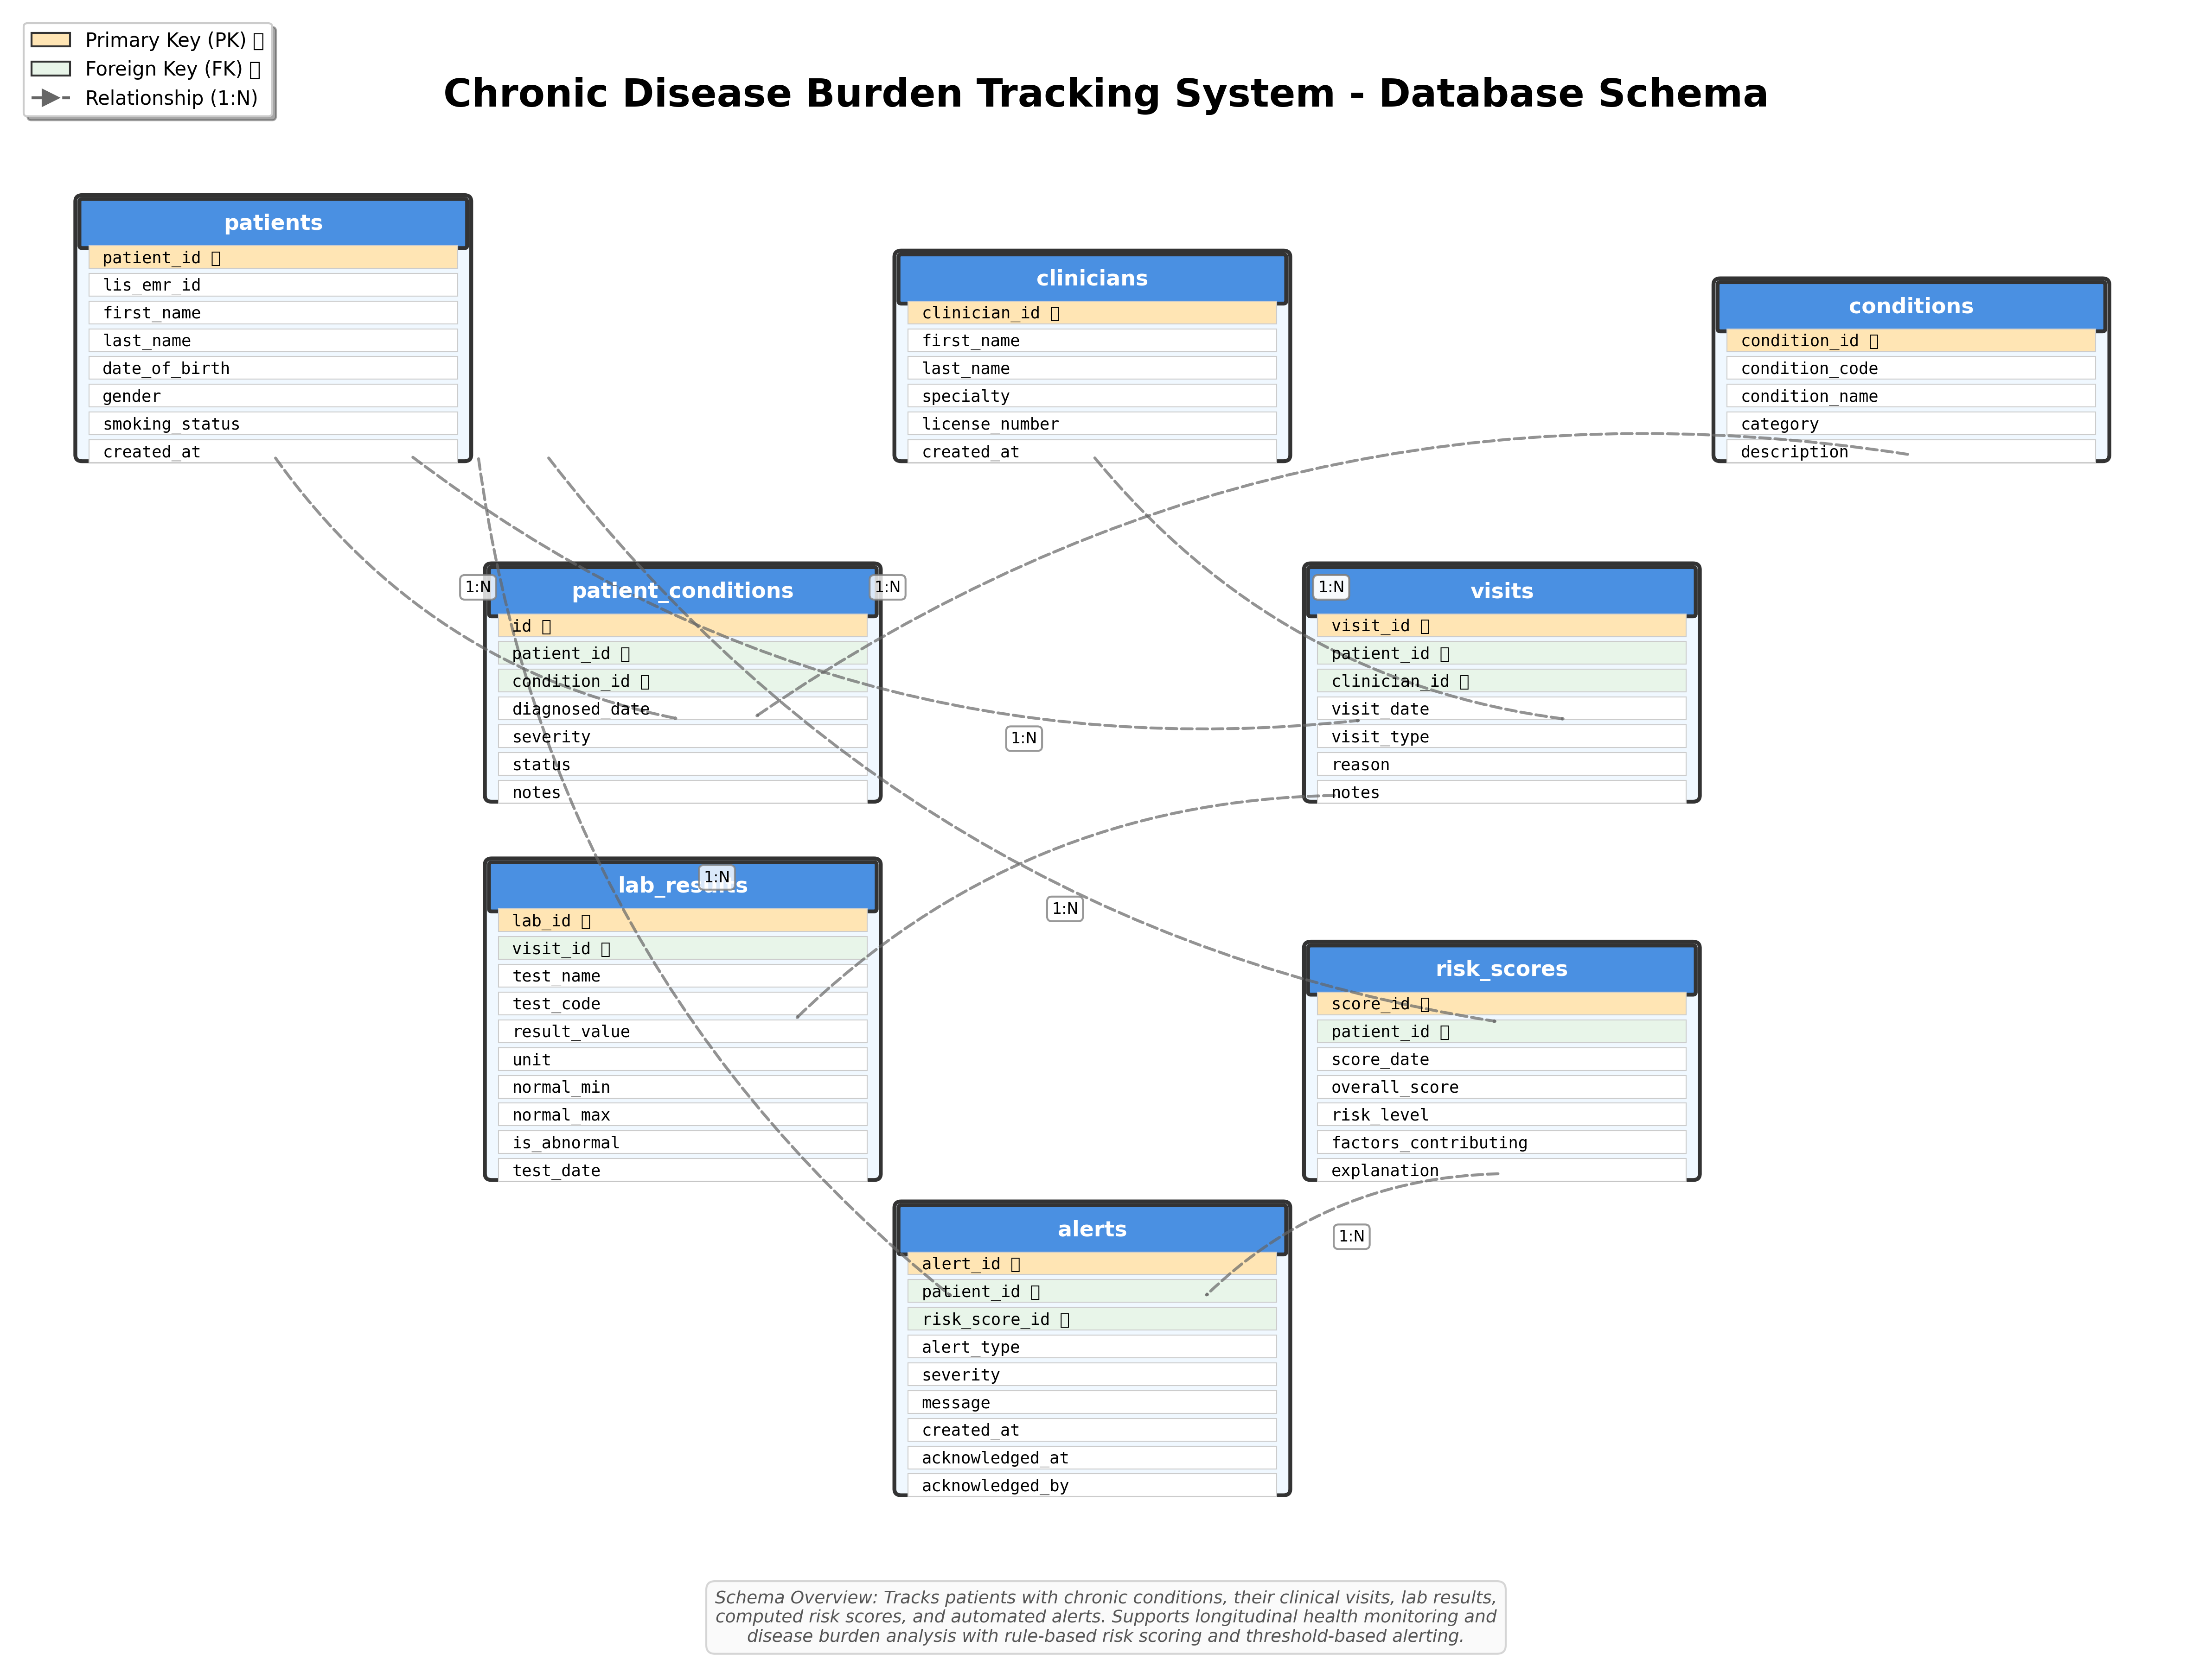
Figure 3: Chronic Disease Burden Tracking - Complete Database Schema

