ANSHU CHAUDHARY

100360477

DR.ABHIJIT SEN

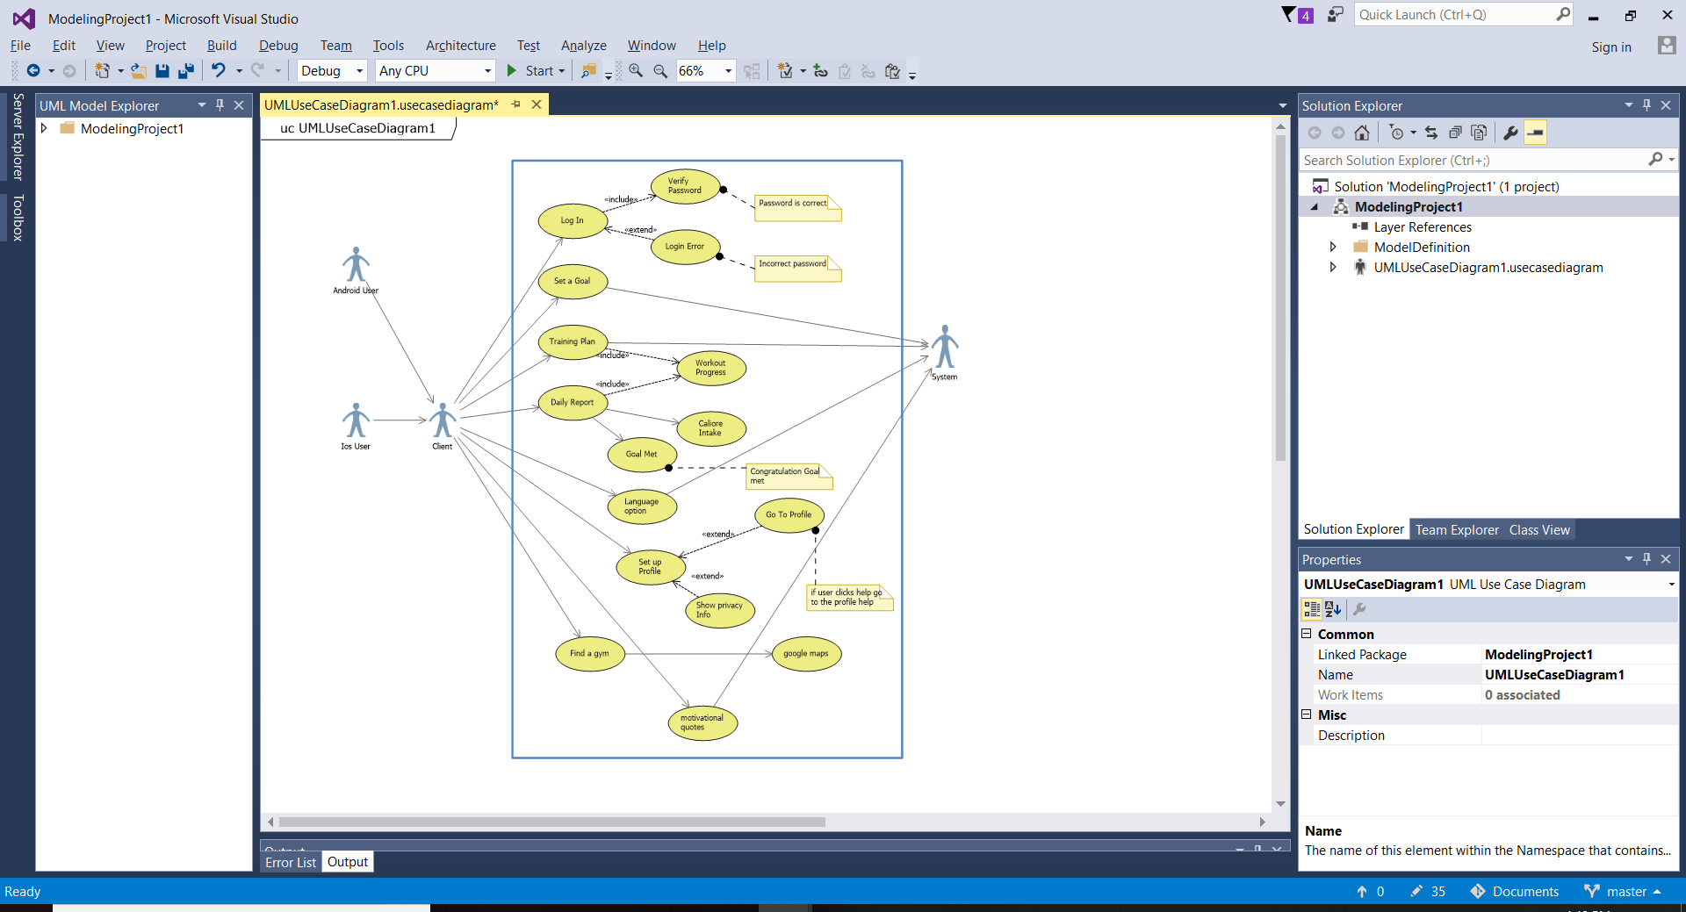

|  |  |
| --- | --- |
| **Use case title:** | Training plan |
| **Primary actor** | user |
| **Level:** | Kite |
| **Stakeholder:** | User |
| **Preconditions:** | Body structure and size |
| **Minimal guarantee:** | Good routine and focus |
| **Success guarantee:** | Hard work daily and diet requirements, supplements |
| **trigger** | Perfect protein and carbo rich diet  Training according to the need. |
| **Main success scenario** | 1. Good fitness 2. Flexibility 3. Good body structure |
| **Extension:** | Don’t get demotivated  Try again till one gets positive results |