Project Report
Machine Learning in Transcriptomics:
Classifying Gastric Cancer vs. Normal Samples from Gene Expression Data
Summer School 2026, Omics Nexus
Submitted by: Ansa Aslam

1. Introduction
For this project, I built on the machine learning workflow my teacher had walked us through earlier for brain tumour classification (Astrocytoma vs Oligodendroglioma), and adapted the same pipeline to a completely new dataset and a new biological problem: distinguishing Gastric Cancer (GC) samples from Normal samples using gene expression (transcriptomic) data (Bulk-RNA sequencing data).
The overall aim of the project was to build a complete, end-to-end supervised machine learning pipeline that
- loads and explores raw gene expression data
(2) cleans and filters it down to the genes that actually matter
(3)selects the most statistically discriminative genes using an ANOVA F-test
(4) trains and evaluates three different classifiers — K-Nearest Neighbors (KNN), Decision Tree, and Random Forest
(5) finally deploys the best-performing model on a brand-new, unseen patient sample to generate a real prediction with a confidence score.

2. Dataset Description
I was given four files for this project: a gene expression matrix (rna_seq.xlsx), a metadata file (meta_data.xlsx), a single new patient's expression profile (Patient_1.xlsx), and a short text summary of the class sizes (Sample_info).
- rna_seq.xlsx — 11,903 genes (rows) across 267 samples (columns), with the gene identifier column named Hugo_Symbol.
- meta_data.xlsx — 267 rows with two columns: SAMPLE_ID and Phenotype, where Phenotype takes the values "GC" (Gastric Cancer) or "Normal".
- Patient_1.xlsx — a single new patient's expression values across all 11,903 genes, formatted the same way as the training matrix.
- Sample_info — confirmed the class balance directly: Normal = 133 samples, Gastric Cancer = 134 samples, which is an almost perfectly balanced dataset.
Before model training, I checked the shapes and column names of both files to make sure they matched what the code expected.
Since the column names in this dataset (Hugo_Symbol, Phenotype) were different from the teacher's original notebook (Genes, TUMOR_TYPE), I updated every reference to these columns throughout the pipeline rather than assuming the names carried over.

3. Exploratory Data Analysis
I started by inspecting the first few rows and the .info()/.describe() summaries of both the expression matrix and the metadata to get a feel for the data types and value ranges. I then looked at the class balance directly.
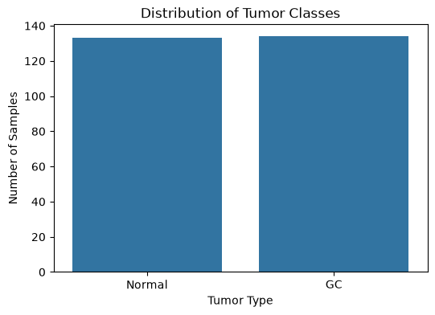
Figure 1. Distribution of the two classes in the dataset — Normal (133 samples) vs. GC (134 samples).
This is an almost perfectly balanced dataset, with GC only one sample more than Normal (134 vs 133). This is an important step as a model don’t always predicting the majority class.

4. Data Preprocessing

4.1 Missing Values and Duplicates
I checked for missing values and duplicate rows first, since a machine learning model can only be as reliable as the data it's trained on. Both checks came back completely clean: 0 missing values and 0 duplicate rows out of 11,903 genes. Nothing need to drop or impute anything at this stage.

4.2 Checking Whether the Data Needed Log Transformation
When I ran the equivalent check on my data, the minimum expression value across the whole matrix was 3.65 and the maximum was 14.85. There were zero genes with any zero values at all. A range this narrow, sitting entirely between roughly 3.6 and 14.9 with no zeros, is the signature of data that has already been log2-normalized upstream (this looks like a log2-transformed, RMA-normalized microarray/RNA-seq dataset rather than raw counts). Applying log2 to already-logged data — a "double-log" transformation would have compressed the real biological differences between GC and Normal samples and distorted every downstream result, including the correlation matrix, the ANOVA test, and the trained models. So I deliberately skipped the log2 transformation for both the training data and Patient_1.xlsx, and used a mean-expression-based low-expression filter conceptually instead of a zero-fraction filter, since there were no zero values for a zero-fraction filter to act on.

4.3 Removing Low-Variance Genes
Not every gene is useful for classification. A gene that has almost the same expression value in every single sample carries no information that can help separate GC from Normal, so I removed genes with very low variance across all 267 samples. I tested several variance thresholds before settling on one:
Variance Threshold | Genes Removed | Genes Remaining
0.10 | 5,822 | 6,081
0.25 | 9,417 | 2,486
0.50 | 10,845 | 1,058
1.00 | 11,531 | 372

I chose a variance threshold of 0.25, which brought the gene count down from 11,903 to 2,486 genes (about 20.9% retained). The dataset shape changed to (2486, 268). I picked this threshold as a middle ground: 0.10 barely removed any genes (leaving over 6,000), while 0.50 and 1.0 became increasingly aggressive and risked throwing away genes that might still be biologically meaningful even with moderate variance. 0.25 gave a large enough reduction to make the correlation analysis in the next step computationally manageable, without being overly aggressive.
- Feature Selection (Removing Highly Correlated (Redundant) Genes)

Unsupervised Feature Selection: Pearson correlation
After variance filtering, I computed a Pearson correlation matrix across all 2,486 remaining genes (a 2,486 × 2,486 matrix, over 6.18 million unique gene pairs) to find genes that were essentially carrying duplicate information. Two genes with a very high correlation are, statistically speaking, telling the model almost the same thing — keeping both just adds redundancy and noise without adding real discriminative power.
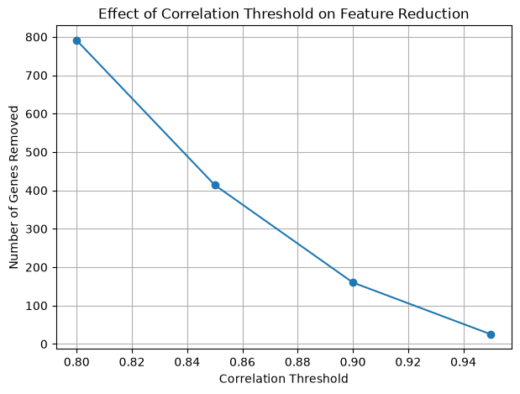
Figure 2. Number of genes removed as the correlation threshold is tightened from 0.80 to 0.95.
Correlation Threshold | Correlated Pairs | Genes Removed | Genes Remaining
0.80 | 8,913 | 791 | 1,695
0.85 | 2,819 | 414 | 2,072
0.90 | 512 | 160 | 2,326
0.95 | 47 | 25 | 2,461

As the plot above shows, the relationship is steep at first and flattens out — most of the highly redundant gene pairs are captured by a moderate threshold, and pushing the threshold higher (toward 0.95) barely removes anything more. I settled on a correlation threshold of 0.85, which removed 414 redundant genes and left 2,072 genes going into the feature selection step changing the datasets shape to (267, 2074). This felt like the right balance: strict enough to genuinely cut redundancy, but not so strict that I'd start losing genes that were only moderately correlated and might still hold independent value.

5.2 Supervised Feature Selection (ANOVA F-test)
Variance and correlation filtering are both unsupervised — they don't look at the class labels at all. To actually find genes that distinguish GC from Normal, I merged the filtered expression matrix with the metadata on SAMPLE_ID, encoded the labels (Normal = 0, GC = 1), and split the data into training (213 samples) and testing (54 samples) sets using an 80/20 stratified split, which kept the class balance almost identical in both sets (Training: 106 Normal / 107 GC; Testing: 27 Normal / 27 GC).
On the training set only (to avoid any data leakage into the test set), I ran an ANOVA F-test on all 2,072 genes to measure how strongly each gene's expression differs between the two classes.
P-value Threshold | Significant Genes
p < 0.05 | 1,657
p < 0.01 | 1,539
p < 0.001 | 1,384
p < 0.0001 | 1,272

1,657 out of 2,072 genes (about 80%) were statistically significant at p ≤ 0.05, which is a strong signal that a large portion of this filtered gene set genuinely separates GC from Normal tissue. To visually sanity-check the ANOVA ranking, I plotted boxplots for the top 5 most discriminative genes by F-score:
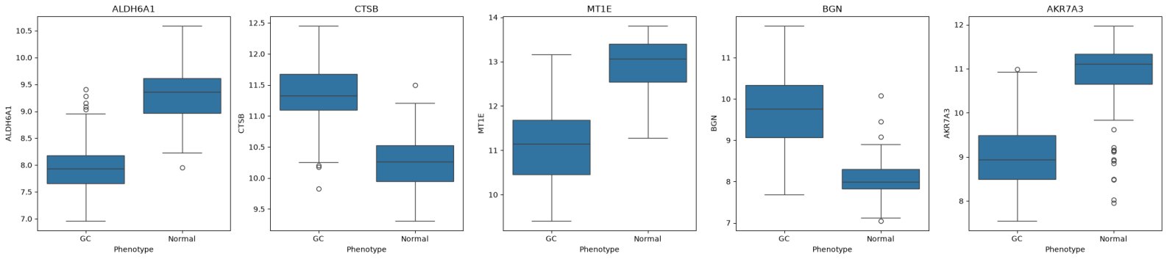
Figure 3. Expression distributions of the top 5 ANOVA-ranked genes (ALDH6A1, CTSB, MT1E, BGN, AKR7A3) across GC and Normal samples.
These boxplots gave me real confidence in the ANOVA ranking. ALDH6A1, MT1E, and AKR7A3 are all clearly lower in GC than in Normal, while CTSB and BGN are clearly higher in GC than in Normal, with very little overlap between the two boxes for each gene. This kind of clean separation is exactly what a high ANOVA F-score should look like, and it made the top-ranked gene, ALDH6A1, an intuitive choice to become the very first split in the Decision Tree model later on.
For the final feature set going into the machine learning models, I selected the top 500 genes by F-score (out of the 1,657 significant genes). This gave a final training matrix of 213 samples × 500 genes and a testing matrix of 54 samples × 500 genes.

6. Machine Learning Model Building (Supervised)
I trained three different classifiers on the same top-500-gene feature set, so I could directly compare how different algorithms handle this classification problem.

6.1 K-Nearest Neighbors (KNN)
KNN classifies a sample by looking at its nearest neighbours in feature space, so it's extremely sensitive to the scale of each feature, a gene with a naturally larger numeric range would dominate the distance calculation otherwise. Because of this, I standardized the 500 selected genes using StandardScaler (fit only on the training data, then applied to the test data) before training KNN with n_neighbors = 5.
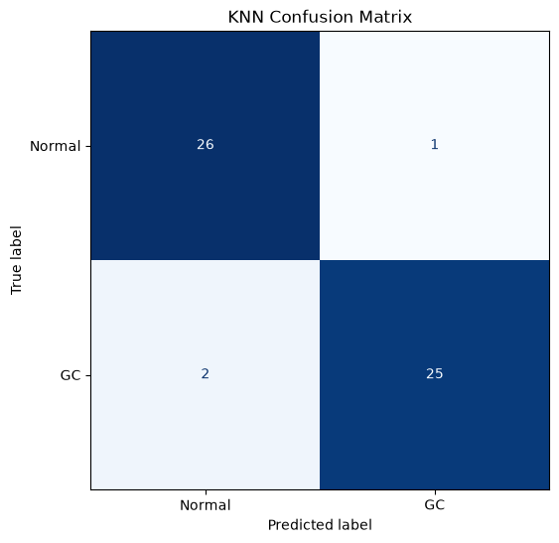
Figure 4. KNN confusion matrix on the 54-sample test set.
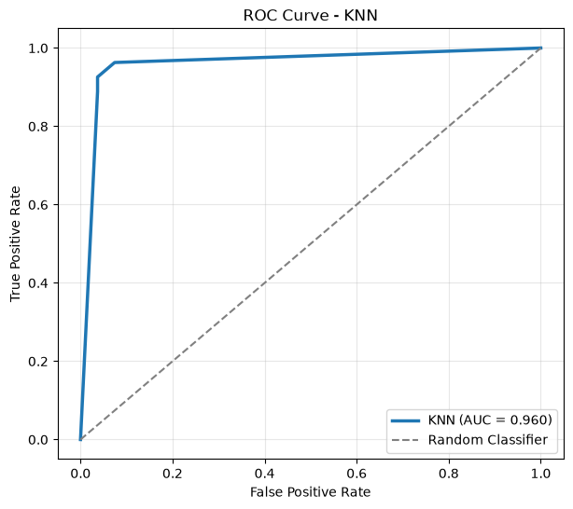
Figure 5. KNN ROC curve — AUC = 0.960.
KNN achieved 94.44% accuracy, misclassifying only 3 out of 54 test samples (1 Normal predicted as GC, 2 GC predicted as Normal). The ROC curve rises almost immediately to a true positive rate above 0.9, giving an AUC of 0.960, his tells me the model is very good at ranking GC samples above Normal samples, not just at the single 0.5 decision threshold.

6.2 Decision Tree
Next, I trained a Decision Tree classifier (criterion = "gini", max_depth = 5, random_state = 42) directly on the unscaled 500-gene feature set,trees split on raw threshold values, so feature scaling isn't necessary here the way it is for KNN.
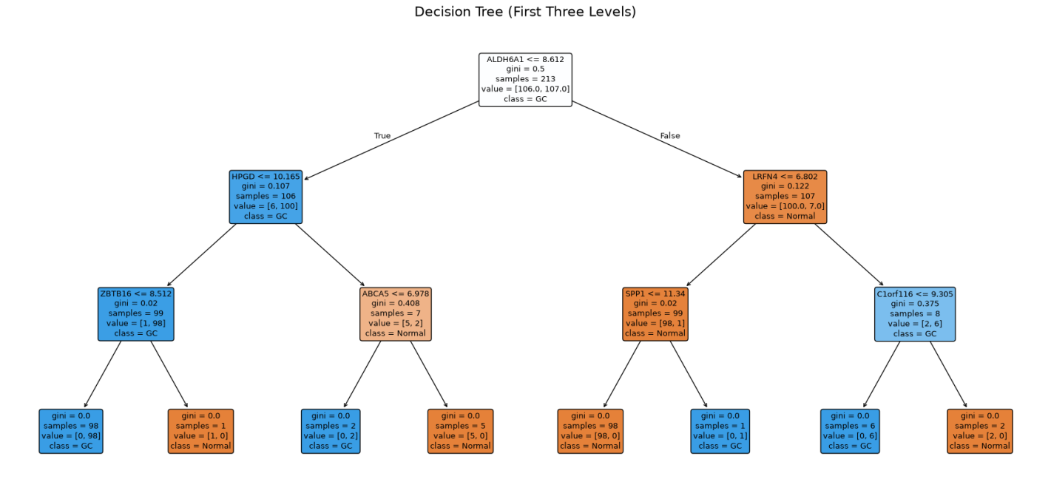
Figure 6. The first three levels of the trained Decision Tree, showing ALDH6A1 as the very first (root) split.
It's genuinely satisfying that the tree's root node split is ALDH6A1 ≤ 8.612,the exact same gene that came out on top of the ANOVA ranking in Section 5.2, and the same gene whose boxplot showed the cleanest separation between classes. This is a nice confirmation that the statistical feature selection step and the tree's own greedy splitting criterion agree on what the single most informative gene is.
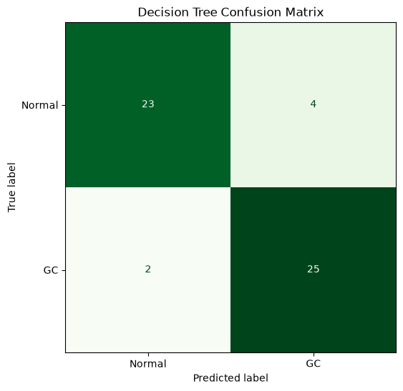
Figure 7. Decision Tree confusion matrix on the test set.
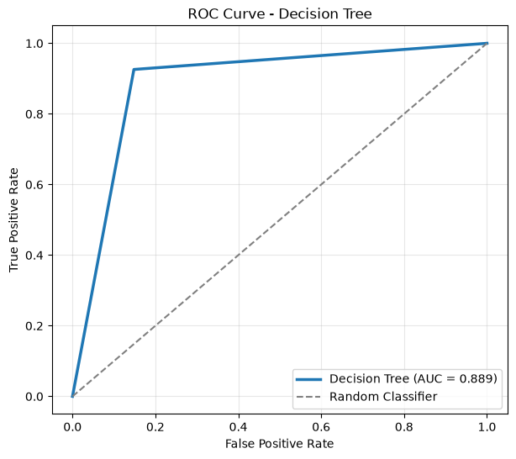
Figure 8. Decision Tree ROC curve — AUC = 0.889.
The Decision Tree reached 88.89% accuracy (48/54 correct), which is noticeably lower than KNN. Looking at the confusion matrix, it made 4 false positives (Normal predicted as GC) and 2 false negatives (GC predicted as Normal), and its ROC curve has a much sharper, more angular shape with an AUC of 0.889. A single decision tree with a fixed depth of 5 is a comparatively simple, high-variance model,it can only draw a handful of straight-line decision boundaries through a 500-dimensional feature space, so it makes sense that it underperforms the two ensemble-style/distance-based approaches here.

6.3 Random Forest
Finally, I trained a Random Forest classifier with 200 trees (n_estimators = 200, criterion = "gini", max_depth = None, random_state = 42), again on the unscaled 500-gene feature set. A Random Forest builds many decision trees on random subsets of the data and features and then averages their votes, which usually makes it far more stable than a single tree.
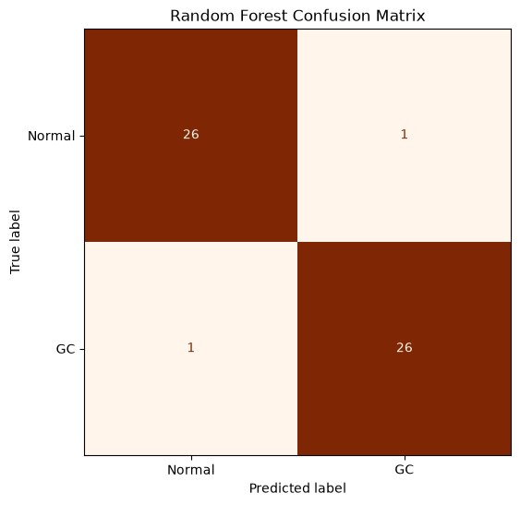
Figure 9. Random Forest confusion matrix on the test set.
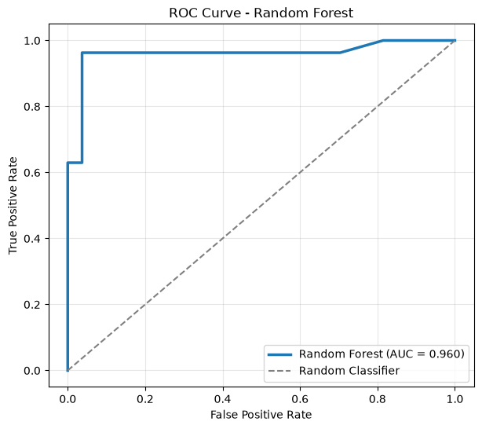
Figure 10. Random Forest ROC curve — AUC = 0.960.
The Random Forest was the best-performing model overall, reaching 96.30% accuracy (52/54 correct) with only 1 false positive and 1 false negative,the most balanced and lowest error count of all three models. Its AUC of 0.960 ties with KNN as the highest of the three. This matches what I would expect biologically and statistically: an ensemble of 200 trees, each seeing a slightly different random subset of the 500 genes, is much better at capturing the many small, distributed gene-expression differences between GC and Normal tissue than either a single tree or a purely distance-based method.

7. Model Comparison
Putting all three models side by side on the same 54-sample test set makes the differences very clear:
Model | Accuracy | Precision | Recall | F1-score | AUC
K-Nearest Neighbors | 0.9444 | 0.9451 | 0.9444 | 0.9444 | 0.9602
Decision Tree | 0.8889 | 0.8910 | 0.8889 | 0.8887 | 0.8889
Random Forest | 0.9630 | 0.9630 | 0.9630 | 0.9630 | 0.9595

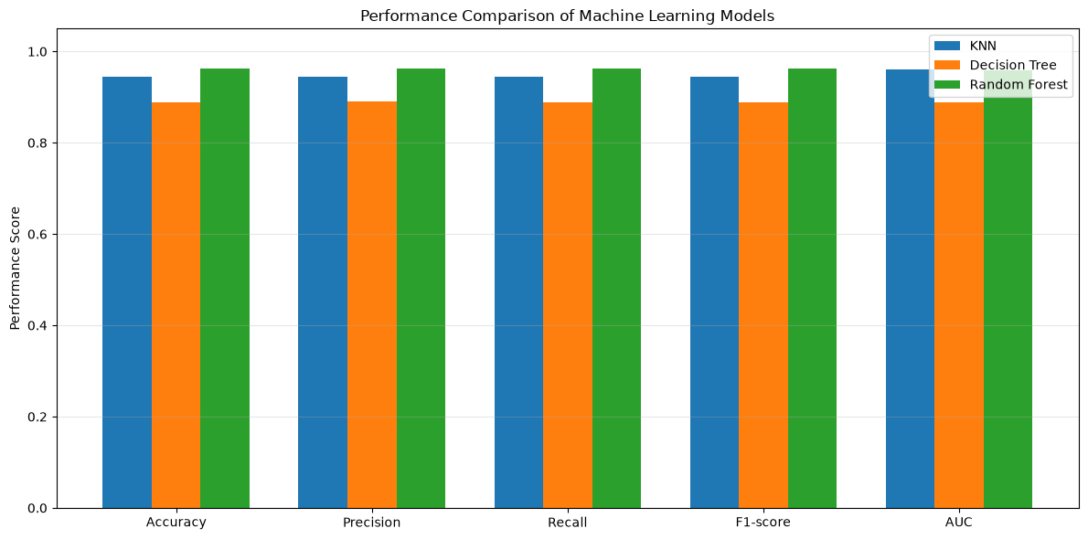
Figure 11. Performance comparison of KNN, Decision Tree, and Random Forest across all five evaluation metrics.
Across every single metric, the ranking is consistent: Random Forest > KNN > Decision Tree. Random Forest edges out KNN slightly on accuracy, precision, recall and F1-score (96.30% vs 94.44%), while KNN has a marginally higher AUC (0.9602 vs 0.9595),practically a tie. The Decision Tree trails behind both by a clear margin on every metric. Given this, I chose Random Forest as my primary deployment model, since it had the best overall balance of accuracy and error minimization on the test set, while still keeping KNN and Decision Tree predictions available for comparison during deployment.

8. Model Deployment on a New Patient
The final was using the trained models to actually classify a brand-new, previously unseen patient (Patient_1.xlsx). I saved all three trained models (RandomForest_Model.pkl, DecisionTree_Model.pkl, KNN_Model.pkl) along with the fitted StandardScaler and the list of 500 selected genes, so they could be reloaded independently for deployment without retraining.
The new patient's file contained expression values for all 11,903 genes (uploaded_genes = 11,903), and after selecting only the 500 genes the models were trained on, all 500 required genes were found with zero missing genes,o no imputation or error handling was needed. I did not apply a log2 transformation to this patient's data either, for the same reason as the training data: the values already sat in the same ~3.8–14.2 log-like range, so re-transforming it would have created the exact same double-log distortion I avoided in Section 4.2. For the KNN prediction specifically, I transformed the patient's 500-gene vector using the same StandardScaler that was fit on the training data (not a freshly-fit one), since using a new scaler would have standardized the patient relative to a completely different, single-sample distribution and produced meaningless results.
Model | Prediction | Confidence
Random Forest | Gastric Cancer | 95.50%
Decision Tree | Gastric Cancer | 100.00%
K-Nearest Neighbors | Gastric Cancer | 100.00%

All three models unanimously predicted that Patient_001 has Gastric Cancer, with the Random Forest model — my chosen primary model — giving a 95.50% confidence score (4.50% probability of Normal). Both the Decision Tree and KNN pushed the prediction all the way to 100% confidence, which is not unusual for these two model types on a single, clearly-separated sample: a Decision Tree gives a hard, deterministic probability based on which leaf the sample lands in, and with only 5 nearest neighbours, KNN can easily end up with all 5 neighbours agreeing on the same class. Random Forest's slightly softer 95.50% is, in a way, the more trustworthy number of the three, since it comes from averaging the votes of 200 independently-grown trees rather than a single deterministic path or a small neighbourhood of 5 points. Since the Random Forest confidence was well above the 70% threshold I used to define a "high-confidence" prediction, this counts as a high-confidence classification of Patient_001 as Gastric Cancer, though as with any ML-based screening tool, this result should still be confirmed with proper clinical evaluation before being acted on.

9. Conclusion
This project took me through a complete, real machine learning workflow on genomic data. The most important lesson for me was in Section 4.2: I couldn't just trust that every gene expression dataset needs the same preprocessing. Checking the actual value range (3.65–14.85, no zeros) before blindly applying log2(x+1) again was the difference between a correct pipeline and a silently broken one.
After careful filtering — removing low-variance genes (11,903 → 2,486), removing redundant highly-correlated genes (2,486 → 2,072), and selecting the top 500 genes by ANOVA F-score — all three models performed well, with Random Forest achieving the best overall test performance at 96.30% accuracy and a 0.9595 AUC. The fact that the Decision Tree's root split and the ANOVA's top-ranked gene both independently pointed to ALDH6A1 gave me real confidence that the feature selection was capturing genuine biological signal, not noise. Finally, deploying the trained models on a completely new patient and getting a unanimous, high-confidence "Gastric Cancer" prediction from all three models tied the whole pipeline together, from raw expression values all the way to a usable clinical-style prediction report.

