Module 2

Single-Cell RNA-Seq Analysis of Leukemia vs Normal Bone Marrow
Report

Submitted by: Ansa Aslam

1. Introduction
Bulk RNA-seq provides one averaged gene expression of all the cells for the whole tissue, however, single-cell RNA-seq allows gene expression to be measured one cell at a time instead of as a bulk average across millions of cells. This is especially valuable in blood cancers such as leukemia, where a tumour sample is not one uniform population but a mixture of different cells at different stages of differentiation
In this project, I analysed two 10x Genomics single-cell datasets, one from a Leukemia sample and one from a Normal (healthy) bone marrow sample, with the goal of characterising the cellular composition of each sample, identifying which cell populations differ between the two conditions, and finding genes that are differentially expressed between Leukemia and Normal cells within matched cell types.. The workflow included loading datasets, quality control, normalization and log-transformation, dimensionality reduction, clustering, cell type annotation and differential expression using Python with scanpy package for scRNA-seq analysis, AnnData, and CellTypist

2. Dataset Description
The data consist of two 10x Genomics single-cell samples, each provided as a standard barcodes/features/matrix triplet (barcodes.tsv.gz, features.tsv.gz, matrix.mtx.gz):
Sample | Condition | Cells (raw) | Genes detected | Sequencing platform
Normal | Healthy bone marrow | 760 | 36,601 | Illumina HiSeq 4000
Leukemia | Leukemia bone marrow | 971 | 36,601 | Illumina HiSeq 4000

Methodology

3.1 Data Loading and Merging
Each sample was read individually using sc.read_10x_mtx() with gene symbols as variable names, and a 'sample' label ('Leukemia' or 'Normal') was attached to every cell. Cell barcodes were prefixed with their sample name to guarantee uniqueness before the two AnnData objects were concatenated with ad.concat() (outer join), giving one combined object of 1,731 cells x 36,601 genes.

3.2 Quality Control
For each cell, I computed the number of genes detected (n_genes), total UMI counts (n_counts), and counts-per-gene (a rough measure of library complexity). I also flagged mitochondrial genes (prefix MT-, human) and ribosomal genes (prefix RPS/RPL), and used sc.pp.calculate_qc_metrics() to get the percentage of counts coming from each of these gene sets per cell — pct_counts_mt and pct_counts_ribo.These are the standard numbers checked in scRNA-seq, which tells whether a “cell” in the matrix is actually a real, healthy, intact cell, or whether it is empty droplet noise, a dying cell, or a doublet, e.g., high mitochondrial content, etc.

3.2.1 What the raw data looked like/ Before Filtration
Here is what the four core QC metrics looked like before I removed anything:
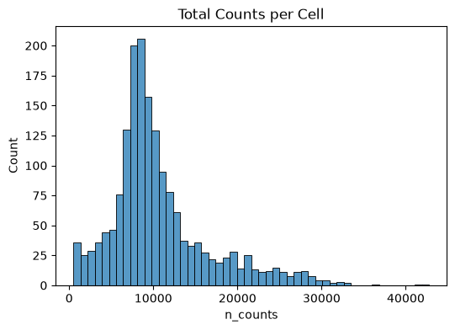
Figure 1. Total UMI counts per cell, raw data.
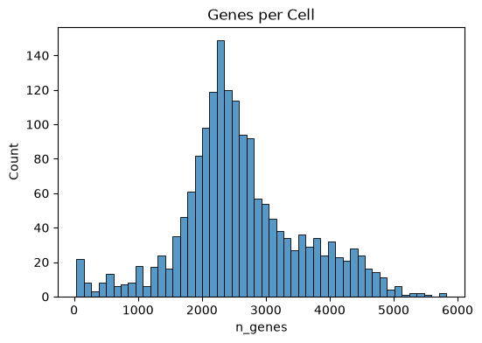
Figure 2. Number of genes detected per cell, raw data.
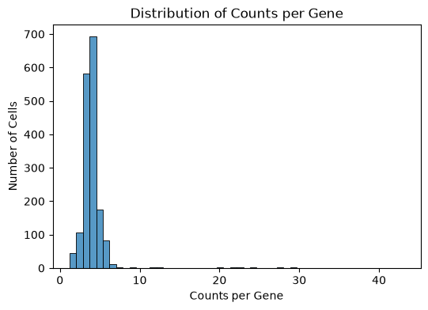
Figure 3. Counts-per-gene distribution across cells, raw data.
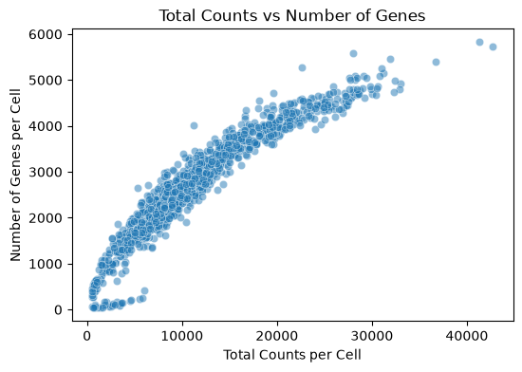
Figure 4. . Total counts vs. number of genes per cell (pre-filtering). The tight, near-linear relationship is expected ( cells with more RNA molecules tend to have more distinct genes detected, and the absence of a separate low-complexity population running along the x-axis is a good early sign that the data does not contain a large fraction of empty droplets)
Most cells sit in a nice, expected range (around 7,000-12,000 counts (figure1), roughly 2,000-3,000 genes(figure2)), but there is a long tail of cells with very high counts/genes(figure3), and on the low end a cluster of near-empty droplets. Splitting this by sample also showed the Leukemia sample has a wider spread and a heavier high-count tail than the Normal sample(figure5, violin plot).
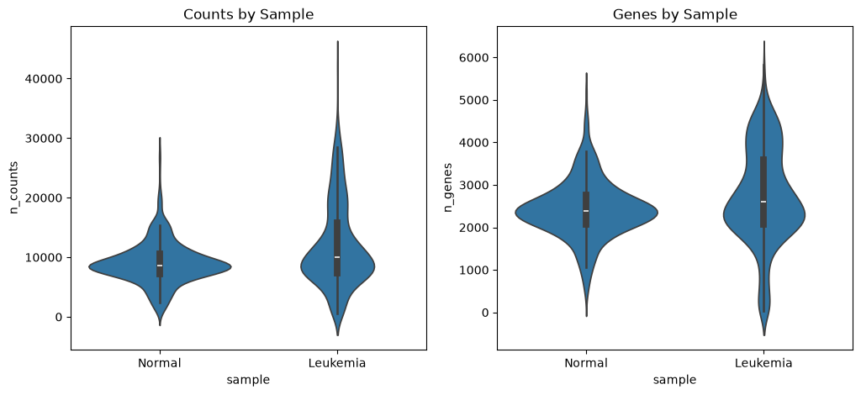
Figure 5. Counts and genes per cell, split by sample, before filtering.

3.2.2 After Filtration
A total of 13 mitochondrial genes and 103 ribosomal genes were identified in the reference. Cells were filtered using a combination of statistical (1st-99th percentile) and biological thresholds:
- n_counts, n_genes, counts_per_gene: kept between the 1st and 99th percentile (removes the most extreme outliers on either end, which are usually empty droplets or multiplets).
- pct_counts_mt < 15% (cells above this are likely stressed or dying).
- pct_counts_ribo < 60% (an unusually high ribosomal fraction can indicate a technical artefact or a very specific, low-complexity cell state). 40% was too strigent, removing a lot of cells (biological replicates) leading to 323 cells only.
After applying all filters together, 1,643 of the original 1,731 cells were retained (88 cells removed, ~5.1%). Filtering removed cells fairly evenly from both conditions rather than disproportionately gutting one sample:
Sample | Cells before QC | Cells after QC | Cells removed | % removed
Normal | 760 | 753 | 7 | 0.9%
Leukemia | 971 | 890 | 81 | 8.3%
That is a good sign: it means the sample prep going in was already fairly clean, and I was not throwing away a big chunk of the data. Of the 1,643 surviving cells, 890 are Leukemia and 753 are Normal.
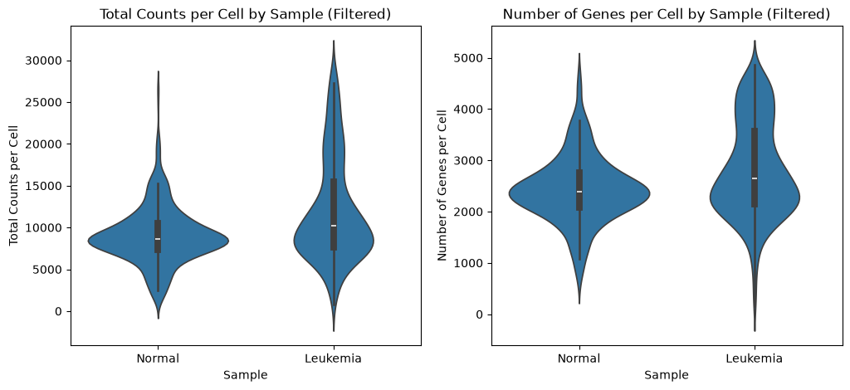
Figure 6. Counts and genes per cell, split by sample, after filtering, Leukemia cells show a visibly higher median and a wider spread for both metrics than Normal cells.
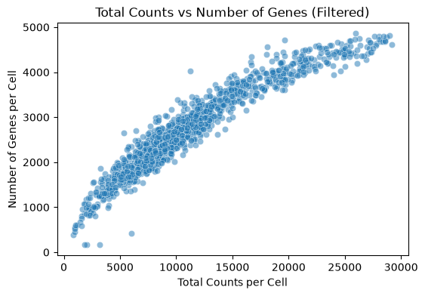
Figure 7. Total counts vs. number of genes after filtering ( the same clean, roughly linear relationship persists, confirming the filtering step removed outliers without distorting the overall structure of the data)

3.3 Normalization and Picking the Most Informative Genes
Normalization was done to correct for the fact that different cells were sequenced to different depths (some just have more total counts than others for purely technical reasons, not biological ones). Raw counts were frozen in adata_filtered.raw varaible before any transformation, so the original counts remain available for reference. Library-size normalization was then applied with sc.pp.normalize_total(target_sum=1e4), which scales each cell's counts so that all cells have the same total count (10,000), and then log1p-transformed to stabilise variance and compress the long right tail typical of count data. This log-normalized matrix was stored separately as a layer ('lognorm') so it stays accessible even after later steps (like scaling) overwrite the main .X matrix.
Out of 36,601 genes, the top 2,000 highly variable genes were selected using the Seurat flavor of sc.pp.highly_variable_genes(). Restricting downstream analysis (PCA, clustering) to HVGs focuses the signal on genes that actually vary meaningfully between cells, rather than being diluted by thousands of genes that are flat, lowly expressed, or dominated by technical noise.
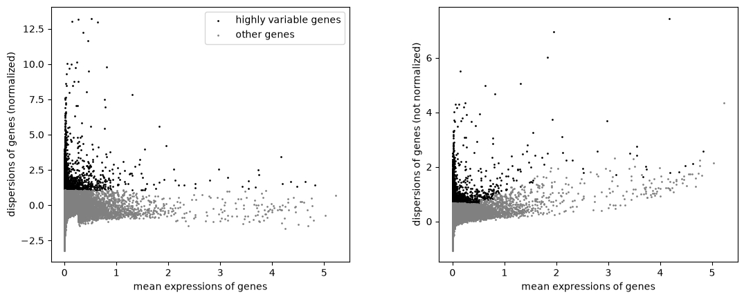
Figure 8. Mean expression vs. dispersion for every gene. Black points are the 2,000 genes selected as highly variable; grey points were excluded.

3.4. Scaling and Principal Component Analysis
The HVG-restricted matrix was z-score scaled (sc.pp.scale, capped at max_value=10 to limit the influence of extreme outlier values), then PCA was run with the arpack solver.Fifty principal components were computed. Interestingly, cumulative variance analysis showed that all 50 PCs were needed to reach 80% of total explained variance figure 10. When I plotted PC1 vs PC2 and coloured by sample, the Leukemia and Normal cells already separate quite noticeably showing the two conditions have a real, strong transcriptional difference, different cell states and it is not just noise.
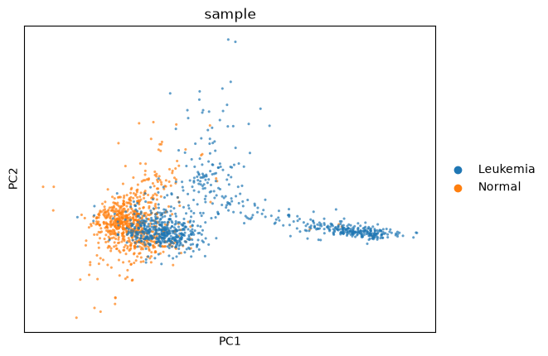
Figure 9. PC1 vs PC2, coloured by sample. Leukemia (blue) and Normal (orange) already form largely separate clouds, with a shared/overlapping region in the middle
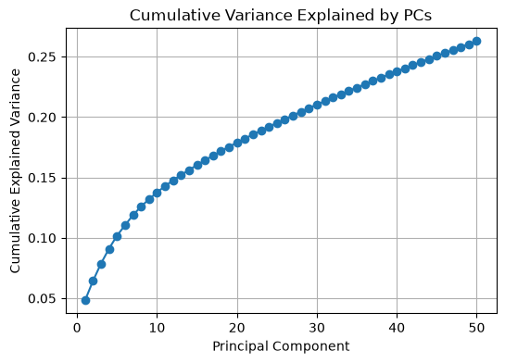
Figure 10. Cumulative variance explained as more principal components are added.
I pulled the top loading genes for the first 5 PCs and looked at how they behave across the two samples in a heatmap, this is a useful sanity check before clustering, because it shows the HVGs are not random.
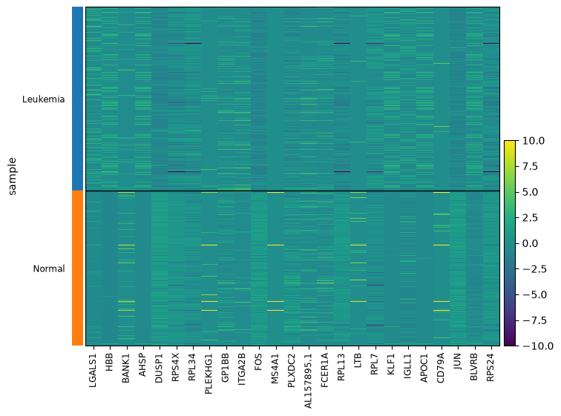
Figure 11. Heatmap of the top loading genes from PCs 1–5, split by sample. Leukemia (top block) and Normal (bottom block) show visibly different expression patterns across these genes, consistent with the PCA separation above.

3.5 Neighbourhood Graph and UMAP

A k-nearest-neighbour graph was built (n_neighbors=15, using the first 30 PCs), and UMAP was computed from this graph (min_dist=0.3, spread=1.0) to visualise cell relationships in two dimensions.
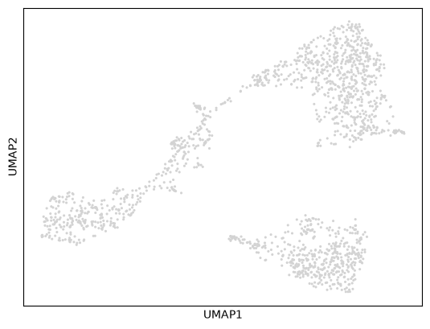
Figure 12. Plain UMAP layout, no colouring — three main groups and a connecting bridge are already visible just from the shape.
Colouring the same UMAP by sample makes the split extremely clear: the top-right group is almost entirely Normal cells, while the left and bottom-right groups are almost entirely Leukemia cells, with a narrow bridge of cells connecting them in the middle.
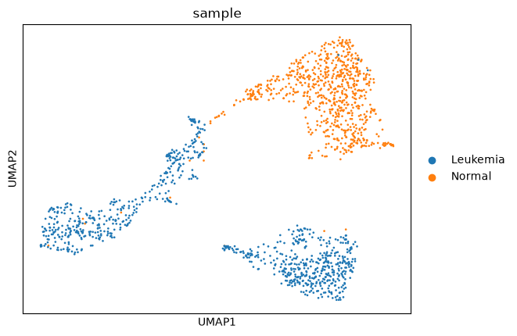
Figure 13. UMAP coloured by sample — Normal (orange) sits in one region, Leukemia (blue) occupies the other two.

3.6 Leiden Clustering
For the actual clustering I used the Leiden algorithm, which is the current standard for scRNA-seq. I tested four resolutions — 0.2, 0.3, 0.4 and 0.6 — to see how the clusters split as resolution increases:
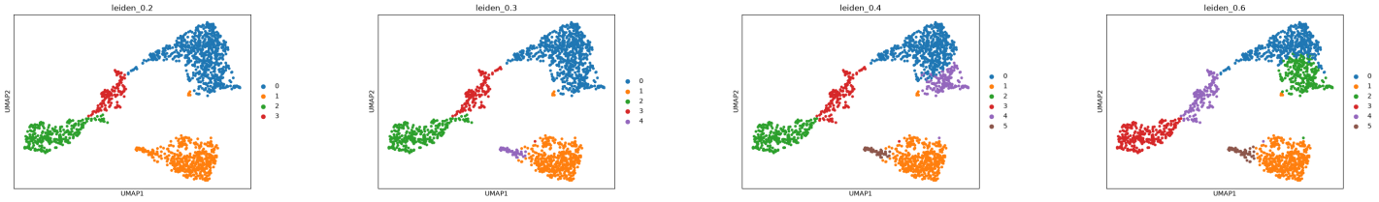
Figure 14. Leiden clustering at four resolutions (0.2, 0.3, 0.4, 0.6) on the same UMAP.
At resolution 0.2 I get 4 clusters, and pushing to 0.6 mostly just splits one of the small clusters further without changing the overall picture. I settled on resolution 0.3 as my final clustering, because it gives clean, well-separated clusters that already line up with the visible UMAP structure, without over-splitting the data into artificially small groups. That gave me 5 clusters:
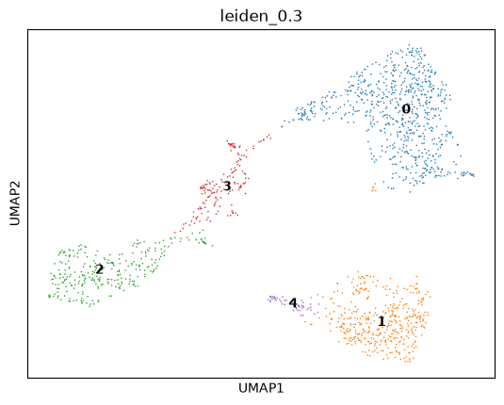
Figure 15. Final Leiden clustering at resolution 0.3 — clusters 0–4.
Leiden cluster | Number of cells
0 | 728
1 | 423
2 | 287
3 | 155
4 | 50

3.7. Marker Gene Identification
For each Leiden cluster, marker genes were identified with the Wilcoxon rank-sum test (sc.tl.rank_genes_groups, using the log-normalized layer), comparing each cluster against all others. The full result (183,006 gene-cluster comparisons) was filtered down to a 'gold-standard' marker set using four criteria: adjusted p-value ≤ 0.05, |log2 fold-change| ≥ 1, expressed in at least 25% of cells in that cluster, and expressed in no more than 25% of cells outside that cluster (pct_nz_group ≥ 0.25, pct_nz_reference ≤ 0.25). That last pair of cutoffs is what actually makes a gene a good marker — it is not enough for a gene to be “significant”, it needs to be reasonably specific to that one cluster.
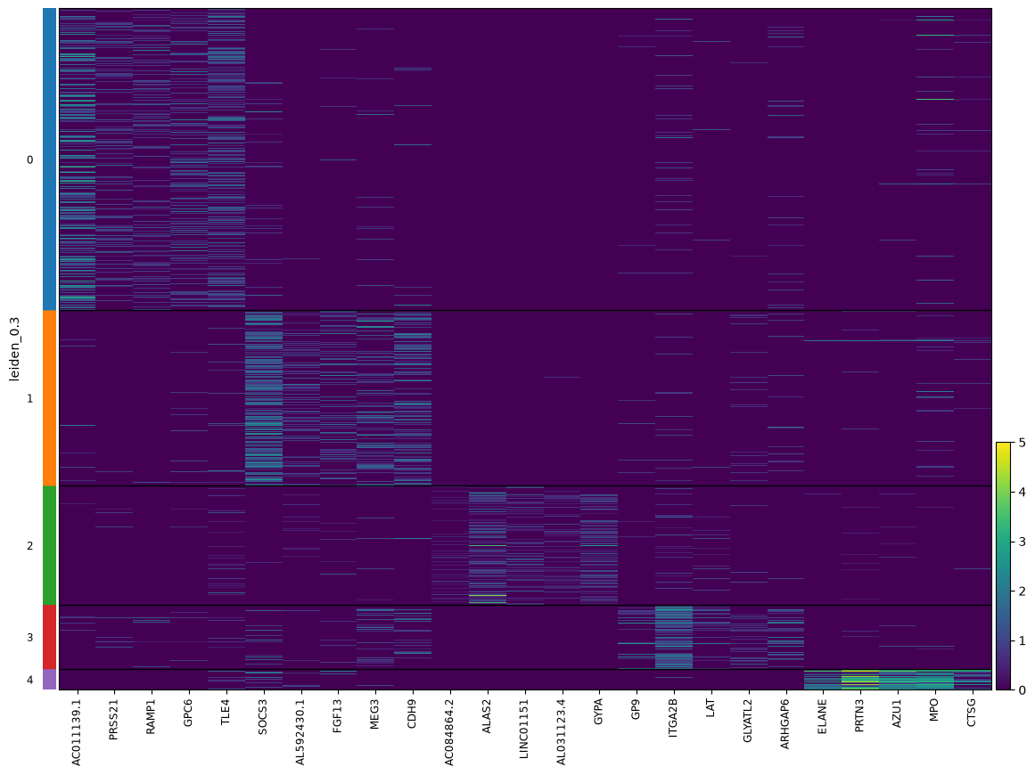
Figure 16. Heatmap of the top marker genes per cluster (top 5 markers by log fold-change, per cluster). The block-diagonal pattern shows each cluster has a distinct, largely non-overlapping marker signature.
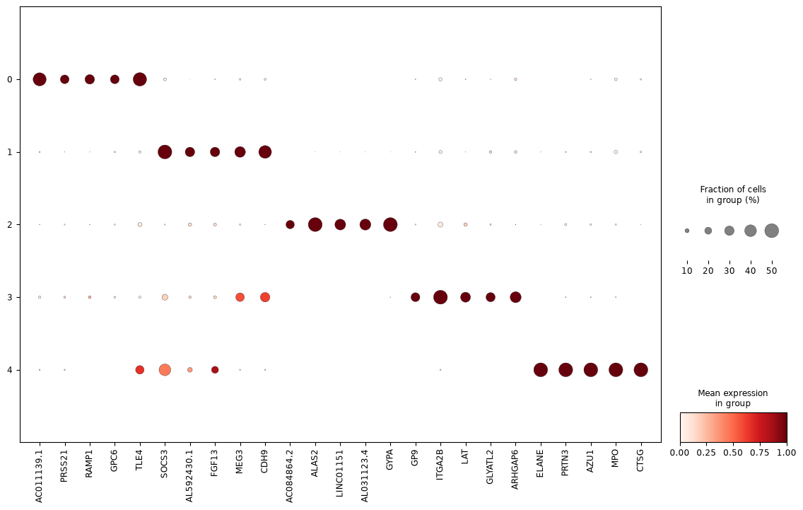
Figure 17. Dot plot of the same marker genes: dot size reflects the fraction of cells expressing the gene, colour reflects mean scaled expression. This view makes cluster specificity easier to read at a glance than the heatmap.

Cluster | Cells no. | Top marker genes | Interpretation
0 | 728 | HLA-DRB5, AC011139.1, TLE4 | Normal-dominant HSC/MPP-like population
1 | 423 | SOCS3, BAALC, LGALS1, PRKG1 | Leukemia HSC/MPP-like; BAALC is a known AML prognostic marker
2 | 287 | APOC1, AHSP, HBA1, KLF1 | Erythroid lineage (haemoglobin synthesis genes)
3 | 155 | ITGA2B (CD41), FCER1A, PLEK | Megakaryocyte lineage (platelet genes)
4 | 50 | AZU1, MPO, PRTN3, ELANE | Myeloid progenitor / granulocyte primary-granule genes

3.8. Automated Cell Type Annotation with CellTypist
Cluster identity was cross-checked using CellTypist, an automated cell-type classifier trained on reference atlases. Because this dataset is human bone marrow / haematopoietic tissue, the Immune_All_Low.pkl model was used. Majority-voting was enabled so that each Leiden sub-cluster gets a single consensus label rather than noisy per-cell calls.
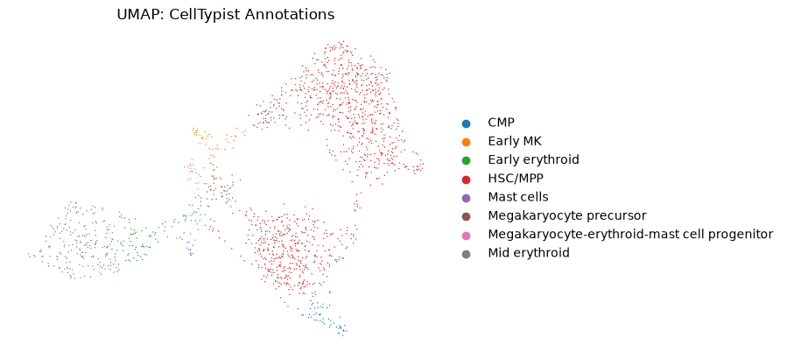
Figure 18. UMAP coloured by the CellTypist cell type call for every cell.
This confirmed the marker-gene reading almost exactly. Cross-tabulating the CellTypist labels against my Leiden clusters:
Cluster | CMP | Early MK | Early eryth. | HSC/MPP | Mast | MK precursor | MEMP | Mid eryth.
0 | 0 | 2 | 0 | 678 | 0 | 48 | 0 | 0
1 | 4 | 0 | 0 | 418 | 0 | 1 | 0 | 0
2 | 0 | 0 | 89 | 0 | 21 | 0 | 0 | 177
3 | 0 | 48 | 34 | 8 | 0 | 45 | 20 | 0
4 | 49 | 0 | 0 | 1 | 0 | 0 | 0 | 0

Cross-tabulating these CellTypist labels against the Leiden clusters confirmed excellent agreement between the two independent methods: Cluster 0 and Cluster 1 are almost entirely HSC/MPP, Cluster 2 is dominated by Early and Mid erythroid cells (plus mast cells), Cluster 3 is a mixed megakaryocyte/erythroid progenitor cluster, and Cluster 4 corresponds almost one-to-one with CMP — matching the MPO/ELANE/PRTN3/AZU1 granulocyte-primary-granule marker genes found for that cluster in Section 4.8. The two independent approaches (unsupervised clustering + marker genes, versus supervised reference-based annotation) converge on the same biological picture, which is reassuring.
Overall cell type composition across both samples combined:
Cell type | Cells (both samples)
HSC/MPP | 1,105
Mid erythroid | 177
Early erythroid | 123
Megakaryocyte precursor | 94
CMP | 53
Early MK | 50
Mast cells | 21
MEMP | 20
The sample split for each cell type is where the leukemia biology really shows up:
Cell type | Leukemia | Normal
CMP | 52 | 1
Early MK | 38 | 12
Early erythroid | 121 | 2
HSC/MPP | 422 | 683
Mast cells | 20 | 1
Megakaryocyte precursor | 46 | 48
MEMP | 16 | 4
Mid erythroid | 175 | 2
The Leukemia sample is heavily skewed toward CMP, Early MK, Early erythroid, Mast cells and Mid erythroid — cell types that are almost completely absent from the Normal sample. That is consistent with what leukemia actually does: it blocks normal differentiation and causes an abnormal build-up of cells stuck at particular progenitor stages, rather than a smooth, evenly-populated maturation pipeline the way a healthy marrow has.

3.9. Differential Expression: Leukemia vs. Normal, per Cell Type
The most important biological question — which genes actually differ between Leukemia and Normal cells — was addressed by comparing sample condition within each CellTypist-annotated cell type separately, using the Wilcoxon test again (Normal set as the reference group), and called a gene significant if adjusted p-value ≤ 0.05 and |log2 fold-change| ≥ 1. I only did this for cell types where I had at least 10 cells in both conditions — otherwise the statistics are not trustworthy. That left three cell types with a valid comparison: HSC/MPP, Megakaryocyte precursor, and Early MK. The other cell types (CMP, Early erythroid, Mast cells, MEMP, Mid erythroid) had too few Normal cells to compare fairly, since they were almost entirely Leukemia-specific to begin with.

3.9.1 HSC/MPP (422 Leukemia cells vs 683 Normal cells)
This is by far the biggest and most statistically powered comparison, since HSC/MPP is the largest cell type in both samples. It turned up 302 significant genes — 150 upregulated and 152 downregulated in Leukemia relative to Normal, a very even split.
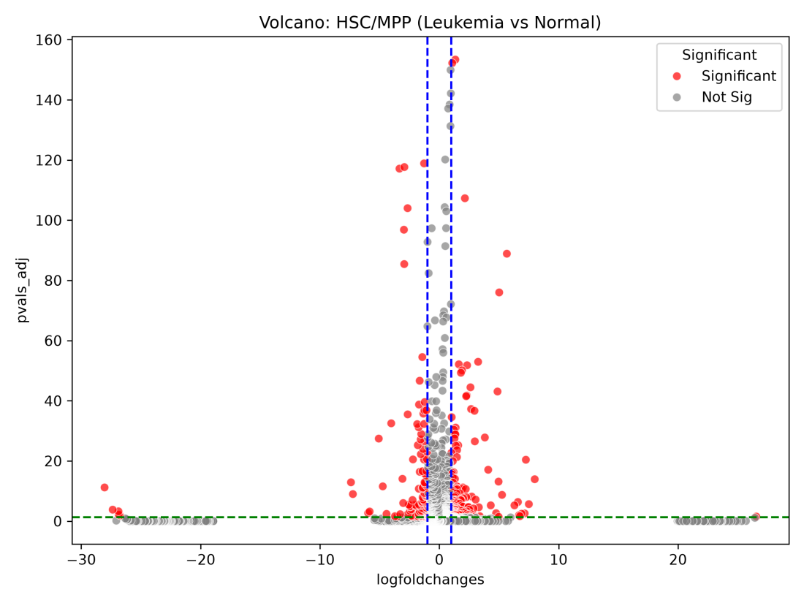
Figure 19. Volcano plot, HSC/MPP: Leukemia vs Normal. Red = significant (|log2FC| ≥ 1, padj ≤ 0.05).
Top genes upregulated in Leukemia HSC/MPP cells (ranked by test statistic):
Gene | log2FC (Leuk vs Norm) | Adj. p-value
RPS26 | +1.35 | 4.1e-154
RPL36 | +1.09 | 5.8e-153
GIHCG | +2.15 | 5.0e-108
HBB | +5.66 | 1.3e-89
SOCS3 | +5.02 | 9.9e-77
Top genes downregulated in Leukemia HSC/MPP cells:
Gene | log2FC (Leuk vs Norm) | Adj. p-value
MT-ND2 | -1.27 | 1.3e-119
FOS | -2.93 | 2.2e-118
JUN | -3.33 | 7.2e-118
DUSP1 | -2.66 | 1.0e-104
EIF5A | -2.96 | 1.4e-97
FOS, JUN and DUSP1 dropping together is a pattern I recognise — these are immediate-early response genes, normally switched on transiently when a cell responds to a signal or stress. Leukemic HSC/MPP cells losing this signature fits with a stem/progenitor population that has become locked into an abnormal, less-responsive state instead of behaving like normal, dynamically-regulated stem cells. On the other side, HBB (haemoglobin beta) showing up as strongly upregulated in what is supposed to be an undifferentiated HSC/MPP cluster is a sign of some erythroid-lineage priming leaking into this compartment in leukemia.

3.9.2 Megakaryocyte precursor (46 Leukemia cells vs 48 Normal cells)
A much smaller, more balanced comparison (roughly equal cell numbers in each condition), giving 80 significant genes — 47 up and 33 down in Leukemia.
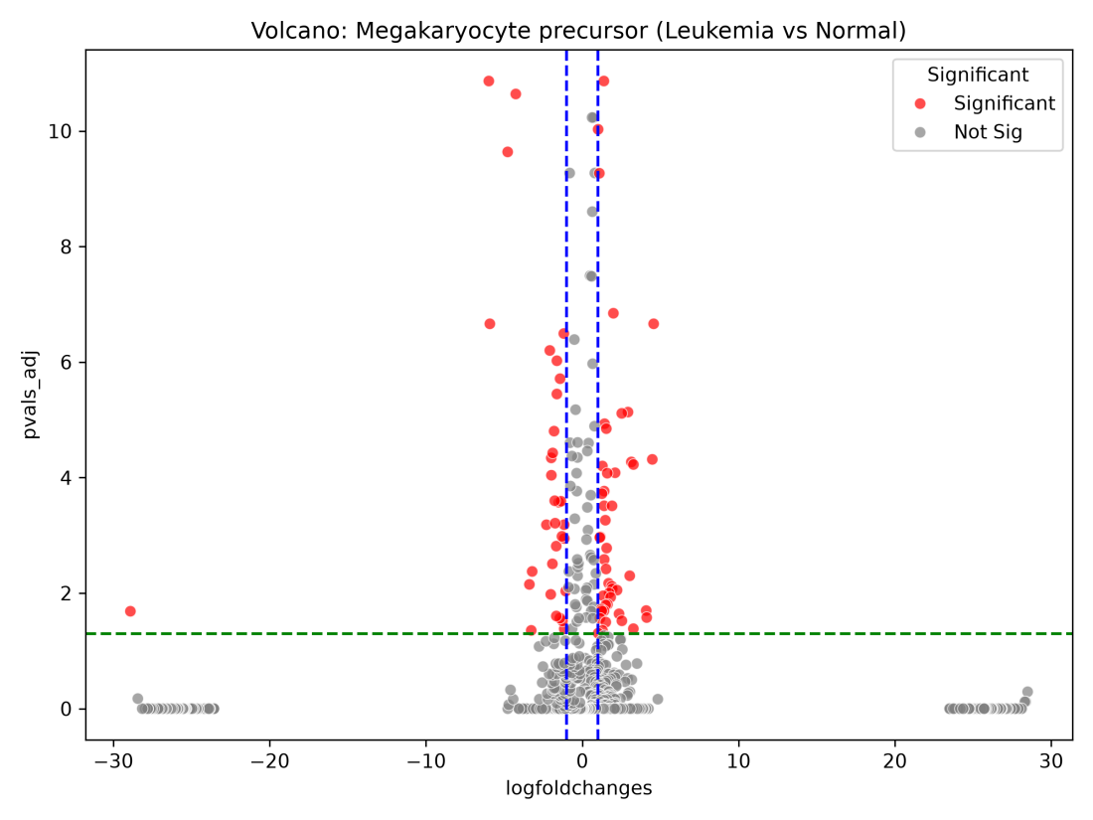
Figure 20. Volcano plot, Megakaryocyte precursor: Leukemia vs Normal.
Top upregulated genes in Leukemia:
Gene | log2FC (Leuk vs Norm) | Adj. p-value
RPS26 | +1.38 | 1.4e-11
RPL36 | +1.01 | 9.4e-11
B2M | +1.09 | 5.4e-10
PDLIM1 | +1.99 | 1.4e-7
HBB | +4.56 | 2.2e-7
Top downregulated genes in Leukemia:
Gene | log2FC (Leuk vs Norm) | Adj. p-value
DUSP1 | -5.98 | 1.4e-11
FOS | -4.26 | 2.3e-11
JUN | -4.77 | 2.3e-10
AC011139.1 | -5.91 | 2.2e-7
ZFAS1 | -1.18 | 3.2e-7
The exact same FOS/JUN/DUSP1 downregulation shows up here too, in a completely different cell type — which makes me trust the pattern more, not less, because it means it isn't a fluke of one cell type's statistics. It looks like a shared feature of the leukemic marrow environment across multiple progenitor populations, rather than something specific to one lineage.

3.9.3 Early MK (38 Leukemia cells vs 12 Normal cells)
This comparison has the smallest and most unbalanced cell numbers of the three, so I expected, far fewer significant genes: only 2 passed both cutoffs, HBD (log2FC +6.37, padj 0.027) and RPS26 (log2FC +1.14, padj 0.027). With only 12 Normal cells in this group, the test has much less statistical power, so this result should be read as suggestive rather than conclusive — I would not over-interpret the small number of hits here as “nothing is happening”, it more likely reflects the small sample size than a genuinely quiet comparison.
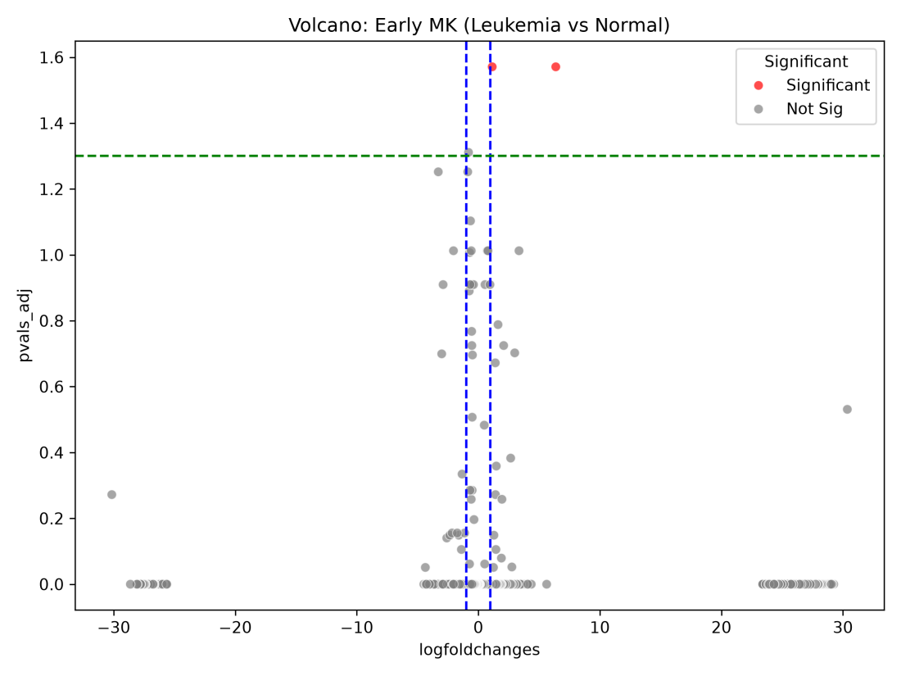
Figure 21. Volcano plot, Early MK: Leukemia vs Normal — note the small number of points overall, reflecting the smaller cell numbers in this comparison.
HBD (haemoglobin delta) being the top hit again points to erythroid-programme genes bleeding into the megakaryocyte-erythroid branch in leukemia, echoing what I already saw in HSC/MPP with HBB.

Discussion
Bringing all of the analysis together, several consistent threads emerge. First, at the whole-sample level, Leukemia and Normal cells separate almost completely on both PCA and UMAP, and Leiden clustering — run with no knowledge of which sample each cell came from — independently rediscovers this same split, plus subdivides the Leukemia population into several transcriptionally distinct sub-states (megakaryocyte-leaning, erythroid-leaning, and CMP/granulocyte-primed) that have no real counterpart among the Normal cells. This suggests the Leukemia sample is not simply 'more of the same' cells as Normal, but instead contains an expanded and more heterogeneous progenitor compartment, consistent with the general biology of leukemia as a disease of blocked, aberrant differentiation.
Second, the automated CellTypist annotation and the manual marker-gene-based interpretation of Leiden clusters agreed closely, which gives good confidence in the cluster identities reported here — particularly the erythroid cluster (KLF1, AHSP, HBA1), the megakaryocyte cluster (ITGA2B/CD41, PLEK), and the CMP/granulocyte-primed cluster (MPO, ELANE, PRTN3, AZU1).
Third, the direct Leukemia-vs-Normal differential expression results, while limited to the three cell types with adequate cell numbers on both sides, produced biologically plausible signals — most notably the coordinated down-regulation of JUN/FOS/DUSP1 in Leukemia megakaryocyte precursors, and the presence of BAALC (a known adverse-prognosis AML marker) as a top marker of the largely Leukemia-specific Cluster 1.

5. Conclusion
Starting from 1,731 raw cells across a Leukemia and a Normal bone marrow sample, I filtered down to 1,643 high-quality cells, reduced them to their 2,000 most informative genes, and used PCA, Leiden clustering and CellTypist to resolve them into 5 clusters covering 8 distinct hematopoietic cell types. Comparing Leukemia against Normal within each well-populated cell type turned up hundreds of differentially expressed genes in the stem/progenitor compartment (HSC/MPP) and dozens in the megakaryocyte lineage, with a consistent signature of lost immediate-early gene expression and abnormal erythroid-gene activation running through multiple cell types. Together, this paints a picture of a leukemic marrow that is not just “more of the same cells” but a genuinely disrupted differentiation landscape, at both the composition level and the gene-expression level, within the cell types that are shared between the two samples.

