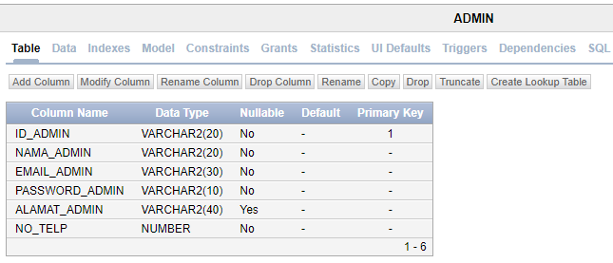

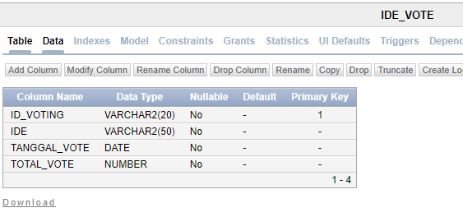

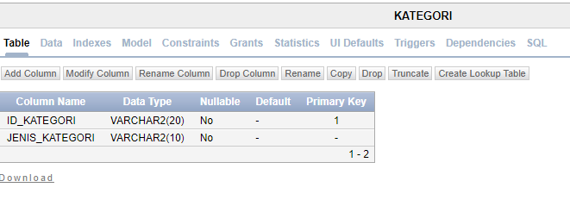

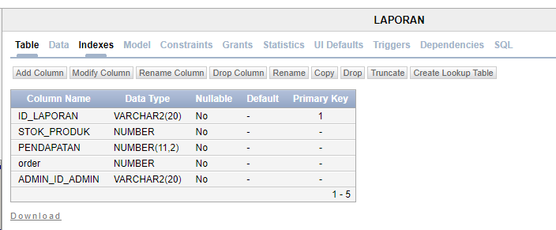

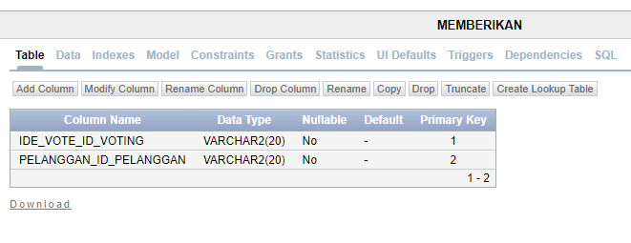

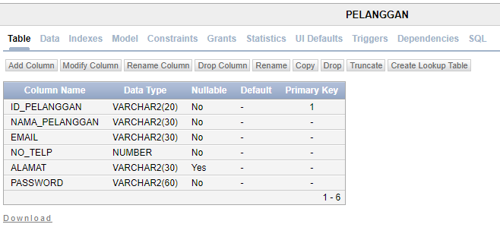

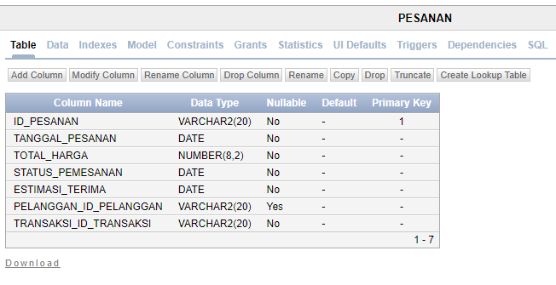

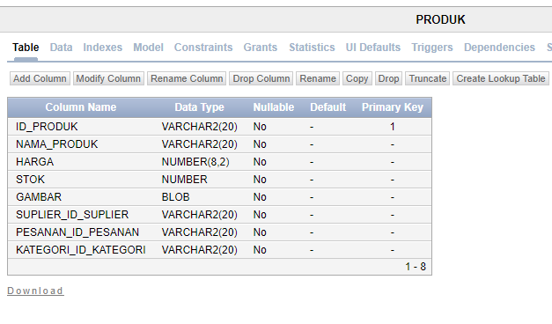

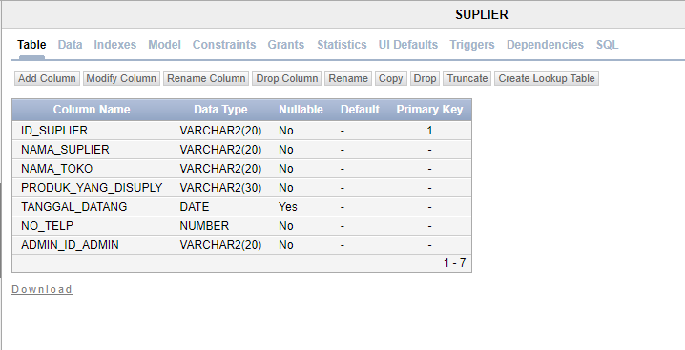

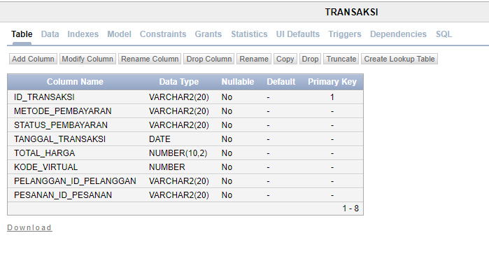

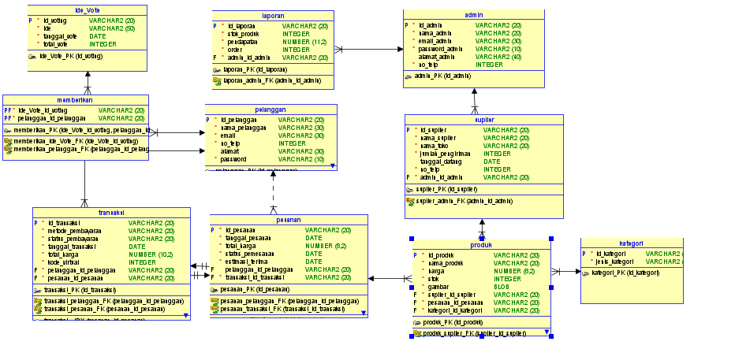

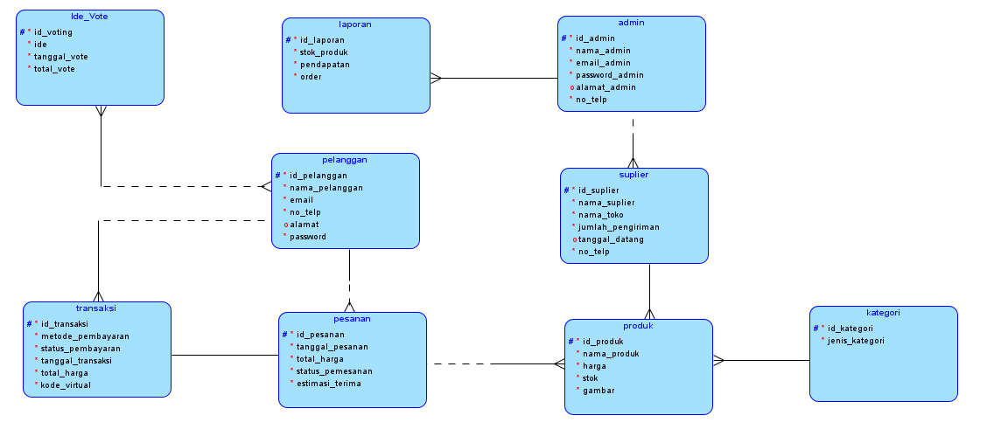

REF YOUTUBE:

<https://youtu.be/_CNM6ie-PwQ?si=uLZH0JQ8nlpKekro> (INSTAL XAMPP, OCI8, ORACLE INSTAN CLINET SESUAIIN AMA WINDOWS KALIAN)

<https://www.youtube.com/watch?v=BNPMcuxyRLU>

<https://www.youtube.com/watch?v=jyAfY6oz5u0>

<https://www.youtube.com/watch?v=WxOFKTBsw_k>