

Faculty of Engineering and Technology

Electrical and Computer Engineering Department

Computer Networks Laboratory ENCS4130

**Dynamic Routing 2 EXP. No. 4**

Prepared by : Ansam Osama Hababeh

ID Number : 1201127

Instructor : Dr.Ahmad Shawahneh

Teaching Assistant : Eng.Ahed Mafarjeh

Section : 7

Birzit

20November – 2022

# **Abstract**

This experiment aims to understand how to construct a network topology using a PC and a router, and how to set up and confirm IP routing using Cisco routers, as well as dynamic routing using the Open Shortest Path First (OSPF) protocol.

# **Table of Contents**

Contents

**Abstract** I

**Table of Contents** II

**1.** **Introduction** 1

**1.1 Dynamic Routing** 1

**1.2 OSPF** 1

**1.3 routing Hierarchy** 2

**1.4 Loopback Router Interfaces** 2

**1.5 Route Summarization** 2

**2.** **Procedure and Discussion** 3

**2.1** **Building the topology** 3

**2.2 configure IPS** 4

**2.2** **Loopback configuration** 8

**2.3** **Configuring OSPF Routing** 9

**2.4** **Changing the cost** 10

**2.5** **Summarization** 11

**2.6** **ping to loopback** 12

**2.7** **Important Questions** 12

**2.7.1Why do we need for loopback interfaces?** 12

**2.7.2 What is the router-id for OSPF? And why do we need it?** 13

**2.7.3 Hardcode the router-id for R1, R2, and R3 as 1.1.1.1, 2.2.2.2, and 3.3.3.3 respectively. And Verify that.** 13

**3.Task** 14

**4.Problem** 16

**4.1 Part One** 16

**4.1.1 Dijkstra’s algorithm** 16

**4.1.2 Shortest path** 16

**4.2 Part Two** 17

**4.2.1 build the topology** 17

**4.2.2 Ip configuration** 17

**4.2.3 ospf** 18

**4.2.4 Configure bandwidth values between links** 19

**4.2.5 Configure Router 6 with a loopback IP address 7.7.7.7/24** 20

**5. Conclusion** 22

**6. References** 23

# **Table of Figures**

Figure 1:Commands to configure OSPF 1

Figure 2:How to use Router summarization 3

Figure 3: My Topology 3

Figure 4:router 0 ip configuration 5

Figure 5:router 1 ip configuration 5

Figure 6:router 2 ip configuration 6

Figure 7:router 3 ip configration 6

Figure 8:ip for pc 0 7

Figure 9: ip for pc4 7

Figure 10:test bing 8

Figure 11:loopback for router 2 9

Figure 12:OSPF router 2 10

Figure 13:path from pc0 to 1 11

Figure 14:ping to loopback 12

Figure 15:Configure Router-ID Manually 13

Figure 16:Show Router-ID 14

Figure 17:path 15

Figure 18:task path 16

Figure 19:Topology 17

Figure 20:ips 18

Figure 21:ospf for router 2 19

Figure 22:bandwidth 20

Figure 23:loopback 20

Figure 24:show cost 21

# **Table of Tables**

Table 1:Networks IPS 10

Table 2:Dijkstra’s algorithm……………………………………………………………………………...22

# **Introduction**

## **1.1 Dynamic Routing**

In order for the process of dynamic information exchange between routers, dynamic routing protocols are used. Its implementation allows the network topology to dynamically adapt to changing network conditions, and to ensure that effective and frequent routing continues despite any changes. Its work depends on choosing the best path that the data packet should follow through network to reach a specific destination. It also uses two algorithms distance vector protocols and link state protocols to calculate multiple possible paths to choose the path, The advantages of dynamic routing are that it works to reduce errors that result from the exchange of information and has a high scalability with lower administrative overhead costs.[1]

## **1.2 OSPF**

OSPF functions as a dynamic routing protocol based on the link-state routing principle. Routers in this protocol share detailed topology information with their nearest neighbors, which is then distributed throughout the autonomous system (AS) to ensure that every router within the AS comprehensively understands the network's topology. By using a variation of the Dijkstra algorithm, OSPF calculates the most efficient paths from source to destination within the AS. Consequently, in a link-state routing protocol like OSPF, the next hop address for data forwarding is determined by selecting the best end-to-end path to reach the final destination. The protocol provides the advantage of comprehensive knowledge of the network topology, allowing routers to calculate optimal routes based on specific criteria. However, its scalability becomes challenging as more routers are added to the network. With an increased number of routers, the size and frequency of topology updates grow, and the time required to compute end-to-end routes also lengthens. As a result, link-state routing protocols like OSPF are generally not well-suited for routing over the Internet, where large-scale networks demand efficient routing protocols capable of handling the complexities of the global routing table.[2]

The Figure shows the commands that we used to configure OSPF routing for a simple router

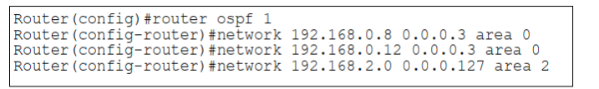

Figure 1:Commands to configure OSPF

## **1.3 routing Hierarchy**

In order to enhance OSPF scalability and minimize routing traffic, an Autonomous System (AS) is divided into multiple areas or subdomains. One specific area, known as area 0 or the backbone area, acts as the central hub and is connected to all other non-backbone areas. This connection can be established either physically or virtually using a virtual link. It is crucial that the backbone area remains contiguous and is never partitioned.To determine membership in an area, a router must have at least one interface operating within that specific area. By doing so, routers only maintain detailed knowledge about the network topology within their respective areas, which helps reduce the size of the database. A router that belongs to multiple areas is referred to as an Area Border Router (ABR). ABRs play a vital role in inter-area routing, which involves routing between different areas. It is important to note that all inter-area routes must pass through the backbone area.[3]

## **1.4 Loopback Router Interfaces**

A loopback interface is a virtual interface created on Layer 3 devices like routers, L3 switches, or firewalls. It doesn't require physical connections and is assigned an IP address. Loopback interfaces are used for network testing, management, routing, and protocol advertisement. They provide a stable endpoint for network services and can be configured with features like ACLs and routing protocols. Overall, loopback interfaces enhance network functionality and resource management.[4]

## **1.5 Route Summarization**

Route summarization, also known as route aggregation, is a technique used to minimize the number of routing tables in an IP network. It involves consolidating multiple routes into a single summarized route advertisement. This is in contrast to flat routing, where each route has a unique entry in the routing table. By summarizing routes, a group of contiguous routes is advertised as a single aggregated route. The contiguous routes must be adjacent or adjoining for this feature to work effectively. The importance of route summarization lies in its ability to reduce the size of routing updates. Without summarization, a router would need to include specific lines for each individual route in its update packet. As the number of routes increases, so does the packet size and the amount of bandwidth consume. This can limit available bandwidth for actual data transfer. Route summarization addresses this issue by allowing multiple routes to be advertised with just one line in the update packet. By reducing the packet size, more bandwidth is available for data transfer, improving overall network efficiency.

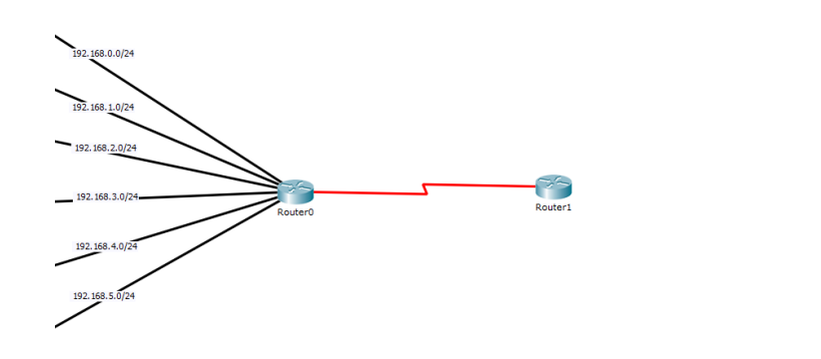

Figure 2:How to use Router summarization

# **Procedure and Discussion**

## **Building the topology**

The topology shown in Figure 3 has been built . Router-PT has been used for the routers and Switch-PT for the switches and PC-PT for PCs. Automatically connection type has been used for the connections between the PCs, switches and routers.

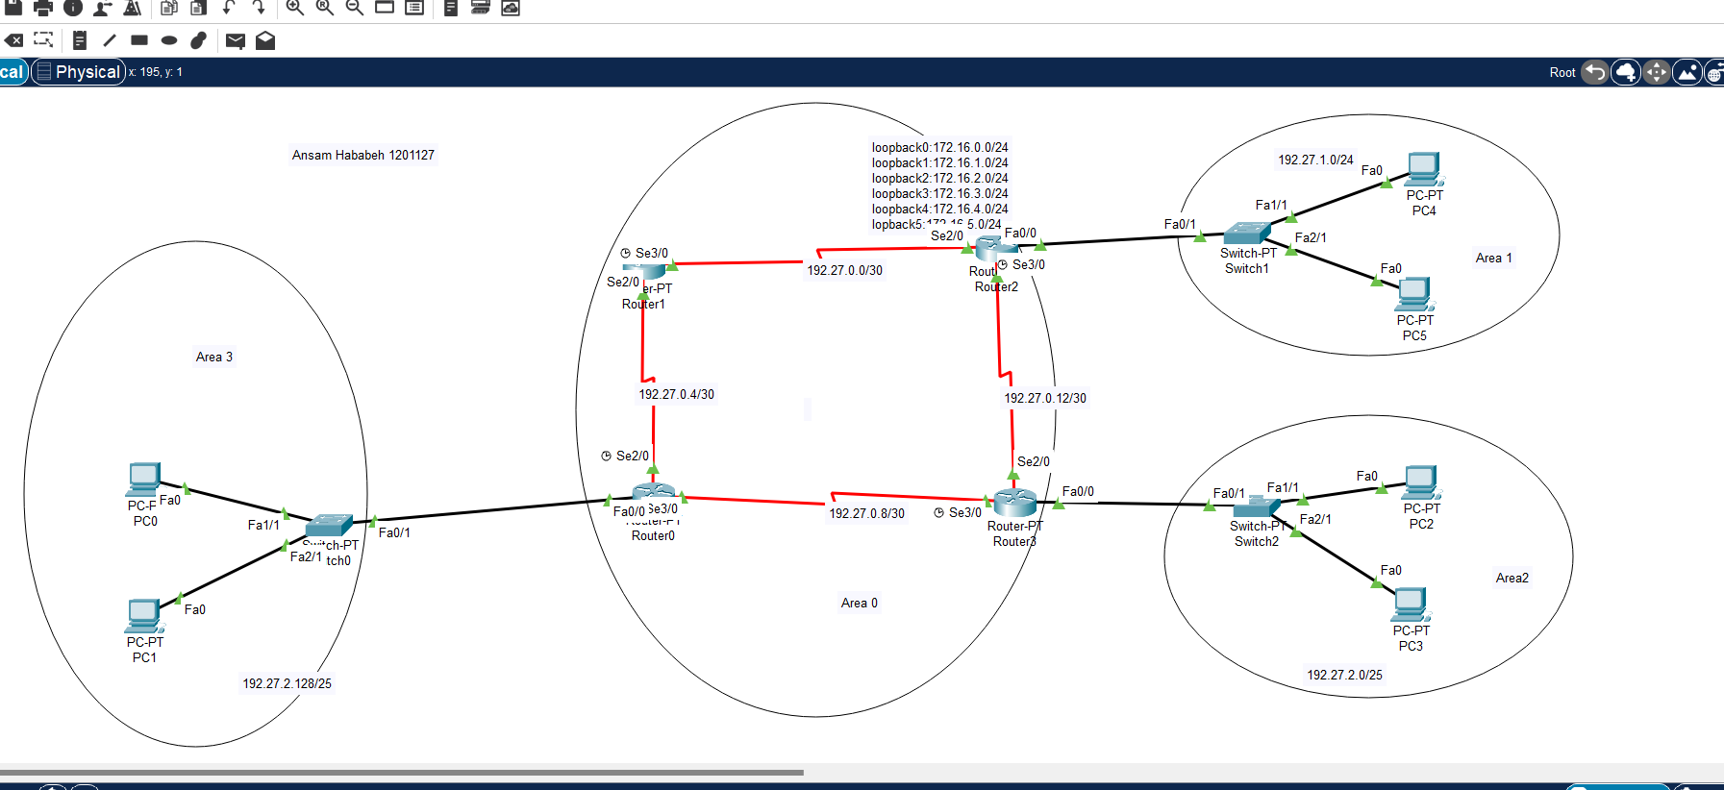

Figure 3: My Topology

## **2.2 configure IPS**

Table 1:Networks IPS

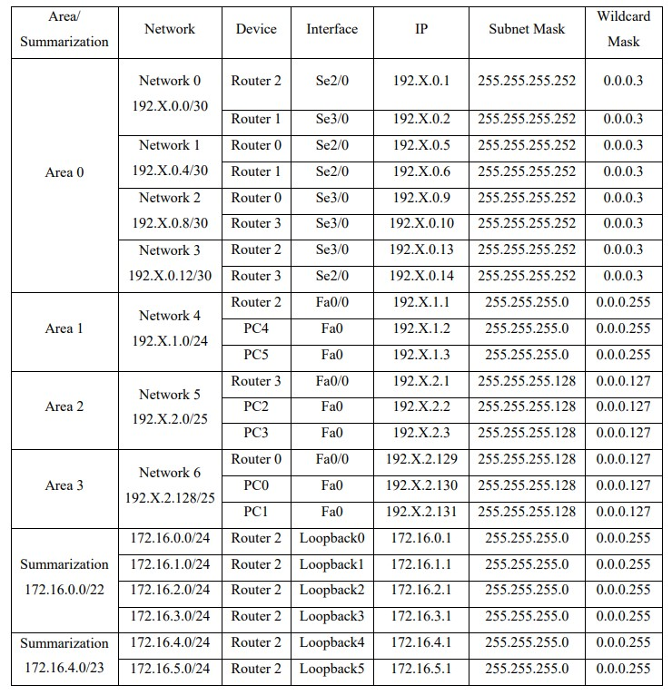

My ID is 1201127 so X=27

to configure the IPs for Routers we used this :

Router>enable Router

Router#

Router#configure

Configuring from terminal, memory, or network [terminal]? Enter configuration commands, one per line. End with CNTL/Z.

Router(config)#

Interface <TYPE> <SLOT> /<PORT> ip address <IP-ADDRESS> <SUBNET-MASK>

Router(config-if)#no shutdown So here the result for all router:

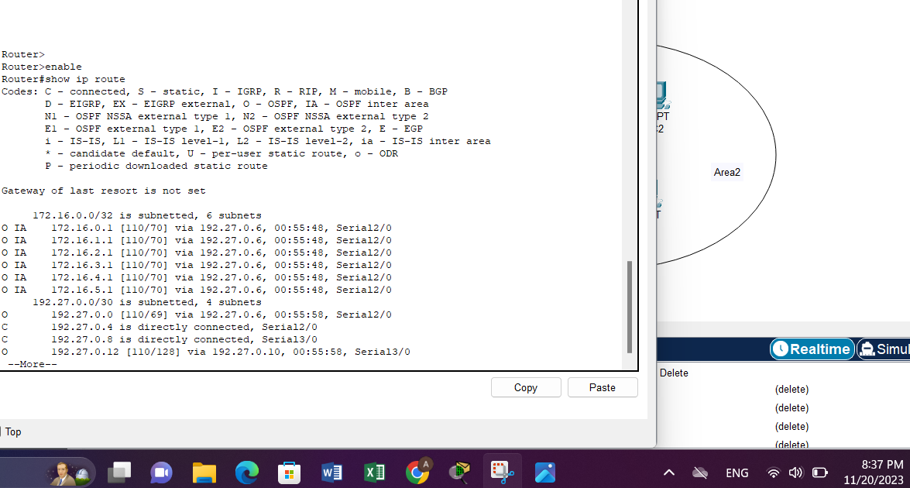

Figure 4:router 0 ip configuration

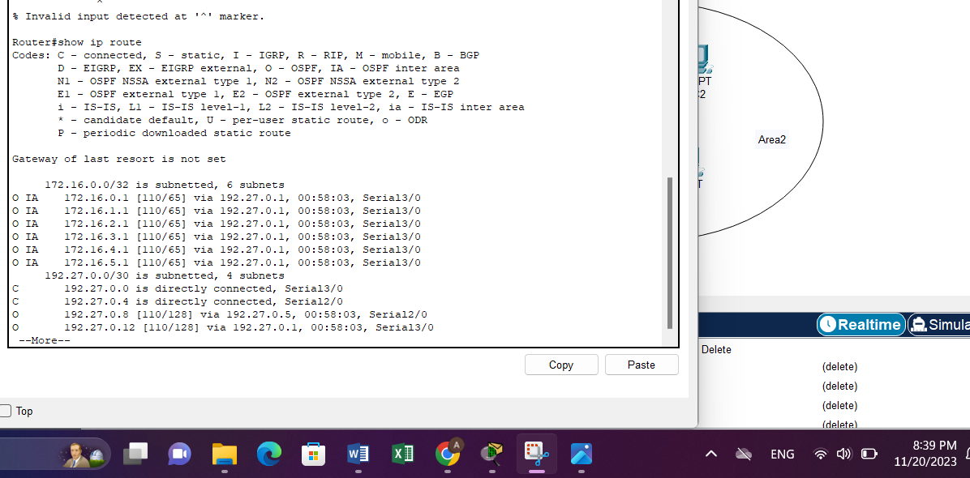

Figure 5:router 1 ip configuration

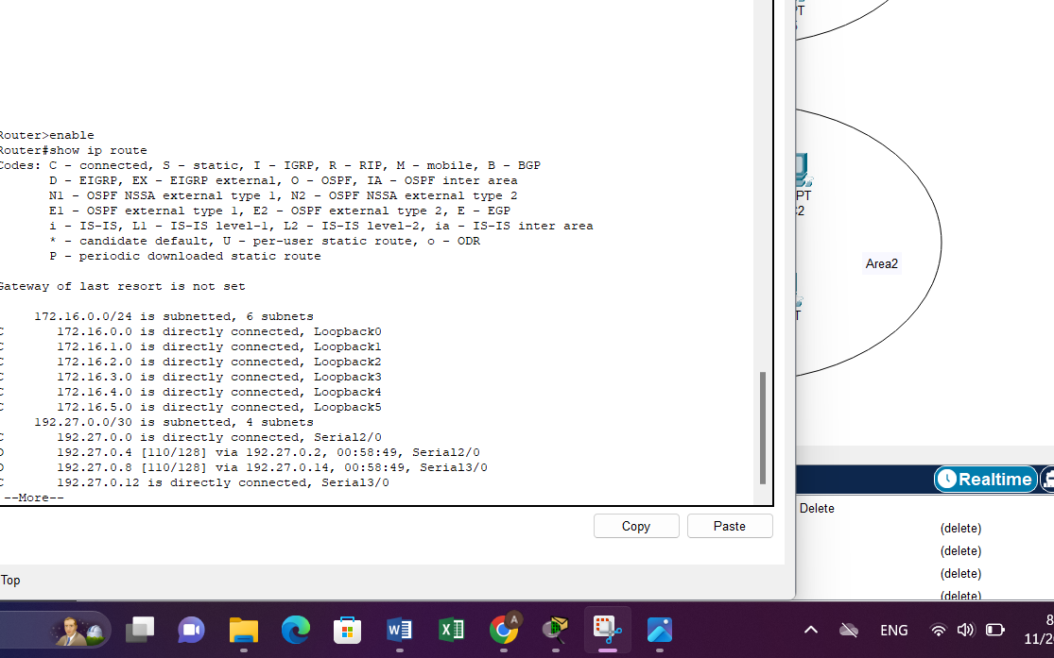

Figure 6:router 2 ip configuration

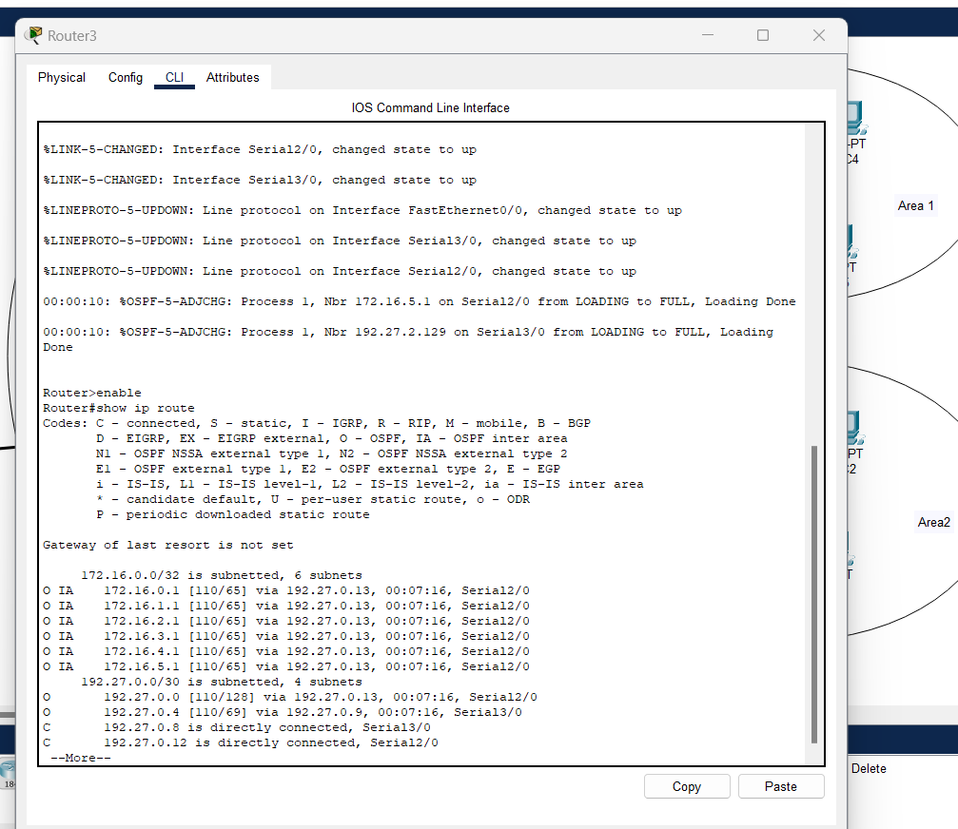

Figure 7:router 3 ip configration

And these for pc:

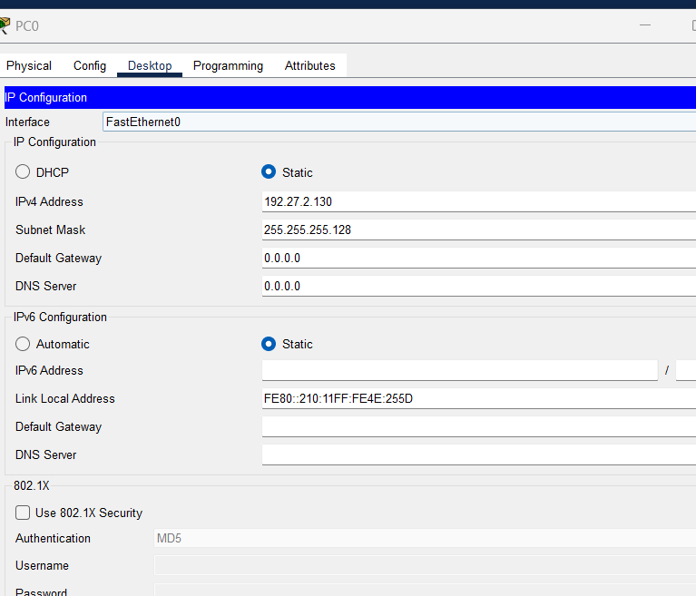

Figure 8:ip for pc 0

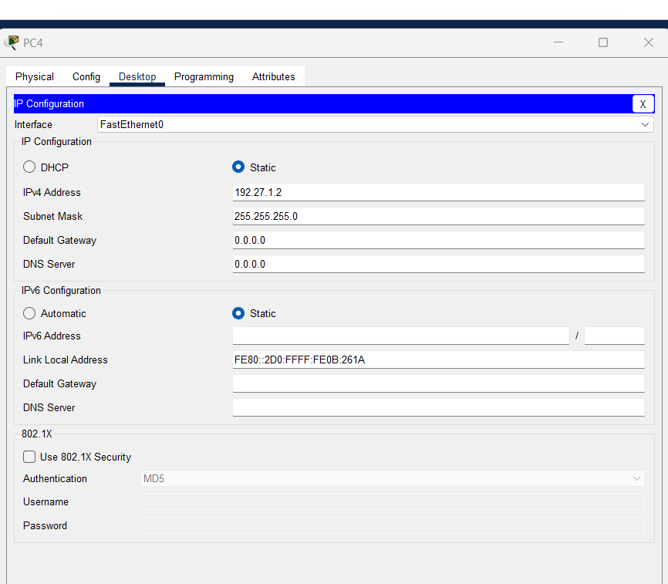

Figure 9: ip for pc4

Here the test bing between pc’s:

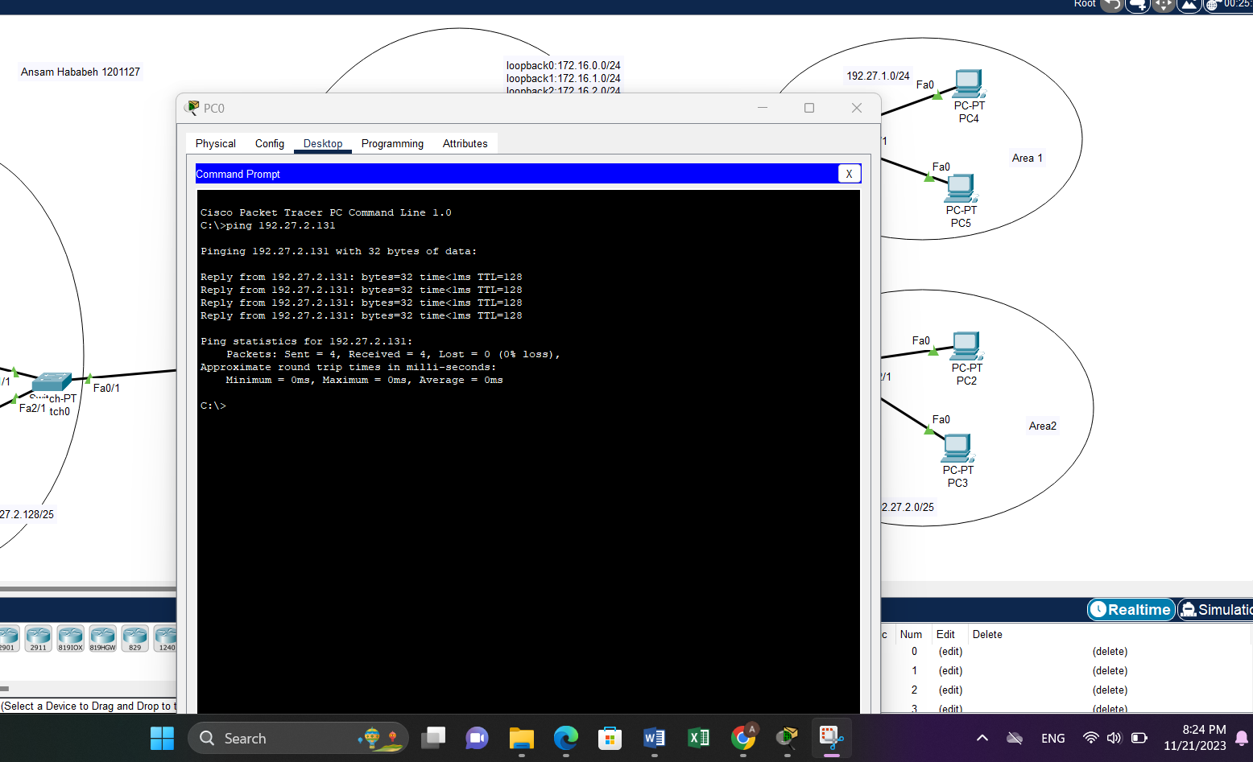

Figure 10:test bing

## **Loopback configuration**

Loopback has been configured by writing commands in the routers2 like this :

Router(config)#interface loopback 0

%LINK-5-CHANGED: Interface Loopback0, changed state to up %LINEPROTO-5-UPDOWN: Line protocol on Interface Loopback0, changed state to up Router

(config-if)#ip address 172.16.0.1 255.255.255.0

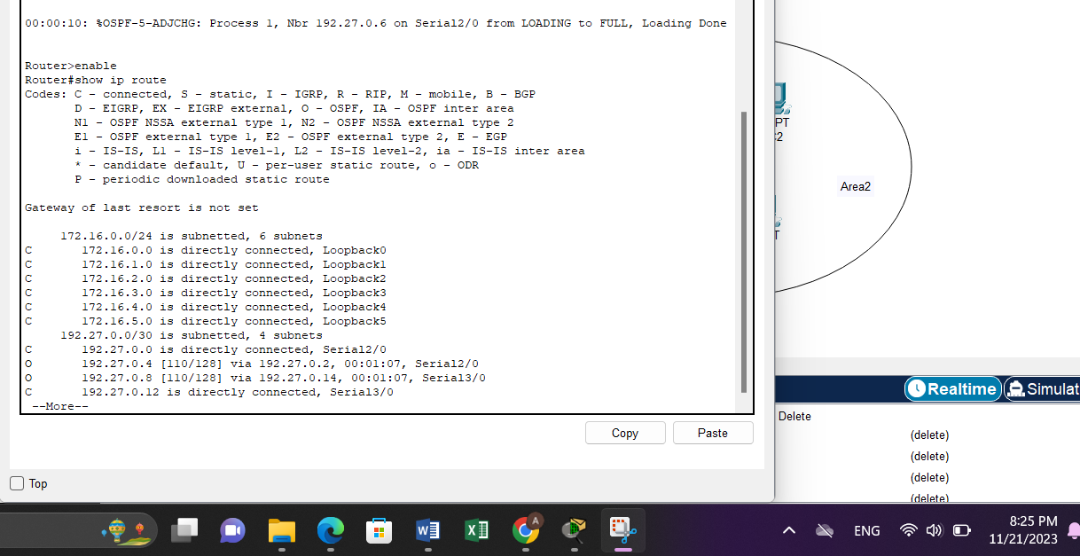

Figure 11:loopback for router 2

## **Configuring OSPF Routing**

From Table 1, each PC has been configured its IP address, subnet mask and gateway. Also, the routers have been turned on for each interface that we used in the network and each interface has been given a certain IP address. After that, OSPF has been configured by writing commands in the routers that specify process ID of the routing, and select which networks contain this specified router by writing the network ID, wildcard mask and the area number.

The command used for adding a network is: Router(config-router)#network < NETWORK- ID >< OSPF-WILDCARDBITS >area< AREA-ID>

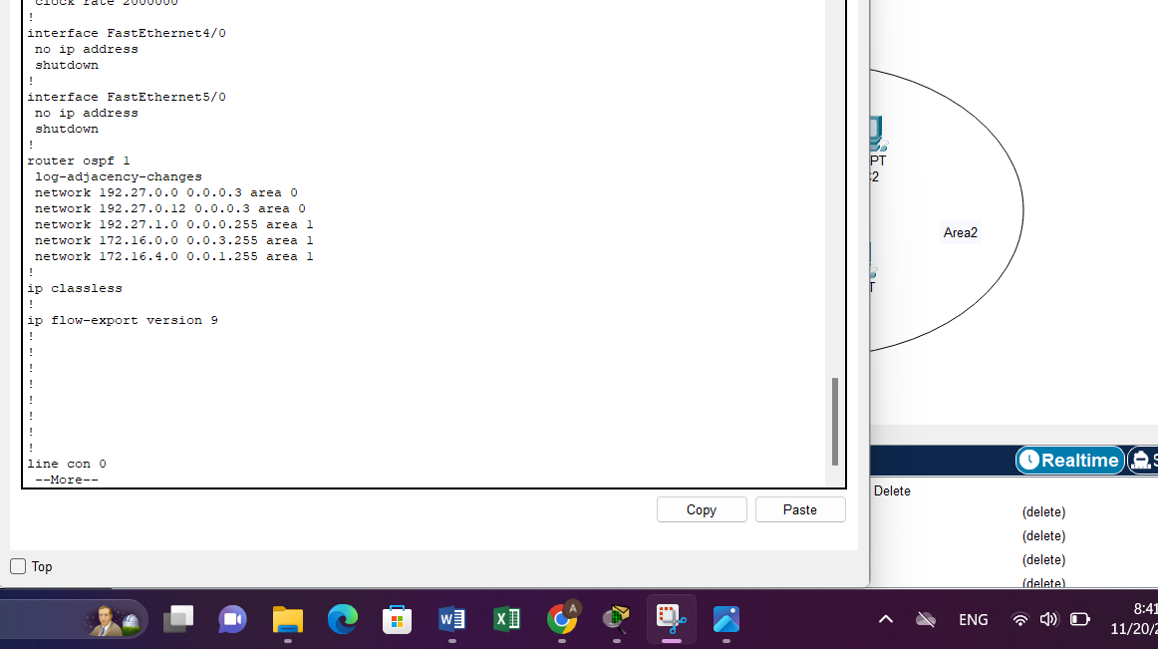

Figure 12:OSPF router 2

And I have been do that for all routers

## **Changing the cost**

The cost of the serial interface 2/0 on router 0 has been modified from 1 to 5. This change was made by adjusting the bandwidth to 20000KB, following the equation used to calculate OSPF cost.

𝐵𝑎𝑛𝑑𝑤𝑖𝑑𝑡ℎ = 100𝑀𝐵/ 𝐶𝑜𝑠𝑡 = 100𝑀𝐵 /5 = 20000𝐾B to change the cost to 5 for interface Se2/0 for router0 we used the following commands: Router(config)#interface se2/0 Router(config-if)#bandwidth 20000

To see the path of our message that has been passed from PC0 to PC4, tracert command has been executed as shown in Figure

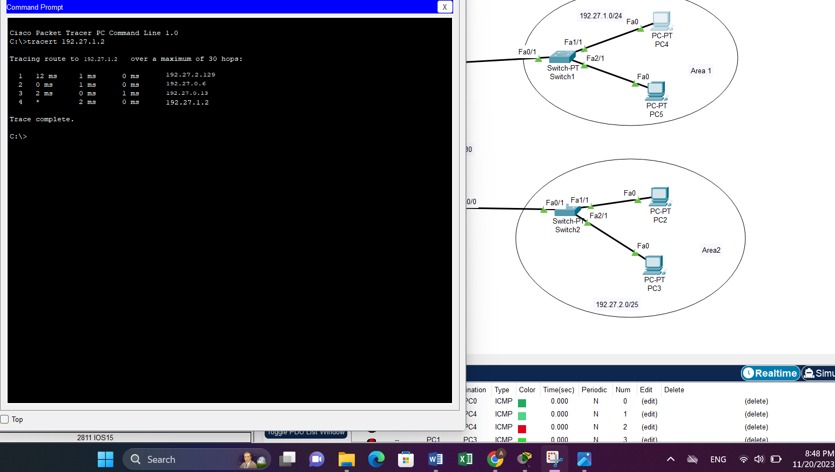

Figure 13:path from pc0 to 1

From the figure the path was from above (router 0 to router 1 finally with router 2 to reach pc4).

## **Summarization**

To incorporate the loopback networks into OSPF on router 2, we can add them individually using the network command. However, it's more efficient to combine certain networks into larger network blocks to reduce CPU processing and simplify the configuration.

here , we can replace the first four networks (172.16.0.0/24, 172.16.1.0/24, 172.16.2.0/24, 172.16.3.0/24) with a single network block, 172.16.0.0/22. This results in the following configuration:

Router(config)#router ospf 1

Router(config-router)#network 172.16.0.0 0.0.3.255 area 1

Router(config-router)#network 172.16.4.0 0.0.0.255 area 1

Router(config-router)#network 172.16.5.0 0.0.0.255 area 1

Additionally, the last two networks (172.16.4.0/24 and 172.16.5.0/24) can be combined into a single network block, 172.16.4.0/23. This further simplifies the configuration:

Router(config)#router ospf 1

Router(config-router)#network 172.16.0.0 0.0.3.255 area 1

Router(config-router)#network 172.16.4.0 0.0.1.255 area 1

By consolidating the networks, we reduce the number of network statements from six to two, making the configuration more efficient and easier to manage.

## **ping to loopback**

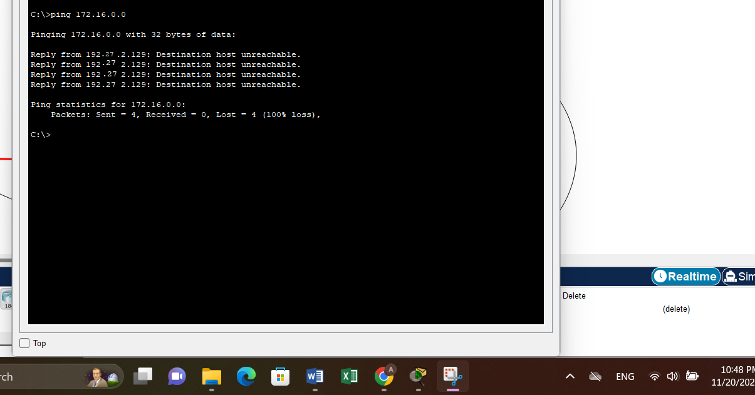

Figure 14:ping to loopback

## **Important Questions**

### **2.7.1Why do we need for loopback interfaces?**

Loopback interfaces are virtual network interfaces that allow a device to communicate with itself using the loopback address. They are crucial for testing, troubleshooting, and running network services locally. Loopback interfaces simplify network configurations, provide a stable reference point for routing, and facilitate software development by simulating network interactions. In summary, they enable self-communication, enhance reliability, and improve network functionality.

### **2.7.2 What is the router-id for OSPF? And why do we need it?**

Each OSPF router chooses a unique router ID (RID) in the network. OSPF preserves the network topology inside its LSDB (Link State Database), and each router is identifiable by a unique router ID.

### **2.7.3 Hardcode the router-id for R1, R2, and R3 as 1.1.1.1, 2.2.2.2, and 3.3.3.3 respectively. And Verify that.**

When the OSPF router ID is modified, it is necessary to either reload the IOS or employ the "clear ip ospf process" command for the new Router ID to be implemented. It is important to note that both actions, reloading the IOS or executing the "clear ip ospf process" command, may cause a temporary disruption in the network. Figure 9 provides instructions on how to manually configure the router's Router ID and verifies the successful change of the Router ID for the router.

We use this command:

* Router(config)#router ospf 1
* Router(config-router)#router-id
* Router(config-router)#exit
* Router(config)#exit
* Router#clear ip ospf process
* Reset ALL OSPF processes? [no]: yes

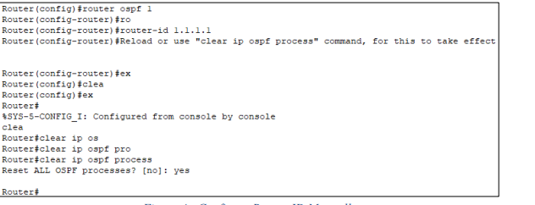

Figure :Configure Router-ID Manually

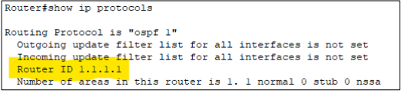

Figure :Show Router-ID

# **3.Task**

From the Result that we showed from this figure



We noticed that the path is that 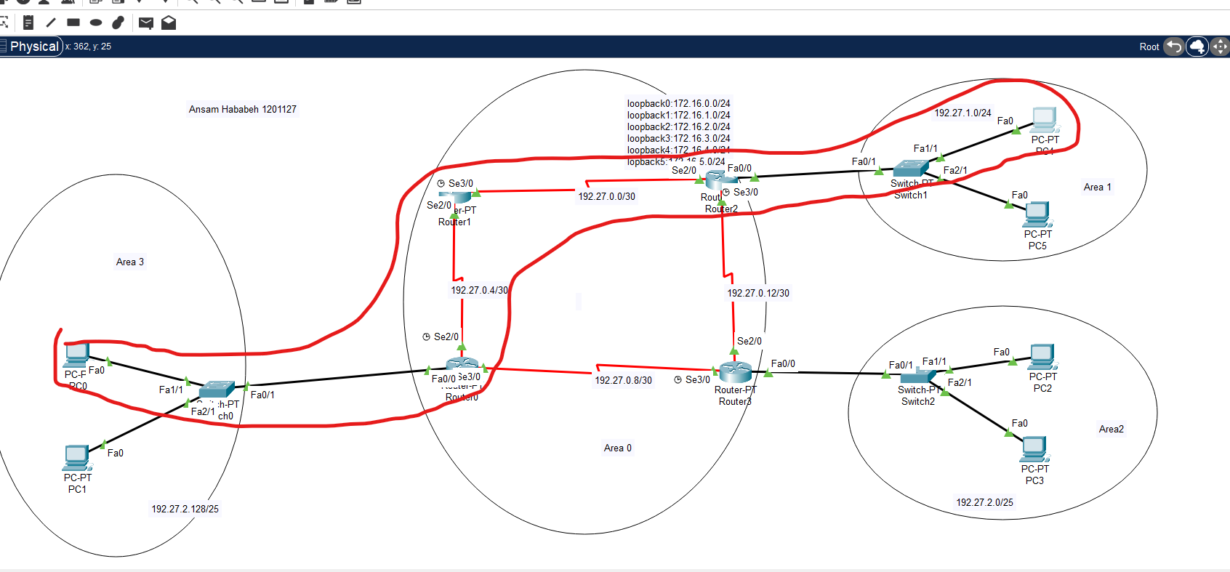

Figure :path

**So our Task was to make path from router 0 to 3 and finish with router 2**

To solve this task I changed the cost to make it smaller and I get that result and the time and date of it among last lap we take it .

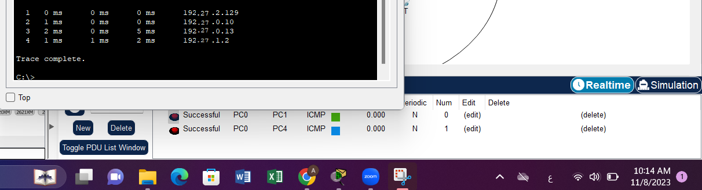

And the path as shown become that

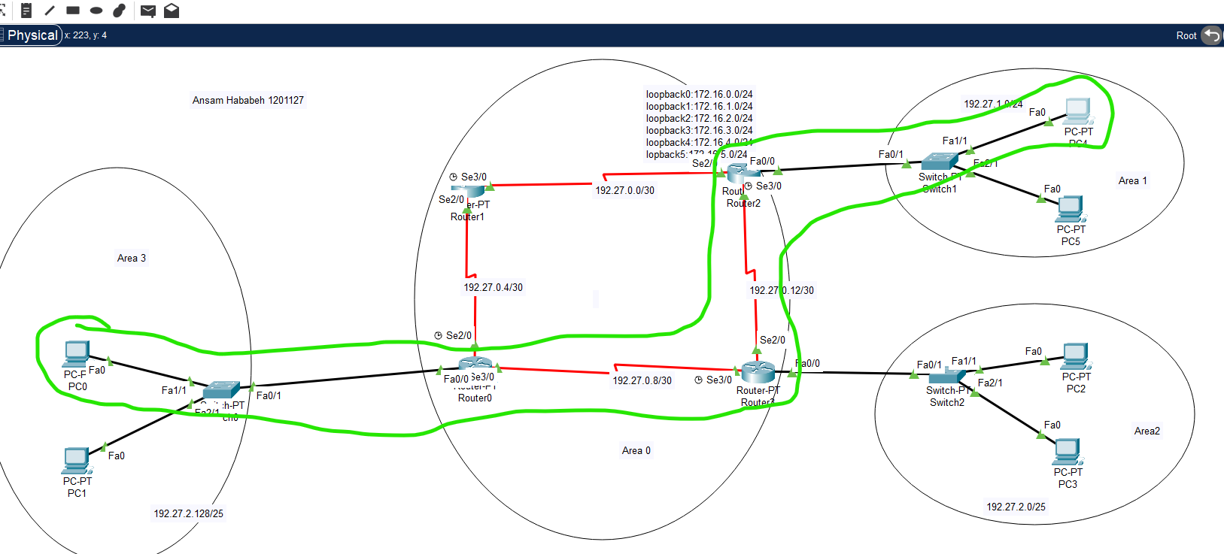

Figure 18:task path

# **4.Problem**

## **4.1 Part One**

### **4.1.1 Dijkstra’s algorithm**

|  |  |  |  |  |  |  |  |  |  |  |  |  |  |
| --- | --- | --- | --- | --- | --- | --- | --- | --- | --- | --- | --- | --- | --- |
| **N** | | **D(B)** | | **D(c)** | | **D(D)** | | **D(E)** | | **D(F)** | | **D(G)** | |
| **A** | | 2,A | | ∞ | | 8,A | | 4,A | | ∞ | | ∞ | |
| **AB** | |  | | 4,B | | 8,A | | 4,A | | ∞ | | ∞ | |
| **ABC** | |  | |  | | 6,C | | 4,A | | ∞ | | 104,C | |
| **ABCE** | |  | |  | | 6,C | |  | | 12,E | | 104,C | |
| **ABCED** | |  | |  | |  | |  | | 12,E | | 8,D | |
| **ABCEDG** | |  | |  | |  | |  | | 12,E | |  | |
| **ABCEDGF** | |  | |  | |  | |  | |  | |  | |

### **4.1.2 Shortest path**

shortest path from Router 0 to Router 6: R0->R1->R2->R3->R6

SO the cost for shortest path=8

## **4.2 Part Two**

### **4.2.1 build the topology**

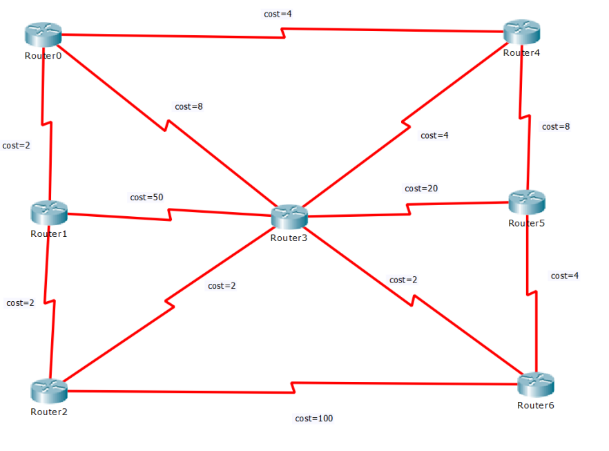

Figure :Topology

### **4.2.2 Ip configuration**

My Id 1201127

A=11 and B =27

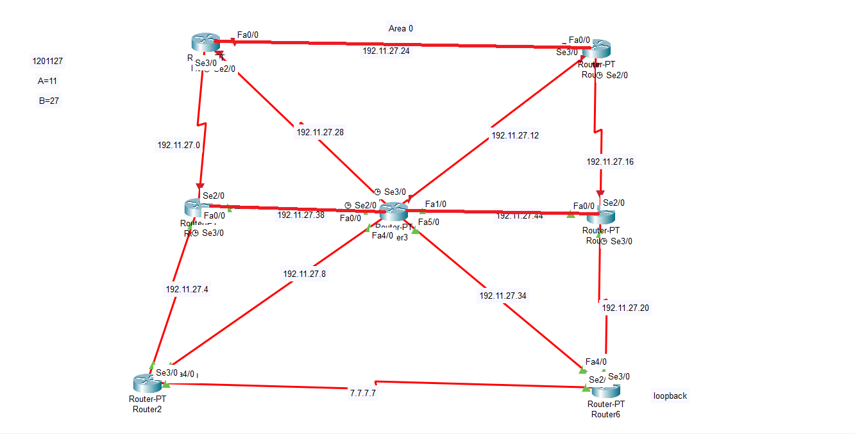

Figure :ips

In this figure IPS of network are shown and continued ips for all devices

### **4.2.3 ospf**

After setting the IPs, the OSPF routing was enabled for all routers. For example, this is how the OSPF routing was set for router 2

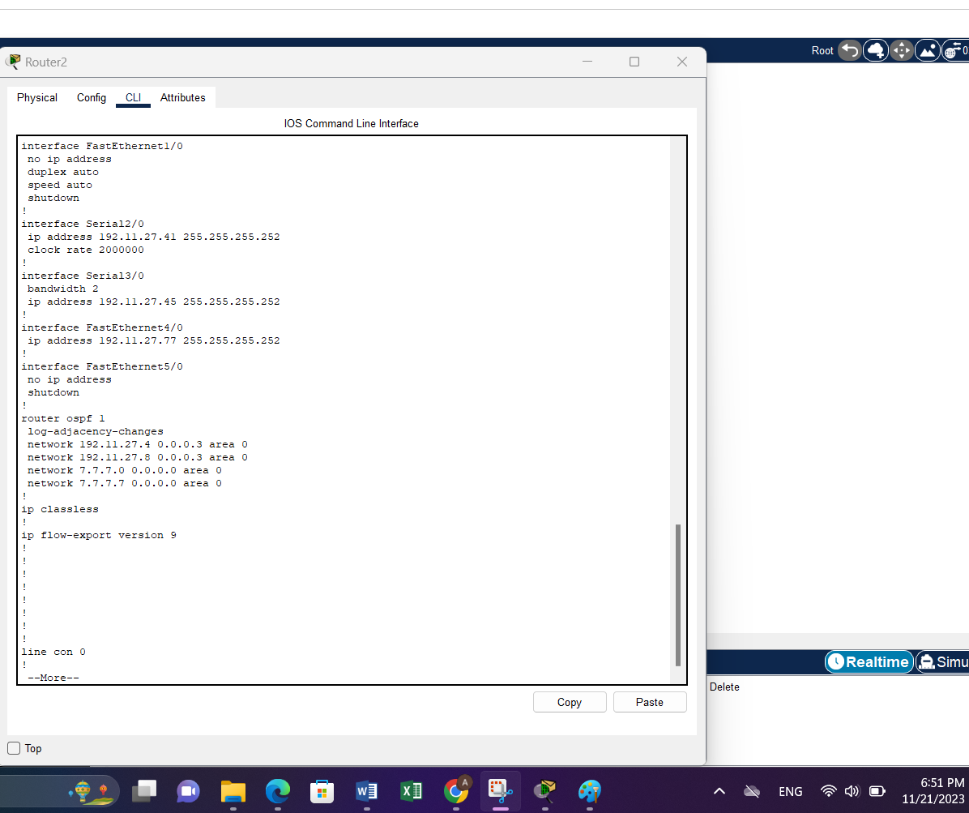

Figure :ospf for router 2

### **4.2.4 Configure bandwidth values between links**

Cost=2->bandwidth=50000kb

Cost=4->bandwidth=25000kb

Cost=8->bandwidth=12500kb

Cost=20->bandwidth=5000kb

Cost=50->bandwidth=2000kb

Cost=100->bandwidth=1000kb

After calculation the bandwidth values, I set them in my topology, this is in router 1:

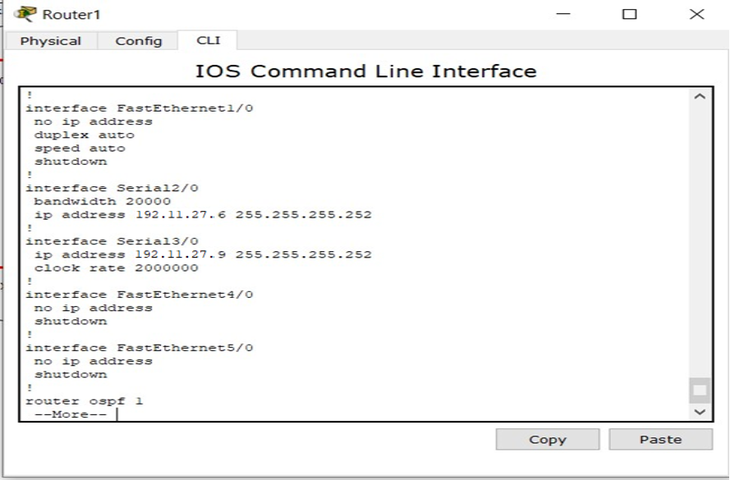

Figure :bandwidth

### **4.2.5 Configure Router 6 with a loopback IP address 7.7.7.7/24**

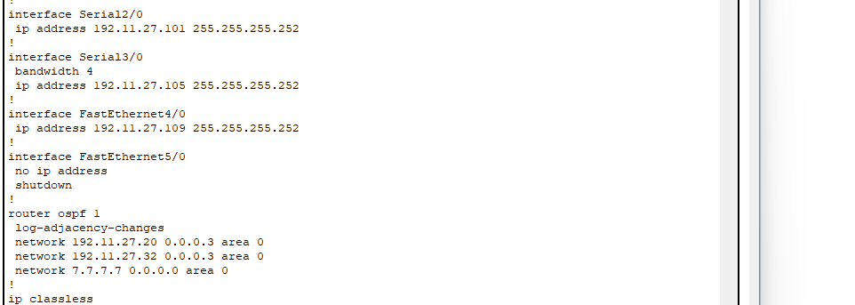

Figure :loopback

Run the show IP route command on Router 0. From the output result. What is the cost (metric) to get from Router 0 to Router 6?

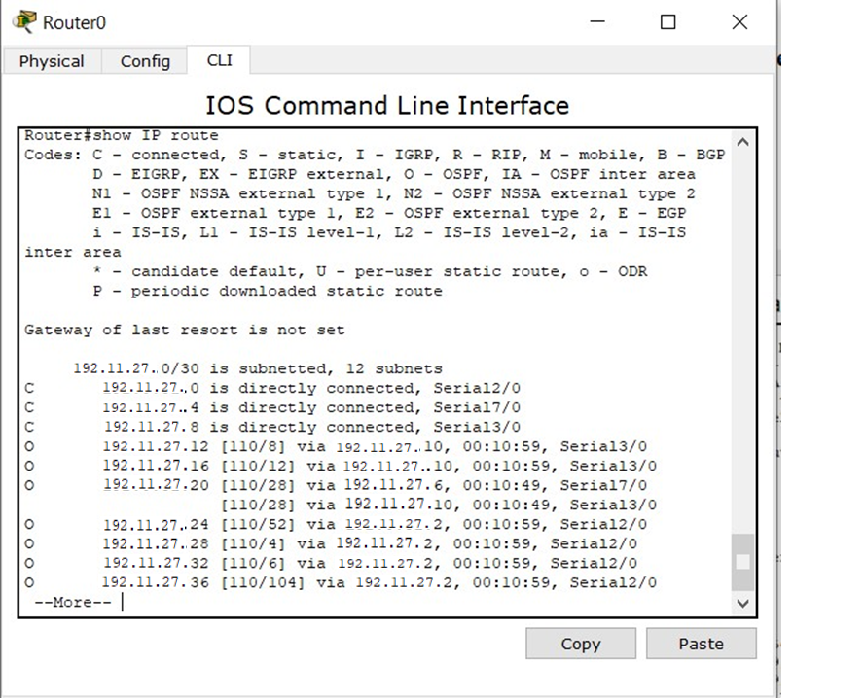

Figure :show cost

# **5. Conclusion**

The results that were obtained from the previous procedures are successful and agree with the theoretical results. Moreover, we conclude that we can use Cisco Packet Tracer to build our topologies and advertise them, so we became more familiar with this program. We learned what every number in the IP address means and does. We learnt another dynamic routing protocol that finds the shortest path depending on the costs to reach the destination successfully. OSPF is a great protocol to routing the topology. We knew that every router in the OSPF process has a special Router ID which be selected by three methods: Manual configuration of the router ID, Highest IP address on a loopback interface, Highest IP address on a non-loopback interface.

# **6. References**

[1]. <https://gomotive.com/blog/what-is-dynamic-routing/>

Accessed on 19 November 8:22pm.

[2]. <https://www.ibm.com/docs/en/i/7.4?topic=routing-open-shortest-path-first>

Accessed on 19 November 8:50pm.

[3[]](https://www.tutorialspoint.com/what-is-hierarchical-routing) [.](https://www.tutorialspoint.com/what-is-hierarchical-routing) <https://www.tutorialspoint.com/what-is-hierarchical-routing>

Accessed on 19 November 9:10pm.

[4]. <https://www.omnisecu.com/cisco-certified-network-associate-ccna/what-is-loopbackinterface-in-a-router.php>

Accessed on 19 November 9:30pm.

[5]. Lab Manual

[6]. Cisco Packet Tracer