

**Faculty of Engineering & Technology**

**Electrical & Computer Engineering Department**

**Communications Lab-****ENEE4113**

**Report #3 Experiment 10**

**Amplitude Shift Keying (ASK)**



**Prepared by:** Ansam Hababeh  **ID:** 1201127

**Partners**: Entisar Qandil **ID:**1200073

**Instructor**: Dr. Ashraf Al-Rimawi

**Assistant**: Eng. Hazem Awaysa

**Section:** 1

**Date:** 26/12/2023

# **Abstract**

This experiment aims to present two keying techniques, namely Hard Keying and Soft Keying, as well as Amplitude Shift Keying (ASK). This experiment will also demonstrate and analyze the modulation index effect. The time and frequency domains will both be the subject of the inquiry.

Contents

**Abstract** 2

**1.** **Theory** 6

**1.1** **Amplitude Shift Keying (ASK):** 6

**1.1.1** **Hard Keying** 6

**1.1.2** **Soft Keying** 6

**1.1.3** **Detecting the comparator threshold** 7

**1.1.4** **Unipolar Non-Return-to-Zero (NRZ)** 7

1.2 Amplitude shift keying Demodulation 8

**1.2.1** **Coherent detection** 8

**1.2.2** **Non-coherent detection** 8

**2.** **Procedure** 10

**2.1** **Amplitude shift keying Modulation (Time domain)** 10

**2.1.1** **Hard keying** 10

**2.1.2** **Soft Keying** 14

**2.2.3 Detecting the comparator threshold** 16

**2.2** **Amplitude shift keying Modulation (Frequency domain)** 18

**2.2.1** **Studying the effect of changing the message signal amplitude (Time and frequency domains)** 18

**2.2.2** **Studying the effect of changing the message signal frequency on (Time and frequency domains)** 20

**2.2.3** **Studying the effect of changing the message signal duty cycle (Time and frequency domains)** 22

**2.3** **Amplitude shift keying Demodulation (Time and frequency domain)** 23

**2.3.1** **Hard Keying** 24

**2.3.2 soft Keying** 26

**2.3.3 Studying the effect of changing the message signal frequency on the demodulation** 28

**2.3.4 Studying the effect of changing the message signal duty cycle on the demodulation** 29

**3.** **Conclusion** 33

**4.** **References** 34

# **Table of figures:**

Figure 1:Amplitude shift key 8

Figure 2:NRZ 9

Figure 3:ASK Generation method for Unipolar 9

Figure 4:Coherent detection of binary ASK signals 10

Figure 5:non-coherent-ASK-detection 11

Figure 6:Setup of ASK modulation 12

Figure 7:Message Signal in the time domain 13

Figure 8:in frequency domain 13

Figure 9:The A_11 ASK modulation hard keying (Time domain) 14

Figure 10:ASK frequency domain modulation 14

Figure 11:The A_21 modulation hard keying (time domain) 15

Figure 12:frequency domain 15

Figure 13:The A_12 ASK modulation Soft keying 16

Figure 14:The A_12 ASK Modulation Soft keying (Frequency domain) 17

Figure 15:A_22 ASK modulation Soft keying 17

Figure 16:ASK modulation Soft keying (Frequency domain) 18

Figure 17:ASK signal at DC upper threshold value in time domain. 19

Figure 18ASK signal at DC upper threshold value in frequency domain. 19

Figure 19:ASK signal in time domain at DC lower threshold value. 20

Figure 20:ASK time domain when amplitude was set to 1.5 volts. 20

Figure 21:ASK frequency domain when amplitude was set to 1.5 volts. 21

Figure 22:with 2.5 volt 21

Figure 23:2.5 volt in frequency 22

Figure 24:ASK modulated signal in time domain when the frequency = 500Hz. 23

Figure 25:ASK modulated signal in frequency domain when the frequency = 500Hz. 23

Figure 26:ASK modulated signal in time domain with frequency =1000Hz and duty cycle=10%. 24

Figure 27:when 10% duty cycle 24

Figure 28:when 90% duty cycle 25

Figure 29:Amplitude shift keying Demodulation 25

Figure 30:The A_11 demodulation Hard Keying 26

Figure 31:Demodulated signal output 26

Figure 32:ASK demodulated signal in time domain with modulation index= 50 and duty cycle =50%. 27

Figure 33:ASK demodulated signal in frequency domain with modulation index= 50 and duty cycle =50%. 27

Figure 34:ASK demodulated signal in time domain with modulation index= 100 and duty cycle =50%- A12. 28

Figure 35:the same in frequency 28

Figure 36:Soft keying with modulation index m = 50% (A_22) in time domain 29

Figure 37:frequency 29

Figure 38:Effect of changing m(t) frequency on the demodulation 30

Figure 39:in frequency 31

Figure 40:the effect of changing the message signal duty cycle on the demodulation in time domain. 31

Figure 41:frequency 32

Figure 42:Effect of changing the m(t) duty cycle(50%) on the demodulation in the Time Domain 32

Figure 43:Effect of changing the m(t) duty cycle(90%) on the demodulation in the Time Domain 33

Figure 44:frequency of 50% 33

Figure 45:of 90% 34

# **Theory**

## **Amplitude Shift Keying (ASK):**

A digital modulation method called Amplitude Shift Keying (ASK) alternates the amplitude of a carrier signal between two levels to represent binary data. Another name for this is binary ASK (BASK). Although it delivers lower bitrates, it modulates and demodulates using straightforward logic circuits. More sophisticated versions use four amplitude levels to modulate multiple bits together in order to obtain larger bitrates.[1]

Hard keying and soft keying are the two primary keying techniques used in ASK.

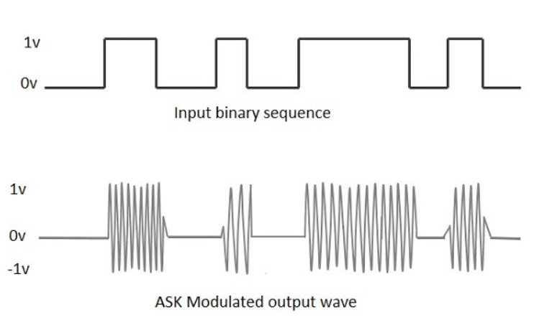

Figure 1:Amplitude shift key

### 

### **Hard Keying**

The simplest type of amplitude-shift keying (ASK) modulation is called on-off keying (OOK), which expresses digital data as the presence or absence of a carrier wave. A binary 0 is represented by lowering the amplitude of the carrier signal to zero, and a binary 1 is represented by a non-zero amplitude (Ac). By connecting digital data directly to the carrier signal, this approach uses the presence or lack of amplitude to signify conveyed binary values.[2]

### **Soft Keying**

When using soft keying, which is more adaptable than hard keying, the signal strength determines which value is assigned—a strong signal receives a value of 1, while a weak signal receives a value of 0. Additionally, it can function in two different ways based on the modulation index value: A12 indicates a 100% (full carrier) modulation index, while A22 indicates a 50% modulation index. The modulation index is defined as the ratio of the peak amplitude of the digital data to the peak amplitude of the carrier signal. This has the drawback of requiring reaction time to obtain the outcome.

### **Detecting the comparator threshold**

Amplitude Shift Keying (ASK) uses a comparator threshold to demodulate incoming signals, distinguishing between high and low binary states and recovering transferred data.[4]

### **Unipolar Non-Return-to-Zero (NRZ)**

Bit 0 is defined by zero voltage, while bit 1 is defined by positive voltage. NRZ is a Unipolar scheme used for digital data transfer that represents binary data with distinct voltage levels. [3]

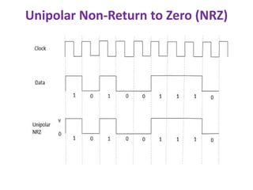

Figure 2:NRZ

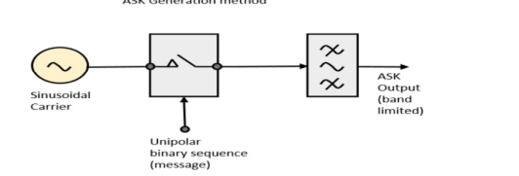

Figure 3:ASK Generation method for Unipolar

## Amplitude shift keying Demodulation

The original digital signal was recovered by demodulation. The receiver may compare the amplitude of the received signal at various intervals and, based on the threshold value, use the matching filter to determine whether the signal is one or zero.

Binary ASK demodulation can result in either a coherent or non-coherent detection.

### **Coherent detection**

The most sophisticated detection technique is coherent detection, which enables the receiver to calculate decision variables based on the recovery of the entire electric field, which includes phase and amplitude data.[5]

The product modulator's input is subjected to the incoming ASK signal. A sinusoidal carrier, produced with the aid of a local oscillator, is fed into the product modulator's other input.

The integrator receives the output of the product modulator as its input. The integrator effectively carries out a low-pass filtering function by working on the multiplier's output for successive bit intervals. The integrator's output is sent into a device that makes decisions.

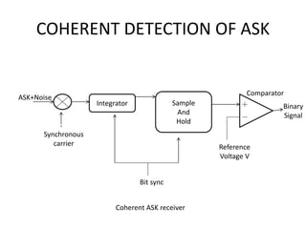

Figure 4:Coherent detection of binary ASK signals

### **Non-coherent detection**

it depends only on the properties of the modulated signal itself rather than a reference signal. The energy, amplitude, frequency, or phase of the modulated signal are measured by the receiver using a detector or filter, which allows it to deduce the original data. Since non-coherent demodulation doesn't require a carrier or synchronization mechanism, it can be easier and less expensive than coherent demodulation.

The block diagram of a non-coherent ASK detection method, which consists of an envelope detector, bandpass filter, and decision device.

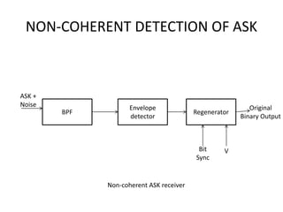

Figure 5:non-coherent-ASK-detection

# **Procedure**

## **Amplitude shift keying Modulation (Time domain)**

### **Hard keying**

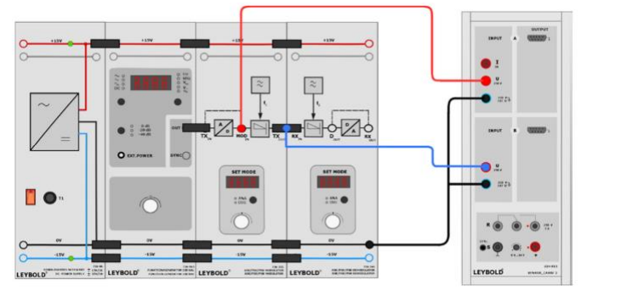

Figure 6:Setup of ASK modulation

The function generator was configured to produce square waves with 50% duty cycle, frequency of 1000 Hz, and vss of 10v. Digital mode (DIG) was selected as the modulator mode.

The Amplitude Shift Keying (ASK) with hard keying was used for modulation, with a 100% modulation index. Cassy sensors UA1 and UB1 were connected to the modulating signal and unipolar square-wave signal at the MODIN socket.

It monitors the modulated signal's changes over time utilizing hard keying and ASK modulation. This shift is dependent on how the amplitude of the carrier signal changes in response to the input signal.

The modulating signal T(t) is shown in the time domain in Figure 7 below, and the modulating signal in the frequency domain is shown in Figure 8:

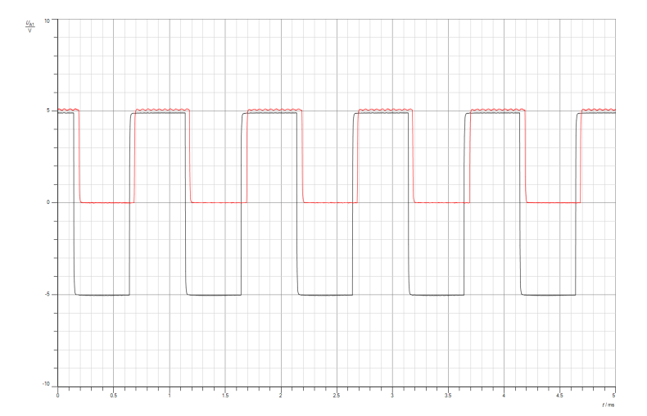

Figure 7:Message Signal in the time domain

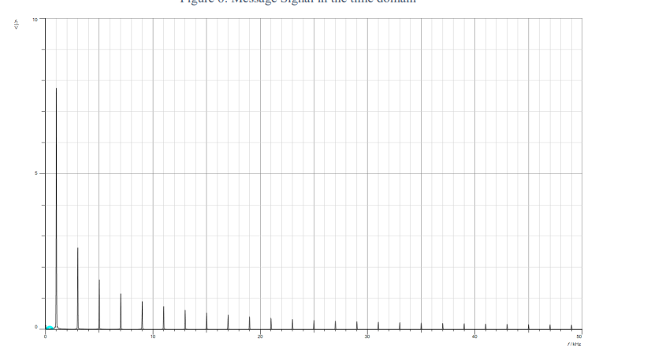

Figure 8:in frequency domain

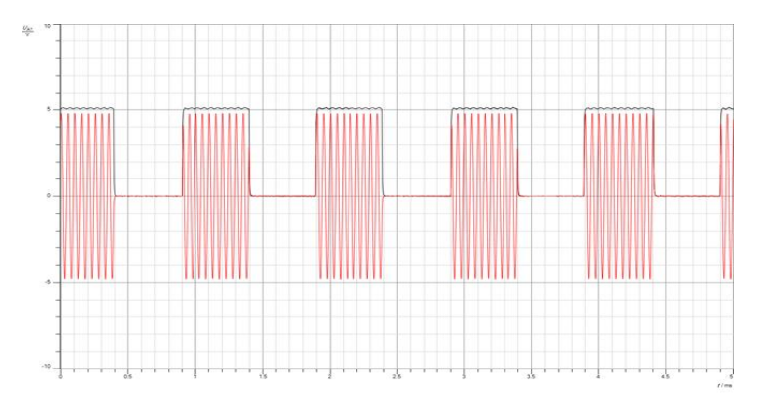

Figure 9:The A_11 ASK modulation hard keying (Time domain)

In this figure(9) the the unipolar square-wave signal was linked to the Cassy sensor UA1 at the MODIN socket, while the ASK signal was attached to the Cassy sensor UB1 at the modulator's output TXout.

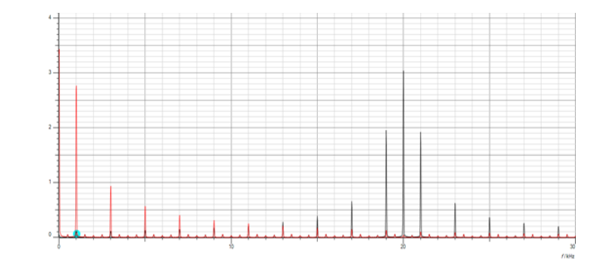

Figure 10:ASK frequency domain modulation

In Fig 10 depicts the frequency domain modulated signal in (Black). Furthermore, the red hue denotes UA1's output.

The spectrum's impulse in an ASK modulation relates to a distinct carrier frequency harmonic. In hard keying ASK modulation (A_11), the modulation index is 100%, which determines the behavior and separation of the impulses.

The preceding section was repeated, but this time the hard keying with modulation index m = 50% (A_21) was used instead of the amplitude shift keying.

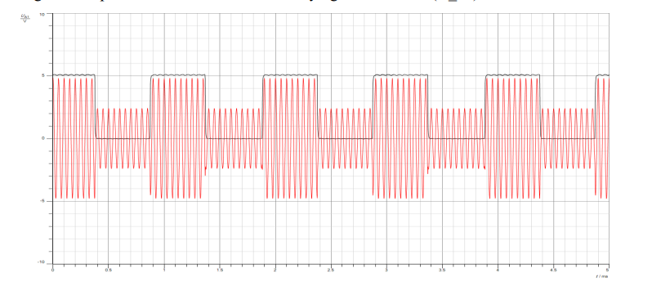

Figure 11:The A_21 modulation hard keying (time domain)

fig 11 contain the modulation hard keying with m=50% (A_21) in time domain

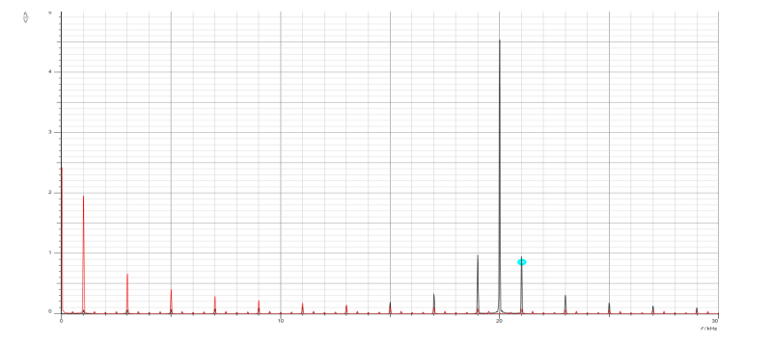

Figure 12:frequency domain

In this figure the black color represents the A_21 modulation hard keying in frequency domain.

As seen in the above images, we are using Unipolar Non-Returned to Zero (NRZ) in this experiment. The wave takes two value levels: zero takes zero volts, and one takes five volts.

The modulation index, 50%, indicates two amplitude values in the output signal: 50% reduction when input value equals zero, and 100% carrier amplitude when input value equals one, resulting in a 50% reduction in the original value and a 100% carrier amplitude.

The output value takes on the full amplitude of the carrier signal when the modulation index equals 100% and the input equals one; this is referred to as turning on. Similarly, when the input value equals zero, the output value also equals zero; this is referred to as completely turning off. In both scenarios, the signal appears as a carrier signal. This is the same as what the theoretical data indicates.

### **Soft Keying**

For hard keying, the connection was maintained as it was in the previous section, but the time was changed to amplitude shift keying,- soft keying with a modulation index of 100% (A_12).

The modulating signal softly modifies the carrier signal's intensity in soft keying. In some communication systems, this technique lowers possible issues and enhances signal quality.

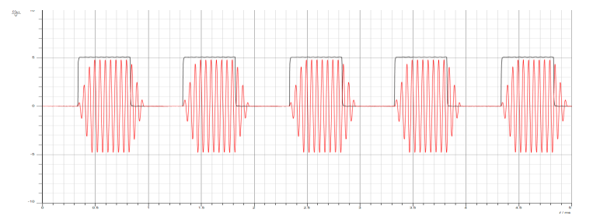

Figure 13:The A_12 ASK modulation Soft keying

And the frequency domain:

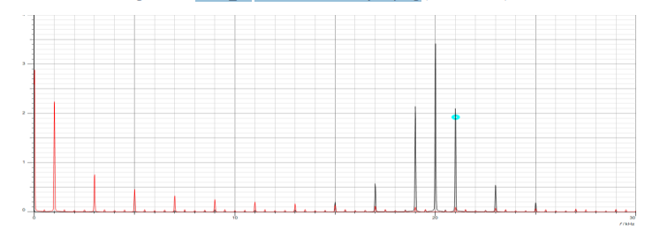

Figure 14:The A_12 ASK Modulation Soft keying (Frequency domain)

In this part the amplitude shift keying –soft keying index m was changed to 50%(A-22)

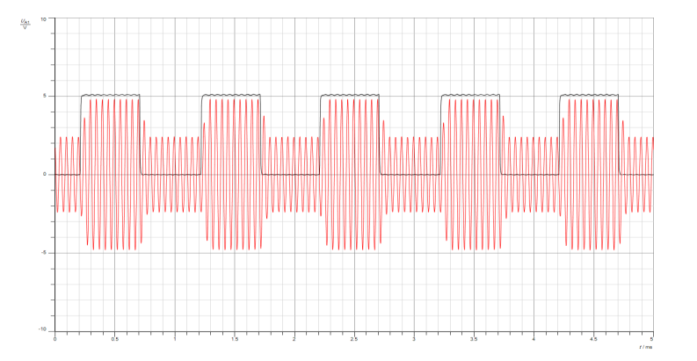

Figure 15:A_22 ASK modulation Soft keying

In frequency domain :

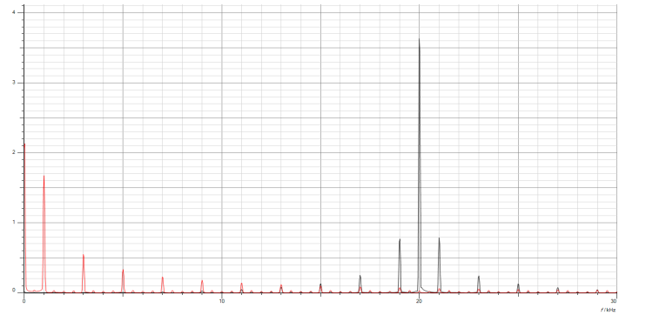

Figure 16:ASK modulation Soft keying (Frequency domain)

The Results of this figures show that changes are less noticeable, the carrier signal's amplitude variation is still noticeable when utilizing a modulation index of 50% as opposed to 100%.

The modulation index of 50% and 100% on amplitude shift keying modulating leads us to the conclusion that the wave exhibits a smoother amplitude transition at 50% and a higher contrast and clarity at 100%.

Each amplitude modulation and amplitude shift keying use in different purpose and work and each depend on varying the amplitude of a carrier.

In conclusion, soft keying in Amplitude Shift Keying has a larger bandwidth than hard keying because it employs progressive amplitude fluctuations, whereas hard keying utilizes abrupt amplitude changes. Modulation index, amplitude variation form, and data rate are a few examples of the variables that affect the precise bandwidth.

### **2.2.3 Detecting the comparator threshold**

The ASK signal is switched between two thresholds (upper and lower) that change its amplitude from high to low. The connection remains the same as it did in the previous parts, and the function generator is set to equal (DC signal, V = 0V). Hard keying with a modulation index of 100% (A_11) is selected. Additionally, begin the measurement and gradually raise the DC value until the ASK signal's high level manifests.

The Dc upper threshold value =2.21.

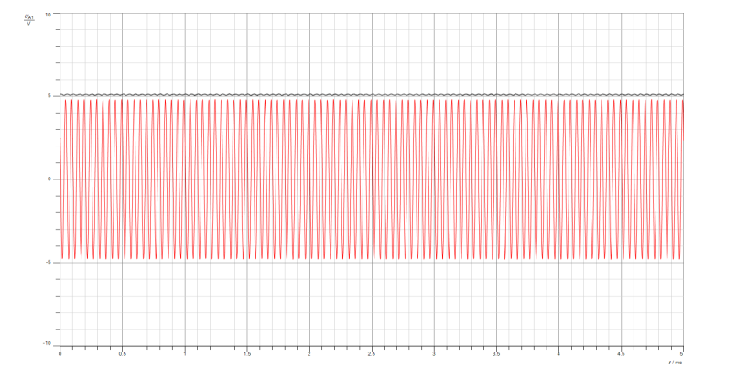

Figure 17:ASK signal at DC upper threshold value in time domain.

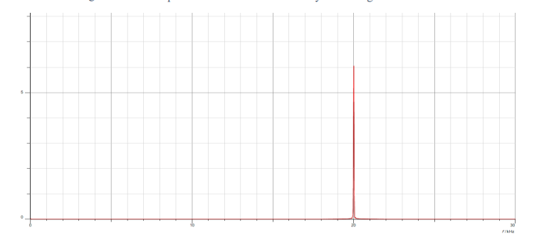

Figure 18ASK signal at DC upper threshold value in frequency domain.

Subsequently, the value was decreased from 2.5V to the DC lower threshold value of 1.74V, which is when the low level (zero volt) occurs on the ASK output signal.

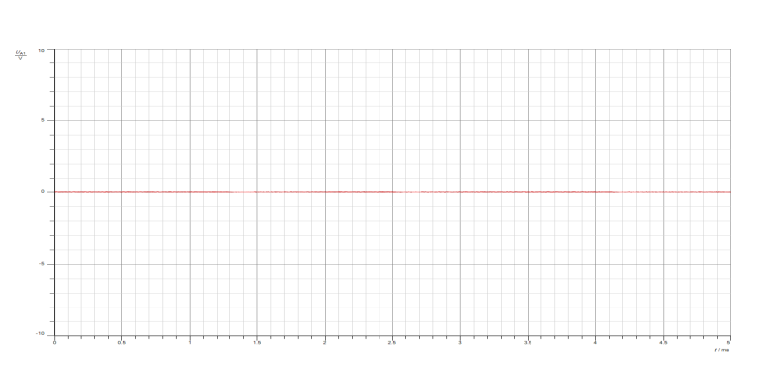

Figure 19:ASK signal in time domain at DC lower threshold value.

## **Amplitude shift keying Modulation (Frequency domain)**

### **Studying the effect of changing the message signal amplitude (Time and frequency domains)**

The link was maintained from the earlier sections. However, the amplitude of the message signal was decreased to 1.5V (Vss = 3V).

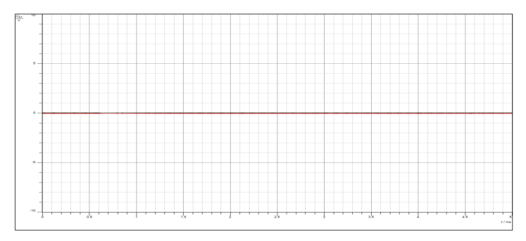

Figure 20:ASK time domain when amplitude was set to 1.5 volts.

And the frequency domain:

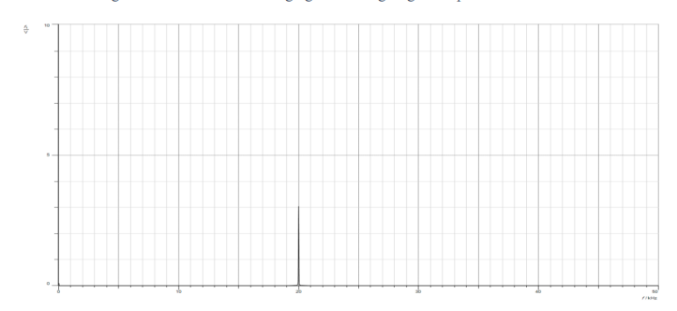

Figure 21:ASK frequency domain when amplitude was set to 1.5 volts.

Reducing the message signal amplitude in ASK leads to a smaller spectrum and lower sideband amplitudes, as can be seen in figures 20 and 21 where sideband amplitudes fall in the spectrum as well until they hit zero.

By changing amplitude to to 2.5

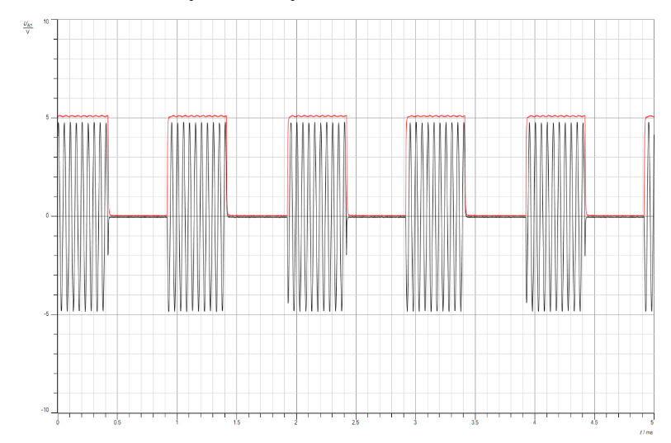

Figure 22:with 2.5 volt

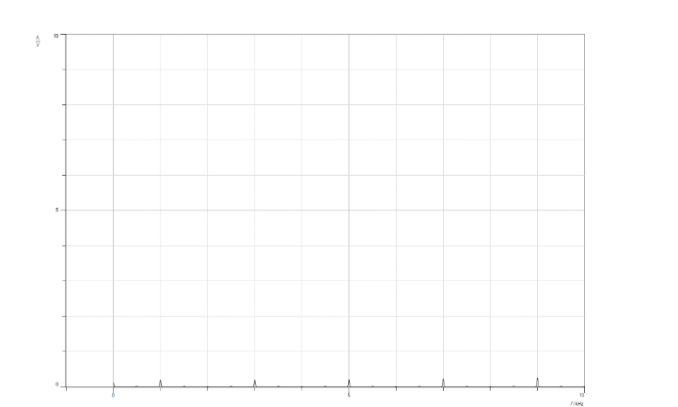

Figure 23:2.5 volt in frequency

The amplitude value in figures 22 and 23 is set to 2.5 volts, while the higher threshold value is set to 2.4 volts. This means that if the amplitude value is greater than the upper threshold, the output signal will manifest as a signal with a value and shape, as it has in this instance.

The message's amplitude affects the signal in both the time and frequency domains. If the amplitude is less than the lower threshold, the output is zero in both domains, and if it is more than the higher threshold, the signal is also received in both domains.

Our experiment also leads us to the conclusion that the signal is zero in both domains for any amplitude value that falls between the higher and lower threshold values.

### **Studying the effect of changing the message signal frequency on (Time and frequency domains)**

The Cassy sensor UA1 is connected to the Unipolar square-wave signal at socket MODIN, and UB1 is connected to the ASK signal at the modulator's output TXOUT. Maintain the same connections as the previous sections. Set the function generator to Square wave, frequency = 500 Hz, Vss = 10V, duty-cycle = 50%.

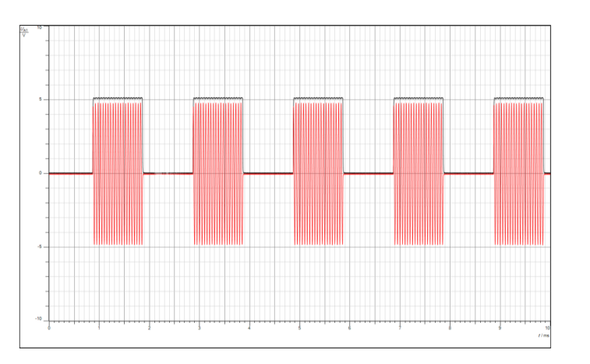

Figure 24:ASK modulated signal in time domain when the frequency = 500Hz.

And in frequency domain

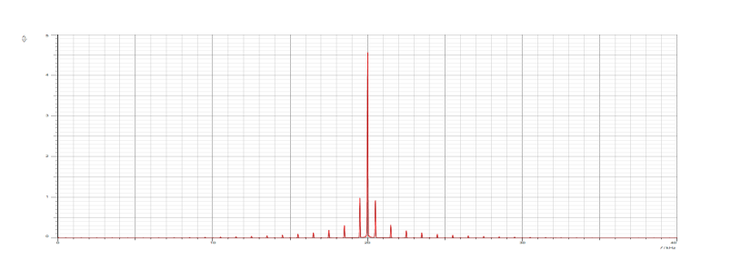

Figure 25:ASK modulated signal in frequency domain when the frequency = 500Hz.

We see that altering the message signal frequency has an impact on the spectrum; a slower message causes the spectrum to shrink and concentrate closer to the carrier. Higher message frequency results in a broader bandwidth, whereas lower message frequency produces a narrower bandwidth. Faster messages also cause the spectrum to widen, extending away from the carrier.

### **Studying the effect of changing the message signal duty cycle (Time and frequency domains)**

The function generator was programmed to produce a square wave with a frequency of 1000 Hz and a Vss of 10 volts and 10% of the duty cycle. The connection was maintained exactly as it was in the previous sections.

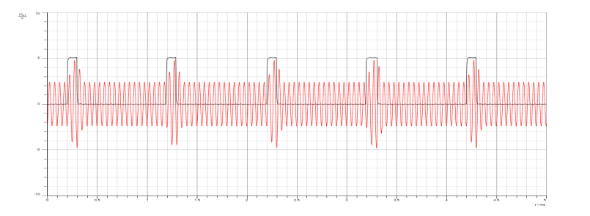

Figure 26:ASK modulated signal in time domain with frequency =1000Hz and duty cycle=10%.

And in frequency domain

For 10%

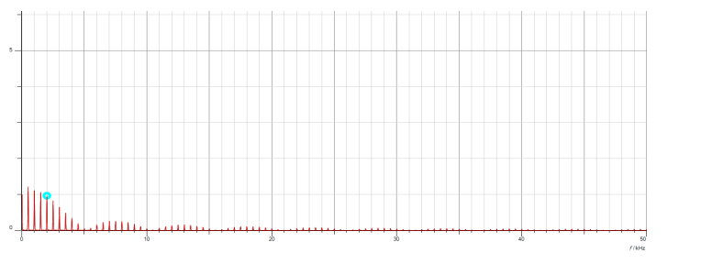

Figure 27:when 10% duty cycle

90% duty cycle:

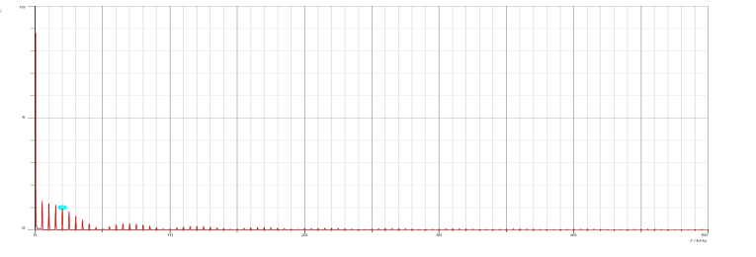

Figure 28:when 90% duty cycle

We see that a lower duty cycle, such as 10%, produces a smaller spectrum that is primarily centered on the carrier frequency, and that a higher duty cycle widens the signal's spectrum.

## **Amplitude shift keying Demodulation (Time and frequency domain)**

A square wave signal with a frequency of 1000 Hz, an amplitude of 5V (Vss = 10), and a duty cycle of 50% was produced by the function generator. Type A demodulation was chosen, and the demodulator mode was changed to Digital (DIG). Cassy sensor UB1 was linked to the demodulated signal at the output RXOUT, while Cassy sensor UA1 was coupled to the bipolar message square-wave signal at MODIN.

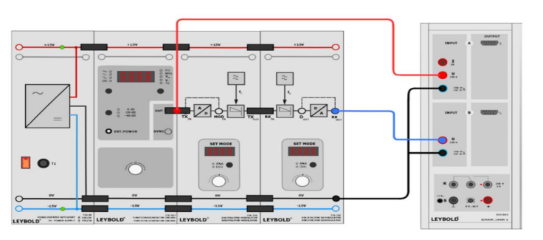

Figure 29:Amplitude shift keying Demodulation

### **Hard Keying**

Select Amplitude shift keying – Hard keying with modulation index m = 100% (A_11).

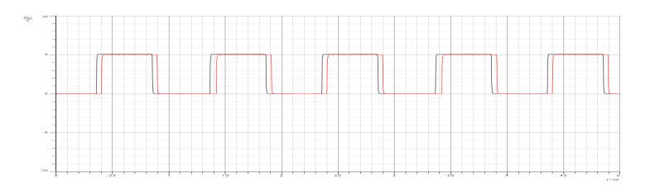

Figure 30:The A_11 demodulation Hard Keying

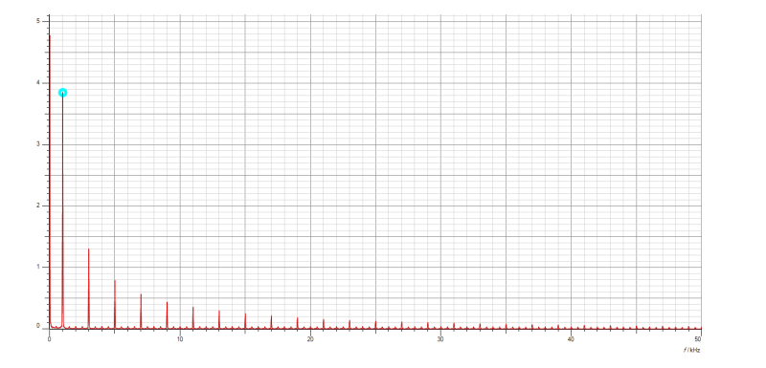

Figure 31:Demodulated signal output

The demodulated signal has a slight delay, as seen in figures 30 and 31, but overall signal recovery is effective.

Then the Amplitude shift keying - Hard keying with modulation index was turned to m = 50% (A_21).

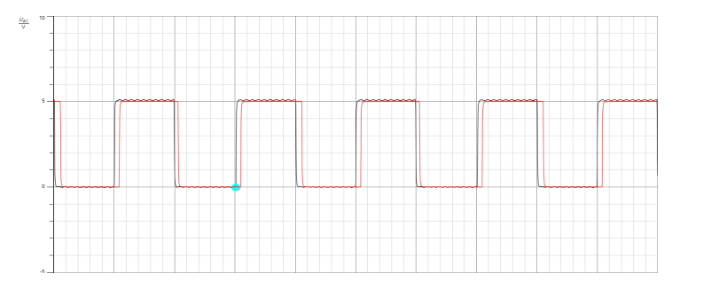

Figure 32:ASK demodulated signal in time domain with modulation index= 50 and duty cycle =50%.

In frequency domain:

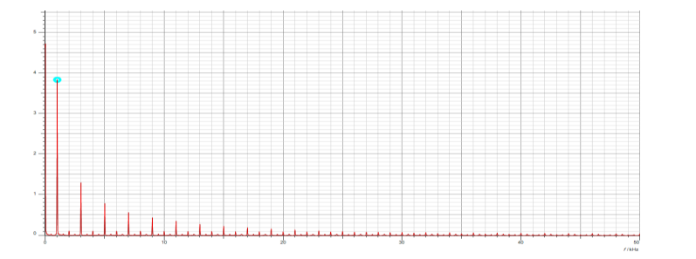

Figure 33:ASK demodulated signal in frequency domain with modulation index= 50 and duty cycle =50%.

We find that demodulating an ASK with 50% hard keying can be accomplished, but further demodulation techniques and careful examination of the Signal-to-Noise Ratio (SNR) and noise levels may be necessary.

### **2.3.2 soft Keying**

For the hard keying portion, the connection was retained as it was previously put together. The process was repeated, and Amplitude Shift Keying (ASK)—soft keying with a modulation index (m) of 100% was chosen as the modulation scheme (A_12).

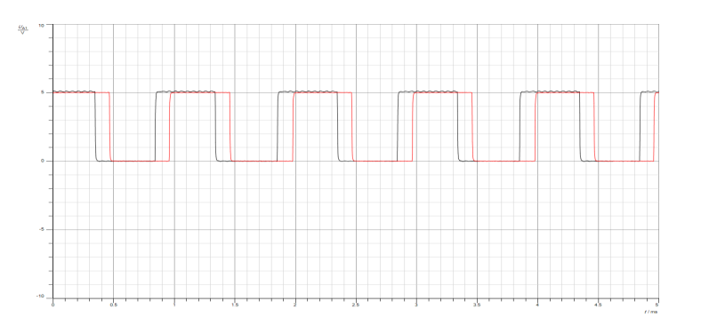

Figure 34:ASK demodulated signal in time domain with modulation index= 100 and duty cycle =50%- A12.

In frequency domain

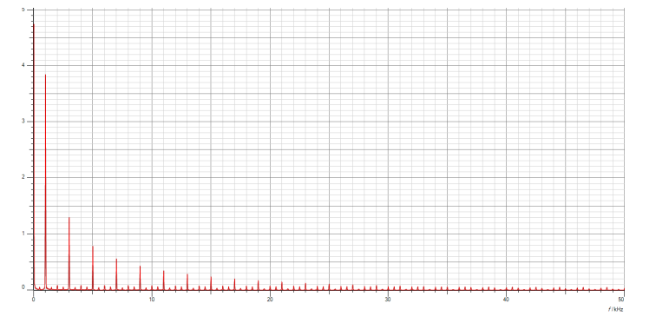

Figure 35:the same in frequency

After that we selected the Amplitude shift keying - Soft keying with modulation index m = 50% (A_22)

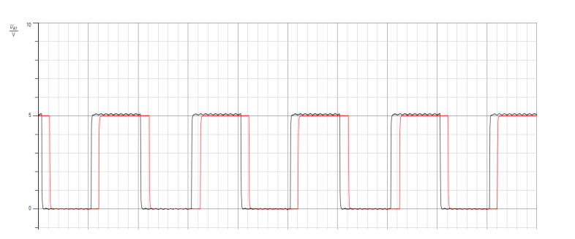

Figure 36:Soft keying with modulation index m = 50% (A_22) in time domain

And in frequency domain

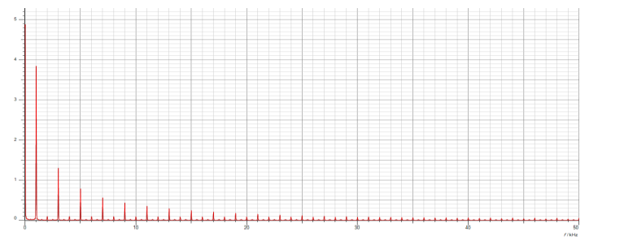

Figure 37:frequency

Both 100% and 50% ASK soft keying effectively achieve demodulation, as seen in the preceding figures, and recover the identical input signal.

The primary distinction between the demodulated signal and the message signal is that the latter is the result of processing the former through reverse modulation and modulation followed by transmission, whereas the former is the original data prior to transmission. The information is carried by the message signal, and our effort to reconstruct the original message is represented by the demodulated signal.

Compared to hard keying, soft keying has a larger time delay. The modulation methods employed in each approach are what give rise to the differences. Sharp amplitude level changes are a feature of hard keying, which accelerates demodulation and reduces latency.

In amplitude shift keying (ASK) modulation and demodulation, the modulation index can affect the temporal delay between the message and the demodulated signal. A higher modulation index of 100% results in more variations in the carrier signal's amplitude, necessitating a wider bandwidth to accommodate those variations and lengthening the delay. On the other side, a lower modulation index of 50% with smoother transitions can lead to a quicker demodulation time delay.

### **2.3.3 Studying the effect of changing the message signal frequency on the demodulation**

The function generator was configured to produce a square wave with a frequency of 500Hz, a duty cycle of 50%, and a Vss of 10V, maintaining the same connection as in the earlier sections.

The bipolar message square wave signal at TXin was assigned to the Cassy sensor UA1, and the demodulated signal at the output RXout was assigned to the Cassy sensor UB1.

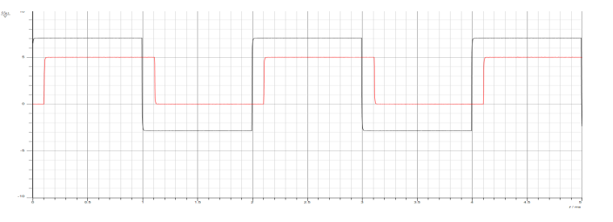

Figure 38:Effect of changing m(t) frequency on the demodulation

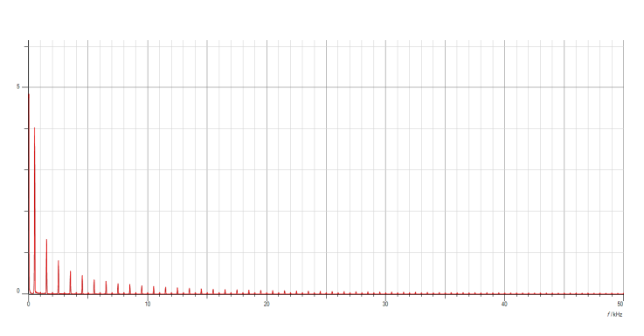

Figure 39:in frequency

The demodulation signal recovered successfully, with a bit shift to the left due to the frequency being decreased and the on/off range being increased when the duty cycle reached 50%.

### **2.3.4 Studying the effect of changing the message signal duty cycle on the demodulation**

The function generator was configured to produce a square wave with a frequency of 1000Hz, a duty cycle of 10%, and a Vss of 10V. The connection was maintained exactly as it was in the earlier sections.

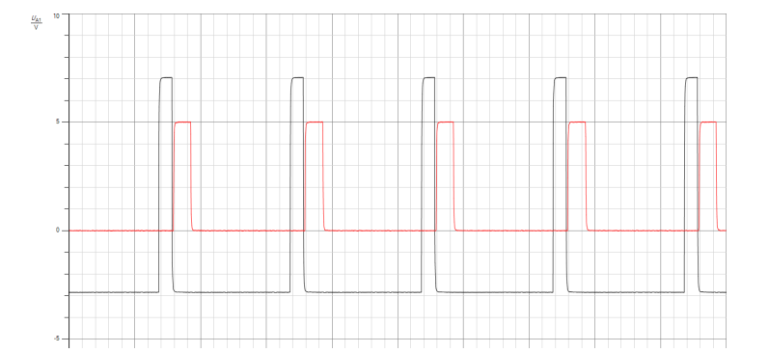

Figure 40:the effect of changing the message signal duty cycle on the demodulation in time domain.

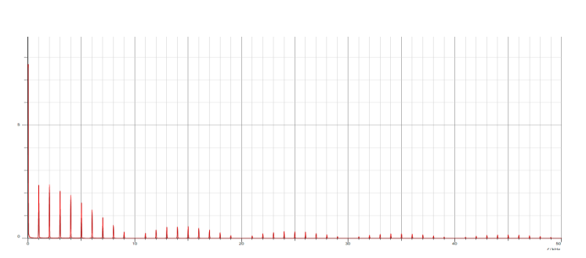

Figure 41:frequency

When duty cycle =50% and 90%

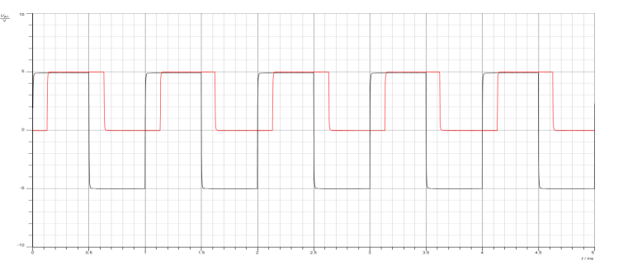

Figure 42:Effect of changing the m(t) duty cycle(50%) on the demodulation in the Time Domain

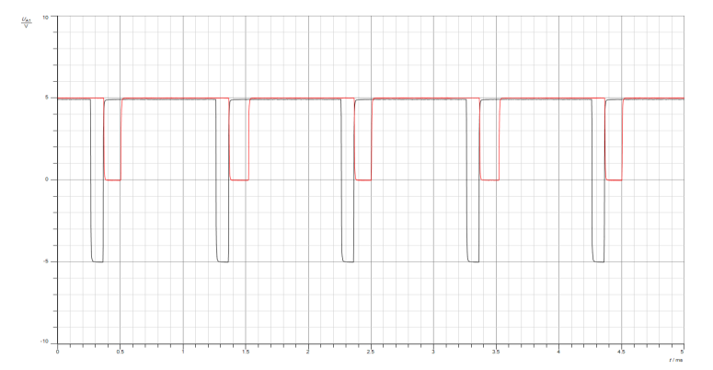

Figure 43:Effect of changing the m(t) duty cycle(90%) on the demodulation in the Time Domain

For frequency

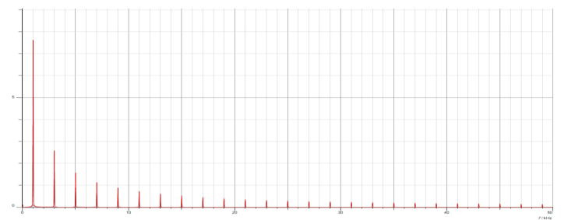

Figure 44:frequency of 50%

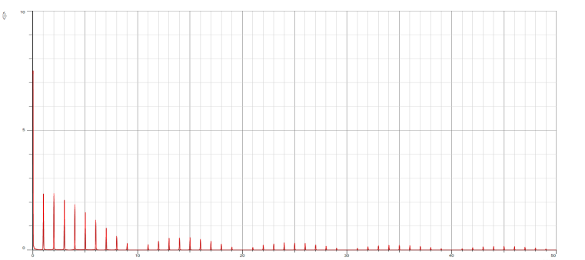

Figure 45:of 90%

When the duty cycle changes, the carrier signal value remains at 100% during the interval in which the signal is on, and the amplitude of the carrier signal decreases to half during the remaining duty cycle. Therefore, increasing the duty cycle results in a higher percentage of the original carrier signal form.

Greater duty-cycle values, such as 90% or higher, indicate that the signal's high and low phases occur more quickly. As a result, the demodulated signal gains power and strength and may experience less interference. It may, however, also cause the signal to transition from high to low more slowly, which would slow down data transfer.

# **Conclusion**

As a result, this experiment on Amplitude Shift Keying (ASK) modulation offered a thorough grasp of both hard and soft ASK keying techniques. It also looked at comparator threshold detection and saw the modulated signal with lower threshold fading. We were able to effectively investigate how the modulation index affected the spectrum in the frequency and temporal domains. We are also investigating the effects of changing the message signal's amplitude, frequency, and duty cycle in the time and frequency domains. Next, we looked at how the (ASK) of both hard and soft keying was demodulated and how altering the demodulation's duty cycle and message signal frequency would affect the system.

# **References**

[1]. <https://www.geeksforgeeks.org/amplitude-shift-keying/>

Accessed on December 25 2023, at 6:20 PM

[2].<https://www.tutorialspoint.com/digital_communication/digital_communication_amplitude_shift_keying.htm>

Accessed on December 25 2023, at 6:40 PM

[3]. <https://byjus.com/gate/difference-between-unipolar-polar-and-bipolar-line-coding-schemes/>

Accessed on December 25 2023, at 6:57 PM

[4]. <https://www.researchgate.net/figure/a-Threshold-detection-comparator-b-Block-Diagram-of-the-implemented-ADC-c-Simulated_fig1_277453559>

Accessed on December 25 2023, at 7:15 PM

[5]. <https://www.sciencedirect.com/topics/engineering/coherent-detection>

Accessed on December 25 2023, at 7:25 PM