I-RIGEL IONIC-4

**Installation Guide**

# Introduction

This document is for the installation and easy usage of code. First thank you for your great interest in our application. We are first focused on ionic main components. Project contains home page for I-RIGEL side navigation and for I-RIGEL bottom navigations and category page for both apps with all other required pages for shopping app which will give you a professional look. So, these app’s brings you ready to use in your app and in future you can get many more features. You can pick some parts of these app’s or even whole screen to use in your app. These app’s saves your precious time and effort so that you don’t need to create project from scratch. The code is very simple to understand; the customization is quite handy for all Ionic developers.

# Objectives

* High Sales, Product Quality and on Time Delivery.
* Reduce Time for the Completion of Ongoing Task.
* High Reachability.
* High Conversions.
* Customer Satisfaction.

# Pre-requisites

Following are pre-requisites of Ionic App:

* Need computer having minimum 4Gb ram and 20Gb free space for software installation.
* Visual Studio Code(recommended).
* Google Chrome(recommended).
* Node Version: V10.15.1(recommended).
* Android Studio latest
* Xcode 7 or higher
* npm Version: 6.4.1(recommended).
* Ionic CLI Version: 5.3.0(recommended).
* Ionic Framework: @ionic/angular 4.9.0
* @angular-devkit/build-angular Version: 0.801.3(recommended).
* @angular-devkit/schematics Version: 8.1.3(recommended).
* @angular/Cli Version: 8.1.3(recommended).
* @ionic-angular-toolkit Version: 2.0.0(recommended).
* Cordova CLI Version: 9.0.0(recommended).
* Cordova Platforms: android 7.1.4
* Cordova-res : 0.5.2

# tools for configuration

Following are tools that you need to configure application

1. Download and install **Node.JS(10.15.1)**

<https://nodejs.org/en/download/releases/>

You can download Node.Js according to your operating system.

1. Install **Visual Studio Code** latest version and install it.

<https://code.visualstudio.com/download>

1. Make **Google Chrome browser** your default browser.
2. Now in Visual Studio code apply the following command

* **npm install -g** [**ionic@5.3.0**](mailto:ionic@5.3.0)
* **npm install @ionic/angular@4.9.0**
* **npm install -g ionic** [**cordova@9.0.0**](mailto:cordova@9.0.0)

1. Now add platforms

* **ionic cordova platform add** [**android@7.1.4**](mailto:android@7.1.4)
* **ionic cordova platform add ios**

1. Now following are some mandatory commands
   * **npm rebuild node-sass**

For more information, go to

<https://ionicframework.com/docs>

# Project structure

# First open Visual Studio Code

# Open File and click on the Open Folder to select the project

# To import file, browse directory **\iShoeSide or \iShoeBottom**

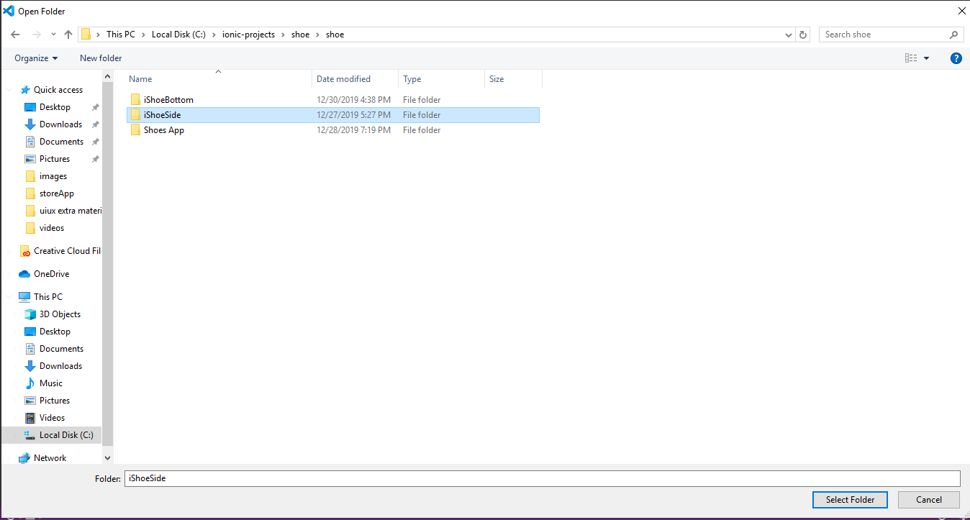

1. You need to check terminal, as it must contain the project directory

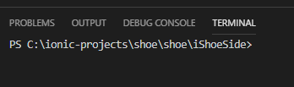

1. 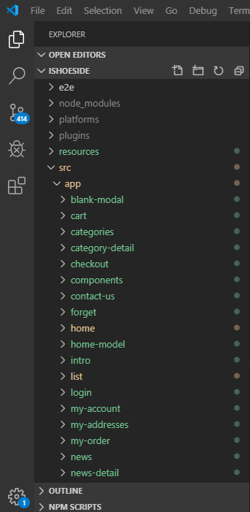 Preview project in visual studio code and you can see project structure as below
2. Use services page (theme.service and custom.theme) to change color scheme for local storage

# 

# For adding fonts you can add fonts to the **assets>font>[place custom fonts in “ttf” format].**

# 

1. Import font in **theme>font.scss** file

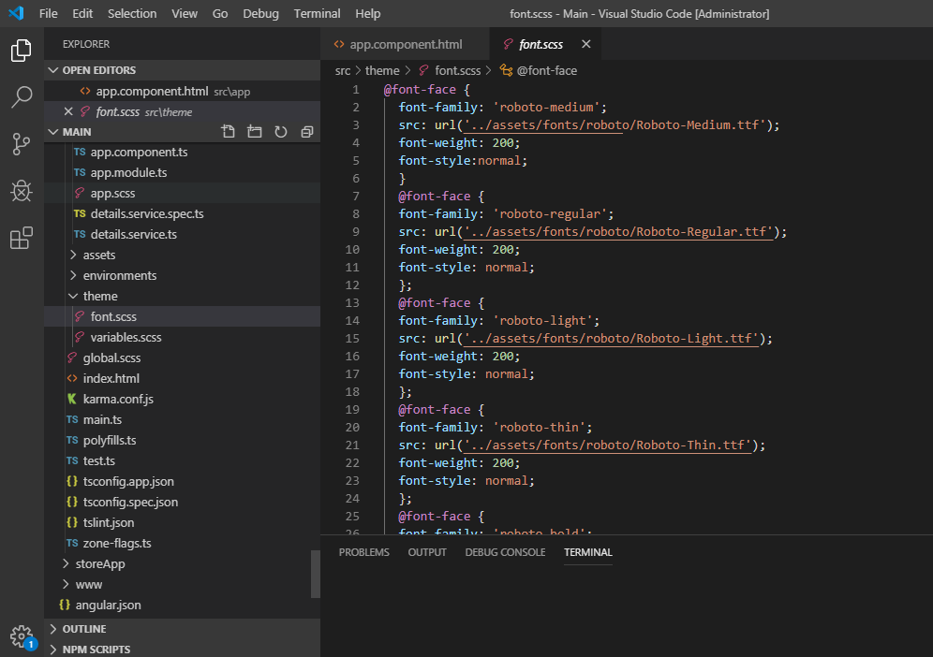

1. After installation of “node module” if you find an error in it then apply below command

**npm install fsevents –unsafe-perm=true –allow-root**

# SUPPORT

For any questions or suggestions, you can email or comment us on our item.

Please don’t forget to rate our item. We shall update it soon with new rich features. Thanks ☺